Module-6, Unit-1
Pipeline Strategy

Question 1: What are hazard in pipeline processor? Explain with suitable examples.

Solution 1:
We know that in a pipeline processor instructions are pre-fetched sequentially into the various stages even if some preceding instruction has not been executed. Hazards are cases that do not allow the trailing instruction(s) in the pipeline to execute during the scheduled clock cycle. This situation occurs due to dependency among instructions and the result is stalling of execution of instructions in the pipeline until the condition is recovered. There are main three types of hazards:

- Data Hazard
- Control Hazard
- Structure Hazard

Data Hazard

Data hazard results because results of earlier instructions are not available yet. To elaborate, data hazard in a pipeline occurs when a source operand of instruction I_{j} depends on the results of executing a preceding instruction, I_{i,} where j>i, and results of executing I_{i} have not been saved before executing I_{j}. It should be noted that although instruction I_{j} can be fetched and decoded, its operand(s) may not be available until the results of instruction I_{i} are stored.

Example:
I₁: M₁← M₂ + M₃
I₂: M₄← M₁ + M₅

In this case, instruction I₂ requires the result stored in M₁ (Memory Location), that is written by instruction I₁ to M₁. So unless instruction I₁ is executed and results written, the trailing instruction I₂ cannot be executed (or even its operands cannot be fetched). This is typical example of data hazard. This hazard is illustrated in the following instruction execution sequence:

Time  Instruction | 1 | 2 | 3 | 4 | 5 | 6 | 7 | 8 | 9 | 10
 |  | 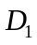 | 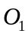 | 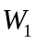
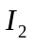 |  | 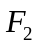 | 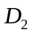 | XX | 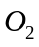 | 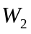
The notations are defined as follows:

 | Instruction fetch
 | Instruction decode
 | Operand fetch
 | Instruction execute and write

Control Hazard:

In pipeline organization instructions are fetched one after another sequentially. It works in all cases, but for conditional branch instruction, the address of the next instruction to be fetched depends on the result of the execution of the conditional instruction. Since the execution of next instruction depends on the previous branch instruction, sometimes it may be required to invalidate several instruction fetches. This is called control hazard.

Example:
I₁: JNZ I₄
I_{2:} M₁← M₂ + M₃
I₃: R₄← M₁ + M₅
I₄: HALT

is a conditional branch instruction. Before the results of the instruction is computed, the fetch unit has already fetched the instruction (and/or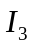, depending on the number of stages). If the branch condition is false, the next instruction to be executed is which is already fetched and is available for execution. In the other case, when the condition is true, and we have to execute the instruction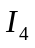, which will cause flashing of (and/or); this is a control hazard. This hazard is illustrated in the following instruction execution sequence:

Time  Instruction | 1 | 2 | 3 | 4 | 5 | 6 | 7 | 8 | 9 | 10
 |  |  | 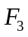 | 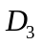
 |  |  |  |  | 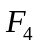 | 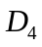 | 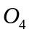 | 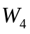

Structural hazards:

Structural hazard occurs when two or more instruction contents the same resource (in the same clock cycle). For example, in same clock cycle two instructions cannot perform ADD.

Question 2: What is the major issue of branching instructions in a pipelined processor?

Solution 2:

In general when we are executing a program the next instruction to be executed is brought from the next memory location. Therefore, in pipeline organization, we are fetching instructions one after another. But in case of conditional branch instruction, the address of the next instruction to be fetched depends on the result of the execution of the instruction. Since the execution of next instruction depends on the previous branch instruction, sometimes it may be required to invalidate several instruction fetches.

Consider the following instruction execution sequence:

Time  Instruction | 1 | 2 | 3 | 4 | 5 | 6 | 7 | 8 | 9 | 10
 |  |  |  |  | 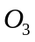 | 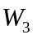
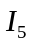 |  |  |  |  | 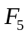 | 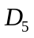 | 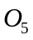 | 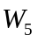
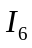 |  |  |  |  |  | 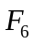 | 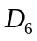 | 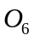 | 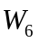
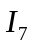 |  |  |  |  |  |  | 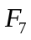 | 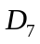 | 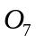 | 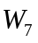

In this instruction sequence, we consider that is a conditional branch instruction. The result of the instruction will be available at clock cycle 5. But by that time the fetch unit has already fetched the instructions and. If the branch condition is false, then branch won’t take place and the next instruction to be executed is which already fetched and is available for execution. Now consider the case when the condition is true, and we have to execute the instruction 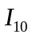. After clock cycle 5, it is known that branch condition is true and now instruction has to be executed. But already the processor has fetched instruction and . It is required to invalidate these two fetched instructions and the pipe line must be loaded with new instruction . Due to this reason, the pipeline will stall for some time. The time lost due to branch instruction is often referred as branch penalty.

The effect in pipeline due to the branch is shown below.

Time  Instruction | 1 | 2 | 3 | 4 | 5 | 6 | 7 | 8 | 9 | 10
 |  |  |  |  |  | 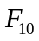 | 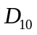 | 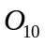 | 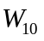
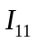 |  |  |  |  |  |  | 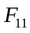 | 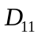 | 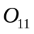 | 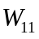

Due to the effect of branching the instructions and which have already been fetched are not executed and new instruction is fetched at clock cycle 6. There is not effective output in clock cycles 7 and 8, and so the branch penalty is 2. The branch penalty depends on the number of stages in the pipeline. More number of stages results more branch penalty.

Question 3: Discuss some basic approaches to dealing with conditional branches.

Solution 3:

One of the major problems in designing an instruction pipeline is assuming a steady and sequential flow of instructions to the initial stages of the pipeline. The primary problem is the conditional branch instruction because until the instruction is actually executed, it is impossible to determine whether the branch will be taken or not. So, without the branch instruction being actually executed it is impossible to know the flow of instructions in future. This makes pre-fetch of instructions in a sequential manner (before branching instruction being executed) to pipeline stages invalid if branching takes place.

Some basic approaches for dealing with conditional branches are as follows:
- Multiple streams
- Pre-fetch branch target
- Loop buffer

Multiple streams

A single pipeline suffers a penalty for a branch instruction because it must choose one of two instructions (i.e., (i) branch not taking place and (ii) branch taking place) to fetch next and sometimes it may make the wrong choice. A brute-force approach is to replicate the initial portions of the pipeline and allow the pipeline to fetch both instructions, making use of two streams.

There are two problems with this approach.
- With multiple pipelines there are contention delays for access to the registers and memory
- Additional branch instructions may enter the pipeline (either stream) before the original branch decision is resolved. Each such instruction needs as additional stream.

Pre-fetch Branch target

When a conditional branch is recognized, the target of the branch is pre-fetched, in addition to the instruction following the branch. This target is then saved until the branch instruction is executed. If the branch is taken, the target has already been pre-fetched.

Loop Buffer:

A loop buffer is a small, very high speed memory maintained by the instruction fetch stage of the pipeline and contains the most recently fetched instructions, in sequence. If a branch is to be taken, the hardware first cheeks whether the branch target is within the buffer. If so, the next instruction is fetched from the buffer.

The loop buffer has three benefits:

- With the use of prefetching, the loop buffer will contain some instruction sequentially ahead of the current instruction fetch address. Thus, instructions fetched in sequence will be available without the usual memory access time.
- If a branch occurs to a target just a few locations ahead of the address of the branch instruction, the target will already be in the buffer. This is usual for the common occurrence of IF-THEN and IF-THEN-ELSE sequences.
- This strategy is particularly well suited to deal with loops, or iterations; hence the name loop buffer. If the loop buffer is large enough to contain all the instructions in a loop, then those instructions are to be fetched from memory only once, for the first iteration. For subsequent iterations, all the needed instructions are already in the buffer.

The loop buffer is similar in principle to a cache dedicated to instructions. The differences are that the loop buffer only retains instructions in sequence and is much smaller in size and hence lower in cost.

Question 4: Discuss some basic approaches to predict branching.

Solution 4:

Solution 4:

Various techniques can be used to predict whether a branch will be taken or not. The most common techniques are:

- Predict never taken
- Predict always taken
- Predict by opcode
- Taken/not taken switch
- Branch history table.

The first three approaches are static, i.e., they do not depend on the execution history up to the time of conditional branch instruction. The latter two approaches are dynamic i.e., they depend on the execution history.

Predict never taken

Predict never taken and predict always taken are the simplest. Predict never taken always assumes that the branch will not be taken and continue to fetch instruction in sequence.

Predict always taken

Predict always taken assumes that the branch will be taken and always fetch the branch target.

In these two approaches it is also possible to minimize the effect of a wrong decision. If the fetch of an instruction after the branch will cause a page fault or protection violation, the processor halts its prefetching until it is sure that the instruction should be fetched. Studies analyzing program behavior have shown that conditional branches are taken more than 50% of the time, and so if the cost of prefetching from either path is the same, then always prefetching from the branch target address should give better performance than always prefetching from the sequential path. However, in a paged machine, prefetching the branch target is more likely to cause a page fault than prefetching the next instruction in the sequence and so this performance penalty should be taken into account.

Predict by opcode

Predict by opcode approach makes the decision based on the opcode of the branch instruction. The processor assumes that the branch will be taken for certain branch opcodes and not for others. Studies showed that success rate is greater than 75% with the strategy.
Dynamic Branch Strategies

Dynamic branch strategies attempt to improve the accuracy of prediction by recording the history of conditional branch instructions in a program.

Taken/not taken switch

One or more bits can be associated with each conditional branch instruction that reflect the recent history of the instruction. These bits are referred to as a taken/not taken switch that directs the processor to make a particular decision the next time the instruction is encountered. Generally these history bits are not associated with the instruction in main memory. It will unnecessarily increase the size of the instruction. With a single bit we can record whether the last execution of this instruction resulted in a branch or not. With only one bit of history, an error in prediction will occur twice for each use of the loop--once for entering the loop and once for exiting. If two bits are used, they can be used to record the result of the last two instances of the execution of the associated instruction. One possibility is to associate these bits with any conditional branch instruction in a cache. However, when the instruction is replaced in the cache, its history is lost. Another possibility is to maintain a small table for recently executed branch instructions with one or more bits in each entry.

Branch history table

The branch history table is a small cache memory associated with the instruction fetch stage of the pipeline. Each entry in the table consists of three elements:
- The address of the branch instruction.
- Some member of history bits that record the state of use of that instruction.
- Information about the target instruction; it may be the address of the target instruction, or may be the target instruction itself.

Question 5: What is Delayed Branch? How can it handle the issue of branch instruction in Pipeline processor?

Solution 5:
In this answer we will consider an example of a two stage pipeline processor. Execution of instructions in this pipelined processor with branch instruction is shown below.

Instruction
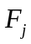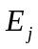
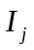(Branch)
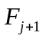

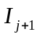
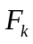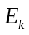

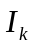

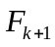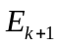

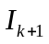
Time

Let the instruction be a branch instruction. The processor begins fetching instruction before it determines whether the current instruction, , is a branch instruction. When execution of is completed and a branch must be made, the processor must discard the instruction that was fetched and then fetch the instruction at the branch target. The location following a branch instruction is called a branch delay slot. There may be more than one branch delay slot, depending on the time it takes to execute a branch instruction. The instructions in the delay slots are always fetched and at least partially executed before the branch decision is made and the branch target address is computed.

Delayed branching is a technique to minimize the penalty incurred as a result of conditional branch instructions. The instructions in the delay slots are always fetched, so we can arrange the instruction in delay slots to be fully executed whether or not the branch is taken. The objective is to place useful instruction in these slots. If no useful instructions can be placed in the delay slots, these slots must be filled with NOP instructions. While feeling up the delay slots with instructions, it is required to maintain the original semantics of the program.

For example consider the following code segment:

 | Loop | Shift-left | 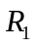
 |  | Decrement | 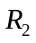
 |  | Branch-if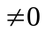 | Loop | Original program loop
 | Next | Add | 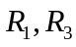

Here register is used as a counter to determine the number of times the contents of register are sifted left. Consider a processor with a two-stage pipeline and one delay slot. During the execution phase of the instruction , the fetch unit will fetch the instruction . After evaluating the branch condition only, it will be clear whether instruction or will be executed next. The nature of the code segment says that it will remain in the top depending on the initial value of and when it becomes zero, it will come out from the loop and execute the instruction. During the loop execution, every time there is a wrong fetch of instruction.

The code segment can be recognized without disturbing the original meaning of the program, explained as follows.

Loop | Decrement
 | Branch-if | Loop | Reordered instruction for program loop
 | Shift-left |  | Delay slot
Next | Add

In this case, the shift instruction is fetched while the branch instruction is being executed.
After evaluating the branch condition, the processor fetches the instruction at LOOP or at NEXT, depending on whether the branch condition is true or false, respectively. In either case, it completes execution of the shift instruction. Logically the program is executed as if the branch instruction was placed after the shift instruction. In other words, branching takes place one instruction later than where the branch instruction appears in the instruction sequence in the memory, hence the name “delayed branch”

Figure below shows the execution timing for the last two passes through the loop of reordered instructions.

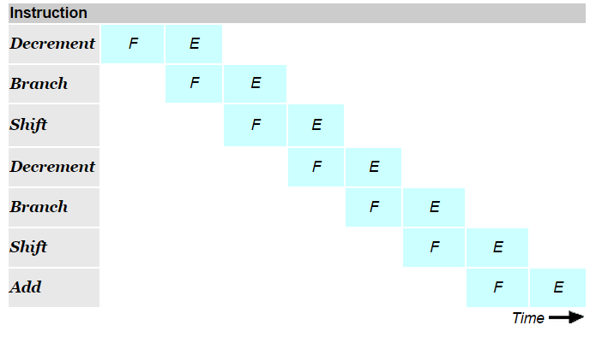

Execution timing for last two passes through the loop of reordered instructions.

Figure below shows the execution timing for the last two passes through the loop of the original program loop.

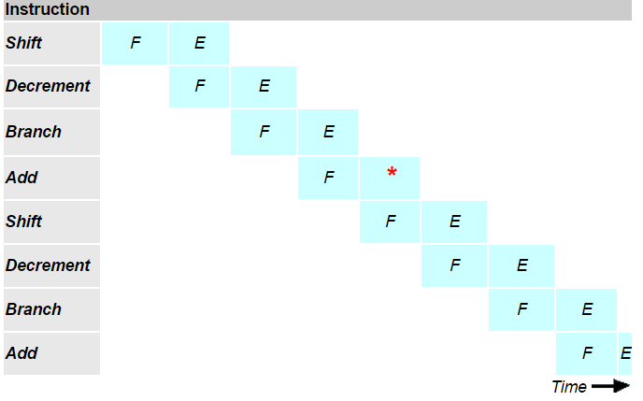
*Note: Execution Unit Idle

Execution timing for the last two passes through the loop of the original program loop.

