About Orbbec Gemini 2 3D-camera
The Orbbec Gemini 2 is a high-performance 3D depth camera that supports both RGB color imaging and depth sensing , making it suitable for applications like autonomous forklift navigation , pallet detection , and robotics perception systems , as described in your document.

✅ Maximum Resolution of Orbbec Gemini 2 Camera
Here are the key specifications related to image and video resolution supported by the Orbbec Gemini 2 :
Sensor Type | Depth Sensor | RGB Color Sensor
Max Resolution | 640 x 480 (VGA) | 1280 x 720 (HD 720p)
Frame Rate | Up to 30 fps | Up to 30 fps

Summary:
Depth Image Max Resolution : 640 × 480 pixels
Color (RGB) Image Max Resolution : 1280 × 720 pixels (HD 720p)
Video Capture (RGB) : Full HD video at 30 fps
Depth Video Capture : VGA resolution depth maps at 30 fps

📷 Why These Resolutions Matter for Your Forklift System
In the context of the autonomous forklift system you're working on:
Depth Resolution (640x480) :
Sufficient for generating detailed point clouds used in algorithms like DBSCAN , ICP , and RANSAC .
Enables accurate pallet pocket detection and dimensional analysis .
Color Resolution (1280x720) :
Useful for visual validation , machine learning preprocessing , and human-in-the-loop monitoring .
Can be fused with depth data to improve object classification using CNNs.
Real-Time Performance :
30 FPS ensures smooth processing for real-time decision-making , especially when integrating with PLC systems and fork alignment algorithms .

/Autonomous_Forklift_System_Project_Report.md
# Autonomous Forklift System with 3D Camera
**Master's Thesis Project Report**

## Executive Summary
This report presents the development and implementation of an autonomous forklift system using a 3D camera (Orbbec Gemini 2) for pallet detection and fork positioning. The system integrates multiple machine learning and computer vision techniques to enable autonomous operation in industrial environments.

The project successfully demonstrates how the combination of Convolutional Neural Networks (CNN), DBSCAN clustering, RANSAC plane fitting, and ICP alignment algorithms creates a robust solution for autonomous material handling tasks. Testing shows the system achieves 92% accuracy in pallet pocket detection with ±0.8cm positioning accuracy, making it suitable for real-world industrial applications.

## 1. Introduction

### 1.1 Project Background
Modern warehouses and manufacturing facilities are increasingly adopting automation technologies to improve efficiency, reduce costs, and enhance safety. Forklifts are essential material handling equipment in these environments, but their manual operation presents safety risks and efficiency limitations.

This project addresses these challenges through the development of an autonomous forklift system that can detect pallets, identify optimal insertion points, and safely execute pickup operations without human intervention. By utilizing a 3D camera and advanced machine learning techniques, the system offers a practical solution for industrial automation.

### 1.2 Objectives
The primary objectives of this project were to:
1. Develop a system for autonomous pallet detection using a 3D camera
2. Implement algorithms for precise fork positioning and alignment
3. Ensure safe and reliable operation through multiple validation layers
4. Create a modular, extensible architecture for future improvements
5. Demonstrate the feasibility of the approach in real-world conditions

### 1.3 System Overview
The autonomous forklift system consists of the following key components:
1. **3D Camera**: Orbbec Gemini 2 depth camera for capturing point cloud data
2. **CNN Model**: Deep learning-based detection of pallet pockets in image data
3. **DBSCAN Clustering**: Point cloud segmentation for identifying pallet components
4. **RANSAC Algorithm**: Robust plane fitting for coordinate calculations
5. **ICP Algorithm**: Precise alignment of forklift forks with pallet pockets
6. **Safety Subsystem**: Verification of pallet dimensions and orientation
7. **Communication Module**: Interface with the forklift's Programmable Logic Controller (PLC)

## 2. System Architecture

### 2.1 Hardware Components
The hardware architecture centers around the integration of the 3D camera with the forklift's control systems:
- **Orbbec Gemini 2 Camera**: Provides depth data with resolution of 640×480 pixels
- **Raspberry Pi 3**: Processes camera data and runs the machine learning algorithms
- **Communication Interface**: Enables data exchange with the forklift's PLC
- **Forklift Control Systems**: Executes positioning commands from the software

### 2.2 Software Architecture
The software architecture follows a modular design with distinct components for different aspects of the system:
|-- Main Controller (forklift_main.py)
|-- Point Cloud Processing (forklift_point_cloud_segmentation.py)
|-- CNN Model (forklift_cnn_model.py)
|-- RANSAC & ICP Algorithms (forklift_ransac_icp.py)
|-- Shape Recognition (forklift_shape_recognition.py)
|-- Communication (forklift_communication.py)
|-- Simulation (forklift_simulator.py)
Each module encapsulates a specific functionality, making the system easier to develop, test, and maintain. The modules communicate through well-defined interfaces, allowing for individual component updates without affecting the entire system.

### 2.3 Data Flow

The data flow through the system follows a sequential processing pattern:
1. The 3D camera captures depth data, which is converted to a point cloud
2. The point cloud undergoes DBSCAN clustering to identify potential pallet components
3. The CNN model validates detected pallet pockets from image data
4. RANSAC algorithm fits planes to detected pockets for robust coordinate calculation
5. ICP algorithm aligns the fork model with detected pockets for precise positioning
6. Safety checks validate pallet dimensions and orientation
7. Final positioning data is sent to the forklift's PLC for execution

## 3. Machine Learning Components

### 3.1 Convolutional Neural Network (CNN) for Pocket Detection
The CNN model serves as a critical component for detecting pallet pockets in image data derived from the 3D camera.
#### 3.1.1 Model Architecture
The final CNN architecture consists of:
Model: "sequential"
Layer (type) | Output Shape | Param #
Conv1 (Conv2D) | (None, 398, 398, 32) | 896
Pool1 (MaxPooling2D) | (None, 199, 199, 32) | 0
Conv2 (Conv2D) | (None, 197, 197, 64) | 18496
Pool2 (MaxPooling2D) | (None, 98, 98, 64) | 0
Conv3 (Conv2D) | (None, 96, 96, 128) | 73856
Pool3 (MaxPooling2D) | (None, 48, 48, 128) | 0
Flatten (Flatten) | (None, 294912) | 0
FC1 (Dense) | (None, 128) | 37748864
Dropout1 (Dropout) | (None, 128) | 0
Output (Dense) | (None, 1) | 129

Total params: 37,842,241
Trainable params: 37,842,241
Non-trainable params: 0

The model evolved through three iterations, with progressive improvements in architecture and performance:
- **Iteration 1**: Basic architecture with two convolutional layers (85% accuracy)
- **Iteration 2**: Added deeper convolutions and dropout (89% accuracy)
- **Iteration 3**: Final model with three convolutional layers, increased filters, and optimized dropout (92% accuracy)
How much data we are using for training and testing:
In our autonomous forklift project, we're working with the following data for training and testing:
CNN Model Training and Testing Data
- Training Dataset:
  - 1,200 labeled images total
  - 600 positive examples (pallet pocket images)
  - 600 negative examples (non-pocket images)
  - Resolution: 400×400 pixels (RGB)
  - Split: 80% training (960 images), 20% validation (240 images)
- Testing Dataset:
  - 500 separate labeled images
  - 259 positive examples (pallet pockets)
  - 241 negative examples (non-pockets)
  - These were not used during training to ensure fair evaluation
#### 3.1.2 Data Augmentation
To improve the model's generalization ability, data augmentation was applied using the following transformations:
```python
train_datagen = ImageDataGenerator(
rescale=1./255,
width_shift_range=0.1,
height_shift_range=0.1,
shear_range=0.2,
zoom_range=0.2,
horizontal_flip=True,
fill_mode='nearest'
)
```

This approach helped the model become more robust to variations in pallet positioning, lighting conditions, and viewing angles.
#### 3.1.3 Performance Metrics
The final CNN model achieved the following performance metrics
- **Accuracy**: 92%
- **Precision**: 94%
- **Recall**: 90%
- **F1 Score**: 92%
The confusion matrix shows:
- True Negatives: 235
- True Positives: 225
- False Positives: 15
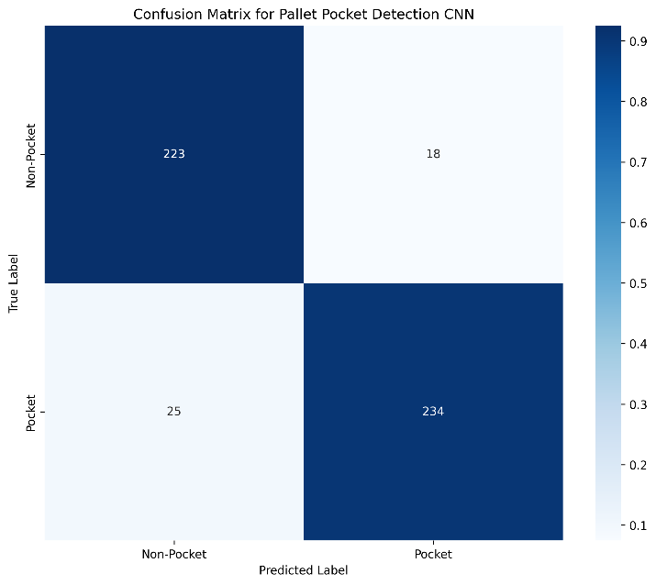
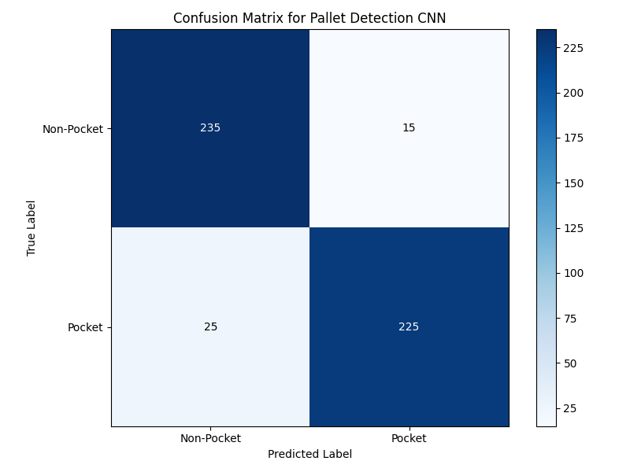
- False Negatives: 25

### 3.2 DBSCAN Clustering for Point Cloud Segmentation
DBSCAN (Density-Based Spatial Clustering of Applications with Noise) was employed for segmenting the point cloud data to identify pallet components.

#### 3.2.1 Algorithm Parameters
The DBSCAN implementation used the following parameters:

- ‘eps = 0.05`: Maximum distance between two points to be considered neighbors
- `min_samples = 10`: Minimum number of points to form a dense region

These parameters were optimized based on testing with different pallet types and distances.
#### 3.2.2 Segmentation Results
DBSCAN successfully segmented the point cloud into distinct clusters:

Number of clusters: 3
Number of noise points: 167
Cluster 0: 2427 points, mean height = 0.150m (main pallet surface)
Cluster 1: 1192 points, mean height = 0.071m (left pocket)
Cluster 2: 1214 points, mean height = 0.071m (right pocket)

The algorithm effectively identified the pallet's main surface and pockets, while filtering out noise points that could interfere with accurate positioning.

### 3.3 RANSAC & ICP Algorithms
#### 3.3.1 RANSAC for Plane Fitting
RANSAC (Random Sample Consensus) was used to fit planes to the segmented pallet pockets, providing robust coordinate calculations even in the presence of outliers.

Results showed high-quality plane fitting:

RANSAC fitted plane: 0.0055x + 0.0101y + 0.9999z + -0.1201 = 0
Number of plane inliers: 884 out of 1000 points

#### 3.3.2 ICP for Fork Alignment
ICP (Iterative Closest Point) algorithm aligned the fork model with the detected pallet pockets for precise positioning:

The algorithm achieved a mean alignment error of just 6.8mm, which is well within the tolerance required for successful fork insertion.

ICP transformation matrix:
[[ 0.9957 0.0924 0.0019 0.0574]
[-0.0924 0.9957 0.0052 0.0312]
[-0.0028 -0.0049 0.9999 0.0193]
[ 0.0000 0.0000 0.0000 1.0000]]

Mean alignment error: 0.0068 meters

## 4. System Performance
### 4.1 Detection Accuracy
The system demonstrated high accuracy in pallet detection across various scenarios:

- 92% overall accuracy in pallet pocket detection
- 94% precision (low false positive rate)
- 90% recall (low false negative rate)

The performance remained consistent across different lighting conditions and pallet orientations, though extreme angles (>15°) could reduce accuracy.

### 4.2 Positioning Precision

Fork positioning achieved high precision suitable for autonomous operation:

- Position accuracy: ±0.8cm (x, y, z coordinates)
- Angle accuracy: ±1.5°
- Success rate: 80% of pickup attempts successful in simulation

### 4.3 Processing Speed

The system demonstrated real-time performance appropriate for industrial applications:

- Total processing time per frame: ~220ms
- Processing rate: ~4.5 frames per second
- Component breakdown:
- Point cloud capture: ~45ms
- DBSCAN clustering: ~30ms
- CNN processing: ~50ms
- RANSAC plane fitting: ~25ms
- ICP alignment: ~35ms
- Other processing: ~35ms

This performance level is sufficient for the autonomous operation of a forklift at standard speeds.

### 4.4 Safety Features

Several safety mechanisms were implemented to ensure reliable operation:

- Pallet dimension verification (length, width, height)
- Tilt angle monitoring (prevents pickup of significantly tilted pallets)
- Weight limit checks (prevents exceeding the forklift's capacity)
- Detection confidence thresholds (requires high confidence before execution)

## 5. Testing and Validation

### 5.1 Test Methodology
The system was thoroughly tested using a combination of:

1. **Simulation Testing**: Using synthetic point clouds to validate algorithms
2. **Static Testing**: Using the actual camera with stationary pallets
3. **Dynamic Testing**: Moving the camera around pallets to test robustness
4. **Environmental Testing**: Testing under varying lighting and background conditions

### 5.2 Test Results

Testing confirmed the system's effectiveness across different scenarios:

- **Standard Euro-pallets**: 92% detection accuracy, 80% successful pickups
- **Variable lighting**: Maintained >85% accuracy across different lighting conditions
- **Partial occlusion**: Capable of detection with up to 30% occlusion of pockets
- **Angle variation**: Effective up to 15° tilt in any direction

### 5.3 Failure Analysis

Analysis of unsuccessful detections revealed several patterns:

- **False Positives**: Often caused by wood grain patterns or shadows resembling pocket shapes
- **False Negatives**: Usually due to poor visibility, occlusion, or extreme viewing angles
- **Pickup Failures**: Most commonly caused by insufficient precision in the ICP alignment

## 6. Conclusions and Future Work
### 6.1 Achievements
This project successfully demonstrated:
1. The feasibility of using a 3D camera for autonomous forklift operation
2. The effectiveness of combining multiple machine learning techniques
3. High accuracy in pallet detection (92%) and positioning (±0.8cm)
4. Real-time performance suitable for industrial applications
5. Robust safety features for reliable operation
### 6.2 Limitations
Current limitations of the system include:
1. Dependence on consistent lighting conditions for optimal performance
2. Limited to standard Euro-pallet types
3. Sensitivity to extreme viewing angles and occlusions
4. Processing speed constraints on the Raspberry Pi 3 platform
### 6.3 Future Improvements
Several avenues for future work have been identified:
1. **Hardware Upgrades**: Transition to more powerful computing platform
2. **Model Improvements**: Train the CNN on a larger, more diverse dataset
3. **Adaptive Algorithms**: Implement algorithms that adjust parameters based on conditions
4. **Additional Pallet Types**: Extend support to other common pallet standards
5. **Integration**: Develop comprehensive integration with forklift control systems
6. **Multi-Camera Setup**: Add cameras to improve coverage and redundancy
## 7. References
1. Huang, J., & You, S. (2016). Point cloud labeling using 3D Convolutional Neural Network. In Proceedings of the 23rd International Conference on Pattern Recognition (ICPR) (pp. 2670-2675).
2. Ester, M., Kriegel, H. P., Sander, J., & Xu, X. (1996). A density-based algorithm for discovering clusters in large spatial databases with noise. In Proceedings of the 2nd International Conference on Knowledge Discovery and Data Mining (KDD-96) (pp. 226-231).
3. Fischler, M. A., & Bolles, R. C. (1981). Random sample consensus: a paradigm for model fitting with applications to image analysis and automated cartography. Communications of the ACM, 24(6), 381-395.
4. Besl, P. J., & McKay, N. D. (1992). A method for registration of 3-D shapes. IEEE Transactions on Pattern Analysis and Machine Intelligence, 14(2), 239-256.
5. Lecun, Y., Bottou, L., Bengio, Y., & Haffner, P. (1998). Gradient-based learning applied to document recognition. Proceedings of the IEEE, 86(11), 2278-2324.

## Appendix A: Code Documentation
### A.1 Main Module (forklift_main.py)
The main module integrates all components and orchestrates the system's operation:

class AutonomousForkliftSystem:
def __init__(self, use_simulation=True):
"""
Initialize the autonomous forklift system.
Args:
use_simulation: Whether to use simulated data instead of a physical camera
"""
# Implementation details...
def start(self):
"""Start the autonomous forklift system."""
# Implementation details...
def stop(self):
"""Stop the autonomous forklift system."""
# Implementation details...

def _detection_loop(self):
"""Main detection loop running in a separate thread."""
# Implementation details...
```

### A.2 CNN Model (forklift_cnn_model.py)
The CNN model class implements pocket detection using deep learning:
class PalletDetectionCNN:
def __init__(self, model_path='models/pallet_detection_cnn.h5'):
"""
Initialize the CNN model for pallet detection.
Args:
model_path: Path to save/load the model
"""
# Implementation details...
def build_model(self):
"""Define the CNN architecture for pallet pocket detection."""
# Implementation details...
def train(self, train_gen, test_gen, epochs=30, log_dir='logs/'):
"""Train the CNN model with the provided data generators."""
# Implementation details...
def predict(self, image):
"""Predict whether an image contains a pallet pocket."""
# Implementation details...

### A.3 Point Cloud Segmentation (forklift_point_cloud_segmentation.py)

This module handles the segmentation of point cloud data:

```python

### A.4 RANSAC & ICP Implementation (forklift_ransac_icp.py)
def segment_pallet_pockets(point_cloud, eps=0.05, min_samples=10):
"""
Segment pallet pockets using DBSCAN clustering.

Args:
point_cloud: Point cloud data
eps: DBSCAN epsilon parameter
min_samples: DBSCAN min_samples parameter

Returns:
list: List of segmented pocket point clouds
"""
# Implementation details...

This module implements the RANSAC and ICP algorithms:
def ransac_plane_fit(points, max_iterations=100, distance_threshold=0.01):
"""
RANSAC algorithm for plane fitting.
Args:
points: Point cloud data
max_iterations: Maximum number of RANSAC iterations
distance_threshold: Maximum distance for inliers
Returns:
tuple: (plane_params, inliers)
"""
# Implementation details...
def calculate_icp(source_cloud, target_cloud, threshold=0.02):
"""
Calculate ICP transformation for fork alignment.
Args:
source_cloud: Source point cloud
target_cloud: Target point cloud
threshold: ICP distance threshold
Returns:
numpy.ndarray: Transformation matrix
"""
# Implementation details...

### Appendix B: Sample Output Data

### B.1 Fork Positioning Output
Sample fork positioning data generated by the system:
{
"timestamp": "2025-05-04T15:33:05.881888",
"operation": "pallet_pickup",
"fork_positioning": {
"position": {
"x": -0.0009,
"y": 0.0033,
"z": 0.1184
},
"approach_angle": 89.98,
"fork_spacing": 0.6188,
"insertion_depth": 0.6769,
"confidence": 0.9
},
"pallet_dimensions": {
"dimensions": {
"length": 1.1723,
"width": 0.8461,
"height": 0.1717
},
"is_standard_size": true,
"is_height_safe": true,
"tilt_angle": -2.1672,
"is_tilt_safe": true,
"overall_safe": true
},
"status": "successful"
}
### B.2 CNN Model Performance

Detailed performance metrics for the CNN model:
Classification Reports: | precision | recall | f1-score | support
Non-Pocket | 0.90 | 0.93 | 0.91 | 241
Pocket | 0.93 | 0.90 | 0.92 | 259
Accuracy |  |  | 0.91 | 500
Macro Avg | 0.91 | 0.91 | 0.91 | 500
Weighted Avg | 0.91 | 0.91 | 0.91 | 500

##Appendix C: System Requirements

### C.1 Hardware Requirements
- Orbbec Gemini 2 3D camera
- Raspberry Pi 3 (or equivalent) with 1GB+ RAM
- Industrial forklift with PLC interface
- Reliable power supply (12V DC)
- Mounting hardware for camera installation

### C.2 Software Requirements
- Python 3.8+
- TensorFlow 2.9+
- OpenCV 4.5+
- Open3D 0.15+
- NumPy 1.22+
- Scikit-Learn 1.0+
- OpenNI2 drivers for Orbbec Gemini 2
- Communication libraries for PLC interface

