SIMATS ENGINEERING
ASSESSMENT TOOL 3

COURSE NAME: INTERNET PROGRAMMING
COURSE CODE: CSA4303
Name : G.Vamsi krishna
Reg. No. : 192311362

COURSE OUTCOME COVERED

CO-1: Develop well-structured, standards-compliant web pages using HTML/XHTML and XML, and apply Internet protocols and HTTP communication mechanisms for web content delivery. (L2)

Assessment Tool : Case Study

Weightage: 10%

QUESTIONS: Total Marks: 10

Scenario: Web Development Standards Implementation
A startup is developing a modern web application. During development, the team encounters multiple issues related to HTML elements, HTTP methods, XML syntax, and web communication protocols.
The following observations are made:
- The team needs to embed a promotional video on the homepage.
- A registration form must securely send user data to the server.
- The navigation menu must follow semantic HTML standards.
- XML configuration files are being used but contain syntax errors.
- The application must communicate over the correct web protocol.

Data Snippets Provided
Snippet 1: Video Embedding Options
A. <media src="video.mp4"></media>
B. <video src="video.mp4" controls></video>
C. <movie src="video.mp4"></movie>
D. <vid src="video.mp4"></vid>
Snippet 2: Form Submission Methods
A. GET
B. POST
C. PUT
D. DELETE
Snippet 3: Navigation Elements
A. <div>
B. <nav>
C. <section>
D. <header>
Snippet 4: XML Syntax
A. <note><to>User</to><from>Admin</from>
B. <note><to>User</to><from>Admin</from></note>
C. <note><to>User</from></note>
D. <note to="User"></note
Snippet 5: Web Communication Protocols
A. FTP
B. HTTP
C. SMTP
D. SNMP

Questions:
- Select the correct HTML tag for video embedding and justify your answer.
- Identify the appropriate HTTP method for form submission and explain why.
- Choose the proper semantic element for navigation and justify its usage.
- Identify the correct XML syntax and explain the error in other options.
- Choose the correct protocol for web communication and justify your choice.

Code of Conduct:

I G.VAMSI KRISHNA (192311362) certify that this submission is my original work and that I have adhered to the guidelines specified for this assessment.
I understand that any violation of academic integrity rules will result in disciplinary action.

Signature of the student: G.VAMSI KRISHNA

RUBRICS FOR CALCULATION:

Criteria | Weightage | Level 4 – Exemplary | Level 3 – Proficient | Level 2 – Developing | Level 1 – Beginning
Understanding of Case | 25 | Thorough understanding; clearly identifies all key issues | Good understanding with most issues identified | Basic understanding; some issues missed | Poor understanding; problem not identified correctly
Application of Concepts | 25 | Effectively applies relevant concepts to analyze the case deeply | Applies appropriate concepts with minor gaps | Limited application of concepts | Fails to apply relevant concepts
Analysis | 20 | In-depth analysis with strong reasoning and insights | Good analysis with logical reasoning | Basic analysis with limited depth | Weak or no analysis; lacks reasoning
Solution Design | 20 | Innovative, feasible solutions with strong justification | Logical solutions with adequate justification | Basic solutions with weak justification | Incorrect or no solution provided
Clarity | 10 | Clear, well-structured, and easy to understand | Organized and understandable presentation | Limited clarity and structure | Poor clarity; difficult to understand

Answers:
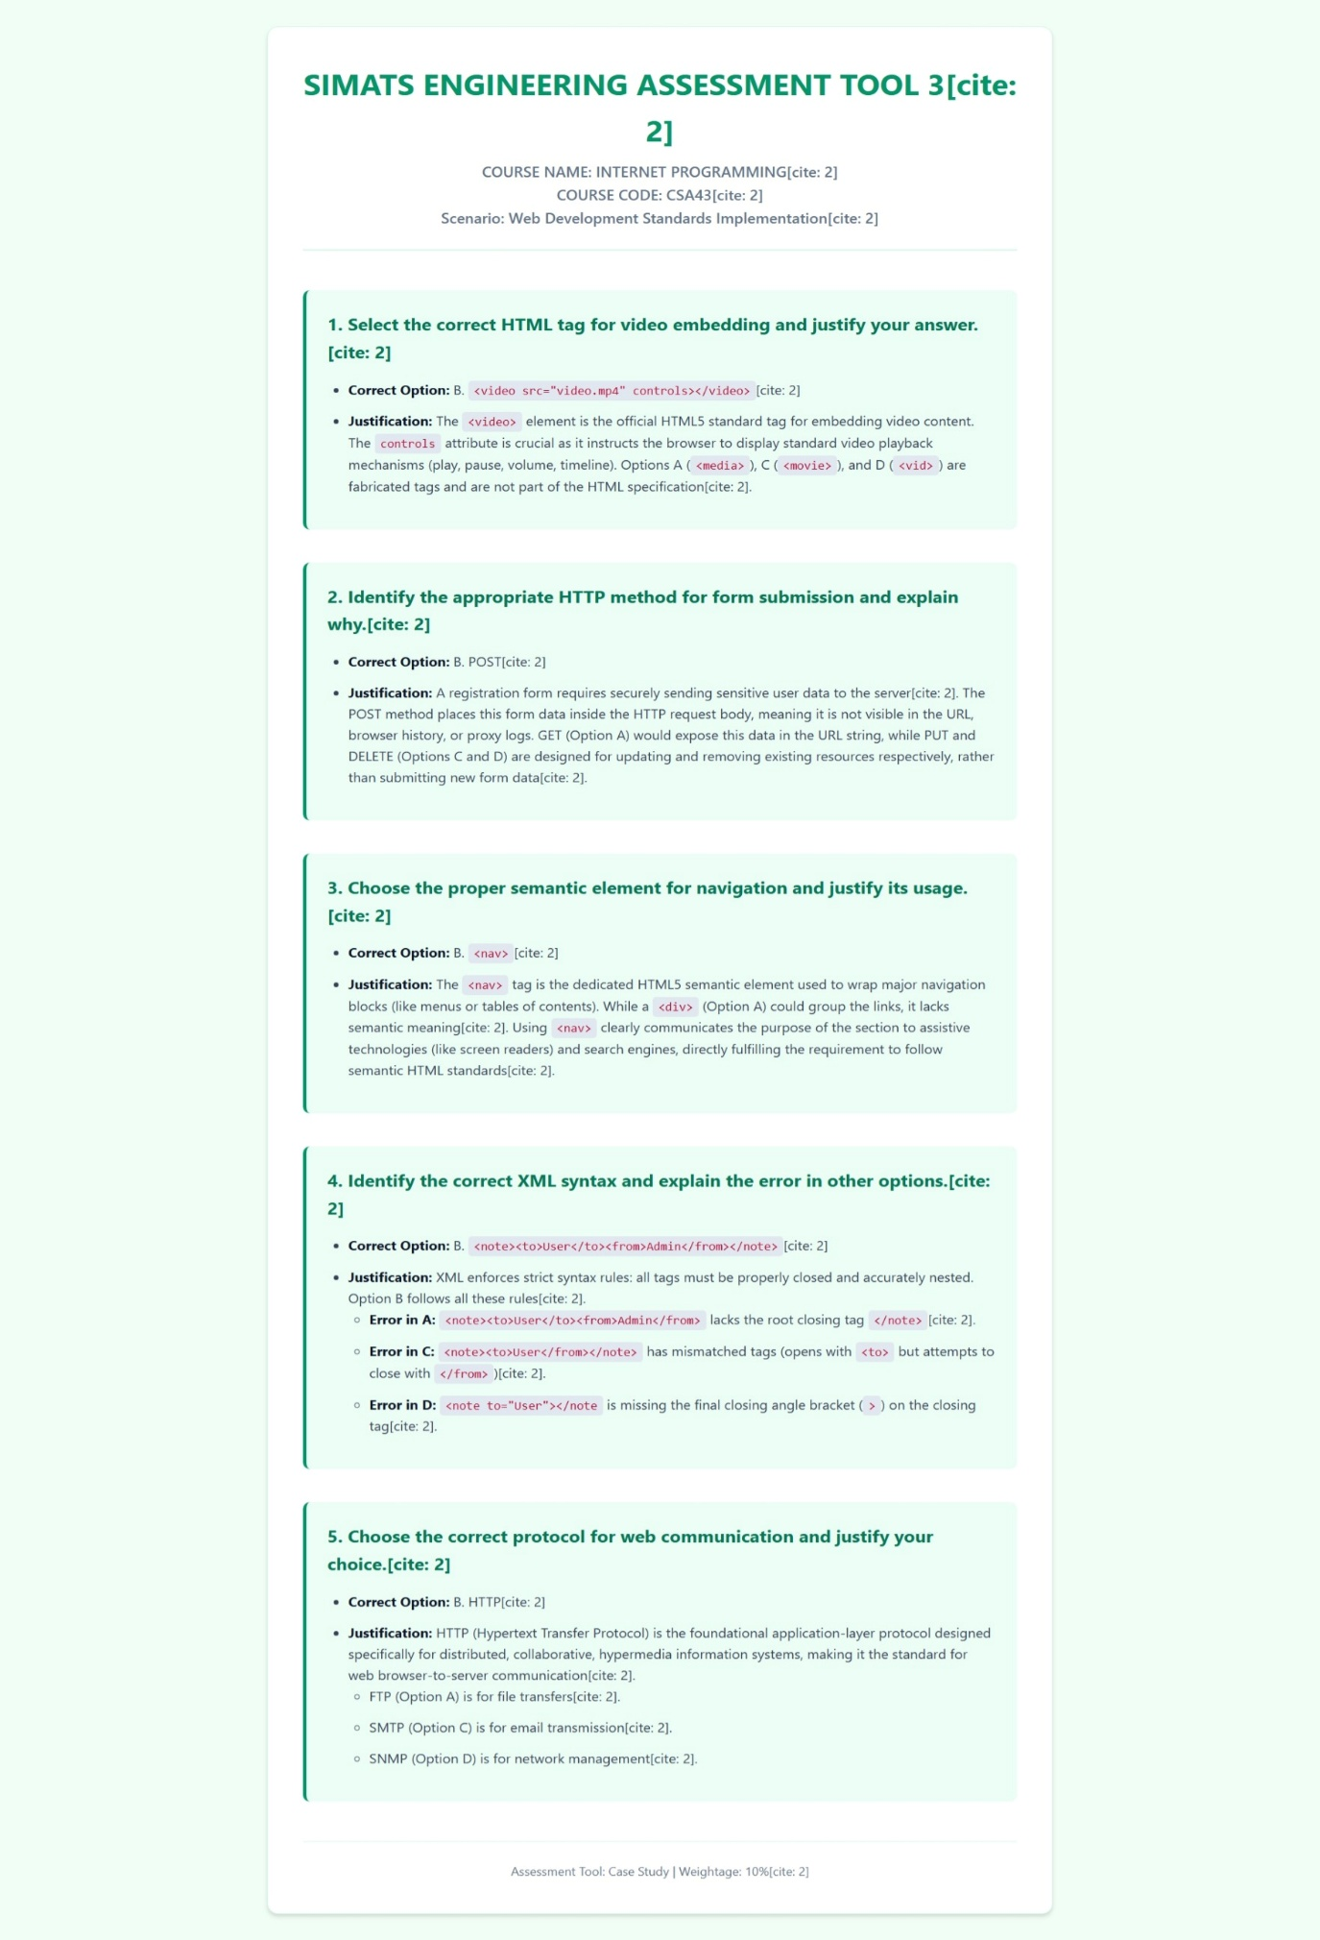

Output:
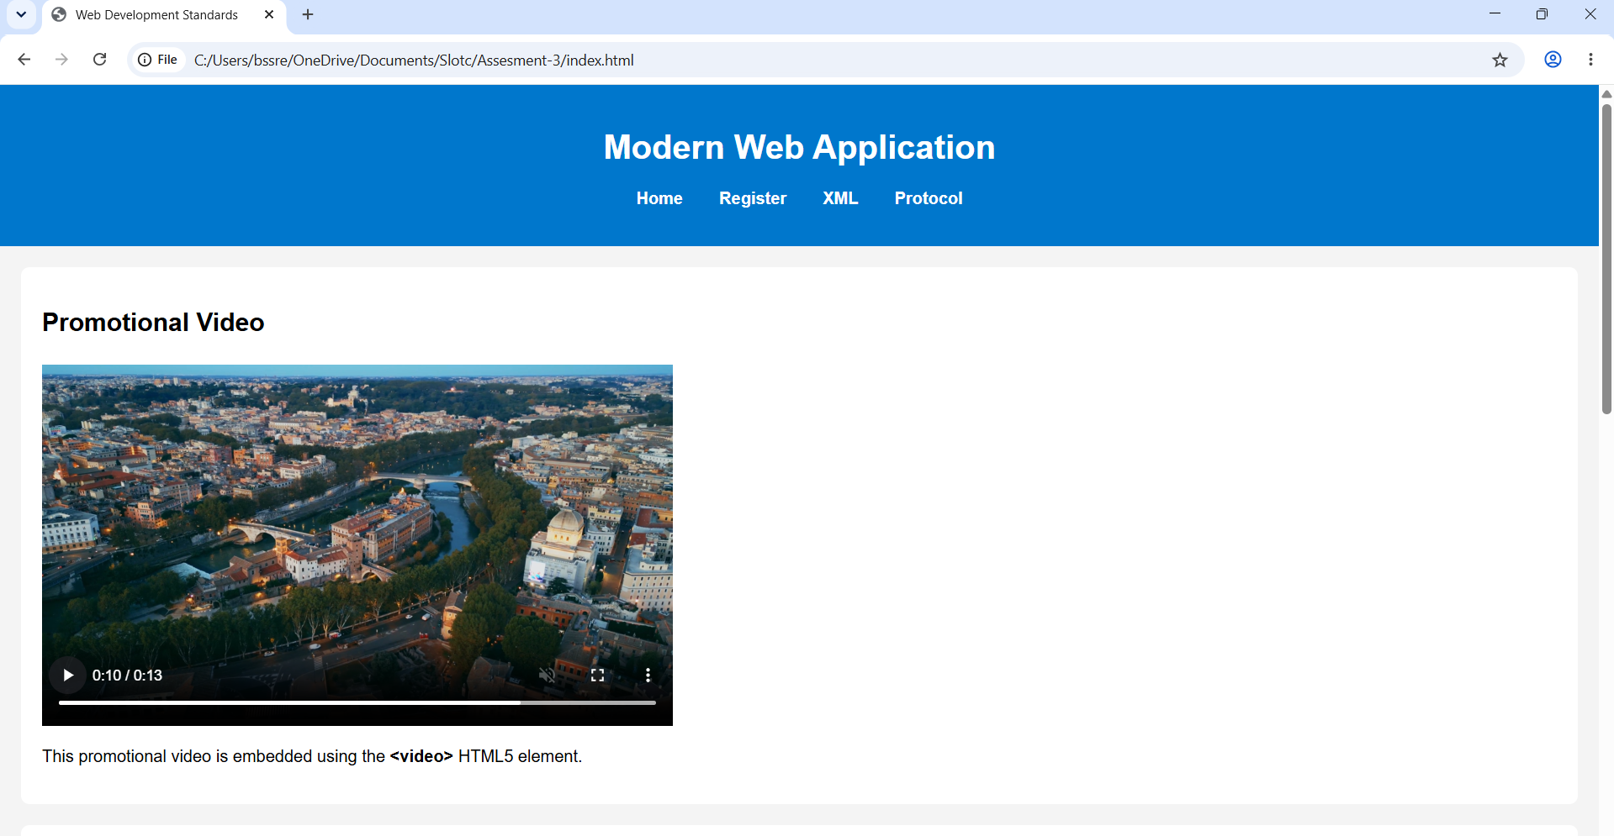

RESULT: We Developed well-structured, standards-compliant web pages using HTML/XHTML and XML, and apply Internet protocols and HTTP communication mechanisms for web content delivery. (L2)

