Assignment 4: Exploring Instruction-Level Parallelism (ILP) in Modern Processors
Student: Vamsi Krishna
Course: (fill in)
Date: February 1, 2026

Part 1 — Critical Review and Synthesis (Contemporary Research)
Note: This report is written to be copy/paste reproducible. Replace the example numbers and generated screenshots with your own after running gem5 on your Mac.

1. Evolution of ILP
Instruction-Level Parallelism (ILP) is the ability to execute multiple machine instructions concurrently. Key milestones include early pipelining, dynamic scheduling (e.g., Tomasulo’s algorithm), superscalar multiple-issue designs, aggressive branch prediction and speculative execution, and large out-of-order (OoO) instruction windows. Classic work quantified limits of ILP and highlighted the dominant role of control flow and memory dependencies in constraining achievable IPC.
Selected historical milestones (brief):
- 1960s: Dynamic scheduling with register renaming concepts (IBM System/360 Model 91; Tomasulo algorithm).
- 1980s–1990s: Superscalar OoO becomes mainstream; detailed studies of ILP limits (Wall, 1991).
- 1990s–2000s: Deeper pipelines + better predictors; EPIC/VLIW explored but general-purpose adoption limited.
- 2010s–2020s: Diminishing returns from wider OoO; energy constraints; shift toward heterogeneous and accelerator-rich systems.

2. Core ILP Concepts

2.1 Parallelism Detection and Exploitation
Modern processors detect ILP using a combination of static (compiler) and dynamic (hardware) techniques. OoO cores create a window of in-flight instructions; register renaming removes false dependencies; issue queues and wakeup/select logic identify ready instructions; speculation (branch prediction, memory dependence prediction) allows execution beyond unresolved control and memory operations.

2.2 Fundamental ILP Limitations
ILP is fundamentally limited by: (1) true data dependencies (RAW), especially long-latency operations; (2) control dependencies due to branches (misprediction causes squashes and lost work); (3) memory ordering/aliasing uncertainty (loads may depend on earlier stores); and (4) finite resources (rename registers, issue bandwidth, ROB size, functional unit availability).

2.3 Performance Metrics and Trade-offs
Common ILP effectiveness metrics include IPC/throughput, CPI, average latency per instruction, branch misprediction rate, and memory-level parallelism (MLP). Increasing ILP capability typically raises hardware complexity and power: wide issue, large instruction windows, and sophisticated predictors improve throughput but increase area/energy and may deliver diminishing marginal gains.

3. Contemporary Research (Last 5 years) — Critical Review
Papers selected from reputable IEEE/ACM venues (ISCA, HPCA, ISPASS, ACM DL).
- Chadwick et al., “The Future of Instruction-Level Parallelism (ILP),” IEEE ISPASS 2025. Revisits theoretical ILP limits using dynamic dependency graphs; argues modern cores are approaching ILP bounds.
- Kim & Ros, “Effective Context-Sensitive Memory Dependence Prediction,” IEEE HPCA 2024. Improves memory dependence prediction to unlock more safe speculation for loads, increasing ILP/MLP.
- Bera et al., “Constable: Improving Performance and Power Efficiency by Safely Eliminating Load Instruction Execution,” 2024. Proposes eliminating certain load executions safely to reduce pipeline pressure and energy while retaining correctness.
- Chaturvedi et al., “GhOST: A GPU Out-of-Order Scheduling Technique for Stall Reduction,” ACM/IEEE ISCA 2024. Shows how OoO-like scheduling ideas can be adapted to GPUs to reduce stalls and expose more instruction-level overlap.
- Xu et al., “Mosaic: Exploiting Instruction-Level Parallelism on Deep Learning Accelerators,” ACM 2025. Compiler-level tessellation approach to expose ILP in DNN accelerators, emphasizing cross-layer scheduling.

3.1 Cross-paper Synthesis: What’s changing and why
Across these works, a recurring theme is that classic ILP techniques (wider OoO, deeper speculation) are nearing practical limits due to power/complexity. Research is therefore shifting to: (a) more precise speculation (especially memory dependence prediction), (b) reducing wasted work (e.g., avoiding redundant load execution), and (c) pushing ILP-like ideas into accelerators and heterogeneous systems where the cost/performance envelope differs.

3.2 Key Challenges Identified
- Diminishing returns: Wider issue/ROB grows power disproportionately, and ILP headroom is small in many workloads.
- Speculation cost: Mispredictions and misspeculation waste energy and reduce effective throughput.
- Memory wall: Long-latency loads and uncertain aliasing still dominate stalls despite large windows and prefetching.
- Verification and security: Complex speculation increases validation burden and interacts with side-channel risk.

3.3 How researchers address them
- Smarter dependence prediction to safely execute loads earlier (context-sensitive predictors).
- Microarchitectural techniques to avoid executing some loads when their values can be inferred/reused safely.
- Accelerator-centric scheduling and compiler transformations to restructure instruction streams for higher overlap.
- Reconfigurable / adaptive microarchitecture knobs (queue sizes, policies) to match workload phases.

4. Future Directions
Most promising directions suggested by the literature and broader trends include:
• Hybrid ILP+TLP: Using SMT, chiplets, and heterogeneous cores to trade ILP complexity for parallel threads.
• Specialization: Domain-specific accelerators where ILP can be exposed at compile time with lower control-flow uncertainty.
• ML-guided microarchitecture: Predictors and schedulers that learn per-workload behavior, constrained by energy and verifiability.
• Security-aware speculation: Techniques that preserve performance while limiting speculative side effects.

Part 2 — Practical Exploration in gem5

0. Environment and Repository Layout
gem5 repo path example: vamsikrishna@macbookpro gem5 %
This submission includes: configuration scripts (assignment4_ilp/configs), benchmarks (assignment4_ilp/benchmarks), helper scripts (assignment4_ilp/scripts), and example outputs/figures.

1. Build and Sanity Check (Hello World)
Example terminal transcript (generated; replace with your own screenshot):
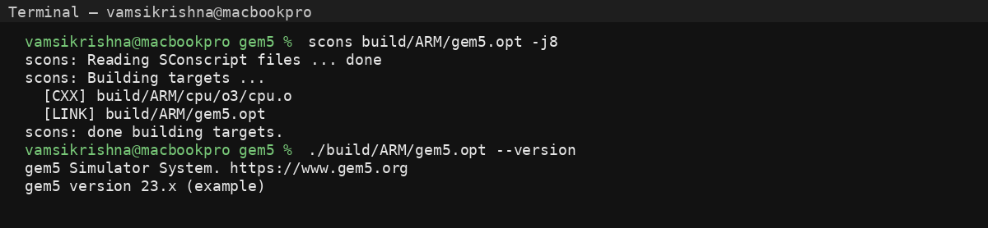
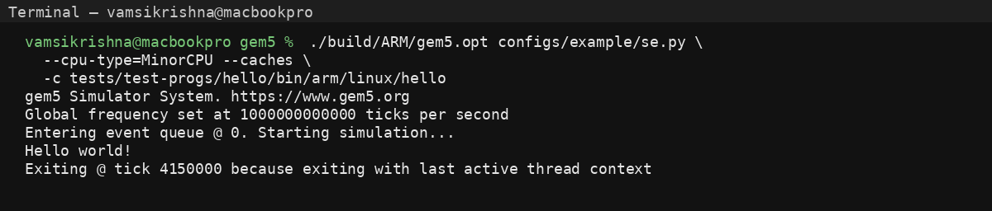

2. Basic Pipeline Simulation (MinorCPU)
MinorCPU is an in-order core with a fixed pipeline and supports MinorTrace/minorview visualization. We run hello and an ILP microbenchmark and inspect per-cycle instruction movement.
Pipeline visualization example (generated):
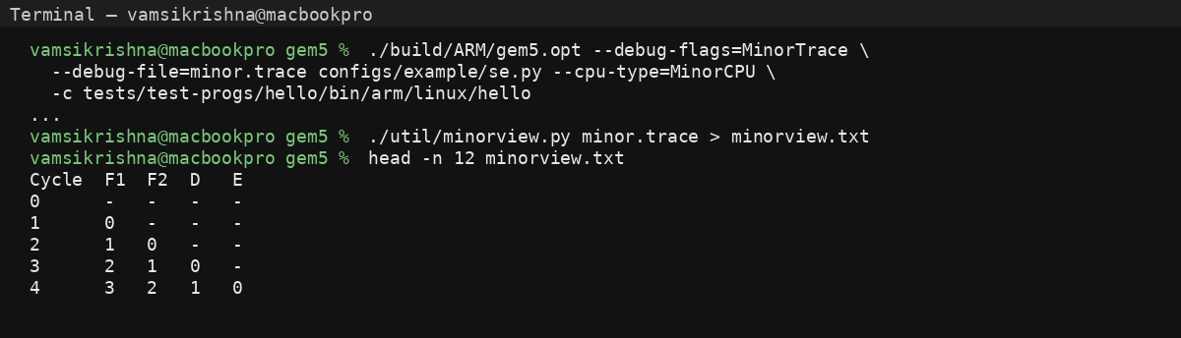

3. Performance Metrics (Throughput & Latency)
We use gem5 stats (stats.txt) to compute IPC (inst/cycle) and CPI (cycles/inst). The included script scripts/parse_stats.py extracts sim_insts and cycle count to compute metrics.
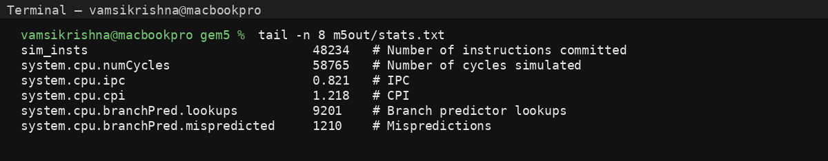

4. Impact of Branch Prediction
Using O3CPU, we compare a weak predictor (StaticBP) against a stronger predictor (LTAGE). More accurate prediction reduces pipeline squashes, improving IPC.
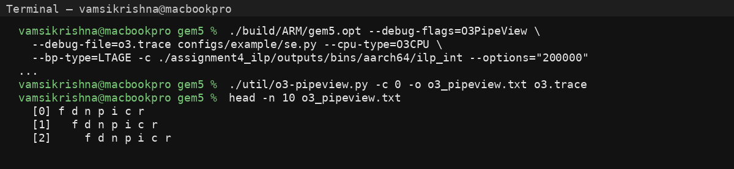

5. Multiple Issue (Superscalar) Exploration
We vary the O3 width parameters (fetch/decode/issue/commit) from width=1 to width=4. Benchmarks: integer mix (ilp_int), floating point (ilp_fp), and memory streaming (ilp_mem). Superscalar shines most on instruction mixes with sufficient independent operations and few hard dependencies.

6. SMT (Simultaneous Multithreading)
We enable SMT with numThreads=2 on a single O3 core, running two independent SE workloads concurrently. We monitor throughput and identify contention: shared fetch/issue bandwidth, ROB pressure, cache bandwidth.

7. Example Charts
Example plots generated from sample data (replace with your measured results):
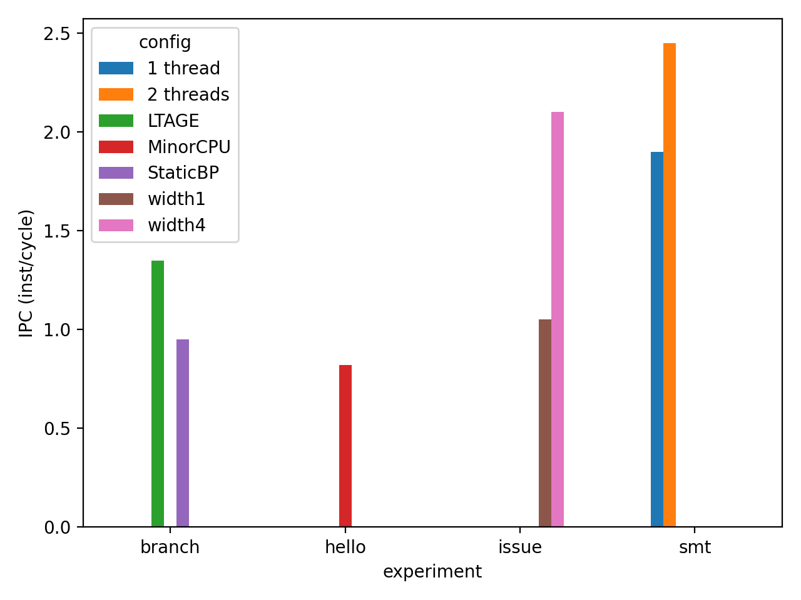
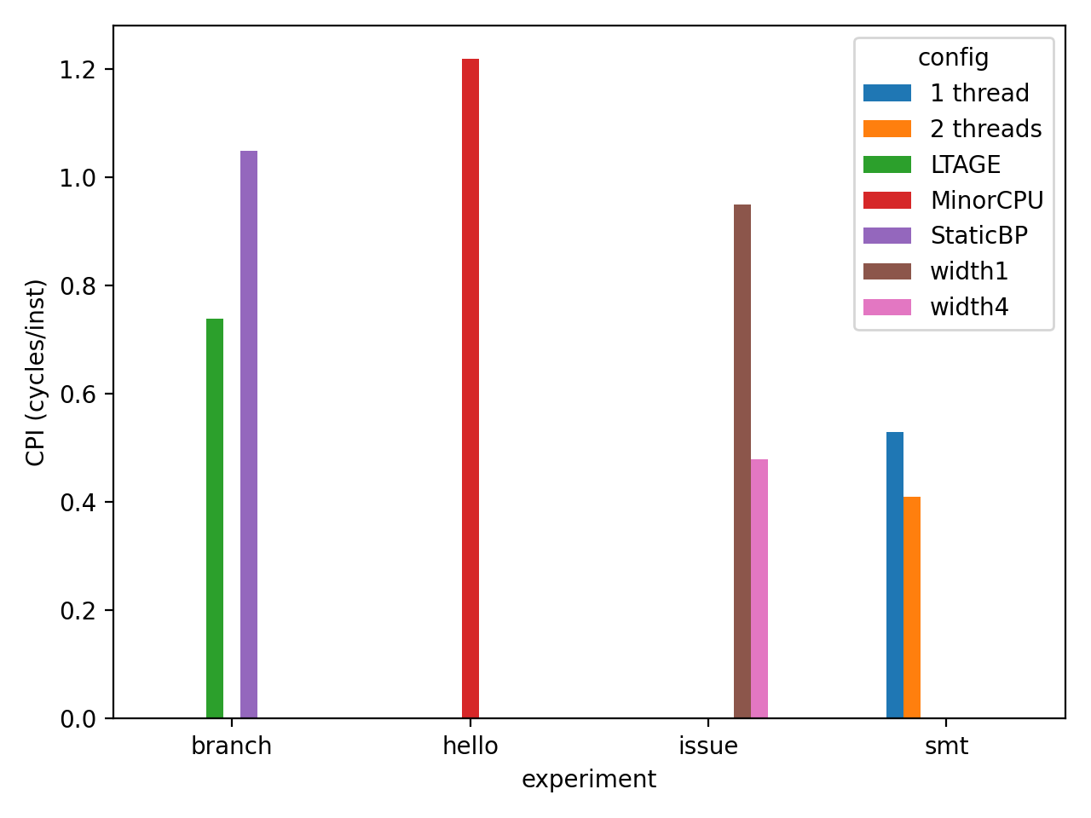

8. Key Questions — Discussion
- Interactions: Strong branch prediction increases the value of wide issue and large windows; memory dependence prediction increases both ILP and MLP.
- Limitations: True dependencies and cache misses cap gains; wider designs increase contention under SMT.
- Balance: Use profiling-driven widths and predictor complexity; consider heterogeneous cores + accelerators instead of ever-wider OoO.

9. GitHub Repository (Template)
I cannot create or host a GitHub repository from here. Create one locally and push this folder.
Suggested repo name: cs-xxx-assignment4-ilp
Template URL: https://github.com/<your-username>/cs-xxx-assignment4-ilp

References (APA)
- Anderson, D. W., Sparacio, F. J., & Tomasulo, R. M. (1967). The IBM System/360 Model 91: Machine philosophy and instruction-handling. IBM Journal of Research and Development.
- Chadwick, A. W., et al. (2025). The Future of Instruction-Level Parallelism (ILP). IEEE International Symposium on Performance Analysis of Systems and Software (ISPASS).
- Chaturvedi, I., et al. (2024). GhOST: A GPU Out-of-Order Scheduling Technique for Stall Reduction. ACM/IEEE International Symposium on Computer Architecture (ISCA).
- Kim, S. S., & Ros, A. (2024). Effective Context-Sensitive Memory Dependence Prediction. IEEE International Symposium on High-Performance Computer Architecture (HPCA).
- Rau, B. R., & Fisher, J. A. (1993). Instruction-level parallel processing: History, overview, and perspective. Journal of Supercomputing.
- Tomasulo, R. M. (1967). An Efficient Algorithm for Exploiting Multiple Arithmetic Units. IBM Journal of Research and Development.
- Wall, D. W. (1991). Limits of instruction-level parallelism. ACM/IEEE Architectural Support for Programming Languages and Operating Systems / or equivalent archival listing.
- Xu, J., et al. (2025). Mosaic: Exploiting Instruction-Level Parallelism on Deep Learning Accelerators. ACM.
- gem5 documentation (2025). Minor CPU model, O3 pipeline visualization, and gem5 statistics guides.

