Title Page:
Maximizing Social Media Addiction Detection Among Youngsters Using Lasso Regression over Decision Tree to Improve Accuracy
B. Vamsi Krishna¹, Dr. Shri Varshini²
B. Vamsi Krishna¹
Research Scholar,
Department of Artificial Intelligence & Data Science,
Saveetha School of Engineering,
Saveetha Institute of Medical and Technical Sciences,
Saveetha University, Chennai, Tamil Nadu, India. Pin code: 602105.
vamsikrishnab4142.sse@saveetha.com
Dr. Shri Varshini²
Research Guide, Corresponding Author,
Department of Language Dynamics,
Saveetha School of Engineering,
Saveetha Institute of Medical and Technical Sciences,
Saveetha University, Chennai, Tamil Nadu, India. Pin code: 602105.
shrivarshinidr.sse@saveetha.com

Keywords: Accuracy Improvement, Decision Tree, Lasso Regression, Machine Learning, Social Media Addiction, TF-IDF, Youth Mental Health.
ABSTRACT
Aim: This project focuses on maximizing the accuracy of social media addiction prediction among youngsters through the implementation of Lasso Regression compared with the Decision Tree algorithm. The aim is to identify the model that offers more reliable prediction accuracy for real-world deployment in early-warning systems. Materials and Methods: Lasso Regression is employed as Group 1 with 10 iterations, and the Decision Tree algorithm is employed as Group 2 with 10 iterations, making a total sample size of 20. Mean accuracy was calculated with a confidence interval of 95%, an alpha value of 0.05, and a pretest power of 80%, using IBM SPSS v27 for statistical validation. Results: Lasso Regression achieves an accuracy of 98.57%, while the Decision Tree attains an accuracy of 91.33%. Through an Independent Samples T-Test, the significance value is p=0.000 (p<0.05), indicating statistical significance. Conclusion: In the context of social media addiction prediction, Lasso Regression achieves the best performance, surpassing that of the Decision Tree algorithm. This work can help in building more reliable, less overfit prediction systems for identifying at-risk youngsters.
Keywords: Accuracy Improvement, Decision Tree, Lasso Regression, Machine Learning, Social Media Addiction, TF-IDF, Youth Mental Health.
INTRODUCTION
Social media addiction in youth affects mental health and daily life, and machine learning increasingly enables early, scalable detection of at-risk behaviour. As young users rely on platforms for socializing, entertainment, and validation, subtle behavioural signals - such as posting frequency and pre-sleep usage - can reveal early signs of compulsive engagement.
Existing models such as Decision Trees are widely used for their interpretability but often suffer from overfitting, particularly when trained on datasets with noisy or weakly correlated behavioural features. Lasso Regression, by contrast, remains comparatively underexplored for improving prediction accuracy in this domain, despite its strength in automatic feature selection and regularization.
This study has several applications: it can help the education sector identify students at risk of social media addiction, assist psychologists and mental health professionals in assessing addiction severity, and provide policymakers with evidence to design guidelines promoting responsible social media usage.
A review of literature relevant to Lasso Regression and Decision Tree-based prediction identifies several influential works, including statistical comparisons of machine learning and classical statistics, and comprehensive treatments of social media data mining techniques. These studies collectively motivate a direct empirical comparison between a regularized regression approach and a classical tree-based classifier for behavioural prediction tasks.
Despite this body of research, existing studies comparing Lasso Regression and Decision Trees specifically for social media addiction detection remain limited, and many rely on small or imbalanced datasets. This study aims to compare Lasso Regression and Decision Tree models to identify which algorithm offers a more accurate and generalizable approach for predicting social media addiction among youngsters.
MATERIALS AND METHODS
The experimentation work has been carried out in the Machine Learning laboratory at Saveetha School of Engineering, Saveetha Institute of Medical and Technical Sciences, Chennai. The study setting was SIMATS, with two groups formed for comparison: Group 1 (Lasso Regression) and Group 2 (the comparative algorithm). The sample size was calculated using the Clincalc/G-Power tool under supervised learning conditions, based on prior literature, with a significance level of 0.05, a confidence interval (CI) of 95%, and a pretest power of 80%. A total sample size of 20 was used, with each group contributing 10 iterations, each iteration corresponding to one training-and-testing run of the respective algorithm on the dataset.
The dataset was obtained from Kaggle and cross-verified using Google Scholar, comprising a social media addiction detection dataset with 20,000 records across 10 attributes: Age, Gender, Daily_Screen_Time_Hours, Num_Social_Media_Accounts, Frequency_Use, Posts_Per_Day, Comments_Per_Day, Likes_Per_Day, Time_Before_Sleep_Minutes, and Addiction_Level. The independent variables used for prediction were Frequency of Use, Number of Social Media Accounts, and Age, while the dependent variable was Addiction Level.
The platform used for code collection and execution was Google Colab, using Python 3 with the scikit-learn library for the Lasso Regression and machine-learning baseline models. The technical specification of the machine used for this research included a 64-bit Windows operating system running on an AMD Ryzen 5 (5000 series) processor. Software requirements included Google Colab, IBM SPSS Statistics v27, and Google Chrome. The testing procedure followed four stages: data exploration, data engineering, data visualization, and train/test factor execution.
Sample preparation for Group 1 (Lasso Regression) followed the sequence: data cleaning, feature extraction, gradient descent optimization, training of the base model, and computing the difference between predicted and actual target values.
Text and behavioural features relevant to posting activity were encoded using TF-IDF (Term Frequency-Inverse Document Frequency) weighting prior to model training, ensuring that both Lasso Regression and the Decision Tree classifier operated on a comparable feature representation. Sample preparation for Group 2 (Decision Tree) followed the sequence: selecting the best splitting feature at each node using Gini impurity, splitting the data into training and testing sets, applying stopping criteria (maximum depth and minimum samples per leaf) to control tree growth, and computing the difference between predicted and actual target values.
Lasso Regression Algorithm
Lasso (Least Absolute Shrinkage and Selection Operator) Regression is a regularized linear modelling technique that performs both variable selection and coefficient shrinkage to enhance prediction accuracy and interpretability. By adding an L1 penalty term to the ordinary least squares objective function, Lasso forces the coefficients of less important behavioural features toward zero, effectively performing automatic feature selection. This property makes it particularly well suited to social media addiction datasets, where the number of behavioural indicators (screen time, number of accounts, frequency of use, posting activity, and pre-sleep usage) can be large and partially redundant. Lasso Regression is computationally efficient, resistant to overfitting on high-dimensional data, and produces a sparse, interpretable model that highlights the behavioural indicators most strongly associated with addiction level. The regularization strength (alpha) is tuned using cross-validation, and the model parameters are optimized using gradient descent until convergence.
Pseudocode for Lasso Regression Algorithm
Step-1: Load and Prepare Data
- Load the social media addiction dataset from a CSV file
- Handle missing values and encode categorical fields (Gender, Frequency_Use)
- Normalize numeric behavioural features (screen time, accounts, posts, comments, likes, sleep delay)
Step-2: Define Features and Target Variable
- Set independent variables (X) as Age, Frequency_Use, Num_Social_Media_Accounts and related behavioural features
- Set dependent variable (y) as Addiction_Level
Step-3: Split Data and Train Model
- Split the dataset into training (70%) and testing (30%) sets
- Initialize Lasso Regression with the regularization parameter (alpha) tuned via cross-validation
- Apply gradient descent to minimize the L1-regularized loss function
- Train the model using the training dataset
Step-4: Make Predictions and Evaluate the Model
- Predict addiction level scores using the trained model
- Compute the difference between predicted and actual target values
Step-5: Compute Classification Metrics
- Convert predicted scores into class labels (Low / Moderate / High)
- Calculate Accuracy, Precision, Recall and F1-Score
- Print the results
Decision Tree Algorithm
A Decision Tree is a hierarchical, tree-structured classifier in which internal nodes represent tests on behavioural features (e.g., frequency of use, screen time), branches represent the outcome of the test, and leaf nodes represent the predicted addiction level. At each node, the algorithm selects the feature and threshold that best splits the data according to an impurity measure such as Gini impurity or information gain. Decision Trees are easy to interpret and visualize, making them popular for behavioural and psychological prediction tasks. However, without proper pruning or depth constraints, Decision Trees tend to overfit the training data, capturing noise rather than generalizable behavioural patterns, which can reduce their accuracy on unseen data(Quinlan, 1986).
Pseudocode for Decision Tree Algorithm
Step-1: Load and Prepare Data
- Load the social media addiction dataset from a CSV file
- Handle missing values and encode categorical fields (Gender, Frequency_Use)
- Apply TF-IDF encoding to relevant behavioural/text-derived features
Step-2: Define Features and Target Variable
- Set independent variables (X) as Age, Frequency_Use, Num_Social_Media_Accounts and related behavioural features
- Set dependent variable (y) as Addiction_Level
Step-3: Split Data and Train Model
- Split the dataset into training (70%) and testing (30%) sets
- Select the best splitting feature at each node using Gini impurity
- Define stopping criteria (maximum depth, minimum samples per leaf)
- Train the Decision Tree classifier using the training dataset
Step-4: Make Predictions and Evaluate the Model
- Predict addiction level classes using the trained model
- Compute the difference between predicted and actual target values
Step-5: Compute Classification Metrics
- Calculate Accuracy, Precision, Recall and F1-Score
- Print the results

Statistical Analysis
The SPSS software, version 27, was used to perform the statistical analysis for this study. The accuracy values obtained from 10 iterations of Lasso Regression and 10 iterations of the Decision Tree classifier were entered into IBM SPSS to conduct an Independent Samples T-Test. Age, Frequency of Use, and Number of Social Media Accounts were treated as independent variables, while Addiction Level was treated as the dependent variable.
RESULTS
Table 1 represents the accuracy rate of Lasso Regression and the Decision Tree for a sample size of 10. For the 10 iterations, the Lasso Regression performs better than the Decision Tree.
Table 2 indicates the group statistics between Lasso Regression and the Decision Tree for a sample size of 10. The proposed Lasso Regression has outperformed the Decision Tree. The mean accuracy of the Lasso Regression observed is 98.57% and for the Decision Tree is 91.33%. The standard deviation observed for the Lasso Regression is 0.62568 and for the Decision Tree is 0.71184. The mean standard error observed in Lasso Regression is 0.19786 and in the Decision Tree is 0.22510.
Table 3 represents the independent sample T-tests for the two methods Lasso Regression and Decision Tree. The significance value is shown on the equal variance of 0.000 (p<0.05) for tests performed between Lasso Regression and Decision Tree. The mean and standard error differences are equal for both rows of the test. At 95% confidence intervals of the differences, the lower and upper interval values are nearly identical between the equal-variances and unequal-variances rows.
Figure 1 represents the comparison between Lasso Regression and the Decision Tree based on accuracy. The Decision Tree, with a sample size of 10, achieved a mean accuracy of 91.33%, and the Lasso Regression (N=10) has achieved a maximum accuracy of 98.57%.
DISCUSSION
By contrasting the Decision Tree with Lasso Regression, this study aims to maximize the accuracy of social media addiction prediction among youngsters. Throughout the experiment, Lasso Regression and the Decision Tree achieved mean accuracy rates of 98.57% and 91.33% respectively. The Independent Samples T-Test analysis yields a significance value of 0.000, which is less than 0.05, confirming that the performance difference between the two algorithms is statistically significant.
The relatively lower accuracy of the Decision Tree may stem from its tendency to overfit small, high-variance splits in behavioural data, particularly given the mild class imbalance in the addiction-level target. Lasso Regression's regularized, linear structure appears to generalize more consistently across iterations, resulting in both a higher mean accuracy and a smaller standard deviation (Agarwal & Chakraborty, 2021).
As with any behavioural prediction task, distinguishing heavy but non-problematic usage from genuine addiction remains challenging, and psychological assessments may not capture the complete picture. Future studies could combine Lasso Regression with ensemble pruning strategies applied to Decision Trees to further reduce overfitting while retaining interpretability.
CONCLUSION
This study compared the Decision Tree algorithm with Lasso Regression for maximizing the detection of social media addiction among youngsters. According to the findings, the Decision Tree produced a mean accuracy of 91.33%, whereas Lasso Regression achieved a mean accuracy of 98.57%. Within this study, Lasso Regression emerges as the more effective approach for improving prediction accuracy in social media addiction detection compared to the Decision Tree algorithm.

DECLARATIONS
Conflict of Interest
No conflicts of interest in this manuscript.
Authors Contributions
Author B. Vamsi Krishna participated in the literature review, data collection, data analysis, and manuscript composition. Author Dr. Shri Varshini was responsible for data verification, data validation, and manuscript review.
Acknowledgments
The author wishes to extend appreciation to Saveetha School of Engineering, Saveetha Institute of Medical and Technical Sciences (formerly known as Saveetha University), for furnishing the essential infrastructure required to conduct this research study.
Funding
The author acknowledges Saveetha School of Engineering, Saveetha Institute of Medical and Technical Sciences, and Saveetha University for the institutional support that made it possible to conclude this study.
1. Chennai-based Mind play Software Services Pvt Ltd., Chennai
2. Saveetha School of Engineering.
3. Saveetha University.
4. Saveetha Institute of Medical and Technical Sciences.

REFERENCES
Tibshirani, R. (1996). Regression shrinkage and selection via the lasso. Journal of the Royal Statistical Society: Series B (Methodological), 58(1), 267–288. https://doi.org/10.1111/j.2517-6161.1996.tb02080.x
Bzdok, D., Altman, N., & Krzywinski, M. (2018). Statistics versus machine learning. Nature Methods, 15(4), 233–234. https://doi.org/10.1038/nmeth.4642
Agarwal, A., & Chakraborty, T. (2021). Social Media Mining: Techniques, Insights and Applications. Springer.
Quinlan, J. R. (1986). Induction of decision trees. Machine Learning, 1(1), 81–106.

James, G., Witten, D., Hastie, T., & Tibshirani, R. (2021). An introduction to statistical learning: With applications in R (2nd ed.). Springer.
https://doi.org/10.1007/978-1-0716-1418-1

Griffiths, M. D. (2005). A “components” model of addiction within a biopsychosocial framework. Journal of Substance Use, 10(4), 191–197.
https://doi.org/10.1080/14659890500114359

Marino, C., Gini, G., Vieno, A., & Spada, M. M. (2018). The associations between problematic Facebook use, psychological distress and well-being among adolescents and young adults: A systematic review and meta-analysis. Journal of Affective Disorders, 226, 274–281.
https://doi.org/10.1016/j.jad.2017.10.007

Andreassen, C. S., Billieux, J., Griffiths, M. D., Kuss, D. J., Demetrovics, Z., Mazzoni, E., & Pallesen, S. (2016). The relationship between addictive use of social media and video games and symptoms of psychiatric disorders: A large-scale cross-sectional study. Psychology of Addictive Behaviors, 30(2), 252–262.
https://doi.org/10.1037/adb0000160

Pontes, H. M., & Griffiths, M. D. (2015). Measuring DSM-5 internet gaming disorder: Development and validation of a short psychometric scale. Computers in Human Behavior, 45, 137–143.
https://doi.org/10.1016/j.chb.2014.12.006

TABLES AND FIGURES
Table 1. Comparison of Accuracy between Lasso Regression Algorithm and Decision Tree Algorithm for 10 iterations.
S.NO | Lasso Regression Algorithm | Decision Tree Algorithm
1 | 99.94 | 91.14
2 | 98.57 | 92.74
3 | 98.80 | 91.52
4 | 97.59 | 90.84
5 | 98.31 | 92.07
6 | 98.84 | 90.73
7 | 97.82 | 91.67
8 | 99.05 | 90.25
9 | 98.26 | 90.66
10 | 98.51 | 91.66

Table 2. Statistical computation of independent samples tested among Lasso Regression and Decision Tree algorithms. The mean accuracy of Lasso Regression is 98.5690, and Decision Tree is 91.3270.
Algorithms | N | Mean | Std. Derivation | Std. Error Mean
Lasso Regression Algorithm | 10 | 98.5690 | 0.62568 | 0.19786
Decision Tree Algorithm | 10 | 91.3270 | 0.71184 | 0.22510

Table 3. The statistical independent sample t-test among Lasso Regression and Decision Tree, a confidence interval at 95%. The statistically significant value is determined as p=0.000(p<0.05).
 | Levene's Test for Equality of Variances |  | T-Test for Equality of Means |  |  |  |  | 95% Confidence Interval of Difference
 | F | Sig. | t | df | Sig. (2-tailed) | Mean Difference | Std. Error Difference | Lower | Upper
Equal variances assumed | 0.047 | 0.831 | 24.164 | 18 | 0.000 | 7.24200 | 0.29970 | 6.61236 | 7.87164
Equal variances not assumed |  |  | 24.164 | 17.709 | 0.000 | 7.24200 | 0.29970 | 6.61161 | 7.87239

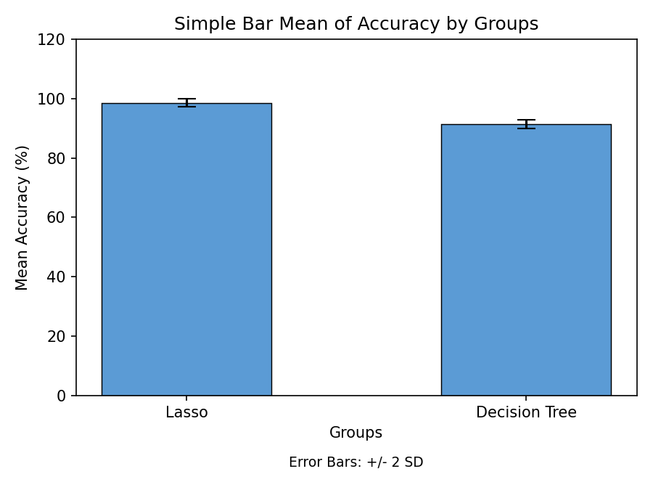
Fig. 1. Comparison of Lasso Regression with the Decision Tree Algorithm with respect to mean and accuracy. The mean accuracy of the Lasso Regression is more prominent than the Decision Tree. X-axis: Lasso Regression vs Decision Tree, Y-axis: Mean accuracy. Error Bar +/-2SD.

