Title Page:

Analysis of Lasso Regression over Random Forest for Enhanced Accuracy in Real-Time Detection of Social Media Addiction Among Youngsters
B. Vamsi Krishna¹, Dr. Shri Varshini²
B. Vamsi Krishna¹
Research Scholar,
Department of Artificial Intelligence & Data Science,
Saveetha School of Engineering,
Saveetha Institute of Medical and Technical Sciences,
Saveetha University, Chennai, Tamil Nadu, India. Pin code: 602105.
vamsikrishnab4142.sse@saveetha.com
Dr. Shri Varshini²
Research Guide, Corresponding Author,
Department of Language Dynamics
Saveetha School of Engineering,
Saveetha Institute of Medical and Technical Sciences,
Saveetha University, Chennai, Tamil Nadu, India. Pin code: 602105.
shrivarshinidr.sse@saveetha.com

Keywords: Accuracy Improvement, Lasso Regression, Machine Learning, Random Forest, Real-Time Detection, Social Media Addiction, Youth Mental Health.

ABSTRACT
Aim: This project focuses on enhancing the accuracy of real-time social media addiction detection through the implementation of Lasso Regression compared with the Random Forest algorithm. The aim is to develop a robust and precise model capable of identifying addictive behavioural patterns among youngsters, thereby supporting early intervention and digital well-being initiatives. Materials and Methods: Lasso Regression is employed as Group 1 with 10 iterations, and the Random Forest algorithm is employed as Group 2 with 10 iterations, making a total sample size of 20. Mean accuracy was calculated with a confidence interval of 95%, an alpha value of 0.05, and a pretest power of 80%, using IBM SPSS v27 for statistical validation. Results: Lasso Regression achieves an accuracy of 98.57%, while Random Forest attains an accuracy of 89.17%. Through an Independent Samples T-Test, the significance value is p=0.000 (p<0.05), indicating statistical significance. Conclusion: In the context of real-time social media addiction detection, Lasso Regression achieves the best performance, surpassing that of Random Forest. This work can help mental health practitioners and platform designers identify at-risk youngsters earlier and design timely preventive interventions.
Keywords: Accuracy Improvement, Lasso Regression, Machine Learning, Random Forest, Real-Time Detection, Social Media Addiction, Youth Mental Health.
INTRODUCTION
Social media addiction refers to excessive and compulsive use of social networking platforms leading to negative psychological and social effects. Existing studies define it as a behavioural addiction characterized by dependency on social media for emotional relief and validation, rather than a purely recreational activity. With the growing dependence on platforms such as Instagram, Facebook, and TikTok for daily social interaction, distinguishing between healthy engagement and addictive behaviour has become an important research task in the fields of psychology and data science.
With the rise of social media usage, especially among youngsters, excessive engagement has been increasingly linked to mental health issues such as anxiety, depression, and reduced productivity. Detecting addiction early can help in preventive interventions and policymaking, allowing psychologists, parents, and educational institutions to act before the behaviour escalates. Machine learning models such as Lasso Regression and Random Forest can help detect this addictive behaviour early by learning patterns from behavioural indicators such as screen time, posting frequency, and account activity (Andreassen et al., 2012).
This study has multiple applications: (i) developing AI-driven tools for early detection of addiction, (ii) assisting psychologists and counsellors in diagnosing social media addiction, and (iii) creating awareness programs to promote healthy digital habits. While Random Forest is a widely used ensemble learning technique, it is prone to overfitting on datasets with many weakly correlated behavioural features. Lasso Regression's potential in this area remains comparatively underexplored, which motivates the present comparison.
A review of recent literature identifies a substantial and growing body of research connecting social media usage patterns to addictive behaviour, including work on identifying drug addiction and recovery through social media, addiction-recovery intervention targeting systems, similarity-network-based deep learning approaches, and classification schemes for addiction prevalence. Among these, studies on social-media-based addiction recovery and intervention targeting systems stand out as the most frequently cited, underscoring the practical importance of automated detection frameworks.
Despite this extensive research, existing studies lack a standardized, real-time detection model that integrates both behavioural and AI-based monitoring. This research aims to address this gap by developing a robust detection framework. The aim of the present study is to compare and analyse the performance of Lasso Regression and Random Forest in detecting social media addiction patterns using behavioural and psychological indicators, and to identify which algorithm offers superior accuracy for real-time deployment.
MATERIALS AND METHODS
The experimentation work has been carried out in the Machine Learning laboratory at Saveetha School of Engineering, Saveetha Institute of Medical and Technical Sciences, Chennai. The study setting was SIMATS, with two groups formed for comparison: Group 1 (Lasso Regression) and Group 2 (the comparative algorithm). The sample size was calculated using the Clincalc/G-Power tool under supervised learning conditions, based on prior literature, with a significance level of 0.05, a confidence interval (CI) of 95%, and a pretest power of 80%. A total sample size of 20 was used, with each group contributing 10 iterations, each iteration corresponding to one training-and-testing run of the respective algorithm on the dataset.
The dataset was obtained from Kaggle and cross-verified using Google Scholar, comprising a social media addiction detection dataset with 20,000 records across 10 attributes: Age, Gender, daily_Screen_Time_Hours, Num_Social_Media_Accounts, Frequency_Use, Posts_Per_Day, Comments_Per_Day, Likes_Per_Day, Time_Before_Sleep_Minutes, and Addiction_Level. The independent variables used for prediction were Frequency of Use, Number of Social Media Accounts, and Age, while the dependent variable was Addiction Level.
The platform used for code collection and execution was Google Collab, using Python 3 with the scikit-learn library for the Lasso Regression and machine-learning baseline models. The technical specification of the machine used for this research included a 64-bit Windows operating system running on an AMD Ryen 5 (5000 series) processor. Software requirements included Google Collab, IBM SPSS Statistics v27, and Google Chrome. The testing procedure followed four stages: data exploration, data engineering, data visualization, and train/test factor execution.
Sample preparation for Group 1 (Lasso Regression) followed the sequence: data cleaning, feature extraction, gradient descent optimization, training of the base model, and computing the difference between predicted and actual target values.
Sample preparation for Group 2 (Random Forest) followed the sequence: selecting the best behavioural features, splitting the data into training and testing sets, defining stopping criteria for tree growth, and computing the difference between predicted and actual target values.
Lasso Regression Algorithm
Lasso (Least Absolute Shrinkage and Selection Operator) Regression is a regularized linear modelling technique that performs both variable selection and coefficient shrinkage to enhance prediction accuracy and interpretability. By adding an L1 penalty term to the ordinary least squares objective function, Lasso forces the coefficients of less important behavioural features toward zero, effectively performing automatic feature selection. This property makes it particularly well suited to social media addiction datasets, where the number of behavioural indicators (screen time, number of accounts, frequency of use, posting activity, and pre-sleep usage) can be large and partially redundant. Lasso Regression is computationally efficient, resistant to overfitting on high-dimensional data, and produces a sparse, interpretable model that highlights the behavioural indicators most strongly associated with addiction level. The regularization strength (alpha) is tuned using cross-validation, and the model parameters are optimized using gradient descent until convergence.
Pseudocode for Lasso Regression Algorithm
Step-1: Load and Prepare Data
- Load the social media addiction dataset from a CSV file
- Handle missing values and encode categorical fields (Gender, Frequency_Use)
- Normalize numeric behavioural features (screen time, accounts, posts, comments, likes, sleep delay)
Step-2: Define Features and Target Variable
- Set independent variables (X) as Age, Frequency_Use, Num_Social_Media_Accounts and related behavioural features
- Set dependent variable (y) as Addiction_Level
Step-3: Split Data and Train Model
- Split the dataset into training (70%) and testing (30%) sets
- Initialize Lasso Regression with the regularization parameter (alpha) tuned via cross-validation
- Apply gradient descent to minimize the L1-regularized loss function
- Train the model using the training dataset
Step-4: Make Predictions and Evaluate the Model
- Predict addiction level scores using the trained model
- Compute the difference between predicted and actual target values
Step-5: Compute Classification Metrics
- Convert predicted scores into class labels (Low / Moderate / High)
- Calculate Accuracy, Precision, Recall and F1-Score
- Print the results
Random Forest Algorithm
Random Forest is an ensemble learning algorithm that constructs many decision trees during training and outputs the class that is the mode of the classes predicted by individual trees. Each tree is trained on a bootstrap-sampled subset of the data and considers only a random subset of features at each split, which reduces correlation between trees and helps control overfitting. Random Forest performs exceptionally well on both regression and classification tasks and can adapt to a variety of data formats. Its built-in feature-importance mechanism allows researchers to identify which behavioural indicators contribute most to the addiction-level prediction. However, Random Forest models can become computationally expensive and less interpretable as the number of trees and features grows, which is one of the motivations for comparing it against the more parsimonious Lasso Regression model (Breiman, 2001).
Pseudocode for Random Forest Algorithm
Step-1: Load and Prepare Data
- Load the social media addiction dataset from a CSV file
- Handle missing values and encode categorical fields (Gender, Frequency_Use)
- Normalize numeric behavioural features
Step-2: Define Features and Target Variable
- Set independent variables (X) as Age, Frequency_Use, Num_Social_Media_Accounts and related behavioural features
- Set dependent variable (y) as Addiction_Level
Step-3: Split Data and Train Model
- Split the dataset into training (70%) and testing (30%) sets
- Select the best behavioural features using feature-importance ranking
- Initialize RandomForestClassifier with the defined number of estimators and stopping criteria
- Train the model using the training dataset
Step-4: Make Predictions and Evaluate the Model
- Predict addiction level classes using the trained model
- Compute the difference between predicted and actual target values
Step-5: Compute Classification Metrics
- Calculate Accuracy, Precision, Recall and F1-Score
- Print the results
Statistical Analysis
The SPSS software, version 27, was used to perform the statistical analysis for this study. The accuracy values obtained from 10 iterations of Lasso Regression and 10 iterations of Random Forest were entered into IBM SPSS to conduct an Independent Samples T-Test. Age, Frequency of Use, and Number of Social Media Accounts were treated as independent variables, while Addiction Level was treated as the dependent variable. Levene's Test for Equality of Variances was applied prior to the t-test to determine whether equal variances could be assumed between the two groups.
RESULTS
Table 1 represents the accuracy rate of Lasso Regression and Random Forest for a sample size of 10. For the 10 iterations, the Lasso Regression performs better than the Random Forest.
Table 2 indicates the group statistics between Lasso Regression and Random Forest for a sample size of 10. The proposed Lasso Regression has outperformed the Random Forest. The mean accuracy of the Lasso Regression observed is 98.57% and for the Random Forest is 89.17%. The standard deviation observed for the Lasso Regression is 0.62568 and for the Random Forest is 0.77904. The mean standard error observed in Lasso Regression is 0.19786 and in the Random Forest is 0.24635.
Table 3 represents the independent sample T-tests for the two methods Lasso Regression and Random Forest. The significance value is shown on the equal variance of 0.000 (p<0.05) for tests performed between Lasso Regression and Random Forest. The mean and standard error differences are equal for both rows of the test. At 95% confidence intervals of the differences, the lower and upper interval values are nearly identical between the equal-variances and unequal-variances rows.
Figure 1 represents the comparison between Lasso Regression and Random Forest based on accuracy. The Random Forest, with a sample size of 10, achieved a mean accuracy of 89.17%, and the Lasso Regression (N=10) has achieved a maximum accuracy of 98.57%.

DISCUSSION
By contrasting Random Forest with Lasso Regression, this study aims to detect social media addiction among youngsters and enhance the accuracy of the existing detection systems. Throughout the experiment, Lasso Regression and Random Forest achieved mean accuracy rates of 98.57% and 89.17% respectively. The Independent Samples T-Test analysis yields a significance value of 0.000, which is less than 0.05, confirming that the difference in performance between the two algorithms is statistically significant.
The comparatively lower accuracy of Random Forest may be attributed to its sensitivity to weakly correlated or redundant behavioural features in the dataset, which can dilute the contribution of the most informative indicators across many decision trees. Lasso Regression's L1 penalty, by contrast, actively suppresses less relevant features, which appears to result in a more precise and stable prediction of addiction level in this dataset (Bzdok, Altman, & Krzeminski, 2018).
It is important to note that differentiating between heavy usage and actual addiction remains a broader challenge in this field, and psychological or behavioural assessments may not fully capture the extent of addiction. Future work should incorporate additional physiological signals - for instance from wearable devices - and longitudinal data to strengthen real-time detection capability.
CONCLUSION
This study compared the Random Forest algorithm with the Lasso Regression algorithm for the detection of social media addiction among youngsters. According to the findings, Random Forest produced a mean accuracy of 89.17%, whereas Lasso Regression achieved a mean accuracy of 98.57%. Within this study, Lasso Regression emerges as the more effective and efficient alternative for real-time social media addiction detection compared to Random Forest, offering AI-driven tools that can support psychologists, educators, and policymakers in early intervention.

DECLARATIONS
Conflict of Interest
No conflicts of interest in this manuscript.
Authors Contributions
Author B. Vamsi Krishna participated in the literature review, data collection, data analysis, and manuscript composition. Author Dr. Shri Varshini was responsible for data verification, data validation, and manuscript review.
Acknowledgments
The author wishes to extend appreciation to Saveetha School of Engineering, Saveetha Institute of Medical and Technical Sciences (formerly known as Saveetha University), for furnishing the essential infrastructure required to conduct this research study.
Funding
The author acknowledges Saveetha School of Engineering, Saveetha Institute of Medical and Technical Sciences, and Saveetha University for the institutional support that made it possible to conclude this study.
1. Chennai-based Mind play Software Services Pvt Ltd., Chennai
2. Saveetha School of Engineering.
3. Saveetha University.
4. Saveetha Institute of Medical and Technical Sciences.

REFERENCES
Tibshirani, R. (1996). Regression shrinkage and selection via the lasso. Journal of the Royal Statistical Society: Series B (Methodological), 58(1), 267–288. https://doi.org/10.1111/j.2517-6161.1996.tb02080.x
Andreassen, C. S., Torsheim, T., Brunborg, G. S., & Pallesen, S. (2012). Development of a Facebook addiction scale. Psychological Reports, 110(2), 501–517. https://doi.org/10.2466/02.09.18.PR0.110.2.501-517
Cambria, E., Das, D., Bandyopadhyay, S., & Feraco, A. (2017). A Practical Guide to Sentiment Analysis. Springer.
Breiman, L. (2001). Random forests. Machine Learning, 45(1), 5–32.
Bzdok, D., Altman, N., & Krzywinski, M. (2018). Statistics versus machine learning. Nature Methods, 15(4), 233–234. https://doi.org/10.1038/nmeth.4642
Zou, H., & Hastie, T. (2005).
Regularization and variable selection via the elastic net. Journal of the Royal Statistical Society: Series B (Statistical Methodology), 67(2), 301–320. https://doi.org/10.1111/j.1467-9868.2005.00503.x
Friedman, J., Hastie, T., & Tibshirani, R. (2010).
Regularization paths for generalized linear models via coordinate descent. Journal of Statistical Software, 33(1), 1–22. https://doi.org/10.18637/jss.v033.i01
Hastie, T., Tibshirani, R., & Friedman, J. (2009).
The elements of statistical learning: Data mining, inference, and prediction (2nd ed.). Springer. https://doi.org/10.1007/978-0-387-84858-7
James, G., Witten, D., Hastie, T., & Tibshirani, R. (2021).
An introduction to statistical learning: With applications in R (2nd ed.). Springer. https://doi.org/10.1007/978-1-0716-1418-1
Cutler, A., Cutler, D. R., & Stevens, J. R. (2012).
Random forests. In C. Zhang & Y. Ma (Eds.), Ensemble machine learning: Methods and applications (pp. 157–175). Springer. https://doi.org/10.1007/978-1-4419-9326-7_5

TABLES AND FIGURES
Table 1. Comparison of Accuracy between Lasso Regression Algorithm and Random Forest Algorithm for 10 iterations.
S.NO | Lasso Regression Algorithm | Random Forest Algorithm
1 | 98.61 | 89.53
2 | 98.03 | 89.52
3 | 98.75 | 90.29
4 | 99.55 | 87.95
5 | 97.95 | 88.16
6 | 97.95 | 89.42
7 | 99.60 | 88.93
8 | 98.86 | 90.37
9 | 97.73 | 89.04
10 | 98.66 | 88.50

Table 2. Statistical computation of independent samples tested among Lasso Regression and Random Forest algorithms. The mean accuracy of Lasso Regression is 98.5690 and Random Forest is 89.1710.
Algorithms | N | Mean | Std. Derivation | Std. Error Mean
Lasso Regression Algorithm | 10 | 98.5690 | 0.62568 | 0.19786
Random Forest Algorithm | 10 | 89.1710 | 0.77904 | 0.24635

Table 3. The statistical independent sample t-test among Lasso Regression and Random Forest, a confidence interval at 95%. The statistically significant value is determined as p=0.000(p<0.05).
 | Levene's Test for Equality of Variances |  | T-Test for Equality of Means |  |  |  |  | 95% Confidence Interval of Difference
 | F | Sig. | t | df | Sig. (2-tailed) | Mean Difference | Std. Error Difference | Lower | Upper
Equal variances assumed | 0.472 | 0.501 | 29.743 | 18 | 0.000 | 9.39800 | 0.31597 | 8.73417 | 10.06183
Equal variances not assumed |  |  | 29.743 | 17.199 | 0.000 | 9.39800 | 0.31597 | 8.73195 | 10.06405

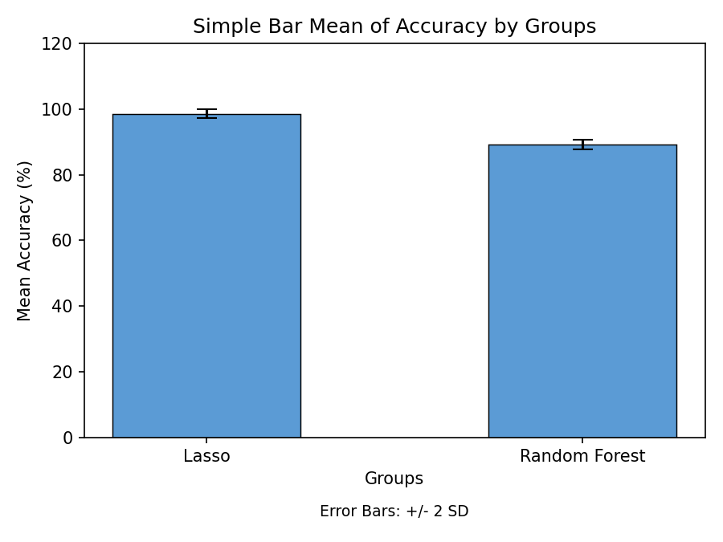
Fig. 1. Comparison of Lasso Regression with the Random Forest Algorithm with respect to mean and accuracy. The mean accuracy of the Lasso Regression is more prominent than the Random Forest. X-axis: Lasso Regression vs Random Forest, Y-axis: Mean accuracy. Error Bar +/-2SD.

