AI ASSISTED CODING LAB 10

Lab 10 – Code Review and Quality: Using AI to Improve Code Quality and Readability

NAME : T.VAMSI KRISHNA
ROLL NO:- 2503A52705
BATCH – 24

Task Description #1 – Syntax and Logic Errors
Task: Use AI to identify and fix syntax and logic errors in a faulty
Python script.
Sample Input Code:
# Calculate average score of a student
def calc_average(marks):

Week5 -
Monday

total = 0
for m in marks:
total += m
average = total / len(marks)
return avrage # Typo here
marks = [85, 90, 78, 92]
print(&quot;Average Score is &quot;, calc_average(marks)
Expected Output:
Corrected and runnable Python code with explanations of the
fixes.
PROMPT:-
Identify the syntax errors and logical errors and fix the code

REVIEVED CODE:-
def calc_average(marks):
total = 0
for m in marks:
total += m
average = total / len(marks) if marks else 0
return average

marks = [85, 90, 78, 92]
print("Average Score is ", calc_average(marks))

OUTPUT:-
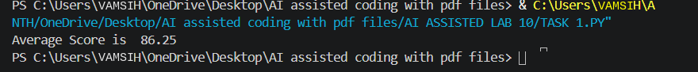

Task Description #2 – PEP 8 Compliance
Task: Use AI to refactor Python code to follow PEP 8 style
guidelines.
Sample Input Code:
def area_of_rect(L,B) : return L*B
print(area_of_rect(10,20))
Expected Output:
• Well-formatted PEP 8-compliant Python code.
PROMPT:-
CAN YOU IDENTIFY THE INDENTATION AND SYNTAX ERRORS AND CORRECT THE CODE

CODE:-
def area_of_rect(L,B):
"""Return the area of a rectangle."""
return L * B

print(area_of_rect(10, 20))
output:-
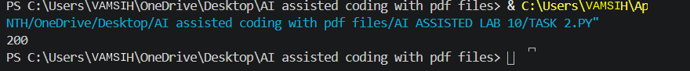

Task Description #3 – Readability Enhancement
Task: Use AI to make code more readable without changing its
logic.
Sample Input Code:
def c(x,y):
return x*y/100
a=200
b=15
print(c(a,b))
Expected Output:
•Python code with descriptive variable names, inline comments, and clear formatting.
Prompt:-
IDENTIFY THE SYNTAX ERROR AND FIX THE CODE
CODE:-
def c(x, y):
return (x * y) / 100

a = 200
b = 15
print(c(a, b))

OUTPUT;-
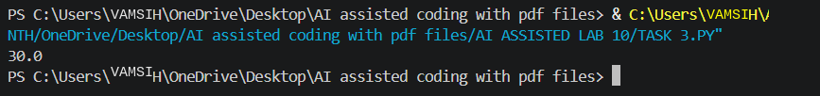

Task Description #4 – Refactoring for Maintainability
Task: Use AI to break repetitive or long code into reusable
functions.
Sample Input Code:
students = [“Alice”,” Bob”,”Charlie”]
print(‘Welcome”,students[0])
print(“Welcome”,students[1])
print(“Welcome”,students[2])
Expected Output:
Modular code with reusable functions.
PROMPT:-
IDENTIFY THE ERRORS IN THE CODE AND CORRECT THE CODE
CODE:-
students = ["Alice", "Bob", "Charlie"]
print("Welcome", students[0])
print("Welcome", students[1])
print("Welcome", students[2])

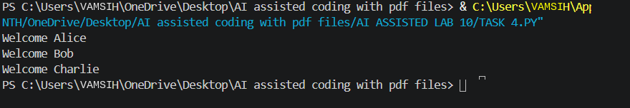

Task Description #5 – Performance Optimization
Task: Use AI to make the code run faster.
Sample Input Code:
# Find squares of numbers
nums = [i for i in range(1,1000000)]
squares = []
for n in nums:
squares.append(n**2)
print(len(squares))
Expected Output:
Optimized code using list comprehensions or vectorize operations.
PROMPT:-
IDENTIFY THE SYNTAX ERRORS AND FIX THE CODE
Code:-
nums = [i for i in range(1,1000000)]
squares = []

for n in nums:
squares.append(n**2)
print(len(squares))

OUTPUT:-
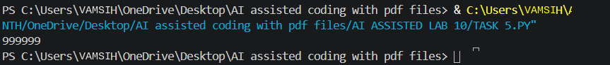

Task Description #6 – Complexity Reduction
Task: Use AI to simplify overly complex logic.
Sample Input Code:
def grade(score):
if score >= 90:
return”A”
else:
if score >= 80:
return”B”
else:
if score >= 70:
return”C”
else:
if score >= 60:
return “D”
else:
return ”F”
Expected Output:
Cleaner logic using elif or dictionary mapping.

PROMPT:-
IDENTIFY THE SYNTAX AND INDENTATION AND LOGICAL ERRORS AND CORRECT THE CODE

CODE:-
def grade(score):
if score >= 90:
return "A"
elif score >= 80:
return "B"
elif score >= 70:
return "C"
elif score >= 60:
return "D"
else:
return "F"
print(grade(85))
OUTPUT:-
