a)Develop a static web application and deploy it in any one of the web servers (WAMP/Apache Tomcat/IIS).
Code:-
<html>
<head>
<title>Registration form</title>
</head>
<body>
<form>
<center>
<h1>Registration Form</h1>
<table border="5">
<tr>
<th>Username: </th>
<th><input id="Username" type="text"/></th>
</tr>
<tr>
<th>Password: </th>
<th><input id="Password" type="text"/></th>
</tr>
<tr>
<th>Email: </th>
<th><input id="Email" type="email"/></th>
</tr>
<tr>
<th>Mobile: </th>
<th><input id="mobile" type="number"/></th>
</tr>
<tr>
<td colspan="2">
<center>
<input type="submit" onsubmit="" />
<input type="reset" onsubmit="" />
</center>
</td>
</tr>
</table>
</center>
</form>
</body>
</html>
OUTPUT:-
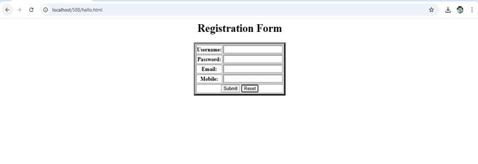
b)Develop a JavaScript program to validate the client-side user input data (Example: username, password, email, phone number).
Code:-
<html>
<head>
<title>Registration form</title>
</head>
<body>
<form>
<center>
<h1>Registration Form</h1>
<table border="5">
<tr>
<th>Username: </th>
<th><input id="Username" type="text" required/></th>
</tr>
<tr>
<th>Password: </th>
<th><input id="Password" type="text"/></th>
</tr>
<tr>
<th>Email: </th>
<th><input id="Email" type="text"/></th>
</tr>
<tr>
<th>Mobile: </th>
<th><input id="mobile" type="number"/></th>
</tr>
<tr>
<td colspan="2">
<center>
<input type="button" onclick="Validate()" value="Submit" />
<input type="reset" />
</center>
</td>
</tr>
</table>
</center>
</form>
</body>
<script>
function Validate()
{
var name = document.getElementById("Username").value;
var pwd = document.getElementById("Password").value;
var mail = document.getElementById("Email").value;
var phno = document.getElementById("mobile").value;
const pwdValid = /^(?=.*[a-z])(?=.*[A-Z])(?=.*\d)(?=.*[@.#$!%*?&])[A-Za-z\d@.#$!%*?&]{8,15}$/;
const emailValid = /^[a-zA-Z0-9._%+-]+@[a-zA-Z0-9.-]+\.[a-zA-Z]{2,}$/;
const nameValid = /^[a-zA-Z]$/;
var atposition=mail.indexOf("@");
var dotposition=mail.lastIndexOf(".");
if(name==="" || name.length<3)
alert("max characters should be 3-25");
else if(!nameValid.test(name))
alert("name should contain only alphabets");
if(pwd.length<8){
alert("password should be atleast 8 characters");
}
else if(!pwdValid.test(pwd)){
alert("password should contain atleast 1 Capital,1 special character and numerical value");
}
if(mail.length===""||mail.length<4)
alert("email should be atleast 4 characters")
else if(atposition<1 || dotposition<atposition+2 || dotposition+2>=mail.length){
alert("Please enter a valid e-mail address \n atpostion:"+atposition+"\n dotposition:"+dotposition);
}
if(phno.length<10 || phno.length>10)
alert("length of mobile no should be 10 digits");
}
</script>
</html>
OUTPUT:-
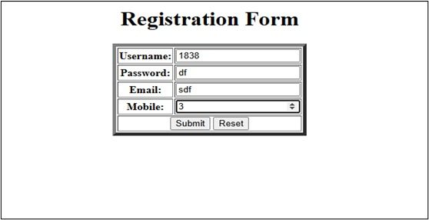
Enter the data without following constraints and click on the Submit button the Outputs are as follows

