- Create a XMLHttpRequest with a callback function and retrieve data from a TXT file by using AJAX.
Code:-
i)index.html
<!DOCTYPE html>
<html lang="en">
<head>
<meta charset="UTF-8">
<meta name="viewport" content="width=device-width, initial-scale=1.0">
<title>Document</title>
<script>
function Show(){
const xhr = new XMLHttpRequest();
xhr.open('GET',"Vamsi.txt");
xhr.onreadystatechange = function(){
if(this.readyState===4 && this.status===200)
document.getElementById("show").innerHTML = this.responseText;
};
xhr.send();
}
</script>
</head>
<body>
<center>
<h1>The XmlHttpRequest Object</h1>
<button onclick="Show()">Click here to get the text</button>
<h2 id="show"></h2>
</center>
</body>
</html>
ii)Vamsi.txt
Hi Vamsi Krishna Welcome To the Server side Scripting Lab

OUTPUT:-
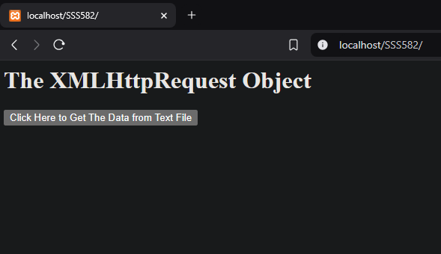

When we click on the button The content of Text file will be displayed
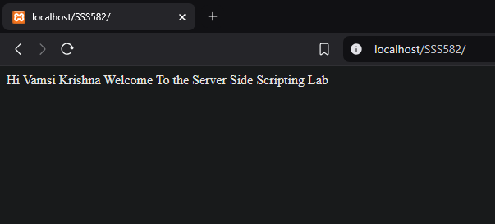

- Create an XMLHttpRequest to retrieve data from an XML file and display the data in an HTML table by using AJAX.
Code:-
i)Module2.html
<html>
<head>
<style>
table, th, td {
border: 2px solid black;
border-collapse: collapse;
}
th, td {
padding: 5px;
}
</style>
</head>
<body>
<h1>The XMLHttpRequest Object for Book Details</h1>
<button type="button" onclick="loadDoc()">Get Books Details</button><br><br>
<div>
<table id="disp"></table></div>
<script>
function loadDoc() {
var xhttp = new XMLHttpRequest();
xhttp.onreadystatechange = function() {
if (this.readyState == 4 && this.status == 200) {
myFunction(this);
}
};
xhttp.open("GET", "data.xml", true);
xhttp.send();
}
function myFunction(xml) {
var i;
var xmlDoc = xml.responseXML;
var table = "<tr><th>Title</th><th>Author</th><th>Year</th><th>Price</th></tr>";
var x = xmlDoc.getElementsByTagName("book");
for (i = 0; i < x.length; i++) {
table += "<tr><td>" +
x[i].getElementsByTagName("title")[0].childNodes[0].nodeValue + "</td><td>" +
x[i].getElementsByTagName("author")[0].childNodes[0].nodeValue + "</td><td>" +
x[i].getElementsByTagName("year")[0].childNodes[0].nodeValue + "</td><td>" +
x[i].getElementsByTagName("price")[0].childNodes[0].nodeValue + "</td></tr>";
}
document.getElementById("disp").innerHTML = table;
}
</script>
</body>
</html>
ii)data.xml
<?xml version="1.0" encoding="UTF-8"?>
<bookstore>
<book>
<title> Java Programming </title>
<author> James Gosling </author>
<year> 2001 </year>
<price> $2.2 </price>
</book>
<book>
<title> Data Base Management System </title>
<author> Raghu Ramakrishna</author>
<year> 2004 </year>
<price> $5.6 </price>
</book>
</bookstore>

OUTPUT:-
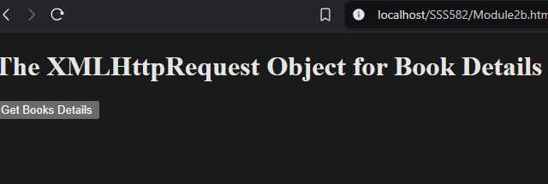

When we click on the button it displays XML file content as HTML Table
