PROJECT & TECHNOLOGY CASE STUDY REPORT
DevPulse
Developer Productivity & Code Quality Dashboard
Submitted as part of the 20-Day Summer Internship
Track 3 — Deployment & Full-Stack Integration
Prepared by: Vamsi Krishna Reddy Vemireddy
Department of Computer Science and Engineering
Vel Tech University
July 2026

Table of Contents
PART 1 — PROJECT CASE STUDY 3
1. Problem Statement 3
2. Existing System Analysis 3
3. Drawbacks of Existing System 3
4. Proposed Solution 4
5. Objectives of the Project 4
6. Scope of the Project 4
7. Features and Modules 5
8. Workflow of the System 5
9. Expected Outputs 5
10. Future Enhancements 6
11. Conclusion 6
PART 2 — TECHNOLOGY CASE STUDY 7
12. Flask Framework 7
13. HTML 8
14. CSS 8
15. JavaScript 9
16. Flask Template Rendering 10
DELIVERABLES — DIAGRAMS & MODULE SUMMARY 12
17. Architecture Diagram 12
18. Workflow Diagram 12
19. Module Explanation Summary 13
20. Screenshots / Reference Images 14

PART 1 — PROJECT CASE STUDY

1. Problem Statement
Modern software teams generate a continuous stream of commits, pull requests, and code changes, yet most teams lack a lightweight, data-driven way to understand developer productivity and code quality trends over time. Engineering managers often rely on subjective impressions, scattered spreadsheets, or expensive enterprise tools to gauge how a team or an individual developer is performing. Small teams, student projects, and open-source maintainers, in particular, have no accessible way to translate raw commit history into actionable insight.
The core problem addressed by this project is: how can raw version-control activity (commits, lines changed, file types, commit messages, timing patterns) be automatically transformed into a meaningful, visual, and predictive measure of developer productivity and code quality, using an accessible, self-hostable web application?

2. Existing System Analysis
Several categories of tools currently attempt to address developer analytics and code quality tracking:
- Enterprise analytics platforms (e.g., large commercial engineering-intelligence suites) that connect to GitHub/GitLab organizations and produce dashboards on cycle time, PR throughput, and code churn.
- Static code analysis tools (e.g., linters, SonarQube-style scanners) that measure code quality metrics such as complexity, duplication, and code smells, but do not correlate this with developer-level productivity trends.
- Manual reporting practices, where team leads compile spreadsheets or standup notes to informally track output.
- Native Git hosting insights (e.g., basic contribution graphs on GitHub/GitLab) that show commit frequency but provide no quality classification or predictive component.

3. Drawbacks of Existing System
- Enterprise tools are expensive, require organizational-level integration, and are inaccessible to students, small teams, or individual learners.
- Static analyzers evaluate code quality in isolation and do not combine this with productivity metrics or present a unified dashboard.
- Manual/spreadsheet-based reporting is time-consuming, error-prone, inconsistent across teams, and does not scale.
- Native Git host insights are purely descriptive (raw counts and graphs) — they lack any predictive or classification layer to flag quality risk before it becomes a problem.
- Most existing tools are closed-source or cloud-locked, offering little flexibility for customization, self-hosting, or integration of custom machine learning models.
- There is no lightweight open tool that combines a trained classifier, a relational data store, and an interactive dashboard in a single deployable Flask application.

4. Proposed Solution
DevPulse is proposed as a self-contained, Flask-based web application that ingests commit-level data, engineers relevant features (lines of code changed, commit frequency, complexity indicators, bug-fix ratios, etc.), and passes them through a trained machine learning classification model to predict a developer productivity / code quality category. The results are persisted in a SQLite database and rendered through an interactive, chart-driven dashboard built with Chart.js, Jinja2 templates, and a responsive HTML/CSS/JavaScript front end.
The system is designed to be lightweight enough to run on a single Render.com instance (via Gunicorn), yet functionally complete — combining data engineering, applied machine learning, and full-stack web development into one deployable product.

5. Objectives of the Project
- To design and engineer a realistic commit-level feature set suitable for productivity and code-quality classification.
- To train and compare multiple machine learning classifiers (Logistic Regression, Decision Tree, Random Forest, Gradient Boosting, SVM) and persist the best-performing model using joblib.
- To build a Flask web application that exposes a live /predict endpoint for real-time inference.
- To design a normalized SQLite schema for storing commits, computed metrics, and prediction results.
- To build an interactive, visually polished dashboard using Chart.js, complete with loading spinners, status badges, and toast notifications.
- To ensure the interface is accessible and responsive across devices.
- To deploy the completed application to a public cloud platform (Render) using a production-grade WSGI server (Gunicorn).

6. Scope of the Project
The scope of DevPulse covers the full pipeline from synthetic/historical commit data through to a deployed, publicly accessible dashboard. It includes:
- Feature engineering and dataset preparation from commit-level data.
- Model training, evaluation (via weighted F1-score), hyperparameter tuning (GridSearchCV), and persistence.
- A Flask back end with routing, templating, and a REST-style prediction endpoint.
- A relational data layer (SQLite) for storing and querying historical metrics.
- A front-end dashboard with charts, tables, and real-time UI feedback.
- Cloud deployment and production server configuration.
The scope explicitly excludes direct, live integration with external Git hosting APIs (e.g., GitHub/GitLab webhooks) in the current version — the system operates on structured commit data prepared during the internship pipeline, with live-integration identified as a future enhancement.

7. Features and Modules
Module | Purpose | Key Functionality
Data Module | Prepare and store commit-level data | Synthetic commit dataset generation, feature engineering, CSV ingestion
ML Engine | Classify productivity / code-quality category | Loads final_model.joblib, final_scaler.joblib, final_label_encoder.joblib; exposes prediction logic
Flask Core | Application routing and orchestration | URL routing, request handling, session management, error handling
/predict API | Real-time inference endpoint | Accepts input features, returns predicted class + confidence via JSON
Database Layer | Persistent storage | SQLite schema for commits, metrics, and prediction history
Dashboard UI | Visual analytics | Chart.js graphs (trend lines, bar/pie charts), summary cards, badges
UX Enhancements | Usability & feedback | Loading spinners, toast notifications, accessibility (ARIA/labels) improvements
Deployment Module | Production hosting | Gunicorn WSGI configuration, Render.com deployment, environment configuration

8. Workflow of the System
The system follows a linear, well-defined data flow, beginning at code commit and ending with a rendered, interactive dashboard view for the developer or team lead:
- A developer's commit activity (represented as structured commit-level records) is collected.
- Relevant features are extracted — lines added/removed, commit frequency, complexity signals, and bug-fix indicators.
- Features are scaled/preprocessed using the persisted scaler artifact.
- The trained classifier predicts a productivity / code-quality category for the commit or developer.
- Prediction results and metrics are stored in the SQLite database.
- The Flask application renders the dashboard using Jinja2 templates, pulling live data from the database.
- Chart.js visualizes trends, and the developer views actionable insights through badges, charts, and summary cards.

9. Expected Outputs
- A live, interactive web dashboard displaying developer productivity and code-quality trends.
- Real-time classification results returned from the /predict endpoint (e.g., 'High Productivity / Good Quality', 'Needs Review', etc.).
- Visual charts showing trends over time — commit volume, quality-classification distribution, and per-developer summaries.
- A persistent, queryable history of all predictions and metrics stored in SQLite.
- A publicly accessible deployed instance of the application running on Render with Gunicorn.

10. Future Enhancements
- Direct integration with GitHub/GitLab APIs or webhooks for live commit ingestion, removing the dependency on prepared datasets.
- Support for team-level and organization-level dashboards with role-based access control.
- Migration from SQLite to a more scalable database (PostgreSQL) for multi-user, production-scale deployments.
- Incorporation of deep learning or NLP-based analysis of commit messages and code diffs for richer quality signals.
- Notification/alerting system (email or Slack integration) for quality-risk flags.
- A REST API layer with authentication for third-party tool integration.

11. Conclusion
DevPulse demonstrates how a complete data science and full-stack engineering pipeline — from feature engineering and model training through to a deployed, production-style Flask application — can be assembled into a single, cohesive tool that addresses a real gap in accessible developer analytics. By combining a trained ML classifier with a relational data store and a polished, chart-driven dashboard, the project fulfills its objective of transforming raw commit activity into actionable, visual insight, while remaining lightweight enough for individual developers, students, and small teams to deploy and use.

PART 2 — TECHNOLOGY CASE STUDY

12. Flask Framework

12.1 Introduction to Flask
Flask is a lightweight, open-source Python web framework classified as a 'micro-framework' because it provides only the essential tools needed to build a web application — routing, request/response handling, and templating — while leaving choices such as database layer, authentication, and project structure to the developer. It is built on top of the Werkzeug WSGI toolkit and the Jinja2 templating engine.

12.2 Features of Flask
- Built-in development server and debugger with live reloading.
- Jinja2 templating engine for dynamic HTML generation.
- Flexible URL routing using Python decorators (@app.route).
- Support for RESTful request handling (GET, POST, PUT, DELETE).
- Built-in support for sessions, cookies, and request objects.
- Extensible via a large ecosystem of extensions (Flask-SQLAlchemy, Flask-Login, Flask-CORS, etc.).
- WSGI-compliant, allowing production deployment through servers such as Gunicorn.

12.3 Advantages of Flask
- Minimal boilerplate — applications can be started with only a few lines of code.
- Fine-grained control over components, unlike more opinionated frameworks.
- Easy integration with machine learning libraries (scikit-learn, joblib) since it is pure Python.
- Lightweight footprint, well-suited for small-to-medium applications and rapid prototyping.
- Large community support and extensive documentation.
- Easily containerized and deployed to cloud platforms such as Render, Heroku, or AWS.

12.4 Why Flask is Suitable for This Project
DevPulse requires tight integration between a Python-based machine learning pipeline (scikit-learn models persisted with joblib) and a web-facing dashboard. Flask's pure-Python nature means the trained model artifacts can be loaded directly into the same process that serves HTTP requests, without the overhead of a separate model-serving layer. Its minimalism also matches the scope of a single-developer academic project: routing, the /predict endpoint, Jinja2-rendered dashboard pages, and SQLite integration can all be implemented within one clear, maintainable app structure, and the same application deploys cleanly to Render using Gunicorn.

13. HTML

13.1 Purpose of HTML
HTML (HyperText Markup Language) defines the structural skeleton of every page in the DevPulse dashboard. It organizes content into semantic sections — headers, navigation, dashboard cards, tables, and forms — that CSS then styles and JavaScript makes interactive.

13.2 Important Tags Used in the Project
- <header> / <nav> — top navigation bar and branding.
- <section> / <div class="card"> — dashboard summary cards and chart containers.
- <canvas> — mount points for Chart.js visualizations.
- <table>, <thead>, <tbody>, <tr>, <td> — tabular display of commit and prediction history.
- <form>, <input>, <select>, <button> — data-entry and filter controls.
- <span class="badge"> — status/quality badges (e.g., 'Good', 'Needs Review').

13.3 Form Elements
Forms in the dashboard use text and number inputs for feature entry (e.g., lines changed, commit count), <select> dropdowns for filtering by developer or date range, and submit buttons wired to JavaScript event handlers that call the /predict endpoint asynchronously rather than performing a full page reload.

13.4 Tables, Cards, and Navigation Components
The dashboard's information architecture relies on three recurring HTML patterns: summary cards (compact <div> blocks showing key metrics such as average productivity score), data tables (structured commit/prediction history with sortable columns), and a persistent top navigation bar linking to dashboard, history, and about views.

14. CSS

14.1 Purpose of CSS
CSS (Cascading Style Sheets) controls the visual presentation of the HTML structure — color scheme, spacing, typography, and layout — giving the DevPulse dashboard a consistent, professional appearance distinct from raw browser defaults.

14.2 Responsive Design Concepts
The interface uses relative units (%, rem, vw/vh) and CSS media queries to adapt layout across breakpoints, ensuring dashboard cards and charts reflow correctly from desktop to tablet to mobile screens without horizontal scrolling or overlapping elements.

14.3 Flexbox and Grid Concepts
Flexbox is used for one-dimensional alignment — arranging navigation items, badge groups, and toolbar buttons in a row with consistent spacing (display: flex, justify-content, align-items). CSS Grid is used for two-dimensional dashboard layouts, arranging summary cards and chart panels into a responsive grid (display: grid, grid-template-columns, gap) that automatically reflows based on available width.

14.4 UI/UX Design Principles
- Visual hierarchy — larger, bolder typography for key metrics; muted tones for secondary text.
- Consistency — a single color palette and spacing scale reused across all components.
- Feedback — visible loading states (spinners) and confirmation cues (toast notifications) after every asynchronous action.
- Accessibility — sufficient color contrast, semantic HTML, and ARIA labels for screen-reader support.
- Minimal cognitive load — dashboard information grouped into scannable cards rather than dense blocks of text.

14.5 Professional Web Design Practices
- A defined CSS variable system (:root { --primary-color, --radius, --spacing }) for consistent theming.
- Separation of concerns — CSS kept in a dedicated static/css/ file rather than inline styles.
- Mobile-first breakpoints and consistent component naming conventions (BEM-style class naming).

15. JavaScript

15.1 Purpose of JavaScript
JavaScript provides the interactivity layer of DevPulse — handling user actions, calling the Flask backend asynchronously, updating charts in real time, and providing immediate visual feedback without full-page reloads.

15.2 DOM Manipulation
JavaScript selects and updates elements (document.querySelector, classList.add/remove, textContent) to dynamically insert prediction results, toggle badge colors based on classification outcome, and show/hide loading spinners while a request is in flight.

15.3 Form Validation
Before a request reaches the /predict endpoint, client-side validation checks that numeric fields (e.g., lines changed, commit count) are present and within expected ranges, giving the user immediate inline error feedback rather than waiting for a server round-trip.

15.4 Dynamic Content Handling
The dashboard uses the Fetch API to call Flask routes asynchronously (fetch('/predict', {...})), parses the JSON response, and dynamically re-renders chart data (Chart.js .update()) and table rows without reloading the page — keeping the dashboard responsive and current.

15.5 Event Handling
Event listeners (addEventListener('click'/'submit'/'change', ...)) drive the interactive elements of the dashboard: submitting the prediction form, filtering the history table by developer, and triggering toast notifications on success or error.

16. Flask Template Rendering

16.1 Project Structure
The DevPulse project follows Flask's conventional application layout, keeping application logic, templates, and static assets clearly separated:
- app.py — application entry point, route definitions, and the /predict endpoint.
- templates/ — Jinja2 HTML templates for each page (dashboard, history, base layout).
- static/ — CSS, JavaScript, and image assets served directly to the browser.
- models/ — persisted ML artifacts (final_model.joblib, final_scaler.joblib, final_label_encoder.joblib).
- database/ — SQLite database file and schema/migration scripts.

16.2 Templates Folder
Flask automatically looks for HTML templates inside a folder named templates/ at the project root. Each route in app.py calls render_template() with the name of a file in this folder, allowing Python data to be injected into HTML at request time.

16.3 Static Folder
The static/ folder holds all assets that do not change per-request — CSS stylesheets, JavaScript files, images, and fonts. Flask serves these automatically under the /static/ URL prefix, referenced in templates via {{ url_for('static', filename='css/style.css') }}.

16.4 render_template() Method
render_template() is the core Flask function that loads a file from templates/, processes any Jinja2 syntax it contains, substitutes in the variables passed as keyword arguments, and returns the resulting HTML string as the HTTP response — for example, return render_template('dashboard.html', predictions=results).

16.5 Jinja Templating Basics
- Variable output: {{ variable }} inserts a Python value into the HTML.
- Control structures: {% if %}, {% for %} loops allow conditional rendering and iteration over lists (e.g., looping through prediction history rows).
- Template inheritance: {% extends 'base.html' %} and {% block content %} allow a shared layout (navigation, footer) to be reused across all pages.
- Filters: expressions such as {{ value | round(2) }} format data directly within the template.

16.6 Passing Data from Flask to HTML
Data computed in Python — such as the ML model's prediction, confidence score, or a queried list of past commits — is passed into render_template() as keyword arguments. Jinja2 then makes these available as native-feeling variables inside the HTML template, so the same route can serve the same template with different, request-specific data.

16.7 Dynamic Rendering Concepts
Because render_template() re-evaluates the template on every request using fresh data from the database and the ML model, the dashboard is never static: each page load reflects the current contents of the SQLite database, and the /predict endpoint's JSON responses allow the front end to update charts dynamically without a full page reload, combining server-side (Jinja2) and client-side (JavaScript/Fetch) rendering in a single cohesive application.

DELIVERABLES — DIAGRAMS & MODULE SUMMARY

17. Architecture Diagram
The diagram below illustrates the layered architecture of DevPulse — from the client-facing browser layer, through the Flask application and machine learning engine, down to the data and deployment layers.
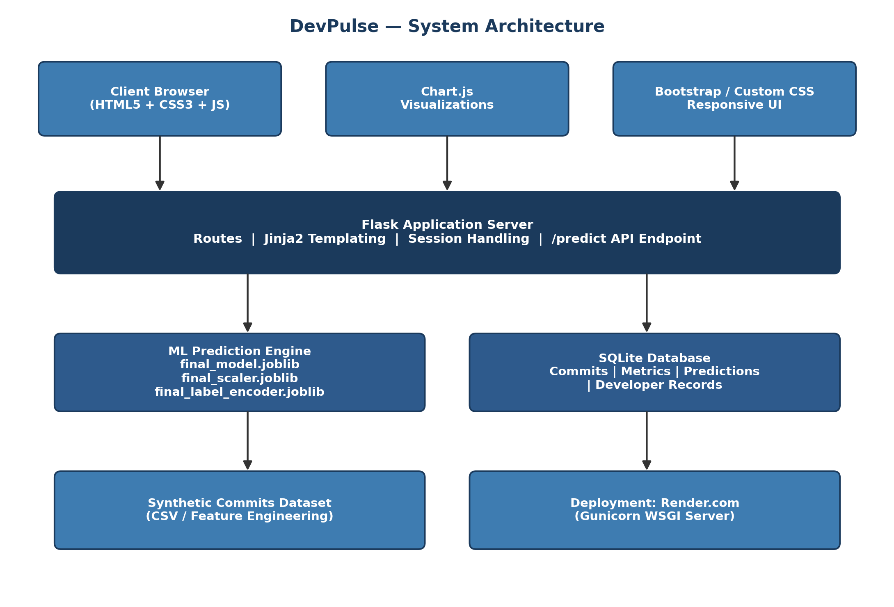
Figure 1: DevPulse Layered System Architecture

18. Workflow Diagram
The following diagram traces the end-to-end process flow of the system, from a developer's commit through to the rendering of insights on the dashboard.
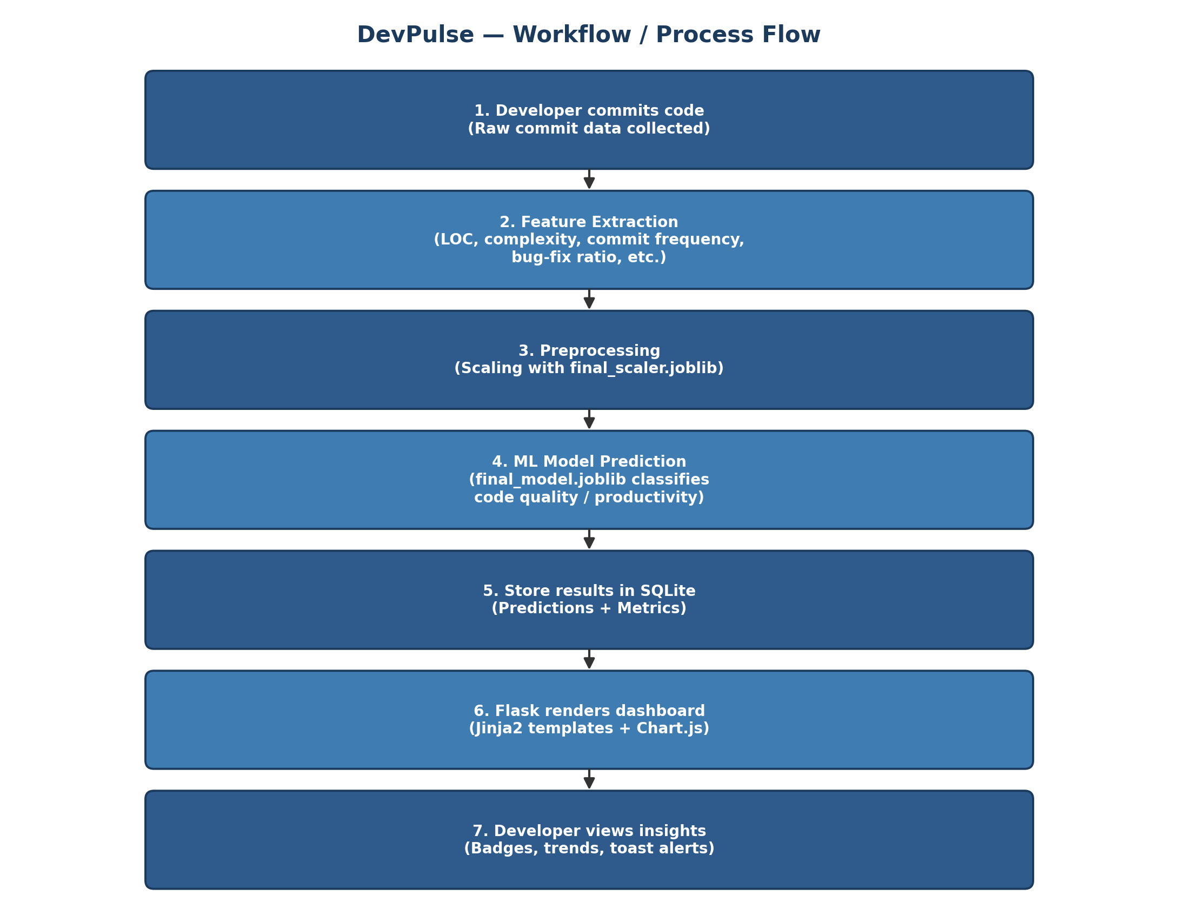
Figure 2: DevPulse Process / Workflow Diagram

19. Module Explanation Summary
The table below summarizes each core module of DevPulse, consistent with the Features and Modules section in Part 1, for quick reference alongside the diagrams above.
Module | Purpose | Key Functionality
Data Module | Prepare and store commit-level data | Synthetic dataset generation, feature engineering, CSV ingestion
ML Engine | Classify productivity / code quality | Loads joblib artifacts; performs scaling, encoding, and inference
Flask Core | Central application controller | Routing, templating, request/response lifecycle
/predict API | Real-time inference | Accepts features as JSON, returns predicted class and confidence
Database Layer | Persistence | SQLite schema for commits, metrics, and prediction history
Dashboard UI | Visualization | Chart.js graphs, summary cards, sortable history table
UX Layer | Usability | Spinners, toast notifications, accessible markup
Deployment | Production hosting | Gunicorn + Render.com configuration

20. Screenshots / Reference Images
Placeholder for application screenshots (dashboard view, prediction form, history table) to be inserted once the Day 20 deployment is finalized and the live Render URL is available. Recommended screenshots: (1) the main dashboard with Chart.js visualizations, (2) the prediction form with a sample /predict response, and (3) the historical commit/prediction table view.

