Mental health posts classification using Deep learning

Vamsi Krishna Remala

*700744730*

*Dept. Cyber Security & Information Assurance University of Central Missouri* [*vxr47300@ucmo.edu*](mailto:vxr47300@ucmo.edu)

Ramcharan Alla

*700745180*

*Dept. Computer Science University of Central Missouri* [*rxa51800@ucmo.edu*](mailto:rxa51800@ucmo.edu)

Manohar Chowdary Kambhampati *700745306*

*Dept. Computer Science University of Central Missouri* [*mxk53060@ucmo.edu*](mailto:mxk53060@ucmo.edu)

Ganash Karthik Satrasala

*700744367*

*Dept. Computer Science University of Central Missouri* [*gxs43670@ucmo.edu*](mailto:gxs43670@ucmo.edu)

1***Abstract*—According to a WHO report of 2019 970 million people around the world were living with a mental disorder these factors are alarming. Amongst the mental disorders anxiety and depressive disorders are the most common mental disorders. The rate of disorders rose significantly during the COVID-19 pandemic from 26 percent to 28 percent. In this study, we are proposing mental disorder classification using deep learning tech- niques. Data for this study is collected from subredditposts post-COVID-19 from 2018-2020 to analyze post- COVIDtrauma.Theproposedmodelanalysesthetextand classifies it into one of 7 categories which include mental disordersandnonmentaldisordersi.e.anxiety,depression, loneliness, bipolar, and mental disorder parenting and teaching. To classify the posts LSTM model is used. The proposed model achieves 60 percent validation accuracy. To enhance the comprehensiveness of our analysis, we conduct a comparative study on data that includes explicit words related to mental disorders and data without such explicit language.**

***Index Terms*—COVID-19, LSTM(Long Short Term Memory), mental health disorders,post COVID trauma, Reddit posts**

1. Introduction

In the past, mental illness was stigmatised, and individuals hesitated to openly discuss their mental healthchallenges.Asknowledgeandunderstanding ofpsychologyhaveadvanced,thereisagrowing

<https://github.com/vamsikrishnaremala/Final_Project_Mental_Health_Posts_classification>

recognition of the significance of acknowledging andappropriatelytreatingmentalillness.Examining historical perspectives reveals the alarming percep- tionsofmentalillnessduringthe18thcenturywhen itwasattributedtosupernaturalforces.Inthe2000s, legislative measures were implemented to combat stigma and ensure proper care for mental health issues.

Recognizing the significance of mental health is crucial, yet identifying specific mental health con- ditions poses challenges due to their diverse nature. A reliable approach involves seeking professional medical advice and obtaining a formal diagnosis. Key indicators encompass emotions such as sad- ness, low energy, mood swings, and difficulties in concentration. Discerning these primary symptoms may be intricate. Even in the absence of explicit expressions of stress, depression, or anxiety, indi- viduals often manifest these sentiments indirectlyon social media platforms. Research indicates that social media posts can provide insights into an in- dividual’s mental state, offering glimpses into their behavioural patterns. Users frequently turn to social media platforms to articulate intense emotions, par- ticularly during challenging circumstances.

There are different kinds of mental disorders, such as anxiety, depression, bipolar disorder, sui- cidal thoughts, and loneliness. Bipolar disorder in- volvesmoodswings,andalthoughitsexactcause

is unknown, genetic examination can provide some clues about its origins. Anxiety is another mental disorderthatcancausephysicalchangeslikesweat- ing and trembling, and it is associated with feelings of fear and uneasiness. Depression, on the other hand, is a form of intense sadness.

WHO(WorldHealthOrganisation)statesthatanx- ietyanddepressionarethemostcommonmen- tal health issue categories and the second leading cause of death is suicide. WHO is also passing preventivemeasurestoreducethecasesofmen- tal illness it launched various programmes mental illness awareness programmes and preventive mea- sures. It also increased the accessibility to mental health care. Statistics show that it implemented theseprogramsin110countriessuccessfully.Afew of those programs are HIV, Tuberculosis patient recovery, awareness of mental health policies and rights, psychological support in emergencies, and enforcing mental health policies at the workplace. Despitetheseinitiativesfindingtherightpeopleand their diagnosis is difficult.

Social media platforms play a crucial role in finding persons or users through their daily activity posts. This platform reveals their mental behaviour. According to the Statista website or source, people spend 151 minutes online which is a 1 percent rise fromlastyear’s147minutes.Asshowninthefigure 1 The average spend in 2022 is around 2.5 hours whichishuge.Thedailypostofapersonis1-2 this tells the person’s presence of mind.

In our paper, we are collecting the posts from Reddit and analyzing the mental issues of 5 cat- egories and 2 types of nonmental issues as well.We considered the most common types of mental issues anxiety, depression, loneliness, suicide, and bipolarandinthenonmentalcategoryparentingand teaching categories are collected.

Theimpactofmentalillnessaffectsindividualsin several ways. Firstly, it disrupts sleep patterns, con- tributing to sleep disturbances for those grappling with mental health challenges. Moreover, mental illness amplifies the vulnerability to chronic dis- eases, particularly for individuals who are already contending with such conditions.

Presently,thereisanotableincreaseinthepreva- lenceofheartdiseasesamongthoseexperienc- ingmentalhealthissues.Additionally,individuals

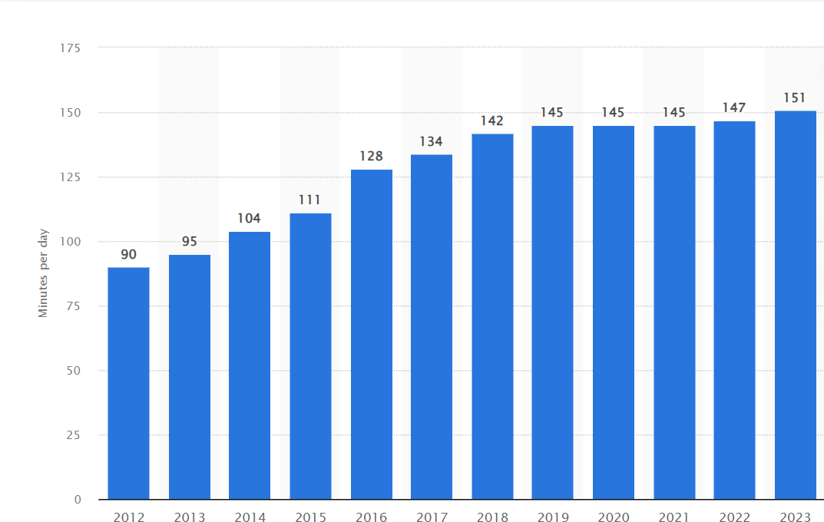

Figure1.dailypostsstatistics

grappling with mental health concerns are more inclinedtoengageinbehavioursthatposeadditional health risks, such as smoking and excessive alcohol consumption. This complex interplay underscores theneedforcomprehensivehealthinterventionsthat addressbothmentalandphysicalwell-being.People with bad physical conditions may also develop mentalhealthissues.OneofthediseasesisPsoriasis.

1. Motivation

In recent years, mental health issues have emerged as a critical concern, affecting individuals acrossdiversedemographics.Socialmedia,particu- larly Reddit, has become a rich source of real-time expressionsofpersonalexperiences,includingthose related to mental health.

The motivation behind this work is firstly, to understandhowindividualsarticulatetheirmental

health struggles in online platforms, thereby pro- vidingvaluableinsights.Secondly,thedevelopment of an effective classification model for identify-ing mental health issues.Leveraging deep learning techniques, specifically Long Short-Term Memory (LSTM)networks.LSTMsarespecificallydesigned to overcome the limitations of traditional neural networks when processing sequential data, making them exceptionally well-suited for analysing the dynamic and context-dependent nature of language within these posts.

1. Objectives

Theprimaryobjectiveoftheprojectistodevelop an effective LSTM-based classification model to classify mental health issues.The main goal of this projectistousedeeplearningtechniquestoclassify thepostsandovercomethechallengesoftraditional machine learning models. Additional objectives of the project are:

* Analysingonlinepostsofmentalhealthissues: Thisobjectiveisthecornerstoneoftheproject. We analyse the posts and draw observationson how people express their struggle on online platforms.
* Analysing temporal nature of the text: This objective addresses the temporal nature of the text that is sequential patterns in the data.
* Adaptability to varied lengths of text: This objective focuses on model compatibility to varied length of texts in real time
* The final objective is to translate all these observations into practical solutions

1. Relatedwork

Excessivesmartphoneusemaycontributetomen- tal and emotional health issues among adolescents. This study’s goal is to understand how teenagers’ smartphone use in Indonesia is connected to their mental and emotional well-being. A cross-sectional correlational design method is used in this study. The gathered data is a sample of 350 adolescents aged 10-22 years sampling. The application of Kendall’s method demonstrated that the correla- tion coefficient of -0.255 suggests a negative re- lationship. The above study is set in Indonesia.It specifically addresses smartphone addiction among adolescents.Itproposessolutionstothesmartphone

addictions like cognitive counselling and therapies depending on the severity [21].

ThisstudyissetinSriLanka.Itfocusesonthe broader behavioural patterns like sleep pat-terns through sensors like accelerometer, and GPS sensors.The data is collected using questionnaires without informing the study purpose. In this the patterns are divided into active and passive in these twocategoriesmentalhealthstatusisanalysedusing various techniques. In conclusion the results show that the location variance and sleep patterns are highly correlated.And it also shows that the smart- phone samples are effective data points to analyse the mental health problems [9].

The current mental health challenges underscore the necessity for research in today’s society. The data uses mental IQ tests. According to this study Artificial Neural Network (ANN) algorithms over- come the limitations of existing methods. For that the study introduces integration of decision trees with compound learning algorithms and the system analyses and classifies mental health IQ tests [5].

Thisstudyinvestigatesthementalwell-beingof students amid the COVID-19 pandemic. It fo- cusesonundergraduatesfromWuhanUniversity of Science and Technology, gathering data through questionnaires. The goal is to pinpoint factors af- fecting psychological stress responses. Using SPSS software, the study analyses correlations in thedata. Results reveal no noteworthy difference in psychological stress levels between students who were infected and those who were not. In summary, the findings indicate that Wuhan college students displayed diverse degrees of psychological stress reactions following the COVID-19 outbreak [14].

Thegoalofthisstudyistodrawinsightsinto the public’s perception and awareness of mental health in the Malaysian community. This study considered the data of the Malaysian community and the data is gathered from Non-Governmental Organization (NGO) Twitter accounts. The study usedexperimentalmethods,withsentimentanalysis to gauge the Malaysian community’s awareness of mental health problems. The implementation pro- cess involves data collection, preprocessing, andthe application of machine learning techniques and deep learning techniques, Neural Networks (NN), SupportVectorMachine(SVM),andNaiveBayes

(NB). The results of the study revealed that positive tweets are the dominant class. From the above research, we can say that mental health awareness can be enhanced by fostering positivity in tweets [19].

In the pursuit of understanding the relationship between technology use and mental well-being us- ing machine learning, the paper delves into the application of machine learning algorithms and the algorithms include K-Nearest Neighbour, Random Forest, Decision Tree, and Logistic regression. The main goal of the study is to compare the perfor- mancesinpredictingmentalhealthstatus.Themain challenges in this study are the limited size of the data and the potential bias of the data [7].

Notonlyisthepredictionofmentalhealthcrucial but also assessing the severity of mental health issues holds paramount importance. The paper in- troduces a comprehensive framework using data science principles to predict the severity of mental healthinto3categoriesofseveritylow,medium,and high. To put the theory into practice an empirical approachisproposedtoassessthehealthconditions of both healthy individuals and people with mental illness. The novel framework for predicting public mentalhealthfaceschallengesindatacategorization due to issues of quality and accuracy. Additionally, assessing individuals’ health conditions in sample tests becomes complex, especially when handling sensitive mental health information [17].

The discussion emphasizes how AI can enhance patient care and mental health issues. This paper introduces28studiesfocusedonemotionalstability highlighting the promising outcomes of machine learning algorithms [16].

The study employs the DMADV (Define- Measure-Analyze-Design-Verify) methodology. Data for the study is gathered through an online survey PHQ-9 (Patient Health Questionnaire) and the factors include personal, social, and academic. The results of the study show that there is atangible effect of a pandemic on the student’s emotional well-being. During the pandemic, the mental state of the students shifted from mild to moderate negative emotions [3].

This study explores a range of mental health concernssuchasschizophrenia,bipolarillness,anx- iety,depression,andPTSD.Thestudyenvisions

future possibilities for research and development, seekingtomakethemostofemergingopportunities in utilising machine learning for mental health. The reviewcarefullyanalysesfindingsandconsidersthe challenges encountered by the research community [18].

In the swiftly evolving times, future generations, particularly students, are facing significant stress, due to intense competition, societal issues, and constant pressure. This paper addresses five preva- lent disorders affecting young individuals: bipolar disorder, anxiety disorders, depression, eating dis- orders, and sleep issues. The research uses Machine Learning (ML) algorithms to screen mental health, utilising a Mental Disorder Questionnaire (MDQ) [11].

Thebigchallengeinorganizationsisbigdata management with the constant immense daily data, themajorityofbigdataisunstructured(about85 percent).Thepaperdelvesintodimensionsofbig data quality, explores big data analytics during the COVID-19pandemic,andaddressesbothphysical and mental health issues arising post-COVID [10]. Thestudycentersonoverlookedphysicaland mental health needs of older adults, particularly in the context of challenges posed by new coronavirus variants. This study implements iAssist, a compre- hensiveplatformdesignedtodeliverpromptmedical aid.iAssistincludesfunctionalitieslikedoctorap- pointments, medicine orders, and lab appointments, withaprimaryaimtobenefitcaregiverssuchas

familymembersandhealthcareprofessionals[6].

The study addresses the challenge of mental health in today’s modern world, considering tradi- tional factors like family pressure, unemployment, homesickness, and unhappy relationships as com- mon triggers for mental illness. The study conducts a comparative analysis of Conv-LSTM and BERT models. The study proposes a user-friendly, deep learning-based chatbot framework. The proposed framework includes a module to track social media activity, a chat module for real-time conversations, and a deep learning-based mental illness detection [1]. This study presents a two-phase mental status detection system for schizophrenia patients. The proposed framework uses a Cross-Modality Graph Convolutional Network (CMGCN) to integrate vi- sualfeaturesfromdiversemodalities.Experiments

exhibit substantial advancements compared to ex- isting methods, achieving real-world mAP of 69.52 [13].

The proposed approach involves employing NLP BERT with a deep neural network to analyze social media conversations over time. The primary goal is to assist the Omani Ministry of Health in delivering comprehensive mental health care services. The datasetisevaluatedforemotionalbehaviors,specif- ically focusing on identifying signs of depression. Thesystemnot onlyurgesusers toprioritizemental health but also informs the mental health sector about individuals’ mental health status. [2]

This study explores the machine learning tech- niques’ efficiency in the health informatics sector. Theexperimentevaluatesvariousconvolutionalneu- ral network architectures, commonly used in text classification tasks. The data for the experiment is ElectronicHealthRecords.Theexperimentalresults show that the multi-channel model outperformed others, achieving a 92 percent accuracy, while the attentionandsequentialmodelsachievedaccuracies of 90 percent and 89 percent, respectively [20]. The research employs data mining techniques, includ- ing statistical reports, machine learning, and deep learning, to analyze users’ mental health statuses. Thestudyidentifiesdepressiveindicativewordsand proposes methods to enhance efficiency, accuracy, and scalein mentalhealth analysis.By integrat- ing technology such as data mining and machine learning [8]. This research introduces SPRSound, the inaugural freely accessible pediatric respiratory sound database. The initiative aims to enhance objectivity and alleviate the workload on doctorsby automating respiratory sound analysis. The suc- cess of such methods is contingent on the quality and comprehensiveness of the respiratory sound databases utilized, emphasizing the significance of SPRSound in advancing this field [4].

Analyzingrespiratorysoundsiscriticalforevalu- atinglunghealth,andthereisanincreasingdemand for automated software to streamline the process. Ourstudyfocusesondistinguishingbetweentypical lungsoundsandthoseaffectedbyairwayblockages using a wearable sensor paired with a smartphone. This innovation has the potential to revolutionize asthma care, making it more efficient and cost- effective.Theuseofthistechnologysimplifies

signal collection for battery-powered systems [12]. Inrecentyears,therehasbeenagrowingin- terestinautomatingthecategorizationofrespira- torysounds.However,theeffectivenessofcurrent deep learning approaches is hindered by small and unevenly distributed datasets. Our study introduces anoveltechniquecalledMBTCNSE,whichcom- binesamulti-branchTemporalConvolutionalNet- work(TCN)withaSqueeze-and-ExcitationNet- work(SEnet)toenhancetheclassificationofres-

piratorysounds[4].

Respiratory sounds offer valuable insights into lung function, and diagnosing lung issues often involves listening for abnormal sounds during aus- cultation. To make this process less subjective and reduce the burden on doctors, many methods auto- mate sound analysis. However, the success of these methods depends on the quality and breadth of the respiratorysounddatabasetheyuse.Inourresearch, we’ve developed SPRSound, the first freely acces- sible pediatric respiratory sound database [2].

Abnormal respiratory sounds, such as crackles, arecrucialindicatorsofvariousrespiratorydiseases. Understanding the characteristics of crackles is es- sential for developing a computerized diagnostic approach. Our study proposes a methodology that integrates a random forest classifier and Empirical Mode Decomposition (EMD) to classify subjects into six respiratory conditions: healthy, bronchiec- tasis, bronchiolitis, COPD, pneumonia, and URTI [6].

1. Data Description

From the subreddit repository, the data is gath- ered. We used this dataset to understand the impact of COVID-19 on mental health support groups[15].Wehaveselected4mentalhealth-relatedposts anxiety, bipolar, depression loneliness, and suicide ontheotherhandwehaveselected2categories of nonmental health posts also are parenting and teaching. Each category of the file is downloadedin CSV format and combined with the data usingthepandasframework.Thetotalnumberofposts is 42865. The dataset contains various features but removed all the unnecessary features and retained only posts and subreddits (the emotion or label). Another data frame is created by removing explicit wordslikeanxiety,depression,andloneliness.After

removing the explicit words we are left with 24018 posts.

1. ProposedFramework

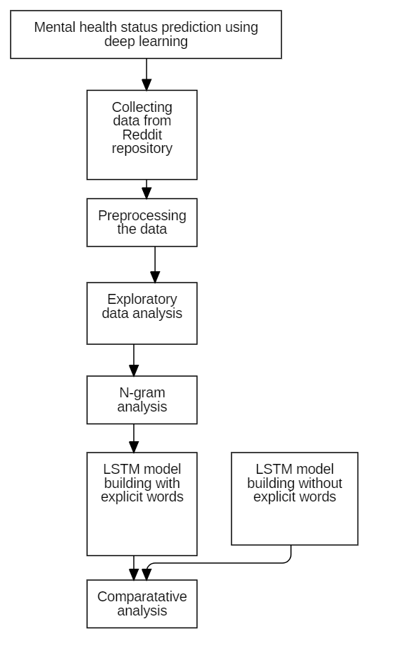

Figure2.Workflow

As shown in figure 2 the proposed work is divided into data preprocessing, EDA(Exploratory Data Analysis), and methods.

1. *Datacollectionandpreprocessing*

Reddit Mental Health Dataset is collected from the Zonado open-source repository. The main goal ofthisprojectistoclassifythetypeofpostusingthe

LSTM model. In the data collection preprocessing stage though the repository contains 15 types of posts for this study we have picked 7 types of posts for analysis. These 7 individual files are concate- nated using pandas. In the stage of preprocessing cleaned the data by removing stop words and sep- arated the data into containing explicit words and non-explicit words. In this, we analyze the data in two different ways.

1. *Exploratorydataanalysis*

In exploratory data analysis class distribution for different categories is analyzed, and the distribution is again broken into mental and nonmental post cat- egories, the average length of posts is analyzed and word frequency distributions are plotted. As shown infigure3Inthedatabasewehave15differentcate- gories of mental health we have considered 4 major categories depression, anxiety, lonely, bipolar, and suicidal2categoriesofnon-mentalhealth(parenting and teaching) dominant class is depression and non dominantclassisteachingFigure4representsthe

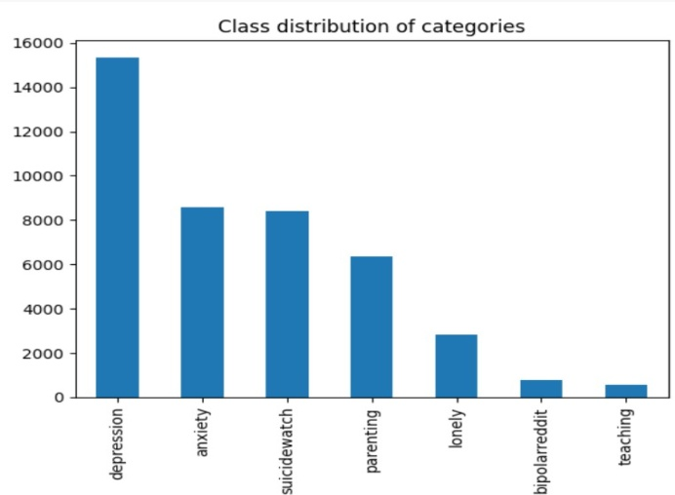

Figure3.Postdistribution

distribution of posts in the context of mental health vs nonmental health.

Figure 5 represents the average length distribu- tions of different posts. mental disorder posts have long sentences compared to mental health disorder- related posts In the category of mental health issues category bipolar and depression categories have lengthysentences.Thisanalysishelpstobuildbetter models and word embedding sizes.

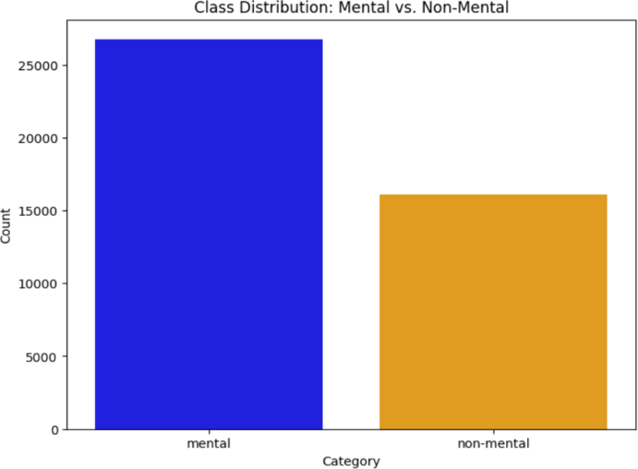 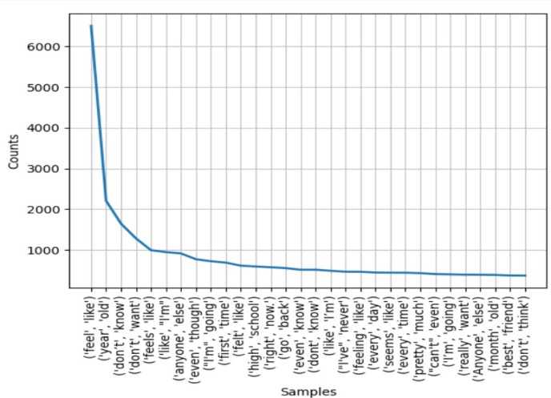

Figure4.mentalvsnonmentaldistribution

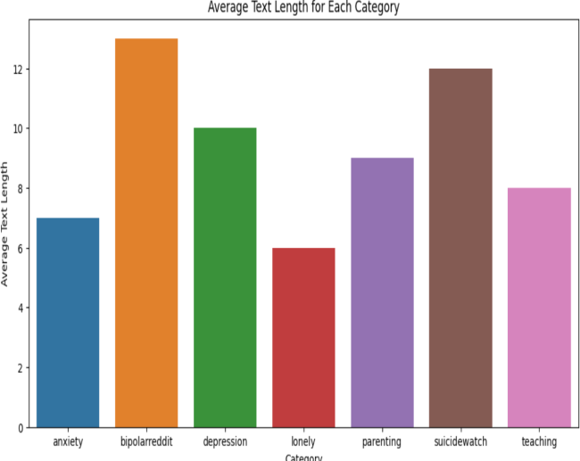

Figure5.Averagelengthsofposts

Apart from the above visualizations word clouds show that feel is the common frequent word across mental issue posts and in the nonmental disorder category kid is common in parenting and teacher and student are the frequent words. There are com- monexplicittermsalsoineachmentalcategorylike depression, lonely, anxiety, and bipolar

1. *Methods*

In the proposed methodology n-gram analysis is performed and the LSTM model is built to classify the posts. In the section of N-gram analysis data is analysed in the context of bi-grams and trigrams. The figure 6 represents the bi-gram analysis andthefigure7representsthetri-gramanalysis.This is performed after removing the stop words fromthe data using NLTK stopwords.

Figure6.Bi-gramanalysis

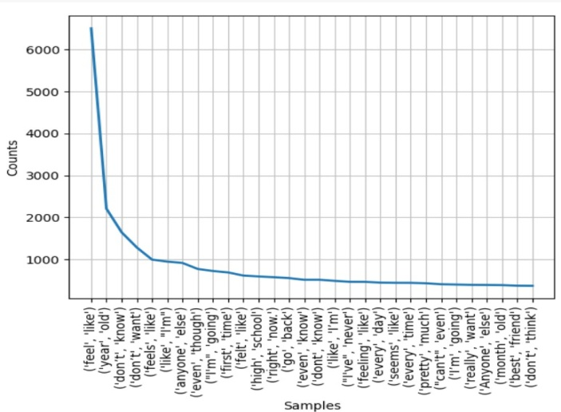

Figure7.Tri-gramanalysis

To classify the text an LSTM model is built for two different contexts one is for without explicit words and the other one is for overall data. The LSTM model is built using Keras sequential layers this study used common architecture for the cases before choosing the word embedding length we analyzed the word frequency distribution separately for explicit words and without explicit words.

The figure shows 8 word frequency distribution for data without explicit words. This analysis helps in choosing the word embedding dimensions and tokenization process.

1. Resultssummary

Two LSTM models are built and trained. The models are built using keras. The embedding layers areselectedas100fromthefrequencyanalysiswe

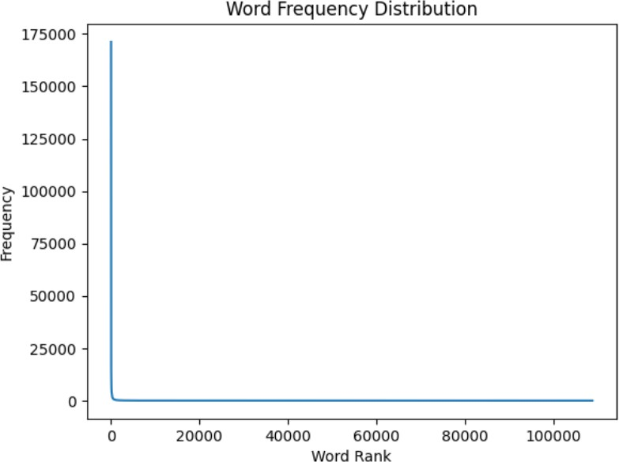 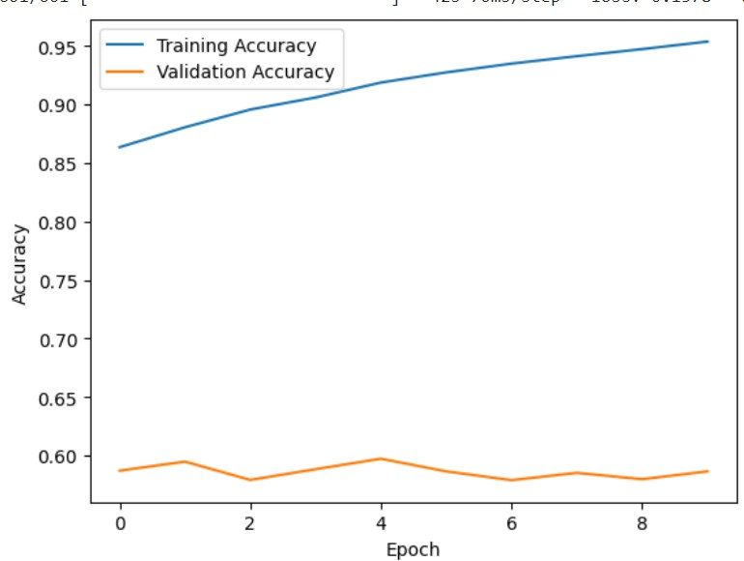

Figure8.Wordfrequencyanalysisforwithoutexplicitwordsdata

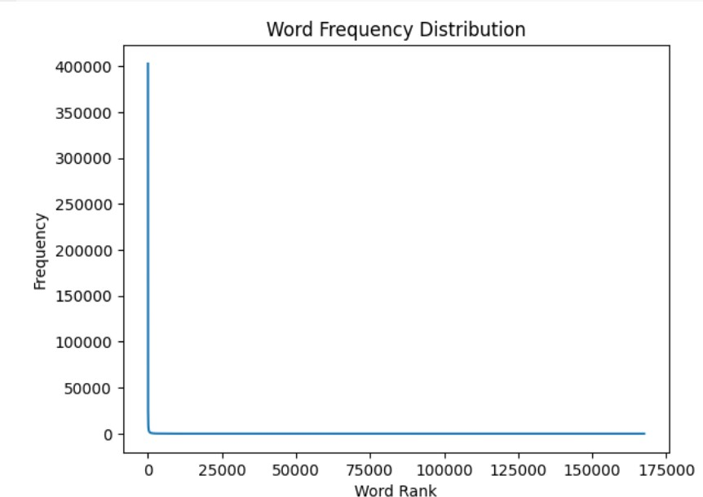

Figure9.Wordfrequencyanalysisforwithoutexplicitwordsdata

have selected the input dimension as 5000. The modelistrainedfor10epochs.Figure10represents theaccuracyofthewithoutexplicitwordsdata. At the end of 10 epochs, the model achieved 95 percent training accuracy and 58 percent validation accuracy.

Figure11representstheaccuracyofdatawithex- plicitwordsthismodelisalsotrainedfor10epochs. Attheendof10epochs,themodelachieved85

Figure10.Accuracyforeachepoch(Withoutexplicitwords)

percent training accuracy and 60 percent validation accuracy.

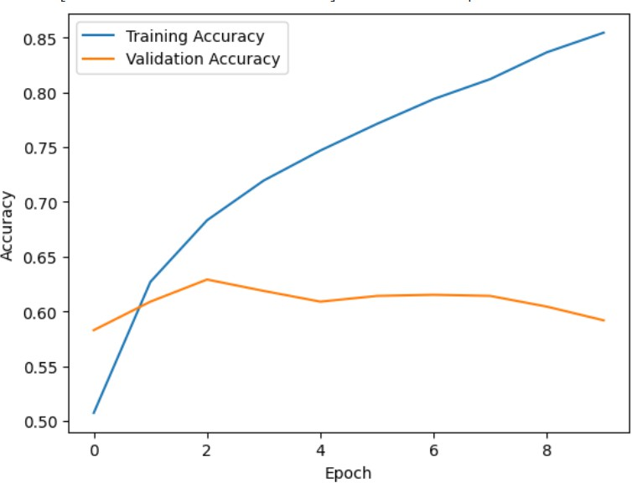

Figure11.Accuracyforeachepoch(Withexplicitwords)

For further analysis, we have plotted the confu- sion matrix for each case.

As per the figure 12 Upon detailed examination using the confusion matrix, it is evident that the model achieves remarkable accuracy in correctly classifyingpostsunderthe”Parenting”category,

which falls into the non-mental disorder category. However,challengesariseinaccuratelydistinguish- ing between posts related to depression, a mental disordercategory,andthosecategorizedunder”Sui- cide Watch.” Notably, the model tends to misclas- sifyposts,mistakenlycategorizingsomedepression posts as belonging to ”Suicide Watch” and vice versa. Additionally, there are instances where posts associatedwithanxietyareerroneouslyclassifiedas depression.

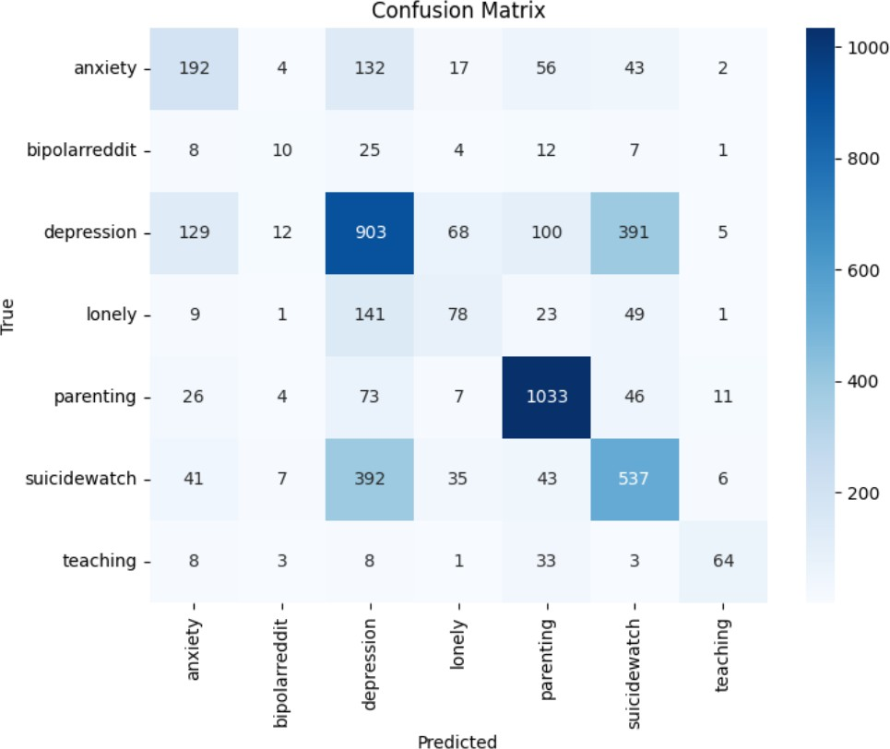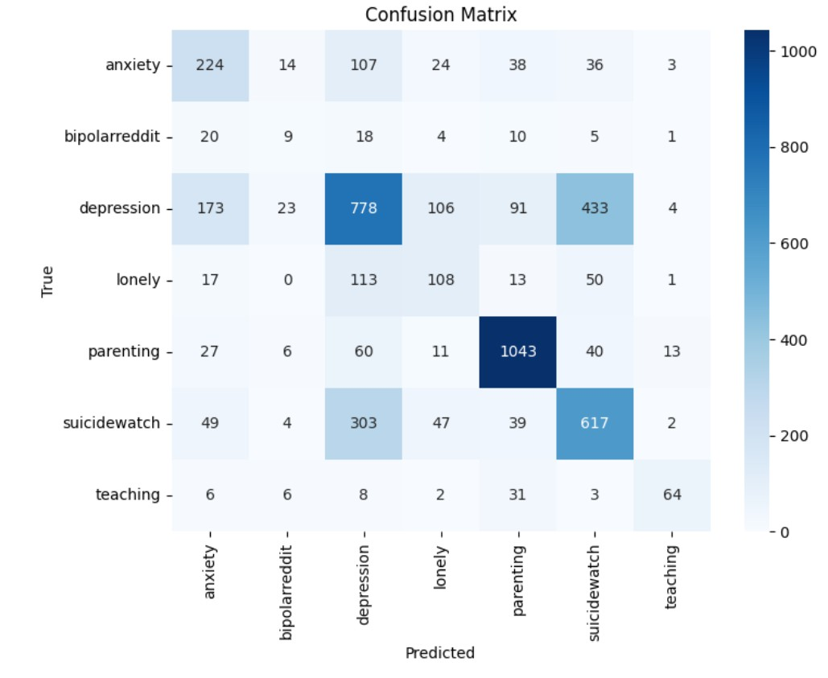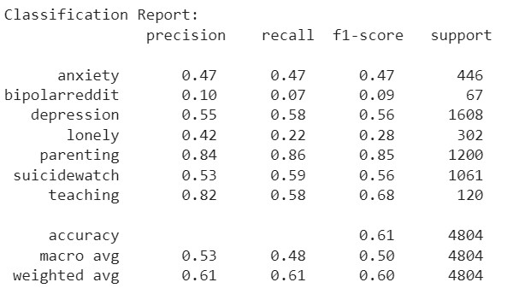

Insummary,theconfusionmatrixanalysisreveals the model’s strong performance in classifying non- mentaldisorderpostsrelatedtoparenting.However, challenges persist in accurately categorizing posts related to depression, suicide watch, and anxiety, leading to misclassifications in these mental health categories.

indistinguishingbetweenpostsrelatedtodepression and suicide watch, as well as occasionally misclas- sifying anxiety posts as depression.

Figure13.Confusionmatrixforoveralldata

Theclassificationreport14offiltereddatashows the same results as overall data. Highest scores of precision, recall, and F1 score for parenting non- mental health category and low scores for bipolar disease.

Figure12.Confusionmatrix(Withexplicitwords)

Asperthefigure13Themodeldemonstrateshigh accuracy in classifying posts related to ”Parenting,” achievingthemostaccuratepredictions.However,it tends to struggle with distinguishing between posts inthe”Depression”and”SuicideWatch”categories. Specifically, the model often misclassifies ”Suicide Watch”postsas”Depression”andviceversa.Addi- tionally, posts related to ”Anxiety” are occasionally misclassified as ”Depression.”

In summary, the model excels in accurately iden- tifyingpostsaboutparenting,butfaceschallenges

Figure14.Classificationreportforfiltereddata

Figure 15 highlights significant variations in the model’s performance across different categories. Notably:

Themodelexcelsinprecisionforthe”Parenting” category, indicating a high proportion of correctly identified parenting posts among those predicted as such. Conversely, the precision for the ”Bipolar” category is relatively lower, suggesting a higher likelihood of misclassifying posts as bipolar among those predicted.

The recall metric underscores the model’s strong ability to capture a large proportion of actual par- enting posts, as evidenced by the highest recall for this category. Conversely, the ”Bipolar” category exhibits the lowest recall, indicating that the model may miss a significant number of actual bipolar posts.

The F1 score, which balances precision and re- call, is highest for the ”Parenting” category, reflect- ing a robust overall performance in this class. On the contrary, the ”Bipolar” category demonstrates a lowerF1score,emphasizingchallengesinachieving abalancedtrade-offbetweenprecisionandrecallfor bipolar posts.

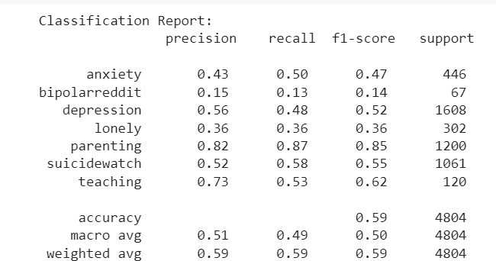

Figure15.Classificationreportforoveralldata

References

1. SayedAbuNomanSiddik,B.M.Arifuzzaman,andAbulKalam. Psycheconversa-adeeplearningbasedchatbotframework to detect mental health state.In *2022 10th International Conference on Information and Communication Technology (ICoICT)*, pages 146–151, 2022.
2. B.K. AlSaidi, S.K. AlMamari, and F. Hajamohideen. A survey on mental health based on nlp. In *6th Smart Cities Symposium (SCS 2022)*, volume 2022, pages 210–215, 2022.
3. Jack D. Armando, Garry A. Fiedacan, Patrick John D. Olmedo, Julius Caesar D. Sevilleno, Marcial P. Usaraga, Sarah C. Van- guardia,MaryGraceP.Bean˜o,BernieB.Domingo,MichaelM. Parondo, and Vanessa Ici M. Nieva. Impacts of covid-19 pan- demic on mental health condition of pnc engineering students: A basis for development of intervention program using dmadv. In *2021 IEEE 13th International Conference on Humanoid, Nanotechnology,InformationTechnology,Communicationand Control,Environment,andManagement(HNICEM)*,pages1–5, 2021.
4. Muhammad Zeeshan Arshad, Daehyun Lee, Dawoon Jung, Ankhzaya Jamsrandorj, Jinwook Kim, and Kyung-Ryoul Mun. Deep learning-based gait event prediction through a single waist-worn wearable sensor.In *2023 IEEE International ConferenceonConsumerElectronics(ICCE)*,pages1–6,2023.
5. Roja Boina, S Sangeethapriya, Hemant Singh Pokhariya, Ashish Sharma, ALN Rao, and Surendra Singh. Data mining- based classification methods for mental health prediction.In *20233rdInternationalConferenceonPervasiveComputingand Social Networking (ICPCSN)*, pages 738–743, 2023.
6. Vaishnavi Sunil Desai, Anika Tibrewala, Krithika Saravanan, Preethika K, Tanvi Mantri, and Isha Ghiria. iassist: An online wellness platform to elevate the physical and mental health of the elderly. In *2022 IEEE Conference on Interdisciplinary Ap- proachesinTechnologyandManagementforSocialInnovation (IATMSI)*, pages 1–5, 2022.
7. Naveen Paul E and Sujitha Juliet.Comparative analysis of machine learning techniques for mental health prediction.In *2023 8th International Conference on Communication and Electronics Systems (ICCES)*, pages 1–6, 2023.
8. KevinGagnon,TamiLCrawford,andJihadObeid.Comparison of convolutional neural network architectures and their influ- ence on patient classification tasks relating to altered mental status. In*2020IEEEInternationalConferenceonBioinformat- ics and Biomedicine (BIBM)*, pages 2752–2756, 2020.
9. K.A.A.B. Gunarathne and K.P.N. Jayasena. Monitoring mental health disorder symptoms and behavioral problems of under- graduates in sri lanka using smartphone sensors. In *2021 Inter- national Conference on Decision Aid Sciences and Application (DASA)*, pages 544–549, 2021.
10. VinumonJacobandM.Prakash. Areviewofbigdataanalytics on post-covid health issues.In *2022 IEEE 7th International Conference on Recent Advances and Innovations in Engineer- ing (ICRAIE)*, volume 7, pages 138–143, 2022.
11. Manivannan Karunakaran, Jeevanantham Balusamy, and Kr- ishnakumar Selvaraj.Machine learning models based mental health detection.In *2022 Third International Conference on Intelligent Computing Instrumentation and Control Technolo- gies (ICICICT)*, pages 835–842, 2022.
12. KyuBeomLeeandHyuSoungShin.Anapplicationofa deep learning algorithm for automatic detection of unexpected accidents under bad cctv monitoring conditions in tunnels.In *2019InternationalConferenceonDeepLearningandMachine*

*Learning in Emerging Applications (Deep-ML)*, pages 7–11, 2019.

1. Bing-Jhang Lin, Yi-Ting Lin, Chen-Chung Liu, Lue-En Lee, Chih-Yuan Chuang, An-Sheng Liu, Shu-Hui Hung, and Li- Chen Fu.Mental status detection for schizophrenia patientsvia deep visual perception.*IEEE Journal of Biomedical and Health Informatics*, 26(11):5704–5715, 2022.
2. XiyuLiu,MengjieLi,andYanliangZhang.Howcovid-

19 affects mental health of wuhan college students and it’s countermeasures.In *2020 International Conference on Public Health and Data Science (ICPHDS)*, pages 180–185, 2020.

1. DanielMLow,LaurieRumker,JohnTorous,GuillermoCecchi, SatrajitSGhosh,andTanyaTalkar.Naturallanguageprocessing revealsvulnerablementalhealthsupportgroupsandheightened health anxiety on reddit during covid-19: Observational study. *Journal of medical Internet research*, 22(10):e22635, 2020.
2. Arun Kumar Marandi and Harshal Shah. Treatment of mental healthdisordersadvancedbyartificialintelligence. In*20233rd International Conference on Advance Computing and Innova- tiveTechnologiesinEngineering(ICACITE)*,pages2569–2573, 2023.
3. Hari Krishna Marrapu, Balajee Maram, and Prasadu Reddi. New analytic framework of public mental health prediction using data science. In *2022 International Conference on Smart Technologies and Systems for Next Generation Computing (ICSTSN)*, pages 1–6, 2022.
4. KavyashreeNagarajaiah,MadhuHanakereKrishnappa,and K R Asha. Machine learning based detection of post traumatic stress disorder of mental health.In *2023 4th International Conference on Electronics and Sustainable Communication Systems (ICESC)*, pages 1456–1460, 2023.
5. RohizahAbdRahman,FatinHaziqahMohamadZaini, Mohd Shahrul Nizam Mohd Danuri, and Azzan Amin.The sentiment analysis on mental health awareness by non- governmental organisation’s twitter.In *2022 International Visualization, Informatics and Technology Conference (IVIT)*, pages 185–190, 2022.
6. B. Surekha Reddy, Kondaveti Jishitha, V Akshaya Bhavani,and P Aishwarya.Development of a depression detection system using speech and text data. In *2023 14th International Conference on Computing Communication and Networking Technologies (ICCCNT)*, pages 1–7, 2023.
7. Muhammad Arsyad Subu, Mohammad Yousef Alkhawaldeh, Fatma Refaat Ahmed, Nabeel Al-Yateem, Jacqueline Maria Dias,SyedAzizurRahman,MohannadEidAbuRuz,Ah- mad Rajeh Saifan, Amina Al Marzouqi, Heba Hesham Hijazi, Mohamad Qasim Alshabi, and Ahmed Hossain.Smartphone addiction and mental health wellbeing among indonesian ado- lescents. In *2023 IEEE 47th Annual Computers, Software, and ApplicationsConference(COMPSAC)*,pages1408–1411,2023.