1. Write a C++ program to create a pointer to an integer and display its value.

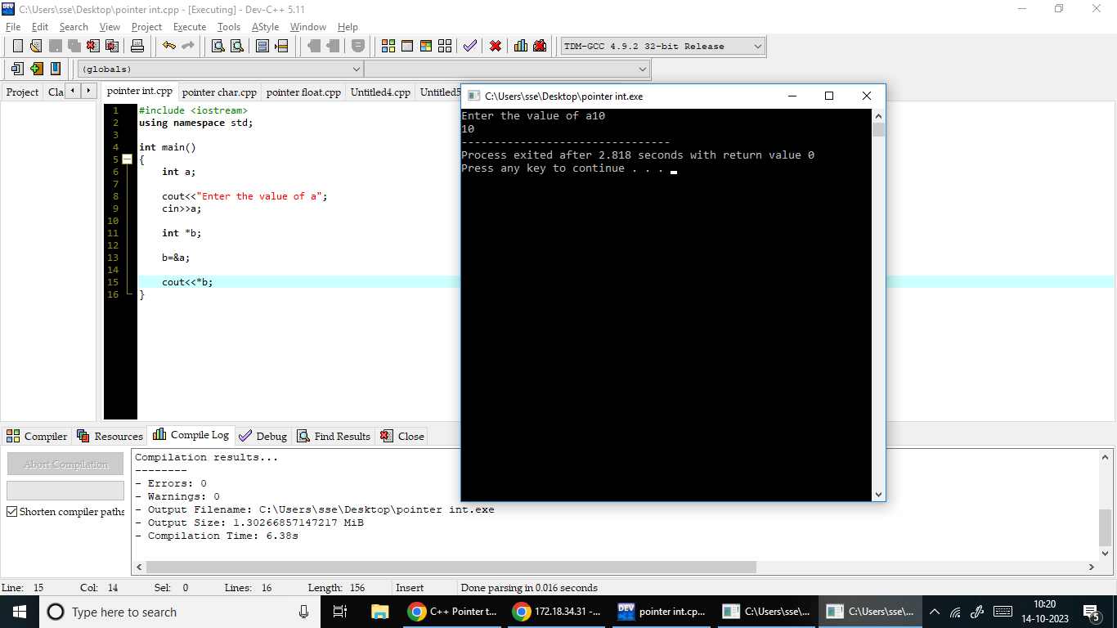

2 .Write a C++ program to create a pointer to an character and display its value.

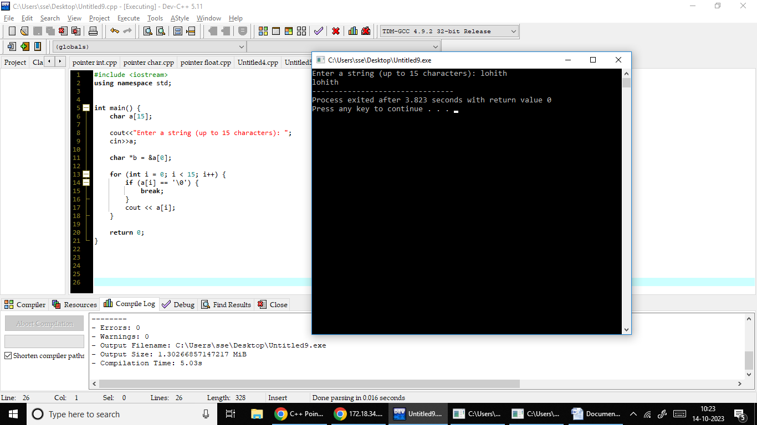

3.Write a C++ program to create a pointer to an float and display its value.

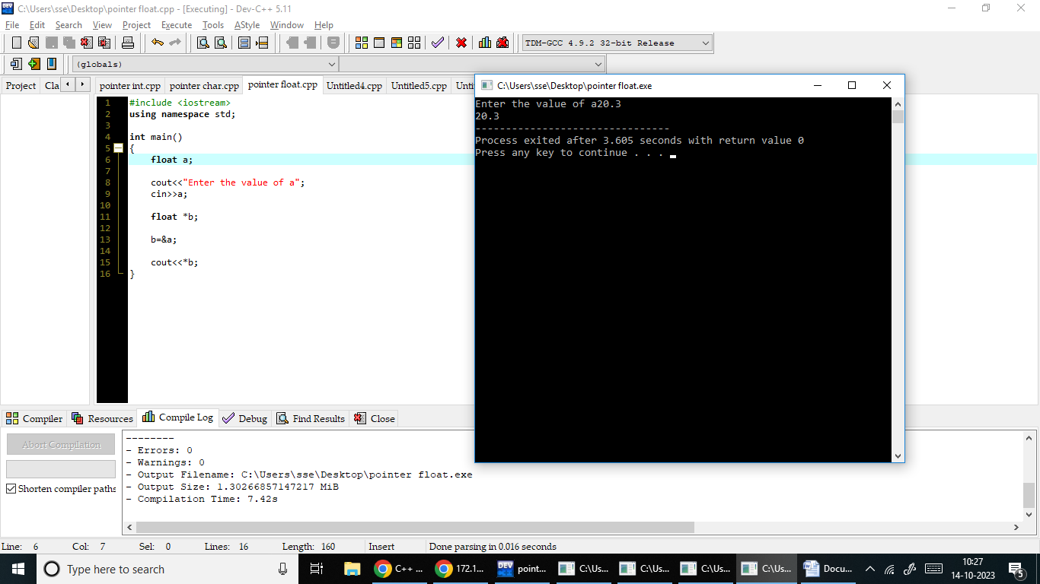

4. Write a C++ program to create a pointer to an object int and display its value.

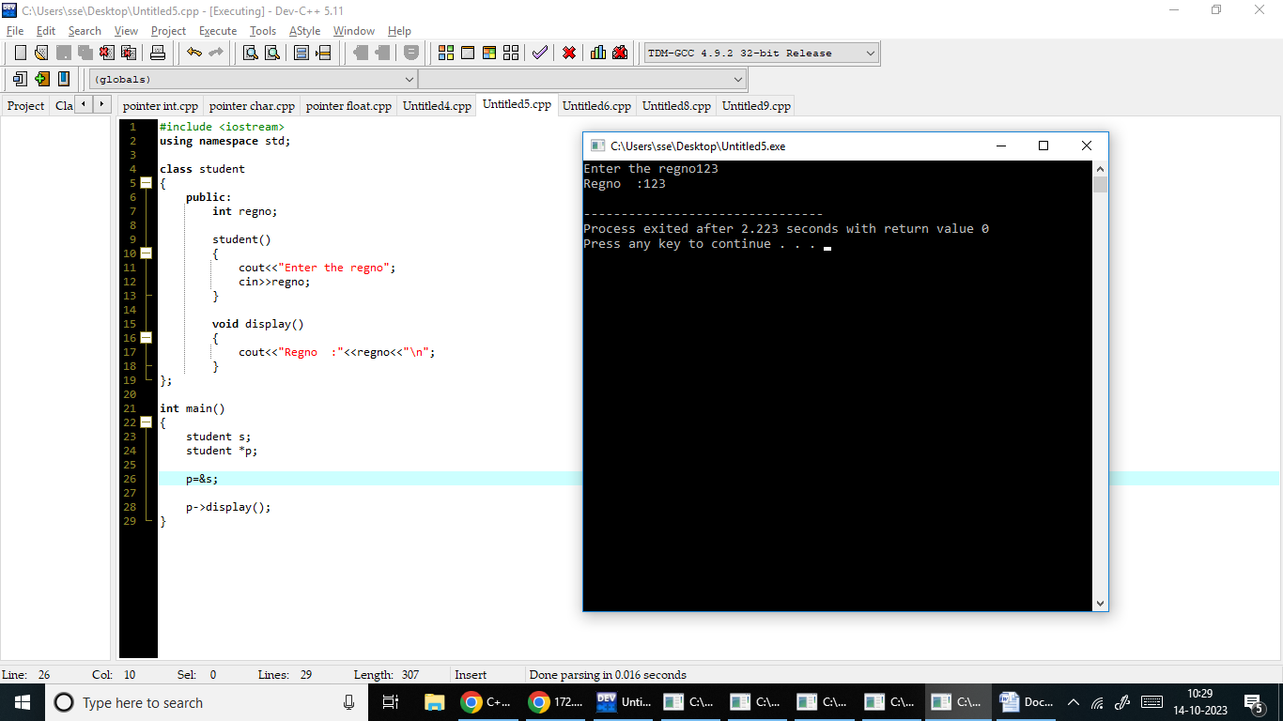

5. Write a C++ program to create a pointer to an object character and display its value.

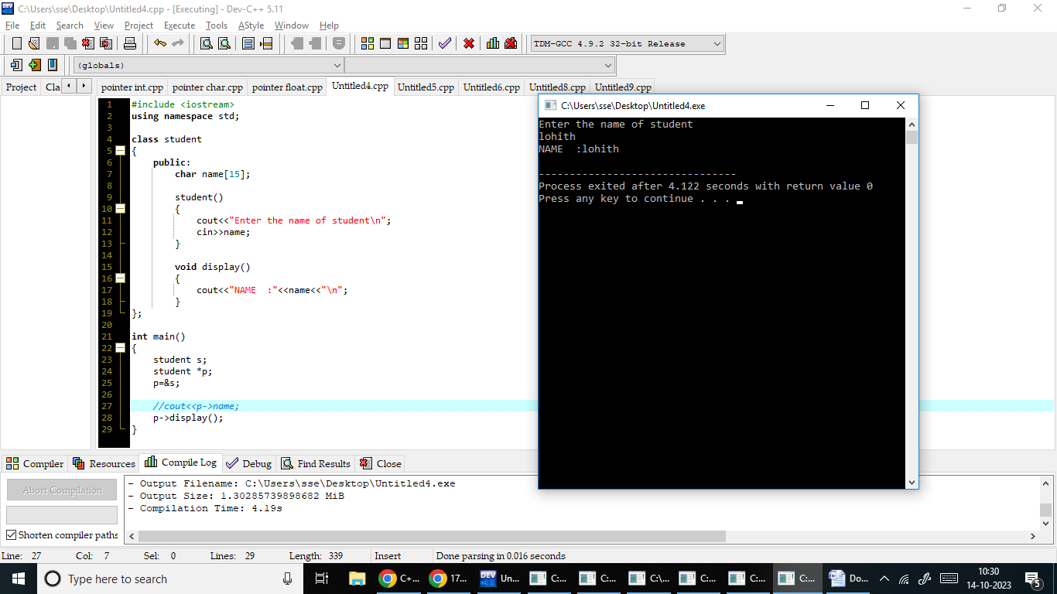

6. Write a C++ program to create a pointer to an object float and display its value.

