1)Why 120ohm ressister is placed to both the ends of can bus?

Ans: 120 Ω resistors was used for termination.

1.Terminator: it is a device added at the end point of the bus network. The purpose of terminator is to absorb signals, so that they do not reflect back down the line.

2.Electro magnetic interference : it is a disturbance to the external source/external components.

3.Signal reflection and

4. impedance.

Note:

Without the resister adding the n/w they is a chance to transmitter send dominant bit in n/w

But the receiver receive the resistive bit because of the Electro magnetic interference. this means noise in a n/w .

If there is no 120ohm resister then the real world error frames were generated.

2)difference between can and can FD ?

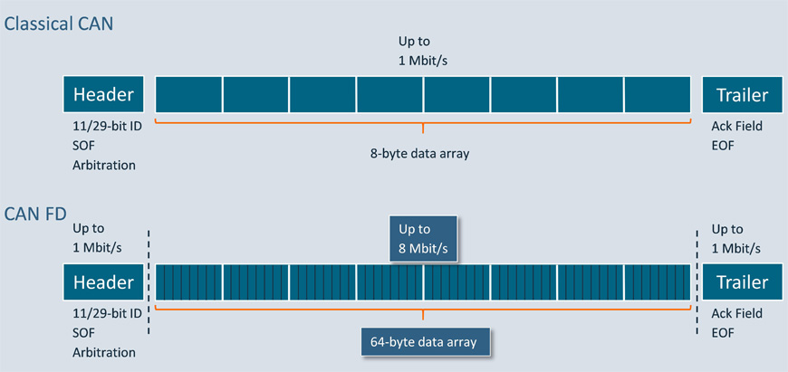

* CAN (Controller Area Network) is a message oriented multi-master protocol for quick serial data exchange between electronic control units in automotive engineering and factory automation.
* CAN FD (CAN with flexible data rate) is an enhancement of the CAN protocol developed by Bosch company. The main differences to CAN are the extended pay- load from 8 up to 64 bytes, and the ability to send the payload with higher data rates. In this way, the requirements for higher bandwidth networks in the automotive industry are fulfilled, while profiting from the experiences in CAN development.
* **CAN FD – Some protocol details**

In order to distinguish between Classical data frames and CAN FD data frames, one of the formerly reserved bits is used. This bit is called FDF (FD frame) bit. If it is of recessive value, the following bit sequence is interpreted as a CAN FD data frame. If it is of dominant value, it is a Classical data or remote frame. In the newly introduced BRS (bit rate switch) bit, the second bit-rate is applied, when it is of recessive (r) value. If it is of dominant (d) value, the arbitration phase bit-time setting is used in the data phase, too.

* 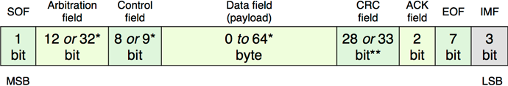Structure of CAN FD data frames: The fields are the same as in Classical CAN data frames, but some extensions have been introduced (* stuff-bits are not considered; ** with fixed stuff-bits)
* SOF = start-of-frame, CRC = cyclic redundancy check, ACK = acknowledgement, EOF = end-of-frame, IMF = intermission field
* The CAN FD protocol controller has to also support Classical CAN frames. Both CAN protocols (Classical as well as CAN FD) are internationally standardized in ISO 11898-1:2015. CAN FD data frames with 11-bit identifiers use the FBFF (FD base frame format) and those with 29-bit identifiers use the FEFF (FD extended frame format). The CAN FD protocol doesn’t support remotely requested data frames.
* 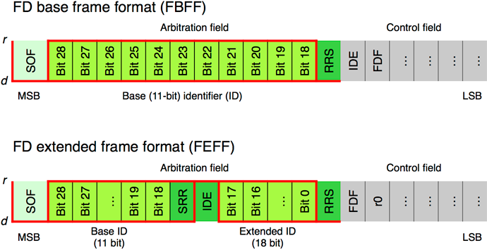Two CAN FD frame formats: The IDE bit is recessive in FEFF, the RRS bit is always dominant, and the value of the SRR bit doesn’t matter
* RRS = remote request substitution, SRR = substitute remote request, IDE = identifier extension, FDF = flexible data rate format, d = dominant, r = recessive, r0 = reserved
* The control field comprises additional bits not provided by the Classical CAN data frames. The FDF (FD format) bit indicates the usage of FD frame formats. At the sample-point of the BRS (bit-rate switch) bit, the bit-rate switch is performed. This guarantees a maximum of robustness. The following ESI (error state indicator) bit provides information about the error status: a dominant value indicates an error active state.
* 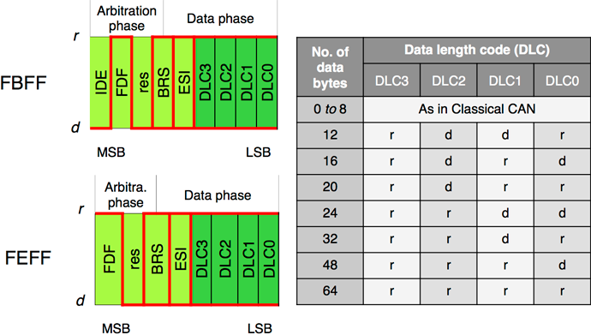Extended control field: The DLC (data length code) values not used by the Classical CAN protocol are shown as used by the CAN FD protocol
* IDE (identifier extension), FDF (flexible data rate format), BRS (bit rate switch; recessive, if alternate bit-rate), ESI (error state indicator; recessive, if error passive)
* During the standardization process of the CAN FD protocol, some additional safe guards were introduced in order to improve the communication reliability. This is why the CRC field comprises 17-bit (for frames with payloads up to 16 byte) or 21-bit (for frames larger than 16 byte) polynomials and an 8-bit stuff-bit counter plus a parity bit. The CRC field use fixed-stuff bits (FSB) with an opposite value of the previous bit. All these safe guards guarantee that all single failures are detected under all conditions. Even the possibility to detect multiple failures has been improved.  
  Medium-term, non-ISO CAN FD controllers might also be on the market – these are not compliant to the ISO 11898-1 standard. They don’t implement the above-mentioned additional safe guard features.
* 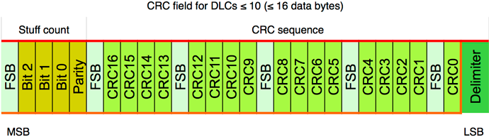Stuff-bit counter: The 3-bit stuff-bit counter is grey-coded and it is protected by a parity bit as well as by the following fixed stuff-bit (FSB)