1.Like RS-232 the RS-485 is faster serial communication. RS-232 is single device to device communication. RS-485 is connection of 32 connectable device.

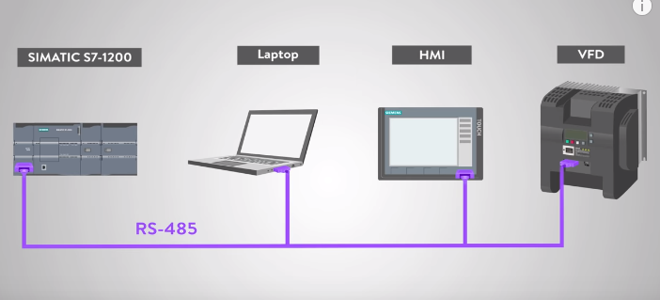

2.The data communication of the RS-485 is fastest communication bus and it be increase the speed instantly. It supports up to 20 mbps speed.

3.RS-232 is supports up to 50 feats. Rs-485 is support 4000 feats.

4.the other advantage of RS-485 is we connect large application with single bus.

5.less noise issues. Because electric noise cause problem ins more electronics. The RS-485 is shielding of the cable to reduce noise.

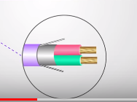

6.the very important feature of this cable is vfd(variable frequency drive) or motor Drives.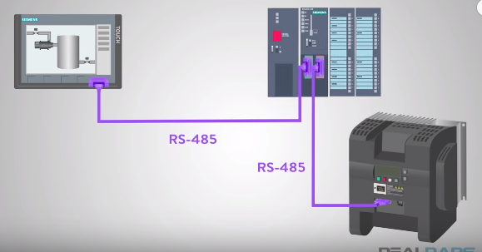

HDMI(Display)

VFD

PLC(monitoring water level

These all are allows to control motors in industrial network