Multithreading in C
What is a Thread?
A thread is a single sequence stream within in a process. Because threads have some of the properties of processes, they are sometimes called lightweight processes.
What are the differences between process and thread?
Threads are not independent of one other like processes as a result threads shares with other threads their code section, data section and OS resources like open files and signals. But, like process, a thread has its own program counter (PC), a register set, and a stack space.
Why Multithreading?
Threads are popular way to improve application through parallelism. For example, in a browser, multiple tabs can be different threads. MS word uses multiple threads, one thread to format the text, other thread to process inputs, etc.
Threads operate faster than processes due to following reasons:
1) Thread creation is much faster.
2) Context switching between threads is much faster.
3) Threads can be terminated easily
4) Communication between threads is faster.

See http://www.personal.kent.edu/~rmuhamma/OpSystems/Myos/threads.htm for more details.
Can we write multithreading programs in C?
Unlike Java, multithreading is not supported by the language standard. POSIX Threads (or Pthreads) is a POSIX standard for threads. Implementation of pthread is available with gcc compiler.
A simple C program to demonstrate use of pthread basic functions
Please note that the below program may compile only with C compilers with pthread library.
filter_none
brightness_4
#include <stdio.h>
#include <stdlib.h>
#include <unistd.h> //Header file for sleep(). man 3 sleep for details.
#include <pthread.h>

// A normal C function that is executed as a thread
// when its name is specified in pthread_create()
void *myThreadFun(void *vargp)
{
sleep(1);
printf("Printing GeeksQuiz from Thread \n");
return NULL;
}

int main()
{
pthread_t thread_id;
printf("Before Thread\n");
pthread_create(&thread_id, NULL, myThreadFun, NULL);
pthread_join(thread_id, NULL);
printf("After Thread\n");
exit(0);
}
In main() we declare a variable called thread_id, which is of type pthread_t, which is an integer used to identify the thread in the system. After declaring thread_id, we call pthread_create() function to create a thread.
pthread_create() takes 4 arguments.
The first argument is a pointer to thread_id which is set by this function.
The second argument specifies attributes. If the value is NULL, then default attributes shall be used.
The third argument is name of function to be executed for the thread to be created.
The fourth argument is used to pass arguments to the function, myThreadFun.
The pthread_join() function for threads is the equivalent of wait() for processes. A call to pthread_join blocks the calling thread until the thread with identifier equal to the first argument terminates.
How to compile above program?
To compile a multithreaded program using gcc, we need to link it with the pthreads library. Following is the command used to compile the program.
gfg@ubuntu:~/$ gcc multithread.c -lpthread
gfg@ubuntu:~/$ ./a.out
Before Thread
Printing GeeksQuiz from Thread
After Thread
gfg@ubuntu:~/$
A C program to show multiple threads with global and static variables
As mentioned above, all threads share data segment. Global and static variables are stored in data segment. Therefore, they are shared by all threads. The following example program demonstrates the same.
filter_none
brightness_4
#include <stdio.h>
#include <stdlib.h>
#include <unistd.h>
#include <pthread.h>

// Let us create a global variable to change it in threads
int g = 0;

// The function to be executed by all threads
void *myThreadFun(void *vargp)
{
// Store the value argument passed to this thread
int *myid = (int *)vargp;

// Let us create a static variable to observe its changes
static int s = 0;

// Change static and global variables
++s; ++g;

// Print the argument, static and global variables
printf("Thread ID: %d, Static: %d, Global: %d\n", *myid, ++s, ++g);
}

int main()
{
int i;
pthread_t tid;

// Let us create three threads
for (i = 0; i < 3; i++)
pthread_create(&tid, NULL, myThreadFun, (void *)&tid);

pthread_exit(NULL);
return 0;
}
gfg@ubuntu:~/$ gcc multithread.c -lpthread
gfg@ubuntu:~/$ ./a.out
Thread ID: 3, Static: 2, Global: 2
Thread ID: 3, Static: 4, Global: 4
Thread ID: 3, Static: 6, Global: 6
gfg@ubuntu:~/$
Please note that above is simple example to show how threads work. Accessing a global variable in a thread is generally a bad idea. What if thread 2 has priority over thread 1 and thread 1 needs to change the variable. In practice, if it is required to access global variable by multiple threads, then they should be accessed using a mutex.

Mutex vs Semaphore
What are the differences between Mutex vs Semaphore? When to use mutex and when to use semaphore?
Concrete understanding of Operating System concepts is required to design/develop smart applications. Our objective is to educate the reader on these concepts and learn from other expert geeks.
As per operating system terminology, mutex and semaphore are kernel resources that provide synchronization services (also called as synchronization primitives). Why do we need such synchronization primitives? Won’t be only one sufficient? To answer these questions, we need to understand few keywords. Please read the posts on atomicity and critical section. We will illustrate with examples to understand these concepts well, rather than following usual OS textual description.
The producer-consumer problem:
Note that the content is generalized explanation. Practical details vary with implementation.

Consider the standard producer-consumer problem. Assume, we have a buffer of 4096 byte length. A producer thread collects the data and writes it to the buffer. A consumer thread processes the collected data from the buffer. Objective is, both the threads should not run at the same time.
Using Mutex:
A mutex provides mutual exclusion, either producer or consumer can have the key (mutex) and proceed with their work. As long as the buffer is filled by producer, the consumer needs to wait, and vice versa.
At any point of time, only one thread can work with the entire buffer. The concept can be generalized using semaphore.
Using Semaphore:
A semaphore is a generalized mutex. In lieu of single buffer, we can split the 4 KB buffer into four 1 KB buffers (identical resources). A semaphore can be associated with these four buffers. The consumer and producer can work on different buffers at the same time.
Misconception:
There is an ambiguity between binary semaphore and mutex. We might have come across that a mutex is binary semaphore. But they are not! The purpose of mutex and semaphore are different. May be, due to similarity in their implementation a mutex would be referred as binary semaphore.
Strictly speaking, a mutex is locking mechanism used to synchronize access to a resource. Only one task (can be a thread or process based on OS abstraction) can acquire the mutex. It means there is ownership associated with mutex, and only the owner can release the lock (mutex).
Semaphore is signaling mechanism (“I am done, you can carry on” kind of signal). For example, if you are listening songs (assume it as one task) on your mobile and at the same time your friend calls you, an interrupt is triggered upon which an interrupt service routine (ISR) signals the call processing task to wakeup.

General Questions:
1. Can a thread acquire more than one lock (Mutex)?
Yes, it is possible that a thread is in need of more than one resource, hence the locks. If any lock is not available the thread will wait (block) on the lock.

2. Can a mutex be locked more than once?
A mutex is a lock. Only one state (locked/unlocked) is associated with it. However, a recursive mutex can be locked more than once (POSIX complaint systems), in which a count is associated with it, yet retains only one state (locked/unlocked). The programmer must unlock the mutex as many number times as it was locked.
3. What happens if a non-recursive mutex is locked more than once.
Deadlock. If a thread which had already locked a mutex, tries to lock the mutex again, it will enter into the waiting list of that mutex, which results in deadlock. It is because no other thread can unlock the mutex. An operating system implementer can exercise care in identifying the owner of mutex and return if it is already locked by same thread to prevent deadlocks.
4. Are binary semaphore and mutex same?
No. We suggest to treat them separately, as it is explained signalling vs locking mechanisms. But a binary semaphore may experience the same critical issues (e.g. priority inversion) associated with mutex. We will cover these in later article.
A programmer can prefer mutex rather than creating a semaphore with count 1.

5. What is a mutex and critical section?
Some operating systems use the same word critical section in the API. Usually a mutex is costly operation due to protection protocols associated with it. At last, the objective of mutex is atomic access. There are other ways to achieve atomic access like disabling interrupts which can be much faster but ruins responsiveness. The alternate API makes use of disabling interrupts.
6. What are events?
The semantics of mutex, semaphore, event, critical section, etc… are same. All are synchronization primitives. Based on their cost in using them they are different. We should consult the OS documentation for exact details.
7. Can we acquire mutex/semaphore in an Interrupt Service Routine?
An ISR will run asynchronously in the context of current running thread. It is not recommended to query (blocking call) the availability of synchronization primitives in an ISR. The ISR are meant be short, the call to mutex/semaphore may block the current running thread. However, an ISR can signal a semaphore or unlock a mutex.
8. What we mean by “thread blocking on mutex/semaphore” when they are not available?
Every synchronization primitive has a waiting list associated with it. When the resource is not available, the requesting thread will be moved from the running list of processor to the waiting list of the synchronization primitive. When the resource is available, the higher priority thread on the waiting list gets the resource (more precisely, it depends on the scheduling policies).
9. Is it necessary that a thread must block always when resource is not available?
Not necessary. If the design is sure ‘what has to be done when resource is not available‘, the thread can take up that work (a different code branch). To support application requirements the OS provides non-blocking API.

For example POSIX pthread_mutex_trylock() API. When mutex is not available the function returns immediately whereas the API pthread_mutex_lock() blocks the thread till resource is available.

Mutex lock for Linux Thread Synchronization
Prerequisite : Multithreading in C
Thread synchronization is defined as a mechanism which ensures that two or more concurrent processes or threads do not simultaneously execute some particular program segment known as critical section. Processes’ access to critical section is controlled by using synchronization techniques. When one thread starts executing the critical section (serialized segment of the program) the other thread should wait until the first thread finishes. If proper synchronization techniques are not applied, it may cause a race condition where the values of variables may be unpredictable and vary depending on the timings of context switches of the processes or threads.
Thread Synchronization Problems
An example code to study synchronization problems :
filter_none
edit
play_arrow
brightness_4
#include<stdio.h>
#include<string.h>
#include<pthread.h>
#include<stdlib.h>
#include<unistd.h>

pthread_t tid[2];
int counter;

void* trythis(void *arg)
{
unsigned long i = 0;
counter += 1;
printf("\n Job %d has started\n", counter);

for(i=0; i<(0xFFFFFFFF);i++);
printf("\n Job %d has finished\n", counter);

return NULL;
}

int main(void)
{
int i = 0;
int error;

while(i < 2)
{
error = pthread_create(&(tid[i]), NULL, &trythis, NULL);
if (error != 0)
printf("\nThread can't be created : [%s]", strerror(error));
i++;
}

pthread_join(tid[0], NULL);
pthread_join(tid[1], NULL);

return 0;
}
How to compile above program?
To compile a multithreaded program using gcc, we need to link it with the pthreads library. Following is the command used to compile the program.
gfg@ubuntu:~/$ gcc filename.c -lpthread
In this example two threads(jobs) are created and in the start function of these threads, a counter is maintained to get the logs about job number which is started and when it is completed.

Output :
Job 1 has started
Job 2 has started
Job 2 has finished
Job 2 has finished
Problem : From the last two logs, one can see that the log ‘Job 2 has finished’ is repeated twice while no log for ‘Job 1 has finished’ is seen.
Why it has occurred ?
On observing closely and visualizing the execution of the code, we can see find that :
- The log ‘Job 2 has started’ is printed just after ‘Job 1 has Started’ so it can easily be concluded that while thread 1 was processing the scheduler scheduled the thread 2.
- If we take the above assumption true then the value of the ‘counter’ variable got incremented again before job 1 got finished.
- So, when Job 1 actually got finished, then the wrong value of counter produced the log ‘Job 2 has finished’ followed by the ‘Job 2 has finished’ for the actual job 2 or vice versa as it is dependent on scheduler.
- So we see that its not the repetitive log but the wrong value of the ‘counter’ variable that is the problem.
- The actual problem was the usage of the variable ‘counter’ by second thread when the first thread was using or about to use it.
- In other words we can say that lack of synchronization between the threads while using the shared resource ‘counter’ caused the problems or in one word we can say that this problem happened due to ‘Synchronization problem’ between two threads.
How to solve it ?
The most popular way of achieving thread synchronization is by using Mutexes.
  - A Mutex is a lock that we set before using a shared resource and release after using it.
  - When the lock is set, no other thread can access the locked region of code.
  - So we see that even if thread 2 is scheduled while thread 1 was not done accessing the shared resource and the code is locked by thread 1 using mutexes then thread 2 cannot even access that region of code.
  - So this ensures a synchronized access of shared resources in the code.
Working of a mutex
  - Suppose one thread has locked a region of code using mutex and is executing that piece of code.
  - Now if scheduler decides to do a context switch, then all the other threads which are ready to execute the same region are unblocked.
  - Only one of all the threads would make it to the execution but if this thread tries to execute the same region of code that is already locked then it will again go to sleep.
  - Context switch will take place again and again but no thread would be able to execute the locked region of code until the mutex lock over it is released.
  - Mutex lock will only be released by the thread who locked it.
  - So this ensures that once a thread has locked a piece of code then no other thread can execute the same region until it is unlocked by the thread who locked it.
Hence, this system ensures synchronization among the threads while working on shared resources.
A mutex is initialized and then a lock is achieved by calling the following two functions : The first function initializes a mutex and through second function any critical region in the code can be locked.
    - int pthread_mutex_init(pthread_mutex_t *restrict mutex, const pthread_mutexattr_t *restrict attr) : Creates a mutex, referenced by mutex, with attributes specified by attr. If attr is NULL, the default mutex attribute (NONRECURSIVE) is used.
Returned value
If successful, pthread_mutex_init() returns 0, and the state of the mutex becomes initialized and unlocked.
If unsuccessful, pthread_mutex_init() returns -1.
    - int pthread_mutex_lock(pthread_mutex_t *mutex) : Locks a mutex object, which identifies a mutex. If the mutex is already locked by another thread, the thread waits for the mutex to become available. The thread that has locked a mutex becomes its current owner and remains the owner until the same thread has unlocked it.When the mutex has the attribute of recursive, the use of the lock may be different. When this kind of mutex is locked multiple times by the same thread, then a count is incremented and no waiting thread is posted. The owning thread must call pthread_mutex_unlock() the same number of times to decrement the count to zero.
Returned value
If successful, pthread_mutex_lock() returns 0.
If unsuccessful, pthread_mutex_lock() returns -1.
The mutex can be unlocked and destroyed by calling following two functions :The first function releases the lock and the second function destroys the lock so that it cannot be used anywhere in future.
    - int pthread_mutex_unlock(pthread_mutex_t *mutex) : Releases a mutex object. If one or more threads are waiting to lock the mutex, pthread_mutex_unlock() causes one of those threads to return from pthread_mutex_lock() with the mutex object acquired. If no threads are waiting for the mutex, the mutex unlocks with no current owner.When the mutex has the attribute of recursive the use of the lock may be different. When this kind of mutex is locked multiple times by the same thread, then unlock will decrement the count and no waiting thread is posted to continue running with the lock. If the count is decremented to zero, then the mutex is released and if any thread is waiting it is posted.
Returned value
If successful, pthread_mutex_unlock() returns 0.
If unsuccessful, pthread_mutex_unlock() returns -1
    - int pthread_mutex_destroy(pthread_mutex_t *mutex) : Deletes a mutex object, which identifies a mutex. Mutexes are used to protect shared resources. mutex is set to an invalid value, but can be reinitialized using pthread_mutex_init().
Returned value
If successful, pthread_mutex_destroy() returns 0.
If unsuccessful, pthread_mutex_destroy() returns -1.
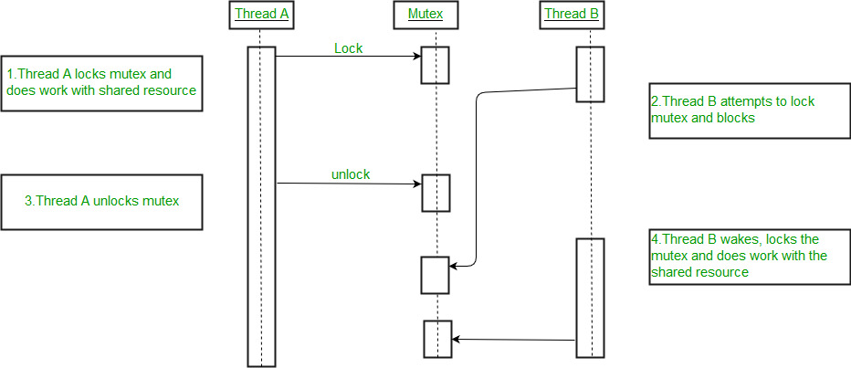
An example to show how mutexes are used for thread synchronization

filter_none
edit
play_arrow
brightness_4
#include<stdio.h>
#include<string.h>
#include<pthread.h>
#include<stdlib.h>
#include<unistd.h>

pthread_t tid[2];
int counter;
pthread_mutex_t lock;

void* trythis(void *arg)
{
pthread_mutex_lock(&lock);

unsigned long i = 0;
counter += 1;
printf("\n Job %d has started\n", counter);

for(i=0; i<(0xFFFFFFFF);i++);

printf("\n Job %d has finished\n", counter);

pthread_mutex_unlock(&lock);

return NULL;
}

int main(void)
{
int i = 0;
int error;

if (pthread_mutex_init(&lock, NULL) != 0)
{
printf("\n mutex init has failed\n");
return 1;
}

while(i < 2)
{
err = pthread_create(&(tid[i]), NULL, &trythis, NULL);
if (error != 0)
printf("\nThread can't be created :[%s]", strerror(error));
i++;
}

pthread_join(tid[0], NULL);
pthread_join(tid[1], NULL);
pthread_mutex_destroy(&lock);

return 0;
}
In the above code :
  - A mutex is initialized in the beginning of the main function.
  - The same mutex is locked in the ‘trythis()’ function while using the shared resource ‘counter’.
  - At the end of the function ‘trythis()’ the same mutex is unlocked.
  - At the end of the main function when both the threads are done, the mutex is destroyed.
Output :
Job 1 started
Job 1 finished
Job 2 started
Job 2 finished
So this time the start and finish logs of both the jobs are present. So thread synchronization took place by the use of Mutex.

How to use POSIX semaphores in C language
Semaphores are very useful in process synchronization and multithreading. But how to use one in real life, for example say in C Language?
Well, we have the POSIX semaphore library in Linux systems. Let’s learn how to use it.
The basic code of a semaphore is simple as presented here. But this code cannot be written directly, as the functions require to be atomic and writing code directly would lead to a context switch without function completion and would result in a mess.
The POSIX system in Linux presents its own built-in semaphore library. To use it, we have to :
- Include semaphore.h
- Compile the code by linking with -lpthread -lrt
To lock a semaphore or wait we can use the sem_wait function:

int sem_wait(sem_t *sem);
To release or signal a semaphore, we use the sem_post function:
int sem_post(sem_t *sem);
A semaphore is initialised by using sem_init(for processes or threads) or sem_open (for IPC).
sem_init(sem_t *sem, int pshared, unsigned int value);
Where,
  - sem : Specifies the semaphore to be initialized.
  - pshared : This argument specifies whether or not the newly initialized semaphore is shared between processes or between threads. A non-zero value means the semaphore is shared between processes and a value of zero means it is shared between threads.
  - value : Specifies the value to assign to the newly initialized semaphore.
To destroy a semaphore, we can use sem_destroy.
sem_destoy(sem_t *mutex);
To declare a semaphore, the data type is sem_t.
Code –
filter_none
edit
play_arrow
brightness_4
// C program to demonstrate working of Semaphores
#include <stdio.h>
#include <pthread.h>
#include <semaphore.h>
#include <unistd.h>

sem_t mutex;

void* thread(void* arg)
{
//wait
sem_wait(&mutex);
printf("\nEntered..\n");

//critical section
sleep(4);

//signal
printf("\nJust Exiting...\n");
sem_post(&mutex);
}

int main()
{
sem_init(&mutex, 0, 1);
pthread_t t1,t2;
pthread_create(&t1,NULL,thread,NULL);
sleep(2);
pthread_create(&t2,NULL,thread,NULL);
pthread_join(t1,NULL);
pthread_join(t2,NULL);
sem_destroy(&mutex);
return 0;
}
Compilation should be done with gcc a.c -lpthread -lrt
Explanation –
2 threads are being created, one 2 seconds after the first one.
But the first thread will sleep for 4 seconds after acquiring the lock.
Thus the second thread will not enter immediately after it is called, it will enter 4 – 2 = 2 secs after it is called.
So the output is:
Entered..

Just Exiting...

Entered..

Just Exiting...

but not:
Entered..

Entered..

Just Exiting...

Just Exiting...

Inter Process Communication
A process can be of two type:
- Independent process.
- Co-operating process.
An independent process is not affected by the execution of other processes while a co-operating process can be affected by other executing processes. Though one can think that those processes, which are running independently, will execute very efficiently but in practical, there are many situations when co-operative nature can be utilised for increasing computational speed, convenience and modularity. Inter process communication (IPC) is a mechanism which allows processes to communicate each other and synchronize their actions. The communication between these processes can be seen as a method of co-operation between them. Processes can communicate with each other using these two ways:
- Shared Memory
- Message passing
The Figure 1 below shows a basic structure of communication between processes via shared memory method and via message passing.

An operating system can implement both method of communication. First, we will discuss the shared memory method of communication and then message passing. Communication between processes using shared memory requires processes to share some variable and it completely depends on how programmer will implement it. One way of communication using shared memory can be imagined like this: Suppose process1 and process2 are executing simultaneously and they share some resources or use some information from other process, process1 generate information about certain computations or resources being used and keeps it as a record in shared memory. When process2 need to use the shared information, it will check in the record stored in shared memory and take note of the information generated by process1 and act accordingly. Processes can use shared memory for extracting information as a record from other process as well as for delivering any specific information to other process.
Let’s discuss an example of communication between processes using shared memory method.
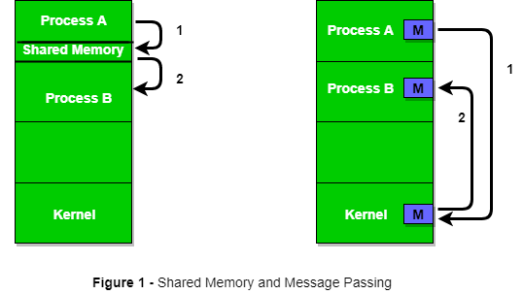
i) Shared Memory Method
Ex: Producer-Consumer problem
There are two processes: Producer and Consumer. Producer produces some item and Consumer consumes that item. The two processes shares a common space or memory location known as buffer where the item produced by Producer is stored and from where the Consumer consumes the item if needed. There are two version of this problem: first one is known as unbounded buffer problem in which Producer can keep on producing items and there is no limit on size of buffer, the second one is known as bounded buffer problem in which producer can produce up to a certain amount of item and after that it starts waiting for consumer to consume it. We will discuss the bounded buffer problem. First, the Producer and the Consumer will share some common memory, then producer will start producing items. If the total produced item is equal to the size of buffer, producer will wait to get it consumed by the Consumer. Sim-
ilarly, the consumer first check for the availability of the item and if no item is available, Consumer will wait for producer to produce it. If there are items available, consumer will consume it. The pseudo code are given below:
Shared Data between the two Processes
filter_none
edit
play_arrow
brightness_4
#define buff_max 25
#define mod %

struct item{

// diffrent member of the produced data
// or consumed data
---------
}

// An array is needed for holding the items.
// This is the shared place which will be
// access by both process
// item shared_buff [ buff_max ];

// Two variables which will keep track of
// the indexes of the items produced by producer
// and consumer The free index points to
// the next free index. The full index points to
// the first full index.
int free_index = 0;
int full_index = 0;

Producer Process Code
filter_none
edit
play_arrow
brightness_4
item nextProduced;

while(1){

// check if there is no space
// for production.
// if so keep waiting.
while((free_index+1) mod buff_max == full_index);

shared_buff[free_index] = nextProduced;
free_index = (free_index + 1) mod buff_max;
}
Consumer Process Code
filter_none
edit
play_arrow
brightness_4
item nextConsumed;

while(1){

// check if there is an available
// item for consumption.
// if not keep on waiting for
// get them produced.
while((free_index == full_index);

nextConsumed = shared_buff[full_index];
full_index = (full_index + 1) mod buff_max;
}
In the above code, The producer will start producing again when the (free_index+1) mod buff max will be free because if it it not free, this implies that there are still items that can be consumed by the Consumer so there is no need to produce more. Similarly, if free index and full index points to the same index, this implies that there are no item to consume.
ii) Messaging Passing Method
Now, We will start our discussion for the communication between processes via message passing. In this method, processes communicate with each other without using any kind of of shared memory. If two processes p1 and p2 want to communicate with each other, they proceed as follow:
- Establish a communication link (if a link already exists, no need to establish it again.)
- Start exchanging messages using basic primitives.
We need at least two primitives:
– send(message, destinaion) or send(message)
– receive(message, host) or receive(message)
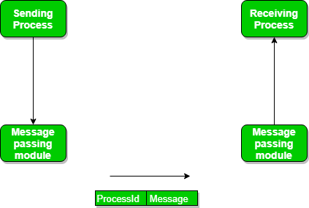
The message size can be of fixed size or of variable size. if it is of fixed size, it is easy for OS designer but complicated for programmer and if it is of variable size then it is easy for programmer but complicated for the OS designer. A standard message can have two parts: header and body.
The header part is used for storing Message type, destination id, source id, message length and control information. The control information contains information like what to do if runs out of buffer space, sequence number, priority. Generally, message is sent using FIFO style.

Message Passing through Communication Link.
Direct and Indirect Communication link
Now, We will start our discussion about the methods of implementing communication link. While implementing the link, there are some questions which need to be kept in mind like :
- How are links established?
- Can a link be associated with more than two processes?
- How many links can there be between every pair of communicating processes?
- What is the capacity of a link? Is the size of a message that the link can accommodate fixed or variable?
- Is a link unidirectional or bi-directional?
A link has some capacity that determines the number of messages that can reside in it temporarily for which Every link has a queue associated with it which can be either of zero capacity or of bounded capacity or of unbounded capacity. In zero capacity, sender wait until receiver inform sender that it has received the message. In non-zero capacity cases, a process does not know whether a message has been received or not after the send operation. For this, the sender must communicate to receiver explicitly. Implementation of the link depends on the situation, it can be either a Direct communication link or an In-directed communication link.
Direct Communication links are implemented when the processes use specific process identifier for the communication but it is hard to identify the sender ahead of time.
For example: the print server.
In-directed Communication is done via a shred mailbox (port), which consists of queue of messages. Sender keeps the message in mailbox and receiver picks them up.

Message Passing through Exchanging the Messages.
Synchronous and Asynchronous Message Passing:
A process that is blocked is one that is waiting for some event, such as a resource becoming available or the completion of an I/O operation. IPC is possible between the processes on same computer as well as on the processes running on different computer i.e. in networked/distributed system. In both cases, the process may or may not be blocked while sending a message or attempting to receive a message so Message passing may be blocking or non-blocking. Blocking is considered synchronous and blocking send means the sender will be blocked until the message is received by receiver. Similarly, blocking receive has the receiver block until a message is available. Non-blocking is considered asynchronous and Non-blocking send has the sender sends the message and continue. Similarly, Non-blocking receive has the receiver receive a valid message or null. After a careful analysis, we can come to a conclusion that, for a sender it is more natural to be non-blocking after message passing as there may be a need to send the message to different processes But the sender expect acknowledgement from receiver in case the send fails. Similarly, it is more natural for a receiver to be blocking after issuing the receive as the information from the received message may be used for further execution but at the same time, if the message send keep on failing, receiver will have to wait for indefinitely. That is why we also consider the other possibility of message passing. There are basically three most preferred combinations:
- Blocking send and blocking receive
- Non-blocking send and Non-blocking receive
- Non-blocking send and Blocking receive (Mostly used)
In Direct message passing, The process which want to communicate must explicitly name the recipient or sender of communication.
e.g. send(p1, message) means send the message to p1.
similarly, receive(p2, message) means receive the message from p2.
In this method of communication, the communication link get established automatically, which can be either unidirectional or bidirectional, but one link can be used between one pair of the sender and receiver and one pair of sender and receiver should not possess more than one pair of link. Symmetry and asymmetry between the sending and receiving can also be implemented i.e. either both process will name each other for sending and receiving the messages or only sender will name receiver for sending the message and there is no need for receiver for naming the sender for receiving the message.The problem with this method of communication is that if the name of one process changes, this method will not work.
In Indirect message passing, processes uses mailboxes (also referred to as ports) for sending and receiving messages. Each mailbox has a unique id and processes can communicate only if they share a mailbox. Link established only if processes share a common mailbox and a single link can be associated with many processes. Each pair of processes can share several communication links and these link may be unidirectional or bi-directional. Suppose two process want to communicate though Indirect message passing, the required operations are: create a mail box, use this mail box for sending and receiving messages, destroy the mail box. The standard primitives used are : send(A, message) which means send the message to mailbox A. The primitive for the receiving the message also works in the same way e.g. received (A, message). There is a problem in this mailbox implementation. Suppose there are more than two processes sharing the same mailbox and suppose the process p1 sends a message to the mailbox, which process will be the receiver? This can be solved by either forcing that only two processes can share a single mailbox or enforcing that only one process is allowed to execute the receive at a given time or select any process randomly and notify the sender about the receiver. A mailbox can be made private to a single sender/receiver pair and can also be shared between multiple sender/receiver pairs. Port is an implementation of such mailbox which can have multiple sender and single receiver. It is used in client/server application (Here server is the receiver). The port is owned by the receiving process and created by OS on the request of the receiver process and can be destroyed either on request of the same receiver process or when the receiver terminates itself. Enforcing that only one process is allowed to execute the receive can be done using the concept of mutual exclusion. Mutex mailbox is create which is shared by n process. Sender is non-blocking and sends the message. The first process which executes the receive will enter in the critical section and all other processes will be blocking and will wait.
Now, lets discuss the Producer-Consumer problem using message passing concept. The producer place items (inside messages) in the mailbox and the consumer can consume item when at least one message present in the mailbox. The code are given below:
Producer Code
filter_none
edit
play_arrow
brightness_4
void Producer(void){

int item;
Message m;

while(1){

receive(Consumer, &m);
item = produce();
build_message(&m , item ) ;
send(Consumer, &m);
}
}
Consumer Code
filter_none
edit
play_arrow
brightness_4
void Consumer(void){

int item;
Message m;

while(1){

receive(Producer, &m);
item = extracted_item();
send(Producer, &m);
consume_item(item);
}
}
Examples of IPC systems
- Posix : uses shared memory method.
- Mach : uses message passing
- Windows XP : uses message passing using local procedural calls
Communication in client/server Architecture:
There are various mechanism:
- Pipe
- Socket
- Remote Procedural calls (RPCs)
The above three methods will be discussed later article as all of them are quite conceptual and deserve their own separate articles.

C program to demonstrate fork() and pipe()
Write Linux C program to create two processes P1 and P2. P1 takes a string and passes it to P2. P2 concatenates the received string with another string without using string function and sends it back to P1 for printing.
Examples:
Other string is: forgeeks.org

Input : www.geeks
Output : www.geeksforgeeks.org

Input : www.practice.geeks
Output : practice.geeksforgeeks.org

Recommended: Please try your approach on {IDE} first, before moving on to the solution.

Explanation:
- To create child process we use fork(). fork() returns :
  - <0 fail to create child (new) process
  - =0 for child process
  - >0 i.e process ID of the child process to the parent process. When >0 parent process will execute.
- pipe() is used for passing information from one process to another. pipe() is unidirectional therefore, for two-way communication between processes, two pipes can be set up, one for each direction.
Example:
int fd[2];
pipe(fd);
fd[0]; //-> for using read end
fd[1]; //-> for using write end

Inside Parent Process : We firstly close the reading end of first pipe (fd1[0]) then write the string though writing end of the pipe (fd1[1]). Now parent will wait until child process is finished. After the child process, parent will close the writing end of second pipe(fd2[1]) and read the string through reading end of pipe (fd2[0]).
Inside Child Process : Child reads the first string sent by parent process by closing the writing end of pipe (fd1[1]) and after reading concatenate both string and passes the string to parent process via fd2 pipe and will exit.
filter_none
edit
play_arrow
brightness_4
// C program to demonstrate use of fork() and pipe()
#include<stdio.h>
#include<stdlib.h>
#include<unistd.h>
#include<sys/types.h>
#include<string.h>
#include<sys/wait.h>

int main()
{
// We use two pipes
// First pipe to send input string from parent
// Second pipe to send concatenated string from child

int fd1[2]; // Used to store two ends of first pipe
int fd2[2]; // Used to store two ends of second pipe

char fixed_str[] = "forgeeks.org";
char input_str[100];
pid_t p;

if (pipe(fd1)==-1)
{
fprintf(stderr, "Pipe Failed" );
return 1;
}
if (pipe(fd2)==-1)
{
fprintf(stderr, "Pipe Failed" );
return 1;
}

scanf("%s", input_str);
p = fork();

if (p < 0)
{
fprintf(stderr, "fork Failed" );
return 1;
}

// Parent process
else if (p > 0)
{
char concat_str[100];

close(fd1[0]); // Close reading end of first pipe

// Write input string and close writing end of first
// pipe.
write(fd1[1], input_str, strlen(input_str)+1);
close(fd1[1]);

// Wait for child to send a string
wait(NULL);

close(fd2[1]); // Close writing end of second pipe

// Read string from child, print it and close
// reading end.
read(fd2[0], concat_str, 100);
printf("Concatenated string %s\n", concat_str);
close(fd2[0]);
}

// child process
else
{
close(fd1[1]); // Close writing end of first pipe

// Read a string using first pipe
char concat_str[100];
read(fd1[0], concat_str, 100);

// Concatenate a fixed string with it
int k = strlen(concat_str);
int i;
for (i=0; i<strlen(fixed_str); i++)
concat_str[k++] = fixed_str[i];

concat_str[k] = '\0'; // string ends with '\0'

// Close both reading ends
close(fd1[0]);
close(fd2[0]);

// Write concatenated string and close writing end
write(fd2[1], concat_str, strlen(concat_str)+1);
close(fd2[1]);

exit(0);
}
}
Input : www.geeks
Output : Concatenated string
www.geeksforgeeks.org

pipe() System call
Prerequisite : I/O System calls
Conceptually, a pipe is a connection between two processes, such that the standard output from one process becomes the standard input of the other process. In UNIX Operating System, Pipes are useful for communication between related processes(inter-process communication).
- Pipe is one-way communication only i.e we can use a pipe such that One process write to the pipe, and the other process reads from the pipe. It opens a pipe, which is an area of main memory that is treated as a “virtual file”.
- The pipe can be used by the creating process, as well as all its child processes, for reading and writing. One process can write to this “virtual file” or pipe and another related process can read from it.
- If a process tries to read before something is written to the pipe, the process is suspended until something is written.
- The pipe system call finds the first two available positions in the process’s open file table and allocates them for the read and write ends of the pipe.
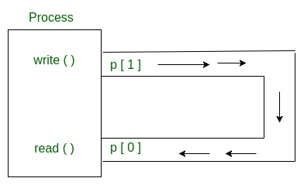
Syntax in C language:
int pipe(int fds[2]);

Parameters :
fd[0] will be the fd(file descriptor) for the
read end of pipe.
fd[1] will be the fd for the write end of pipe.
Returns : 0 on Success.
-1 on error.
Pipes behave FIFO(First in First out), Pipe behave like a queue data structure. Size of read and write don’t have to match here. We can write 512 bytes at a time but we can read only 1 byte at a time in a pipe.
filter_none
edit
play_arrow
brightness_4
// C program to illustrate
// pipe system call in C
#include <stdio.h>
#include <unistd.h>
#define MSGSIZE 16
char* msg1 = "hello, world #1";
char* msg2 = "hello, world #2";
char* msg3 = "hello, world #3";

int main()
{
char inbuf[MSGSIZE];
int p[2], i;

if (pipe(p) < 0)
exit(1);

/* continued */
/* write pipe */

write(p[1], msg1, MSGSIZE);
write(p[1], msg2, MSGSIZE);
write(p[1], msg3, MSGSIZE);

for (i = 0; i < 3; i++) {
/* read pipe */
read(p[0], inbuf, MSGSIZE);
printf("% s\n", inbuf);
}
return 0;
}
Output:

hello, world #1
hello, world #2
hello, world #3
Parent and child sharing a pipe
When we use fork in any process, file descriptors remain open across child process and also parent process. If we call fork after creating a pipe, then the parent and child can communicate via the pipe.
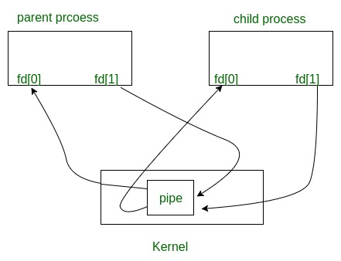
Output of the following programm.
filter_none
edit
play_arrow
brightness_4
// C program to illustrate
// pipe system call in C
// shared by Parent and Child
#include <stdio.h>
#include <unistd.h>
#define MSGSIZE 16
char* msg1 = "hello, world #1";
char* msg2 = "hello, world #2";
char* msg3 = "hello, world #3";

int main()
{
char inbuf[MSGSIZE];
int p[2], pid, nbytes;

if (pipe(p) < 0)
exit(1);

/* continued */
if ((pid = fork()) > 0) {
write(p[1], msg1, MSGSIZE);
write(p[1], msg2, MSGSIZE);
write(p[1], msg3, MSGSIZE);

// Adding this line will
// not hang the program
// close(p[1]);
wait(NULL);
}

else {
// Adding this line will
// not hang the program
// close(p[1]);
while ((nbytes = read(p[0], inbuf, MSGSIZE)) > 0)
printf("% s\n", inbuf);
if (nbytes != 0)
exit(2);
printf("Finished reading\n");
}
return 0;
}
Output:
hello world, #1
hello world, #2
hello world, #3
(hangs) //program does not terminate but hangs
Here, In this code After finishing reading/writing, both parent and child block instead of terminating the process and that’s why program hangs. This happens because read system call gets as much data it requests or as much data as the pipe has, whichever is less.
  - If pipe is empty and we call read system call then Reads on the pipe will return EOF (return value 0) if no process has the write end open.
  - If some other process has the pipe open for writing, read will block in anticipation of new data so this code output hangs because here write ends parent process and also child process doesn’t close.
For more details about parent and child sharing pipe, please refer C program to demonstrate fork() and pipe().

Named Pipe or FIFO with example C program
In computing, a named pipe (also known as a FIFO) is one of the methods for intern-process communication.
- It is an extension to the traditional pipe concept on Unix. A traditional pipe is “unnamed” and lasts only as long as the process.
- A named pipe, however, can last as long as the system is up, beyond the life of the process. It can be deleted if no longer used.
- Usually a named pipe appears as a file, and generally processes attach to it for inter-process communication. A FIFO file is a special kind of file on the local storage which allows two or more processes to communicate with each other by reading/writing to/from this file.
- A FIFO special file is entered into the filesystem by calling mkfifo() in C. Once we have created a FIFO special file in this way, any process can open it for reading or writing, in the same way as an ordinary file. However, it has to be open at both ends simultaneously before you can proceed to do any input or output operations on it.
Creating a FIFO file
In order to create a FIFO file, a function calls i.e. mkfifo is used.
filter_none
edit
play_arrow
brightness_4
int mkfifo(const char *pathname, mode_t mode);
mkfifo() makes a FIFO special file with name pathname. Here mode specifies the FIFO’s permissions. It is modified by the process’s umask in the usual way: the permissions of the created file are (mode & ~umask).

Using FIFO
As named pipe(FIFO) is a kind of file, we can use all the system calls associated with it i.e. open, read, write, close.
Example Programs to illustrate the named pipe.
There are two programs that use same FIFO. The program 1 writes first, then reads. The program 2 reads first, then writes. They both keep doing it until terminated.
filter_none
edit
play_arrow
brightness_4
// C program to implement one side of FIFO
// This side writes first, then reads
#include <stdio.h>
#include <string.h>
#include <fcntl.h>
#include <sys/stat.h>
#include <sys/types.h>
#include <unistd.h>

int main()
{
int fd;

// FIFO file path
char * myfifo = "/tmp/myfifo";

// Creating the named file(FIFO)
// mkfifo(<pathname>, <permission>)
mkfifo(myfifo, 0666);

char arr1[80], arr2[80];
while (1)
{
// Open FIFO for write only
fd = open(myfifo, O_WRONLY);

// Take an input arr2ing from user.
// 80 is maximum length
fgets(arr2, 80, stdin);

// Write the input arr2ing on FIFO
// and close it
write(fd, arr2, strlen(arr2)+1);
close(fd);

// Open FIFO for Read only
fd = open(myfifo, O_RDONLY);

// Read from FIFO
read(fd, arr1, sizeof(arr1));

// Print the read message
printf("User2: %s\n", arr1);
close(fd);
}
return 0;
}
Output: Run the two programs simultaneously on two terminals
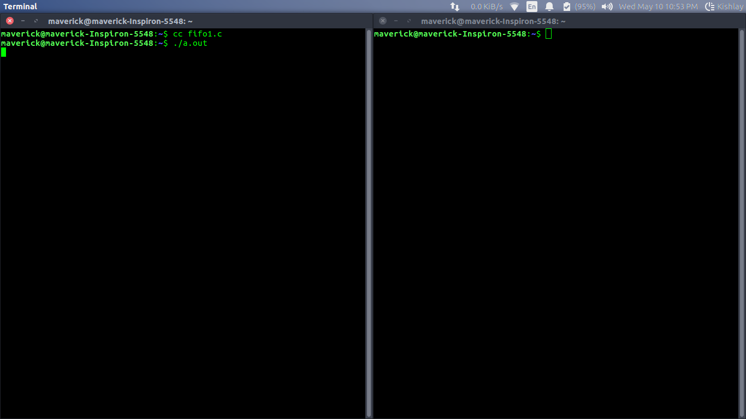

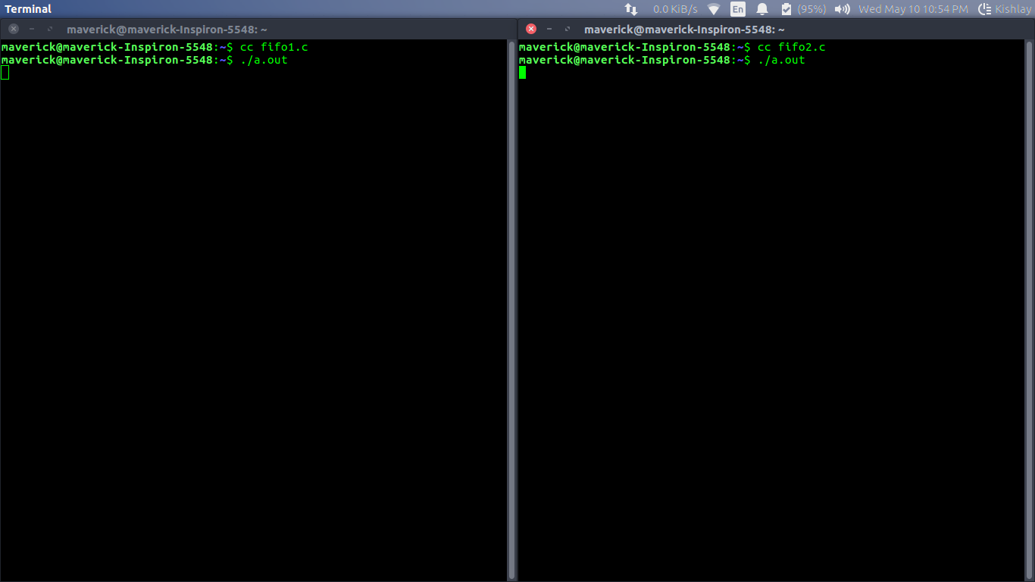

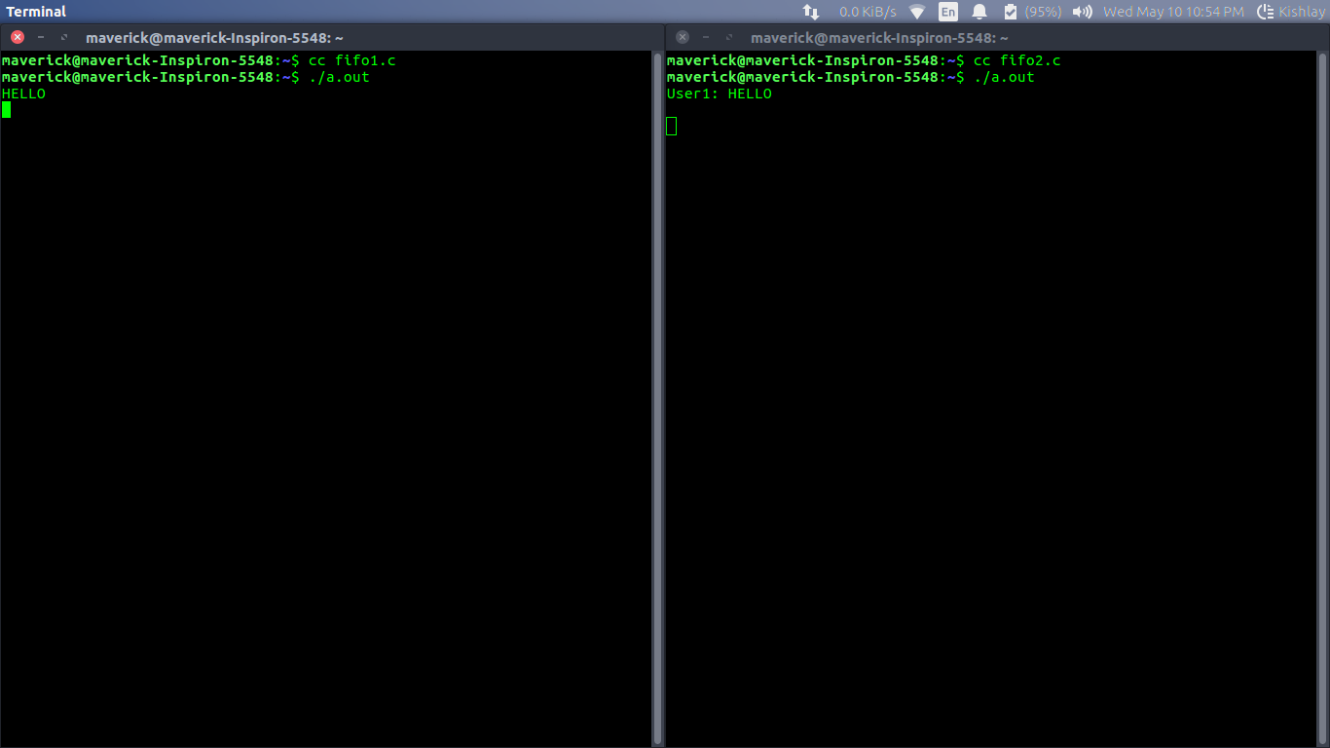

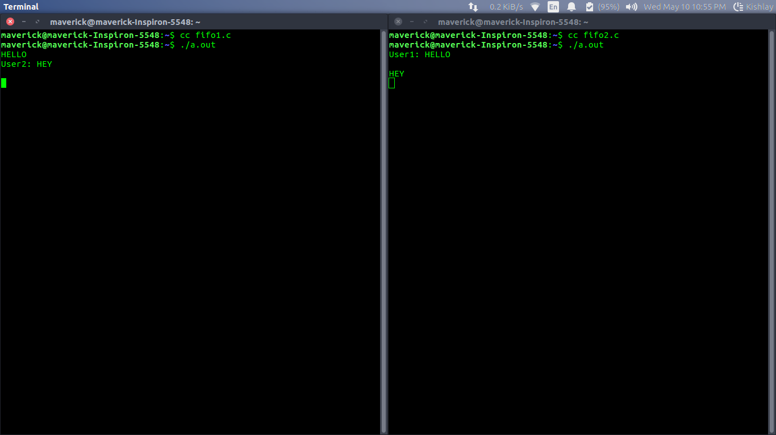

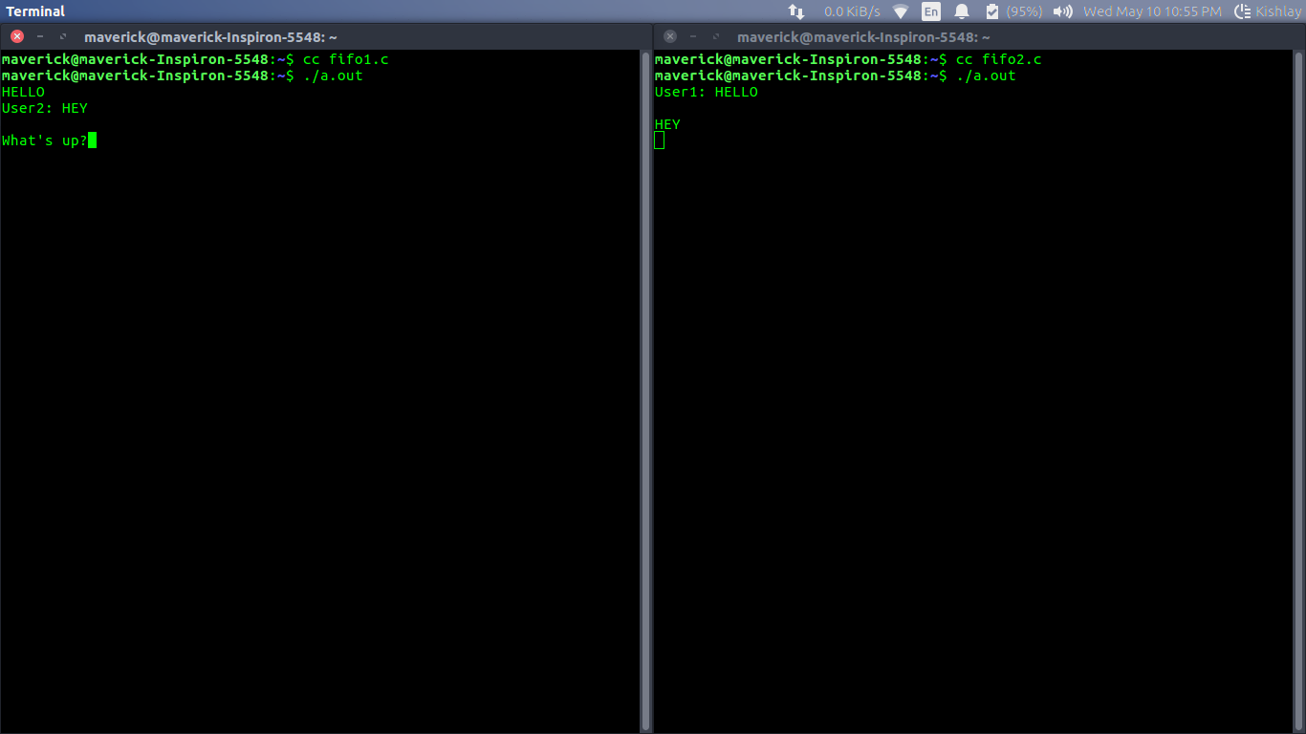

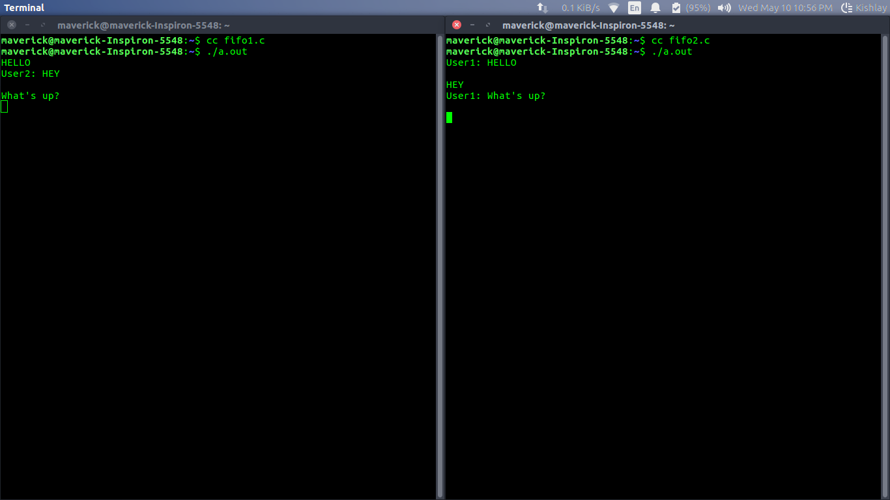

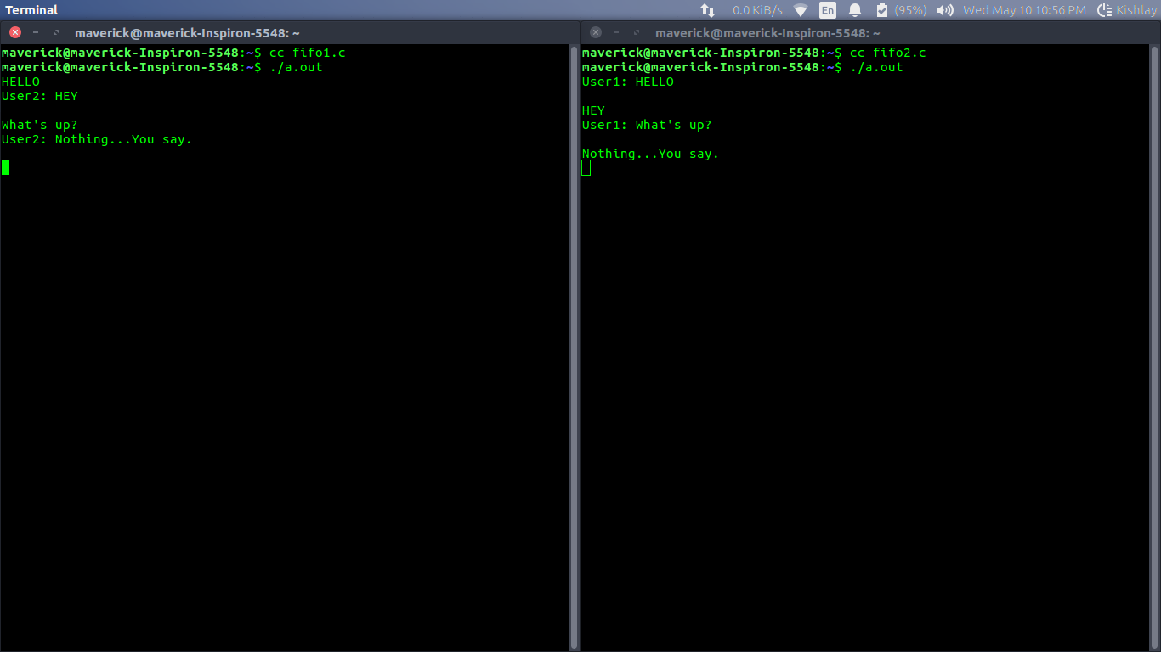

IPC using Message Queues
Prerequisite : Inter Process Communication
A message queue is a linked list of messages stored within the kernel and identified by a message queue identifier. A new queue is created or an existing queue opened by msgget().
New messages are added to the end of a queue by msgsnd(). Every message has a positive long integer type field, a non-negative length, and the actual data bytes (corresponding to the length), all of which are specified to msgsnd() when the message is added to a queue. Messages are fetched from a queue by msgrcv(). We don’t have to fetch the messages in a first-in, first-out order. Instead, we can fetch messages based on their type field.
All processes can exchange information through access to a common system message queue. The sending process places a message (via some (OS) message-passing module) onto a queue which can be read by another process. Each message is given an identification or type so that processes can select the appropriate message. Process must share a common key in order to gain access to the queue in the first place.
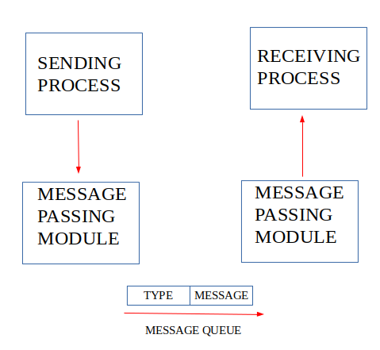
System calls used for message queues:
ftok(): is use to generate a unique key.

msgget(): either returns the message queue identifier for a newly created message
queue or returns the identifiers for a queue which exists with the same key value.

msgsnd(): Data is placed on to a message queue by calling msgsnd().

msgrcv(): messages are retrieved from a queue.

msgctl(): It performs various operations on a queue. Generally it is use to
destroy message queue.

Recommended: Please try your approach on {IDE} first, before moving on to the solution.

MESSAGE QUEUE FOR WRITER PROCESS
filter_none
edit
play_arrow
brightness_4
// C Program for Message Queue (Writer Process)
#include <stdio.h>
#include <sys/ipc.h>
#include <sys/msg.h>

// structure for message queue
struct mesg_buffer {
long mesg_type;
char mesg_text[100];
} message;

int main()
{
key_t key;
int msgid;

// ftok to generate unique key
key = ftok("progfile", 65);

// msgget creates a message queue
// and returns identifier
msgid = msgget(key, 0666 | IPC_CREAT);
message.mesg_type = 1;

printf("Write Data : ");
gets(message.mesg_text);

// msgsnd to send message
msgsnd(msgid, &message, sizeof(message), 0);

// display the message
printf("Data send is : %s \n", message.mesg_text);

return 0;
}
MESSAGE QUEUE FOR READER PROCESS
filter_none
edit
play_arrow
brightness_4
// C Program for Message Queue (Reader Process)
#include <stdio.h>
#include <sys/ipc.h>
#include <sys/msg.h>

// structure for message queue
struct mesg_buffer {
long mesg_type;
char mesg_text[100];
} message;

int main()
{
key_t key;
int msgid;

// ftok to generate unique key
key = ftok("progfile", 65);

// msgget creates a message queue
// and returns identifier
msgid = msgget(key, 0666 | IPC_CREAT);

// msgrcv to receive message
msgrcv(msgid, &message, sizeof(message), 1, 0);

// display the message
printf("Data Received is : %s \n",
message.mesg_text);

// to destroy the message queue
msgctl(msgid, IPC_RMID, NULL);

return 0;
}
Output:
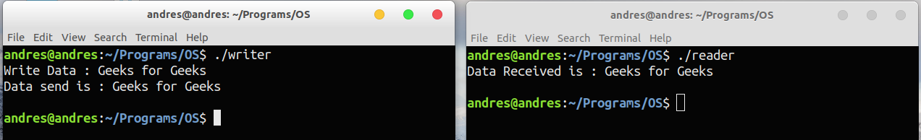

IPC through shared memory
Inter Process Communication through shared memory is a concept where two or more process can access the common memory. And communication is done via this shared memory where changes made by one process can be viewed by anther process.
The problem with pipes, fifo and message queue – is that for two process to exchange information. The information has to go through the kernel.
- Server reads from the input file.
- The server writes this data in a message using either a pipe, fifo or message queue.
- The client reads the data from the IPC channel,again requiring the data to be copied from kernel’s IPC buffer to the client’s buffer.
- Finally the data is copied from the client’s buffer.
A total of four copies of data are required (2 read and 2 write). So, shared memory provides a way by letting two or more processes share a memory segment. With Shared Memory the data is only copied twice – from input file into shared memory and from shared memory to the output file.
SYSTEM CALLS USED ARE:

ftok(): is use to generate a unique key.
shmget(): int shmget(key_t,size_tsize,intshmflg); upon successful completion, shmget() returns an identifier for the shared memory segment.
shmat(): Before you can use a shared memory segment, you have to attach yourself
to it using shmat(). void *shmat(int shmid ,void *shmaddr ,int shmflg);
shmid is shared memory id. shmaddr specifies specific address to use but we should set
it to zero and OS will automatically choose the address.
shmdt(): When you’re done with the shared memory segment, your program should
detach itself from it using shmdt(). int shmdt(void *shmaddr);
shmctl(): when you detach from shared memory,it is not destroyed. So, to destroy
shmctl() is used. shmctl(int shmid,IPC_RMID,NULL);
SHARED MEMORY FOR WRITER PROCESS
filter_none
edit
play_arrow
brightness_4
#include <iostream>
#include <sys/ipc.h>
#include <sys/shm.h>
#include <stdio.h>
using namespace std;

int main()
{
// ftok to generate unique key
key_t key = ftok("shmfile",65);

// shmget returns an identifier in shmid
int shmid = shmget(key,1024,0666|IPC_CREAT);

// shmat to attach to shared memory
char *str = (char*) shmat(shmid,(void*)0,0);

cout<<"Write Data : ";
gets(str);

printf("Data written in memory: %s\n",str);

//detach from shared memory
shmdt(str);

return 0;
}
SHARED MEMORY FOR READER PROCESS
filter_none
edit
play_arrow
brightness_4
#include <iostream>
#include <sys/ipc.h>
#include <sys/shm.h>
#include <stdio.h>
using namespace std;

int main()
{
// ftok to generate unique key
key_t key = ftok("shmfile",65);

// shmget returns an identifier in shmid
int shmid = shmget(key,1024,0666|IPC_CREAT);

// shmat to attach to shared memory
char *str = (char*) shmat(shmid,(void*)0,0);

printf("Data read from memory: %s\n",str);

//detach from shared memory
shmdt(str);

// destroy the shared memory
shmctl(shmid,IPC_RMID,NULL);

return 0;
}
Output:
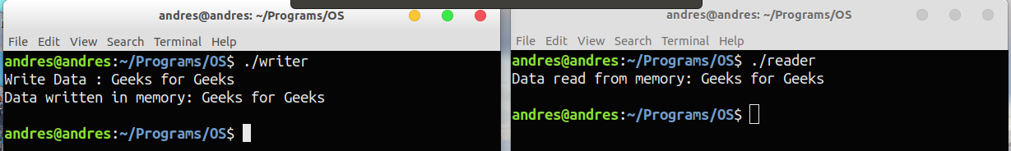

Socket Programming in C/C++
What is socket programming?
Socket programming is a way of connecting two nodes on a network to communicate with each other. One socket(node) listens on a particular port at an IP, while other socket reaches out to the other to form a connection. Server forms the listener socket while client reaches out to the server.
State diagram for server and client model
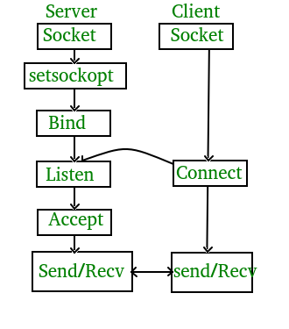
Stages for server
- Socket creation:
int sockfd = socket(domain, type, protocol)
sockfd: socket descriptor, an integer (like a file-handle)
domain: integer, communication domain e.g., AF_INET (IPv4 protocol) , AF_INET6 (IPv6 protocol)
type: communication type
SOCK_STREAM: TCP(reliable, connection oriented)
SOCK_DGRAM: UDP(unreliable, connectionless)
protocol: Protocol value for Internet Protocol(IP), which is 0. This is the same number which appears on protocol field in the IP header of a packet.(man protocols for more details)
- Setsockopt:
int setsockopt(int sockfd, int level, int optname,
const void *optval, socklen_t optlen);
This helps in manipulating options for the socket referred by the file descriptor sockfd. This is completely optional, but it helps in reuse of address and port. Prevents error such as: “address already in use”.
- Bind:
int bind(int sockfd, const struct sockaddr *addr,
socklen_t addrlen);
After creation of the socket, bind function binds the socket to the address and port number specified in addr(custom data structure). In the example code, we bind the server to the localhost, hence we use INADDR_ANY to specify the IP address.
- Listen:
int listen(int sockfd, int backlog);
It puts the server socket in a passive mode, where it waits for the client to approach the server to make a connection. The backlog, defines the maximum length to which the queue of pending connections for sockfd may grow. If a connection request arrives when the queue is full, the client may receive an error with an indication of ECONNREFUSED.
- Accept:
int new_socket= accept(int sockfd, struct sockaddr *addr, socklen_t *addrlen);
It extracts the first connection request on the queue of pending connections for the listening socket, sockfd, creates a new connected socket, and returns a new file descriptor referring to that socket. At this point, connection is established between client and server, and they are ready to transfer data.
Stages for Client
- Socket connection: Exactly same as that of server’s socket creation
- Connect:
int connect(int sockfd, const struct sockaddr *addr,
socklen_t addrlen);
The connect() system call connects the socket referred to by the file descriptor sockfd to the address specified by addr. Server’s address and port is specified in addr.
Implementation
Here we are exchanging one hello message between server and client to demonstrate the client/server model.

filter_none
edit
play_arrow
brightness_4
// Server side C/C++ program to demonstrate Socket programming
#include <unistd.h>
#include <stdio.h>
#include <sys/socket.h>
#include <stdlib.h>
#include <netinet/in.h>
#include <string.h>
#define PORT 8080
int main(int argc, char const *argv[])
{
int server_fd, new_socket, valread;
struct sockaddr_in address;
int opt = 1;
int addrlen = sizeof(address);
char buffer[1024] = {0};
char *hello = "Hello from server";

// Creating socket file descriptor
if ((server_fd = socket(AF_INET, SOCK_STREAM, 0)) == 0)
{
perror("socket failed");
exit(EXIT_FAILURE);
}

// Forcefully attaching socket to the port 8080
if (setsockopt(server_fd, SOL_SOCKET, SO_REUSEADDR | SO_REUSEPORT,
&opt, sizeof(opt)))
{
perror("setsockopt");
exit(EXIT_FAILURE);
}
address.sin_family = AF_INET;
address.sin_addr.s_addr = INADDR_ANY;
address.sin_port = htons( PORT );

// Forcefully attaching socket to the port 8080
if (bind(server_fd, (struct sockaddr *)&address,
sizeof(address))<0)
{
perror("bind failed");
exit(EXIT_FAILURE);
}
if (listen(server_fd, 3) < 0)
{
perror("listen");
exit(EXIT_FAILURE);
}
if ((new_socket = accept(server_fd, (struct sockaddr *)&address,
(socklen_t*)&addrlen))<0)
{
perror("accept");
exit(EXIT_FAILURE);
}
valread = read( new_socket , buffer, 1024);
printf("%s\n",buffer );
send(new_socket , hello , strlen(hello) , 0 );
printf("Hello message sent\n");
return 0;
}
Compiling:
gcc client.c -o client
gcc server.c -o server
Output:
Client:Hello message sent
Hello from server
Server:Hello from client
Hello message sent

Socket Programming in C/C++: Handling multiple clients on server without multi threading
This tutorial assumes you have a basic knowledge of socket programming, i.e you are familiar with basic server and client model. In the basic model, server handles only one client at a time, which is a big assumption if you want to develop any scalable server model.
The simple way to handle multiple clients would be to spawn new thread for every new client connected to the server. This method is strongly not recommended because of various disadvantages, namely:
- Threads are difficult to code, debug and sometimes they have unpredictable results.
- Overhead switching of context
- Not scalable for large number of clients
- Deadlocks can occur
Select()
A better way to handle multiple clients is by using select() linux command.
- Select command allows to monitor multiple file descriptors, waiting until one of the file descriptors become active.
- For example, if there is some data to be read on one of the sockets select will provide that information.
- Select works like an interrupt handler, which gets activated as soon as any file descriptor sends any data.
Data structure used for select: fd_set
It contains the list of file descriptors to monitor for some activity.
There are four functions associated with fd_set:
fd_set readfds;

// Clear an fd_set
FD_ZERO(&readfds);

// Add a descriptor to an fd_set
FD_SET(master_sock, &readfds);

// Remove a descriptor from an fd_set
FD_CLR(master_sock, &readfds);

//If something happened on the master socket , then its an incoming connection
FD_ISSET(master_sock, &readfds);
Activating select: Please read the man page for select to check all the arguments for select command.

activity = select( max_fd + 1 , &readfds , NULL , NULL , NULL);
Implementation:
filter_none
edit
play_arrow
brightness_4

// Write CPP code here
#include <netdb.h>
#include <stdio.h>
#include <stdlib.h>
#include <string.h>
#include <sys/socket.h>
#define MAX 80
#define PORT 8080
#define SA struct sockaddr
void func(int sockfd)
{
char buff[MAX];
int n;
for (;;) {
bzero(buff, sizeof(buff));
printf("Enter the string : ");
n = 0;
while ((buff[n++] = getchar()) != '\n')
;
write(sockfd, buff, sizeof(buff));
bzero(buff, sizeof(buff));
read(sockfd, buff, sizeof(buff));
printf("From Server : %s", buff);
if ((strncmp(buff, "exit", 4)) == 0) {
printf("Client Exit...\n");
break;
}
}
}

int main()
{
int sockfd, connfd;
struct sockaddr_in servaddr, cli;

// socket create and varification
sockfd = socket(AF_INET, SOCK_STREAM, 0);
if (sockfd == -1) {
printf("socket creation failed...\n");
exit(0);
}
else
printf("Socket successfully created..\n");
bzero(&servaddr, sizeof(servaddr));

// assign IP, PORT
servaddr.sin_family = AF_INET;
servaddr.sin_addr.s_addr = inet_addr("127.0.0.1");
servaddr.sin_port = htons(PORT);

// connect the client socket to server socket
if (connect(sockfd, (SA*)&servaddr, sizeof(servaddr)) != 0) {
printf("connection with the server failed...\n");
exit(0);
}
else
printf("connected to the server..\n");

// function for chat
func(sockfd);

// close the socket
close(sockfd);
}

//Example code: A simple server side code, which echos back the received message.
//Handle multiple socket connections with select and fd_set on Linux
#include <stdio.h>
#include <string.h> //strlen
#include <stdlib.h>
#include <errno.h>
#include <unistd.h> //close
#include <arpa/inet.h> //close
#include <sys/types.h>
#include <sys/socket.h>
#include <netinet/in.h>
#include <sys/time.h> //FD_SET, FD_ISSET, FD_ZERO macros

#define TRUE 1
#define FALSE 0
#define PORT 8888

int main(int argc , char *argv[])
{
int opt = TRUE;
int master_socket , addrlen , new_socket , client_socket[30] ,
max_clients = 30 , activity, i , valread , sd;
int max_sd;
struct sockaddr_in address;

char buffer[1025]; //data buffer of 1K

//set of socket descriptors
fd_set readfds;

//a message
char *message = "ECHO Daemon v1.0 \r\n";

//initialise all client_socket[] to 0 so not checked
for (i = 0; i < max_clients; i++)
{
client_socket[i] = 0;
}

//create a master socket
if( (master_socket = socket(AF_INET , SOCK_STREAM , 0)) == 0)
{
perror("socket failed");
exit(EXIT_FAILURE);
}

//set master socket to allow multiple connections ,
//this is just a good habit, it will work without this
if( setsockopt(master_socket, SOL_SOCKET, SO_REUSEADDR, (char *)&opt,
sizeof(opt)) < 0 )
{
perror("setsockopt");
exit(EXIT_FAILURE);
}

//type of socket created
address.sin_family = AF_INET;
address.sin_addr.s_addr = INADDR_ANY;
address.sin_port = htons( PORT );

//bind the socket to localhost port 8888
if (bind(master_socket, (struct sockaddr *)&address, sizeof(address))<0)
{
perror("bind failed");
exit(EXIT_FAILURE);
}
printf("Listener on port %d \n", PORT);

//try to specify maximum of 3 pending connections for the master socket
if (listen(master_socket, 3) < 0)
{
perror("listen");
exit(EXIT_FAILURE);
}

//accept the incoming connection
addrlen = sizeof(address);
puts("Waiting for connections ...");

while(TRUE)
{
//clear the socket set
FD_ZERO(&readfds);

//add master socket to set
FD_SET(master_socket, &readfds);
max_sd = master_socket;

//add child sockets to set
for ( i = 0 ; i < max_clients ; i++)
{
//socket descriptor
sd = client_socket[i];

//if valid socket descriptor then add to read list
if(sd > 0)
FD_SET( sd , &readfds);

//highest file descriptor number, need it for the select function
if(sd > max_sd)
max_sd = sd;
}

//wait for an activity on one of the sockets , timeout is NULL ,
//so wait indefinitely
activity = select( max_sd + 1 , &readfds , NULL , NULL , NULL);

if ((activity < 0) && (errno!=EINTR))
{
printf("select error");
}

//If something happened on the master socket ,
//then its an incoming connection
if (FD_ISSET(master_socket, &readfds))
{
if ((new_socket = accept(master_socket,
(struct sockaddr *)&address, (socklen_t*)&addrlen))<0)
{
perror("accept");
exit(EXIT_FAILURE);
}

//inform user of socket number - used in send and receive commands
printf("New connection , socket fd is %d , ip is : %s , port : %d
\n" , new_socket , inet_ntoa(address.sin_addr) , ntohs
(address.sin_port));

//send new connection greeting message
if( send(new_socket, message, strlen(message), 0) != strlen(message) )
{
perror("send");
}

puts("Welcome message sent successfully");

//add new socket to array of sockets
for (i = 0; i < max_clients; i++)
{
//if position is empty
if( client_socket[i] == 0 )
{
client_socket[i] = new_socket;
printf("Adding to list of sockets as %d\n" , i);

break;
}
}
}

//else its some IO operation on some other socket
for (i = 0; i < max_clients; i++)
{
sd = client_socket[i];

if (FD_ISSET( sd , &readfds))
{
//Check if it was for closing , and also read the
//incoming message
if ((valread = read( sd , buffer, 1024)) == 0)
{
//Somebody disconnected , get his details and print
getpeername(sd , (struct sockaddr*)&address , \
(socklen_t*)&addrlen);
printf("Host disconnected , ip %s , port %d \n" ,
inet_ntoa(address.sin_addr) , ntohs(address.sin_port));

//Close the socket and mark as 0 in list for reuse
close( sd );
client_socket[i] = 0;
}

//Echo back the message that came in
else
{
//set the string terminating NULL byte on the end
//of the data read
buffer[valread] = '\0';
send(sd , buffer , strlen(buffer) , 0 );
}
}
}
}

return 0;
}
Compile the file and run the server.
Use telnet to connect the server as a client.
Try running on different machines using following command:
telnet localhost 8888
Code Explanation:
- We have created a fd_set variable readfds, which will monitor all the active file descriptors of the clients plus that of the main server listening socket.
- Whenever a new client will connect, master_socket will be activated and a new fd will be open for that client. We will store its fd in our client_list and in the next iteration we will add it to the readfds to monitor for activity from this client.
- Similarly, if an old client sends some data, readfds will be activated and we will check from the list of existing client to see which client has send the data.

Linear search using Multi-threading
Given a large file of integers, search for a particular element in it using multi-threading.
Examples:
Input : 1, 5, 7, 10, 12, 14, 15, 18, 20,
22, 25, 27, 30, 64, 110, 220
Output :if key = 20
Key element found

Input :1, 5, 7, 10, 12, 14, 15, 18, 20,
22, 25, 27, 30, 64, 110, 220
Output :if key = 202
Key not present
Prerequisite : Multi-threading

Recommended: Please try your approach on {IDE} first, before moving on to the solution.

Approach :
First create n threads. Then, divide array in to four parts one section for each thread and apply linear search on individual section using multhreading and check whether the key element is present or not.
Command : g++ -pthread linear_thread.cpp
filter_none
brightness_4
// CPP code to search for element in a
// very large file using Multithreading
#include <iostream>
#include <pthread.h>
using namespace std;

// Max size of array
#define max 16

// Max number of threads to create
#define thread_max 4

int a[max] = { 1, 5, 7, 10, 12, 14, 15,
18, 20, 22, 25, 27, 30,
64, 110, 220 };
int key = 202;

// Flag to indicate if key is found in a[]
// or not.
int f = 0;

int current_thread = 0;

// Linear search function which will
// run for all the threads
void* ThreadSearch(void* args)
{
int num = current_thread++;

for (int i = num * (max / 4);
i < ((num + 1) * (max / 4)); i++)
{
if (a[i] == key)
f = 1;
}
}

// Driver Code
int main()
{
pthread_t thread[thread_max];

for (int i = 0; i < thread_max; i++) {
pthread_create(&thread[i], NULL,
ThreadSearch, (void*)NULL);
}

for (int i = 0; i < thread_max; i++) {
pthread_join(thread[i], NULL);
}

if (f == 1)
cout << "Key element found" << endl;
else
cout << "Key not present" << endl;
return 0;
}
Output:
Key not present
Exercise: The above code divides array into four subarrays. Extend this to take a parameter that decides number of divisions (or threads).

Maximum in a 2D matrix using Multi-threading in C++
Given a 2-D matrix, find the element having maximum value using multi-threading.
Prerequisite : Multithreading
Examples :
Input : {{1, 5, 3, 6},
{22, 10, 4, 34},
{4, 45, 67, 3},
{69, 3, 23, 3}}
Output :69

Input :{{1, 2, 3}
{2, 4, 5}}
Output :5
A matrix can be of very large size so when it comes to traversing it, it will take lot of time. When finding the max element in a matrix, each element of the matrix is to be traversed which will take more time. So, to minimize the time taken in traversing the matrix can be avoided using multi-threading.

Recommended: Please try your approach on {IDE} first, before moving on to the solution.

filter_none
brightness_4
// CPP code to find max in 2d
// array using multi-threading
#include <bits/stdc++.h>
using namespace std;

// declaring two thread_id variable
pthread_t thread[2];

// structure for passing arguments
typedef struct dim
{
int s, e;
}dim;

// matrix of 4X4
int mat1[][4] = {{1, 5, 3, 6}, {22, 80, 4, 34},
{4, 45, 67, 3}, {99, 3, 23, 3}};
int maxf[2];

// function that find max from a given array
void *max(void *size)
{
int i, j, max;
dim *b = (dim *)size;
max = mat1[b -> s][0];

// finding max
for(i = b -> s; i < b -> e; i++)
{
for(j = 0; j < 4; j++)
{
if(max < mat1[i][j])
max = mat1[i][j];
}
}

// storing max from first half of
// 2-d array into 0th index
if(b -> s == 0)
maxf[0] = max;

// storing max from second half of
// 2-d array into 1st index
else
maxf[1] = max;
}

// driver function
int main()
{
int i, j;
dim *a, *b;
a = (dim *)malloc(sizeof(dim));
b = (dim *)malloc(sizeof(dim));

// creating thread1
a -> s = 0; a -> e = 4/2;
pthread_create(&thread[0], NULL,
&max, (void *)a);

b -> s = 4/2; b -> e = 4;

// creating thr ead 2
pthread_create(&thread[1], NULL,
&max, (void *)b);

// waiting until the complition of threads
pthread_join(thread[0], NULL);
pthread_join(thread[1], NULL);

// printing max
if(maxf[0] > maxf[1])
cout << maxf[0] << endl;
else
cout<< maxf[1] << endl;

return 0;
}
Output :
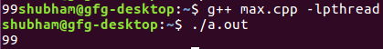

Determinant of N x N matrix using multi-threading
Given a matrix of N x N, task is to find the determinant of the matrix using multi-threading.
Examples :
Input : mat = {{0, 4, 0, -3},
{1, 1, 5, 2},
{1, -2, 0, 6},
{ 3, 0, 0, 1}}
Output : -250

Input : mat = {{1, 0, 2, -1},
{3, 0, 0, 5},
{2, 1, 4, -3},
{1, 0, 5, 0}}
Output: 30
Approach :
It is known that finding the determinant of a matrix can be very costly in the amount of time it takes. So, computing things parallely may lead to a comparatively less costly program. A code can be parallelized using threads, which is light weight process and divides a single flow program into a programs with multiple flows. As for finding the determinant of a matrix, first find the determinant of the submatrices of the matrix, distribute the task of finding the determinant of submatrices to the threads, and these threads will run parallelly resulting in less time execution time than the sequential method.
Note :The code is Linux specific.

Recommended: Please try your approach on {IDE} first, before moving on to the solution.

filter_none
edit
play_arrow
brightness_4
// CPP program for finding determinant matrix
// with parallalizing the code
#include <iostream>
#include <vector>
#include <pthread.h>
#define size 4

using namespace std;

// matrix whoe's determinant is required
int mat[][size] = { { 0, 4, 0, -3 },
{ 1, 1, 5, 2 },
{ 1, -2, 0, 6 },
{ 3, 0, 0, 1 } };
int det[size];

// declaring variable for storing thread id
pthread_t thread[size];

// function for finding determinant
int determinant(vector<vector<int> > mat2, int s)
{

if (s == 2) {

// if size of matrix is 2X2
// then returning the determinant
return mat2[0][0] * mat2[1][1] -
mat2[0][1] * mat2[1][0];
}
else {

// else dividing the matrix in smaller part.
vector<vector<int> > mat1(s - 1),
mat3(s - 1), mat4(s - 1);
int k, l, m, i, j;

for (i = 0; i < s - 1; i++) {
mat1[i] = vector<int>(s - 1);
mat3[i] = vector<int>(s - 1);
mat4[i] = vector<int>(s - 1);
}

for (i = 1; i < s; i++) {
k = 0;
l = 0;
m = 0;
for (j = 0; j < s; j++) {
if (j != 0) {
mat1[i - 1][k] = mat2[i][j];
k++;
}
if (j != 1) {
mat3[i - 1][l] = mat2[i][j];
l++;
}
if (j != 2) {
mat4[i - 1][m] = mat2[i][j];
m++;
}
}
}

return mat2[0][0] * determinant(mat1, s - 1) -
mat2[0][1] * determinant(mat3, s - 1) +
mat2[0][2] * determinant(mat4, s - 1);
}
}

// function for finding determinant using first row
// with each element of row a thread is associated.
void* createTd(void* arg)
{
int *ar = (int *)arg, i, j, k;
vector<vector<int> > mat2(size - 1);

for (i = 0; i < size - 1; i++)
mat2[i] = vector<int>(size - 1);

// extracting the matrix smaller by size one.
// for finding the determinant.
for (i = 1; i < size; i++) {
k = 0;
for (j = 0; j < size; j++) {
if (j != (*ar)) {
mat2[i - 1][k] = mat[i][j];
k++;
}
}
}

// calling determinant function
det[*ar] = det[*ar] * determinant(mat2, size - 1);
}

// driver function
int main()
{
int i, j, detfin = 0;
int p[size];

// storing the first row in a array
// for later multipying with the determinant
// of smaller matrix
for (i = 0; i < size; i++)
det[i] = mat[0][i];

// creating thread
for (i = 0; i < size; i++) {
p[i] = i;
pthread_create(&thread[i], NULL, &createTd, (void*)&p[i]);
}

// waiting for all the threads to join
pthread_join(thread[0], NULL);
pthread_join(thread[1], NULL);
pthread_join(thread[2], NULL);
pthread_join(thread[3], NULL);
for (i = 0; i < size; i++) {
if (i % 2 == 0)
detfin += det[i];
else
detfin -= det[i];
}

cout << detfin << endl;

return 0;
}
Output:
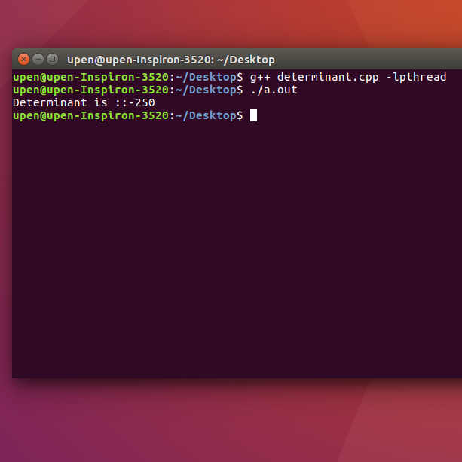

Sort an array using socket programming in C
Given an array of unsorted positive integer, sort the given array using the Socket programming .
Examples:
Input : 4 5 6 1 8 2 7 9 3 0
Output :0 1 2 3 4 5 6 7 8 9

Input : 9 8 1 4 0
Output : 0 1 4 8 9
Compile these files using gcc command (gcc client.c -o client and gcc server.c -o server). Run the program using ./server and ./client (Please note : First you should run server program which will be waiting for client’s response and then client code).

Recommended: Please try your approach on {IDE} first, before moving on to the solution.

In this program, client will take the input and send it to server and the server will sort the array using the bubble sort.
filter_none
brightness_4
// Client code in C to sort the array
#include <arpa/inet.h>
#include <stdio.h>
#include <string.h>
#include <sys/socket.h>
#include <unistd.h>

// Driver code
int main(int argc, char* argv[])
{
int sock;
struct sockaddr_in server;
int server_reply[10];
int number[10] = { 5, 4, 3, 8, 9, 1, 2, 0, 6 }, i, temp;

// Create socket
sock = socket(AF_INET, SOCK_STREAM, 0);
if (sock == -1) {
printf("Could not create socket");
}
puts("Socket created");

server.sin_addr.s_addr = inet_addr("127.0.0.1");
server.sin_family = AF_INET;
server.sin_port = htons(8880);

// Connect to remote server
if (connect(sock, (struct sockaddr*)&server, sizeof(server)) < 0) {
perror("connect failed. Error");
return 1;
}

puts("Connected\n");

if (send(sock, &number, 10 * sizeof(int), 0) < 0) {
puts("Send failed");
return 1;
}

// Receive a reply from the server
if (recv(sock, &server_reply, 10 * sizeof(int), 0) < 0) {
puts("recv failed");
return 0;
}

puts("Server reply :\n");
for (i = 0; i < 10; i++) {
printf("%d\n", server_reply[i]);
}

// close the socket
close(sock);
return 0;
}
Note : Save above file as client.c
filter_none
brightness_4
// Server code in C to sort the array
#include <arpa/inet.h>
#include <stdio.h>
#include <string.h>
#include <sys/socket.h>
#include <unistd.h>

void bubble_sort(int[], int);

// Driver code
int main(int argc, char* argv[])
{
int socket_desc, client_sock, c, read_size;
struct sockaddr_in server, client;
int message[10], i;

// Create socket
socket_desc = socket(AF_INET, SOCK_STREAM, 0);
if (socket_desc == -1) {
printf("Could not create socket");
}
puts("Socket created");

// Prepare the sockaddr_in structure
server.sin_family = AF_INET;
server.sin_addr.s_addr = INADDR_ANY;
server.sin_port = htons(8880);

// Bind the socket
if (bind(socket_desc, (struct sockaddr*)&server, sizeof(server)) < 0) {

// print the error message
perror("bind failed. Error");
return 1;
}
puts("bind done");

// lsiten to the socket
listen(socket_desc, 3);

puts("Waiting for incoming connections...");
c = sizeof(struct sockaddr_in);

// accept connection from an incoming client
client_sock = accept(socket_desc, (struct sockaddr*)&client, (socklen_t*)&c);

if (client_sock < 0) {
perror("accept failed");
return 1;
}

puts("Connection accepted");

// Receive a message from client
while ((read_size = recv(client_sock, &message, 10 * sizeof(int), 0)) > 0) {

bubble_sort(message, 10);

write(client_sock, &message, 10 * sizeof(int));
}

if (read_size == 0) {
puts("Client disconnected");
}
else if (read_size == -1) {
perror("recv failed");
}

return 0;
}

// Function to sort the array
void bubble_sort(int list[], int n)
{
int c, d, t;

for (c = 0; c < (n - 1); c++) {
for (d = 0; d < n - c - 1; d++) {
if (list[d] > list[d + 1]) {

/* Swapping */
t = list[d];
list[d] = list[d + 1];
list[d + 1] = t;
}
}
}
}
Note : Save above file as server.c
Output:
0 1 2 3 4 5 6 7 8 9

Explicitly assigning port number to client in Socket
Prerequisite: Socket programming in C/C++.
In socket programming, when server and client are connected then client is provided any random port number by operating system to run and generally, we don’t care about it, But in some cases, there may be a firewall on the client side that only allows outgoing connections on certain port numbers. So, it is highly probable that the port number provided to client by operating system may have been blocked by client firewall. In that case, we need to explicitly or forcefully assign any port number to the client on which it can operate.
Some protocol like NFS protocol requires client program to run on only certain port number and so in this case, client need to forcefully assigned that port number only as it runs on port number either on 111 or on 2049. This can be done using bind() system call with specifying particular port number in client side socket.
Below is the implementation Server and Client program where client will be forcefully get assigned a port number.

Recommended: Please try your approach on {IDE} first, before moving on to the solution.

Server Side Program
filter_none
edit
play_arrow
brightness_4
// C program to demonstrate
// socket programming in finding ip address
// and port number of connected client
// on Server Side
#include<stdio.h>
#include<sys/types.h>
#include<sys/socket.h>
#include<sys/un.h>
#include<string.h>
#include<netdb.h>
#include<netinet/in.h>
#include<arpa/inet.h>
#include<string.h>

int main()
{
// Two buffers for message communication
char buffer1[256], buffer2[256];
int server = socket(AF_INET, SOCK_STREAM, 0);
if (server < 0)
printf("Error in server creating\n");
else
printf("Server Created\n");

struct sockaddr_in my_addr, peer_addr;
my_addr.sin_family = AF_INET;
my_addr.sin_addr.s_addr = INADDR_ANY;

// This ip address will change according to the machine
my_addr.sin_addr.s_addr = inet_addr("10.32.40.213");

my_addr.sin_port = htons(12000);

if (bind(server, (struct sockaddr*) &my_addr, sizeof(my_addr)) == 0)
printf("Binded Correctly\n");
else
printf("Unable to bind\n");

if (listen(server, 3) == 0)
printf("Listening ...\n");
else
printf("Unable to listen\n");

socklen_t addr_size;
addr_size = sizeof(struct sockaddr_in);

// Ip character array will store the ip address of client
char *ip;

// while loop is iterated infinitely to
// accept infinite connection one by one
while (1)
{
int acc = accept(server, (struct sockaddr*) &peer_addr, &addr_size);
printf("Connection Established\n");
char ip[INET_ADDRSTRLEN];
inet_ntop(AF_INET, &(peer_addr.sin_addr), ip, INET_ADDRSTRLEN);

// "ntohs(peer_addr.sin_port)" function is
// for finding port number of client
printf("connection established with IP : %s and PORT : %d\n",
ip, ntohs(peer_addr.sin_port));

recv(acc, buffer2, 256, 0);
printf("Client : %s\n", buffer2);
strcpy(buffer1, "Hello");
send(acc, buffer1, 256, 0);
}
return 0;
}
Output:
Server Created
Binded Correctly
Listening ...
Connection Established
connection established with IP : 10.32.40.213 and PORT : 12010
Client : Hello

Client Side Program
filter_none
edit
play_arrow
brightness_4
// C program to demonstrate socket programming
// as well as explicitly assigning a port number
// on Client Side
#include<stdio.h>
#include<sys/types.h>
#include<sys/socket.h>
#include<sys/un.h>
#include<string.h>
#include<netdb.h>
#include<netinet/in.h>
#include<arpa/inet.h>
#include<stdlib.h>

int main()
{
// Two buffer are for message communication
char buffer1[256], buffer2[256];
struct sockaddr_in my_addr, my_addr1;
int client = socket(AF_INET, SOCK_STREAM, 0);
if (client < 0)
printf("Error in client creating\n");
else
printf("Client Created\n");

my_addr.sin_family = AF_INET;
my_addr.sin_addr.s_addr = INADDR_ANY;
my_addr.sin_port = htons(12000);

// This ip address will change according to the machine
my_addr.sin_addr.s_addr = inet_addr("10.32.40.213");

// Explicitly assigning port number 12010 by
// binding client with that port
my_addr1.sin_family = AF_INET;
my_addr1.sin_addr.s_addr = INADDR_ANY;
my_addr1.sin_port = htons(12010);

// This ip address will change according to the machine
my_addr1.sin_addr.s_addr = inet_addr("10.32.40.213");
if (bind(client, (struct sockaddr*) &my_addr1, sizeof(struct sockaddr_in)) == 0)
printf("Binded Correctly\n");
else
printf("Unable to bind\n");

socklen_t addr_size = sizeof my_addr;
int con = connect(client, (struct sockaddr*) &my_addr, sizeof my_addr);
if (con == 0)
printf("Client Connected\n");
else
printf("Error in Connection\n");

strcpy(buffer2, "Hello");
send(client, buffer2, 256, 0);
recv(client, buffer1, 256, 0);
printf("Server : %s\n", buffer1);
return 0;
}
Output:
Client Created
Binded Correctly
Client Connected
Server : Hello

UDP Server-Client implementation in C
There are two major transport layer protocols to communicate between hosts : TCP and UDP. Creating TCP Server/Client was discussed in a previous post.
Prerequisite : Creating TCP Server/Client
Theory
In UDP, the client does not form a connection with the server like in TCP and instead just sends a datagram. Similarly, the server need not accept a connection and just waits for datagrams to arrive. Datagrams upon arrival contain the address of sender which the server uses to send data to the correct client.
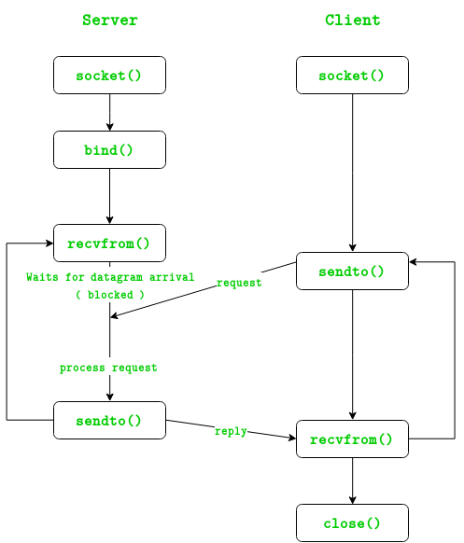

The entire process can be broken down into following steps :
UDP Server :
- Create UDP socket.
- Bind the socket to server address.
- Wait until datagram packet arrives from client.
- Process the datagram packet and send a reply to client.
- Go back to Step 3.
UDP Client :
- Create UDP socket.
- Send message to server.
- Wait until response from server is recieved.
- Process reply and go back to step 2, if necessary.
- Close socket descriptor and exit.
Necessary Functions :
int socket(int domain, int type, int protocol)
Creates an unbound socket in the specified domain.
Returns socket file descriptor.
Arguments :
domain – Specifies the communication
domain ( AF_INET for IPv4/ AF_INET6 for IPv6 )
type – Type of socket to be created
( SOCK_STREAM for TCP / SOCK_DGRAM for UDP )
protocol – Protocol to be used by socket.
0 means use default protocol for the address family.

int bind(int sockfd, const struct sockaddr *addr, socklen_t addrlen)
Assigns address to the unbound socket.
Arguments :
sockfd – File descriptor of socket to be binded
addr – Structure in which address to be binded to is specified
addrlen – Size of addr structure
ssize_t sendto(int sockfd, const void *buf, size_t len, int flags,
const struct sockaddr *dest_addr, socklen_t addrlen)
Send a message on the socket
Arguments :
sockfd – File descriptor of socket
buf – Application buffer containing the data to be sent
len – Size of buf application buffer
flags – Bitwise OR of flags to modify socket behaviour
dest_addr – Structure containing address of destination
addrlen – Size of dest_addr structure
ssize_t recvfrom(int sockfd, void *buf, size_t len, int flags,
struct sockaddr *src_addr, socklen_t *addrlen)
Receive a message from the socket.
Arguments :
sockfd – File descriptor of socket
buf – Application buffer in which to receive data
len – Size of buf application buffer
flags – Bitwise OR of flags to modify socket behaviour
src_addr – Structure containing source address is returned
addrlen – Variable in which size of src_addr structure is returned
int close(int fd)
Close a file descriptor
Arguments :
fd – File descriptor
In the below code, exchange of one hello message between server and client is shown to demonstrate the model.
filter_none
edit
play_arrow
brightness_4
// Server side implementation of UDP client-server model
#include <stdio.h>
#include <stdlib.h>
#include <unistd.h>
#include <string.h>
#include <sys/types.h>
#include <sys/socket.h>
#include <arpa/inet.h>
#include <netinet/in.h>

#define PORT 8080
#define MAXLINE 1024

// Driver code
int main() {
int sockfd;
char buffer[MAXLINE];
char *hello = "Hello from server";
struct sockaddr_in servaddr, cliaddr;

// Creating socket file descriptor
if ( (sockfd = socket(AF_INET, SOCK_DGRAM, 0)) < 0 ) {
perror("socket creation failed");
exit(EXIT_FAILURE);
}

memset(&servaddr, 0, sizeof(servaddr));
memset(&cliaddr, 0, sizeof(cliaddr));

// Filling server information
servaddr.sin_family = AF_INET; // IPv4
servaddr.sin_addr.s_addr = INADDR_ANY;
servaddr.sin_port = htons(PORT);

// Bind the socket with the server address
if ( bind(sockfd, (const struct sockaddr *)&servaddr,
sizeof(servaddr)) < 0 )
{
perror("bind failed");
exit(EXIT_FAILURE);
}

int len, n;
n = recvfrom(sockfd, (char *)buffer, MAXLINE,
MSG_WAITALL, ( struct sockaddr *) &cliaddr,
&len);
buffer[n] = '\0';
printf("Client : %s\n", buffer);
sendto(sockfd, (const char *)hello, strlen(hello),
MSG_CONFIRM, (const struct sockaddr *) &cliaddr,
len);
printf("Hello message sent.\n");

return 0;
}

// Client side implementation of UDP client-server model
#include <stdio.h>
#include <stdlib.h>
#include <unistd.h>
#include <string.h>
#include <sys/types.h>
#include <sys/socket.h>
#include <arpa/inet.h>
#include <netinet/in.h>

#define PORT 8080
#define MAXLINE 1024

// Driver code
int main() {
int sockfd;
char buffer[MAXLINE];
char *hello = "Hello from client";
struct sockaddr_in servaddr;

// Creating socket file descriptor
if ( (sockfd = socket(AF_INET, SOCK_DGRAM, 0)) < 0 ) {
perror("socket creation failed");
exit(EXIT_FAILURE);
}

memset(&servaddr, 0, sizeof(servaddr));

// Filling server information
servaddr.sin_family = AF_INET;
servaddr.sin_port = htons(PORT);
servaddr.sin_addr.s_addr = INADDR_ANY;

int n, len;

sendto(sockfd, (const char *)hello, strlen(hello),
MSG_CONFIRM, (const struct sockaddr *) &servaddr,
sizeof(servaddr));
printf("Hello message sent.\n");

n = recvfrom(sockfd, (char *)buffer, MAXLINE,
MSG_WAITALL, (struct sockaddr *) &servaddr,
&len);
buffer[n] = '\0';
printf("Server : %s\n", buffer);

close(sockfd);
return 0;
}

Output :
$ ./server
Client : Hello from client
Hello message sent.
$ ./client
Hello message sent.
Server : Hello from server

