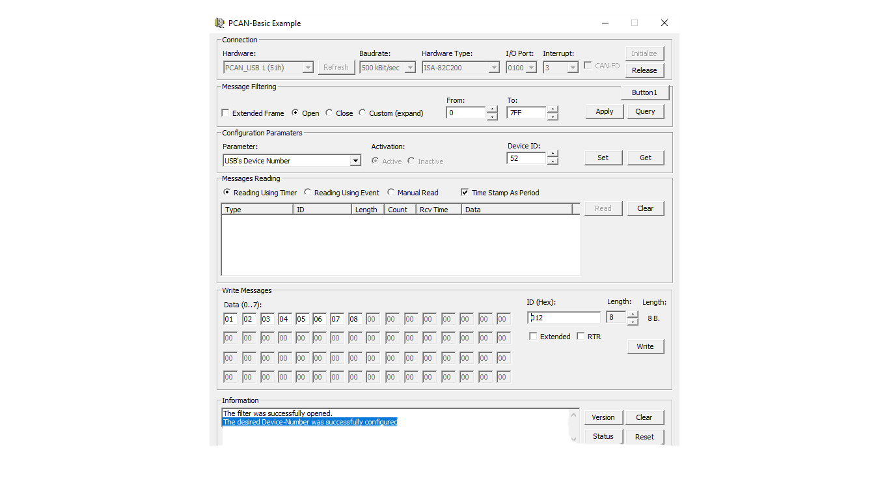

Fig 1: Pcan first TX and RX

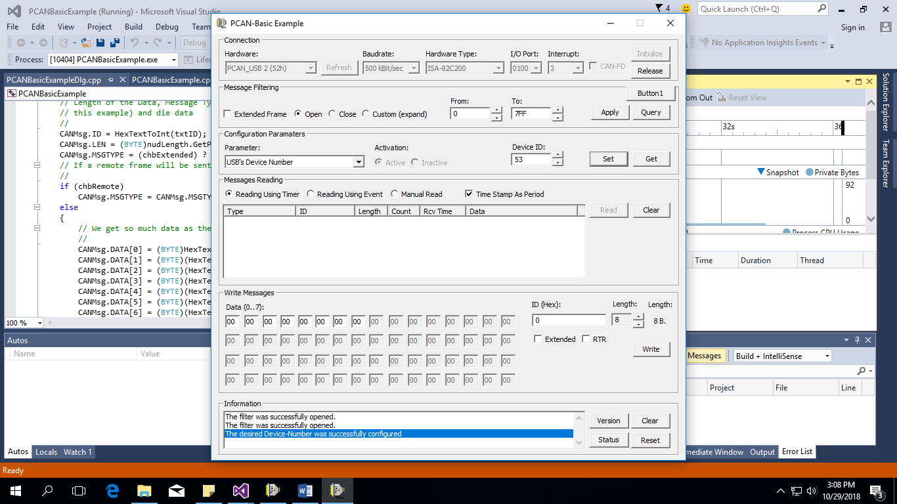

Fig 2:pcan second TX and RX

When I run Pcan in following path

C:\Users\vamsi.machavaram\Desktop\PCAN\PCAN-Basic API - Copy\Samples\C++_MFC in visual studio 2015.

After run this option

STEP 2)READ SPACE

STEP 1)WRITE

STEP 3) READ

2A) READ MSG FROM STEP1 IN UI 1

2B) WRITE CAN MSG AUTOMATICALLY TO STEP 43IN UI 1.

UI 1 (or ) fig 1. UI 2 (or) fig 2.

Read can messages

Write can messages

Same for UI 2 to UI 1 transmit and receiving.

NOTE: The process is after write data from UI 1,the UI 2 is read the can messages and rewrite can message to UI 1.

The main Heart of this event is show below:

**Pcan operation**

TPCANStatus CPCANBasicExampleDlg::ReadMessage()

{

TPCANMsg CANMsg;

TPCANTimestamp CANTimeStamp;

TPCANStatus stsResult;

// We execute the "Read" function of the PCANBasic

//

stsResult = m_objPCANBasic->Read(m_PcanHandle, &CANMsg, &CANTimeStamp);

if (stsResult != PCAN_ERROR_QRCVEMPTY)

// We process the received message

//

if (CANMsg.ID == (unsigned long)0x123)

{

TPCANStatus stsResult1;

// The message is sent

//

stsResult1 = m_IsFD ? WriteFrameFD() : WriteFrame_modify();

// The Hardware was successfully sent

//

if (stsResult1 == PCAN_ERROR_OK)

IncludeTextMessage("Message was successfully SENT");

// An error occurred. We show the error.

//

else

::MessageBox(NULL, GetFormatedError(stsResult), "Error!", MB_ICONERROR);

OutputDebugStringW(L"My output string.");

//MessageBox(NULL, "READ MESSAGES", "DATA READED".MB_OK);

}

ProcessMessage(CANMsg, CANTimeStamp);

return stsResult;

}

We need any change for read and write CAN messages modify according to above code.

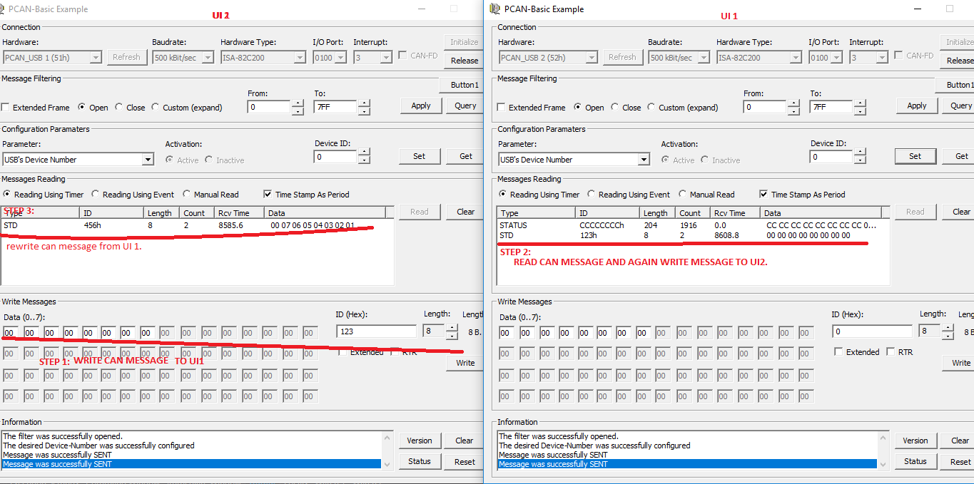 FIG: CHECK THE RESULT FROM ABOVE FIG