**CANDIDA TROPICALIS**

|  |  |
| --- | --- |
| SCIENTIFIC CLASSIFICATION | |
| Kingdom | Fungi |
| Division | Ascomycota |
| Class | Saccharomycetes |
| Order | Saccharomycetales |
| Family | Saccharomycetaceae |
| Genus | Candida |
| Species | C.tropicalis |

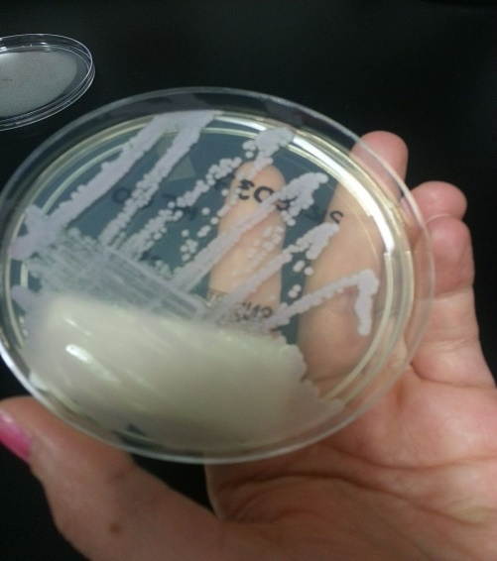

(culture from microbology lab hospital Lisbon)

Candida tropicalis is a species of [yeast](https://en.wikipedia.org/wiki/Yeast) in the genus [Candida](https://en.wikipedia.org/wiki/Candida_(fungus)). It is a common pathogen in neutropaenic hosts, in whom it may spread through the bloodstream to peripheral organs. For invasive disease, treatments include [amphotericin B](https://en.wikipedia.org/wiki/Amphotericin_B), [echinocandins](https://en.wikipedia.org/wiki/Echinocandin" \o "Echinocandin), or extended-spectrum [triazole antifungals](https://en.wikipedia.org/wiki/Triazole_antifungal" \o "Triazole antifungal). Recent research (as of September 2016) suggests that Candida tropicalis, working synergistically with [Escherichia coli](https://en.wikipedia.org/wiki/Escherichia_coli) and [Serratia marcescens](https://en.wikipedia.org/wiki/Serratia_marcescens" \o "Serratia marcescens), may cause or contribute to [Crohn's disease](https://en.wikipedia.org/wiki/Crohn%27s_disease" \o "Crohn's disease). Candida tropicalis can be used to produce [biodiesel](https://en.wikipedia.org/wiki/Biodiesel) from [olive trees](https://en.wikipedia.org/wiki/Olive_tree).

**Morphology:**

Cell: reproduce by budding; spherical to ovoid, 3.0-5.5 x 4.0-9.0 um; pseudohyphae and hyphae may be formed

Colony:

* YPD: off-white to grey, cream –colored, dull, soft, smooth and creamy or wrinkled and tough
* Malt agar: White to cream color, smooth, glabrous, fringed border WL = Positive on cycloheximide 0.1
* Spore: Blastospores produced on pseudohyphae, singly, in chains or clusters; Arthroconidia and ballistoconidia are not formed.
* Zygote: NA
* Ascus: NA

Liquid Growth: Subglobose to ovoid, single and paired, can make thin surface film and bubbles in Sabourand broth; sediments can be formed

**Physiological Traits:**

* Fermentation: Glucose, Maltose, Galactose, Trehalose, Raffinose; Sucrose variable.
* Assimilation: Galactose, Maltose, Trehalose, Soluble starch, Succinate, D-Xylose, Arabinose, D-Mannitol, D-Glucitol; variable: Cellobiose, Citrate, Glycerol, Lactate, Ribitol, Salicin, Sucrose, L-Sorbose, Melezitose, Ribose; No assimilation of nitrate; no growth in vitamin free medium: requires biotin; uses as sole N source: Ethylamine, Lysine, Cadaverine
* Growth at 37 C: +; some strains will grow at 40 and 42 C
* Growth sensitivities: will grow on 0.01% and (some strains) 0.1% cycloheximide
* Chromosome bands: 4 to 12 reported

**Ecological Traits:**

Found on human skin mucous membranes, gut flora, soil, fermentation vats, water, leaves, raw honey and flowers; rarely found in wine when found, likely evidence of human contamination perhaps during plating.

**Distinguishing Features:**

Unlike physiologically similar C. maltose, C. tropicalis can assimilate starch. Unlike C. sake, it can grow at 35° C. inositol -, nitrate -, erythritol -.  
Role in wine:  Genus Candida is known to grow during first few days of fermentation at which point they die off  
 **Sensitivities**:

* SO2:
* Sorbate:
* DMDC:
* Optimum pH: 3.5-6.6
* Ethanol: 0.85M
* Anaerobiosis:
* Optimum Heat: 20 to 45°C