CO2_AT2
Weather Monitoring System – Closest Pair Using Brute Force
Name: P C Vamsidhar Reddy
Reg no: 192465045

Aim:
To find the nearest pair of weather stations using the brute-force closest pair algorithm and analyze its time complexity.
Procedure
- Define the coordinates of all weather stations.
- Compare every station with every other station.
- Calculate the Euclidean distance between each pair.
- Store the minimum distance and the corresponding pair.
- Display the closest pair and minimum distance.
- Analyze the time complexity.

Algorithm
Step 1: Start.
Step 2: Read the coordinates of weather stations.
Step 3: Initialize the minimum distance as infinity.
Step 4: Compare every pair of stations using nested loops.
Step 5: Calculate the Euclidean distance for each pair.
Step 6: Update the minimum distance if a smaller distance is found.
Step 7: Display the closest pair and minimum distance.
Step 8: Stop.

Code & Output
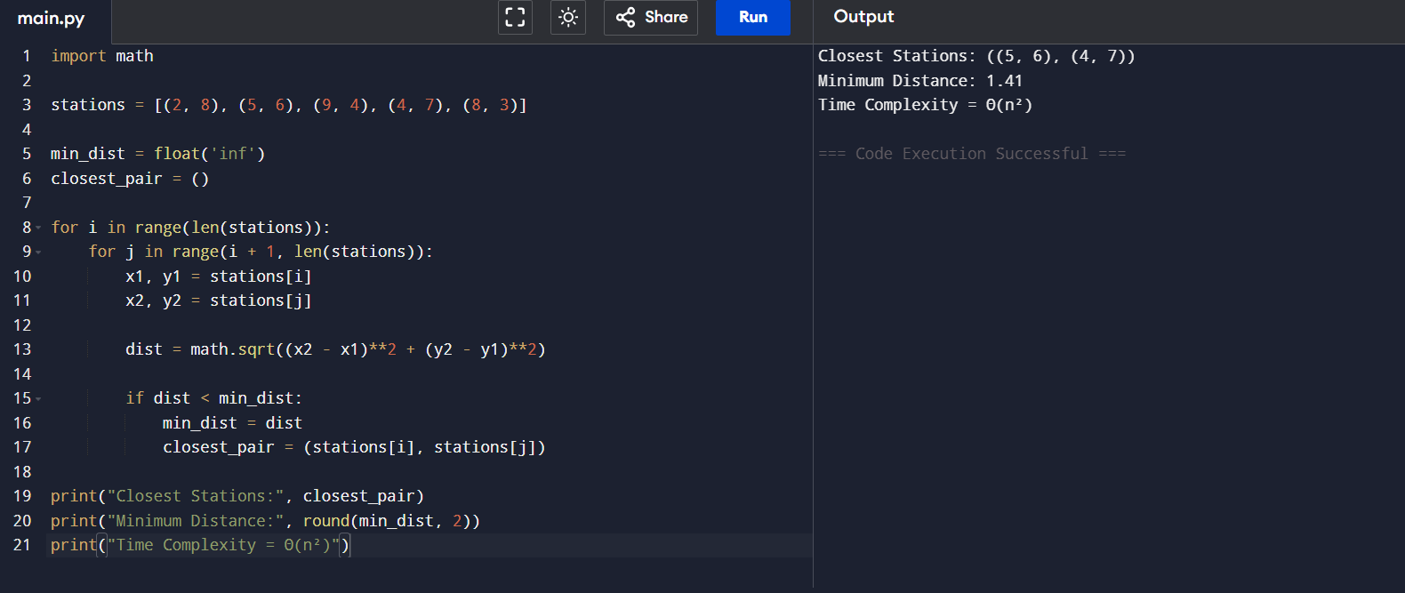

Analysis
- Number of weather stations = 5
- Total pairs compared = 5 × 4 / 2 = 10
- Every pair is checked exactly once.
- Time Complexity = Θ(n²)

Result
The brute-force closest pair algorithm successfully identifies the nearest weather stations by evaluating all possible pairs. Although it guarantees the correct result, its Θ(n²) time complexity makes it inefficient for large-scale weather monitoring systems containing a large number of stations.

