1. *Online TODO List web application*

* This application was developed using Spring boot framework with built in H2 database and Tomcat server.
* To login into the application, there are few predefined users created and user/password are mentioned below.

User1/User1

User2/User2

User3/User3

Password is hardcoded with encrypted format using BCryptPasswordEncoder .

Example is in the source code (SecuredPasswordGenerator.java)

* User can add/delete their task.
* User can able to track his/her tasks along with latest changes with date updated.
* Also, user can mark their tasks.

1. *Application functionality*

* Home screen: (http://localhost:8080/)

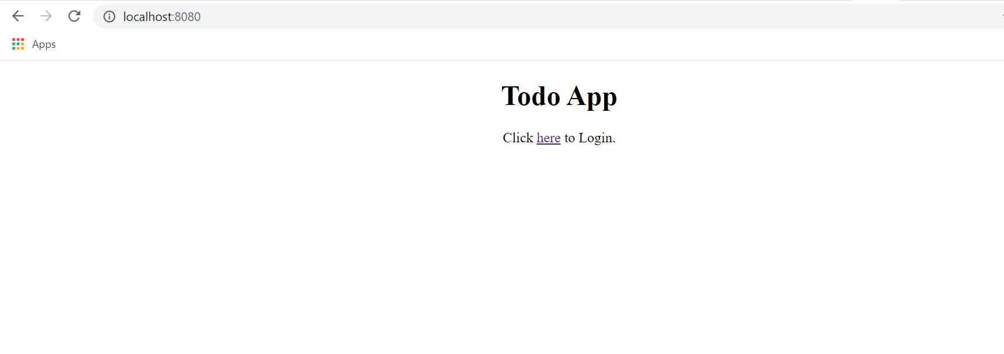

* Login screen: (http://localhost:8080/login)

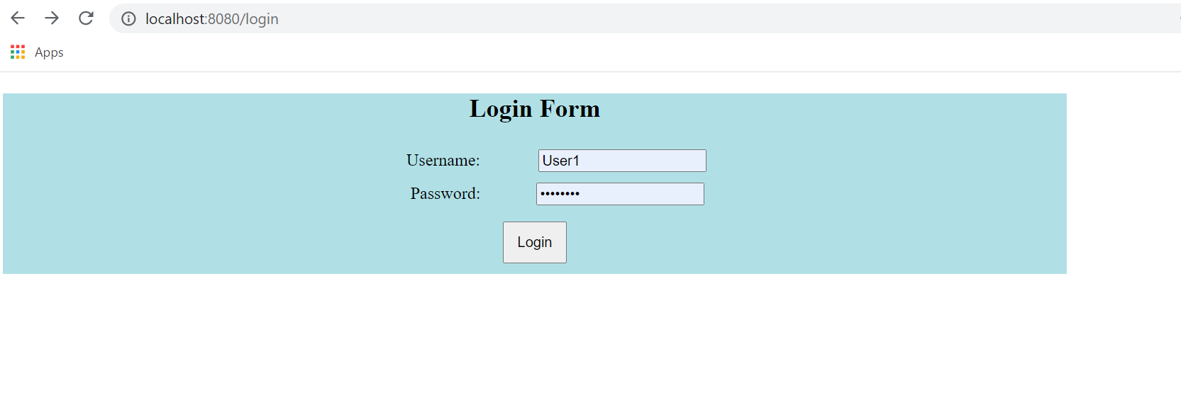

* Welcome screen: (http://localhost:8080/welcome)

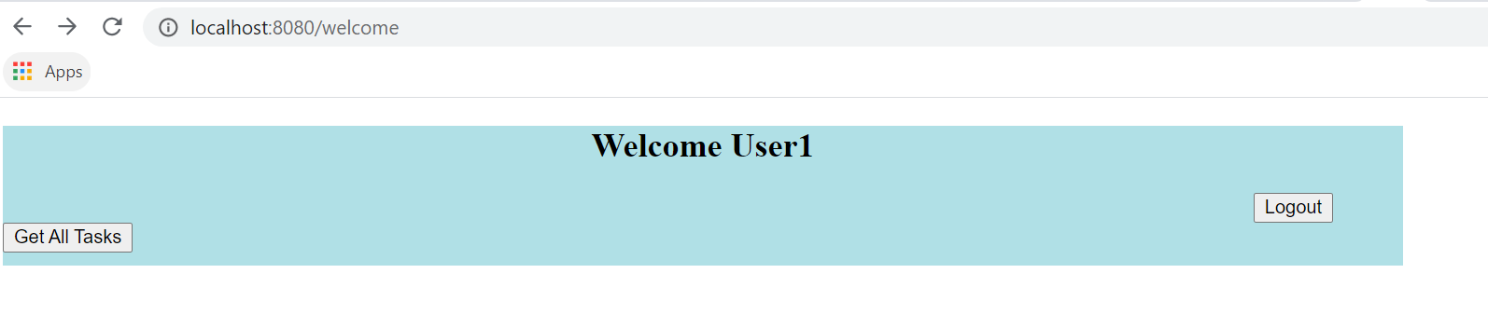

* Get All tasks: By clicking the Get All Tasks button.

If there are no tasks created an empty task list will be displayed.

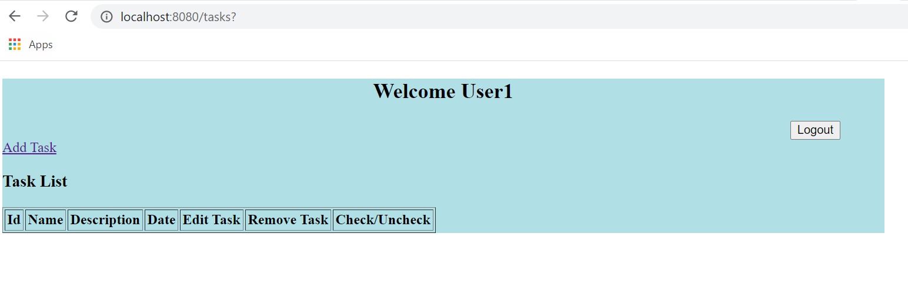

* Add Task : By clicking the Add Task link

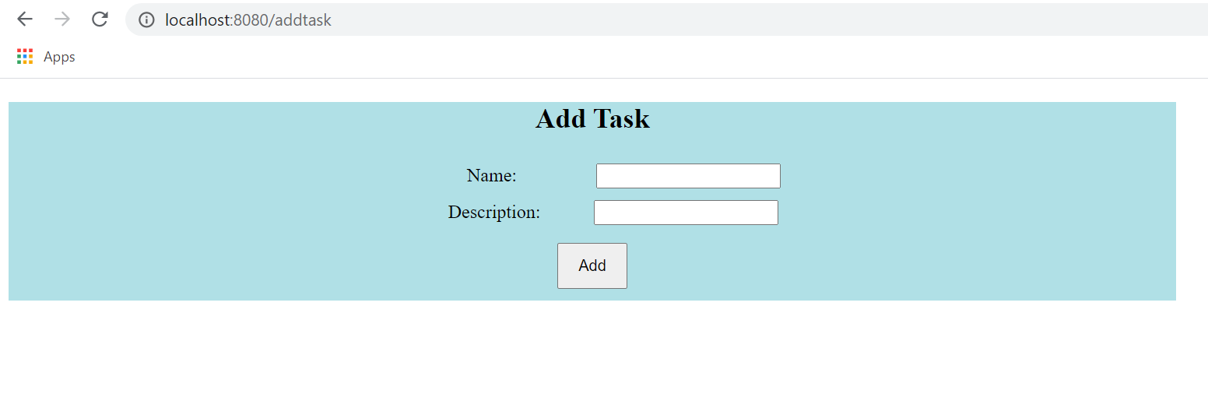

* User can Edit and Delete the task.
* User can also mark their task by clicking check and uncheck box. Marking check and uncheck are auto saved.

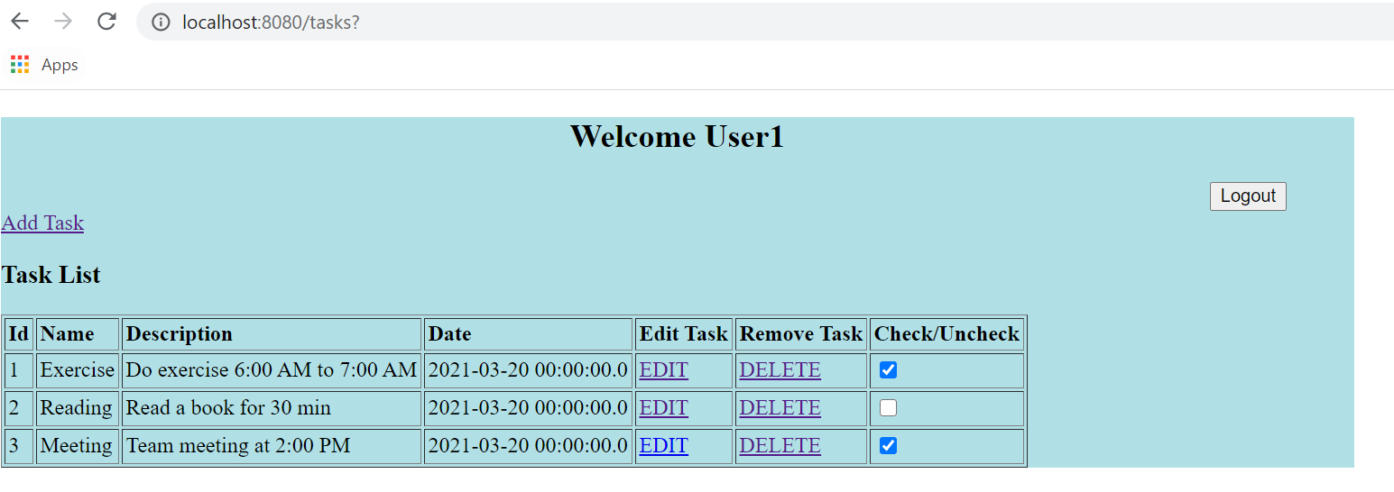

* Logout : User can logout by clicking logout button.

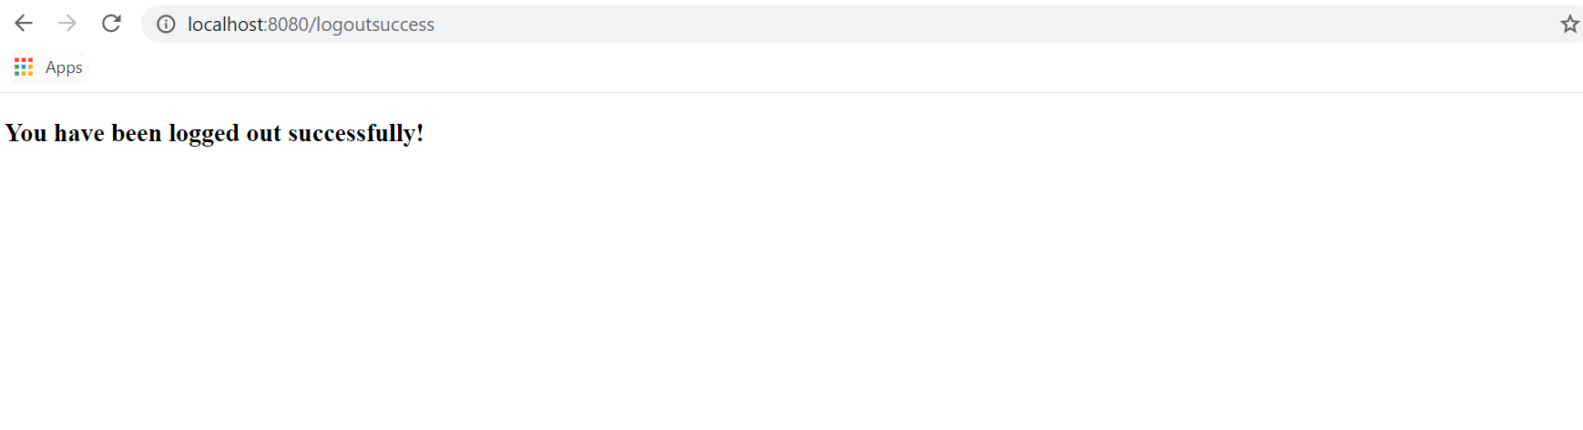

1. *Test cases*

* Below are unit test cases for both the ***Service*** and ***Controller***.

