**V-ACADEMY**

**Team Names:**

Parangi . Sandeep Kumar

Konakanchi . Vamsi Krishna

Kothuri . Bhargava

Use Case:

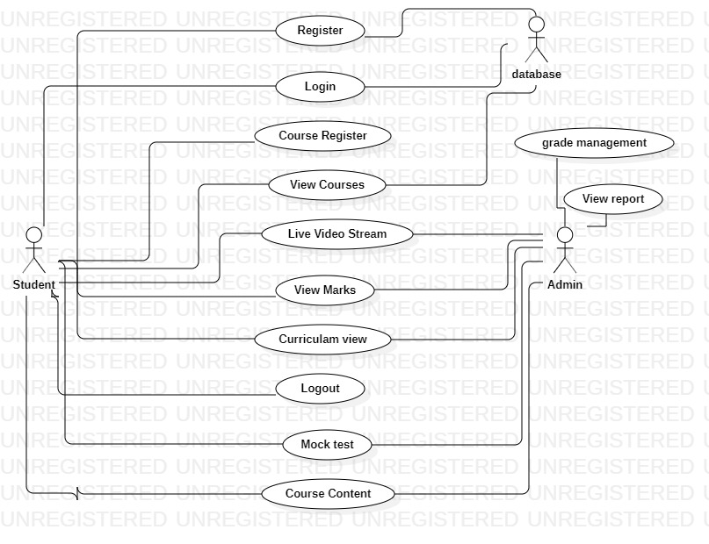

Class Diagram:

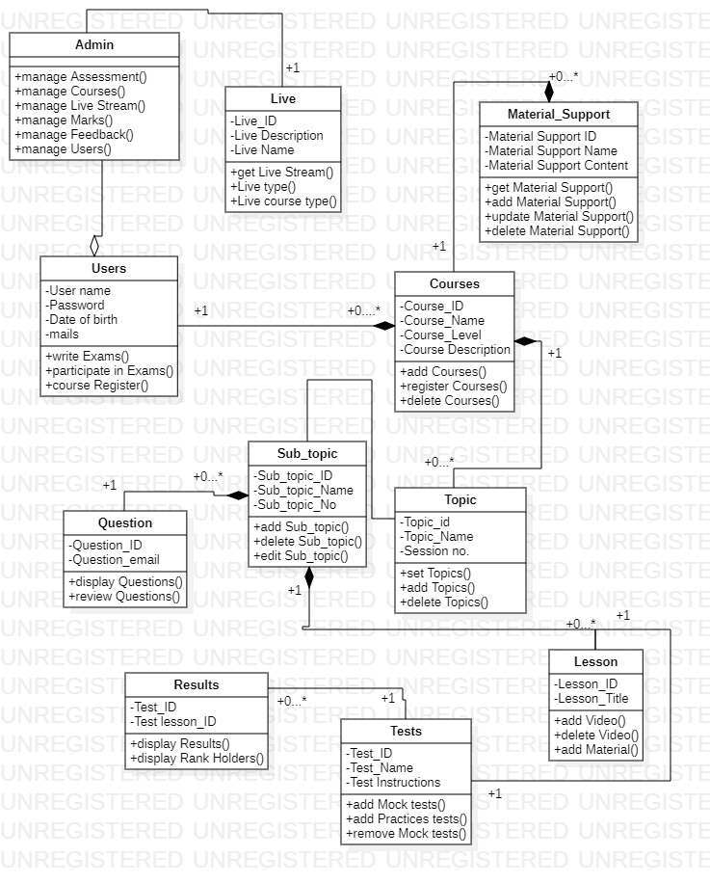

Activity Diagram:

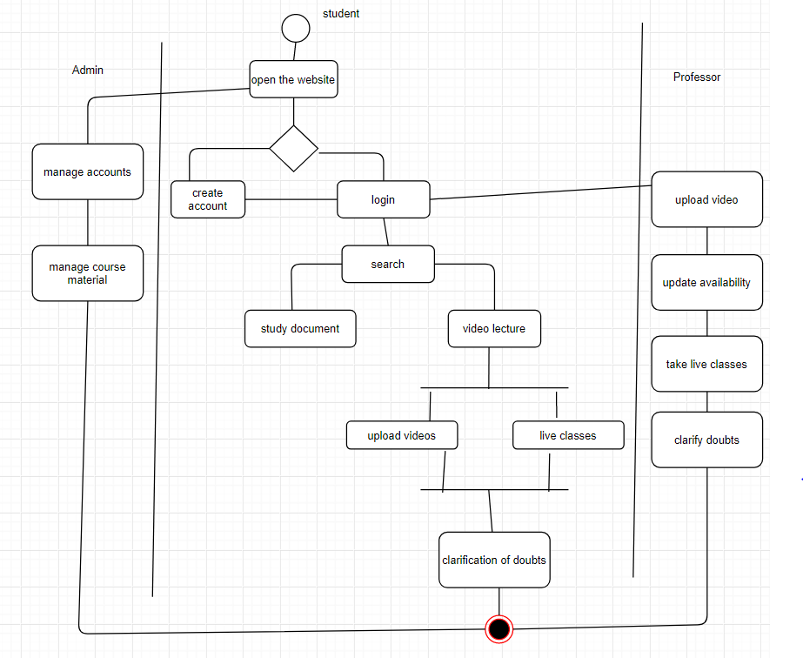

Sequence diagram for user:

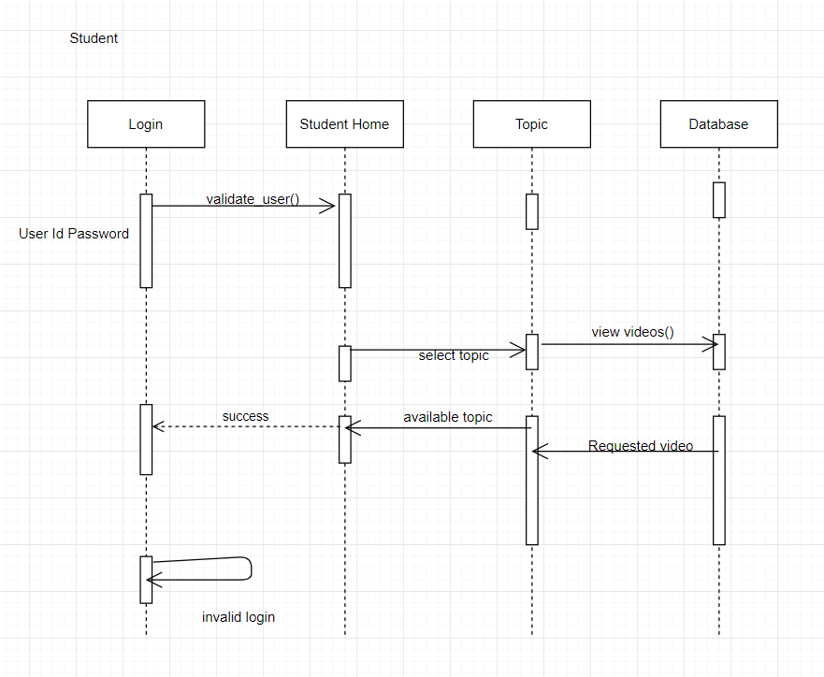

Sequence diagram for Professor:

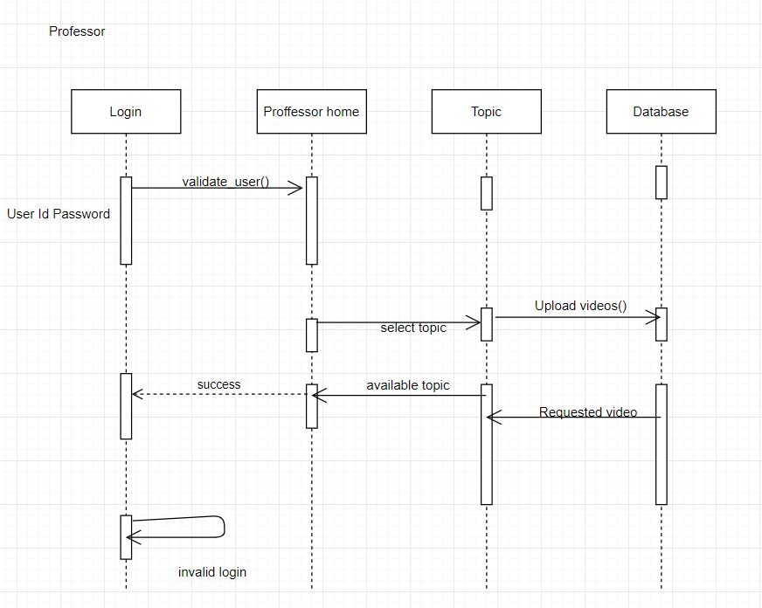

Layered Architecture:

