1.Activate Vagrant by typing in   
>>vagrant up

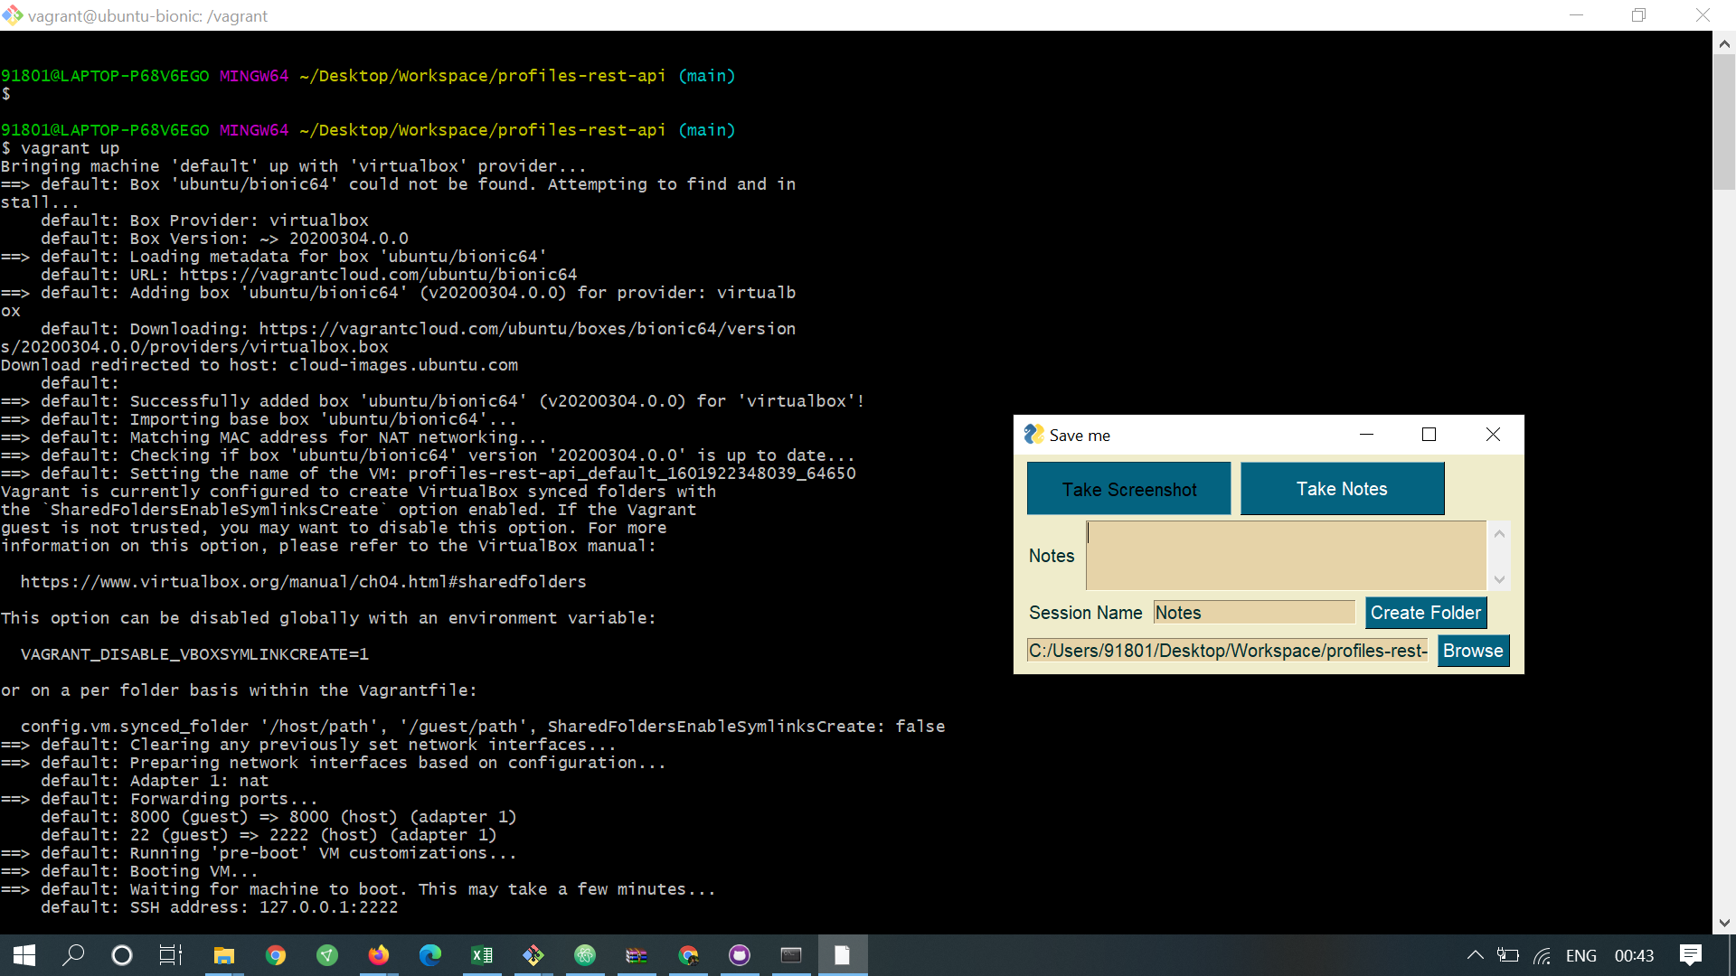

2.Connect by using vagrant by giving this command.  
>>vagrant ssh

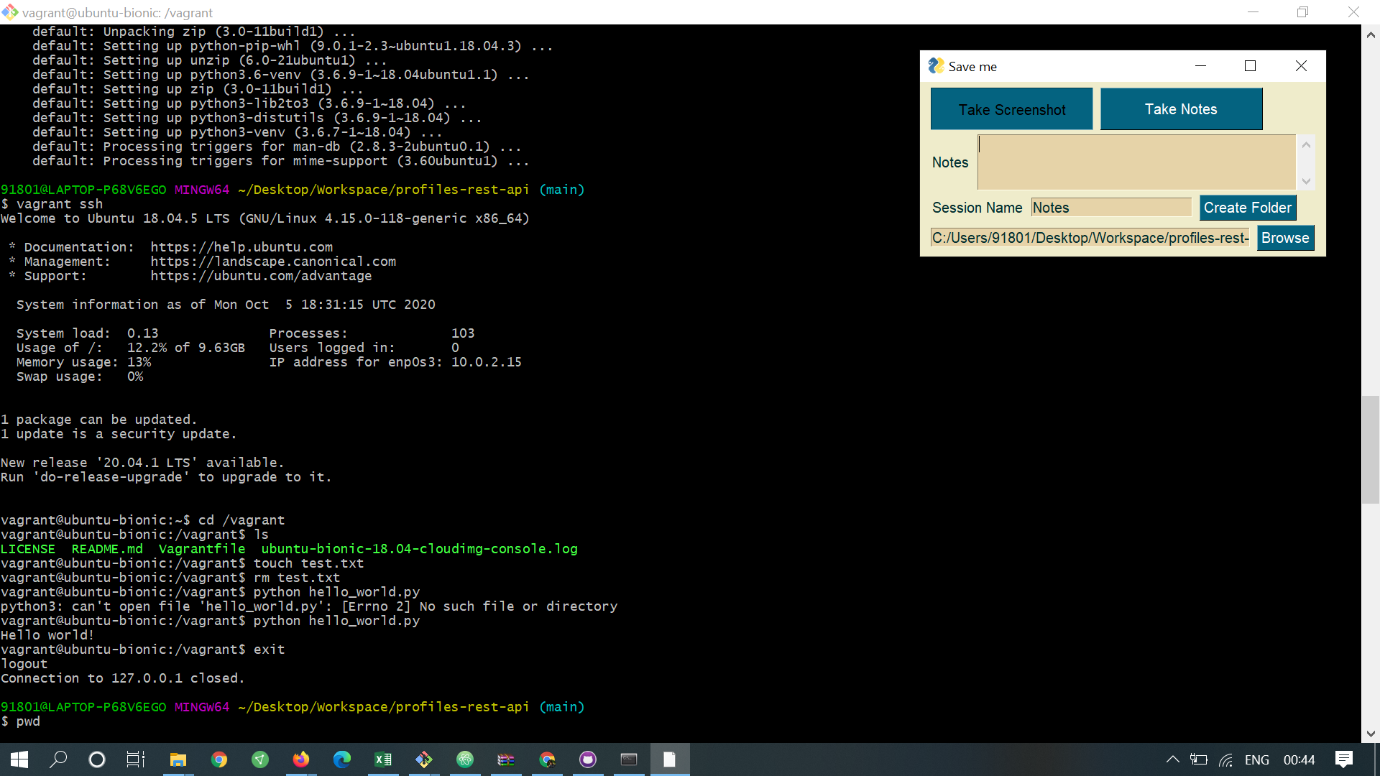

3. The /vagrant folder syncronizes with your root directory.

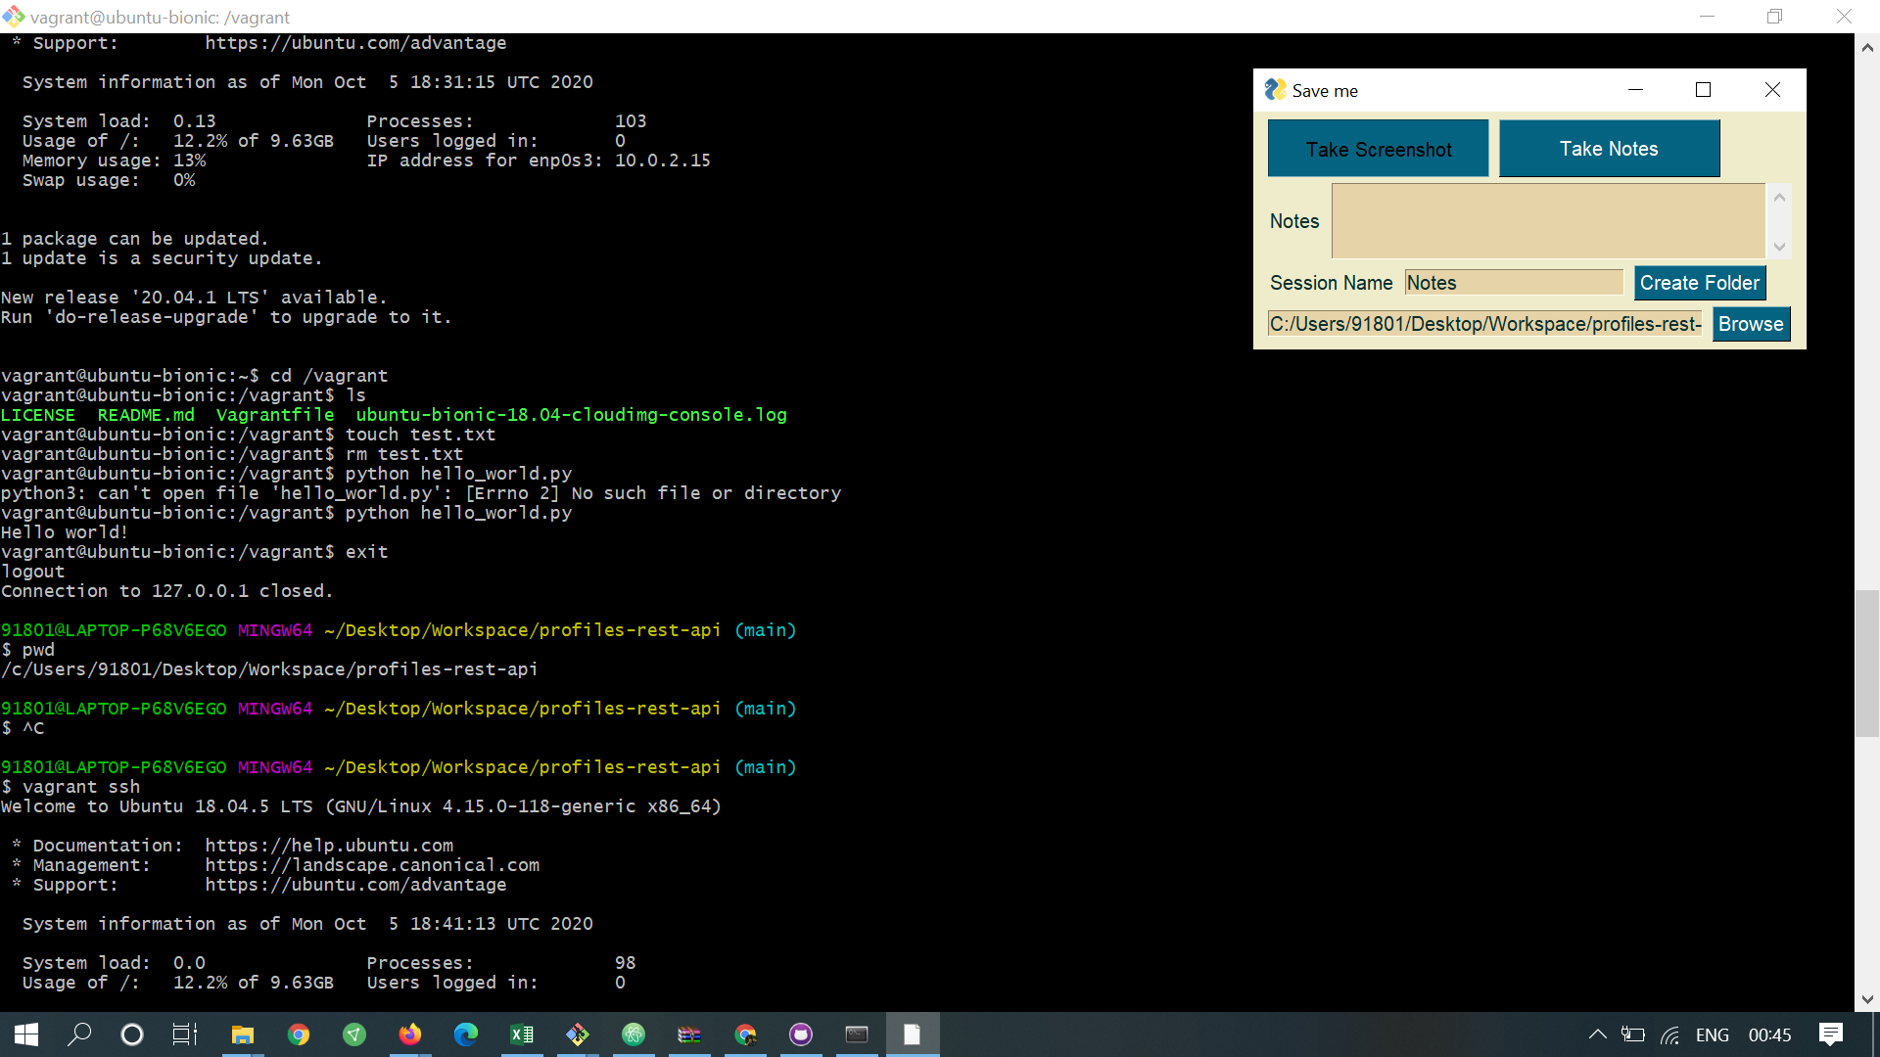

4. you can create a virtual environment in vagrant usingg -   
>>python ~/env/bin/activate

To deactivate - just type in >>deactivate

5.To install django , type -  
>>pip install -r requirements.txt

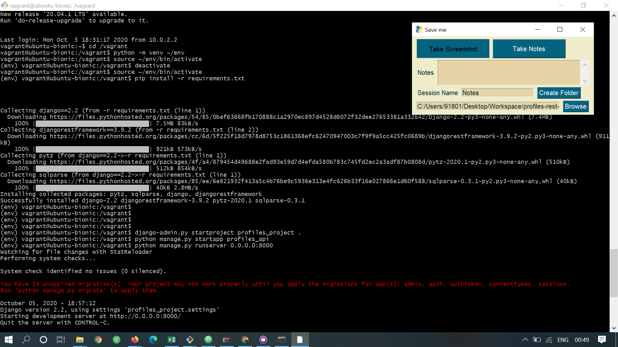

6. Create a Django project with the command (. in the below command saves the profiles_project within the root directory)-  
>>django-admin.py startproject profiles_project .

7. To create a Django APP, type -   
>>python manage.py startapp profiles_api  
  
8. To run the django server (0.0.0.0:8000 is the home )-   
>>python manage.py runserver 0.0.0.0:8000

8. You need to add the APPs created in the project settings file for Django.

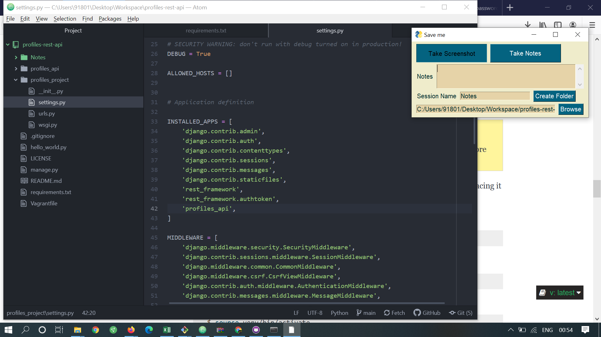

Last 4 rows in the INSTALLED_APPS have been added for our purpose

10. Usually Django has some models concept. (Need to learn more)

Django comes with a default database model, We customise this model for our purpose

We are adding our model code in the models.py in profiles_api folder.  
  
In the code we need to import the following default packages when we overwrite the standard models.  
  
from django.contrib.auth.models import AbstractBaseUser  
from django.contrib.auth.models import PermissionsMix

*mixin

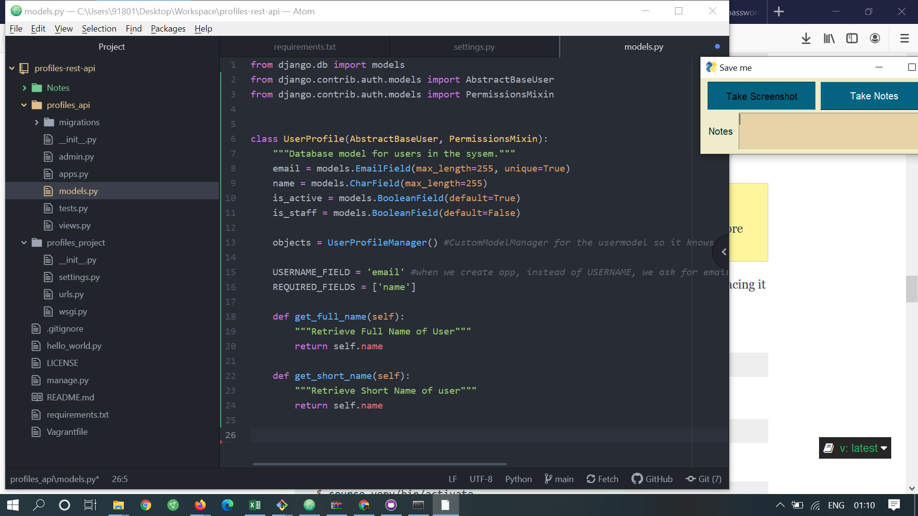

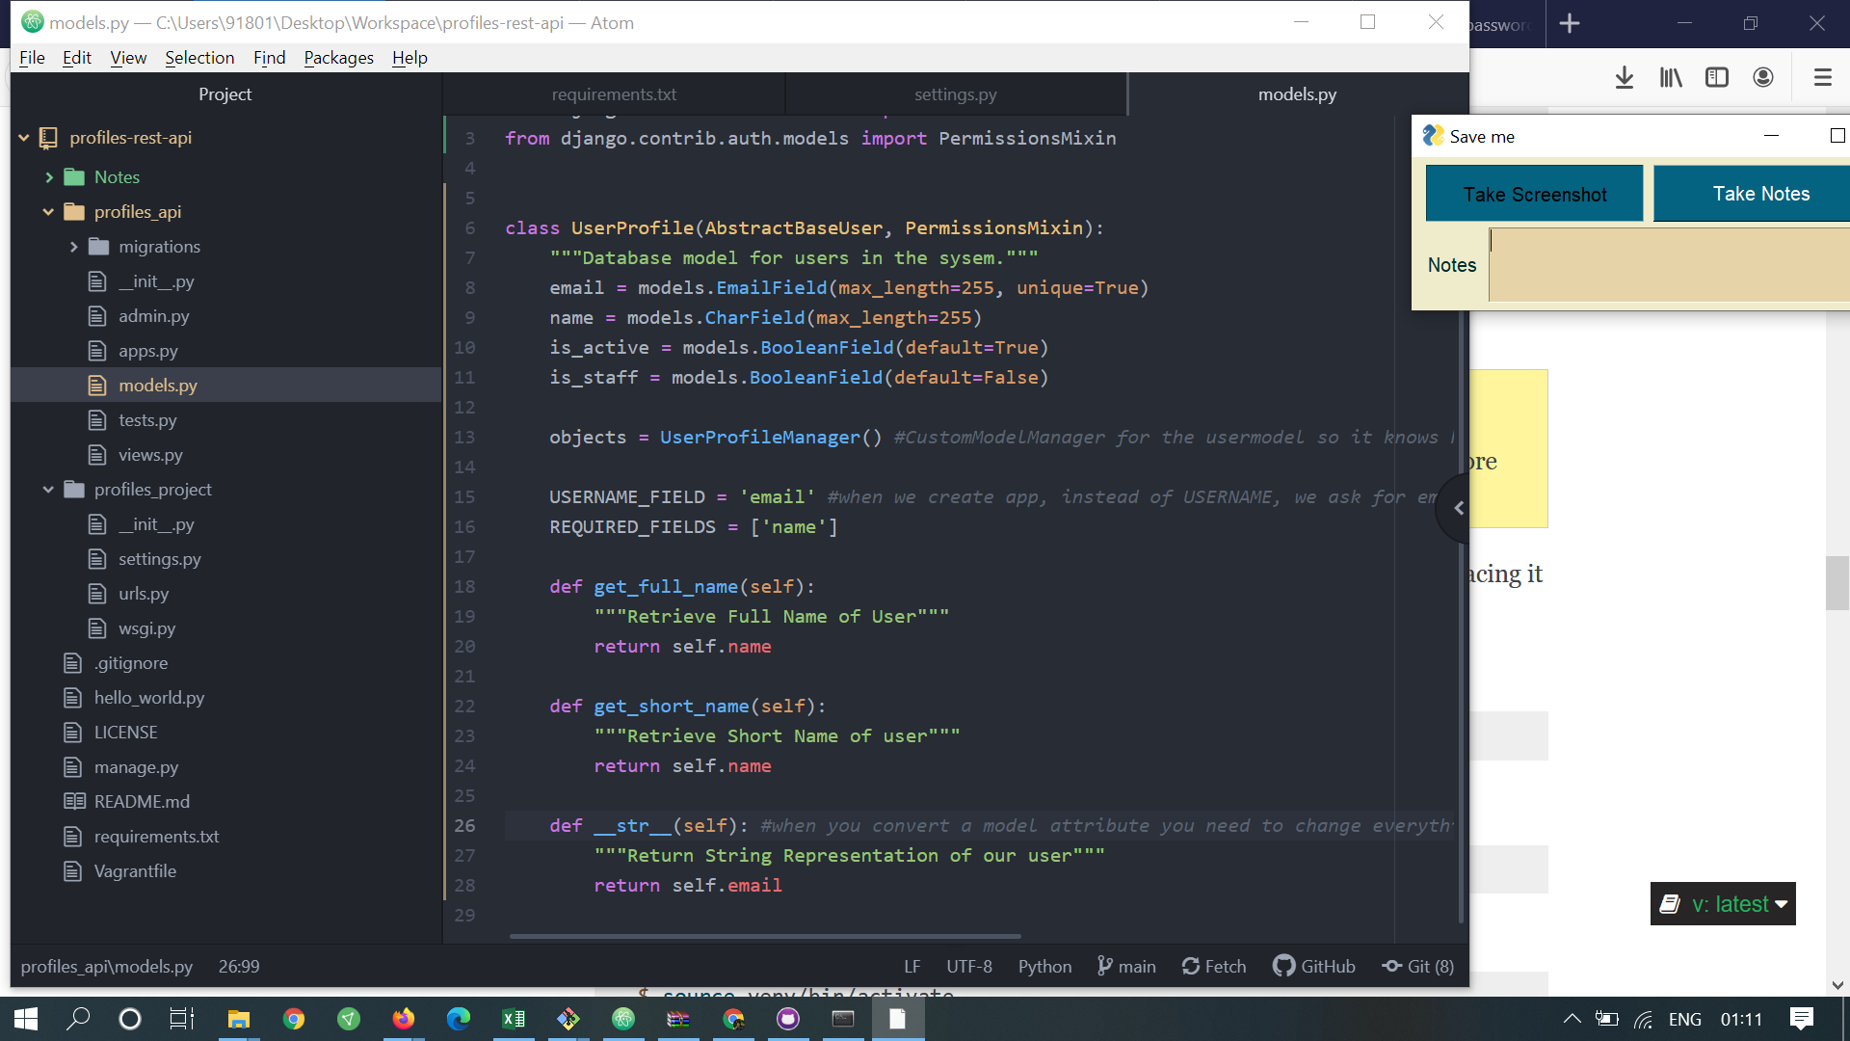

Django Manager has full control and manages all our apps.

We use create SuperUser command to create a manager to customize our models.

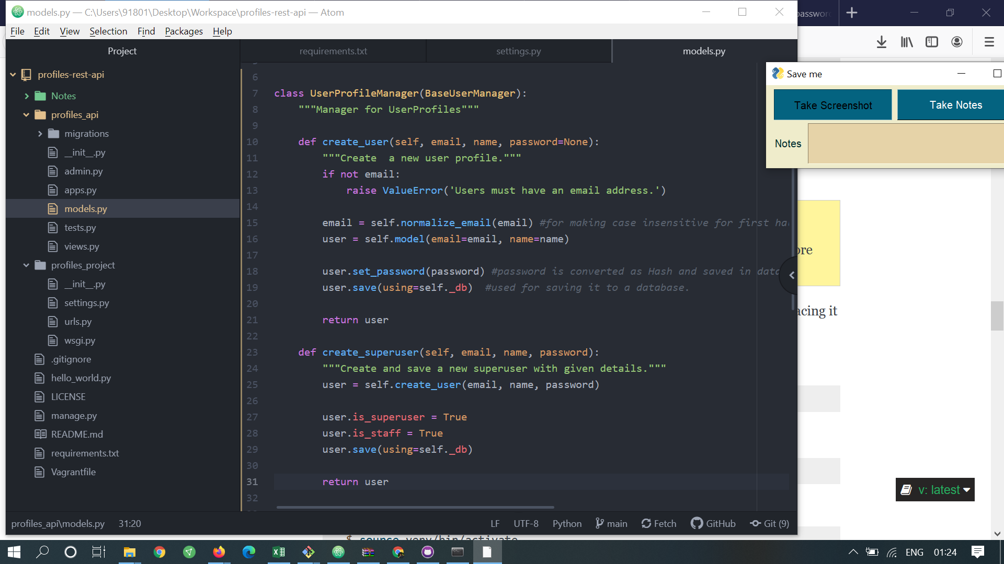

After writing model manage code in models.oy  
  
we need to add a new line in settings.py in profile_project folder -  
>> AUTH_USER_MODEL = 'profiles_api.UserProfile'

This tells our Django app to search for profiles_api and pick the custom user model in the folder.

# We create migrations for our models.  
Django manages its database by creating Migration files.  
Migration files stores all the steps of required to make our database match our Django Models.  
  
So everytime you change or additional models, we need to create a new migration file.

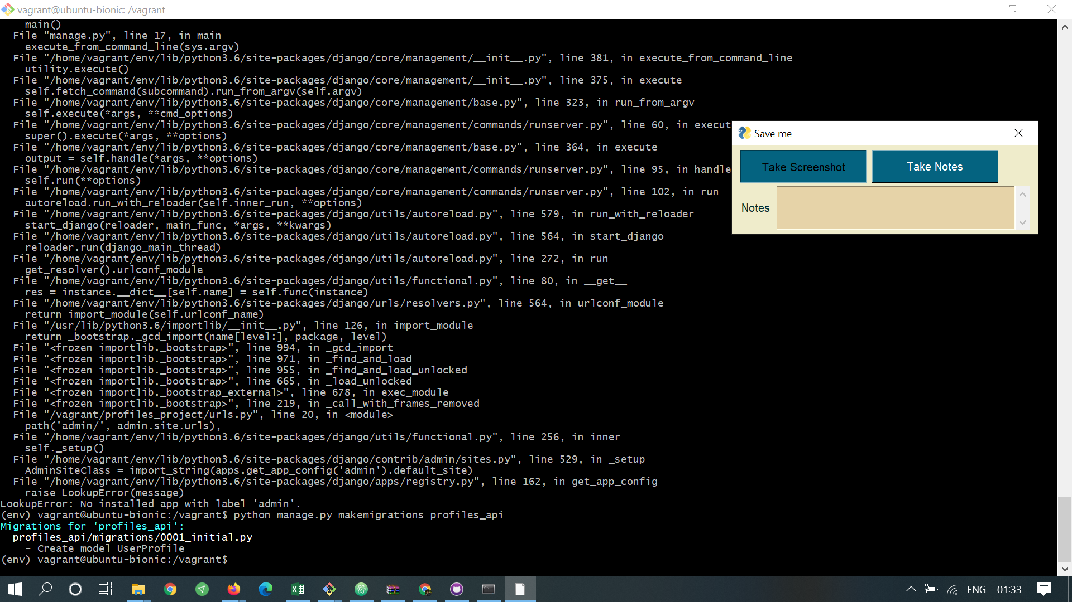

python manage.py makemigrations profiles_api

once migrations file is created, type -   
>>python manage.py migrate

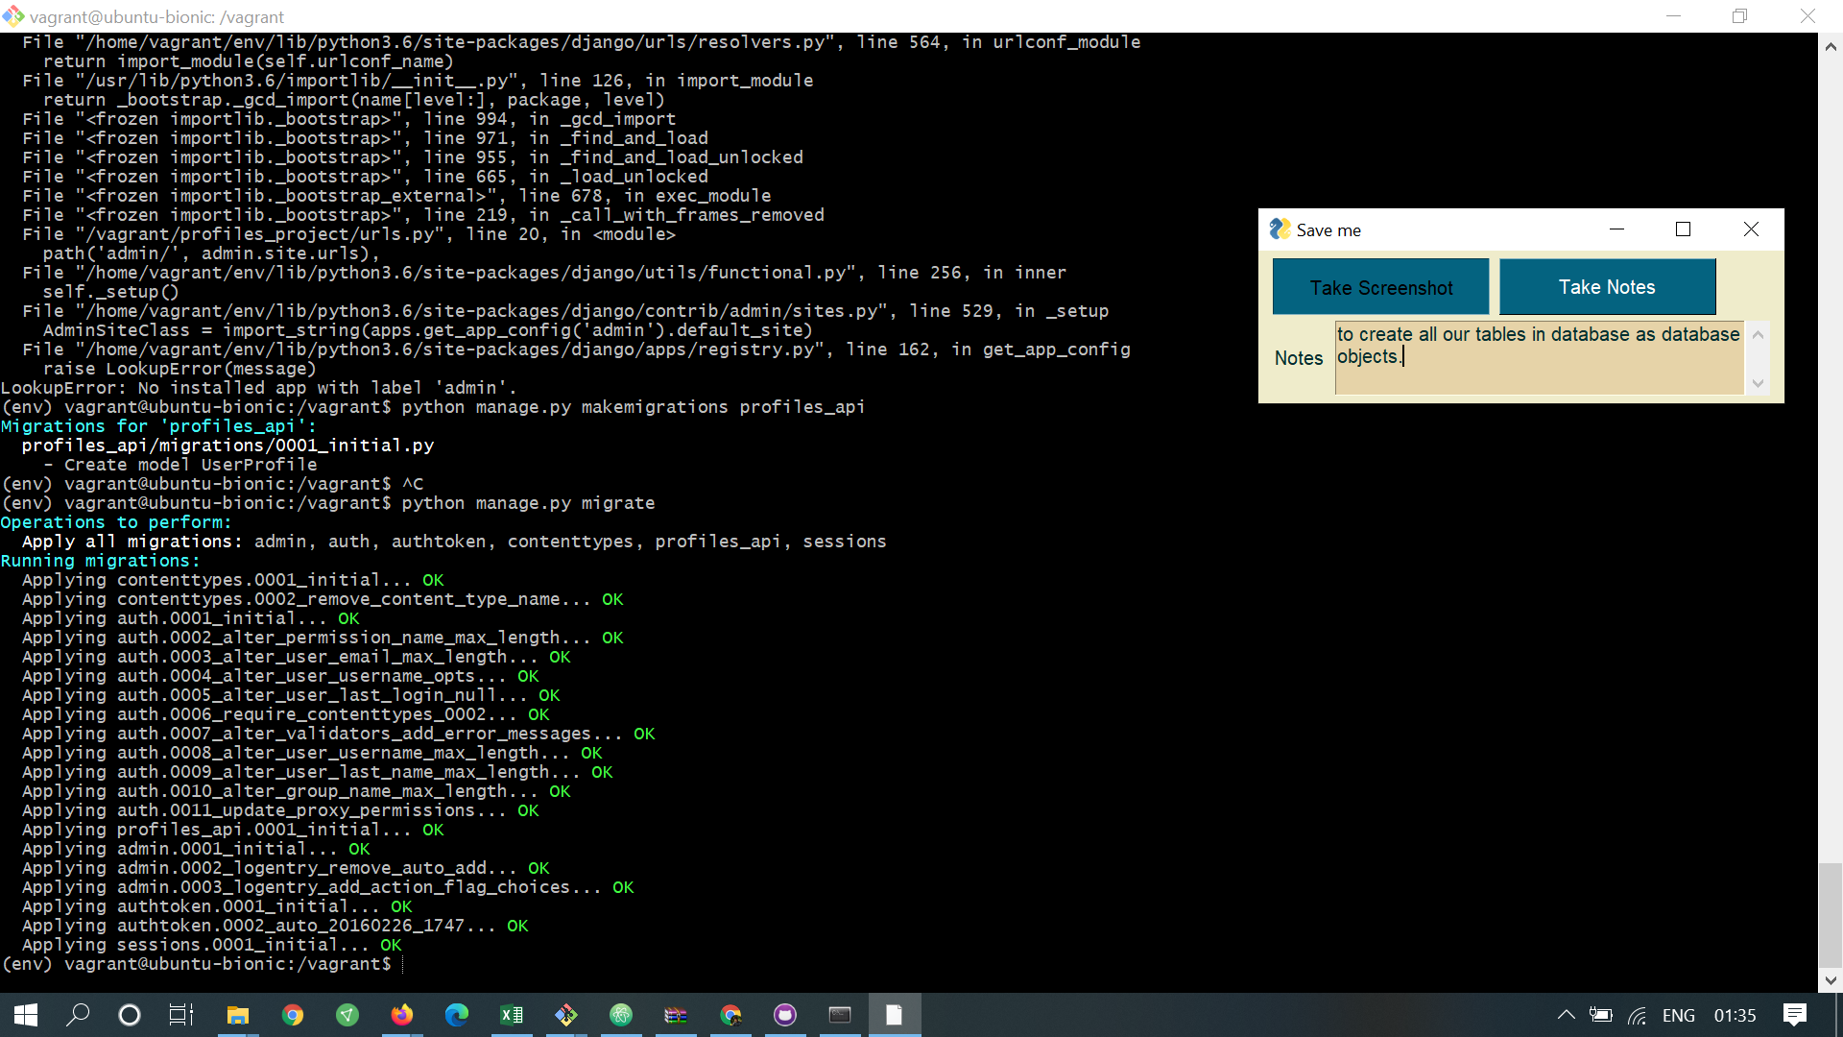

to create all our tables in database as database objects.

Created a SuperUser.

>> python manage.py createsuperuser

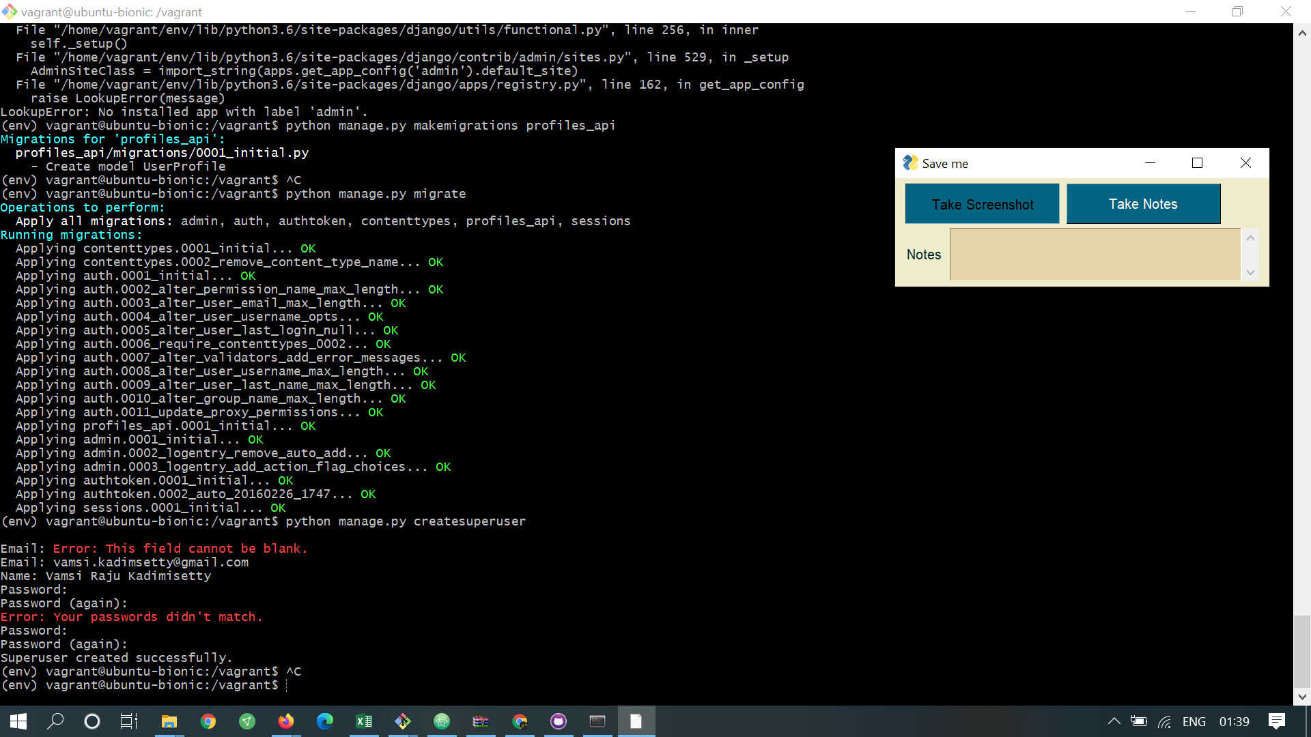

#ByDefault Django Admin is enabled for all the projects.

Any newly created models has to be registered with Django Admin, so that it knows you want to display the model in the admin interface.

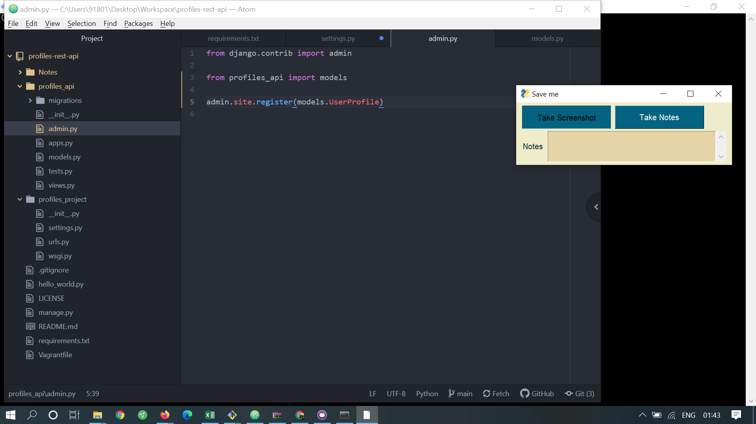

>>admin.site.register(models.UserProfile) in admin,py

To run the Django Server,  
>> python manage.py runserver 0.0.0.0:8000  
and type the url in the browser - > 127.0.0.1:8000  
  
127.0.0.1:8000/admin -> takes you to admin page.

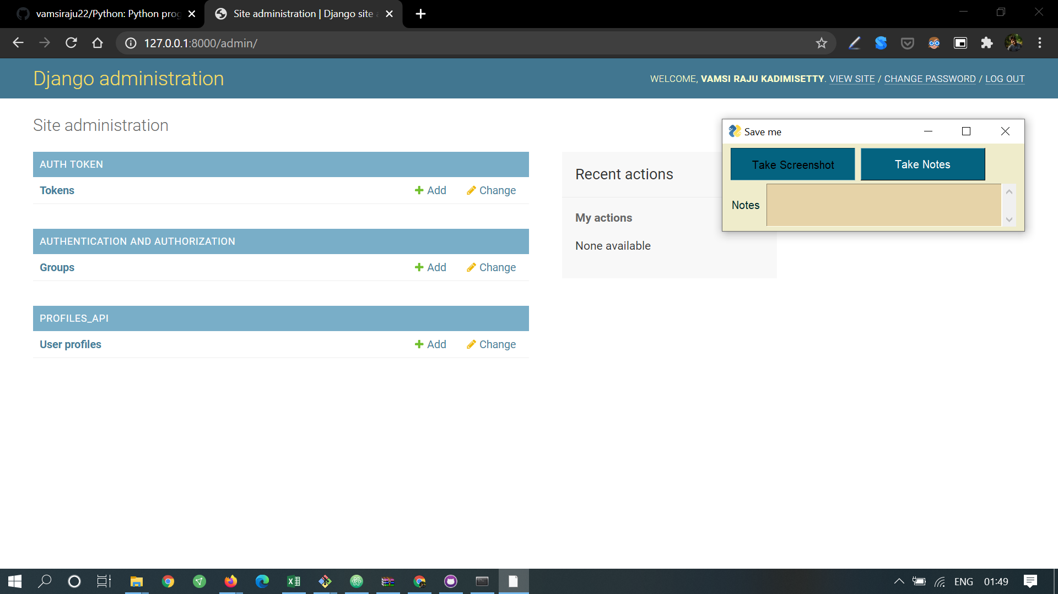

AUTH TOKEN AND   
AUTHENTICATION AND AUTHORIZATION by default.  
 Our App PROFILES_API is displayed.

User Profiles Model that we created is displayed in our APP.