1. Architecture Evidence

API Gateway
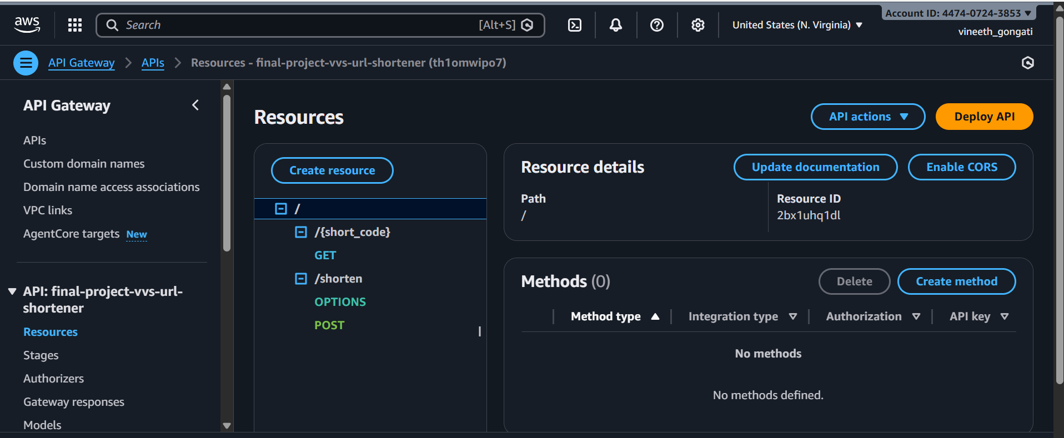

Lambda Functions
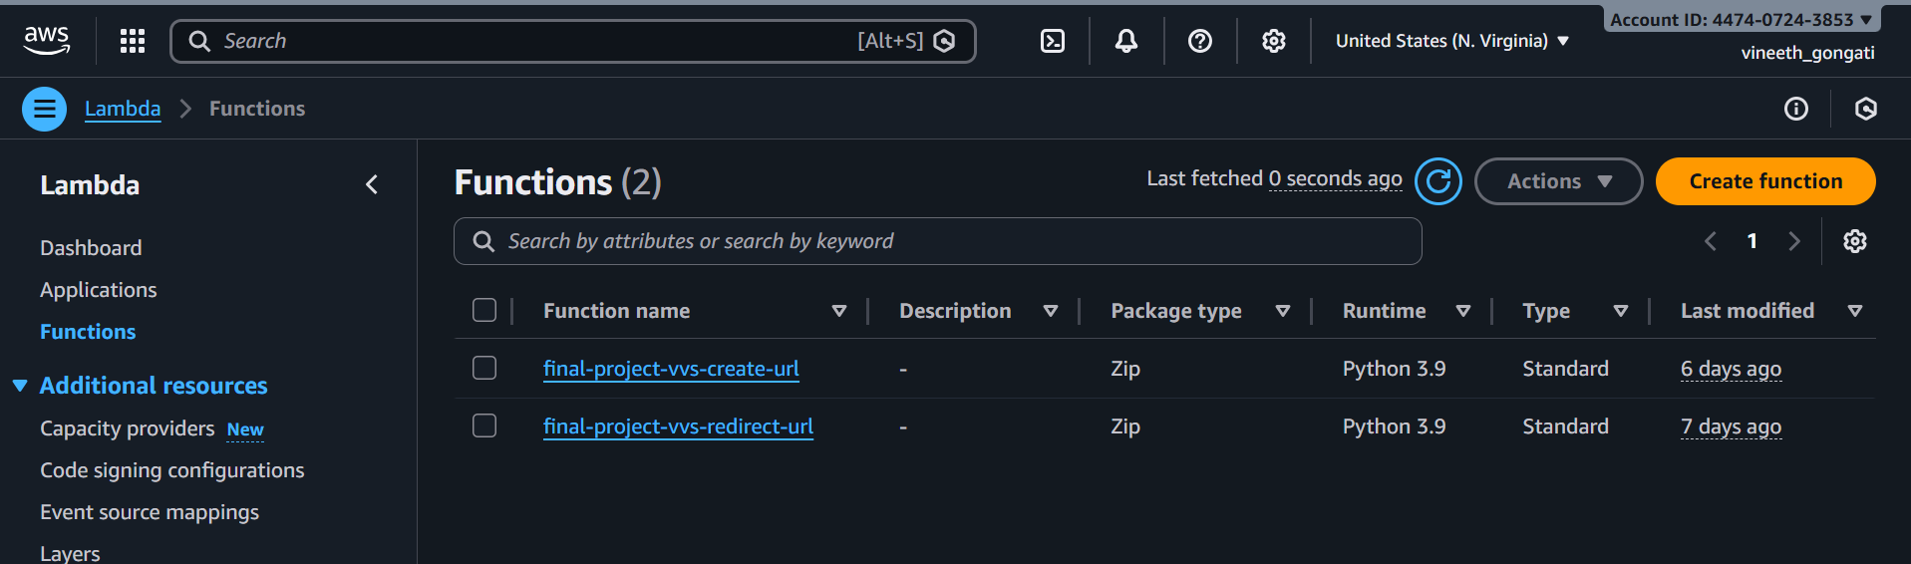

DynamoDB Table
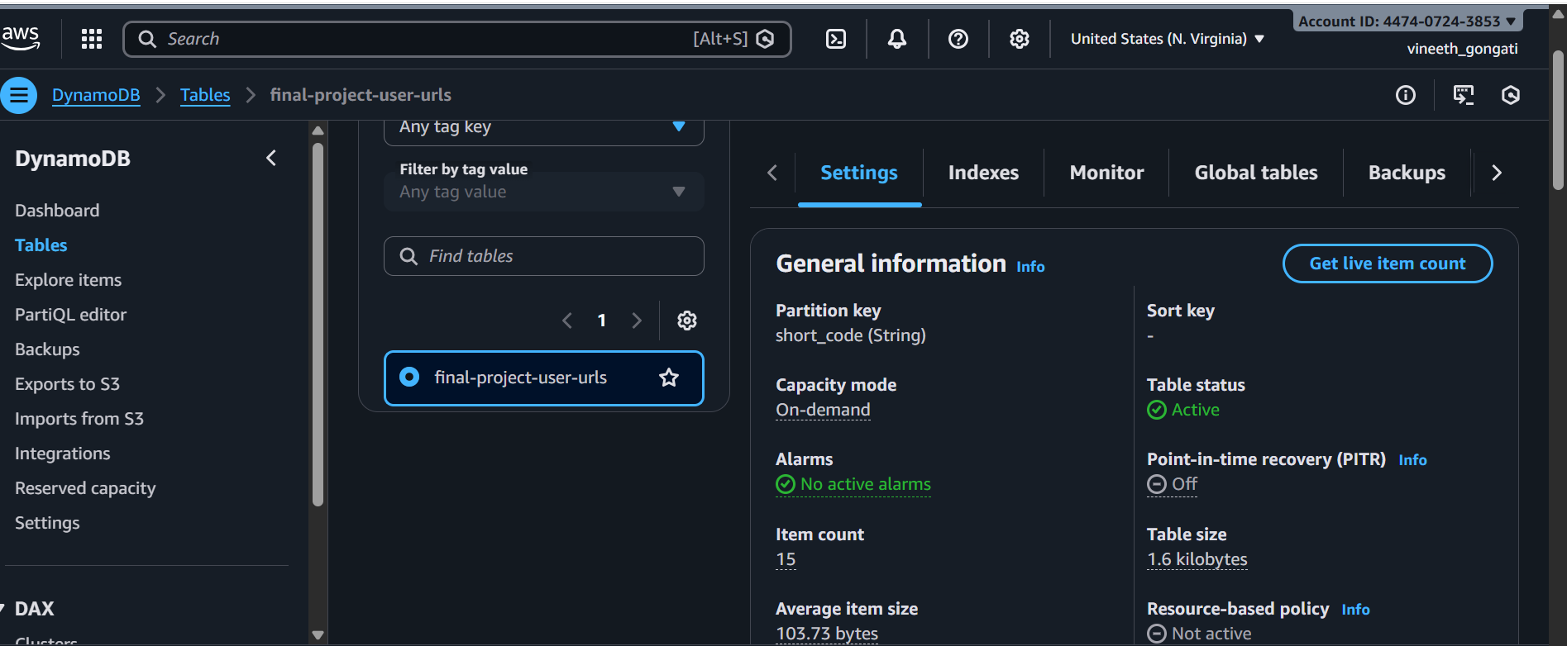
S3 Static Website
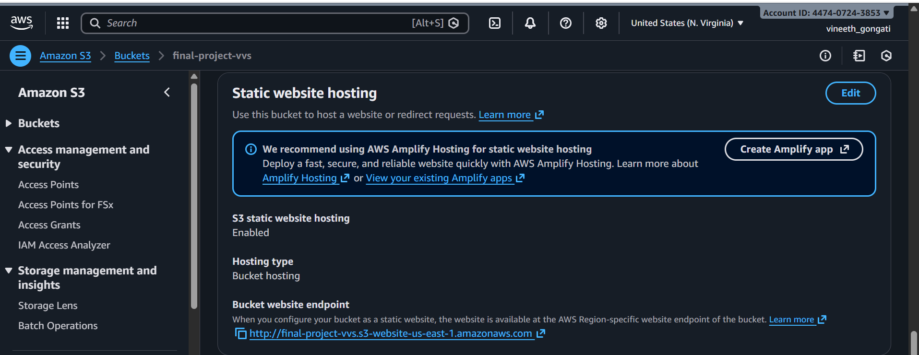

2. Security & IAM Proof
Lambda IAM Role
- With Least-privilege access
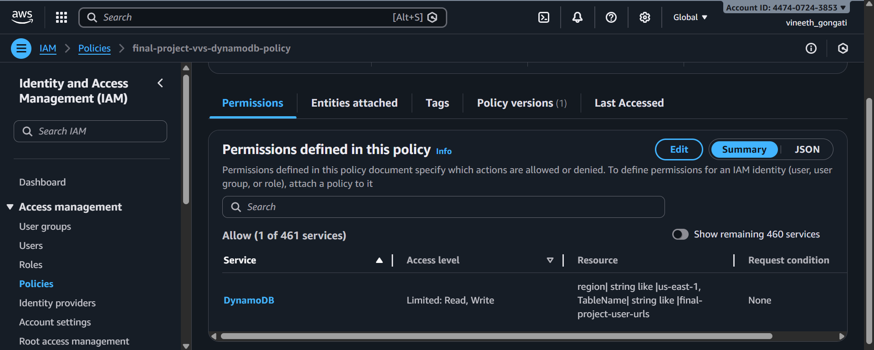

Lambda
- No secrets in code or environment variables
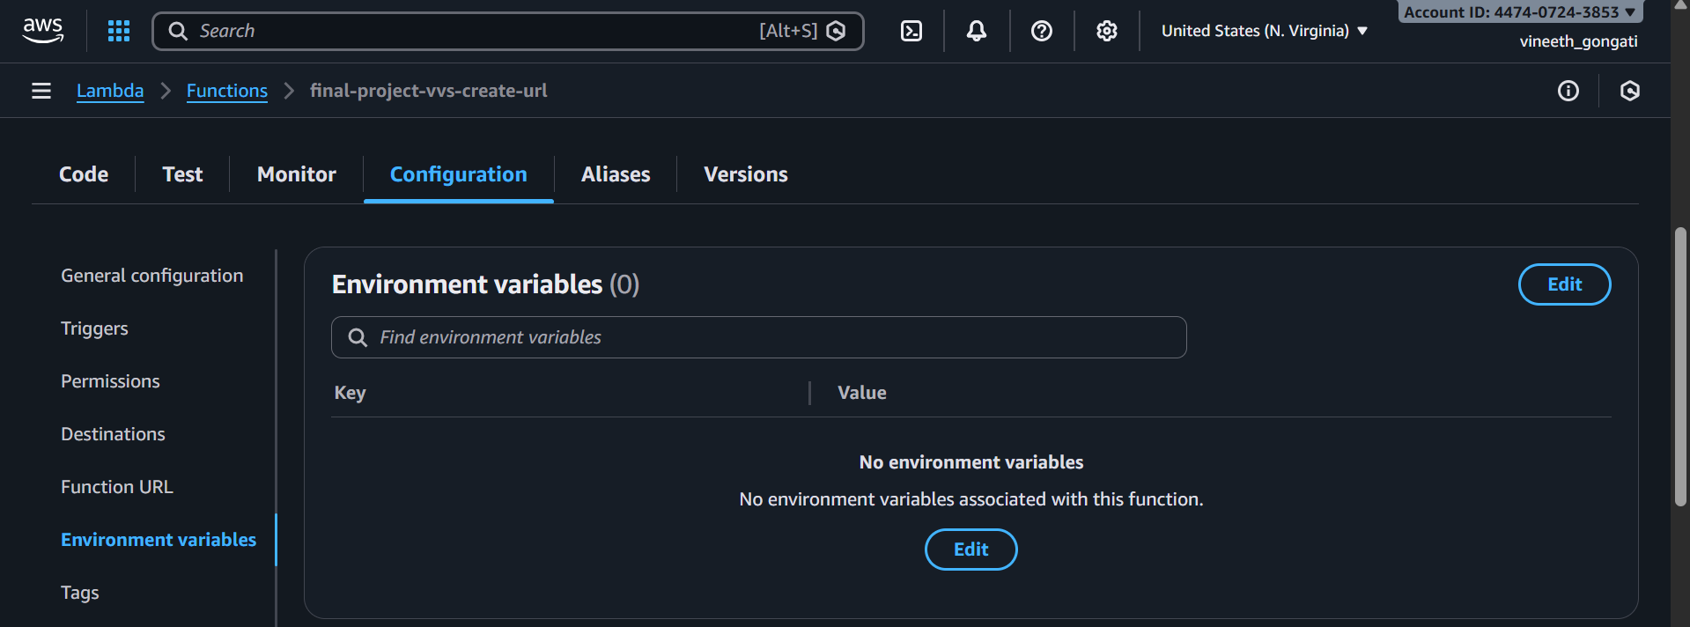

3. Application Working Proof
Write Path (POST) – DB write working
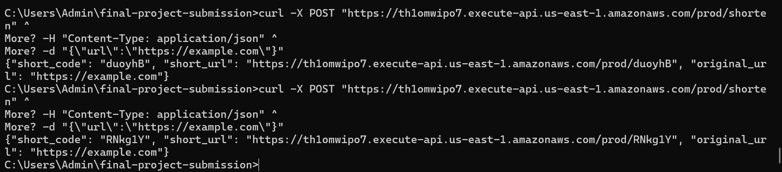

DB read working / Redirect verified
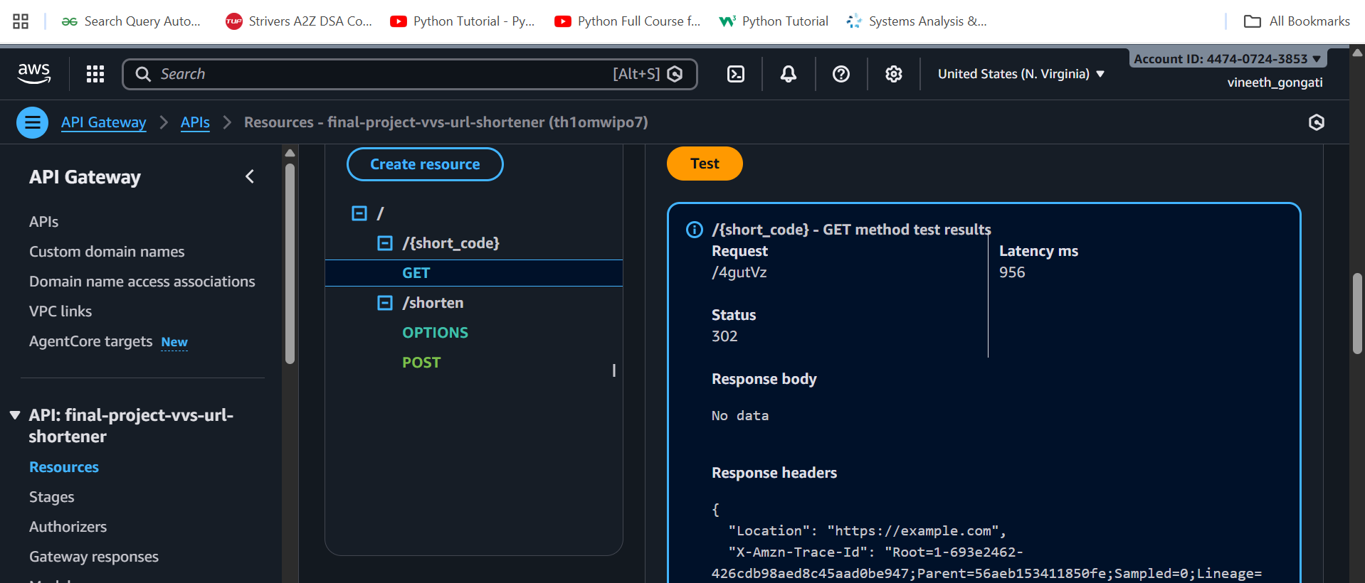

Redirect verified
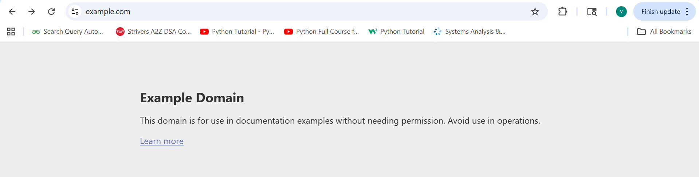

4. Monitoring Evidence
CloudWatch Metrics - Lambda
