Azure Setup Guide
Connecting your Azure environment to the billing assistant
There are two parts:
- Part 1 — register a small app in your Entra ID (Azure AD), so your own team can sign in with their existing company accounts.
- Part 2 — create a read-only credential (a “service principal”) and grant it access to your subscription's cost data, so the assistant can look up spending automatically.

Part 1 — Register the Entra ID App (for sign-in)
This is what lets your team sign in with their existing company Microsoft accounts. It's a separate, unrelated identity from Part 2 — this one only ever handles login, never billing data.

Step 1.1 — Go to Entra ID → App registrations
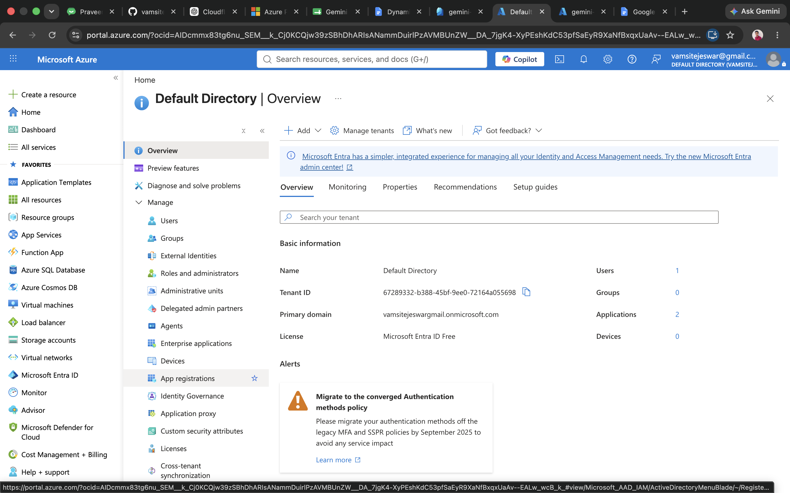
Your Entra ID (Azure AD) Overview page. Your Tenant ID is shown here — you'll need this later. “App registrations” is in the left-hand menu.

Step 1.2 — Click “+ New registration”
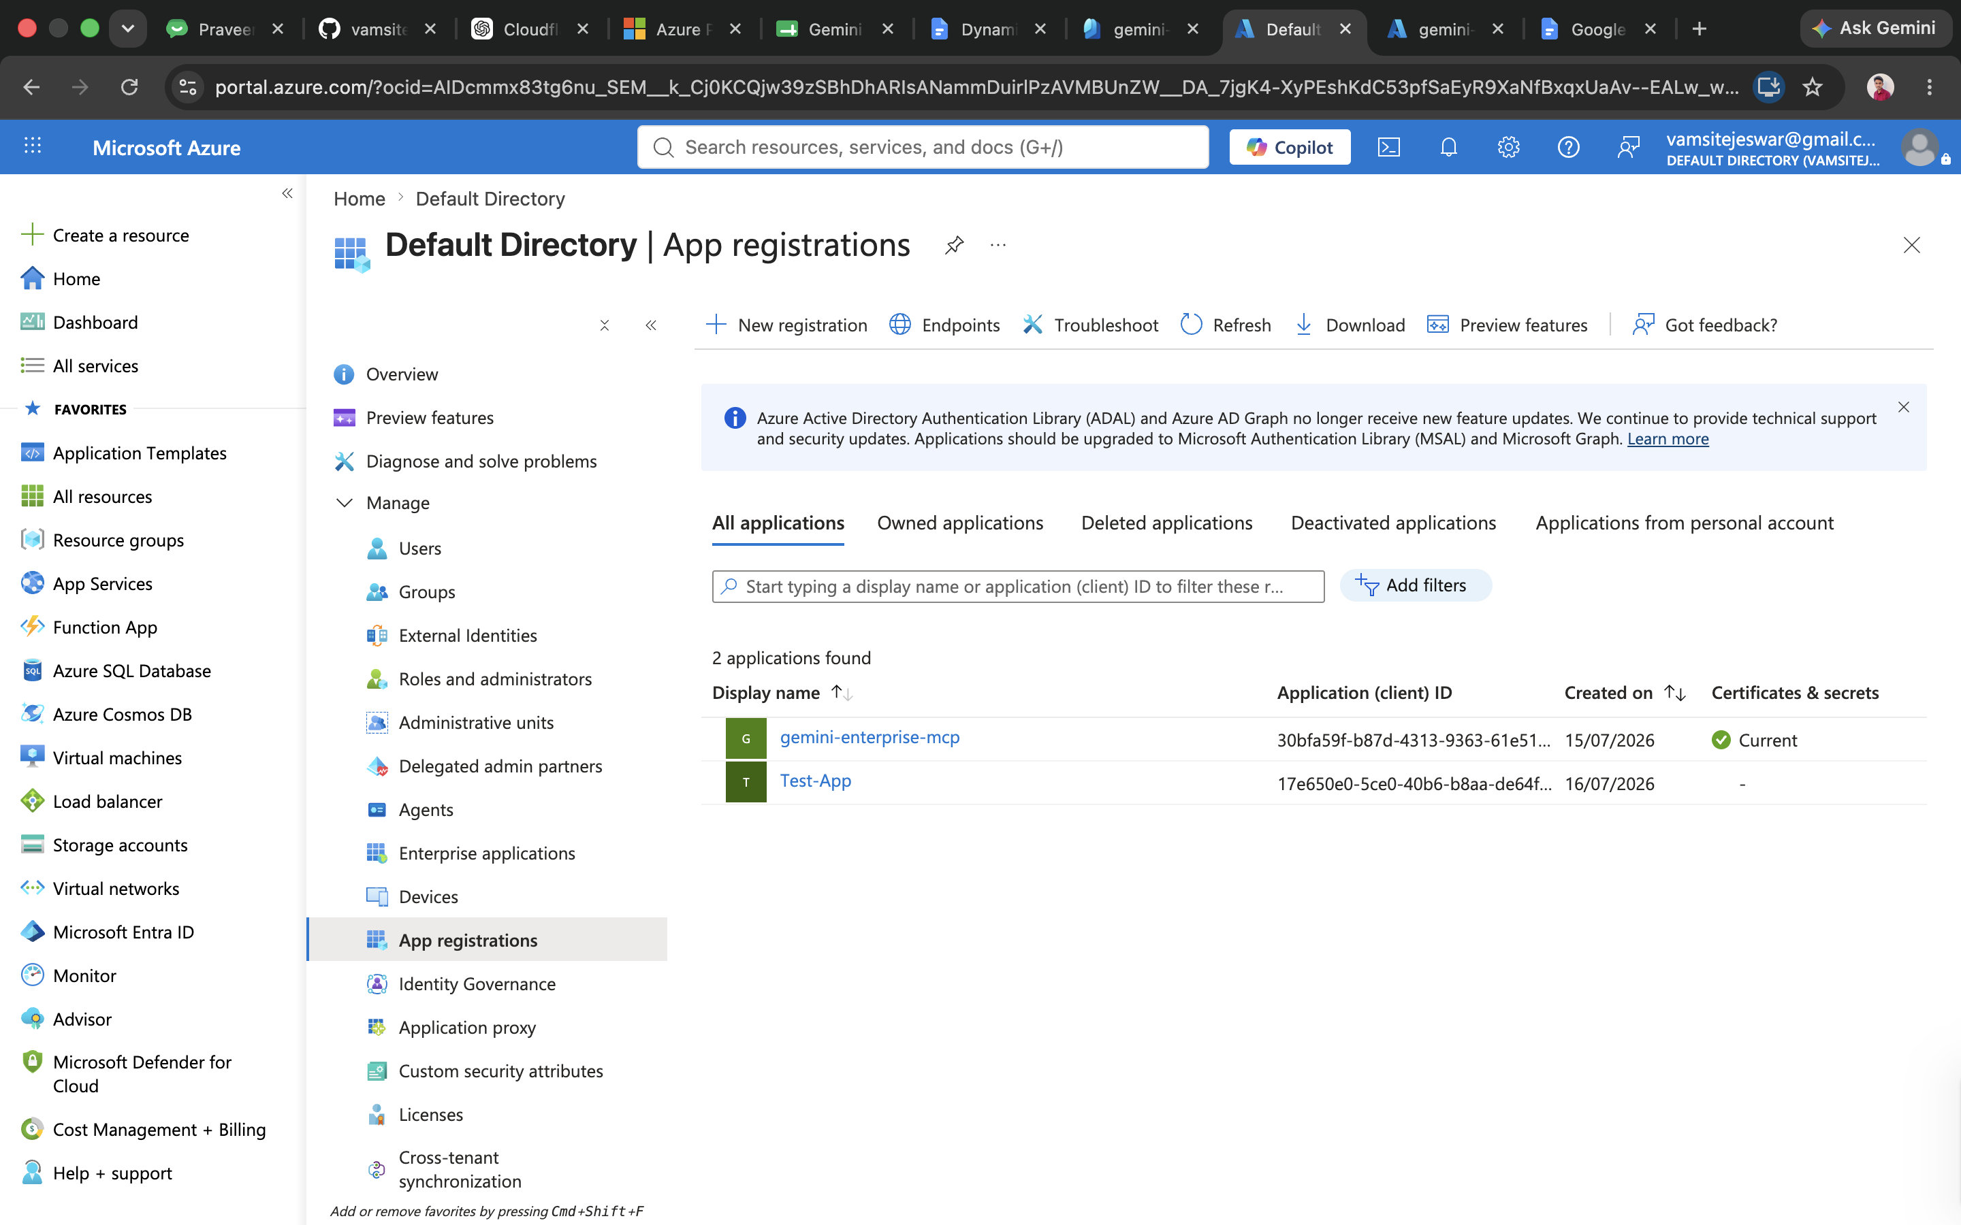
The App registrations list. Click “+ New registration” at the top. Name it anything recognizable (e.g. “billing-assistant”) — leave the redirect URI blank for now, and leave account type on the default (single tenant).

Step 1.3 — Copy the Client ID and Tenant ID
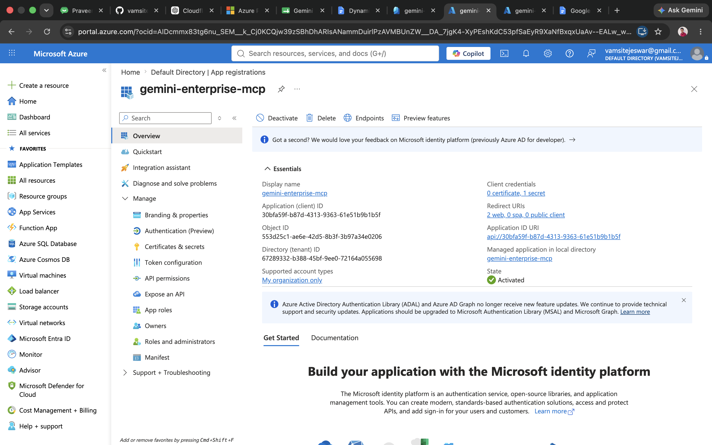
Once registered, the app's Overview page shows both the Application (client) ID and Directory (tenant) ID immediately — copy both.

Step 1.4 — Add the redirect URI
Go to Authentication (left sidebar) → Add a platform → Web, and enter this exact URL:
https://vertexaisearch.cloud.google.com/oauth-redirect
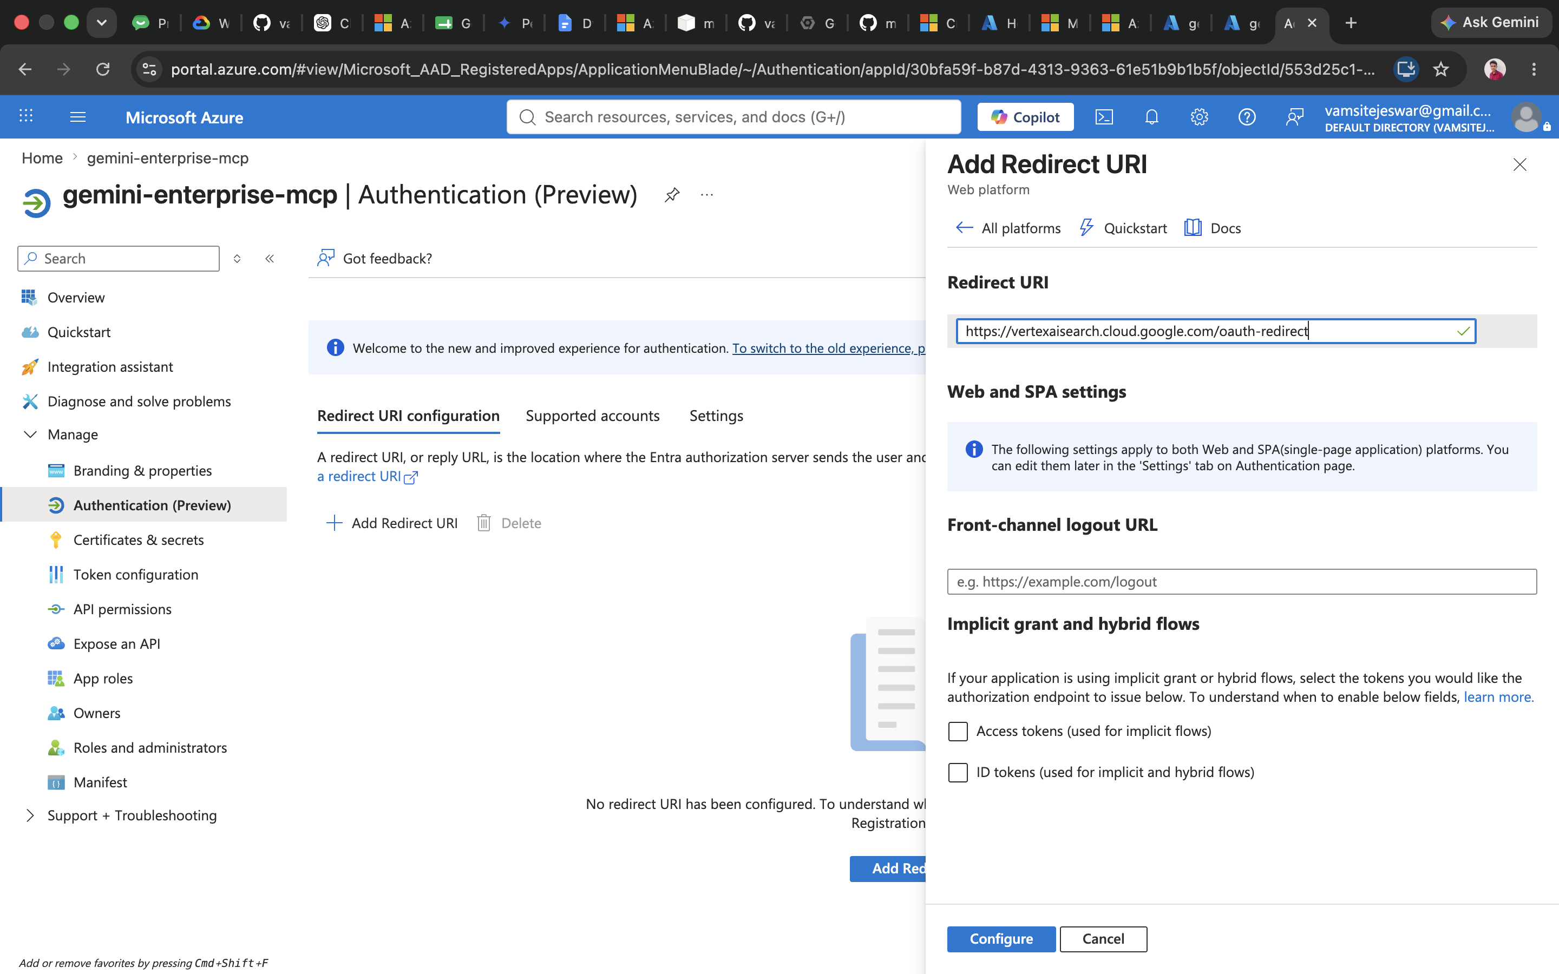
Paste the URL above into the Redirect URI field and click Configure. This URL is the same for every setup — it's not specific to your account.

Step 1.5 — Create a client secret
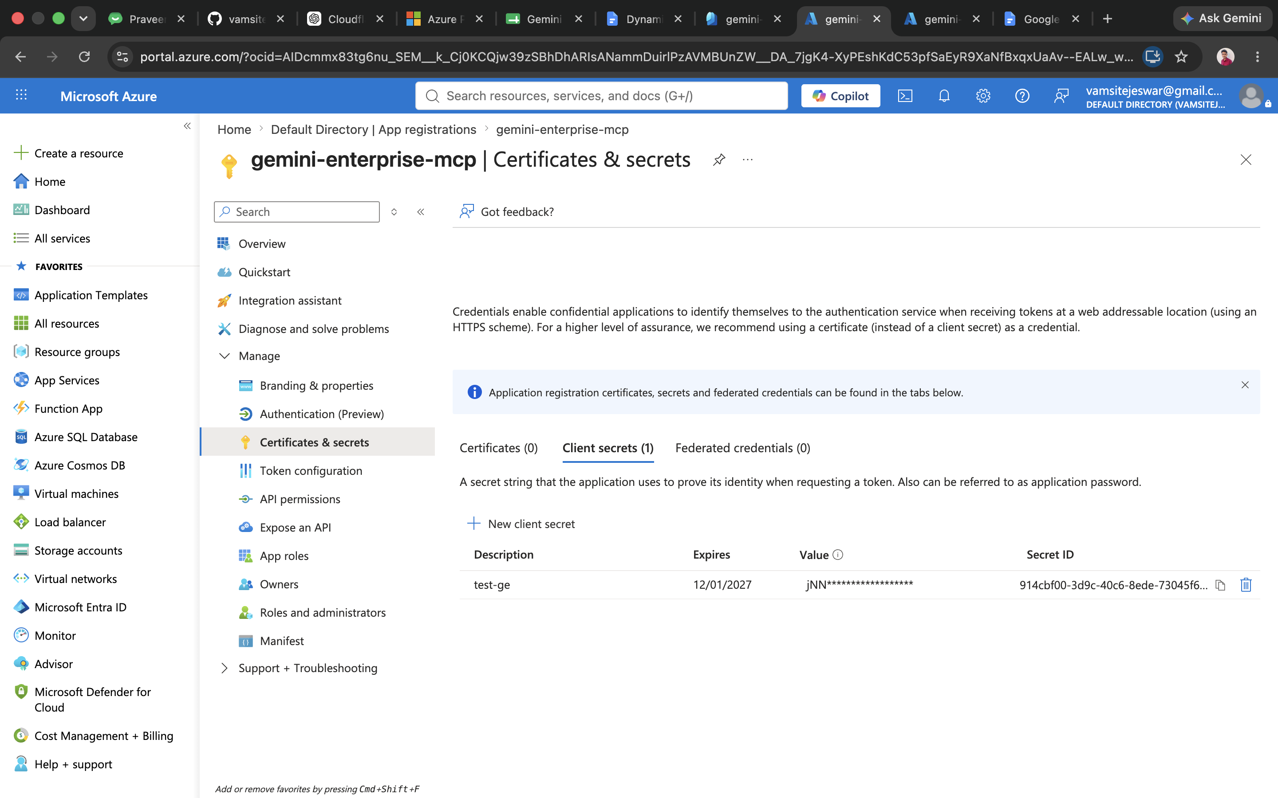
Go to Certificates & secrets → New client secret. Give it a description and an expiry, then copy the Value column immediately — it's only shown once.

Step 1.6 — Expose an API and add a scope
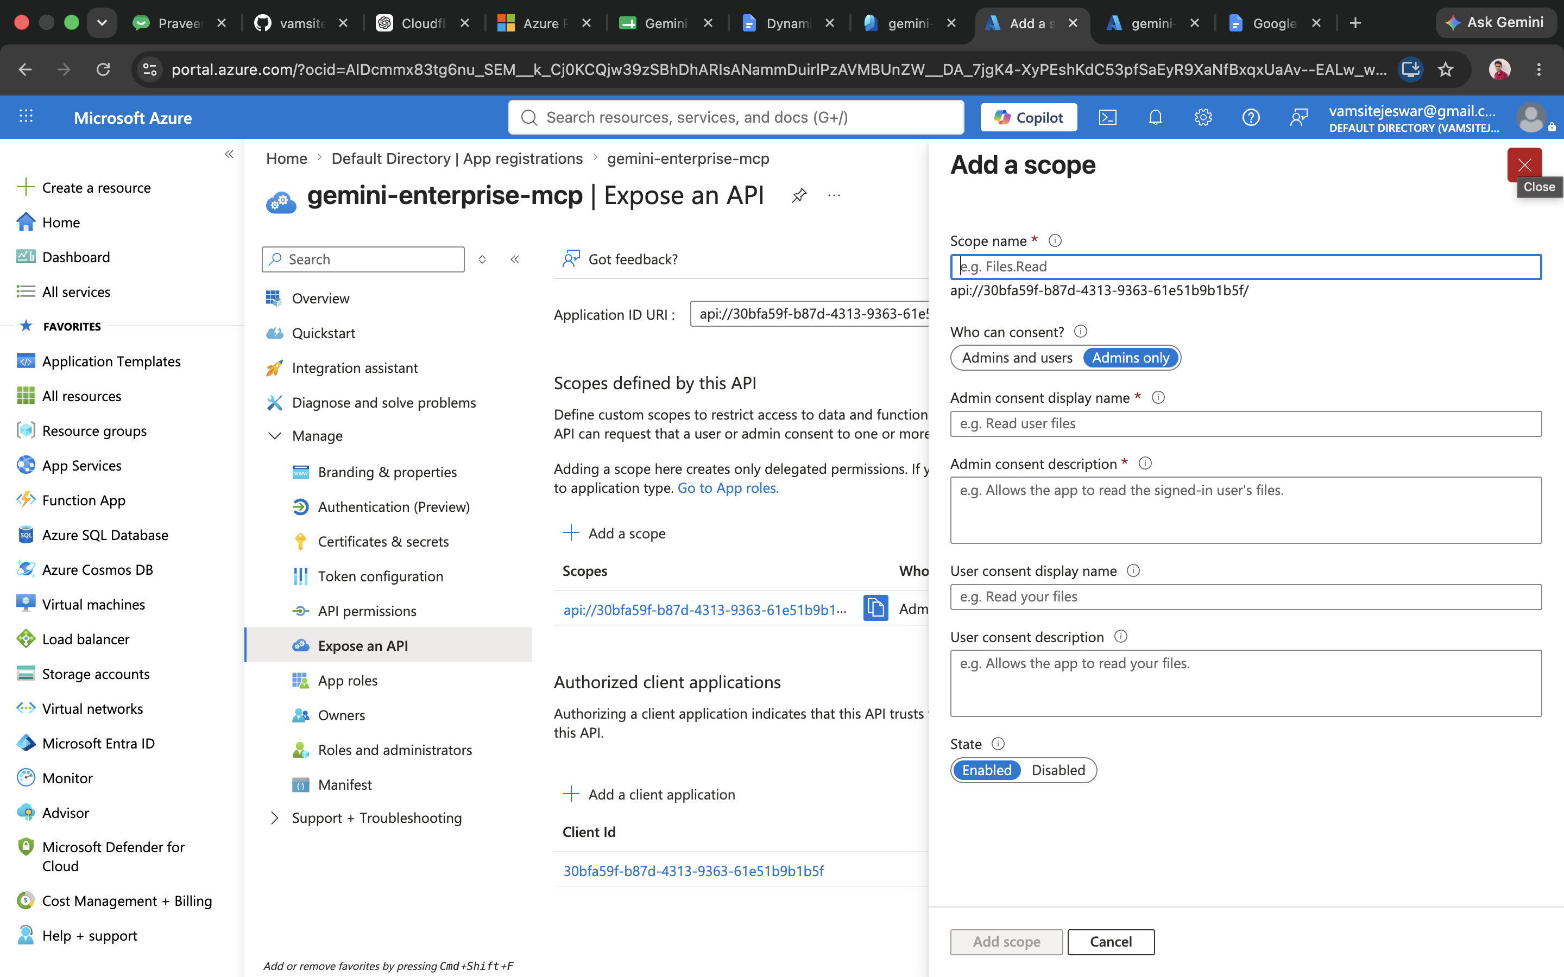
Go to Expose an API → accept the default Application ID URI → Add a scope. Use “mcp.access” as the scope name, set “Who can consent” to Admins and users, fill in the two description fields with anything descriptive, and set State to Enabled.

Step 1.7 — Confirm permissions and grant consent
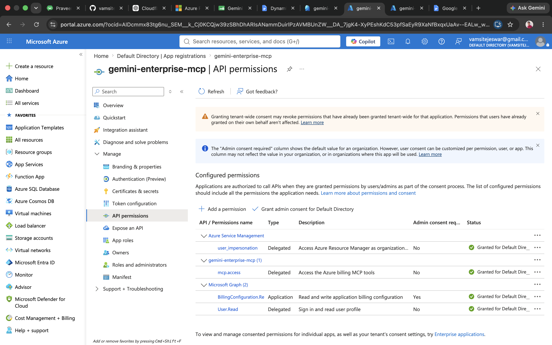
Under API permissions, you should see the mcp.access scope listed (added automatically from the previous step). Click “Grant admin consent” so your team members won't each need to individually approve access.

Part 2 — Create the Service Principal (for reading cost data)
This is a service principal — a dedicated application identity created just for this integration, separate from any individual employee's account. It gets assigned a read-only role (Cost Management Reader, in Step 2.2) on your subscription, which is what actually allows the assistant to retrieve cost and billing data automatically. Because the role is read-only, this identity cannot view, modify, or delete any actual resources (VMs, storage, etc.) — its access is limited to exactly what that role permits, and it's kept separate from Part 1's sign-in setup so a problem with one can never affect the other.

Step 2.1 — Run this command
Open the Cloud Shell in the Azure Portal (the “>_” icon in the top bar), or your own terminal if you have the Azure CLI installed and are signed in (az login). This creates the identity itself — the role that lets it actually read cost data gets assigned separately, in Step 2.2.
az ad sp create-for-rbac --name "azure-billing-mcp-reader"
The output looks like this — copy all three values somewhere safe:
{
"appId": "...", -> Client ID
"password": "...", -> Client Secret (shown once only)
"tenant": "..." -> Tenant ID
}
Important: the “password” value is shown only once, right here in the output. If you don't copy it now, there's no way to view it again later — you'd need to generate a new one.

Step 2.2 — Assign the Cost Management Reader role
This is the step that actually grants access to cost data — do this in the Azure Portal:
- Go to Entra ID → Enterprise applications → search for “azure-billing-mcp-reader” → copy its Object ID (different from the Client ID / appId above).
- Go to Subscriptions → your subscription → Access control (IAM) → Add → Add role assignment.
- Role tab: search for and select Cost Management Reader → Next.
- Members tab: Select members → paste the Object ID from the first bullet → Review + assign.

Step 2.3 — Add the Billing Reader role (if invoices/usage history are needed)
Same steps as above, but choose the Billing Reader role instead. This one only matters if invoice history and detailed usage records are needed — the core cost-analysis features work with just Cost Management Reader from Step 2.2.

One thing worth checking beforehand
The Cost Management and Billing APIs only work on certain Azure subscription types:
Supported | Not supported
Pay-As-You-Go | Free Trial
Enterprise Agreement (EA) | Visual Studio / Dev-Test
Microsoft Customer Agreement (MCA) | CSP / Sponsored

If the subscription is currently a Free Trial, it'll need to be upgraded (Azure Portal → Subscriptions → Upgrade) before any cost or billing data can come through — everything else can still be set up in the meantime.

