*Question 1: Ingest data from a single table in SQL Server database to Azure Blob storage*

*Copy the values from SQL server (on premises) to Azure Blob Storage .Created a table Outlet with records in Store database .Azure Blob storage account is created with a container. The Pipeline is created through Azure Data Factory studio. Now, perform the Copy activity. While creating a Linked Service need to create self-hosted integration runtime (IR) is the component that copies data from the SQL Server database on machine to Blob storage. Select the Source dataset*

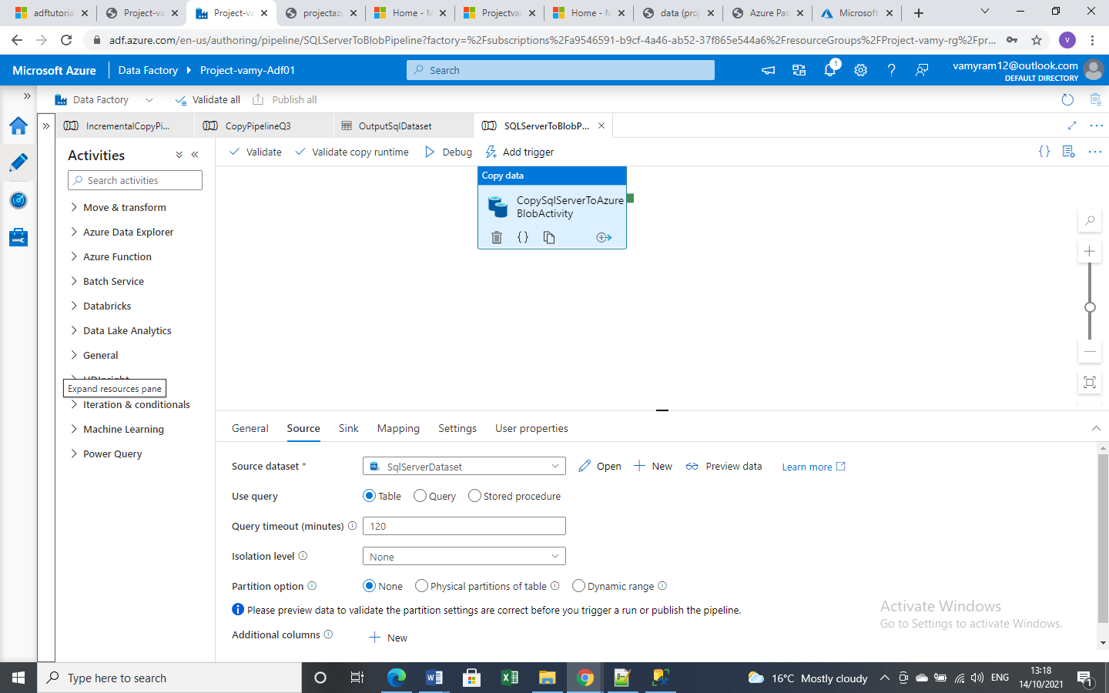*The Sink Dataset where the file to be copied .*

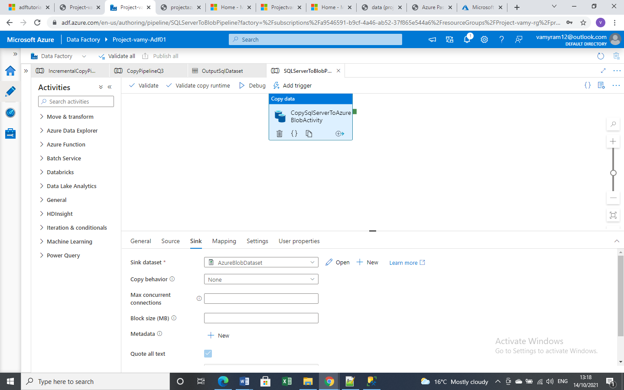

*LinkedService and file path are applied.*

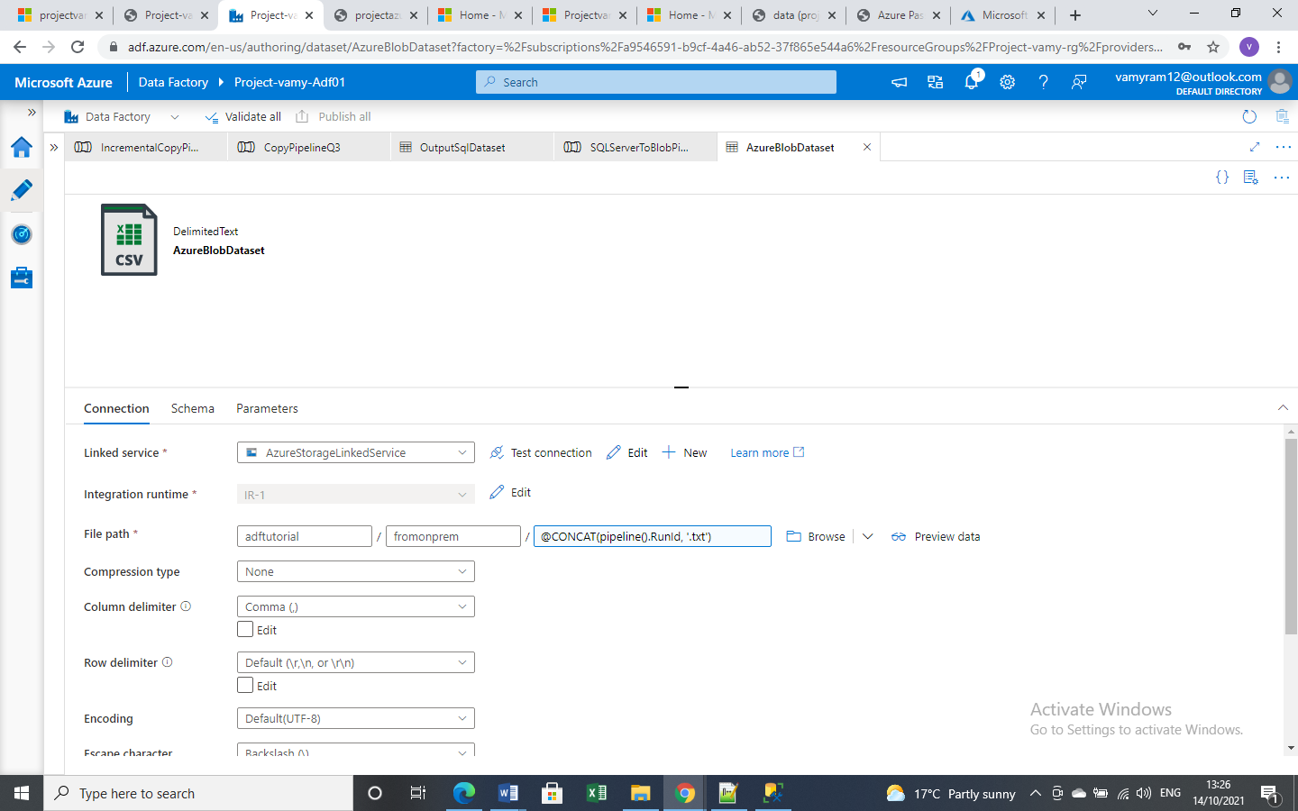

*Debug the pipeline.*

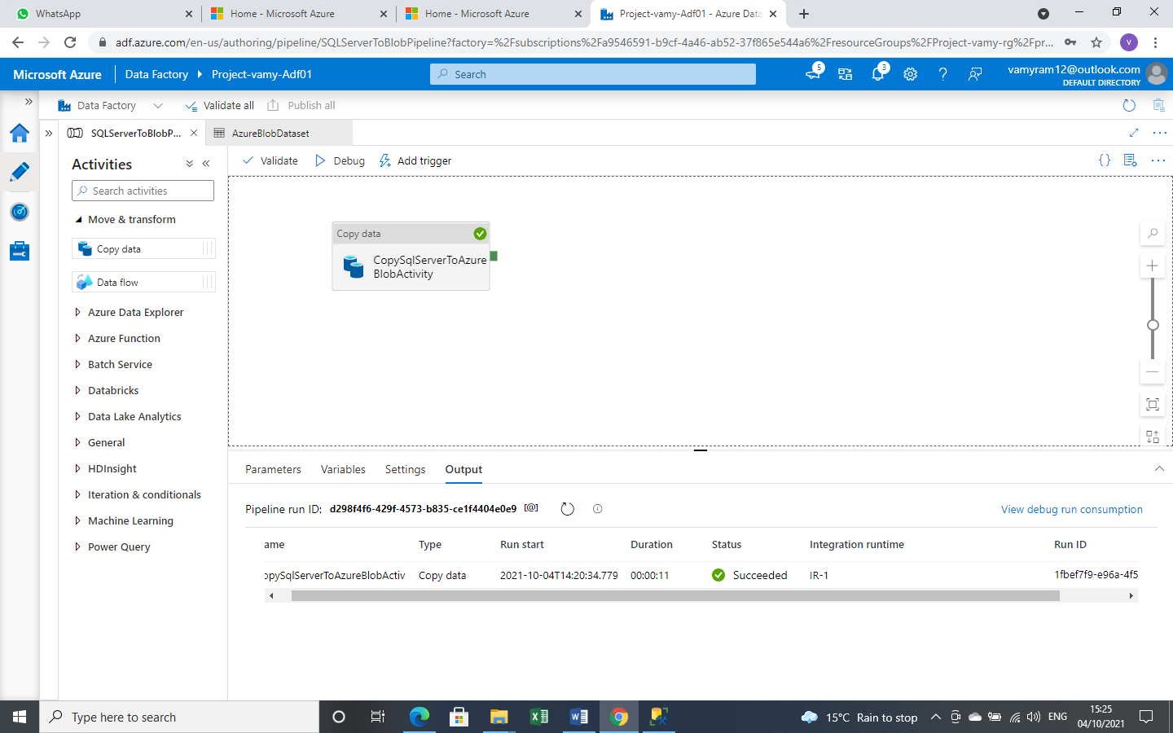

*Pipeline run is successfully finished. The Values are copied from SQL Server to Azure Blob Storage.*

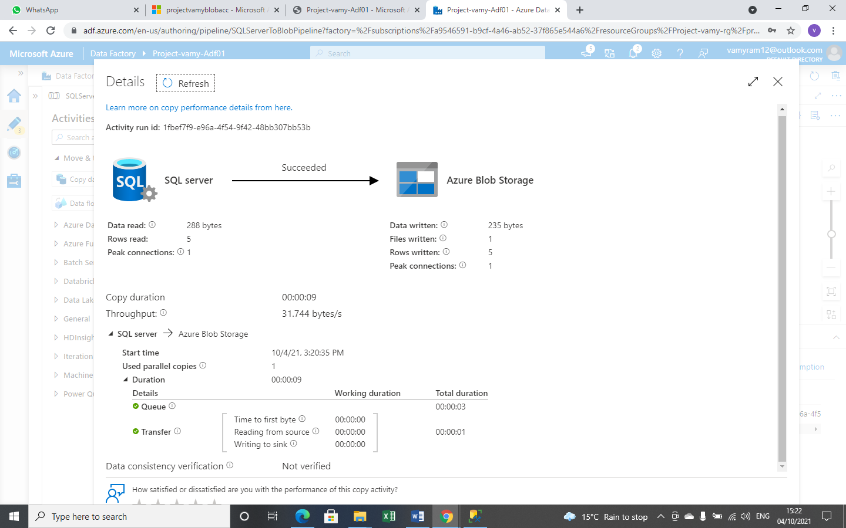

*File is copied into fromonprem folder*

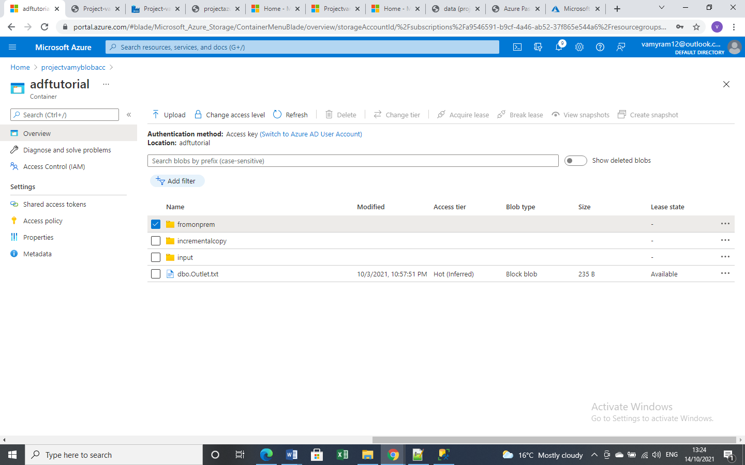

*The file has 6 rows.*

