***Question 2:******Ingest data from multiple Tables in SQL Server database to Azure Synapse Analytics****.*

*Load data into Azure Synapse Analytics using Azure Data Factory or a Synapse pipeline using copy data tool.*

*Adventure Works LT sample dataset is used in Azure SQL Database.*

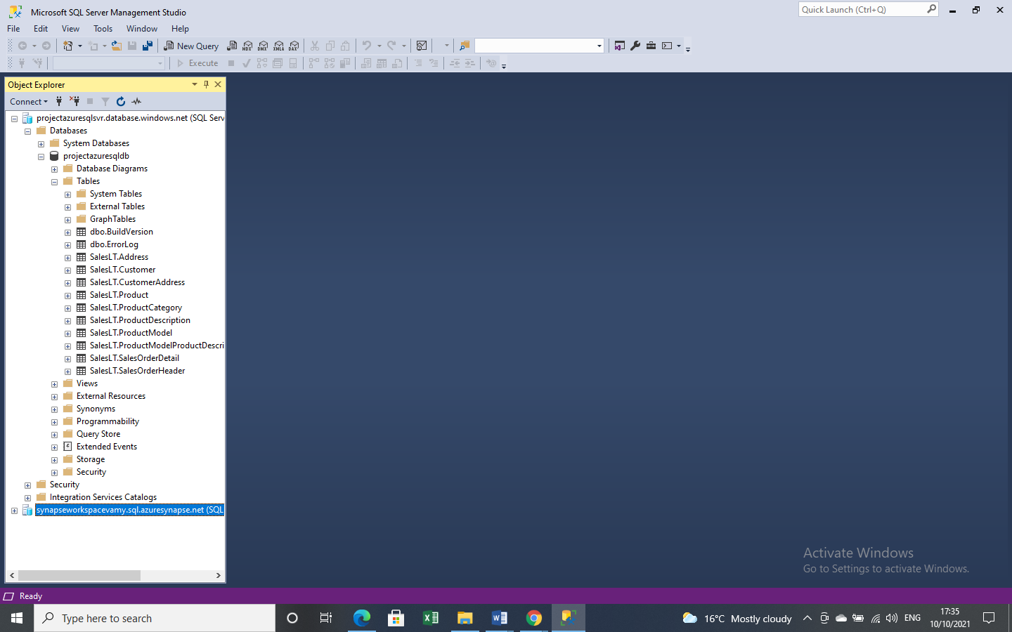

***To load data in Azure Synapse Analytics:*** *In Azure Data Factory, select Ingest to launch the Copy Data tool then choose Built –in-copy task under Task type. Use SQL authentication as the authentication type for source data store. Create new connection for Azure SQL Database .Under Source tables select SalesLT to filter the tables.*

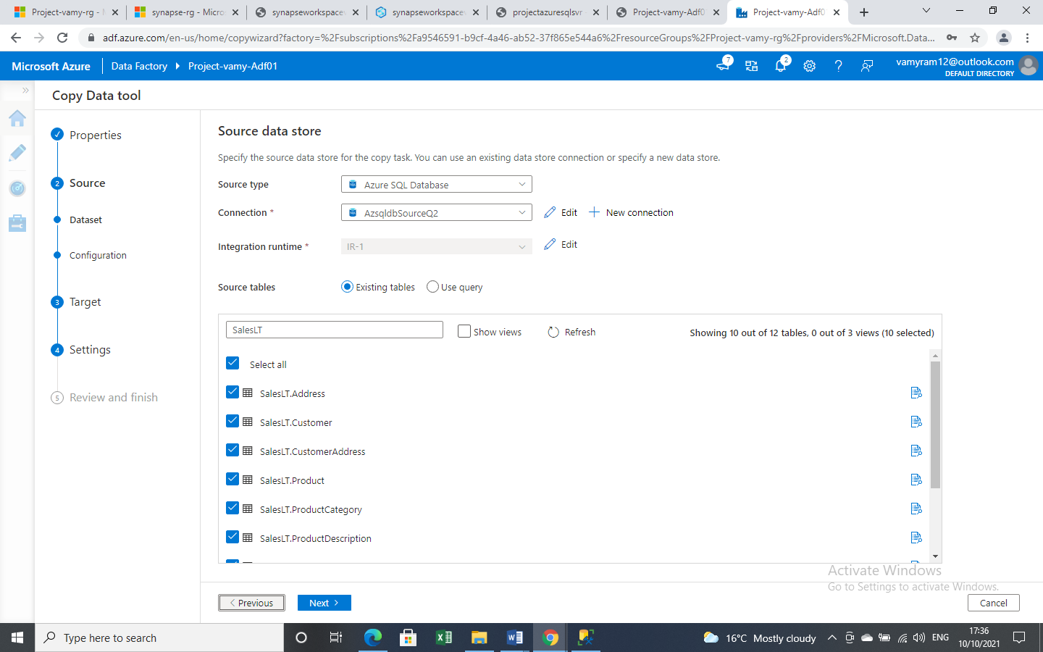

*In Apply filter page specify the setting .Preview the input data.*

*Create new connection for Destination data store. Select Azure Synapse Analytics for destination store .In Table mapping section review the content and select next.*

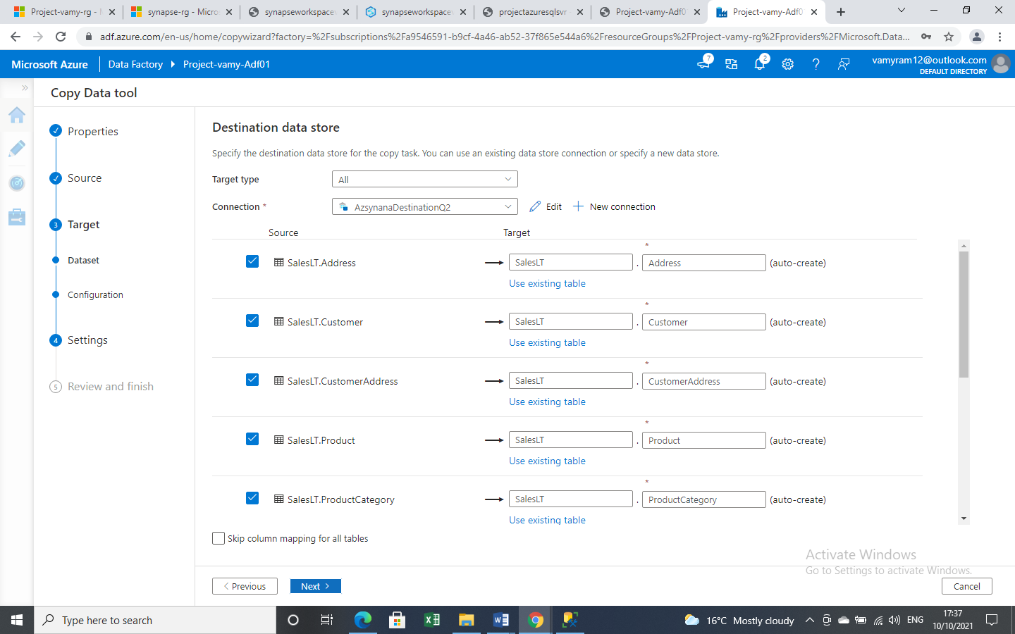

*In column mapping page, review the content and select next. If there's an unsupported data type conversion between the source and destination column, an error message appears next to the corresponding table and make sure no errors.*

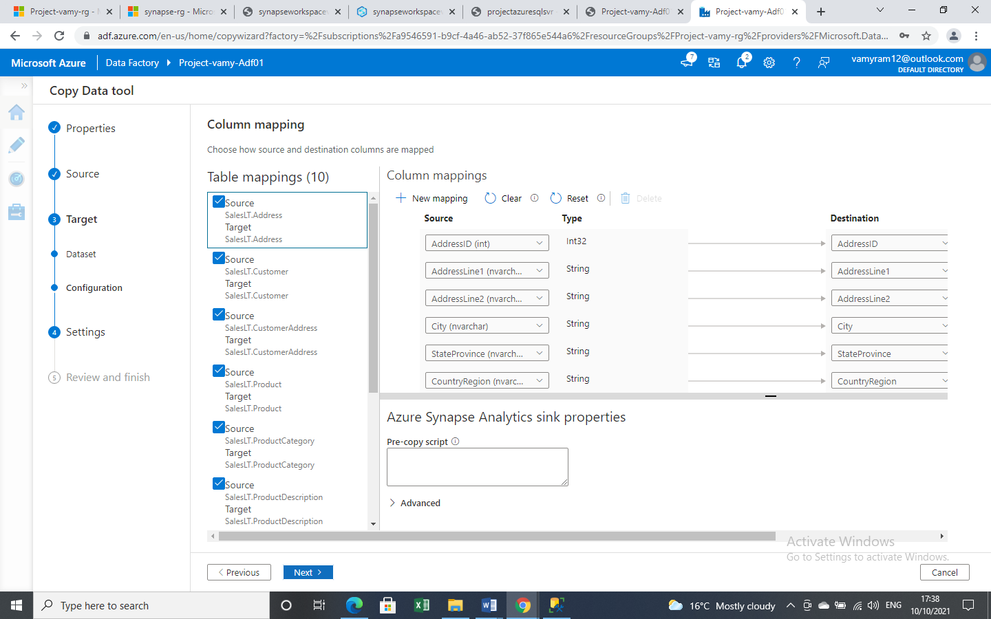

*Here, storage account is used for staging the data before it loads into Azure Synapse Analytics by using PolyBase . After the copy is complete, the interim data in Azure Blob Storage is automatically cleaned up.*

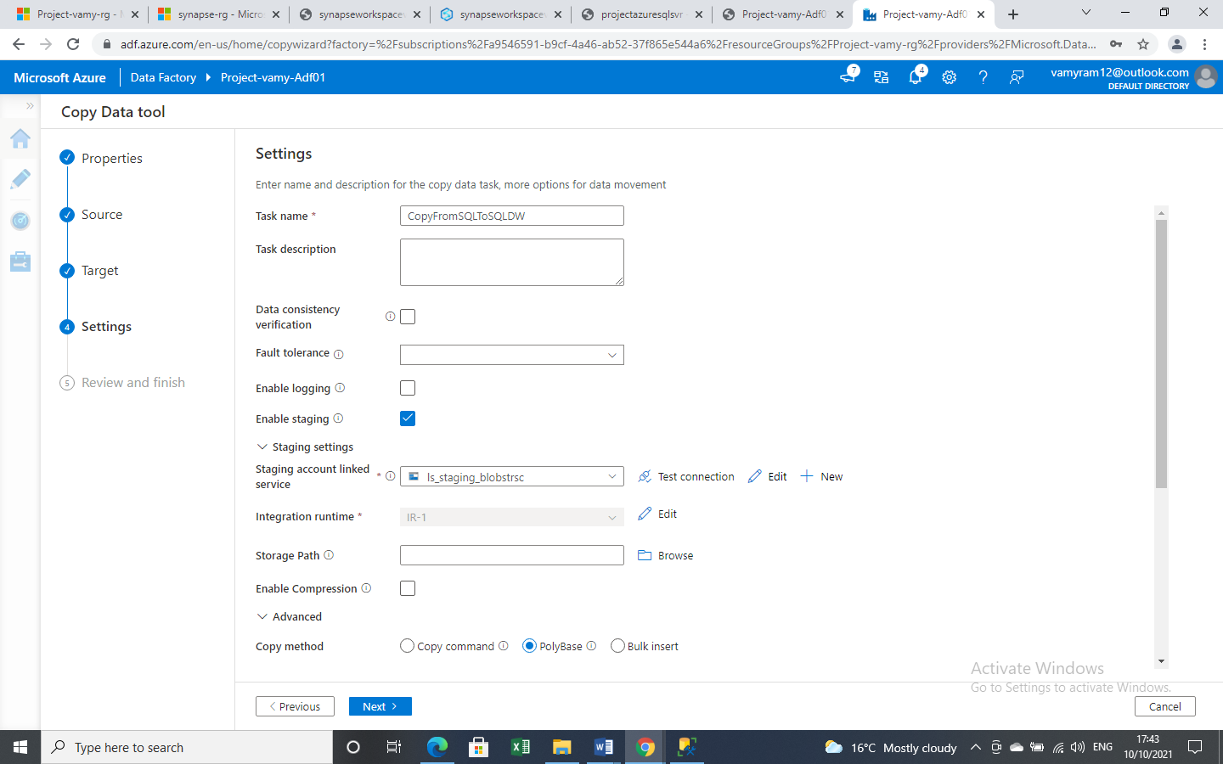

***In Deployment page****, select****Monitor****to monitor the pipeline.*

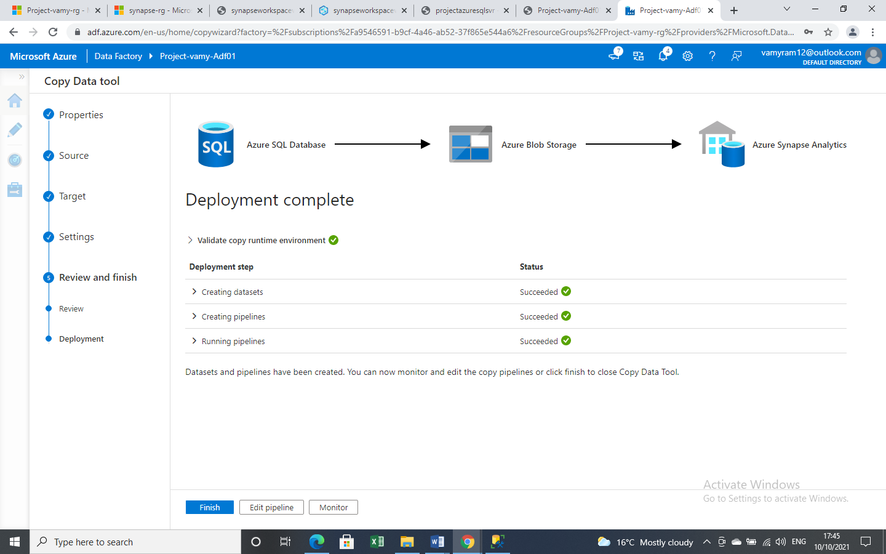

*When the pipeline run completes successfully, select the pipeline name* ***link*** *to view activity run details or to rerun the pipeline*

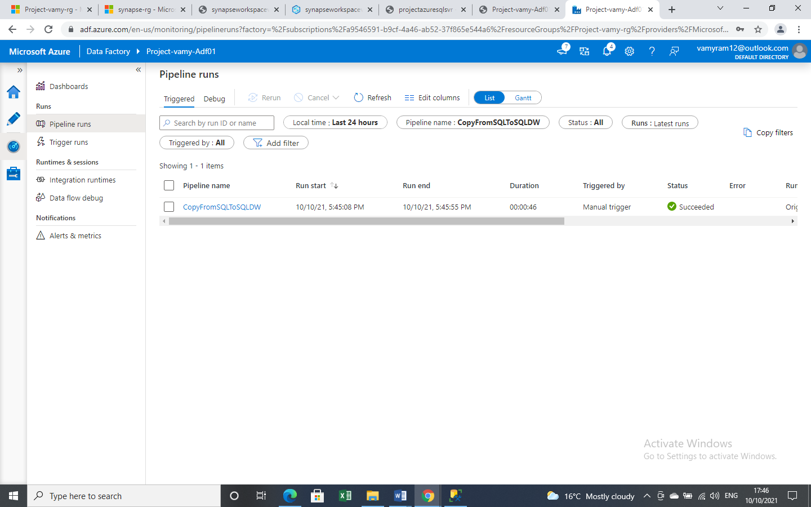

*Monitor details like the volume of data copied from the source to the sink, data throughput, execution steps with corresponding duration, and used configurations are displayed in the screen.*

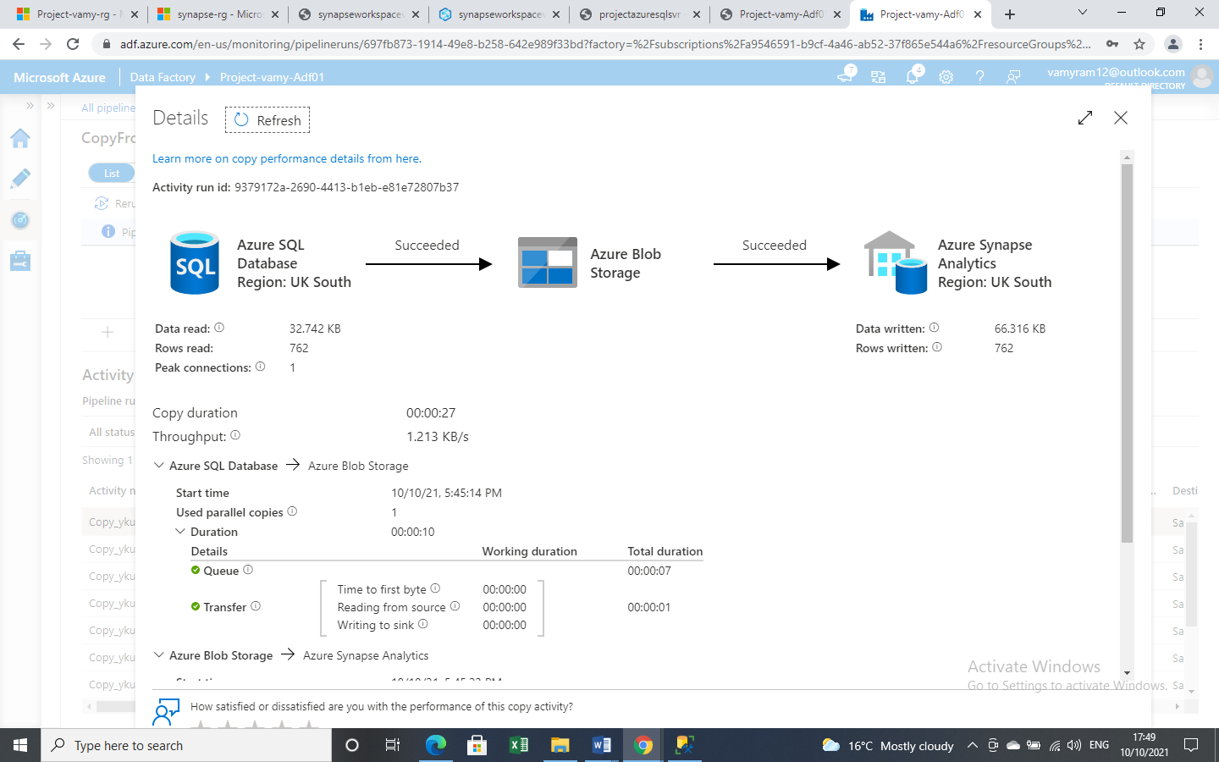

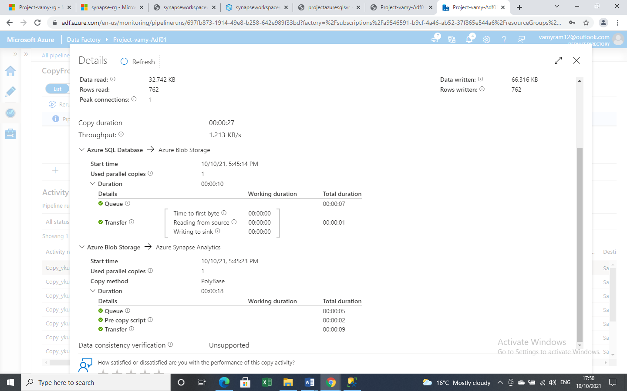

*Address table from Source SQL database*

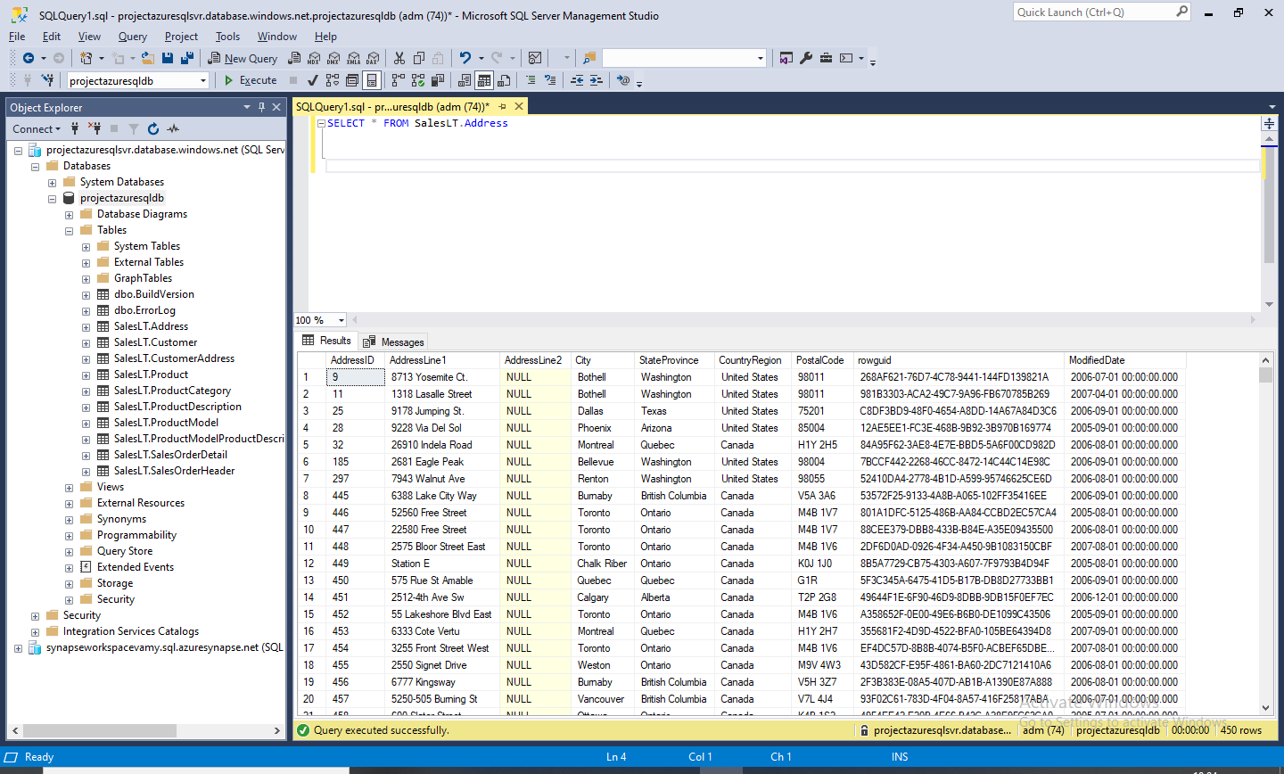

*Now, Address table copied to Destination Azure Synapse Analytics*

