***Question 3****: Load data from Azure Blob storage to a database in Azure SQL Database by using Azure Data Factory.*

*Upload a .txt file in Blob storage container and create a table in SQL database. Allow Azure services to access SQL Server. In Azure Data Factory, create a pipeline for copy activity then create dataset and Linked service for source and select the file which has to be copied.*

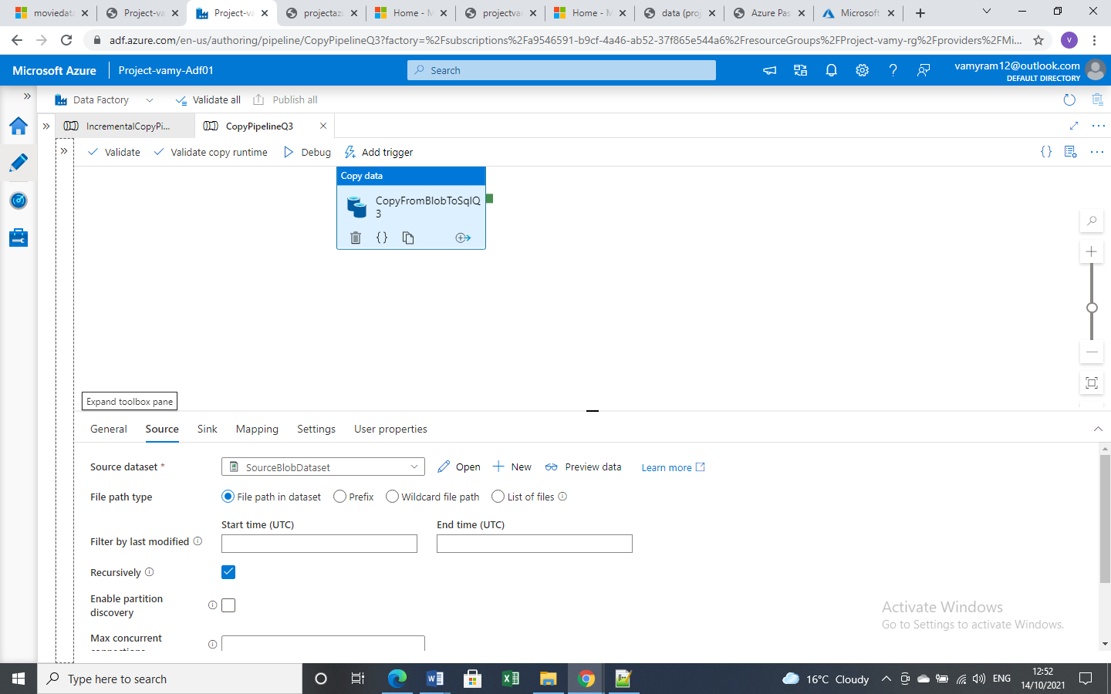

*Create new dataset and new linked service for sink.*

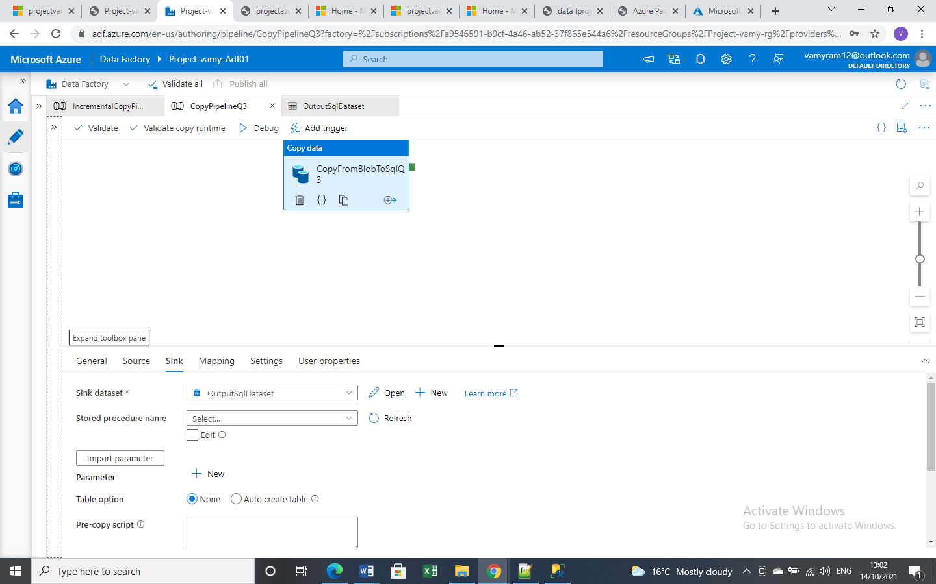

*Validate and Debug the pipeline*

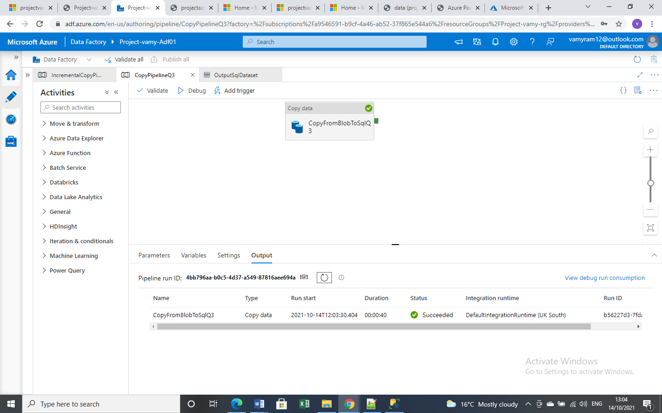

*Values are copied to the destination SQL database.*

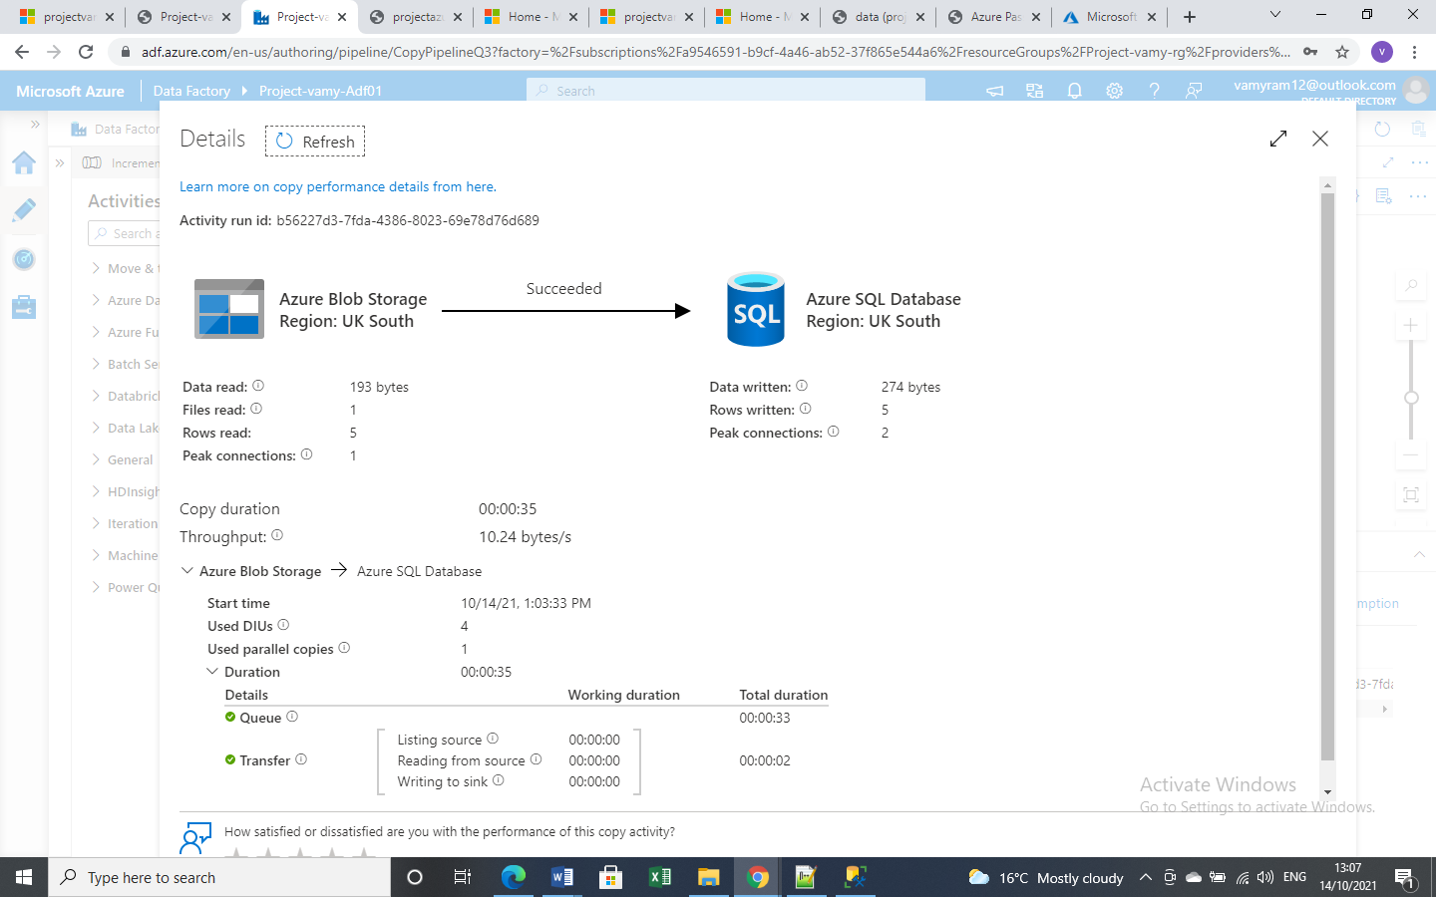

*When a pipeline run is successful, check the Activity type, Run start time, Duration, Status and Integration runtime.*

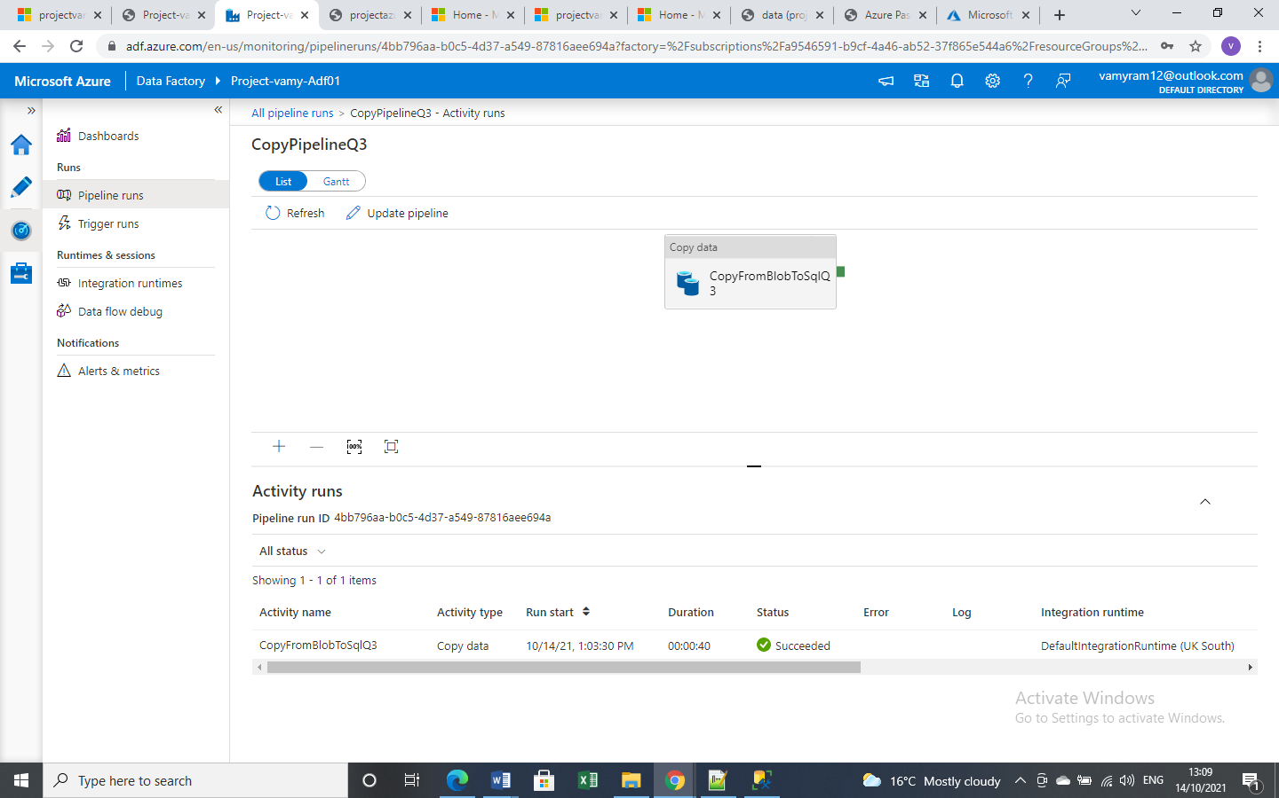

*After adding manual trigger rerun the pipeline.*

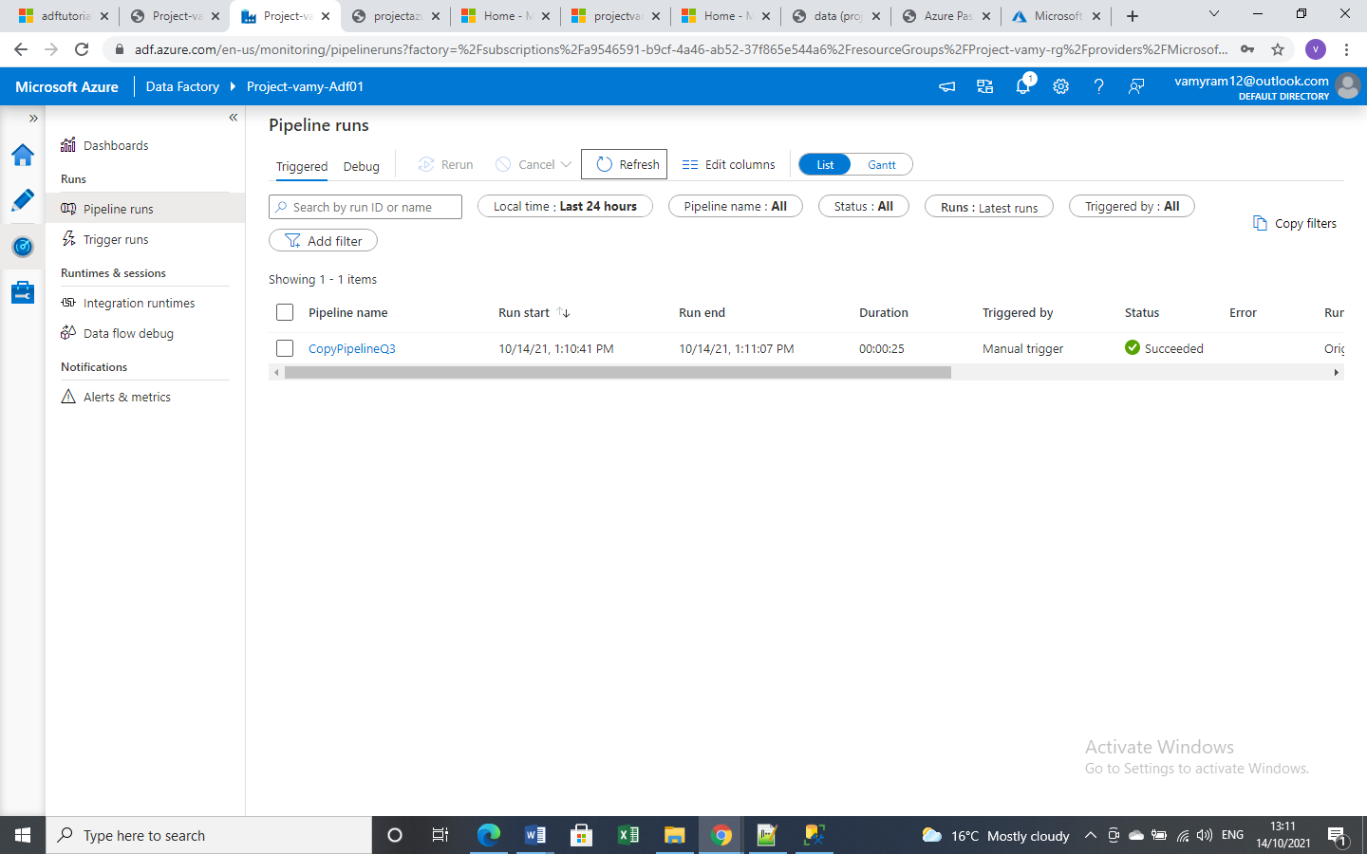

*After each trigger (for each pipeline run), verify that values are inserted into the table. Below is example four rows are inserted after each run.*

