*Question 6 :* ***Design a Relational Database Model for the below scenario in Azure SQL Database***

*The database schema should consist of four tables that model a student management system for universities. Person, Course, Student, Credit.*

*STEPS:*

*1.Created* ***UNIVERSITYDB*** *Database*

*2. Created table name* ***Person*** *and inserted the values.*

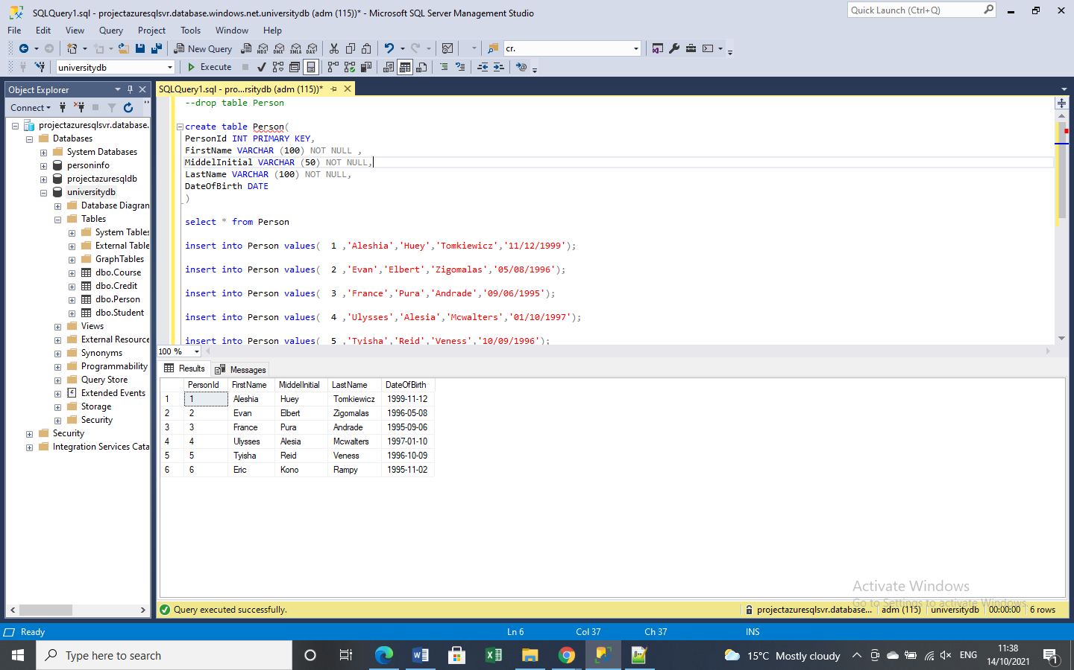

*3. Created table name* ***Course*** *and inserted the values*

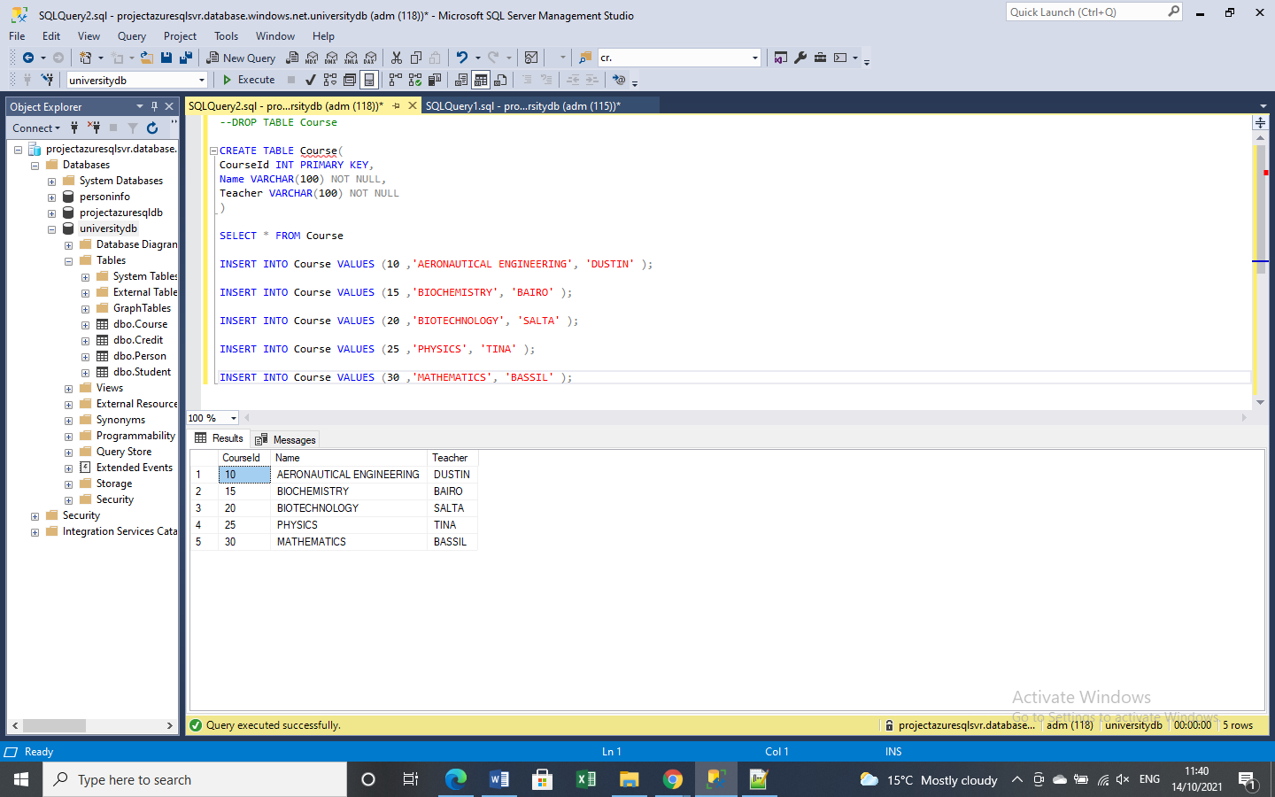

*4. Created table name* ***Student*** *with Foreign Key Reference based on* ***Person*** *table and values are inserted.*

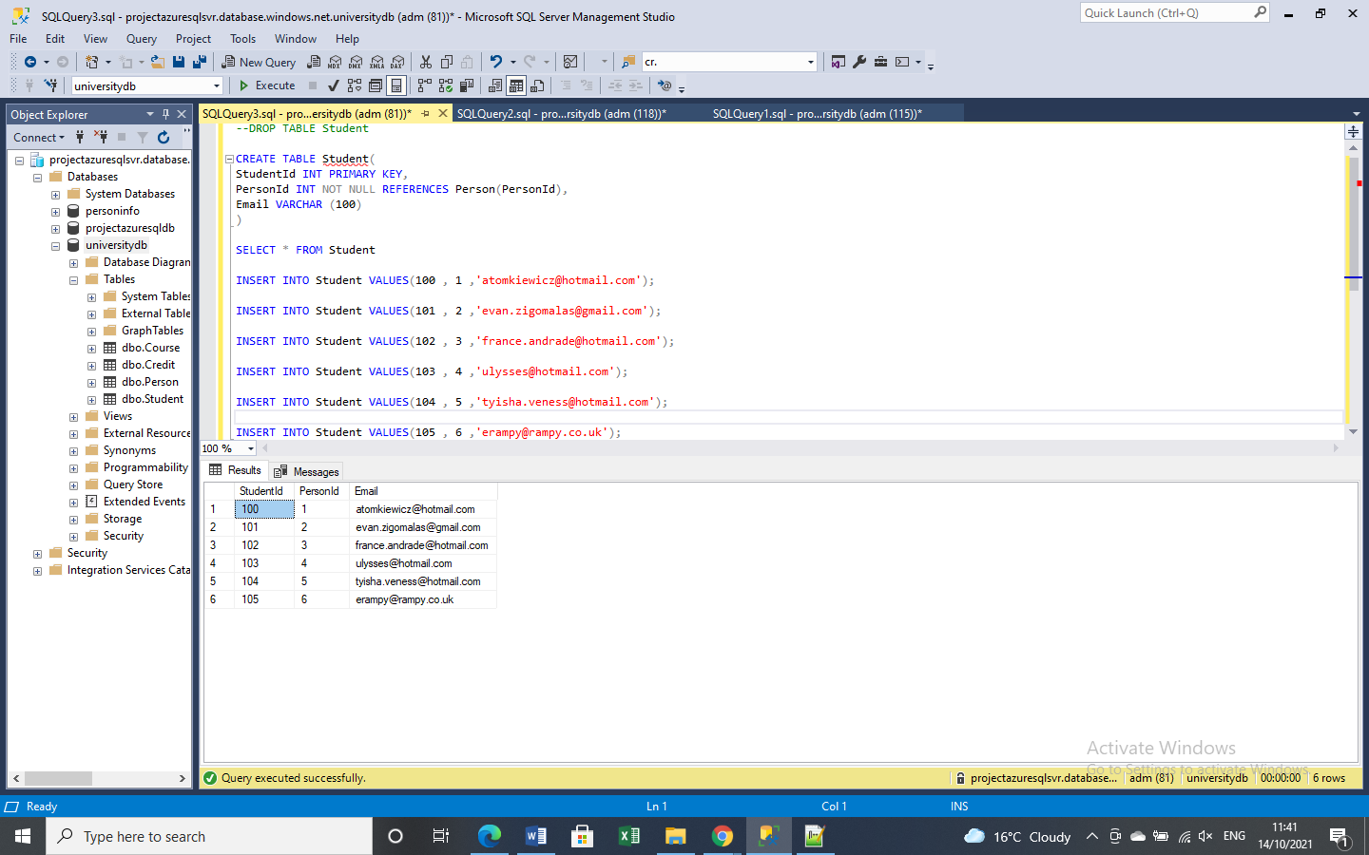

*5. Created table name* ***Credit*** *with Foreign Key Reference based on* ***Course*** *and* ***Student*** *table and values are inserted.*

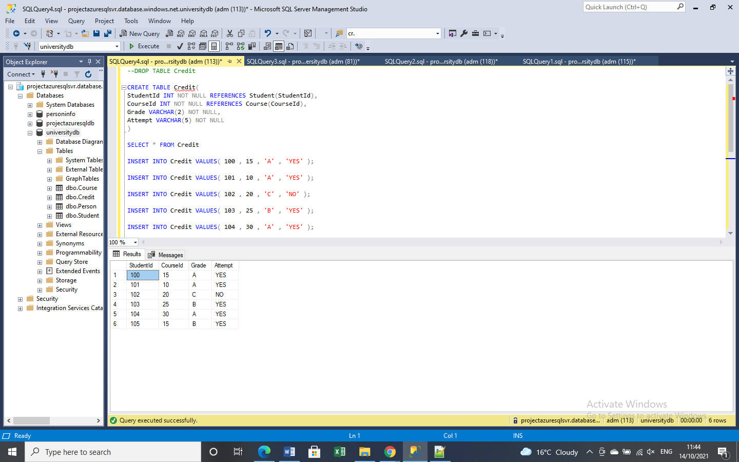

*6. This query shows Student ID and Name using CONCAT function.*

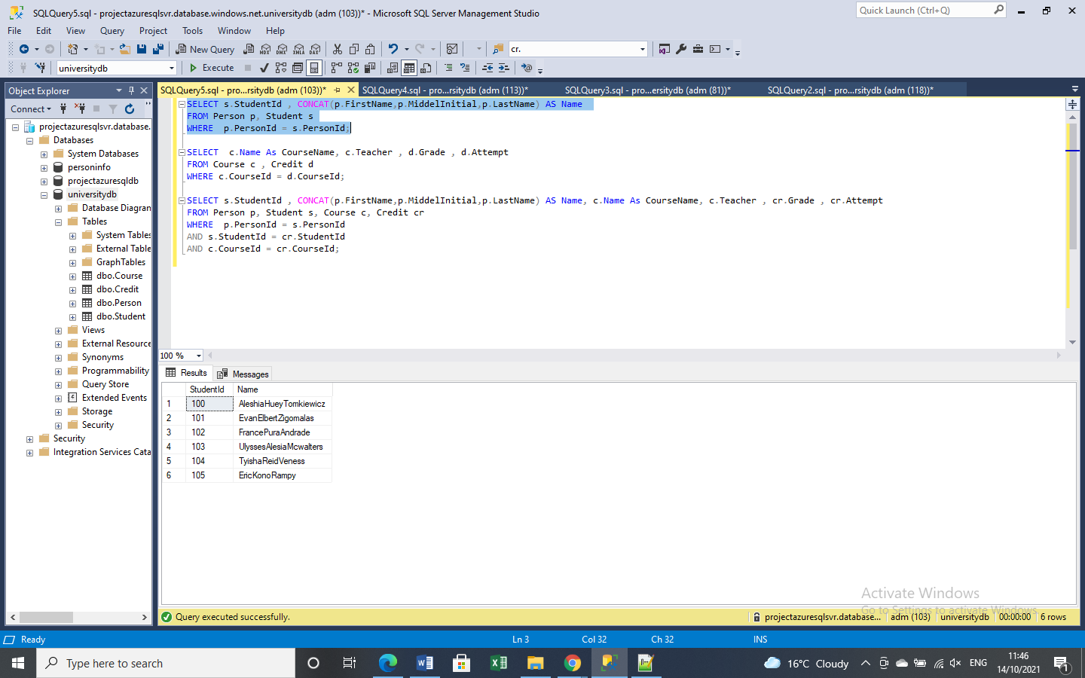

*7. This query shows CourseName, Teacher, Grade and Attempt using WHERE clause.*

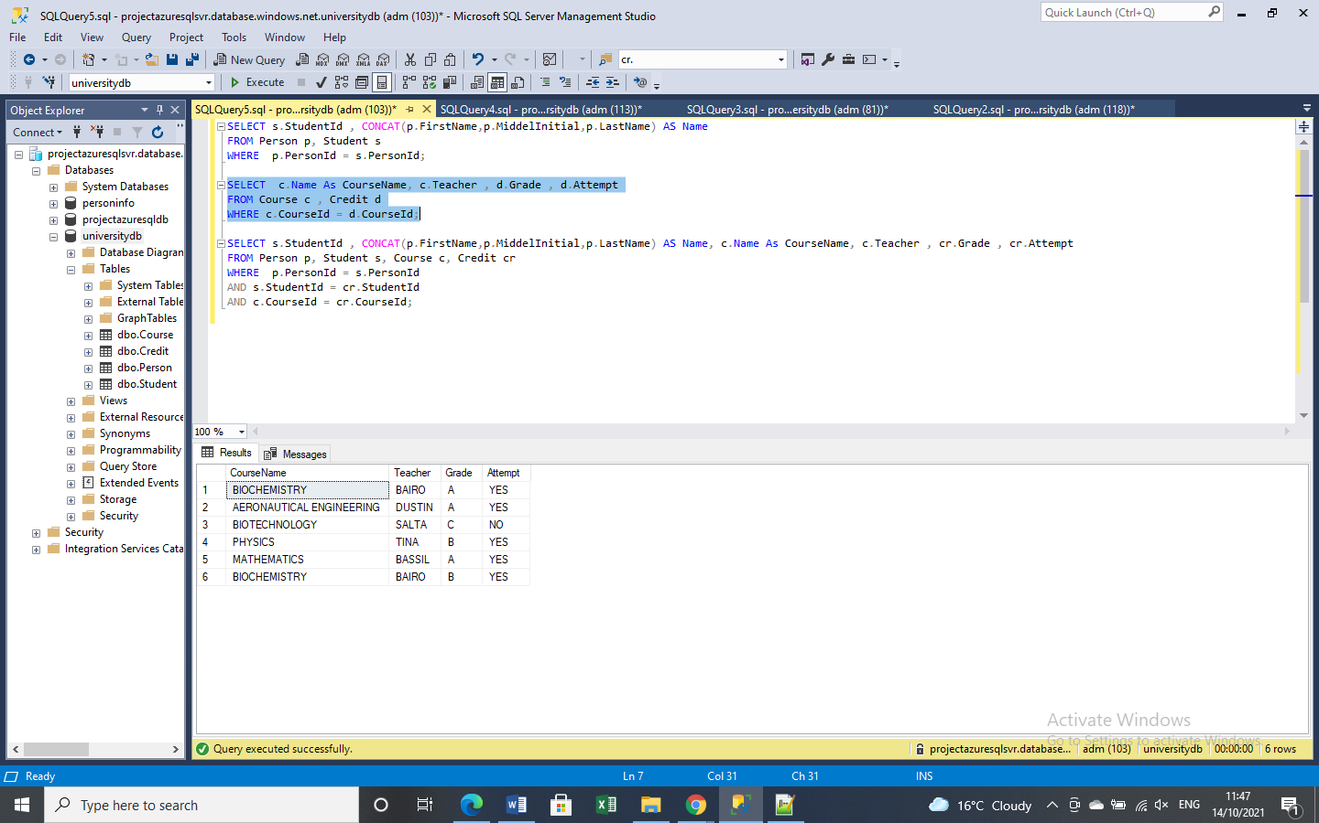

*8. Write a query to show Student Id, Name, Course Name, Teacher, Grade, Attempt information.*

*This query shows Student Id, Name , CourseName , Teacher, Grade and Attempt .*