***Question 7:***  *Design a Relational Database Model for the below scenario in Azure SQL Database. Create a database schema with four tables that model a Person's information. Person, Address, ContactDetail and ContactDetailType.*

*STEPS:*

*1. Created* ***PERSONINFO*** *Database*

*2. Created table name* ***Person*** *and inserted the values.*

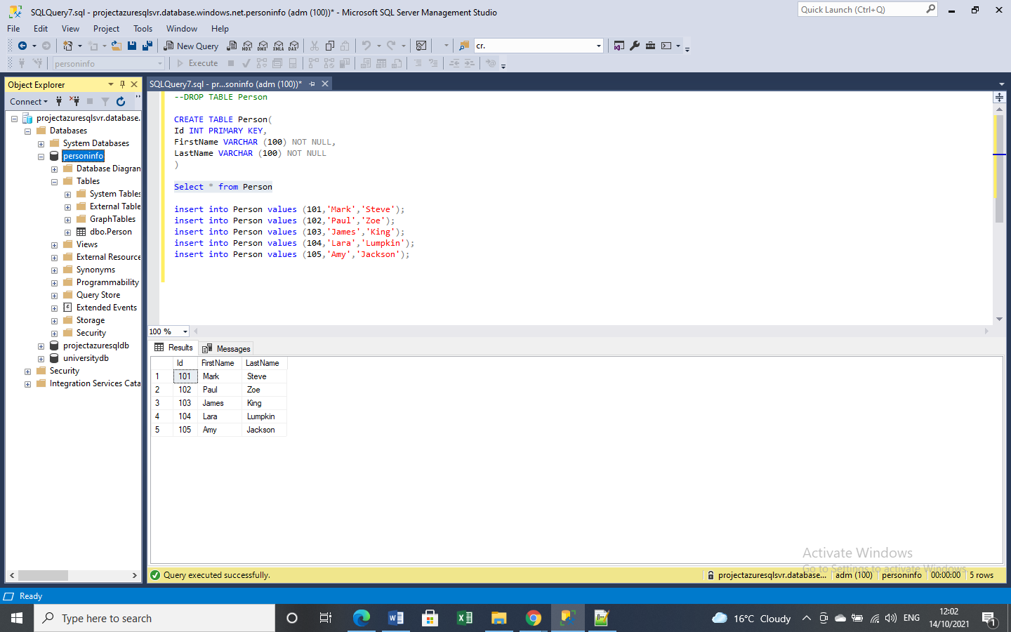

*3. Created table* ***Address*** *with Foreign Key Reference based on* ***Person*** *table and values inserted.*

*Address TypeId 1 as Home and 2 as Office*

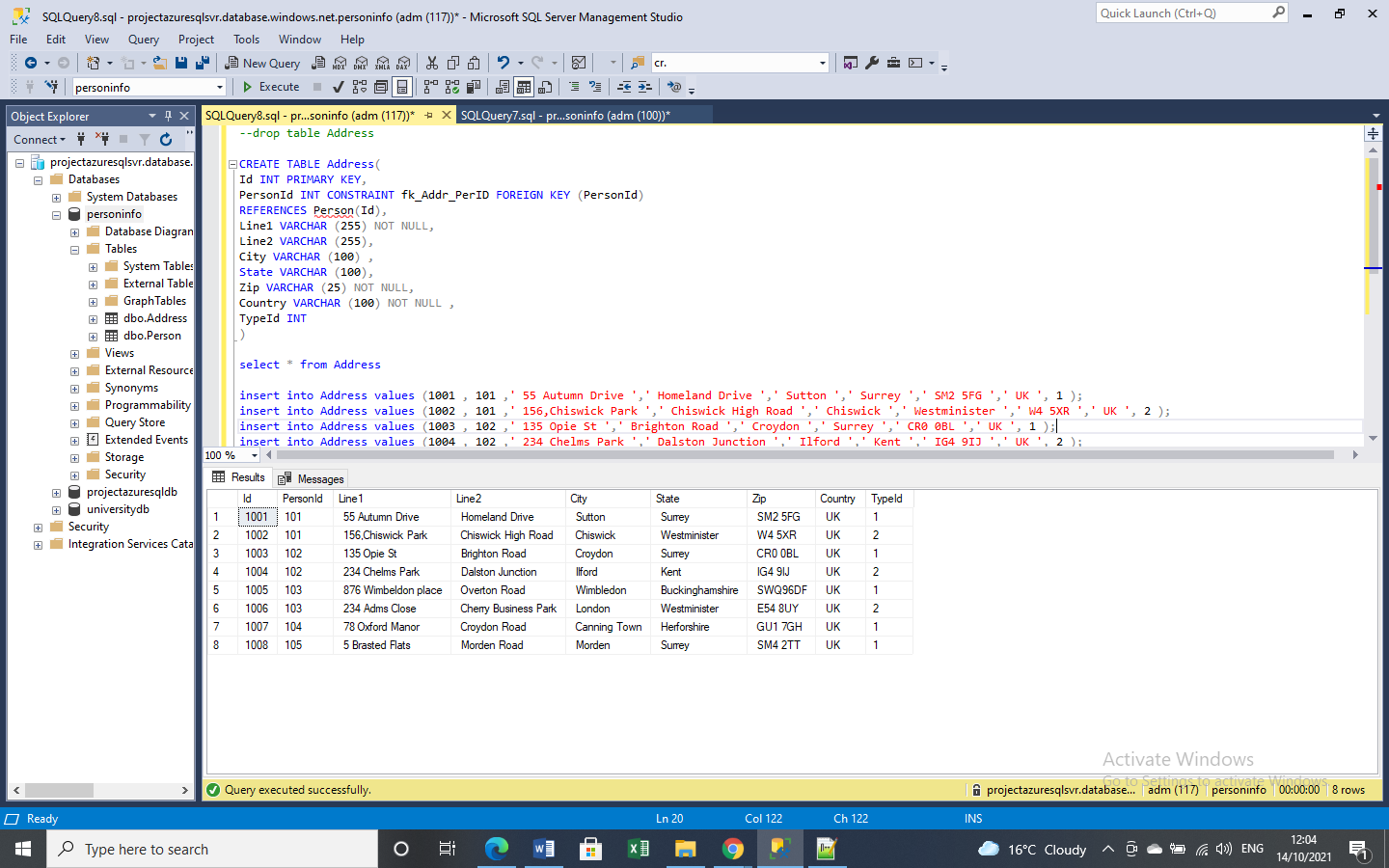

*4. Created table* ***ContactDetailType*** *and values inserted.*

*ContactTypeId 10001 as Home ,10002 as Office, 10003 as MobileNo and 10004 as EmailAddress.*

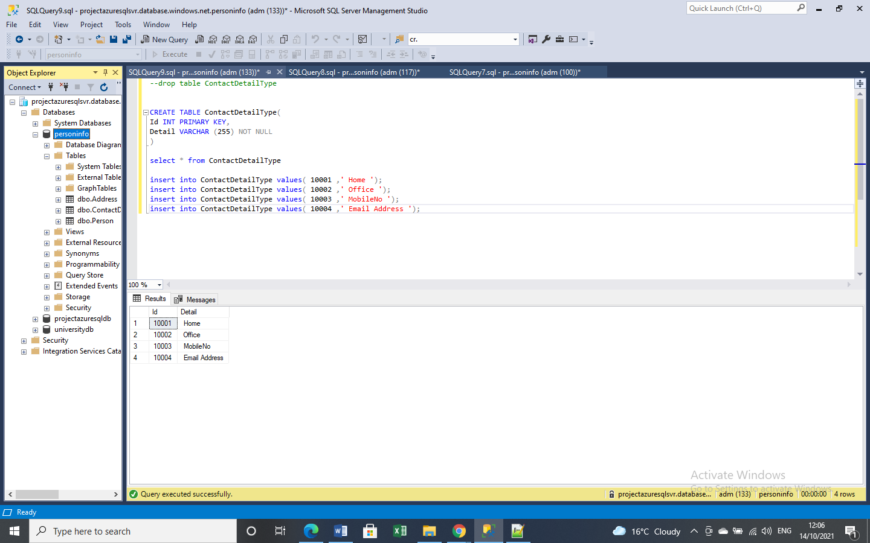

*5. Created table* ***ContactDetail*** *with Foreign Key Reference based on* ***Person*** *and* ***ContactDetailType*** *and values inserted .*

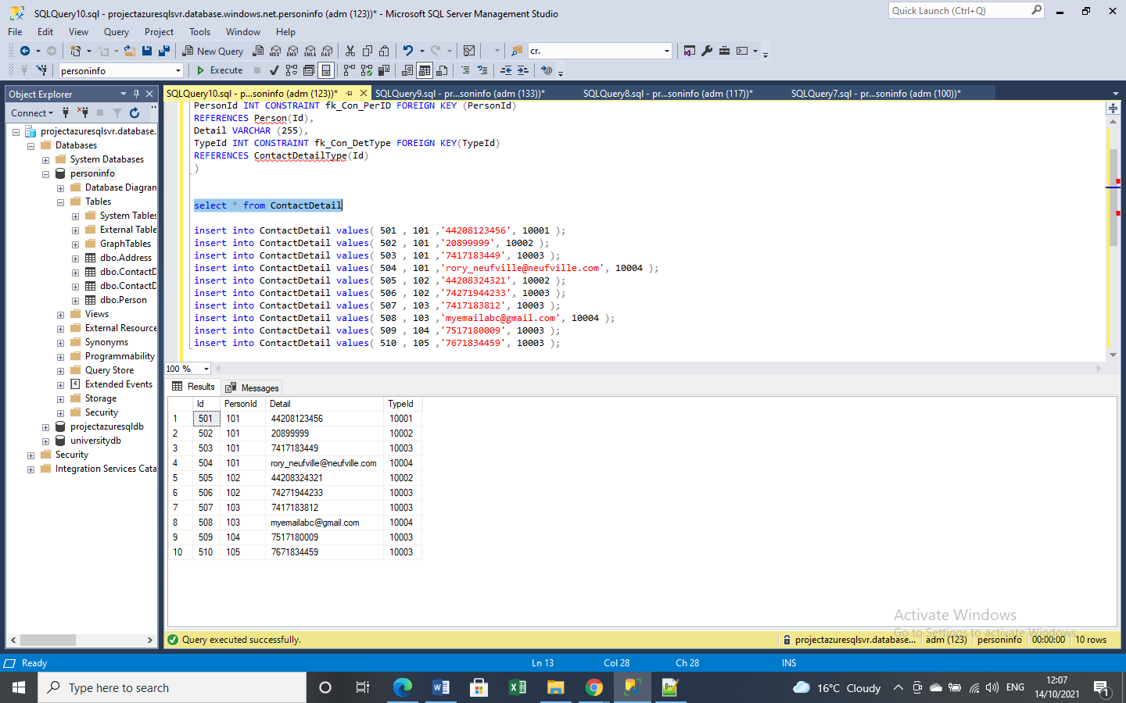

*6. Query to show First Name, Last Name, City, Contact Detail information .*

