***Question 4*** *: How to Load Multiple Files in Parallel in Azure Data Factory*

***Solution:*** *Create metadata table in SQL server (key /value pair) and create parameterised dataset in ADF. Create pipeline based on metadata and use For each Activity. The Dataset dynamically read multiple files or write data into various tables in parallel. The For each iterator loops metadata and perform copy activity dynamically and parallel.*

*This solution is implemented in part 1 and part 2*

*Part 1: Create metadata table in SQL Server and create parameterised dataset in ADF.*

*Part 2:*

1. *Create pipeline to retrieve metadata using lookup activity and preview the meta data query*
2. *For each activity, which iterates*
3. *For each activity performs copy activity dynamically*
4. *Debug the pipeline to check retrieve meta ,loop over meta data and copy activities are successful*
5. *Files copied to target successfully.*

*Retrieve metadata using lookup activity*

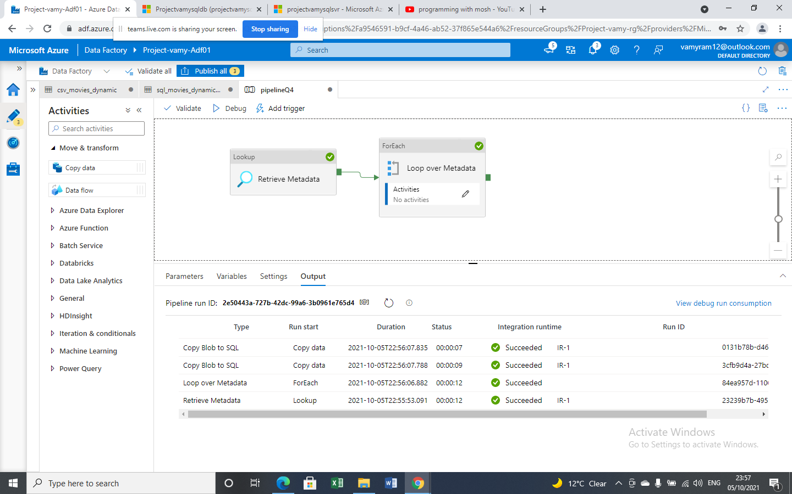

*The source (BLOB) and target (SQL DB) rows count are matched.*

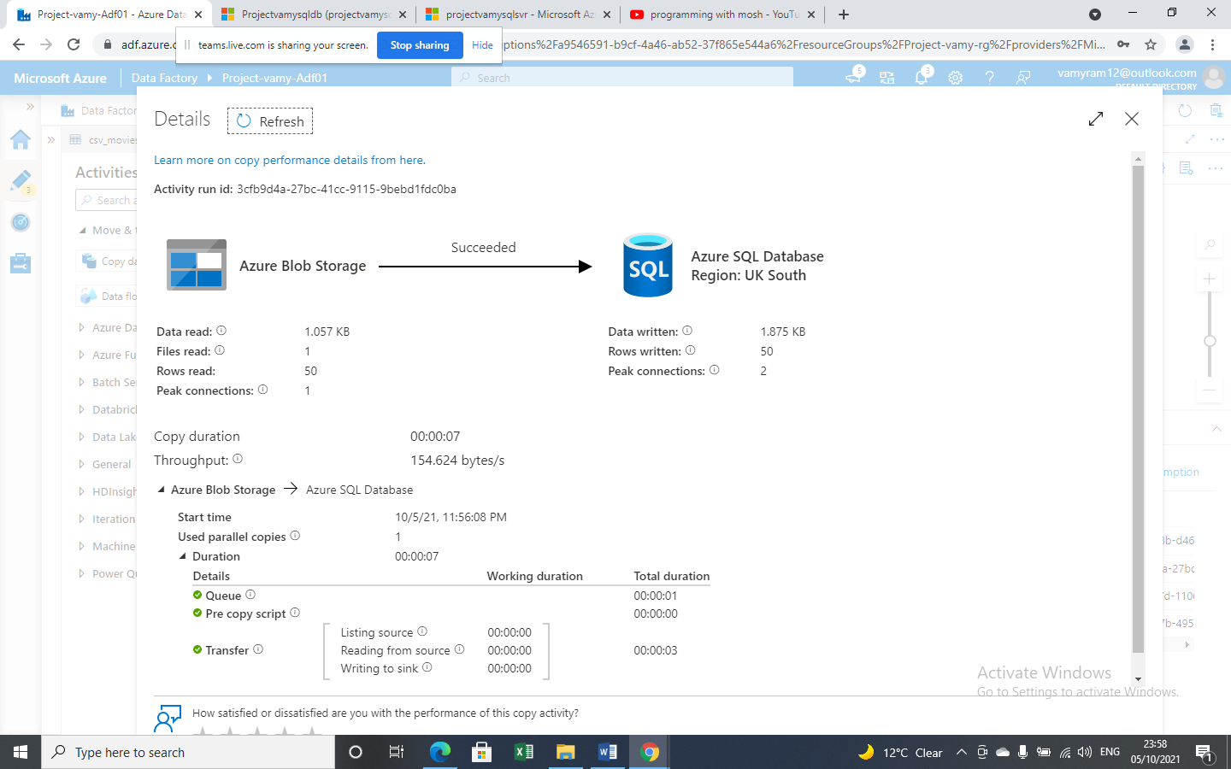

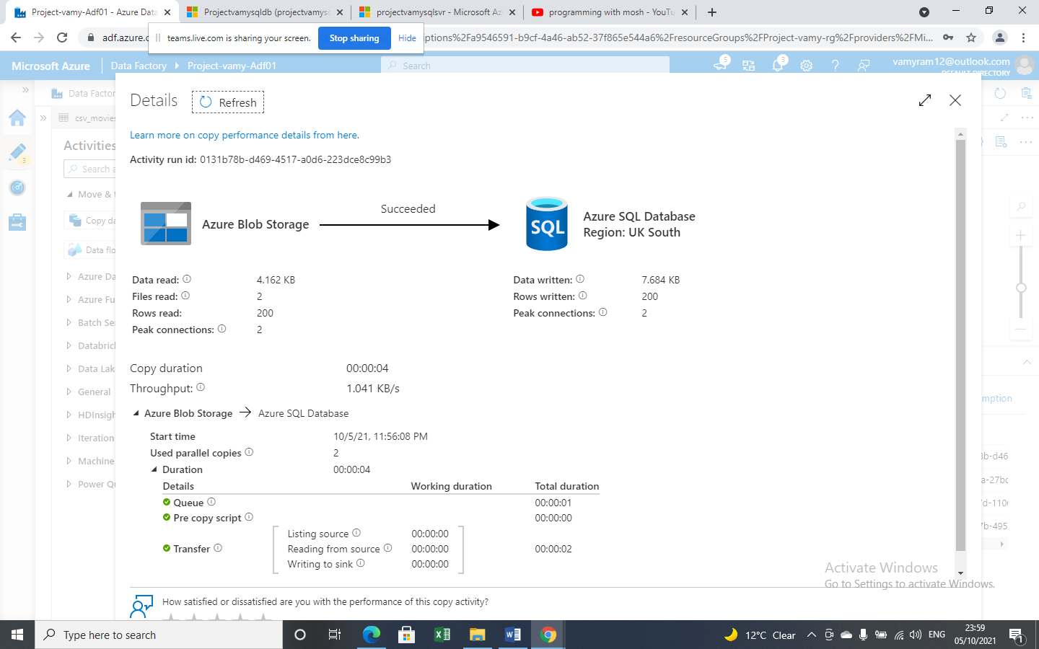

*Meta Data query output sample - Key Value pair*

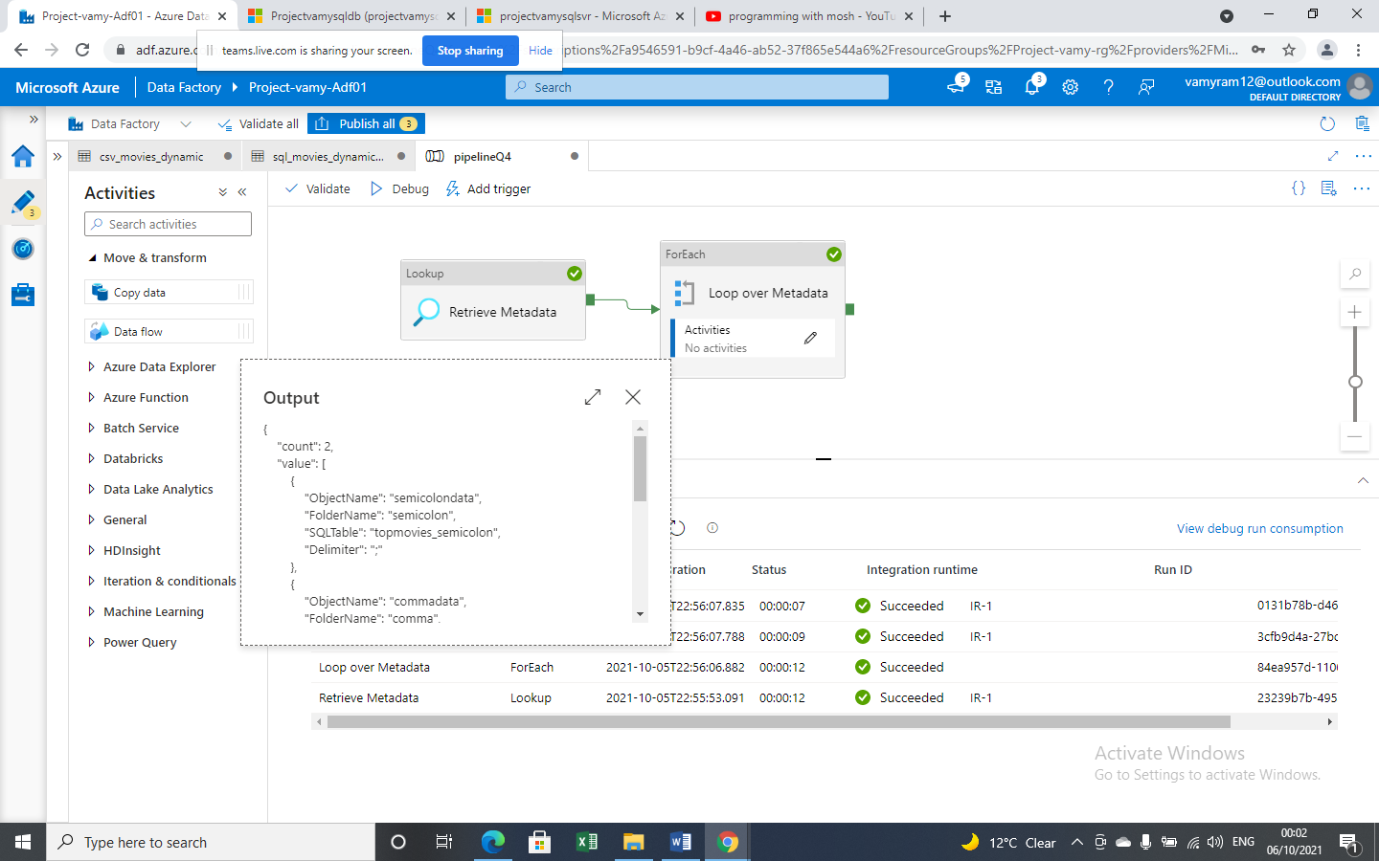

*File location / Folders (comma and semicolon)*

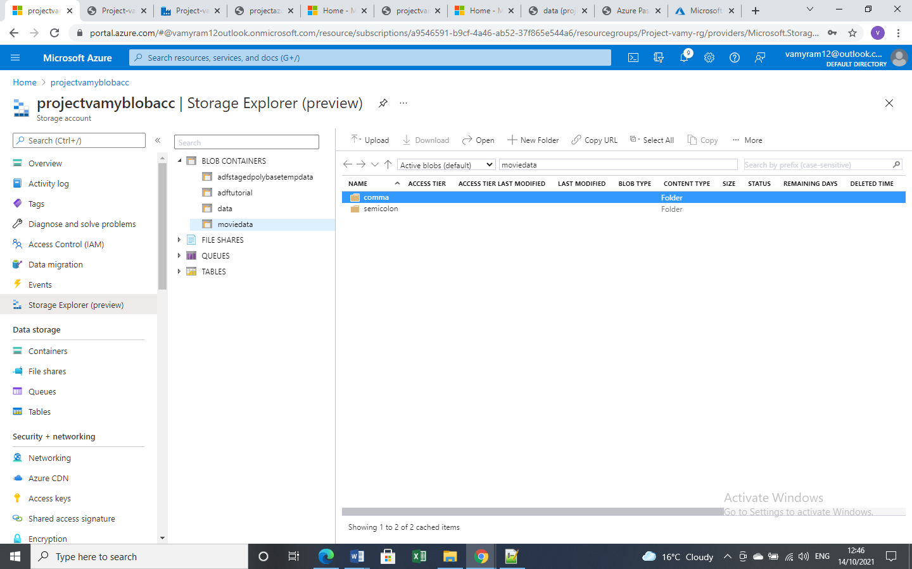

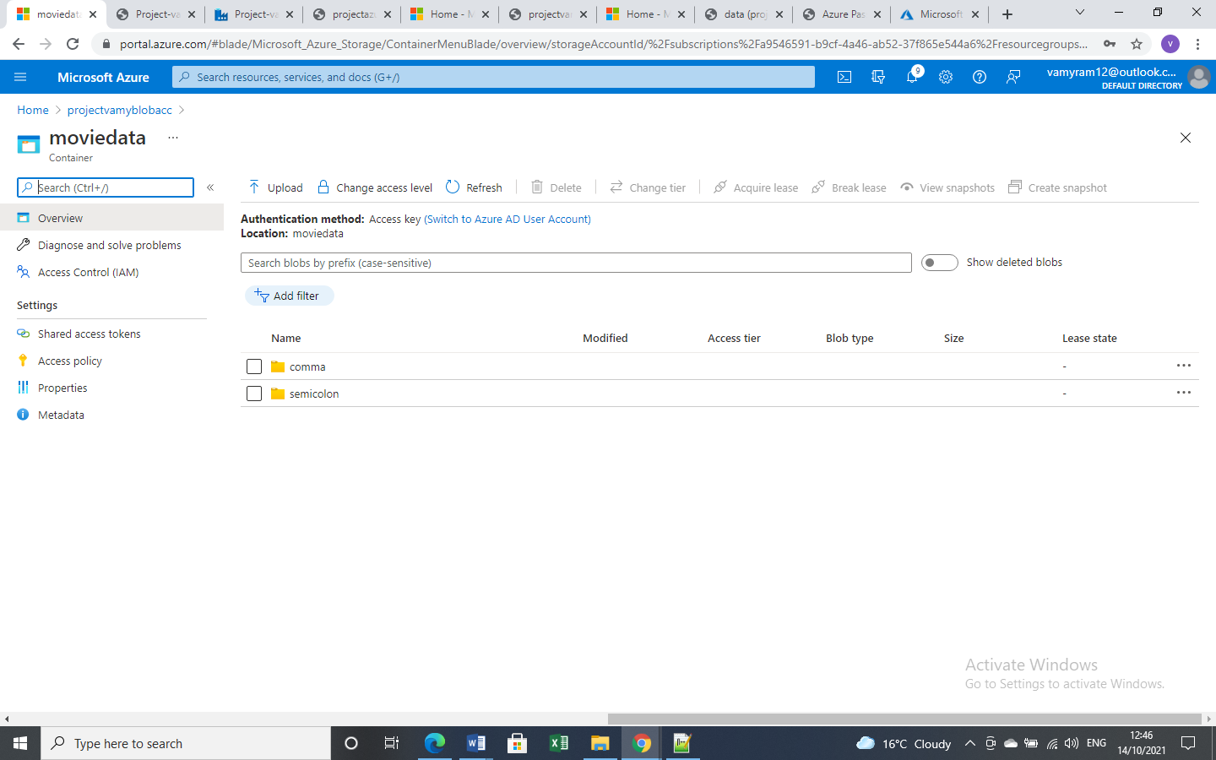

*Files from source*

