***Question 5:*** *Incrementally load data from Azure SQL Database to Azure Blob storage using the Azure portal*

*A data_source_table and watermark table is created and values are inserted. Created a procedure to update the last modified time.*

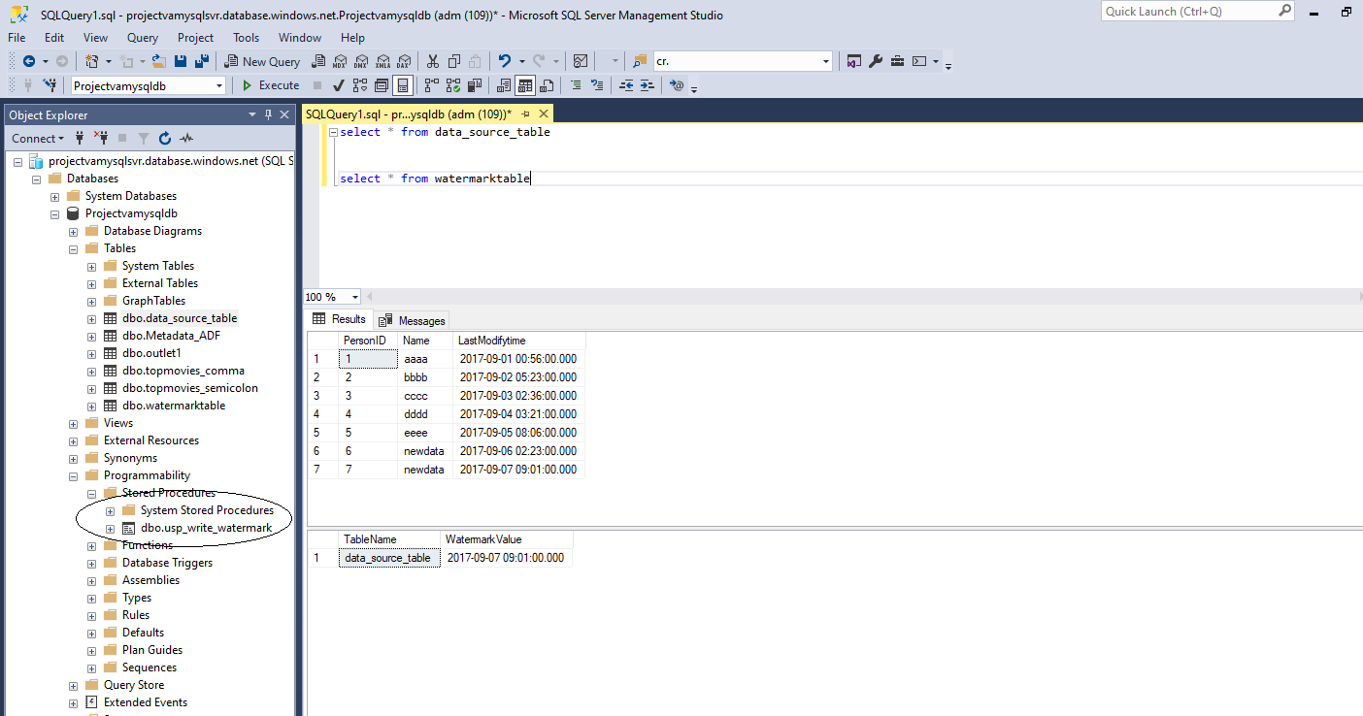

*In Azure Data Factory a pipeline is created with 4 activities. Two lookup activities to store the old and new values. LookupOldwatermarkActivity captures the last modified date from watermark table.*

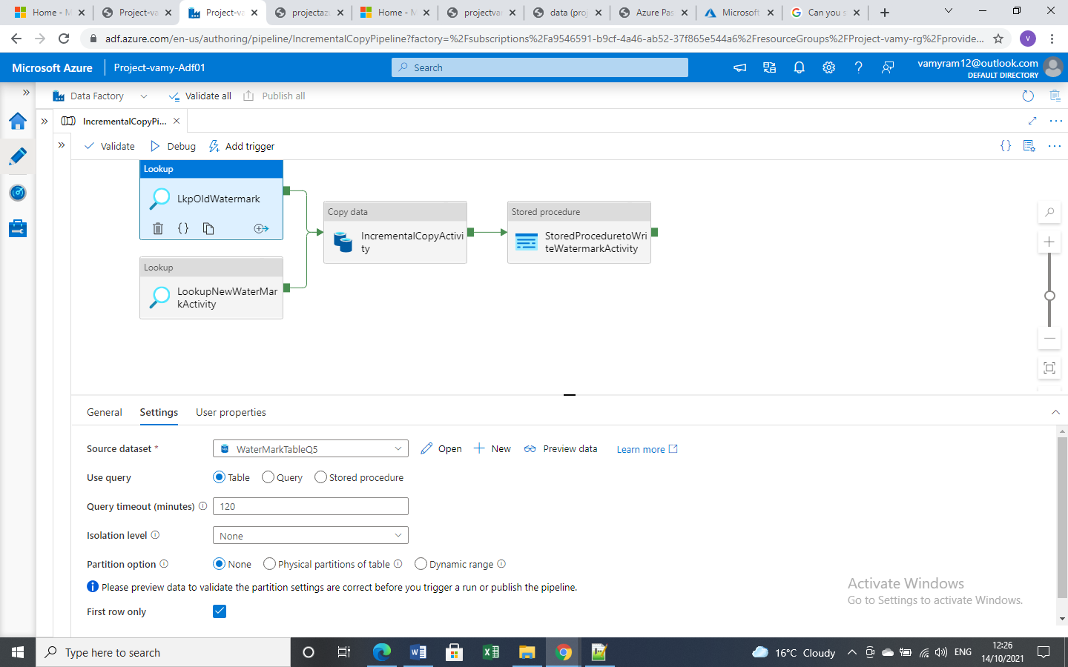

*LookupNewwatermarkActivity retrieve last modified date from the table .Get the maximum updated date from the table.*

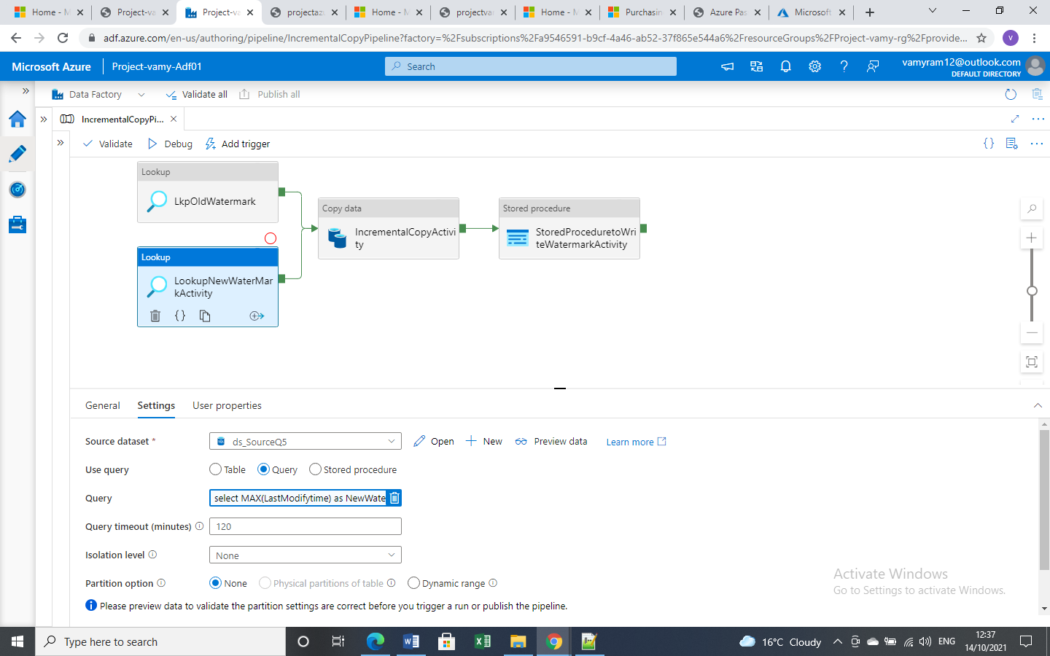

*Incremental copy activity for copying the data from sql db to blob storage. Query to retrieve the data from source table.*

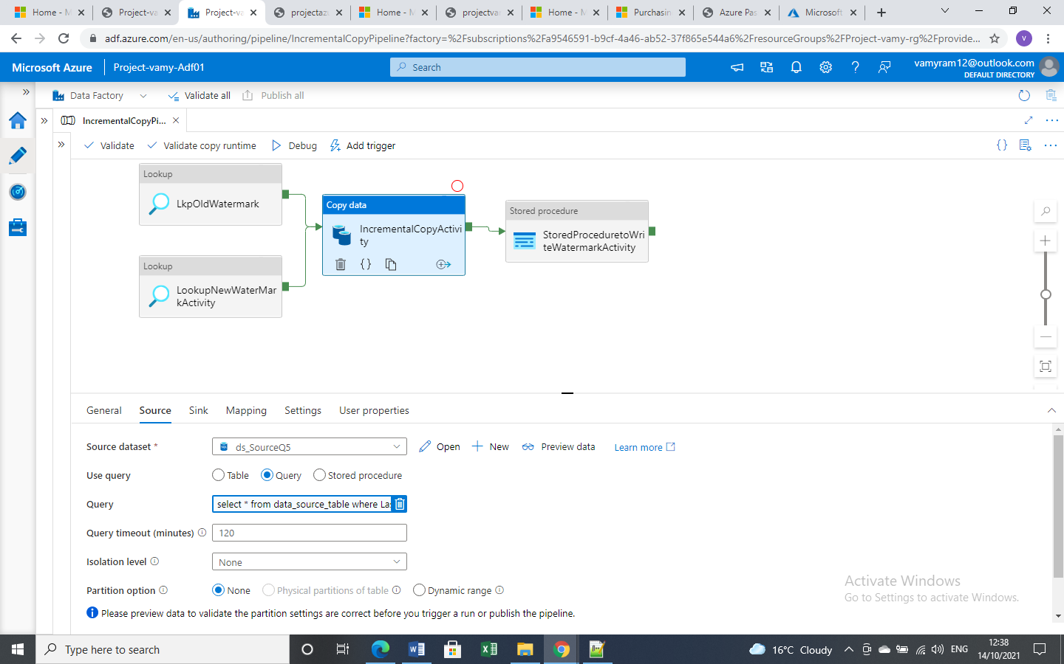

*Sink dataset is created.*

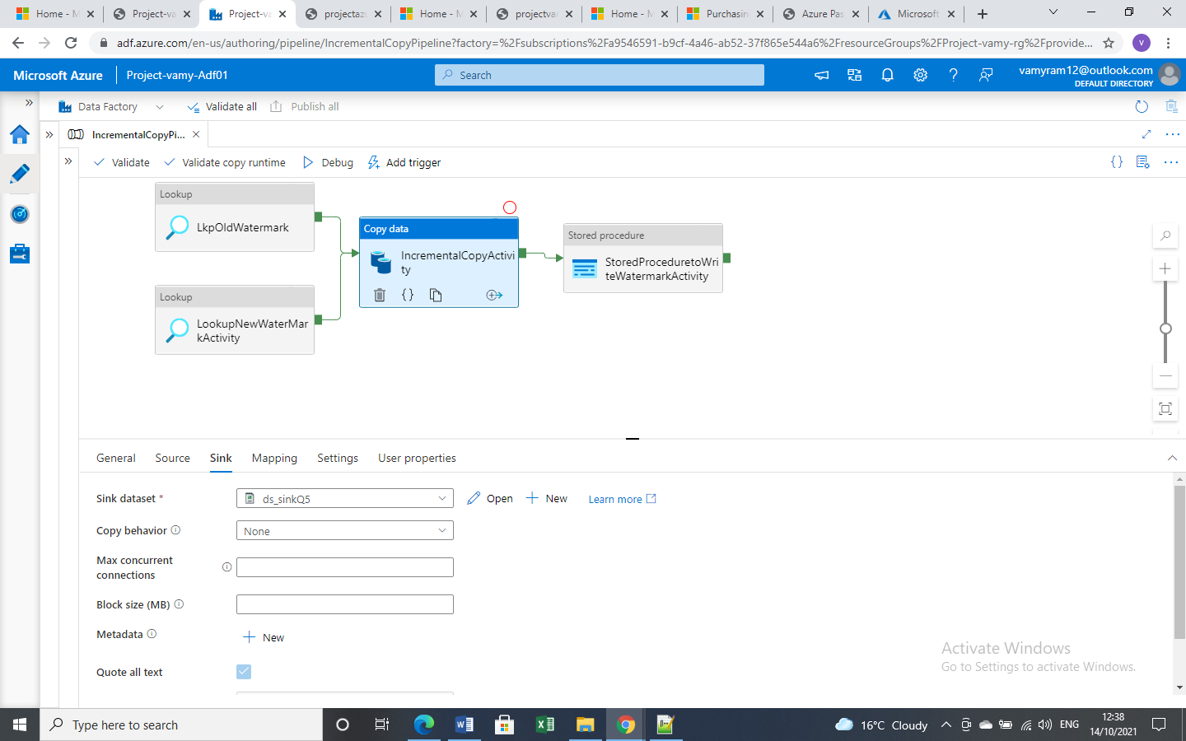

*Store Procedure activity is created to update the watermark table .Pass the parameter and update the last updated date in the watermark value and the table name.*

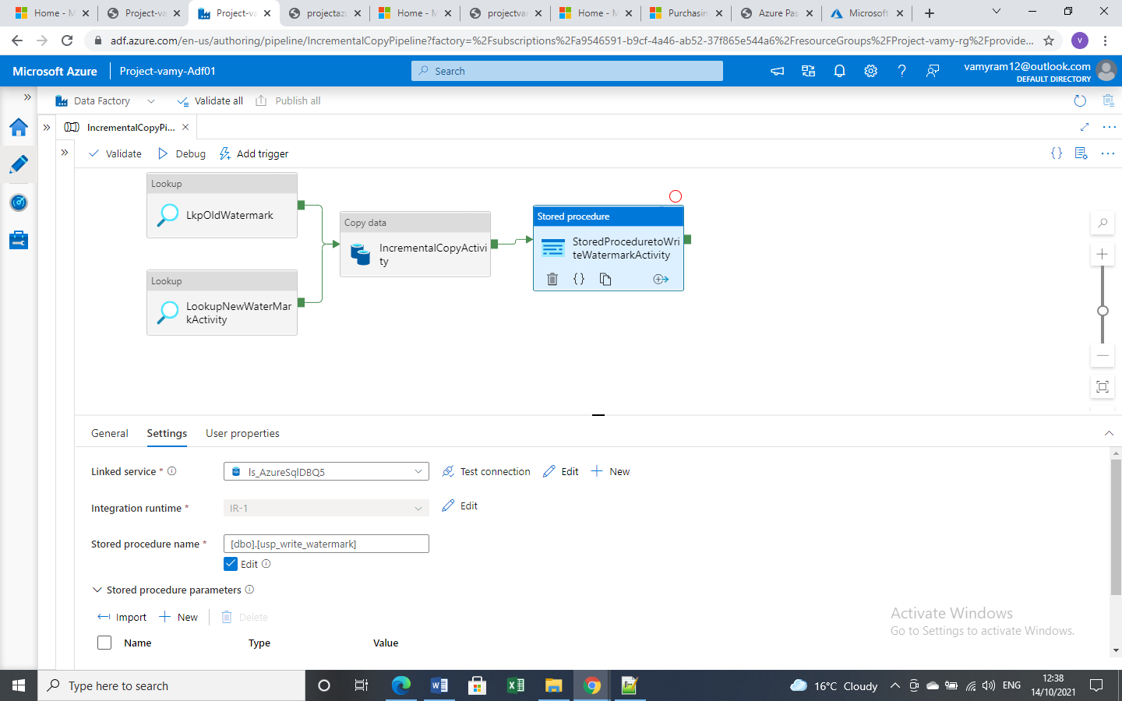

*Debug the pipeline to check all activities are successful.*

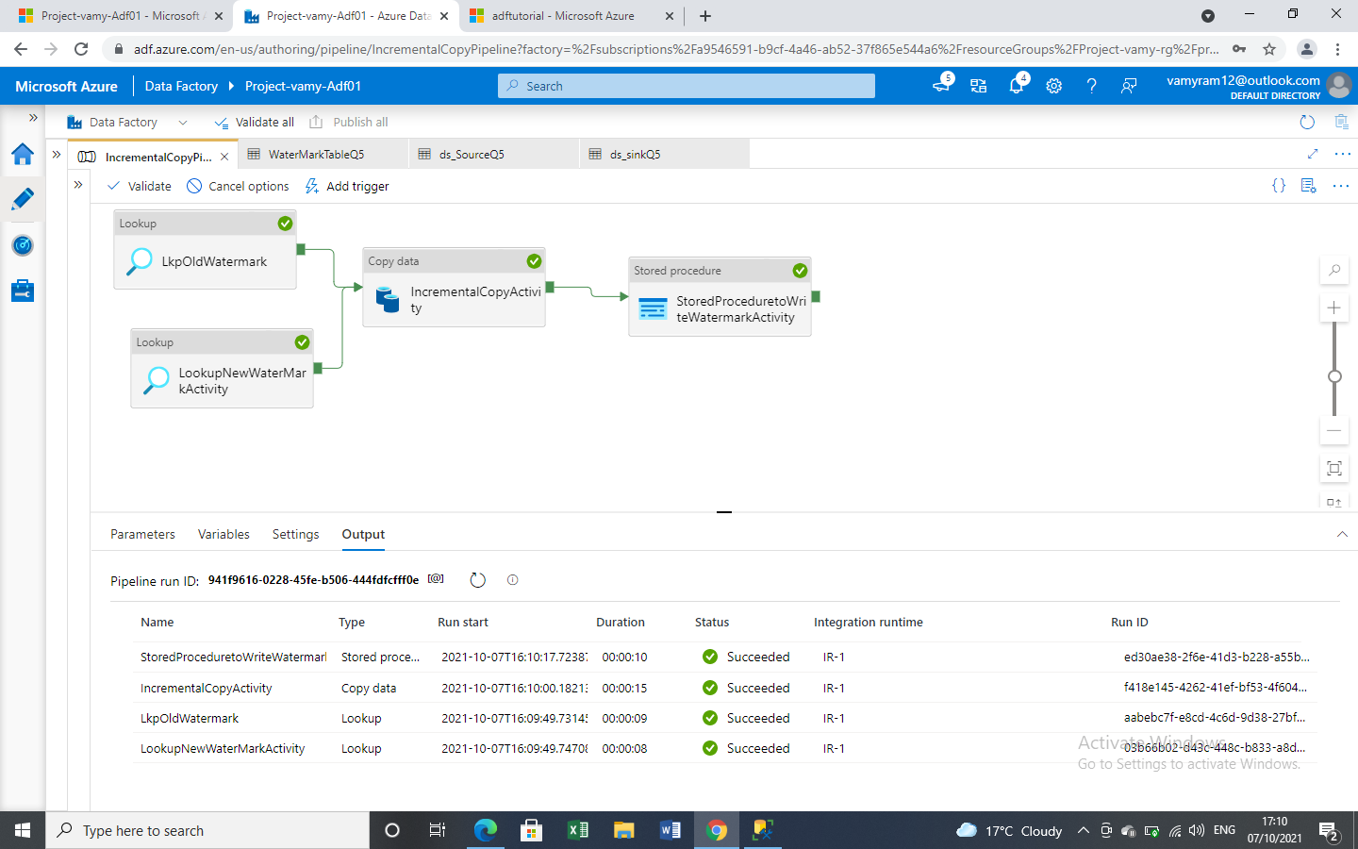

*Values are copied from SQL database to blob storage account in adftutorial container.*

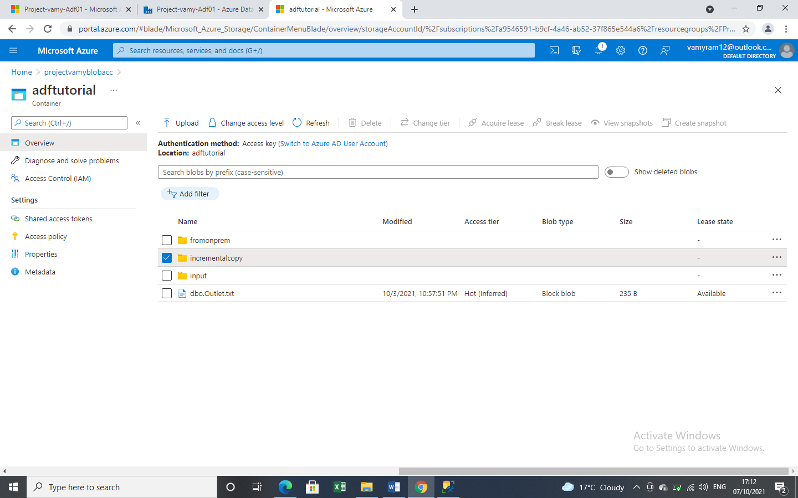

*Under incremental copy folder the values are copied in a file which is created at run time.*

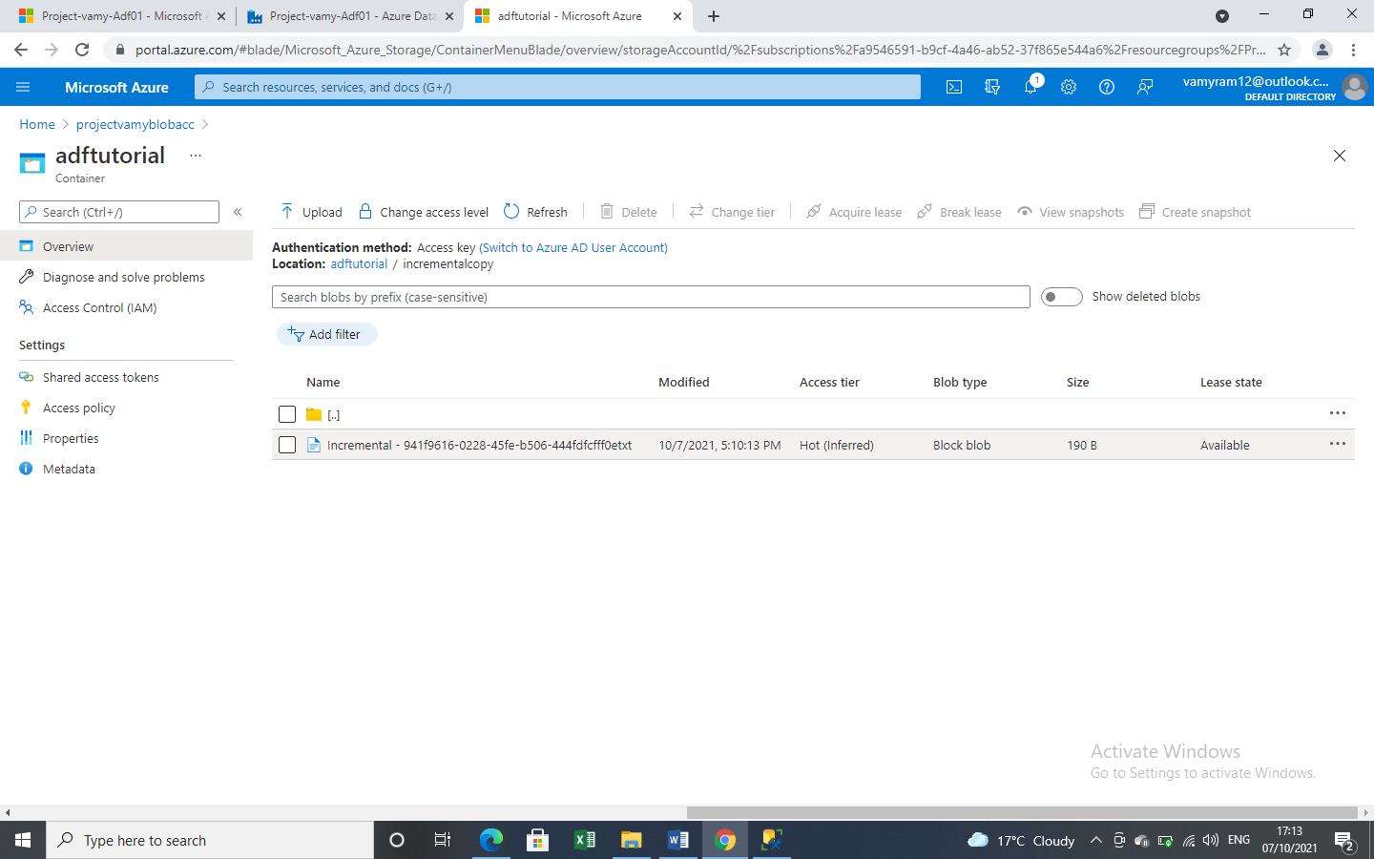

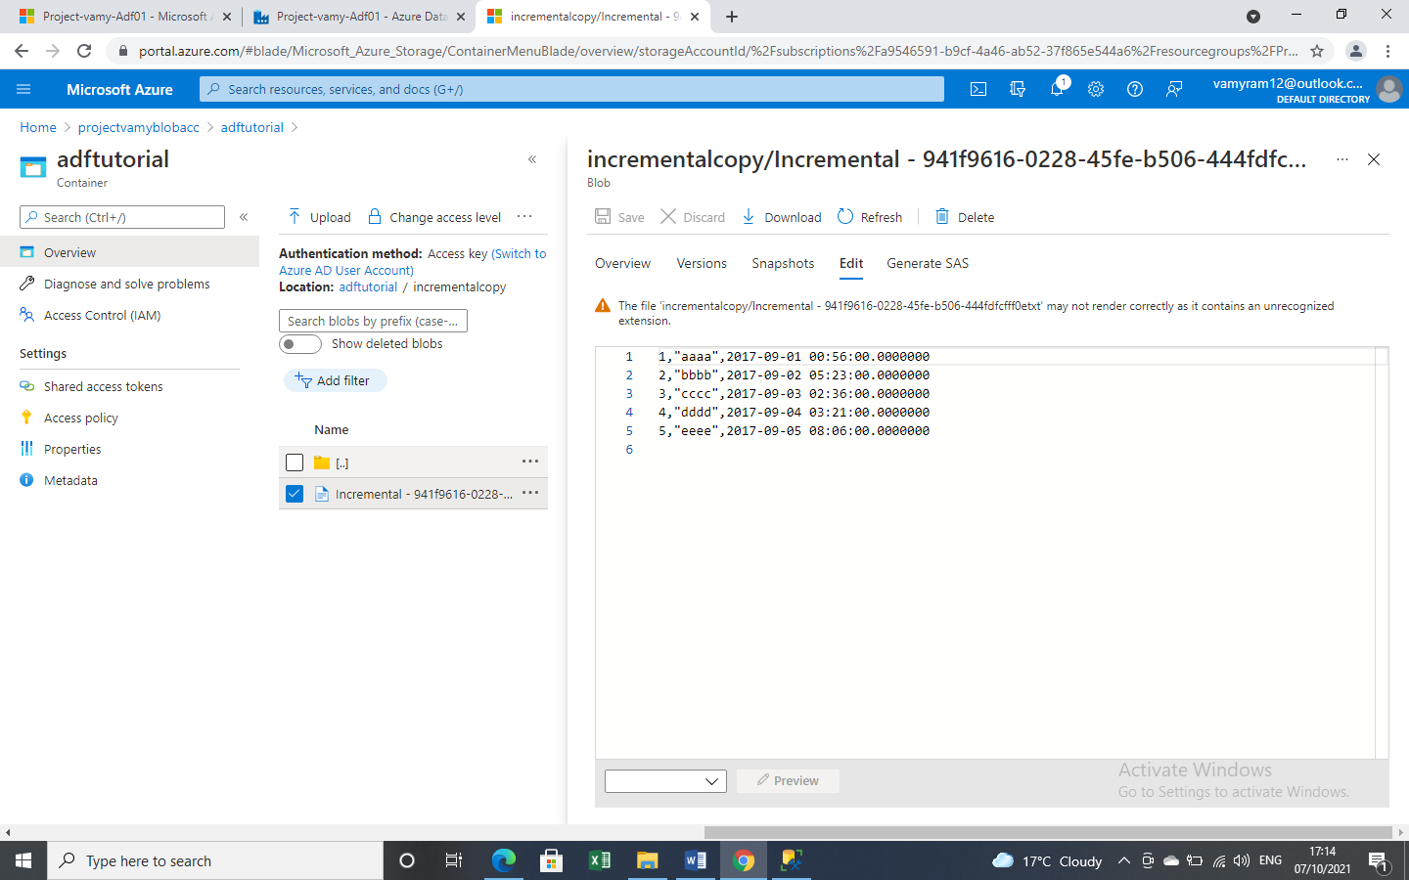

*After adding new values and initiating manual trigger. The new values are copied to a new file.*

