***Question 8****: Design a Non-Relational Database Model equivalent for a Relational Model. For the above Person Schema, preform below tasks.*

*1. Design a json document such that the person's information is all embedded a single json document*

*Mark has home and Office address and* ***multiple*** *contacts (home no, office no, mobile and email) and Amy has single address and contact.*

*Address and contact are defined as* ***Array*** *below*

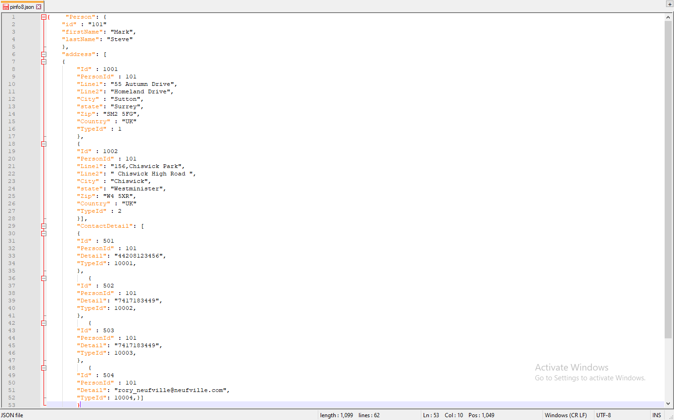

*2. Created Personinfo json Schema based on Person Table includes Single and multiple Address and Contacts.*

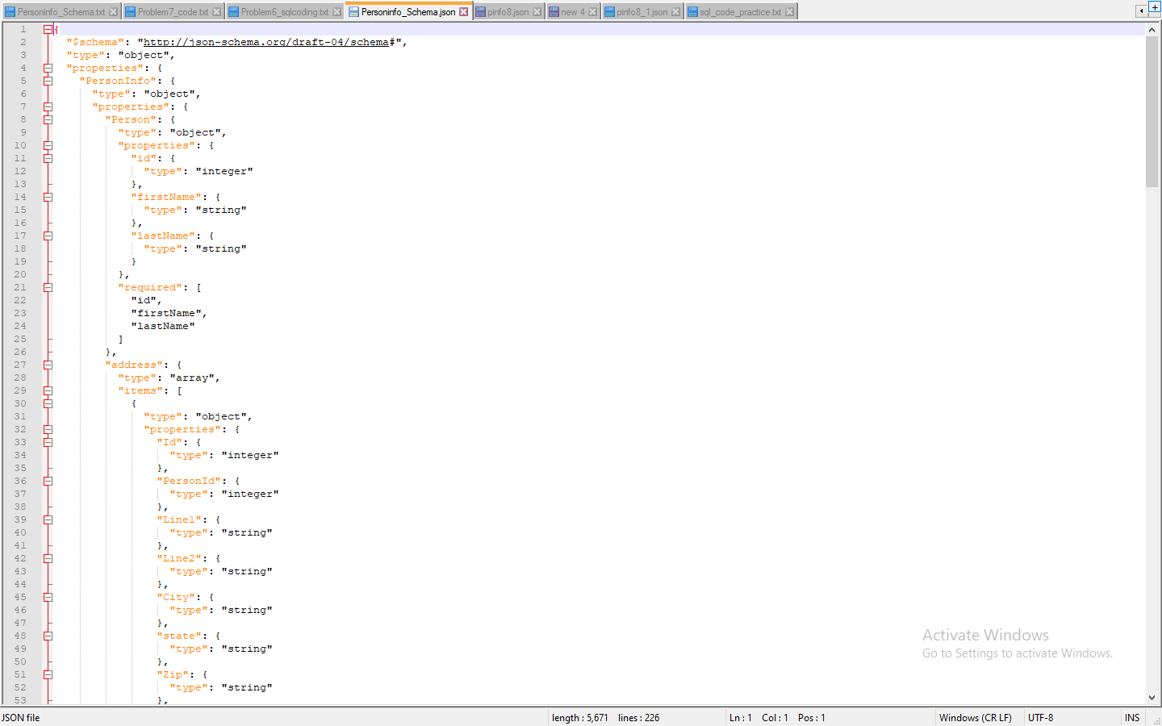

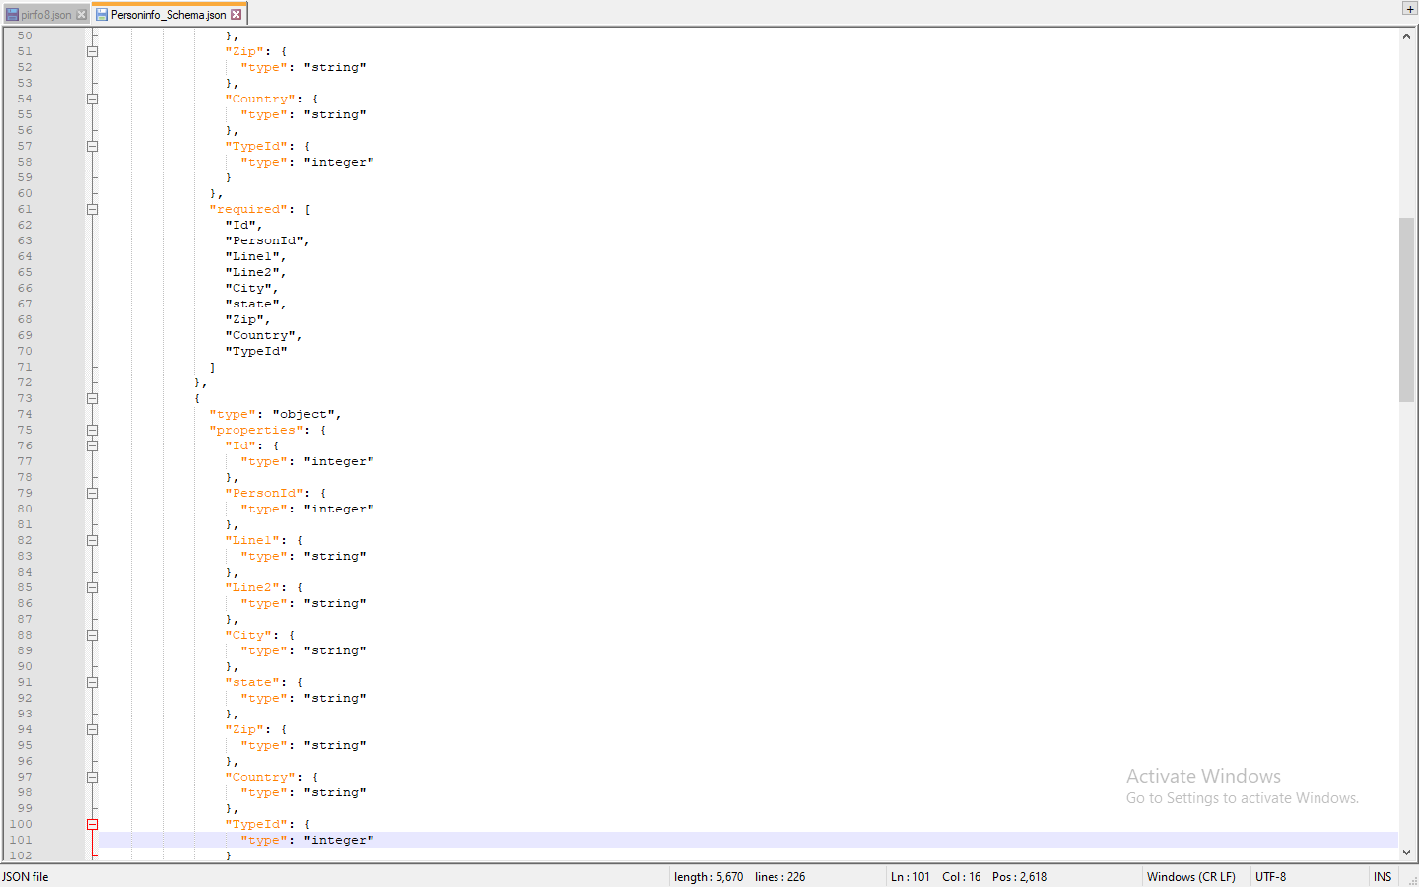

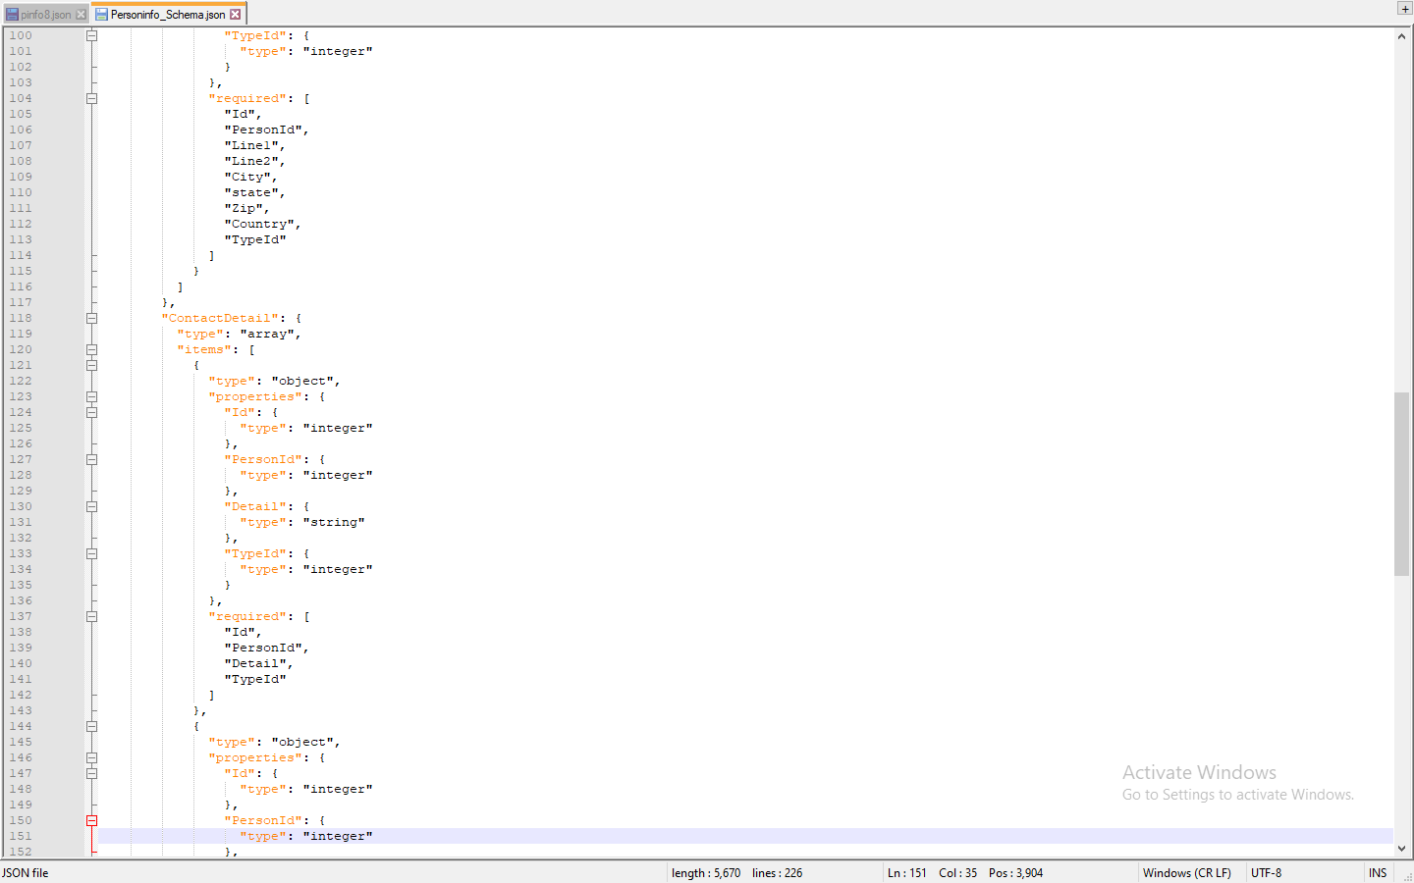

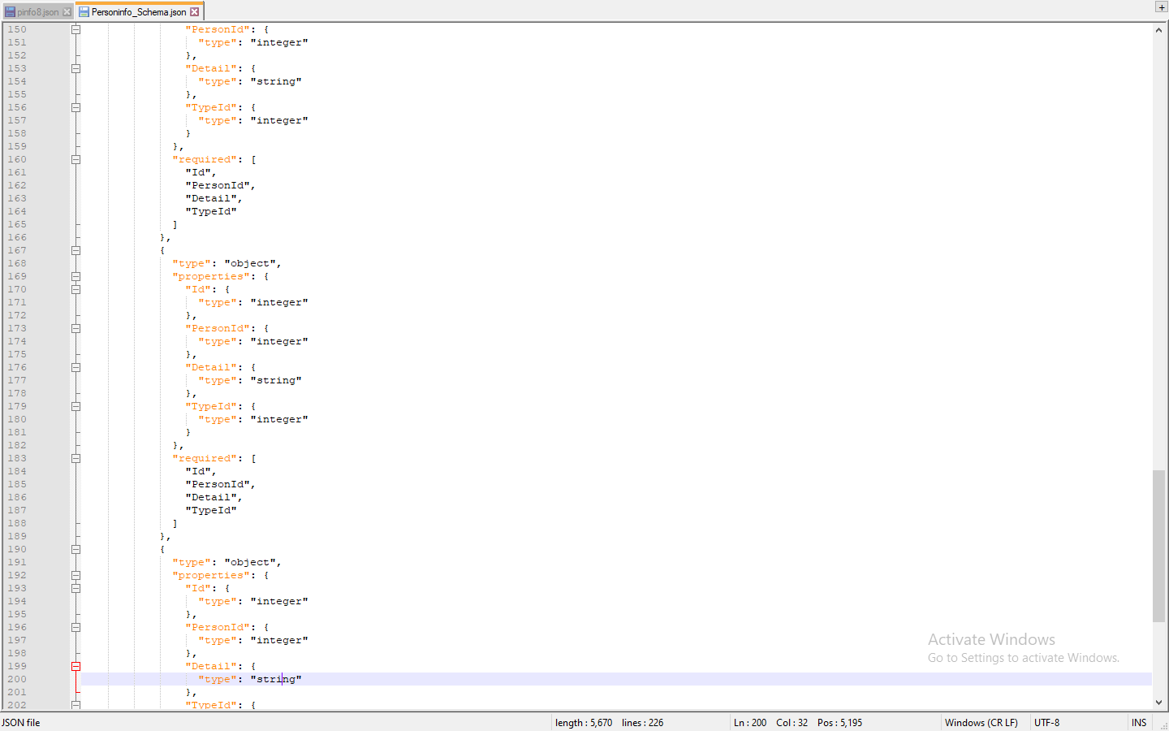

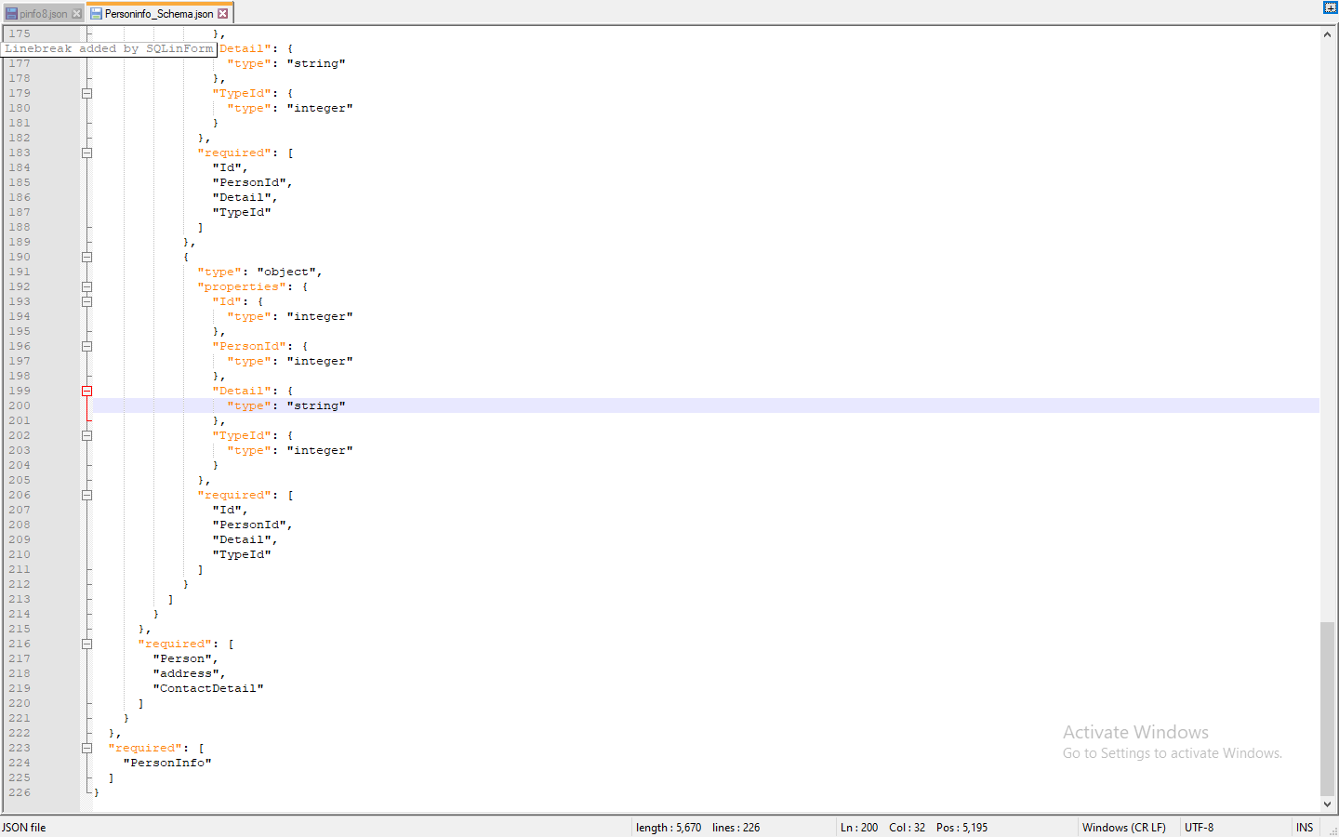

*Another Example for Person only* 