This document describes

* what OPBM is
* setting-up and installing OPBM
* how to use the end-user interface
* how to use the developer interface and command line interface.
* Worklet Descriptions

STANDARD Official Run or official run

Atom or worklet

Use the hyperlinks below to go to the specific OPBM documentation topic.

**WHAT IS OPBM**

Introducing OPBM

Advantages of OPBM

Value of OPBM

Terminology

Scoring Methodology

Worklet Descriptions

**GETTING STARTED**

Minimum Requirements to Run OPBM

Setting-up and Installing OPBM

Starting OPBM

Parts of the OPBM – Office Productivity Benchmark Main Window

Problems Running OPBM

Auto_logon_disable

Conflicts and Resolutions window

Getting Help

**OPBM FOR THE END-USER**

The end-user interface packages pre-defined worklets for distribution to the end-user. The end-user can launch the benchmark, view results and export results to Excel.

About the Simplified Run Interface

The Simplified Run Interface Main Window

Using the **Trial Run** button

Using the **Official Run** button

Using the **View Previous Results** button

Using the **Developer Interface** button

What happens when I start the benchmark? - The **HUD** (Heads Up Display)

What happen when the benchmark completes? - The **Results Viewer**

**OPBM FOR THE DEVELOPER**

There are several features available fore developers. Developers can run OPBM through a GUI developer interface or through a command line interface (CLI). Developers can write scripts, test scripts, and customize predefined worklets.

**THE DEVELOPER INTERFACE**

About the Developer Interface

The Run Modules: Atoms

The Run Modules: Molecules

The Run Modules: Scenarios

The Run Modules: Suites

Full Benchmarks: Trial Run

Full Benchmarks: Official Run

What happens when I start the benchmark? - The **HUD** (Heads Up Display)

What happen when the benchmark completes? - The **Results Viewer**

Shortcuts: Results View

Shortcuts: Results Viewer (Choose)

Shortcuts: Gather Debug Info

Maintenance: Script Definition

Editing <GUI STILL UNDER DEVELOPMENT>

Maintenance

Maintenance: UI Settings

**THE COMMAND LINE INTERFACE**

About The Command Line Interface

Command Line Syntax

Running OPBM from the command line

Executing scripts from the command line

Benchmarking across multiple machines

What happens when I start the benchmark? - The **HUD** (Heads Up Display)

What happen when the benchmark completes? - The **Results Viewer**

**DEVELOPING NEW WORKLOADS**

Worklet Descriptions

Creating new AutoIT workloads

Add an AutoIT based workload to OPBM

OPBM Harness Configuration

**Introducing OPBM**

OPBM (Office Productivity Benchmark) is a comprehensive, verifiable office application benchmark. OPBM allows the an end-user as well as an experienced analyst to produce verifiable, real-world performance workloads utilizing popular office productivity software.

OPBM introduces new terminology to bundle benchmarking concepts so that office productivity workloads can be evaluated for real-world performance. A workload can be defined as an atom, molecule, scenario or suit.

OPBM provides a diversified tool set through 3 user interfaces

**Simplified Run Interface** – an end-user interface which allows users to run preset benchmarks under closed, controlled conditions.

**Developer Interface** – a developer interface to design, customize and capture office productivity tasks in such a way as to simulate “real-world” workloads for benchmark performance analysis.

**Command Line Interface**( CLI) - an end-user interface that allows the user to launch and execute OPBM scripts from a command prompt. The user can terminate the workload immediately from the command line or input files in a self-contained, controlled manner, utilizing the features of the GUI interface.

**Advantages of OPBM**

Value of OPBM

Terminology

Scoring Methodology

**Value of OPBM**

*OPBM’s unique design is customizable and flexible for the end-user as well as the analyst.*

|  |  |
| --- | --- |
| **Customizable** | *OPBM’s unique design makes it customizable for the performance analyst or the hardware benchmarker.*  The end-user can choose which predefined workloads to include in his/her performance analysis, reorder the sequence of workloads in a run of the benchmark, test the workload sequence before launching a full performance run. The developer can design and modify workloads, customize his/her interface in OPBM, and capture errors or other information through the command line interface. |
| **Flexible** | *OPBM’s unique design makes it extremely flexible for scripting purposes.*  The end-user and the developer can reorder workload sequences and determine which workloads to include in a run. The benchmark can focus on specific software, such as, internet browser, office products,…….l |

**Terminology**

*OPBM’s unique design introduces new terminology to better identify benchmark workloads.*

|  |  |
| --- | --- |
| **Worklet** | An operation or group of operations inside an atom. It is the smallest unit of work that is measurable. |
| **Atom** | The most basic bundle of worklets. Like atoms in nature, they may or may not be able to function independently. Worklets combine to form atoms. An atom generates a benchmark score. |
| **Molecule** | A group of atoms, such as Open Word atom, Load Word document atom and Close Word atom. A molecule can run independently. |
| **Scenario** | A group of molecules. A scenario may target performance analysis on a specific office productivity activity such as word processing. A scenario can run independently. |
| **Suite** | A group of scenarios. A suite can be used to define a complete benchmark for office productivity. A suite can run independently. |
| **HUD (Heads-Up-Display)** | Window active during a launch of OPBM. It displays information to show you which workloads and operations are running during the benchmark. |

**Scoring methodology**

*OPBM’s scoring methodology makes it easy for end-users and experts alike to understand performance numbers.*

|  |  |
| --- | --- |
| **Official Run Score** | An Official Run score is the arithmetic mean (average) of three OPBM scenarios. The Official Run score is the **average** of the three OPBM runs. The **Result Viewer** also provides the averages for all of the constituent operations and aggregations. |
| **How a score is generated** | Each atom generates a score. This score is produced by dividing the time it took to complete the operation on the reference system (**tref**) by the time it took to complete the operation on the SUT (**tsut**) during the current run*.*  **tref* / tsut**  **\****The current reference system is the Core i5 SUT.*  This ratio is then multiplied by 100 to produce a more human friendly number.  **score = 100 * (tref / tsut )**  In other words, **the score is the SUT's percentage performance** of the reference system.  A score of  **100** means equal performance  **50** means half the performance  **200** means twice the performance of the reference system |
| **Aggregation level score** | Scores are aggregated at each level by calculating the geometric mean of the component scores. For example,  **ScoremyMolecule = GeometricMean( Scoreatom1, Scoreatom2, Scoreatom3, … Scoreatomn)**  The aggregation level scores are  **Atom** - The score is the geometric mean of internal operations.  **Molecule** -The score is the geometric mean of internal atoms.  **Scenario** - The score is the geometric mean of the internal molecules.  **Suite** - The suite score will be the geometric mean of the internal scenario. A Suite allows for aggregation flexibility in scoring. (This functionality is still under development.) |

**Minimum requirements to run OPBM**

* Oracle HotSpot Java Version 1.7.0 or newer
* Virtual Machine installed (JDK or JRE version 1.7.0 32-bit or 64-bit, preferred 64-bit)
* Internet Explorer 9 (will not work with IE8 or older)
* Microsoft Office 2010
* 24-bit video resolution of at least 1280x1024
* Windows 7

**How to set-up and install OPBM**

Installing OPBM

Creating a git hub account

Disabling Window 7 Login screen

Disabling User Account Control

**Installing OPBM**

|  |  |
| --- | --- |
| **How to install OPBM** | To install OPBM you will   1. Create a git hub account if you will be tracking issues for the OPBM project. 2. Download the OPBM software from Github to a local repository.??? 3. Disable the Windows 7 Login Screen. 4. Disable User Account Control 5. Run the opbm.jar file to start OPBM. |
| **Applications that OPBM installs** | * 7-zip * Adobe Acrobat Reader X (version 10) * Chrome * Firefox * Opera * Safari |
| **Directories and documents that OPBM creates during installation** | Java  Vs2010  OPBM_Documentation.docx  readme.txt  The following default folders are created **in c:\users\user\documents\opbm** when OPBM starts.   |  |  |  | | --- | --- | --- | | **Folder created** | **What is in the folder** | **Sample file** | | \results\csv\ | Benchmark results saved in csv format. |  | | \results\xml | Benchmark results saved in xml format. Default file format for results. |  | | \temp\ | Debug information and the opbm.dat files | debugInfo_Oct_04_2011_at17_13_44.xml  opbm.dat | | \running\ | Manifest.xml  *When you launch the benchmark, OPBM generates a manifest.xml file. It records and accumulates everything necessary to complete the run, along with everything generated while executing scripts. This data exists in a single XML file called* ***manifest.xml****.* | manifest.xml | | \settings\ |  |  | | \scriptOutput\ | csv output file created by AutoIt for debug purposes | ieGoogleV8Times.csv | | \scriptOutput\temp\ |  |  | |

**Creating a GitHub account**

If you track issues for OPBM, you will need a GitHub account. See the Github xxxx.pdf on how to set-up a Github account.

**Disabling the Windows 7 login screen**

You must set windows to automatically log you in. This allows OPBM to reboot the system for an official benchmark run. The benchmark cannot capture appropriate scores if the system does not allow for automatic reboots.

1. Log into Windows 7 using an administrator account.
2. Click on the **Start Menu**. Type "netplwiz" in the search field. Click on "netplwiz" in the list. The **User Accounts** window appears.
3. Click on the user name to be logged in automatically.
4. Uncheck □ **Users must enter a user name and password to use this computer**.
5. Click on **Apply**. The **Automatically Log On** window appears. Enter your password in both **Password:** fields. Click **OK** to accept changes.

**Disable User Account Control**

???? Why

You must disable user account control in windows. This allows OPBM to ??????

1. Go to **Control Panel** in Windows.
2. Click on **User Accounts and Family Safety**.
3. Click on **User Accounts**. **Make changes to your user account** appears.
4. Click on **Change User Account Control settings**. The **User Account Control Settings** window appears.
5. Move the slider to **Never notify**. Click **OK**.
6. The **Action Center** window appears.
7. Restart the computer for the change to take place.

**<THIS PAGE LEFT BLANK INTENTIONALLY.>**

**Starting OPBM**

Double-click on **c:\opbm\java\opbm\opbm.jar** to start OPBM. The **OPBM – Office Productivity Benchmark** main window appears.

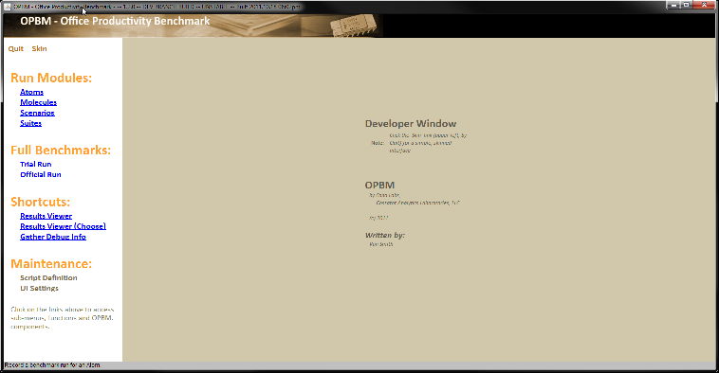

**Parts of the OPBM – Office Productivity Benchmark Main Window**

|  |  |
| --- | --- |
| **Quit** | Closes OPBM |
| **Skin** | Toggles between the **Simplified Run Interface** and the **Developer Interface**. |
| **Run Modules:** | Atoms – Opens the **Run Atoms:** window to test and customize atoms.  Molecules – Opens the **Run Molecules:** window to test and customize molecules.  Scenarios – Opens the **Run Scenarios:** window to test and customize scenarios.  Suites – Opens the **Run Suites:** window to test and customize suites.  Results Viewer – Opens the **OPBM – Results Viewer** window to view benchmark results. |
| **Full Benchmarks:** | Trial Run – Opens the Trial Run window to launch 1 full run of the OPBM benchmark.  Official Run – Opens the Official Run window to launch 3 full runs of the OPBM benchmark. |
| **Shortcuts:** | Results Viewer – Opens a pop-up end that lets the user choose a file of benchmark results for a benchmark run.  Results Viewer (Choose) – Opens a pop-up end that lets the user choose a file of benchmark results for a benchmark run.  Gather Debug Info – Creates an .xml??? file of ????. |
| **Maintenance:** | Script Definition – Opens the **Editing: and Maintenance:** panel. You can develop and edit atoms, molecules, scenarios and suites within OPBM.  Script Maintenance – Opens the View or Edit Raw Files panel. You can view or edit the .xml files that drive the OPBM harness.  UI Settings – Opens the **User interface settings** panel. You can change the settings here |

.

**The HUD (Heads Up Display)**

The HUD lists the execution order for a benchmark run.

The HUD appears when a benchmark run is launched. The HUD appears in the lower right screen of the window.

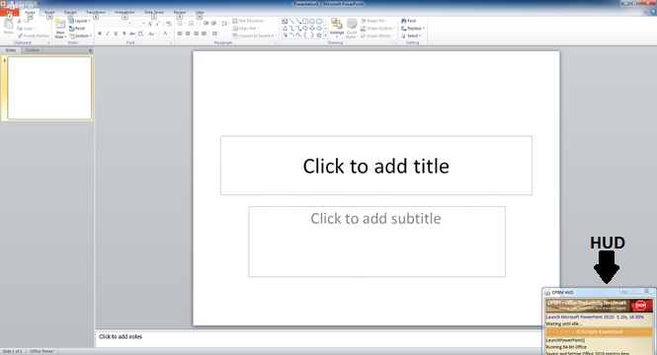

To terminate the run before completion, click on **STOP**. When you stop a run, the results view will ???

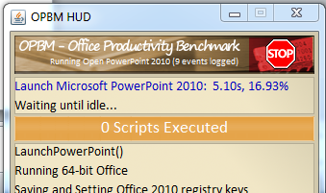

When the benchmark run completes, the **OPBM HUD** window disappears and the **OPBM – Results Viewer** window appears with the results of the benchmark run.

**The Results Viewer**

About the **OPBM – Results Viewer Window**

Parts of **the OPBM – Results Viewer Window**

Using **Show by: Times** button

Using **External Views: CSV** icon

**About OPBM – Results Viewer Window**

The **OPBM – Results Viewer** appears when the benchmark run is completed or terminated.

or

If you click on the **Shortcuts: Results Viewer** link. The results appear by score. **Show by: Scores** is the default setting.

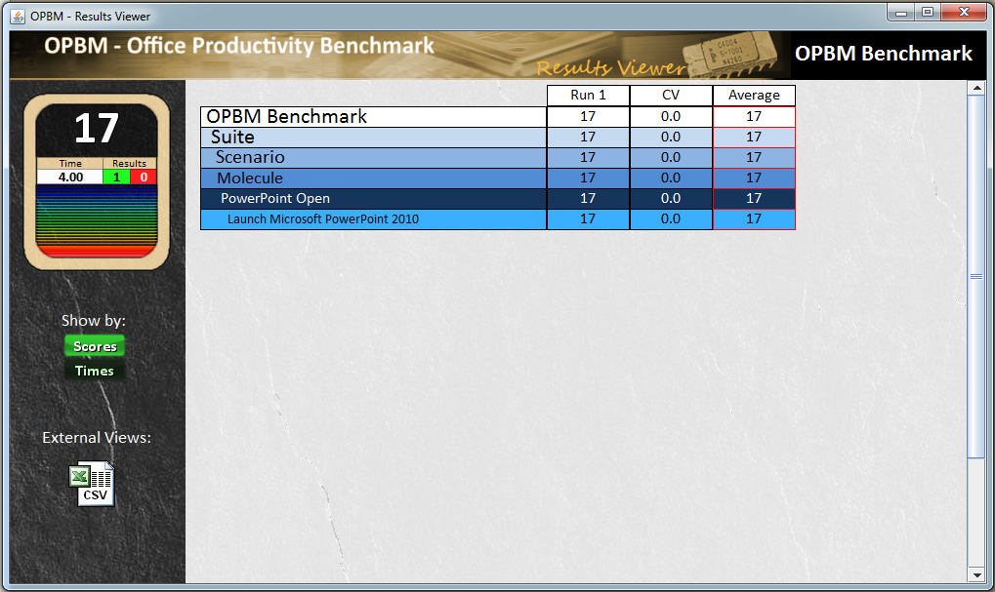

**Parts of the OPBM – Results Viewer Window**

The left panel displays the Official Run benchmark score. A score of 100 is the same performance as the reference system. Currently, this is the corei5. For information on scoring methodology click here.

**Show by:**

**Scores** - Displays the results by score.

**Times -** Displays the results by time.

**External Views:**

CSV icon – Generates a CSV file in EXCEL.

**Using the Show by: Times button**

Click on **Show by: Times** to view the result times for the run.

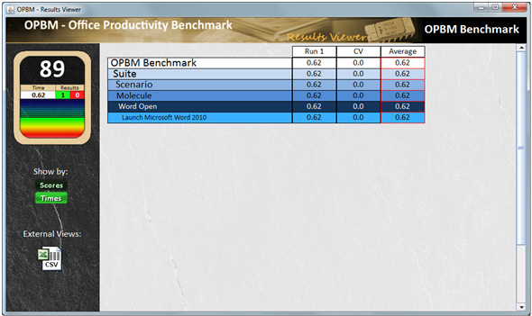

**Using the External Views: icon**

Click on the External Views: icon to view the results in EXCEL. The excel file will have a .cvs extension. The **Using Default CSV Handler** window displays. Click the **OK** button.

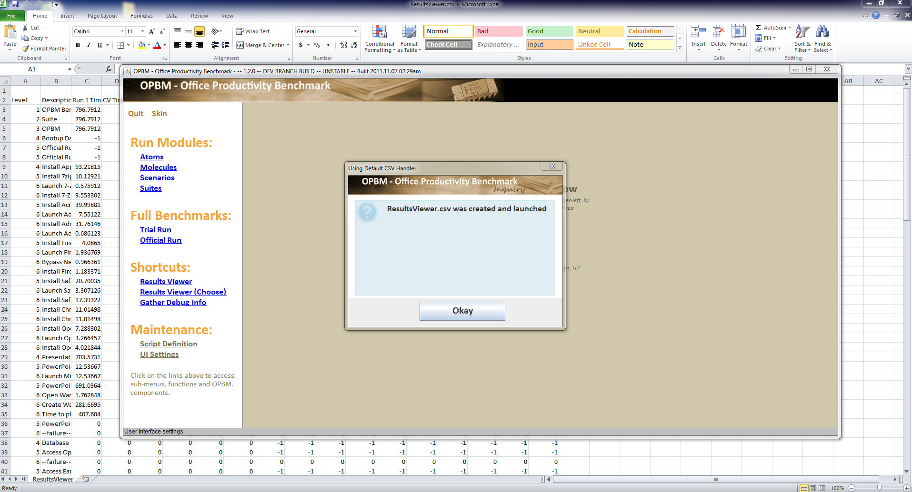

**The Simplified Run Interface**

About the Simplified Run Interface

The Simplified Run Interface Main Window

Using the **Trial Run** button

Using the **Official Run** button

Using the **View Previous Results** button

Using the **Developer Interface** button

**About the Simplified Run Interface**

This interface is deisgned for the end-user. It has 4 buttons and will be the default interface upon release. It restricts the user to an official run or a trial run. An official run is 3 full runs of OPBM preceded by reboots before each run. A trial run is 1 full OPBM run with no reboots.

**The Simplified Run Interface Main Window**

Click on **Skin** from the **OPBM- Office Productivity Benchmark** main window.

The **OPBM Simplified Run Interface** window appears.

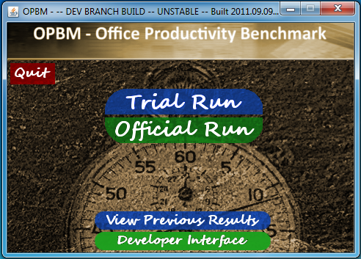

|  |  |
| --- | --- |
| **Button** | **Function** |
| **Quit** | Quits the application. |
| **Trial Run** | Runs the benchmark one time. |
| **Official Run** | Runs the benchmark three times with reboots. |
| **View Previous Results** | Displays a file window to select previous results saved as an *.xml file. Click on the file that you want to view. The results appear in the **OPBM-Results viewer** window. |
| **Developer Interface** | Returns user to the **OPBM – Office Productivity Benchmark** main window. |

**Using the Trial Run button**

Click on the **Trial Run** button. The **Trial Run** window appears.

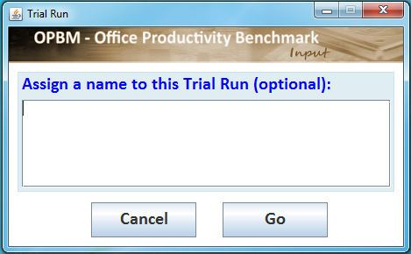

|  |  |
| --- | --- |
| **Save results to a default file** | Click on the **Go** button to start the run. The results are saved to results.xml in the \opbm\results\xml\ folder |
| **Save results to a user-defined file** | .  Type the name of the file <user_name>.xml. Click the **Go** button to start the run. The results are saved to the <user_name>.xml file in the \opbm\results\xml\ folder. |
| **Return to the Simplified Run Interface** | Click on the **Cancel** button. . The Trial Run will not be launched and the pop-up window closes. |

**Using the Official Run button**

Click on the **Official Run** button. The **Official Run** window appears.

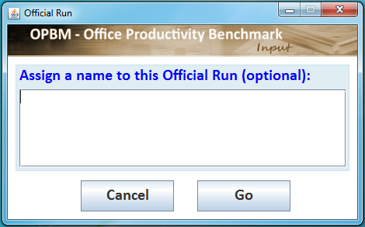

|  |  |
| --- | --- |
| **Save results to a default file** | Click on the **Go** button to start the run. The results are saved to results.xml in the \opbm\results\xml\ folder |
| **Save results to a user-defined file** | .  Type the name of the file <user_name>.xml. Click the **Go** button to start the run. The results are saved to the <user_name>.xml file in the \opbm\results\xml\ folder. |
| **Return to the Simplified Run Interface** | Click on the **Cancel** button. The Offical Run will not be launched and the pop-up window closes. |

**Using the View Previous Results button**

Click on the **View Previous Results** button. The **Open** window appears.

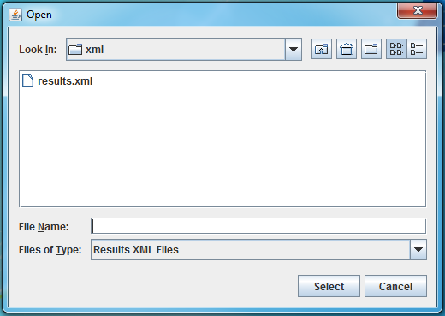

|  |  |
| --- | --- |
| **View the results of a file** | Click on the file in the list, then click on the **Select** button. The **Results Viewer** window will appear.  Or  Double-click on the name of the file. The **Results Viewer** window will appear. |
| **Return to the Simplified Run Interface** | Click on the **Cancel** button. No file will be opened. |

**Using the Developer Interface button**

Click on the **Developer Interface** button to return to the **OPBM – Office Productivity Benchmark** main window.



**<THIS PAGE LEFT BLANK INTENTIONALLY.>**

**The Developer Interface**

About the Developer Interface

The Run Modules: Atoms

The Run Modules: Molecules

The Run Modules: Scenarios

The Run Modules: Suites

Full Benchmarks: Trial Run

Full Benchmarks: Official Run

Shortcuts: Results View

Shortcuts: Results Viewer (Choose)

Shortcuts: Gather Debug Info

Maintenance: Script Definition

Editing <GUI STILL UNDER DEVELOPMENT>

Maintenance

Maintenance: UI Settings

**About the Developer Run Interface**

The developer interface allows benchmark developers to customize, design and develop office productivity workloads for benchmarking. Workloads are defined by the number of tasks they include and can be bundled in several configurations to vary the sequencing and load usage.

From the Developer Interface, you can run Atoms, Molecules, Scenarios, and Suites. The run produces a score.



**The Run Modules: Atoms window**

Click on **Atoms** under the **Run Modules** heading. The **Run Atoms** window appears.

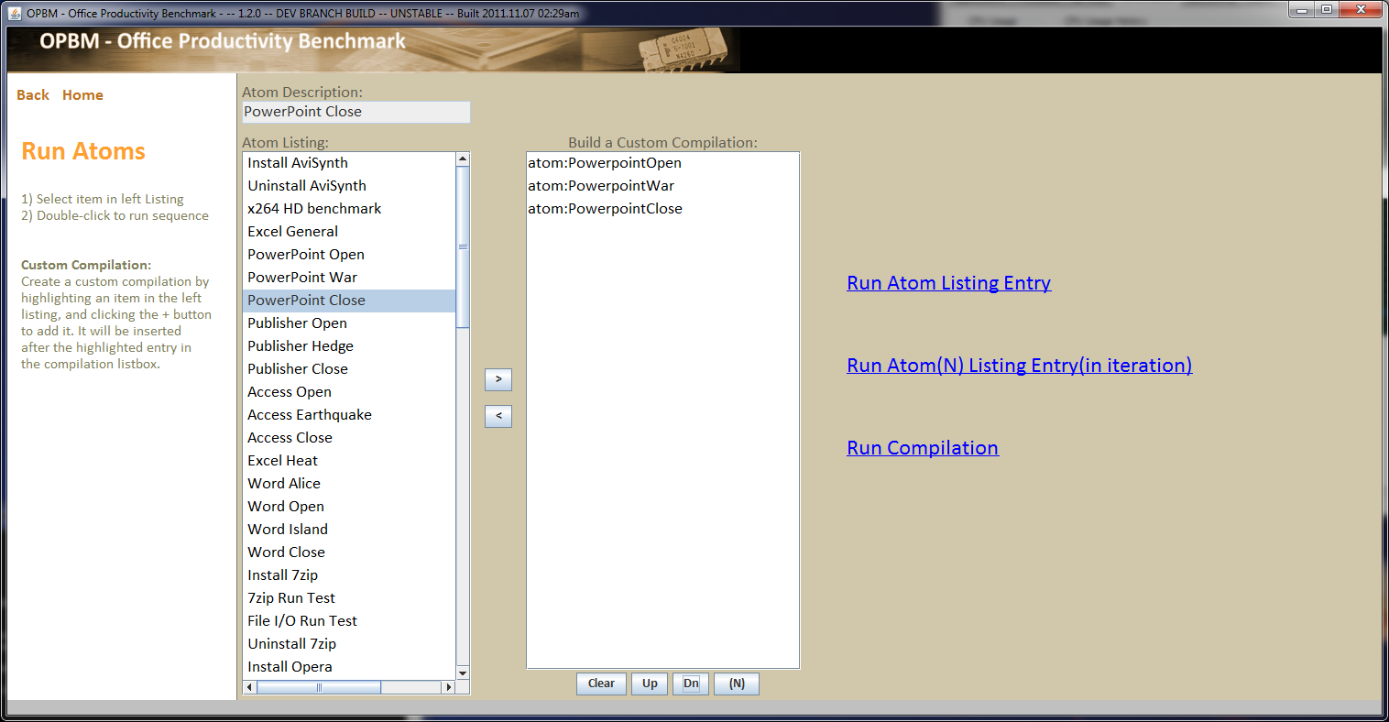

|  |  |
| --- | --- |
| **Run Atom Listing Entry** | 1. Double-click on the atom name in the **Atom Listing:**. OPBM launches the run. The **HUD** (Head-Up-Display) appears in the lower right corner of the screen.   OR |
|  | 1. Click on the atom in the **Atom Listing:** 2. Click on **Run Atom Listing Entry**. OPBM launches the run. The **HUD** (Head-Up-Display) appears in the lower right corner of the display. |
| **Run Atom(N) Listing Entry(in iteration)** | 1. Click on the atom in the **Atom Listing:** to select it. 2. Click on **Run Atom(N) Listing Entry (in iteration)**. The **Iteration Count for Atom** window appears. 3. Type in the number of times that you want to run the atom. 4. Click the **Accept** button.   *You can run multiple atoms with each atom iterated. For example, Powerpoint Open (1), Powerpoint War (5),. Powerpoint Close (1). You cannot run Powerpoint Open, Powerpoint War, Powerpoint Close in a row 3 times, see the Molecules window to run the Presentation molecule.* |
| **Run Compilation** | 1. Click on the atom in the **Atom Listing:**. 2. Click on the arrow to add it to the xxxx?? panel. 3. Click on each additional atom that you want to include in the run. 4. Make sure that the atoms are in sequence in the run. For example, Open Powerpoint, Run Powerpoint, Close Powerpoint. 5. Click on the **Run Compilation** link. |

**The Run Modules: Molecules window**

Click on **Molecules** under the **Run Modules** heading. The **Run Molecules** window appears.

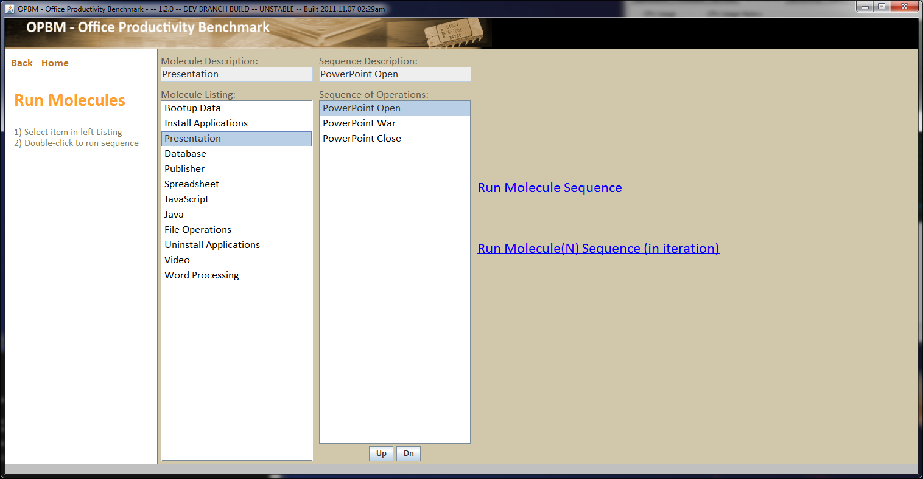

|  |  |
| --- | --- |
| **Run Molecule** | 1. Double-click on the atom name in the **Molecule Listing:**. OPBM launches the run. The **HUD** (Head-Up-Display) appears in the lower right corner of the screen.   OR |
|  | 1. Click on the atom in the **Molecule Listing:** 2. Click on **Run Molecule Listing Entry**. OPBM launches the run. The **HUD** (Head-Up-Display) appears in the lower right corner of the display. |
| **Run Molecule(N) Sequence (in iteration)** | 1. Click on the atom in the **Molecule Listing:** to select it. 2. Click on **Run Atom(N) Listing Entry (in iteration)**. The **Iteration Count for Atom** window appears. 3. Type in the number of times that you want to run the atom. 4. Click the **Accept** button. |

**The Run Modules: Scenarios window**

Click on **Scenarios** under the **Run Modules** heading. The **Run Scenarios** window appears.

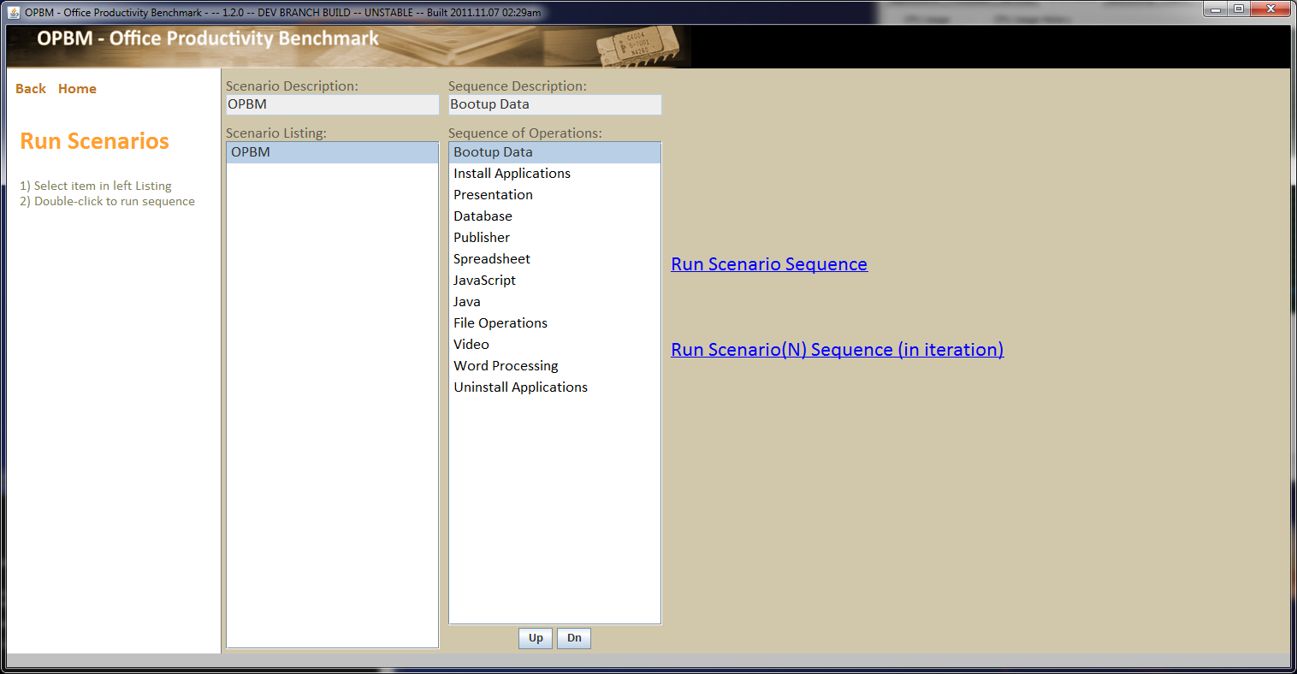

|  |  |
| --- | --- |
| **Run Scenario Sequence** | 1. Double-click on the atom name in the **Scenario Listing:**. OPBM launches the run. The **HUD** (Head-Up-Display) appears in the lower right corner of the screen.   OR |
|  | 1. Click on the atom in the **Scenario Listing:** 2. Click on **Run Scenario Listing Entry**. OPBM launches the run. The **HUD** (Head-Up-Display) appears in the lower right corner of the display. |
| **Run Scenario(N) Sequence (in iteration)** | 1. Click on the atom in the **Scenario Listing:** to select it. 2. Click on **Run Scenario(N) Listing Entry (in iteration)**. The **Iteration Count for Scenario** window appears. 3. Type in the number of times that you want to run the atom. 4. Click the **Accept** button. |

**The Run Modules: Suites window**

Click on **Suites** under the **Run Modules** heading. The **Run Suites** window appears.

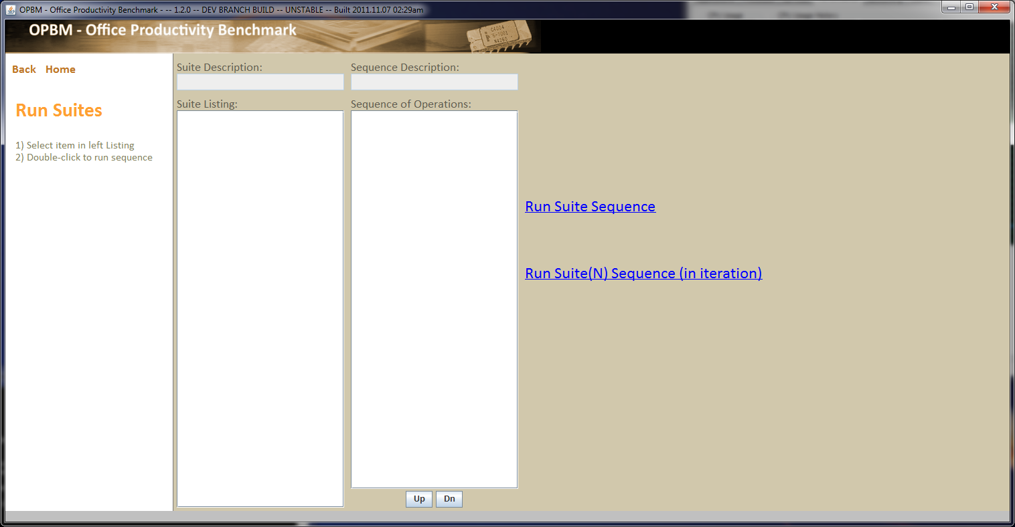

|  |  |
| --- | --- |
| **Run Suite Sequence** | 1. Double-click on the atom name in the **Suite Listing:**. OPBM launches the run. The **HUD** (Head-Up-Display) appears in the lower right corner of the screen.   OR |
|  | 1. Click on the atom in the **Suite Listing:** 2. Click on **Run Suite Listing Entry**. OPBM launches the run. The **HUD** (Head-Up-Display) appears in the lower right corner of the display. |
| **Run Suite(N) Sequence (in iteration)** | 1. Click on the atom in the **Suite Listing:** to select it. 2. Click on **Run Suite(N) Listing Entry (in iteration)**. The **Iteration Count for Suite** window appears. 3. Type in the number of times that you want to run the atom. 4. Click the **Accept** button. |

**Full Benchmarks: Trial Run**

Click on **Trial Run** to launch one run of the OPBM benchmark. The **Trial Run** pop-up window appears.



|  |  |
| --- | --- |
| **Save results to a default file** | Click on the **Go** button to start the run. The results are saved to results.xml in the \opbm\results\xml\ folder |
| **Save results to a user-defined file** | .  Type the name of the file <user_name>.xml. Click the **Go** button to start the run. The results are saved to the <user_name>.xml file in the \opbm\results\xml\ folder. |
| **Cancel the request** | Click on the **Cancel** button. The Trial Run will not be launched and the pop-up window closes. |

**Full Benchmarks: Official Run**

Click on **Official Run** to launch one run of the OPBM benchmark. The **Official Run** pop-up window appears.



|  |  |
| --- | --- |
| **Save results to a default file** | Click on the **Go** button to start the run. The results are saved to results.xml in the \opbm\results\xml\ folder |
| **Save results to a user-defined file** | .  Type the name of the file <user_name>.xml. Click the **Go** button to start the run. The results are saved to the <user_name>.xml file in the \opbm\results\xml\ folder. |
| **Cancel the request** | Click on the **Cancel** button. The Offical Run will not be launched and the pop-up window closes. |

**Shortcuts: Results View**

Click on **Shortcuts: Results View**. The **Open** window appears.



|  |  |
| --- | --- |
| **View the results of a file** | Click on the file in the list, then click on the **Select** button. The **Results Viewer** window will appear.  Or  Double-click on the name of the file. The **Results Viewer** window will appear. |
| **Cancel the request** | Click on the **Cancel** button. No file opens and the **Open** window closes. |

**Shortcuts: Results Viewer (Choose)**

This is the same functionality as the **Results Viewer** currently.

Click on **Shortcuts: Results Viewer (Choose)**. The **Open** window appears.



|  |  |
| --- | --- |
| **View the results of a file** | Click on the file in the list, then click on the **Select** button. The **Results Viewer** window will appear.  Or  Double-click on the name of the file. The **Results Viewer** window will appear. |
| **Cancel the request** | Click on the **Cancel** button. No file opens and the **Open** window closes. |

**Shortcuts: Gather Debug Info**

Click on **Gather Debug Info**. The **Gather Debug Info** pop-up window appears.

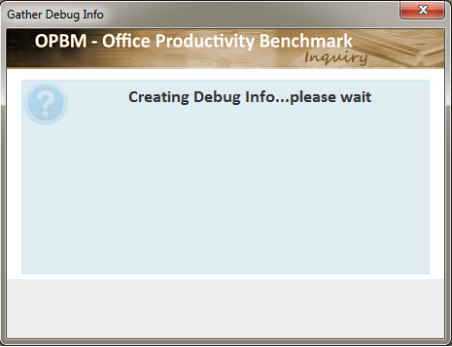

After the information is gathered, Windows Explorer opens in the opbm/temp directory. The debug information file will be highlighted. The debug file has the format debug_month_day_year_at_time.xml.

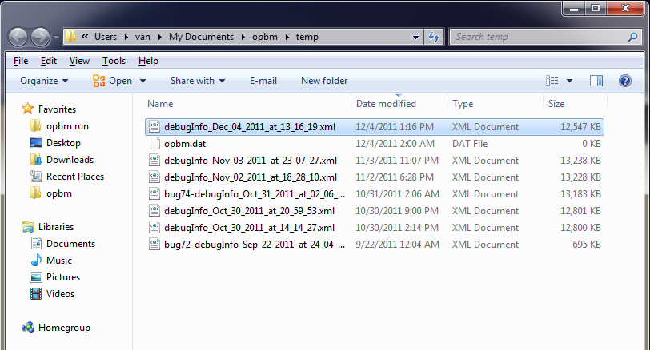

**Maintenance: Script Definition**

Maintenance:Script Definition panel (GUI IS UNDER DEVELOPMENT)

Editing: Atoms

Editing: Molecules

Editing: Scenarios

Editing: Suites

Maintenance: View or Edit raw XML files

View Raw Files:

Edit Raw Files:

Maintenance: UI Settings

**Maintenance: Script Definition panel**

(GUI IS UNDER DEVELOPMENT)

Click on Maintenance: Script Definition. The Editing: and Maintenance: panel appears.

<screen shot>>

These panels will be designed to allow the developer to edit the content of atoms, molecules, scenarios and suites.

**Definitions**

**Flow Control** – directives to handle looping, conditional execution, script commands

**Command Abstracts** – in-between programming layer

**Editing: Atoms**

Click on **Editing: Atoms**, the **Atoms** window appears. (GUI UNDER DEVELOPMENT)

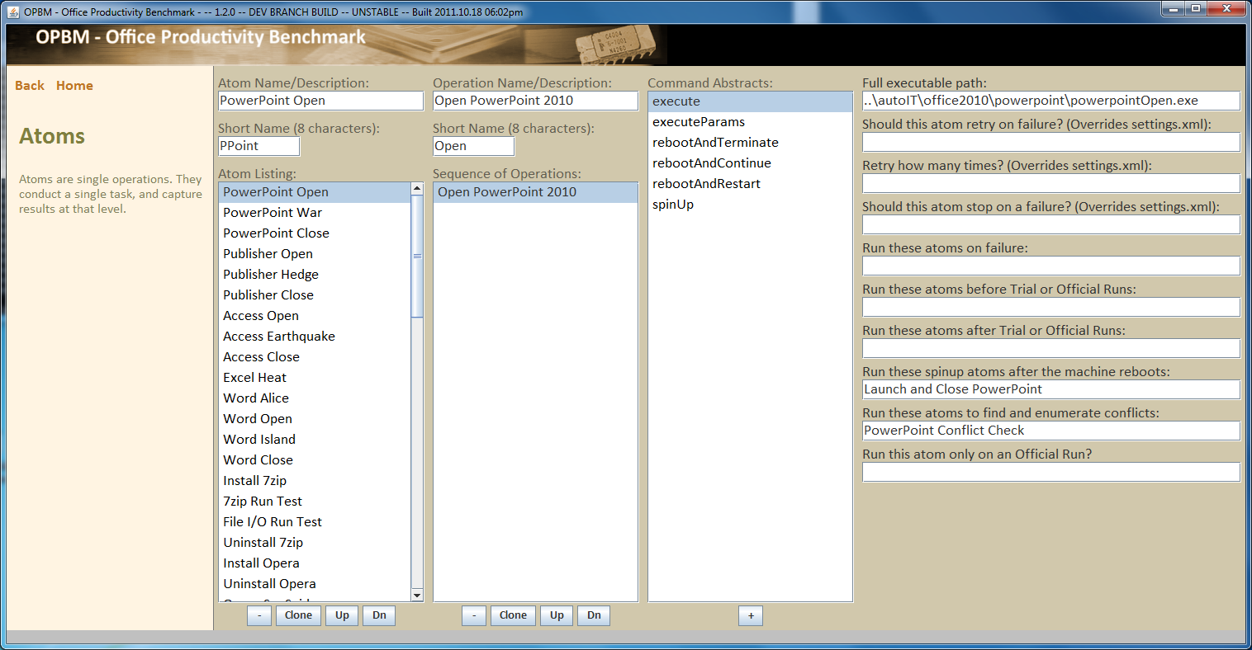

**Editing: Molecules**

Click on **Editing: Molecules**, the **Molecules** window appears. (GUI UNDER DEVELOPMENT)

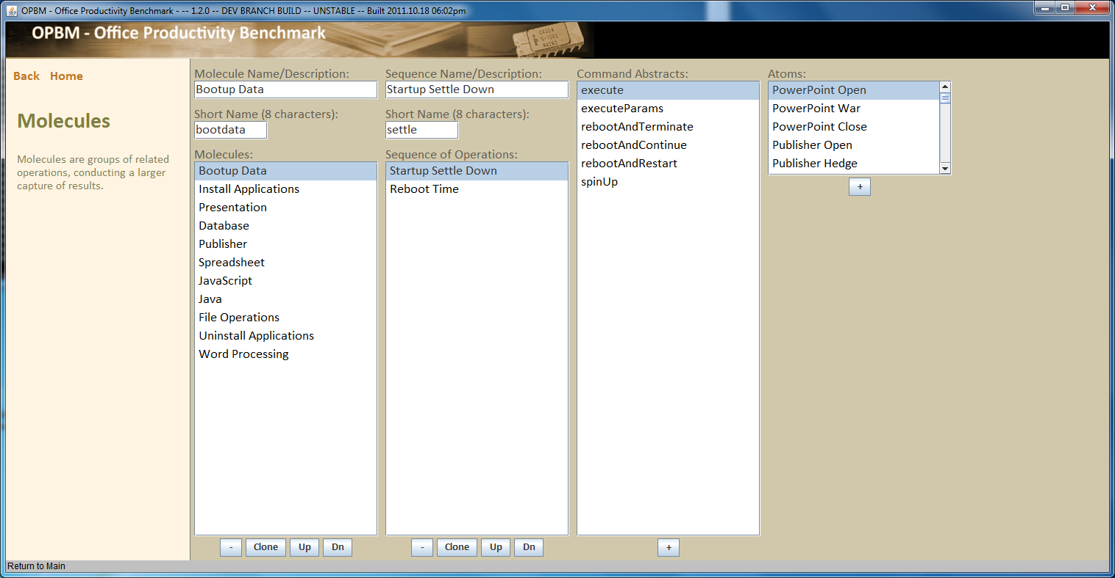

**Editing: Scenarios**

Click on **Editing: Scenarios**, the **Scenarios** window appears. (GUI UNDER DEVELOPMENT)

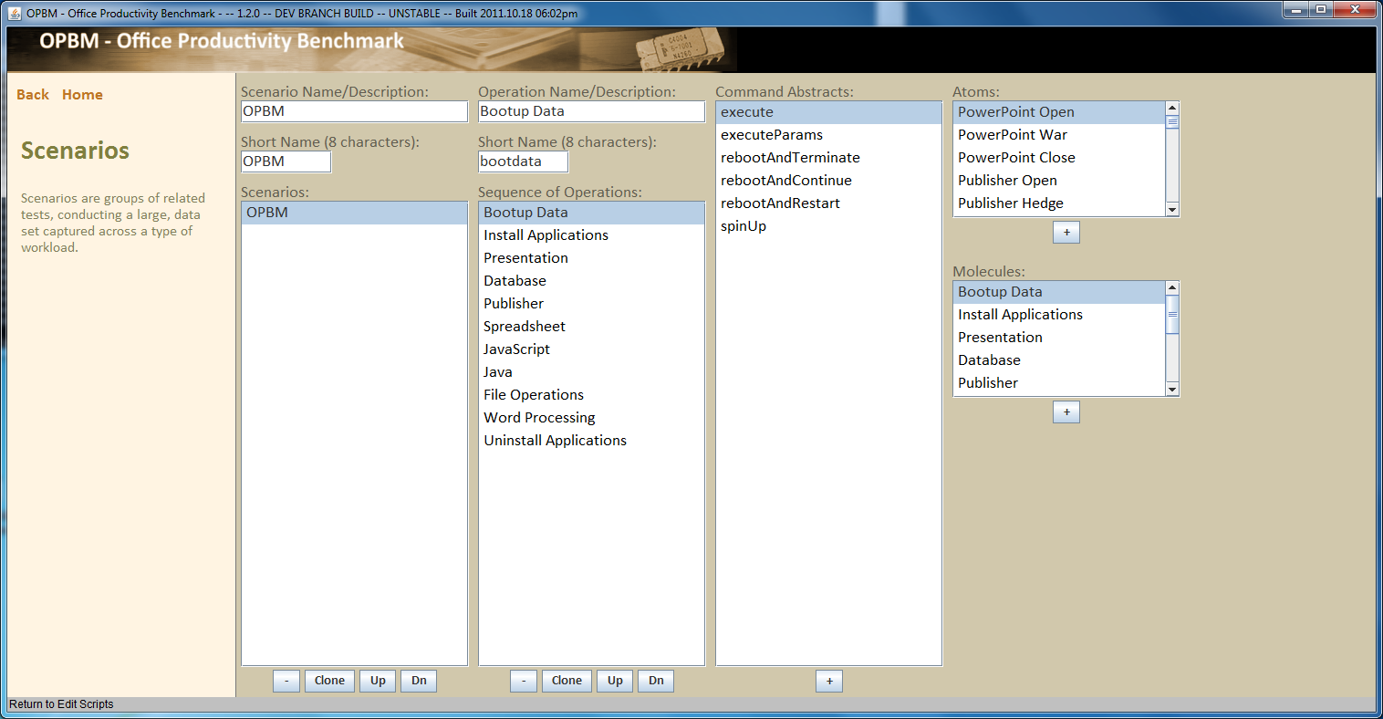

**Editing: Suites**

Click on **Editing: Suites**, the **Suites** window appears. (GUI UNDER DEVELOPMENT)

**Maintenance: View or Edit raw XML files**

Maintenance: Script Definition

Panels.xml - Defines menu navigation options

Edits.xml - Defines how OPBM edits data on-screen

Scripts.xml - Defines the scripts OPBM will execute

Click on **Maintenance: View or Edit raw XML files**, the **View Raw Files:** panel appears.

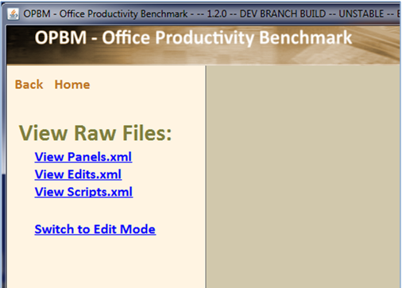

|  |  |
| --- | --- |
| **View Panels.xml** | Click on **View Panels.xml** to load the Panels.xml file. The file looks like this. |
| **View Edits.xml** | Click on **View Edits.xml** to load the Edits.xml file. |
| **View Scripts.xml** | Click on **View Scripts.xml** to load the Scripts.xml file. |
| **Switch to Edit Mode** | Click on **Switch to Edit Mode** to open the **Edit Raw Files panel**. The panel looks like this. |

Click on **View Panels.xml** to display the Panels.xml file. The file appears. To close the file, click **Close**.

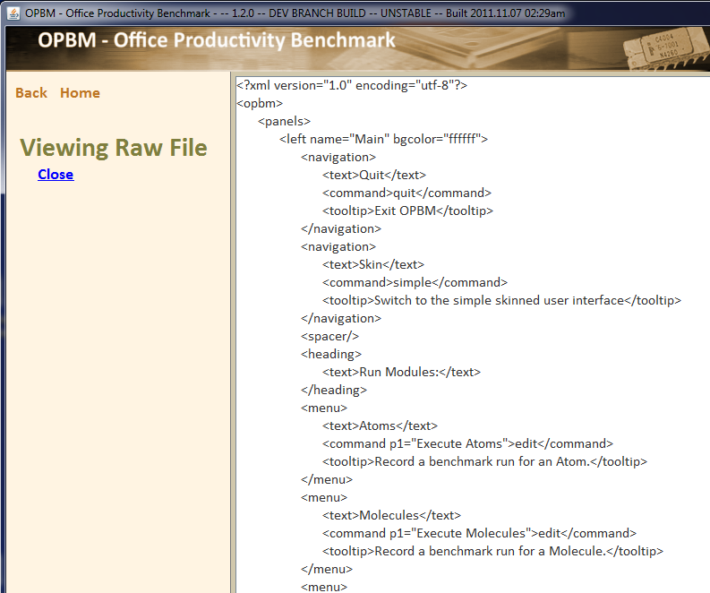

Click on **Switch to Edit Mode** to edit the .xml files.

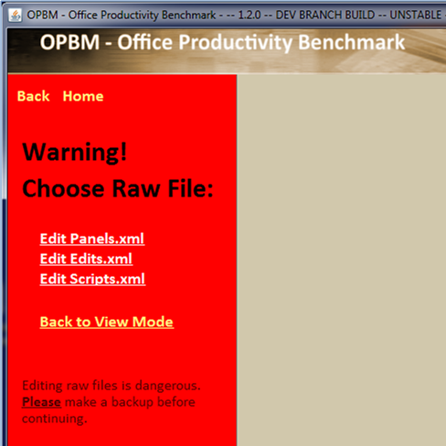

|  |  |
| --- | --- |
| **Edit Panels.xml** | Click on **Edit Panels.xml** to edit the **Panels**.xml file. |
| **Edit Edits.xml** | Click on **Edit Edits.xml** to edit the **Edits**.xml file. |
| **Edit Scripts.xml** | Click on **Edit Scripts.xml** to edit the **Scripts**.xml file. |
| **Back to View Mode** | Click on **Back to View Mode** to return to the **View Raw Files** panel. |

**Maintenance: UI Settings**

Click on **Maintenance: UI Settings**, the User Interface settings appear.

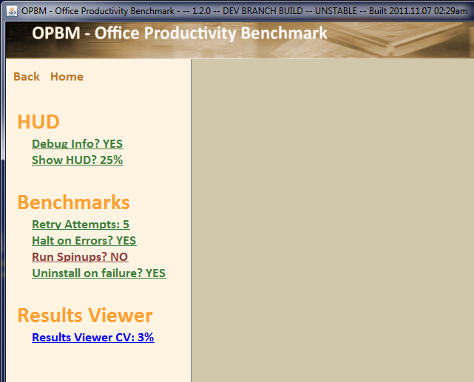

Click on a user setting, to change its value. See the table below for a description of each setting and its value.

|  |  |  |  |
| --- | --- | --- | --- |
| **User Interface Option** | **Setting Type** | **What it does** | **Value for Setting** |
| **HUD settings** | Debug Info? | Displays on the bottom 4 lines of the HUD | YES – Displays Debug information  NO – Hides the Debug Information which makes the HUD smaller on the screen. |
|  | Show HUD? | Transparency of the HUD window | 25%  50%  75%  100%  NO –Does no display the HUD; sets Debug Info? To NO |
| **Benchmarks** | Retry Attempts: | Number of retry attempts before a failure is reported | 0-10 |
|  | Halt on Errors? | Stop the benchnmark because of error | YES – Stops benchmark on error  NO – Does not stop benchmark on error |
|  | Run Spinups? | Run spinup code after each reboot  (What is spinup code) | YES – Run spinup code  NO – Do not run spinup code |
|  | Uninstall on failure? | Failure of a run executes the uninstall atoms | YES – Run uninstall atoms to uninstall applications if the run fails.  NO – Do not run the uninstall atoms if the run fails. |
| **Results Viewer** | Results Viewer CV: | Percent threshold for highlighted display in the **Results Viewer** CV column | Type in a new value in the **Specify Value** window.. Click the **Accept** button to change the value. |

**The Command Line Interface**

About The Command Line Interface

Command Line Syntax

Running OPBM from the command line

Executing atoms from the command line

Benchmarking across multiple machines

**About The Command Line Interface**

The command line interfaces lets benchmark developers run OPBM from the command line. This flexibility allows the developer to create, debug and test his/her atoms from the command line.

**Command Line syntax**

Running OPBM from the command line

Executing scripts from the command line

Benchmarking across multiple machines

**Running OPBM from the command line**

| **ACTION** | **Command** | **Good to know** |
| --- | --- | --- |
| **Run OPBM** | cd c: \location\of\jar  or  c:\path\to\\java\exe – jar opbm.jar |  |
| **Create a shortcut** | C:\path\to\opbm.jar |  |
| **Execute a full Trial Run** | java –jar opbm.jar –trial |  |
| **Execute an Official Run** | java –jar opbm.jar –official |  |
| **Run the Simplified Run Interface** | java –jar opbm.jar –simple  or  java –jar opbm.jar –skin |  |
| **Run the Developer Interface** | java –jar opbm.jar –developer |  |
| **Execute OPBM without the program terminating on completion of a script** | java –jar opbm.jar –noexit |  |
| **Assign a name to the results file (?) for the run** | java –jar opbm.jar –name:”*Give the run a name*” |  |
| **Override the default Oracle system property for java.home** | java –jar opbm.jar –home:”c:\full\path\to\jave.exe” |  |
| **Automatically force an OPBM restart** | java –jar opbm.jar -restart | *The option is used internally as part of the reboot-and-continue operations of an Official Run three-pass benchmark. When present OPBM will attempt to continue processing the manifext.xml file in the c:\users\user\opbm\running directory from where it left off at the reboot. To prevent OPBM from restarting a run automatically, clear out all files in the c:\users\user\opbm\running directory* |

**Executing scripts from the command line**

|  |  |  |
| --- | --- | --- |
| **Action** | **Command** | **Good to know!** |
| **Execute a specific atom script** | **java –jar opbm.jar –atom:***script_name*  Ex. **java –jar opbm.jar –atom:**wordalice | *Strip the spaces from the script name before adding it to the command line.*  *Ex:* **Word Alice** *becomes* **wordalice** |
| **Execute multiple atoms** | **java –jar opbm.jar –atom:***script_name*  **–atom:***script_name*  –**atom:***script_name* | *There is no limit on the number of atoms you can run* |
| **Execute iterations for a atom script** | **java –jar opbm.jar -atom(***iteration_count***):***script_name*  Ex: **java –jar opbm.jar – atom(10):**wordalice | *You can execute multiple atoms with multiple iterations.* |
| **Execute molecule, suite, scenario** | Syntax similar to atom  **java –jar opbm.jar**  **-molecule(***iteration_count***):***script_name*  **-scenario(***iteration_count***):***script_name*  **-suite(***iteration_count***):***script_name* | NOT YET AVAILABLE |
| **Launch the JAR without specifying the java executable** | **opbm.jar –atom:**wordalice  or  **opbm.jar -atom:**wordalice **-atom:**anotheratom  or  **opbm.jar -atom(10):**wordalice **-atom(10):**anotheratom |  |

**Benchmarking across multiple machines**

|  |  |
| --- | --- |
| **What you need to do** | To execute similar benchmarks on multiple machines, create a file which contains the sequence of benchmarks to run in a specified order. . OPBM uses this file at startup to execute identical benchmarks across a host of machines.  1. Create the INPUT FILE  2. Copy the file to the SUTS or network location  3. Access the file through script or network |
| **INPUT FILE syntax** | Each entry must be stored on a separate line in the file. Use the same syntax as the command line syntax, -**atom:***script_name*  Sample input file  Sample.txt  -atom:wordalice  -atom(100):gpuheavy  -atom(100):opencltests  -atom(100):publisherintensive  -atom(500):wordintensive  -atom(200):excelintensive |
| **Running the INPUT FILE** | java -jar opbm.jar @c:\path\to\sample.txt  OPBM interprets the input from the sample.txt file as though the user repeatedly typed entries on the command line, one after the other. The line entries are added in sequence as they appear on the command line.  Any combination of command-line options and command-line input files can be specified, allowing for a concatenation of both directly specified entries on the command line, as well as input from a file. There are no limits to how many entries can be specified in this way, and the entries will be queued in the order stated on the command line. |
| **Examples** | java -jar opbm.jar -atom:wordalice @sample.txt  java -jar opbm.jar @sample.txt -atom(100):wordalice  java -jar opbm.jar -atom:wordalice @sample.txt -atom(100):wordalice  OR  opbm.jar -atom:wordalice @sample.txt  opbm.jar @sample.txt -atom(100):wordalice  opbm.jar -atom:wordalice @sample.txt -atom(100):wordalice |

Click on Edit Panels.xml to edit the **Panels**.xml file.

**Creating new AutoIT worklets**

**Using AutoIT**

AutoIt is the scripting language used within the OPBM harness to generate worklets. You can develop scripts in AutoIT and then add them to OPBM to run them through the GUI or CLI (Command Line Interface).

**Add an AutoIT based worklets to OPBM**

After you have created and tested your AutoIT script, o add an AutoIT based worklet,

1. Add reference times to baselineScores.au3
2. Add any common routines for the application to the common file (e.g. powerpointCommon.au3)
3. Add a score preamble to the script file.  Note that the constants have to correspond to those in the common file.  For example:

$gBaselines[0][0] = $WAR_OPEN_PRESENTATION

$gBaselines[0][1] = $WAR_OPEN_PRESENTATION_SCORE

$gBaselines[1][0] = $WAR_CREATE_WMV

$gBaselines[1][1] = $WAR_CREATE_WMV_SCORE

$gBaselines[2][0] = $WAR_PLAY_PRESENTATION

$gBaselines[2][1] = $WAR_PLAY_PRESENTATION_SCORE

1. Include the application common file (e.g. #include <../../common/office2010/powerpointCommon.au3> )
2. To time operations, you must call TimerBegin() before the start of an operation and TimerEnd( OperationName ) at the finish (e.g. TimerEnd( $WAR_OPEN_PRESENTATION ) ).  Note the format of the TimerEnd message returned through stdout -- potentially any application could return timing data in that format and be utilized within the harness.
3. Return any status messages through outputDebug() (e.g. outputDebug( "Executing saveWarAsWmv()…" ) ).
4. Edit scripts.xml to add the atom.  You will also want to add the atom to a molecule, etc..

**OPBM Harness Configuration**

OPBM Files

|  |  |
| --- | --- |
| **.xml files which drive OPBM** | edits.xmls- defines the way OPBM edits data on-screen  panels.xml- defines menu navigation options  scripts.xml- defines the scripts OPBM will execute  ! These files must be setup correctly or OPBM will not launch properly. OPBM will enter an error-correcting edit mode in which the raw XML files are loaded for editing when not setup correctly. |

Output Files and Processing….

**Output Files and Processing**

As of the first June 27, 2011 release, continued through the August 22, 2011 release, OPBM internally recognizes four types of line items written to stdout or stderr. These are reported by the scripts executing, and are used to update the heads-up-display, and to capture some timing data for debugging:

**timing** Conveys timing information to OPBM. Must have the form “Workload description,timing,percentage”. Example: “Launch Microsoft Word,1.5733983892,89.8329821602”. Appears in blue.

**debug** Conveys debug information (shows up in the debug portion of the heads-up-display, which are the bottom 4 lines).

**status** Conveys status information (shows up in the status portion of the heads-up-display, which are the two lines above the middle gray portion).

**error** Conveys error information, which is usually terminal. In future versions, if the keyword “terminate” is found on the error string, OPBM will automatically terminate the current benchmark test and continue with any more that are scheduled. Appears in red.

**overhead** Conveys timing information related to overhead processing, such as the time required to launch an application, or type in keystrokes to access a file path or URL.

**filter** Conveys filter tags for the executing atom. These are used in the post-processor and Results Viewer to aggregate scores in manifest.xml’s <aggregate> section in a <byFilter> division (planned future feature as of 08/31/2011).

**tags** Conveys worklet tags, which are associated only with the immediately-following timing event. These tags allow individual worklets to be aggregated into similar scores in the manifest.xml’s <aggregate> section in a <byTags> division (planned future feature as of 08/31/2011).

When a benchmark run is requested, OPBM generates a manifest.xml file. It records and accumulates everything necessary to complete the run, along with everything generated while executing scripts. This data exists in a single XML file called **manifest.xml**. This file is written out to a relative location based on the current user, such as:

**C:\Users\username\Documents\opbm\running\manifest.xml**

OPBM also auto-generates two output files following the successful completion of a benchmark, which are **results.xml** and **results.csv**, which are located:

**C:\Users\username\Documents\opbm\results\xml\results.xml**

**C:\Users\username\Documents\opbm\results\csv\results.csv**

The scripts themselves may also write content directly to a designated output directory, though this is not required. The script’s output directory is located:

**C:\Users\username\Documents\opbm\scriptOutput\**

OPBM records each timing line as it was generated. If multiple instances of the same test were run, then OPBM automatically computes the min, max, average, geometric mean, and coefficient of variation in the results. OPBM also automatically appends a “Total” line to the reported timing lines as well in the output CSV. Only *timing* timing events are included in the output, and not the *overhead* lines which also include times.

**Note:** Iteration requests present themselves internally as though the single atom were run successively for the iteration count, meaning each execution by iteration produces its own separate set of summation values, which are recorded within the manifest.xml file. OPBM will automatically sum and average these values into the <aggregate> section entitled <byAtom>. These scores are also conveyed into the results.xml file for viewing in the Results Viewer, with a single line included for every iteration.

**Problems running OPBM**

If you cannot launch an official run, then …..

Auto-Logon Disable

Conflicts and Resolutions Window

**Auto Logon Disable**

If you do not disable the Windows 7 login screen, this window appears when you attempt an official run.

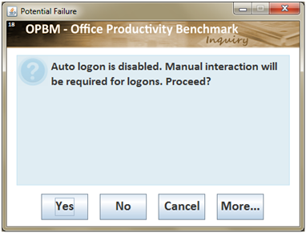

|  |  |
| --- | --- |
| **Button** | **Function** |
| **Yes** | **!** Launches the official run. An official run is 3 iterations of the benchmark. It requires the system to reboot. You will be required to login to Windows when a reboot occurs in order for the benchmark to continue. This will result in skewed scoring times. |
| **No** | Run will not launch. |
| **Cancel** | Cancels the launch. |
| **More…** | Displays the directions to disable the Window 7 login screen. |

**Conflicts and Resolutions**

If you launch an official run and the proper office applications are not installed (see minimum requirements to run OPBM), the **Conflicts and Resolutions** window appears.

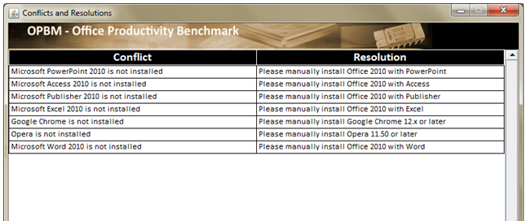

Manually install the application before attempting to launch an official run.

**Getting Help**

|  |  |  |  |
| --- | --- | --- | --- |
| Installation |  |  |  |
| GitHub | Van Smith | [van@canalabs.com](mailto:van@canalabs.com) | (479) 216-3461 |
| Bugs |  |  |  |
| Internal AMD set-up | Jim??? | [jim@amd.com](mailto:jim@amd.com) | (512) 123-1234 |
|  |  |  |  |
|  |  |  |  |

**Worklet Descriptions**

These are the worklet descriptions for the performance areas under test in the OPBM benchmark. A worklet is the smallest unit that is measurable in the benchmark. Each worklet generates a score when run.

| **Analysis Focus** | **Atoms included in workload** | **Atom Short-name** | **Operations of atoms** | **Description** |
| --- | --- | --- | --- | --- |
| **Install Applications** |  |  |  |  |
| Install 7zip | Install 7zip (I7) | I7 | Launch 7-Zip Installer  Install 7-Zip |  |
| Install Adobe Acrobat | Install Adobe Acrobate (IAR) | IAR | Launch Acrobat 10.1 Installer  Install Adobe Acrobat 10.1  Launch Adobe Acrobat 10.1 |  |
| Install Firefox | Install Firefox (IF) | IF | Launch Firefox Installer  Bypass Next Button  Install Firefox 5.0.1 |  |
| Install Opera |  |  |  |  |
| Install Safari | Install Safari (IS) | IS | Launch Safari 5.1.7534.50 Installer  Install Safari 5.1.7534.50 |  |
| **Presentation** |  |  |  |  |
| Powerpoint | Powerpoint Open  Powerpoint War  Powerpoint Close | PPO  PPW  PPC | Launch Microsoft PowerPoint 2010  Open War presentation  Create War WMV  Time to play War presentation  Close Microsoft PowerPoint 2010 | Create and run 21 slide powerpoint presentation. The presentation uses several charts, graphs and transitions. It also uses 2010 features to stress gpu acceleration??? |
| **Database** |  |  |  |  |
| Access | Access Open  Access Earthquake  Access Close | AO  AE  AC | Launch Microsoft Access 2010  Copy earthquake database  Open earthquake database  Run earthquake queries  Run earthquake reports  Compact earthquake database  Close Microsoft Access 2010 | Database has 8 tables. The largest table has 79,000+ rows in it. Simulates operations that a user may perform on a day-to-day basis. |
| **Publisher??** |  |  |  |  |
|  | Publisher Open  Publisher Hedge  Publisher Close | PO  PH  PC | Launch Microsoft Publisher 2010  Open HEDGE flyer  Page through HEDGE flyer  Rotate HEDGE flyer  Save HEDGE flyer as XPS  Zoon HEDGE XPS  Exit HEDGE XPS flyer  Close Microsoft Publisher 2010 | Create flyer that simulates user workload. |

| **Analysis Focus** | **Atoms included in workload** | **Atom Short-name** | **Operations of atoms** | **Description** |
| --- | --- | --- | --- | --- |
| **Spreadsheet** |  |  |  |  |
| Excel Heat | Excel Heat (EH) | EH | Launch Microsoft Excel 2010  Close Empty Worksheet  Open Worksheet  Time to iterate sheet 25 times  Save and Close Worksheet  Close Microsoft Excel 2010 | Create worksheet that calculates heat??? And charts results. Recalculates and charts 25 times. |
| Excel General |  |  | Launch Microsoft Excel 2010  Create Excel Workbook  Open Worksheet  Load 1000 random numbers  Calculate radians, sine, cosine, and tangent  Chart the calculated values  Recalculate 10 times  Simulate 10,000 random Powerball drawing,  Chart the results  Recalculates 10 times  Calculate a 1000 entity Fibonacci series from two random numbers  Calculate and chart the Golden Ratio on the series  Recalculates 10 times  Load 107KB file  Perform Rand and Percentile analysis on the data  Recalculate 10 times  Load 720 KB file | Creates a new workbook to run 5 tests and chart results. The tests perform trigonometric functions, calculate a finbonacci series, chart the Golden Ratio, load external file and perform rank & percentile analysis, load extern 720KB file. |

| **Analysis Focus** | **Atoms included in workload** | **Atom**  **Short-name** | **Operations of atoms** | **Description** |
| --- | --- | --- | --- | --- |
| **JavaScript** |  |  |  |  |
| Chrome SunSpider | Chrome Sunspider | CSS | Launch Chrome  Type SunSpider URL  Run SunSpider  Close Chrome | Runs SunSpider benchmark in Chrome. |
| Chrome Kraken | Chrome Kraken | CK | Launch Chrome  Type URL to Kraken benchmark  Run Kraken  Close Chrome | Runs Kraken benchmark in Chrome. |
| Chrome Google V8 | Chrome Google V8 | CGV8 | Launch Chrome  Type URL to Google V8 benchmark  Run Google V8  Close Chrome | Runs Google V8 benchmark in Chrome. |
| Firefox Sunspider | Firefox Sunspider | FSS | Launch Firefox 5.0.1  Type SunSpider URL  Run SunSpider  Close Firefox | Runs SunSpider benchmark in Firefox. |
| Firefox Kraken | Firefox Kraken | FK | Launch Firefox 5.0.1  Type URL to Kraken benchmark  Run Kraken  Close Firefox | Runs Kraken benchmark in Firefox. |
| Firefox Google 8 | Firefox Google V8 | FGV8 | Launch Firefox 5.0.1  Type URL to Google V8 benchmark  Run Google V8  Close Firefox | Runs Google V8 benchmark in Firefox. |
| Internet Explorer SunSpider | IE Sunspider | IESS | Launch Internet Explorer  Type SunSpider URL  Run SunSpider  Close Internet Explorer | Runs SunSpider benchmark in Internet Explorer. |
| Internet Explorer Kraken | IE Kraken | IEK | Launch Internet Explorer  Type URL to Kraken benchmark  Run Kraken  Close Internet Explorer | Runs Kraken benchmark in Internet Explorer. |
| Internet Explorer Google 8 | IE Google V8 | IEGV8 | Launch Internet Explorer  Type URL to Google V8 benchmark  Run Google V8  Close Internet Explorer | Runs Google V8 benchmark in Internet Explorer. |
| Opera SunSpider | Opera SunSpider | OSS | Launch Opera 11.50  Type SunSpider URL  Run SunSpider  Close Opera | Runs SunSpider benchmark in Opera. |
| Opera Kraken | Opera Kraken | OK | Launch Opera 11.50  Type URL to Kraken benchmark  Run Kraken  Close Opera | Runs Kraken benchmark in Opera. |
| Opera Google 8 | Opera Google V8 | OGV8 | Launch Opera 11.50  Type URL to Google V8 benchmark  Run Google V8  Close Opera | Runs Google V8 benchmark in Opera. |

|  |  |  |  |  |
| --- | --- | --- | --- | --- |
| **Analysis Focus** | **Atoms included in workload** | **Atom**  **Short-name** | **Operations of atoms** | **Description** |
| **JavaScript** |  |  |  |  |
| Safari SunSpider | Safari Sunspider | SSS | Launch Safari 5.1.7534.50  Type SunSpider URL  Run SunSpider  Close Safari | Runs SunSpider benchmark in Safari. |
| Safari Kraken | Safari Kraken | SK | Launch Safari 5.1.7534.50  Type URL to Kraken benchmark  Run Kraken  Close Safari | Runs Kraken benchmark in Safari. |
| Safari Google 8 | Safari Google V8 | SGV8 | Launch Safari 5.1.7534.50  Type URL to Google V8 benchmark  Run Google V8  Close Safari | Runs Google V8 benchmark in Safari. |
| **File Run Test** |  |  |  |  |
| File I/O | File I/O Run Test | FIORT | Create 10GB in 1000 files  Copy 10GB in 1000 files | Creates a directory and fills it with 1000 text files. Copies the directory to a new location. Repeats the steps three times. |
| 7zip Run Test | 7zip Run Test | 7RT | Create .7z archive  Test .7z archive integrity  Create .zip archive  Test .zip archive integrity  Unarchive .7z five times  Unarchive .zip five times | Requires that the reference system takes at least 10s to complete each operation. |
| **Word Processing** |  |  |  |  |
| Word Alice | Word Alice | WA | Launch Internet Explorer  Open AliceInWonderland.html  Page down 60 times in IE9  Copy AliceInWonderland.html to clipboard  Close Internet Explorer  Launch Microsoft Word 2010  Paste into document  Time to page down 60 times normally  Set font ligatures to Standard + Contextual  Time to page down 60 times with font effects  Updating image(singlequote)s text alignment  Save as PDF  Manipulate in Acrobat Reader  Close Microsoft Word 2010 | Opens Alice in Wonderland ebook, scrolls through it in Internet Explorer, moves it to MS Word, saves to a pdf and manipulates it in Adobe Acrobat. |
| Word Open | Word Open | WO | Launch Microsoft Word 2010 |  |
| Word Island | Word Island | WI | Type Word Island  Save Word Island | Instruments user interactions that define responsive performance, install applications, save documents, page through documents, file copying.????Richard Russell speech? |
| Word Close | Word Close | WC | Close Microsoft Word 2010 |  |
| **Uninstaller** |  |  |  |  |
| Uninstall 7zip | Uninstall 7zip | U7 | Launch 7-Zip Uninstaller  Uninstall 7-Zip |  |
| Uninstall Acrobat Reader | Uninstall Acrobat Reader | UAR | Launch Adobe Acrobat 10.1 Uninstaller  Uninstall Adobe Acrobat 10.1 |  |
| Uninstall Firefox | Uninstall Firefox | UF | Launch Firefox Uninstaller  Uninstall Firefox 5.0.1  Close Uninstaller |  |
| Uninstall Safari | Uninstall Safari | US | Launch Safari 5.1.7534.50 Uninstaller  Un-install Safari 5.1.7534.50 |  |
| **Bootup Data** |  |  |  |  |
| Startup Settle Down | Startup Settle Down | SSD | Startup settle down | ARE THESE MOLUECULES OR ATOMS?  The reboot atom does not work as a standard atom in that it does nothing when called.  The reboot and settle down atoms will be two of the most important OPBM tests.  An alternative solution to implementing this functionality at atom level would be to have molecules that simply reboot the system and measure reboot time and another molecule reboots the system and measures reboot and settle down times. |
| Reboot Time | Reboot Time | RT | Reboot Time |
| **SVG Workload** |  |  |  |  |
| **TrueCrypt** |  |  |  |  |
| X.264 HD benchmark. |  |  |  |  |
| STREAM |  |  |  |  |