**Release Document for 9.19.2011 Deliverables**

**Note**: This release requires that the Google Chrome and Opera web browsers are installed on target SUTs before executing an Official Run. However, SUTs that have run OPBM in the past might be in a current state where Google Chrome is not runnable, installable or uninstallable unless manual intervention is taken.

Here are the steps necessary to ensure that Google Chrome is properly installed.

1. Search for the Google Chrome link on the Desktop or in the Start Menu and launch it. If Chrome launches properly then you are finished. If Chrome appears to be installed, but fails to launch, then skip to step 3.
2. If Chrome does not launch, but links are present, attempt to uninstall Chrome by launching the “Uninstall Google Chrome” link from the Start Menu. If that fails, try to uninstall Chrome from the Control Panel. If Chrome appears to uninstall properly (e.g. shortcuts are removed and a feedback window is launched) skip to step 4.
3. If Chrome cannot be uninstalled, manually delete all of the Google Chrome files from the user directory and from the Program Files directory (e.g. "C:\Program Files (x86)\Google\Chrome\Application\chrome.exe").
4. Open Internet Explorer 9 and install Chrome from here: <http://www.google.com/chrome>. Be sure to uncheck the option to set Chrome as the Default Browser.
5. Once installation is complete, attempt to launch Chrome. If Chrome fails to launch, go back to Step 2 (this should only be necessary once).
6. If Google Chrome asks to be the default browser through a message balloon just beneath the address bar, click “Don’t ask again”.

Opera can be downloaded and installed from here: <http://www.opera.com/>

There are known issues running OPBM from the file paths containing spaces (see: <https://github.com/van-smith/OPBM/issues/75> ). To avoid these problems, please copy the OPBM files to C:\OPBM. This directory should then contain the following files:

09/23/2011 04:31 PM <DIR> .  
09/23/2011 04:31 PM <DIR> ..  
09/23/2011 07:56 AM <DIR> java  
09/23/2011 07:56 AM 1,512,478 OPBM_Documentation.docx  
09/23/2011 07:56 AM 1,544 readme.txt  
08/25/2011 06:45 PM <DIR> vs2010

You would then launch OPBM by double-clicking *opbm.jar* in *C:\opbm\java\opbm*. Alternatively, copy a shortcut of *opbm.jar* to the Desktop.

The 9.19.2011 Deliverable release of OPBM can be downloaded from GitHub here:

<https://github.com/van-smith/OPBM>

Change the current branch to test and click the Downloads button.

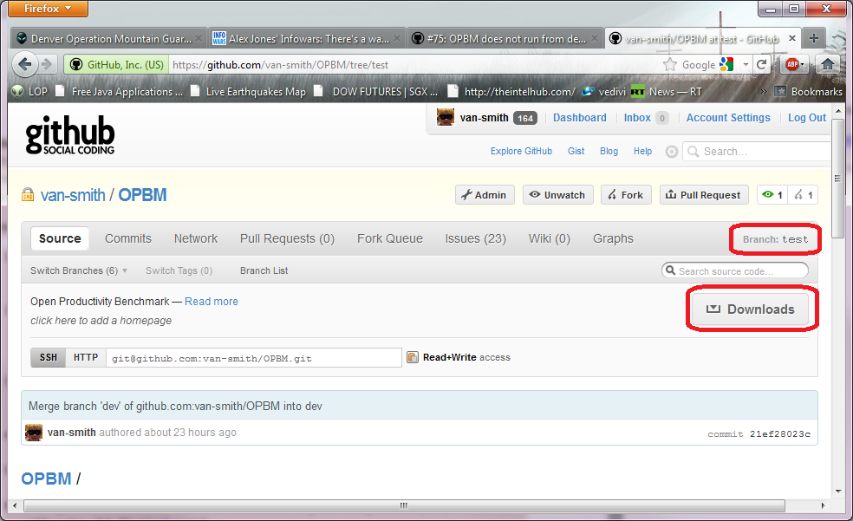

After clicking the Downloads button, download the zip archive. Verify that the current branch is *test* as show in the image below.

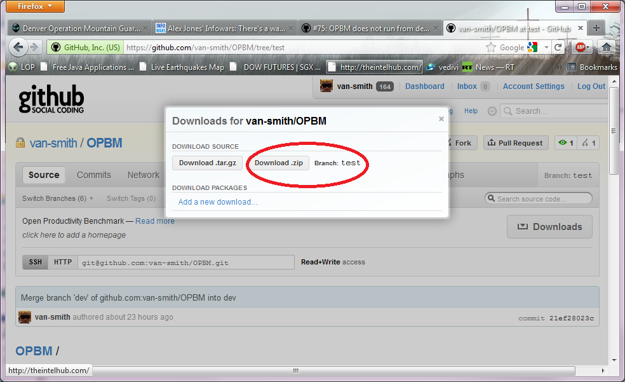

Unzip the archive and copy all of the files to *C:\opbm* as described in the introductory notes and follow the execution instructions there.

To launch an Official Run, click on the *Official Run* link shown below circled in red.

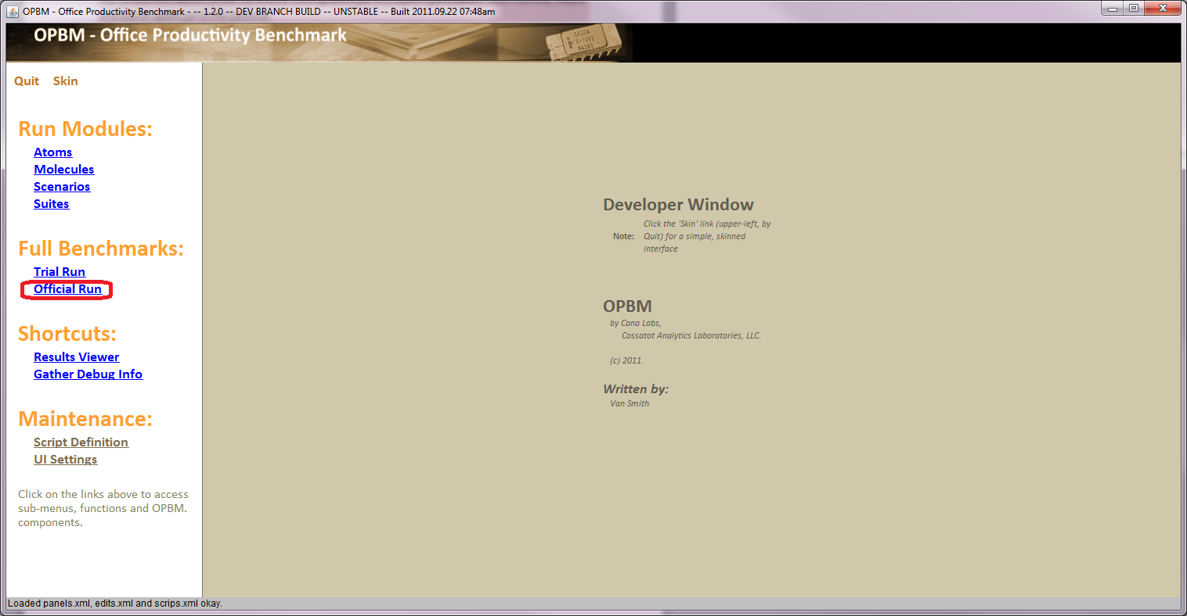

Alternatively, you can launch the simplified OPBM interface by clicking the *Skin* link which results in the following window.

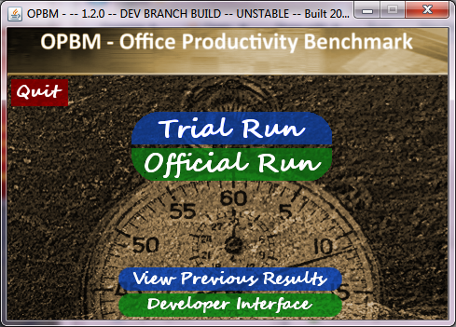

If you want this to be your default interface, you can modify the *opbm.jar* shortcut to:

C:\opbm\java\opbm\opbm.jar –simple.

If you encounter failures, please generate the debug file and email mail it to [van@canalabs.com](mailto:van@canalabs.com) and [rick@canalabs.com](mailto:rick@canalabs.com). To do so, click the link circled in red below.

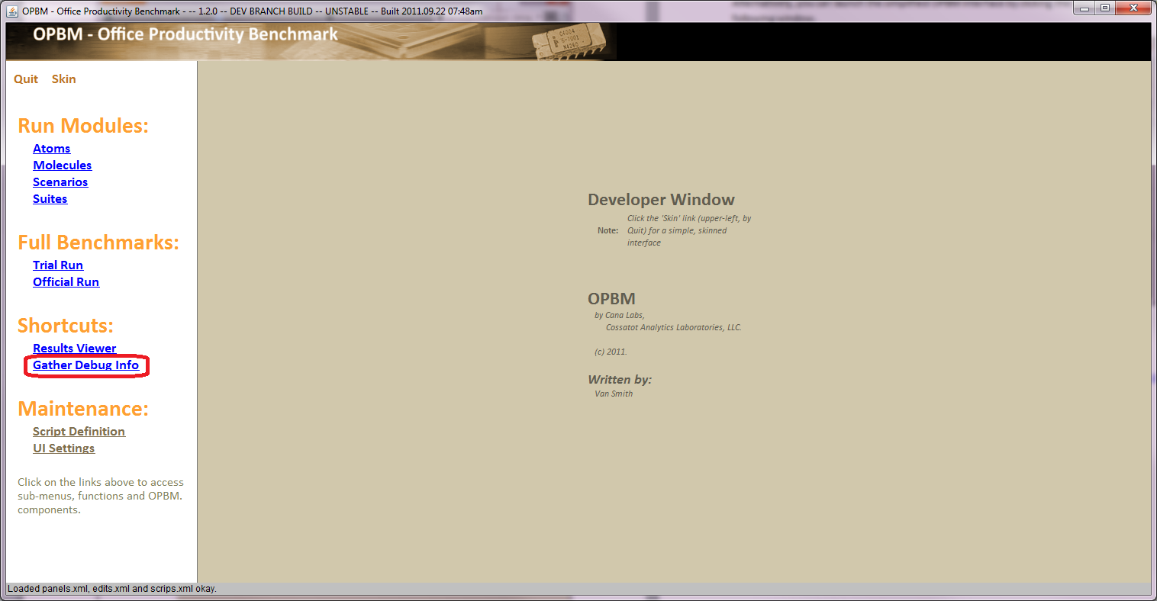

In addition to a long list of bug fixes, the 9.19.2011 Deliverable release introduces the following new workloads.

* **PowerPoint War**: This assessment now measures the duration of the slideshow and exports the slideshow to a WMV.
* **Word Island**: This assessment tests system responsiveness under normal typing conditions.
* **Access Earthquake**: A number of queries and reports are run against a Microsoft Access 2010 database.  Additionally, the database is compacted and repaired.
* **Publisher HEDGE**: In addition to several basic Publisher operations on a prepared flyer, the HEDGE flyer is exported to Microsoft XPS and viewed.
* **File create/copy**: ten iterations of file creation and copy are made.
* **7zip**: Compress/uncompress 7zip archive; Compress/uncompress zip archive.

All of these new assessments are undergoing ongoing characterization for reproducibility and validity.

The Result Viewer has been significantly enhanced. The Result Viewer now reports results in a table where the data can be much more conveniently browsed.  Additionally, CV and average summary information are provided. An example of Official Run results from a Llano A8-3850 based SUT is shown below.

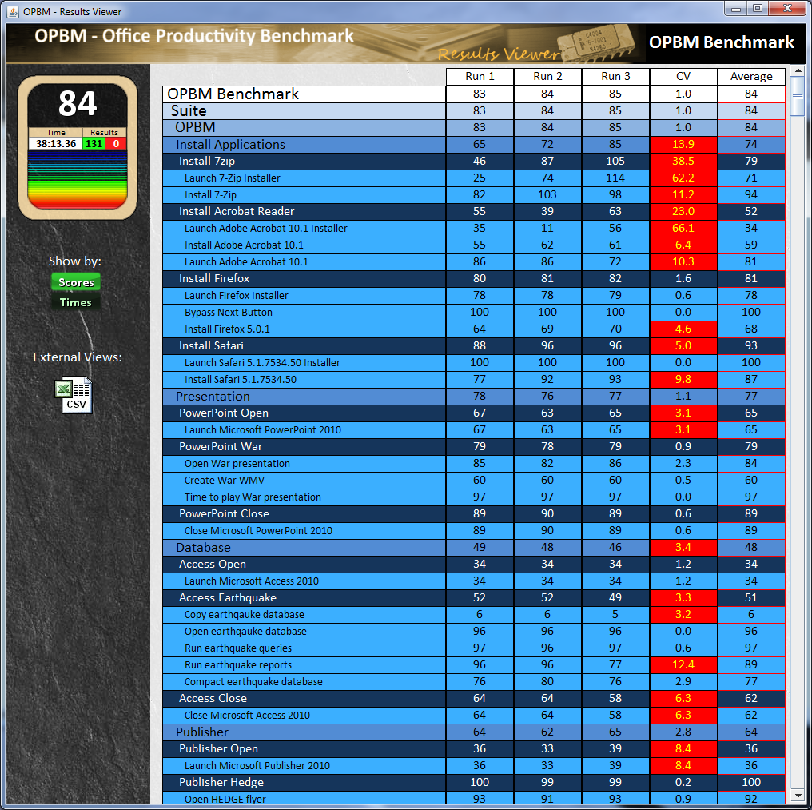

Note that the view can be toggled between “Scores” and “Times” by clicking on the respective buttons on the left pane. The view from clicking “Times” for result set above is shown below

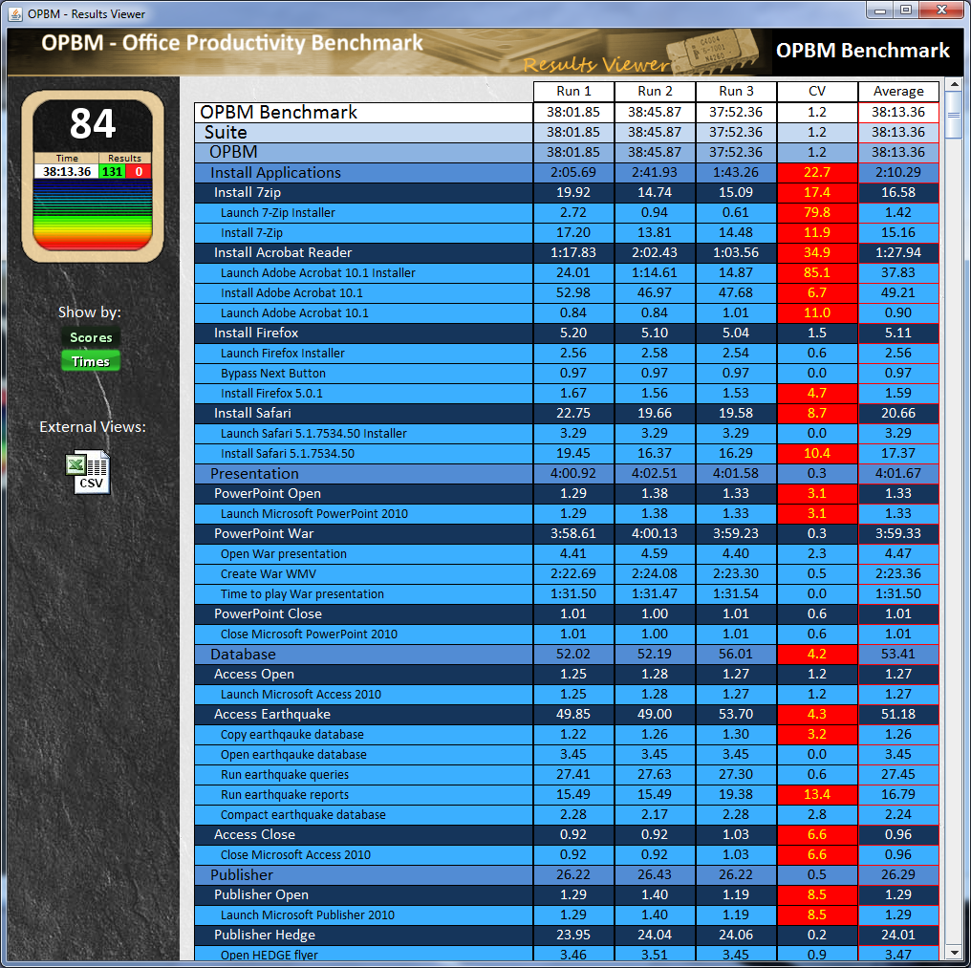

Results can be easily exported to Comma Separated Variable format by clicking the CSV icon in the left pane. Sample results for the 9.19 deliverables can be found in the *sampleResults* directory.

Expected results and run times are shown below.

|  |  |  |
| --- | --- | --- |
|  | **Official Run Score** | **Approximate Run time** |
| **Intel Core i5-2500** | 97 | 1 hr 30 min |
| **AMD Llano A8-3850** | 84 | 2 hrs |
| **AMD Brazos E-350** | 49 | 3 hrs 45 min |
| **Intel Atom D510** | 39 | 5 hrs 40 min |

An actively updated list of OPBM issues can be found here:

<https://github.com/van-smith/OPBM/issues?milestone=&sort=updated&direction=desc&state=open>

Please log any bugs you encounter there.