

TES-070 Custom Interface Unit Test Results
State of New Hampshire
EXT_FIN_004 Approval Workflow - Regression Test Results

Author | Kiro Agent
Creation Date | 2026-03-10
Last Updated | 2026-03-10
Version | Regression_2026-03-10
Document Reference

1 Document Control

1.1 Change Record
Date | Author | Version | Change Description
2026-03-10 | Kiro Agent | Regression_2026-03-10 | Initial version

1.2 Reviewers
Name | Position

Contents
1 Document Control 2
1.1 Change Record 2
1.2 Reviewers 2
Contents 3
2 Custom Interface Unit Test Summary Results 4
2.1 Unit Test Summary 4
2.2 Test Scenarios 4
3 Custom Interface Unit Test Detailed Results 4
Prerequisites for testing: 4
3.1 Scenario 3.1: Garnishment expense invoice auto-approval 4
3.1.1 Description 4
3.1.2 Test Steps 5
3.1.3 Results 9

2 Custom Interface Unit Test Summary Results

2.1 Unit Test Summary
The Custom Interface Unit Test Results consolidate the findings from the unit testing performed on the custom interface.
Count of Total Tests | Count of Completed Tests | % of Completed Tests | Count of Passed Tests | Count of Failed Tests | % of Passed Tests
1 | 1 | 100% | 1 | 0 | 100%

2.2 Test Scenarios
Scenario # | Test Scenario | Infor Test Result
1 | Scenario 3.1: Garnishment expense invoice auto-approval | PASS

3 Custom Interface Unit Test Detailed Results

Prerequisites for testing:
Environment: NMR2N66J9P445R7P_AX4
User Roles: Payables, Process Server Administrator
Test Data: Live FSM data used for regression testing
Configuration: Standard approval workflow configuration

3.1 Scenario 3.1: Garnishment expense invoice auto-approval

3.1.1 Description

3.1.2 Test Steps
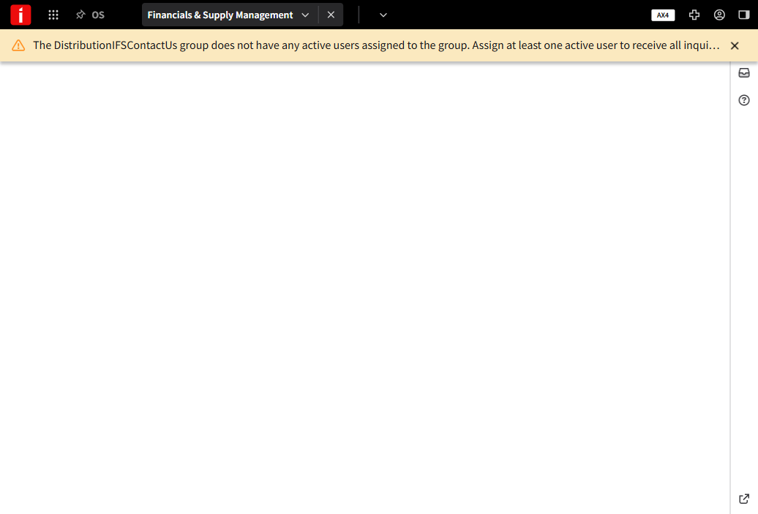

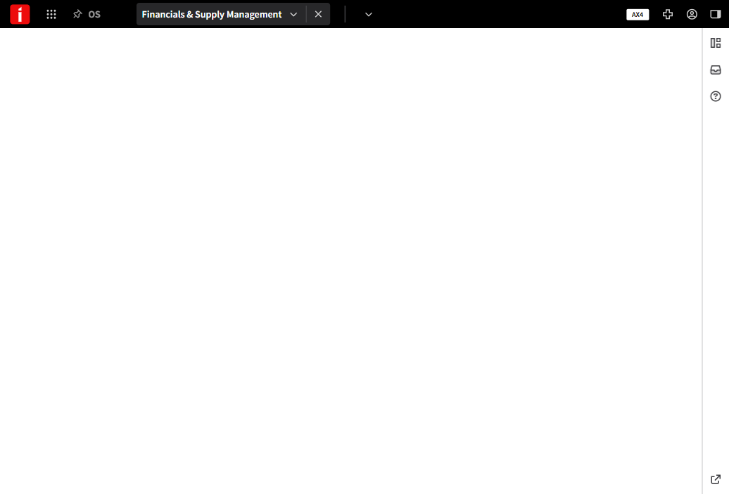

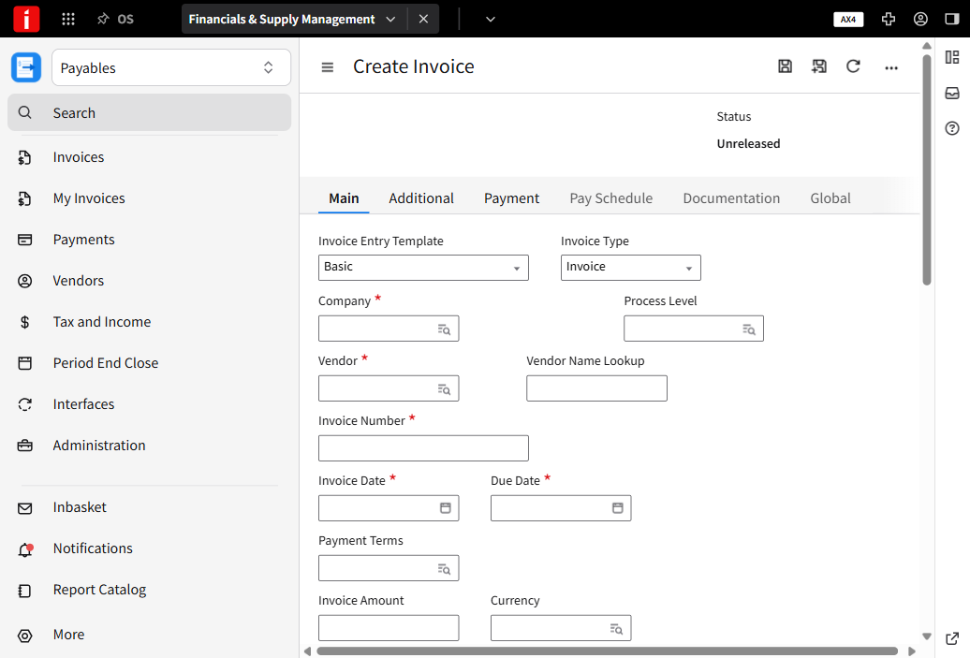

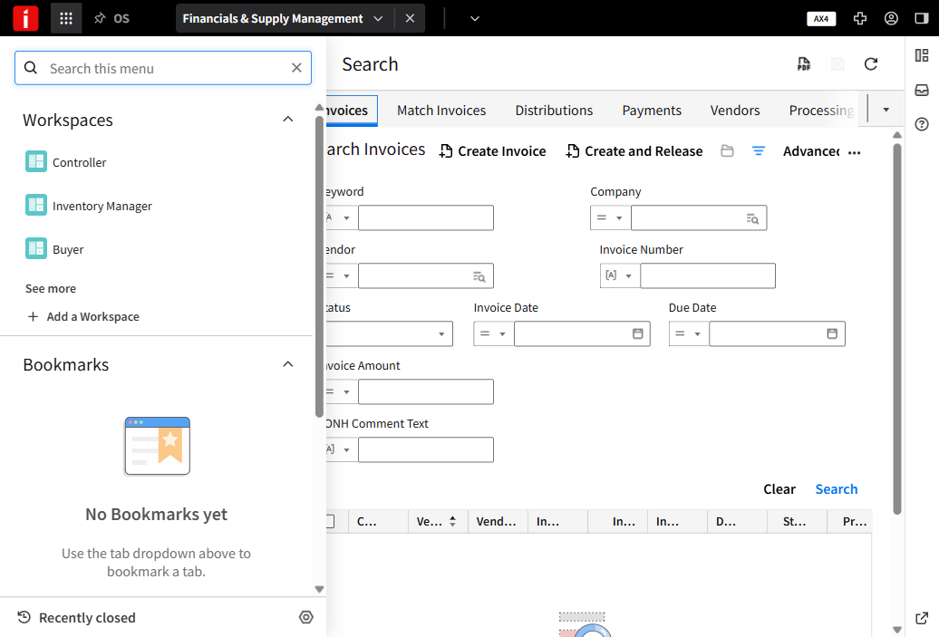

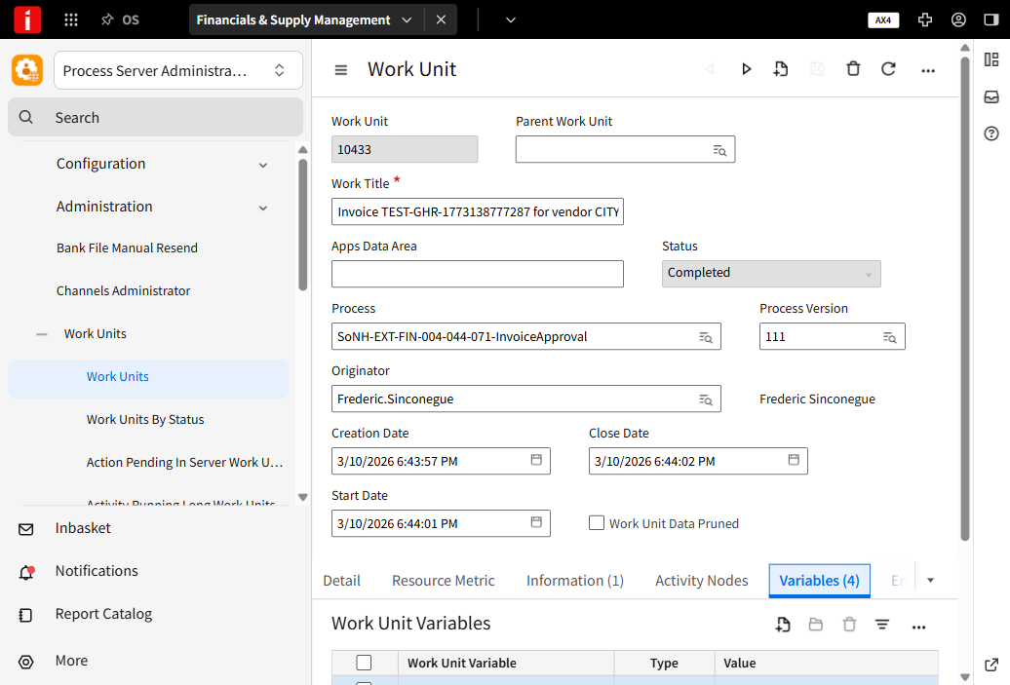

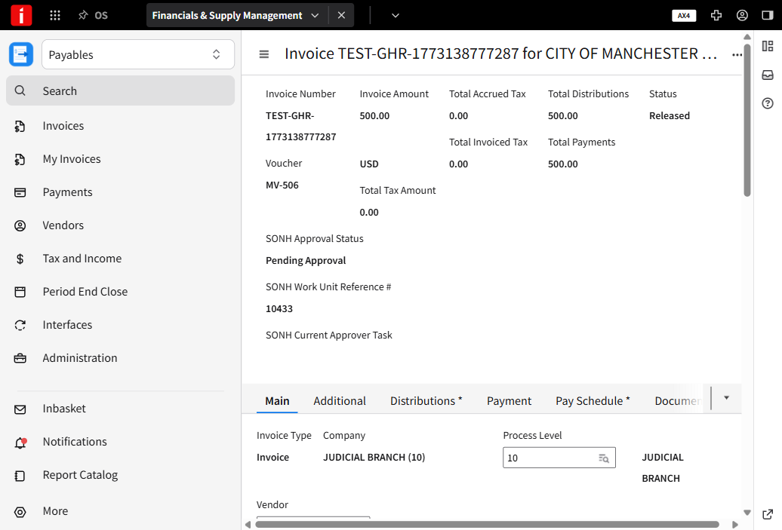

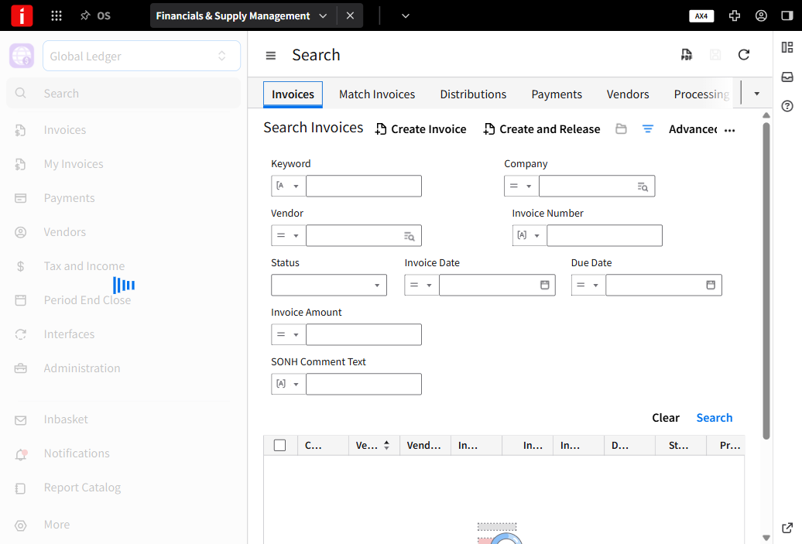

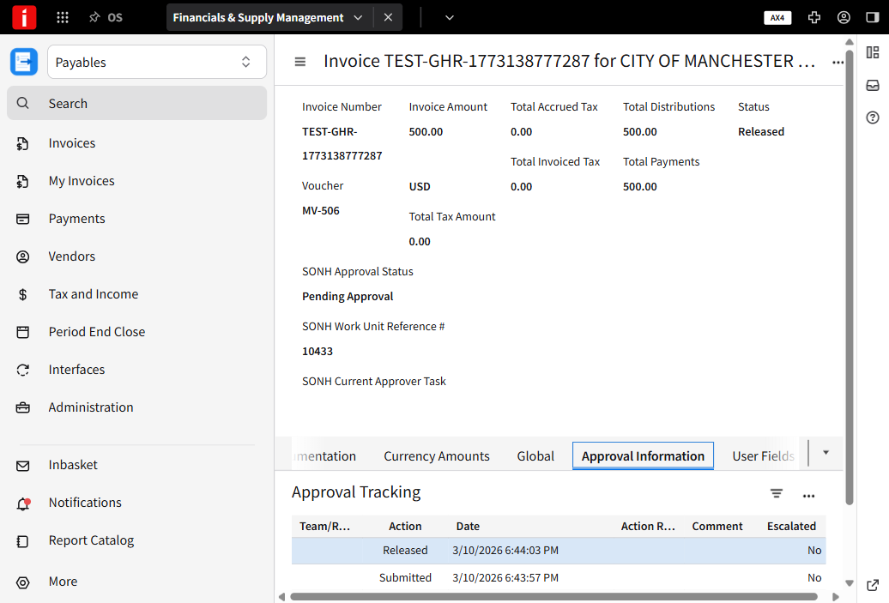

3.1.3 Results
- Expected Result: Invoice should be automatically approved and released without manual intervention
- Actual Result: Invoice was automatically approved and released. Status changed from 'Pending Approval' to 'Released'. Work Unit 10433 completed successfully in 0.870 seconds. Approval tracking shows 'Released' action at 18:44:03.
- Status: ✅ PASS

