SIMATS ENGINEERING
ASSESSMENT TOOL 3

COURSE NAME: Artificial Intelligence COURSE CODE: CSA17

COURSE OUTCOME COVERED

CO2: Experiment search and game-solving techniques such as Greedy Search, A*, CSP, Minimax, and Alpha-Beta pruning with heuristic functions for solving complex AI problems efficiently. (BL3)

Assessment Tool Weightage: 40%

Duration: 1 Hour
QUESTIONS: 3 Total Marks:30

Annexure A

Dry Run Evaluation

Code of Conduct:

I Vanaganti Shiva(192311361) (Name / Reg No) certify that this submission is my original work and that I have adhered to the guidelines specified for this assessment.
I understand that any violation of academic integrity rules will result in disciplinary action.

V Shiva
Signature of the student:

1. Question 1 – Breadth-First Search (BFS)
Consider the following graph: A
/ \
B C
/ \ / \
D E F G
Task: Starting from node A, perform a Breadth-First Search (BFS). Complete the following table.
Iteration | Queue | Visited Node
1
2
3
4
5
6
7
Questions:
- Write the BFS traversal order.
- Show the queue contents after each iteration.
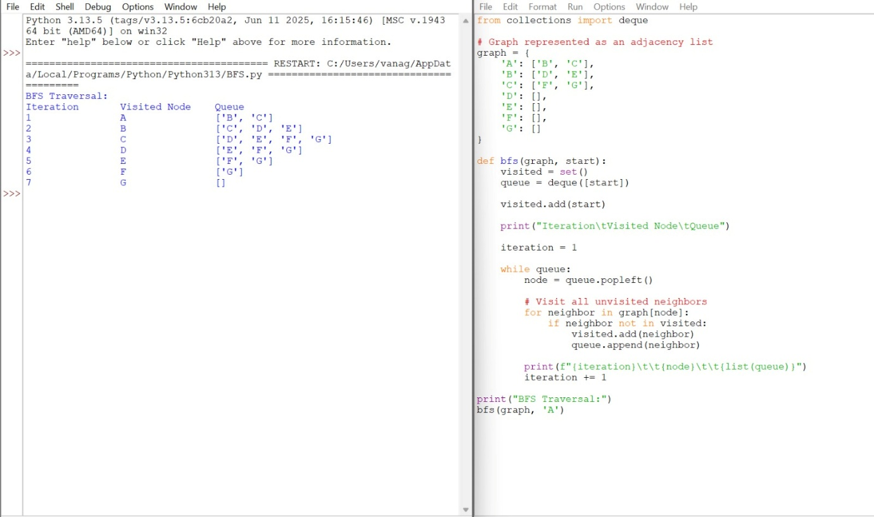

2. Depth-First Search (DFS) Using the same graph,
A
/ \
B C 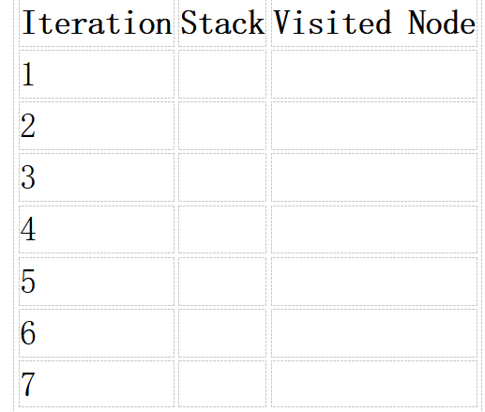
/ \ / \
D E F G
Perform Depth-First Search (DFS) starting from A.
Complete the table.
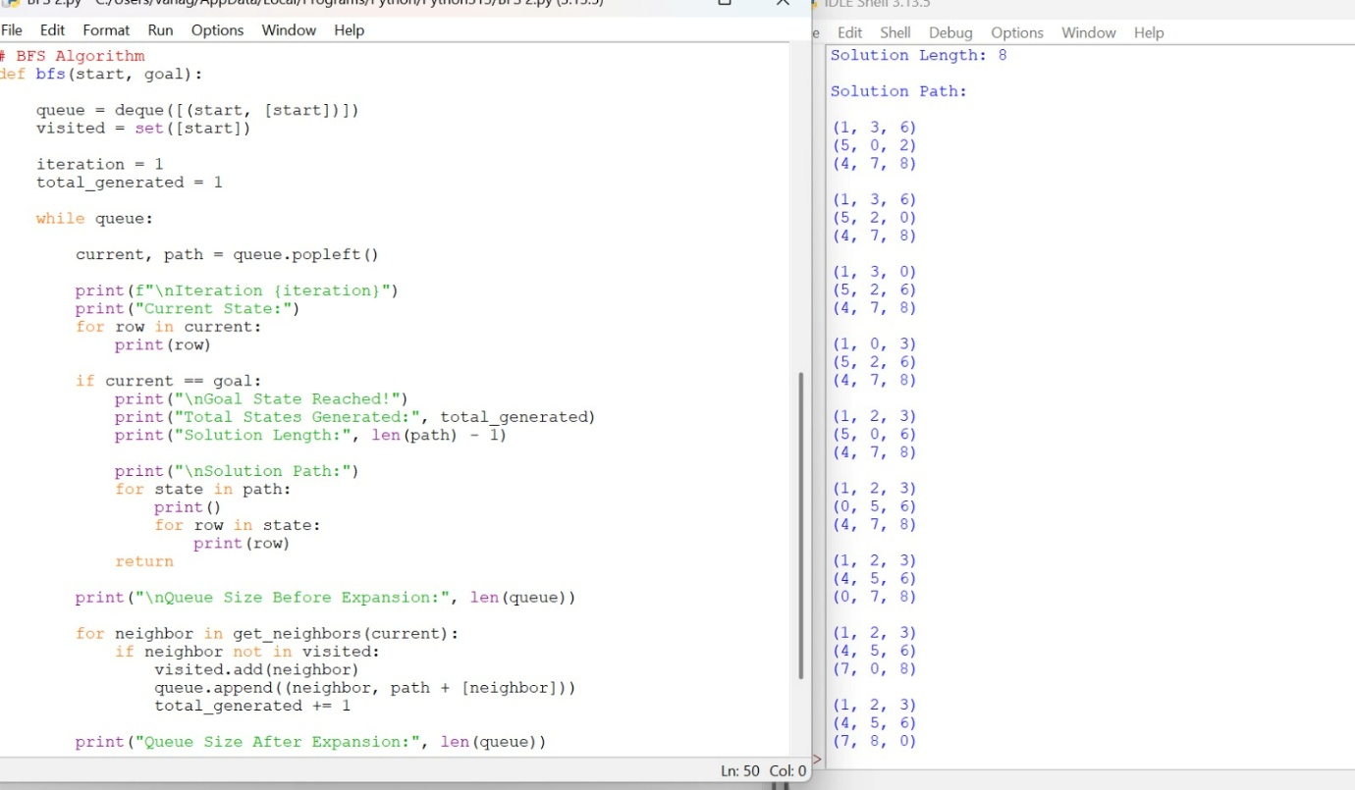

- Initial State :
1 3 6
5 0 2
4 7 8

Goal State :
1 2 3
4 5 6
7 8 0

Task
Trace Breadth-First Search (BFS) until the goal state is reached.
Fill in the table.
Iteration | Current State | Queue Before Expansion | Queue After Expansion
1
2
3
4
5


