Javascript

1.data types in javascript.
String
object
array
boolean
number
null
undefined
2. ,

3. HELLO,WORLD

4. var name = {color:”red”}

5. 9 times it will executed.

6.inner.HTML()
console.log()
window.alert()
document.Write()

7. the length of that array is 51

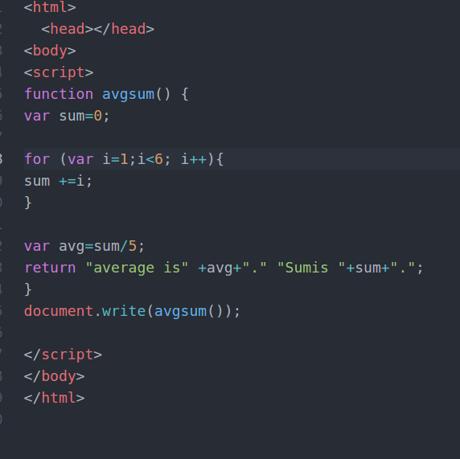
8.

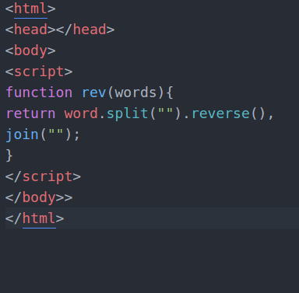
9.

10.

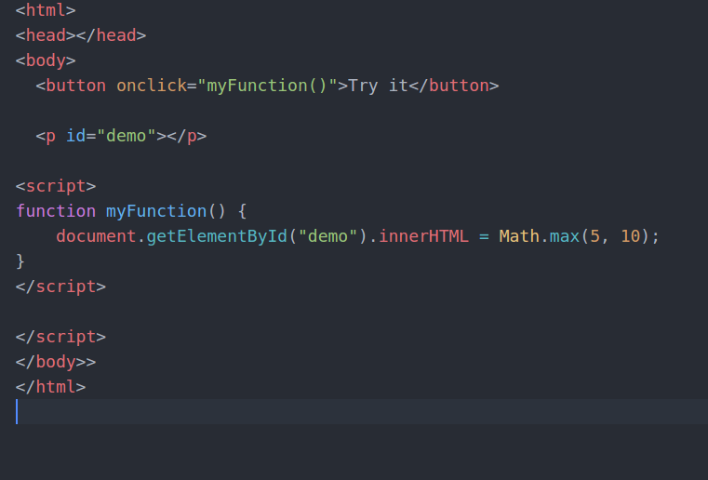
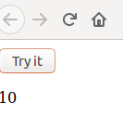

11.== : it is used to check the value equal to
=== : it is used to check the value equal and same data type

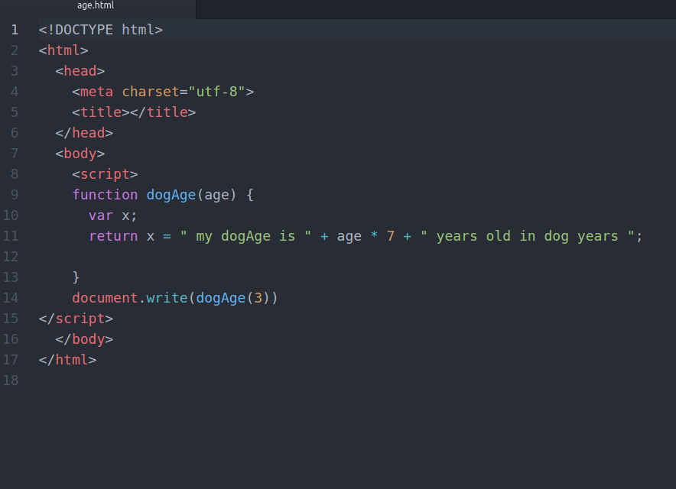
12.

.

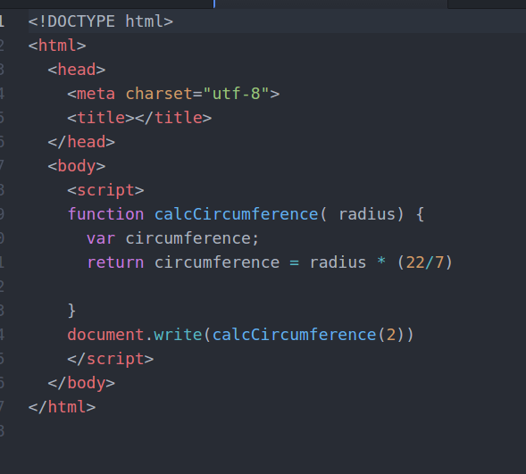
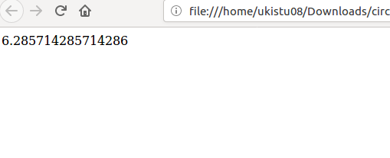

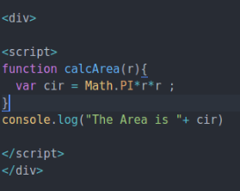

14.`const` is a signal that the identifier won’t be reassigned.

`let`, is a signal that the variable may be reassigned, such as a counter in a loop, or a value swap in an algorithm. It also signals that the variable will be used only in the block it’s defined in, which is not always the entire containing function.
