Nodejs mongodb

1) Create a Database called music​.

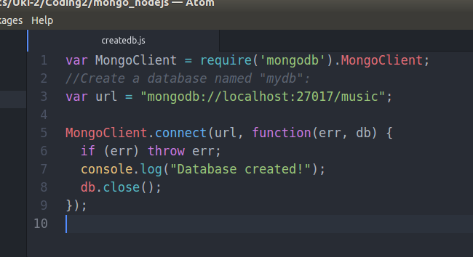

2) Create a collection called songdetails​.

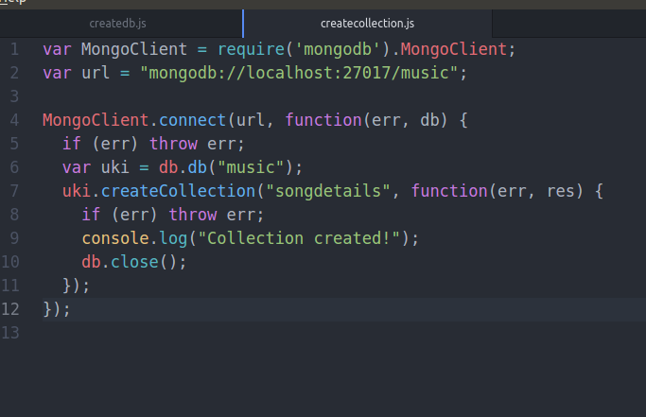
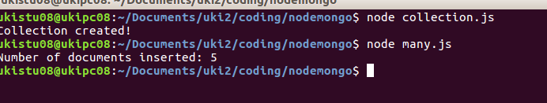

3) Create the above 5 song documents.

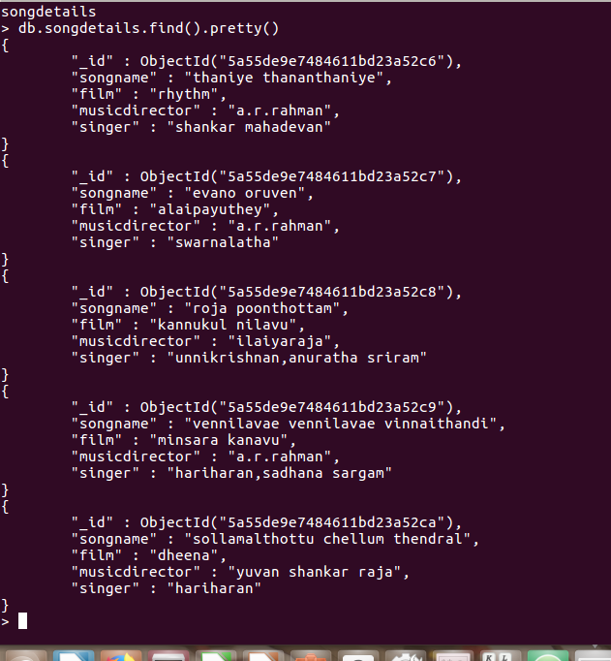
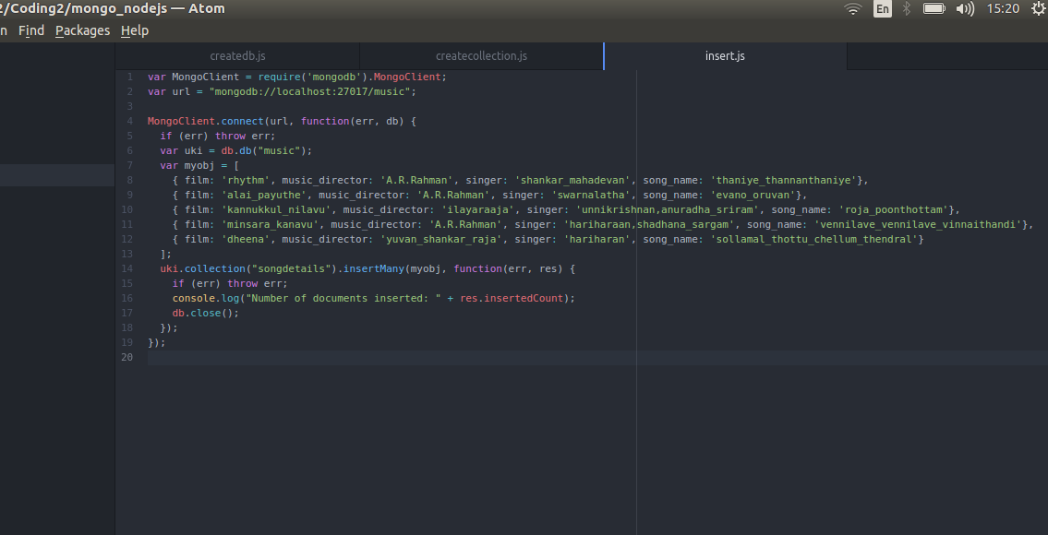

5) List A.R.Rahman’s songs.

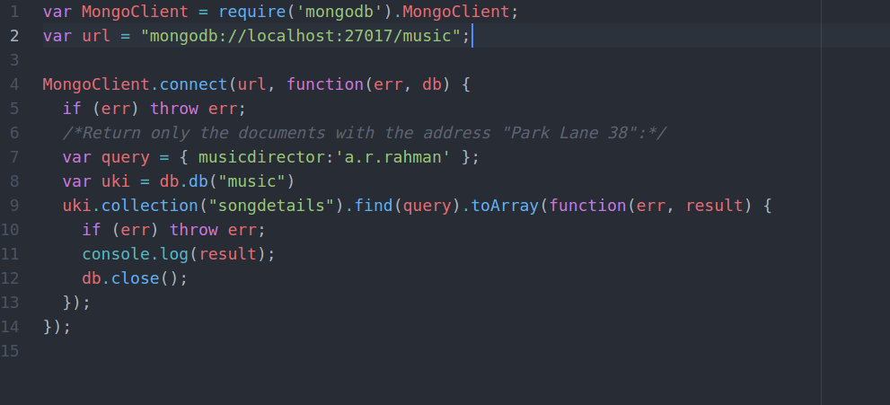

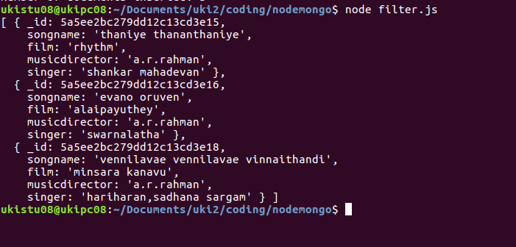

6) List A.R.Rahman’s songs sung by Unnikrishnan.
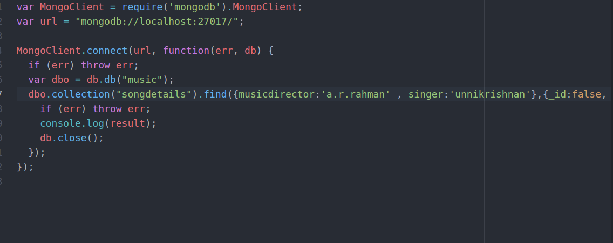

7) Delete the song which you don’t like.

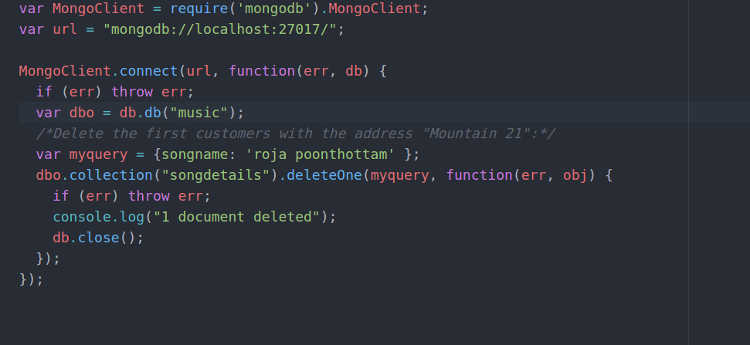

8) Add new song which is your favourite.

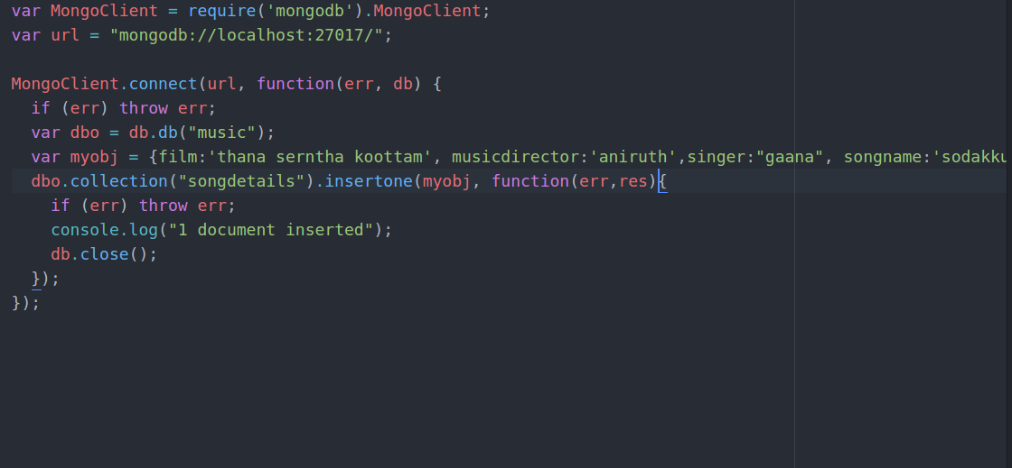

9) List Songs sung by Hariharan from dheena film.

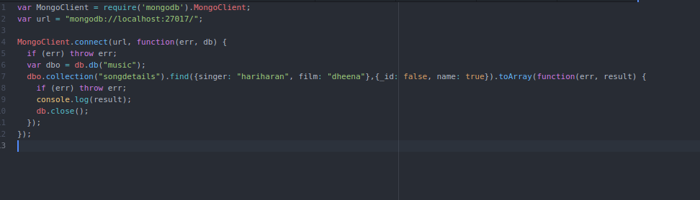

10)List out the singers’ names in your document.

