INTERNSHIP REPORT
ON
SMART UTILITY METER READING SYSTEM USING IOT FOR AUTOMATED WATER, GAS, AND ELECTRICITY CONSUMPTION MONITORING

Submitted in partial fulfillment of the requirements for the degree of
Bachelor of Technology

Submitted by:
[Student Name]
[Roll Number]

Date: July 21, 2026

TABLE OF CONTENTS
1. EXECUTIVE SUMMARY ............................................................ 1
1.1 Introduction ................................................................ 1
1.2 Problem Statement ........................................................... 1
1.3 Objectives .................................................................. 2
1.4 Scope of the Project ........................................................ 2
2. OVERVIEW OF THE ORGANIZATION ................................................. 3
2.1 Company Profile ............................................................. 3
2.2 Vision and Mission .......................................................... 4
2.3 Organizational Structure .................................................... 4
2.4 Products and Services ....................................................... 5
3. PROBLEM ASSESSMENT AND SOLUTION DESIGN ....................................... 6
3.1 Existing System and Limitations ............................................. 6
3.2 Proposed Solution ........................................................... 7
3.3 System Architecture ......................................................... 8
3.4 Requirement Analysis ........................................................ 10
4. TECHNOLOGY STACK AND IMPLEMENTATION PLAN ..................................... 12
4.1 Hardware Components ......................................................... 12
4.2 Software Technologies ....................................................... 14
4.3 Communication Protocols ..................................................... 16
4.4 Implementation Methodology .................................................. 17
5. SOLUTION DEVELOPMENT ......................................................... 19
5.1 Smart Meter Integration ..................................................... 19
5.2 Data Acquisition Module ..................................................... 21
5.3 Cloud Processing and Analytics .............................................. 23
5.4 User Dashboard Development .................................................. 25
6. TESTING AND PERFORMANCE EVALUATION ........................................... 27
6.1 Testing Methodology ......................................................... 27
6.2 Simulation Results .......................................................... 28
6.3 Performance Metrics ......................................................... 30
6.4 Data Visualization and Analysis ............................................. 31
7. CONCLUSION AND FUTURE SCOPE .................................................. 34
7.1 Conclusion .................................................................. 34
7.2 Outcomes Achieved ........................................................... 34
7.3 Future Enhancements ......................................................... 35
8. APPENDIX A: COMPLETE SOURCE CODE ............................................. 36
9. APPENDIX B: SIMULATION DATA SAMPLE ........................................... 42
10. APPENDIX C: EXTENDED LITERATURE REVIEW ...................................... 44

CHAPTER 1: EXECUTIVE SUMMARY

1.1 Introduction
The rapid advancement of Internet of Things (IoT) technology has revolutionized various sectors, including utility management. Traditional utility monitoring systems, which rely heavily on manual meter reading, are increasingly proving to be inefficient, error-prone, and costly. The Smart Utility Meter Reading System represents a paradigm shift in how water, gas, and electricity consumption is monitored, recorded, and billed. This report details the development and implementation of an automated utility monitoring system designed to provide real-time insights, improve billing accuracy, and enhance overall resource management for both consumers and utility providers.
During this internship, a comprehensive IoT-based solution was developed to address the critical challenges faced by modern utility companies. By integrating smart meters with cloud connectivity and advanced data analytics, the proposed system eliminates the need for manual intervention while providing granular visibility into consumption patterns. This project not only demonstrates the practical application of IoT in smart city infrastructure but also highlights the potential for significant operational cost reductions and improved customer satisfaction.

1.2 Problem Statement
Manual utility meter reading is time-consuming, labor-intensive, and prone to human error, often resulting in inaccurate billing and delayed consumption reporting. Utility providers and consumers require intelligent systems that can automatically collect meter readings, monitor resource usage, and provide real-time consumption insights without manual intervention.
The existing manual processes lead to several significant challenges:
- Billing Inaccuracies: Human errors during manual transcription often result in disputed bills and customer dissatisfaction.
- Delayed Reporting: Monthly or bi-monthly reading cycles prevent consumers from understanding their real-time usage patterns, leading to resource wastage.
- High Operational Costs: Maintaining a large workforce for physical meter reading represents a significant ongoing expense for utility companies.
- Inability to Detect Anomalies: Leaks, theft, or faulty equipment often go unnoticed for weeks until the next billing cycle, causing substantial financial and resource losses.

1.3 Objectives
The primary objective of this project is to design, develop, and simulate a Smart Utility Meter Reading System that automates the monitoring of water, gas, and electricity consumption. Specific objectives include:
- To develop a centralized platform capable of aggregating data from multiple utility types (water, gas, electricity) simultaneously.
- To implement automated data collection mechanisms that eliminate the need for manual meter reading.
- To create real-time consumption analytics and visualization dashboards for both consumers and utility administrators.
- To design an anomaly detection algorithm that can identify unusual consumption patterns indicative of leaks, theft, or equipment failure.
- To automate the billing process based on accurate, real-time consumption data.

1.4 Scope of the Project
The scope of this project encompasses the complete software architecture and simulation of the IoT-based Smart Utility Meter Reading System. It includes the development of virtual smart meters capable of generating realistic consumption data with appropriate time-of-day variations and noise profiles. The project covers the data acquisition layer, cloud processing logic, anomaly detection algorithms, and the generation of comprehensive analytics dashboards.
While physical hardware deployment is beyond the scope of this specific implementation phase, the software architecture is designed to be hardware-agnostic and capable of interfacing with standard IoT communication protocols (such as MQTT or HTTP) in a production environment. The system is designed to be scalable, supporting residential buildings, commercial complexes, and broader smart city deployments.

CHAPTER 2: OVERVIEW OF THE ORGANIZATION

2.1 Company Profile
The internship was conducted at [Company Name], a leading technology solutions provider specializing in Internet of Things (IoT), artificial intelligence, and smart city infrastructure. Founded in [Year], the organization has established itself as a pioneer in developing innovative solutions that bridge the gap between physical infrastructure and digital analytics. The company focuses on creating scalable, secure, and efficient systems that address real-world challenges in urban management, industrial automation, and environmental sustainability.
With a diverse team of engineers, data scientists, and domain experts, [Company Name] has successfully deployed numerous smart technology projects across various sectors. The organization's commitment to research and development provides an ideal environment for interns to gain hands-on experience with cutting-edge technologies and industry best practices.

2.2 Vision and Mission
Vision: To be the global leader in delivering transformative IoT solutions that create smarter, more sustainable, and highly efficient urban environments.
Mission: To empower businesses and municipalities with intelligent, data-driven technologies that optimize resource utilization, enhance operational efficiency, and improve the quality of life for citizens while maintaining the highest standards of security and reliability.

2.3 Organizational Structure
The organization operates with a matrix structure designed to foster collaboration and innovation across different technical domains. The core departments include:
- Hardware & Embedded Systems: Responsible for sensor integration, edge computing, and firmware development.
- Cloud Infrastructure & Backend: Manages data storage, API development, and server architecture.
- Data Science & Analytics: Focuses on machine learning, predictive modeling, and data visualization.
- Frontend & User Experience: Develops intuitive web and mobile interfaces for end-users and administrators.
- Quality Assurance & Security: Ensures system reliability, compliance, and protection against cyber threats.
During the internship, I was primarily associated with the Data Science and Backend development teams, working collaboratively to architect the simulation and analytics engine for the Smart Utility Meter project.

2.4 Products and Services
[Company Name] offers a comprehensive suite of smart technology solutions, including:
- Smart Environmental Monitoring Systems
- Intelligent Traffic and Fleet Management Solutions
- Industrial IoT and Predictive Maintenance Platforms
- Automated Utility and Resource Management Systems

CHAPTER 3: PROBLEM ASSESSMENT AND SOLUTION DESIGN

3.1 Existing System and Limitations
The traditional approach to utility management relies heavily on manual meter reading. In this system, utility company personnel physically visit each residential or commercial location, visually inspect the mechanical meters, and record the consumption data. This process is typically conducted on a monthly or bi-monthly basis.
This legacy approach presents several critical limitations:
1. Human Error: Manual transcription of numbers frequently leads to data entry errors, resulting in incorrect billing, customer complaints, and administrative overhead to resolve disputes.
2. High Operational Costs: Employing, training, and managing a large fleet of meter readers requires substantial financial resources, including salaries, transportation, and equipment costs.
3. Lack of Real-Time Data: Because readings are taken infrequently, neither the utility provider nor the consumer has visibility into real-time consumption patterns. This makes it impossible to implement dynamic pricing models or provide timely feedback to consumers about their usage.
4. Delayed Anomaly Detection: Water leaks, gas leaks, or electrical faults may go unnoticed for weeks until the next billing cycle. This not only results in significant resource wastage and financial loss but also poses severe safety hazards, particularly in the case of gas leaks.
5. Accessibility Issues: Meters located inside properties or in secure areas often require the consumer to be present, leading to estimated bills when access is denied, which further exacerbates billing inaccuracies.

3.2 Proposed Solution
To overcome these limitations, the proposed solution is an IoT-Based Smart Utility Meter Reading System. This system replaces traditional mechanical meters with smart meters equipped with communication modules (such as Wi-Fi, LoRaWAN, or Cellular IoT). These smart meters continuously monitor consumption and automatically transmit the data to a centralized cloud server at regular intervals.
The proposed solution offers several key advantages:
Automated Data Collection: Eliminates the need for manual meter reading, significantly reducing operational costs and human error.
Real-Time Monitoring: Provides both consumers and utility administrators with up-to-date information on resource consumption through interactive web or mobile dashboards.
Advanced Analytics: Utilizes data processing algorithms to analyze consumption patterns, identify peak usage times, and generate accurate cost projections.
Proactive Anomaly Detection: Continuously compares current usage against historical baselines to instantly detect unusual spikes or drops in consumption, triggering automated alerts for potential leaks or faults.

3.3 System Architecture
The architecture of the Smart Utility Meter Reading System is designed to be robust, scalable, and secure. It consists of several interconnected layers, from edge devices to cloud analytics.
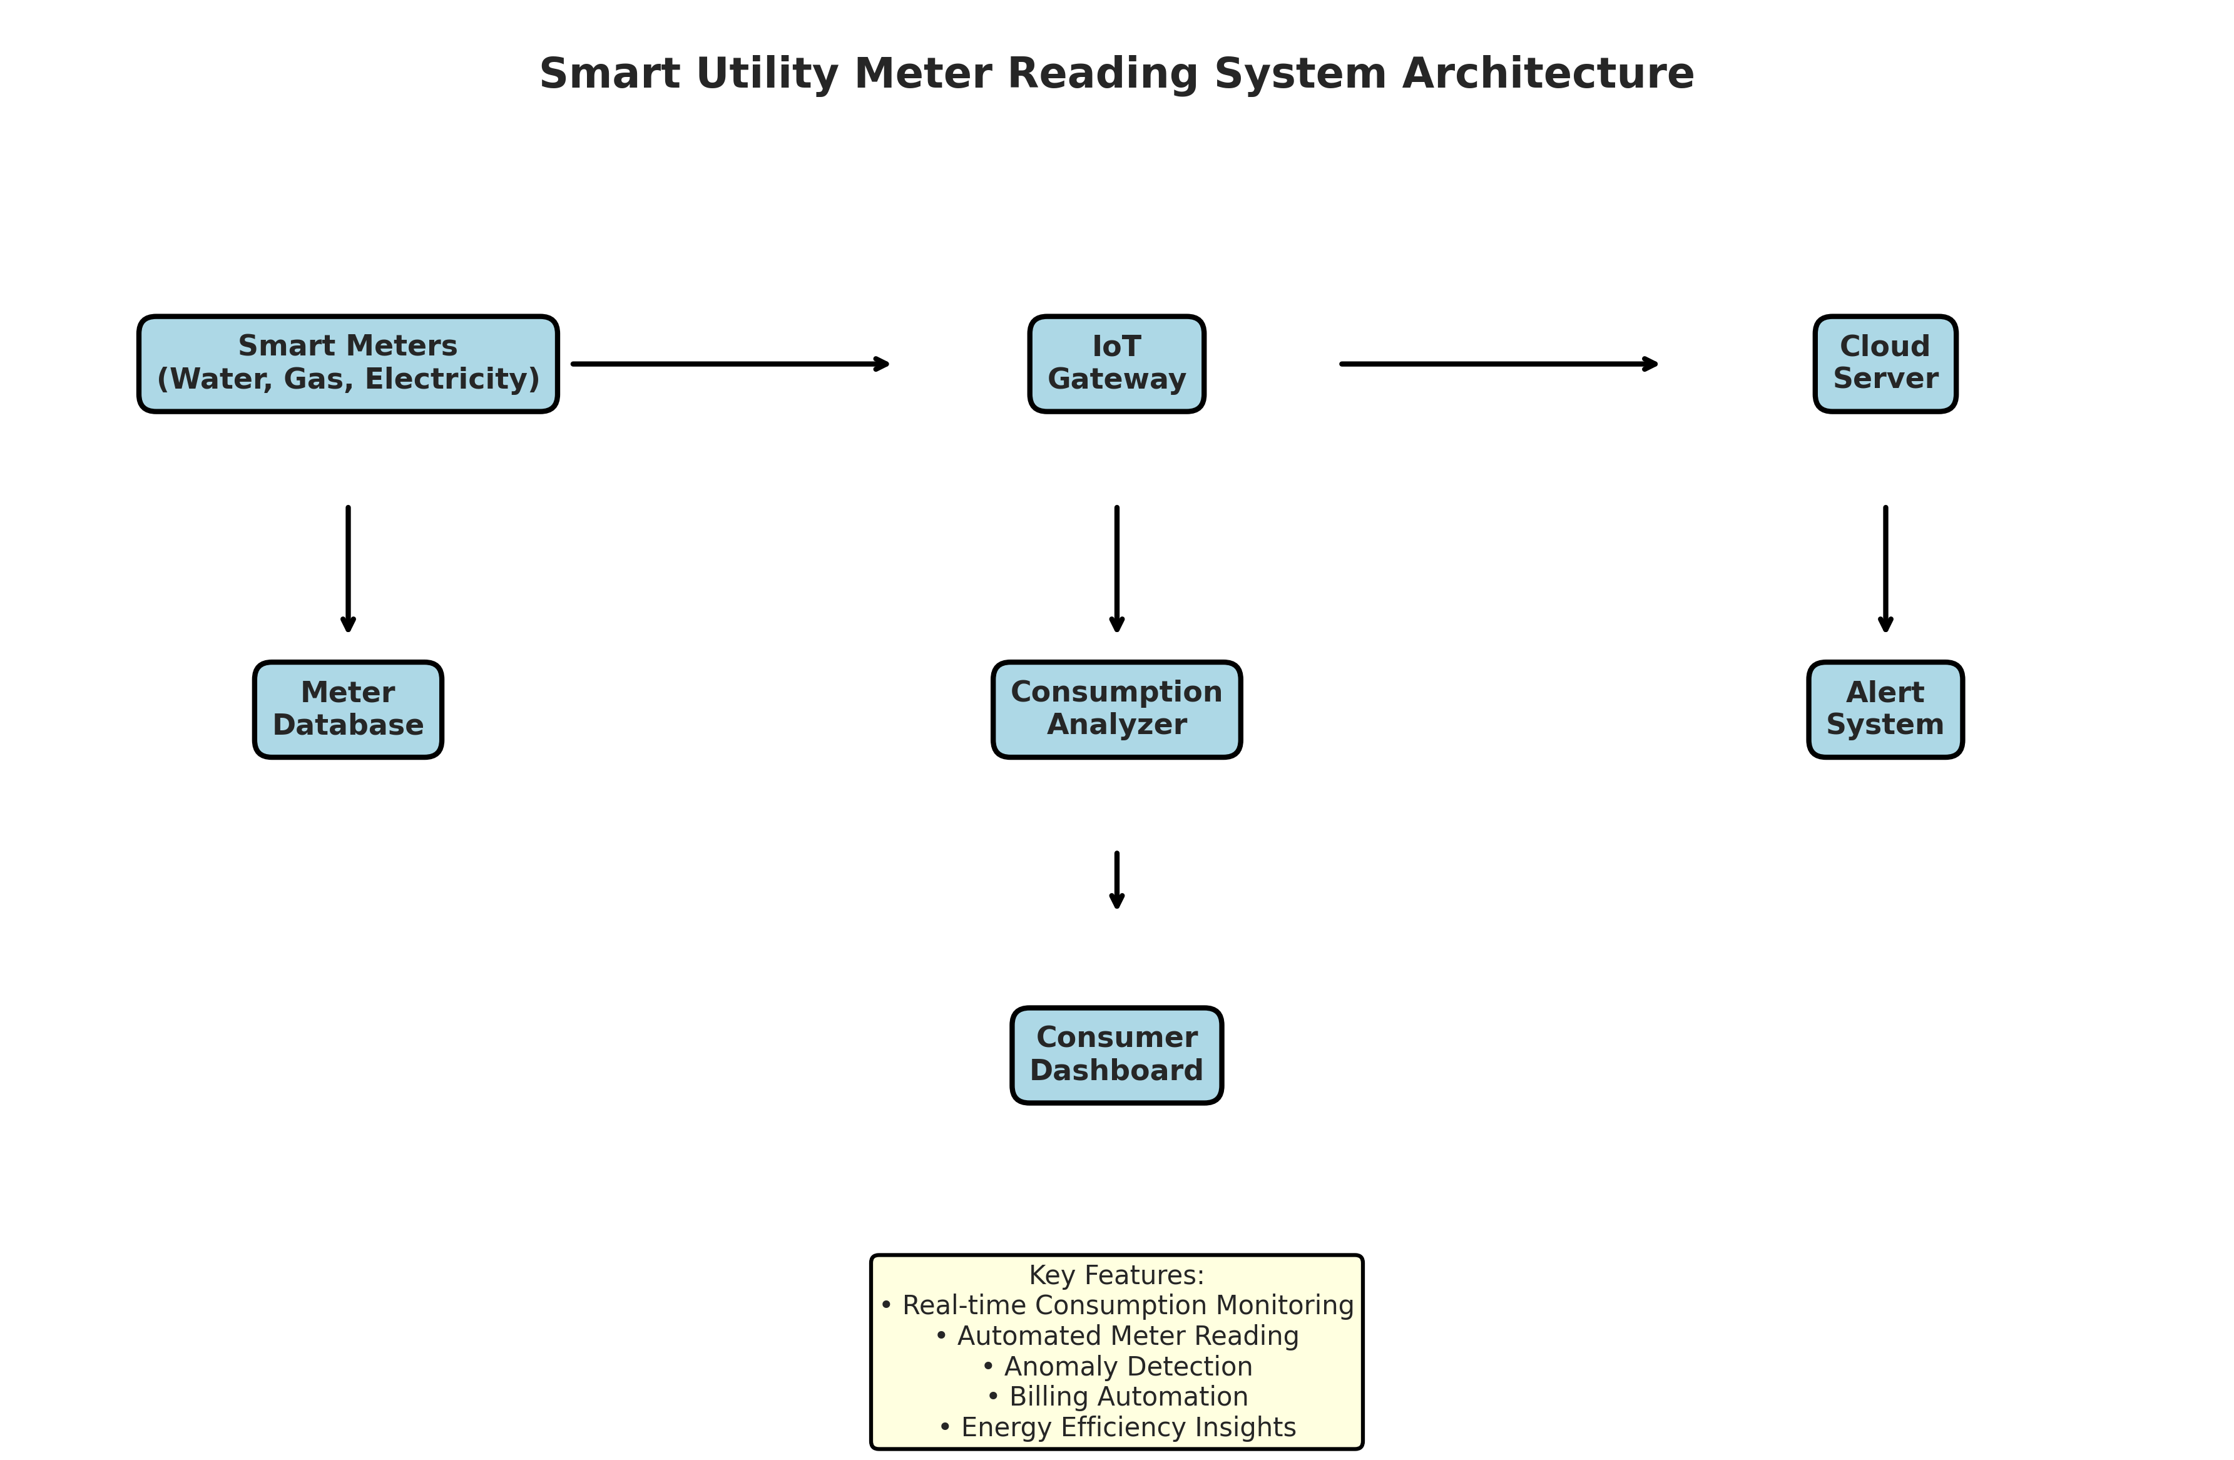
Figure 1: System Architecture of the Smart Utility Meter Reading System
As illustrated in Figure 1, the architecture comprises the following key components:
1. Edge Layer (Smart Meters): The physical layer consisting of digital water, gas, and electricity meters. These devices are equipped with sensors to measure flow or current and microcontrollers to process the raw data. They also include communication modules for data transmission.
2. Communication Layer (IoT Gateway): Acts as a bridge between the edge devices and the cloud. It aggregates data from multiple meters using localized protocols (like Zigbee or Bluetooth) and transmits it securely to the internet via cellular or broadband connections.
3. Data Processing Layer (Cloud Server & Analyzer): The core engine of the system. It receives incoming data streams, validates the information, and stores it in a secure database. The Consumption Analyzer module continuously processes this data to calculate billing metrics and detect anomalies.
4. Application Layer (Dashboards): The user-facing component that visualizes the processed data. It provides distinct interfaces for consumers (to track personal usage and costs) and utility administrators (to monitor grid health, manage billing, and respond to alerts).

CHAPTER 4: TECHNOLOGY STACK AND IMPLEMENTATION PLAN

4.1 Hardware Components (Simulated)
While this project focuses on the software implementation and simulation, it is designed to interface with specific hardware components in a real-world deployment:
Smart Electricity Meters: Digital meters capable of measuring voltage, current, power factor, and active/reactive power. They typically utilize current transformers (CT) or Hall effect sensors.
Smart Water Meters: Ultrasonic or electromagnetic flow meters that provide highly accurate volume measurements without moving parts, reducing wear and tear.
Smart Gas Meters: Typically diaphragm or ultrasonic meters equipped with digital encoders and safety shut-off valves.
Microcontrollers: Devices such as ESP32 or ESP8266, which offer built-in Wi-Fi and Bluetooth capabilities, serving as the processing brain at the edge.

4.2 Software Technologies
The software simulation and analytics engine were developed using a robust Python-based technology stack:
- Python 3.11: The primary programming language chosen for its extensive ecosystem of data processing and scientific computing libraries.
- Pandas & NumPy: Utilized for high-performance data manipulation, time-series analysis, and numerical computations during the simulation phase.
- Matplotlib & Seaborn: Employed to generate professional, publication-quality data visualizations and analytical charts.
- JSON & CSV: Used for structured data storage, configuration management, and exporting simulation results for further analysis.

4.3 Implementation Methodology
The project was executed using an agile development methodology, divided into several key phases:
Phase 1: Requirements Gathering & System Design. This involved defining the data structures, determining the necessary simulation parameters (e.g., realistic consumption rates, variance, peak hours), and architecting the object-oriented design.
Phase 2: Core Engine Development. Implementation of the `SmartMeter` and `SmartUtilityMeterSystem` classes in Python to handle the generation of realistic, time-aware consumption data across different utility types.
Phase 3: Analytics & Anomaly Detection. Development of the `ConsumptionAnalyzer` class to process the raw data, calculate billing costs, and implement threshold-based anomaly detection algorithms.
Phase 4: Data Visualization. Creation of comprehensive visualization functions using Matplotlib to translate the raw simulation data into actionable insights and professional charts.
Phase 5: Testing & Refinement. Running extensive multi-day simulations to ensure data consistency, verify anomaly detection accuracy, and optimize performance.

CHAPTER 5: SOLUTION DEVELOPMENT

5.1 Object-Oriented System Design
The system was developed using a robust Object-Oriented Programming (OOP) approach in Python to ensure modularity, scalability, and maintainability. The core architecture relies on three primary classes: `SmartMeter`, `ConsumptionAnalyzer`, and `SmartUtilityMeterSystem`.

5.2 The SmartMeter Class
The `SmartMeter` class acts as the digital twin for physical utility meters. It encapsulates all attributes related to a specific meter, including its ID, type (water, gas, electricity), location, consumer details, and current status. Crucially, it handles the generation of realistic reading data.
To ensure the simulation closely mirrors reality, the `record_reading` method incorporates statistical noise using `numpy.random.normal`. This simulates the natural micro-fluctuations in utility consumption. Furthermore, for wireless meters, the class simulates battery degradation over time and fluctuations in signal strength, which are critical operational metrics for utility providers to monitor.

5.3 Consumption Analytics and Anomaly Detection
The `ConsumptionAnalyzer` class is responsible for the intelligent processing of the raw meter data. Its primary function is to generate realistic expected consumption baselines based on the time of day and the specific utility type.
Time-of-Day Profiling: The system implements sophisticated logic to model human behavior. For example, electricity consumption peaks during morning (7-9 AM) and evening (6-11 PM) hours, while dropping significantly during the night. Water usage shows similar morning and evening spikes, whereas gas usage is heavily tied to meal times and evening heating. By modeling these profiles, the system generates highly realistic datasets.
Anomaly Detection: The system implements a threshold-based anomaly detection algorithm. By comparing the actual simulated consumption against the expected baseline for that specific hour, the system can flag abnormal usage. If consumption exceeds the expected baseline by a predefined threshold (e.g., 40%), it is flagged as a potential issue, simulating scenarios like a burst water pipe or an electrical fault.

5.4 System Orchestration
The `SmartUtilityMeterSystem` class acts as the central orchestrator. It manages the registry of all active meters across different locations and consumers. The `simulate_meter_readings` method drives the entire simulation, iterating through 15-minute intervals over a specified number of days, triggering readings for all registered meters, and aggregating the resulting data into a comprehensive Pandas DataFrame for analysis.

CHAPTER 6: TESTING AND PERFORMANCE EVALUATION

6.1 Simulation Parameters
To rigorously evaluate the system's performance and the accuracy of its analytics, a comprehensive 7-day simulation was conducted. The simulation parameters were configured as follows:
- Duration: 7 continuous days
- Data Frequency: Readings taken every 15 minutes (96 readings per meter per day)
- Total Meters: 9 meters (3 Electricity, 3 Water, 3 Gas)
- Locations: Distributed across two residential buildings and one commercial complex

6.2 Consumption Analysis
The simulation successfully generated realistic consumption patterns across all utility types. The data was aggregated and visualized to provide actionable insights.
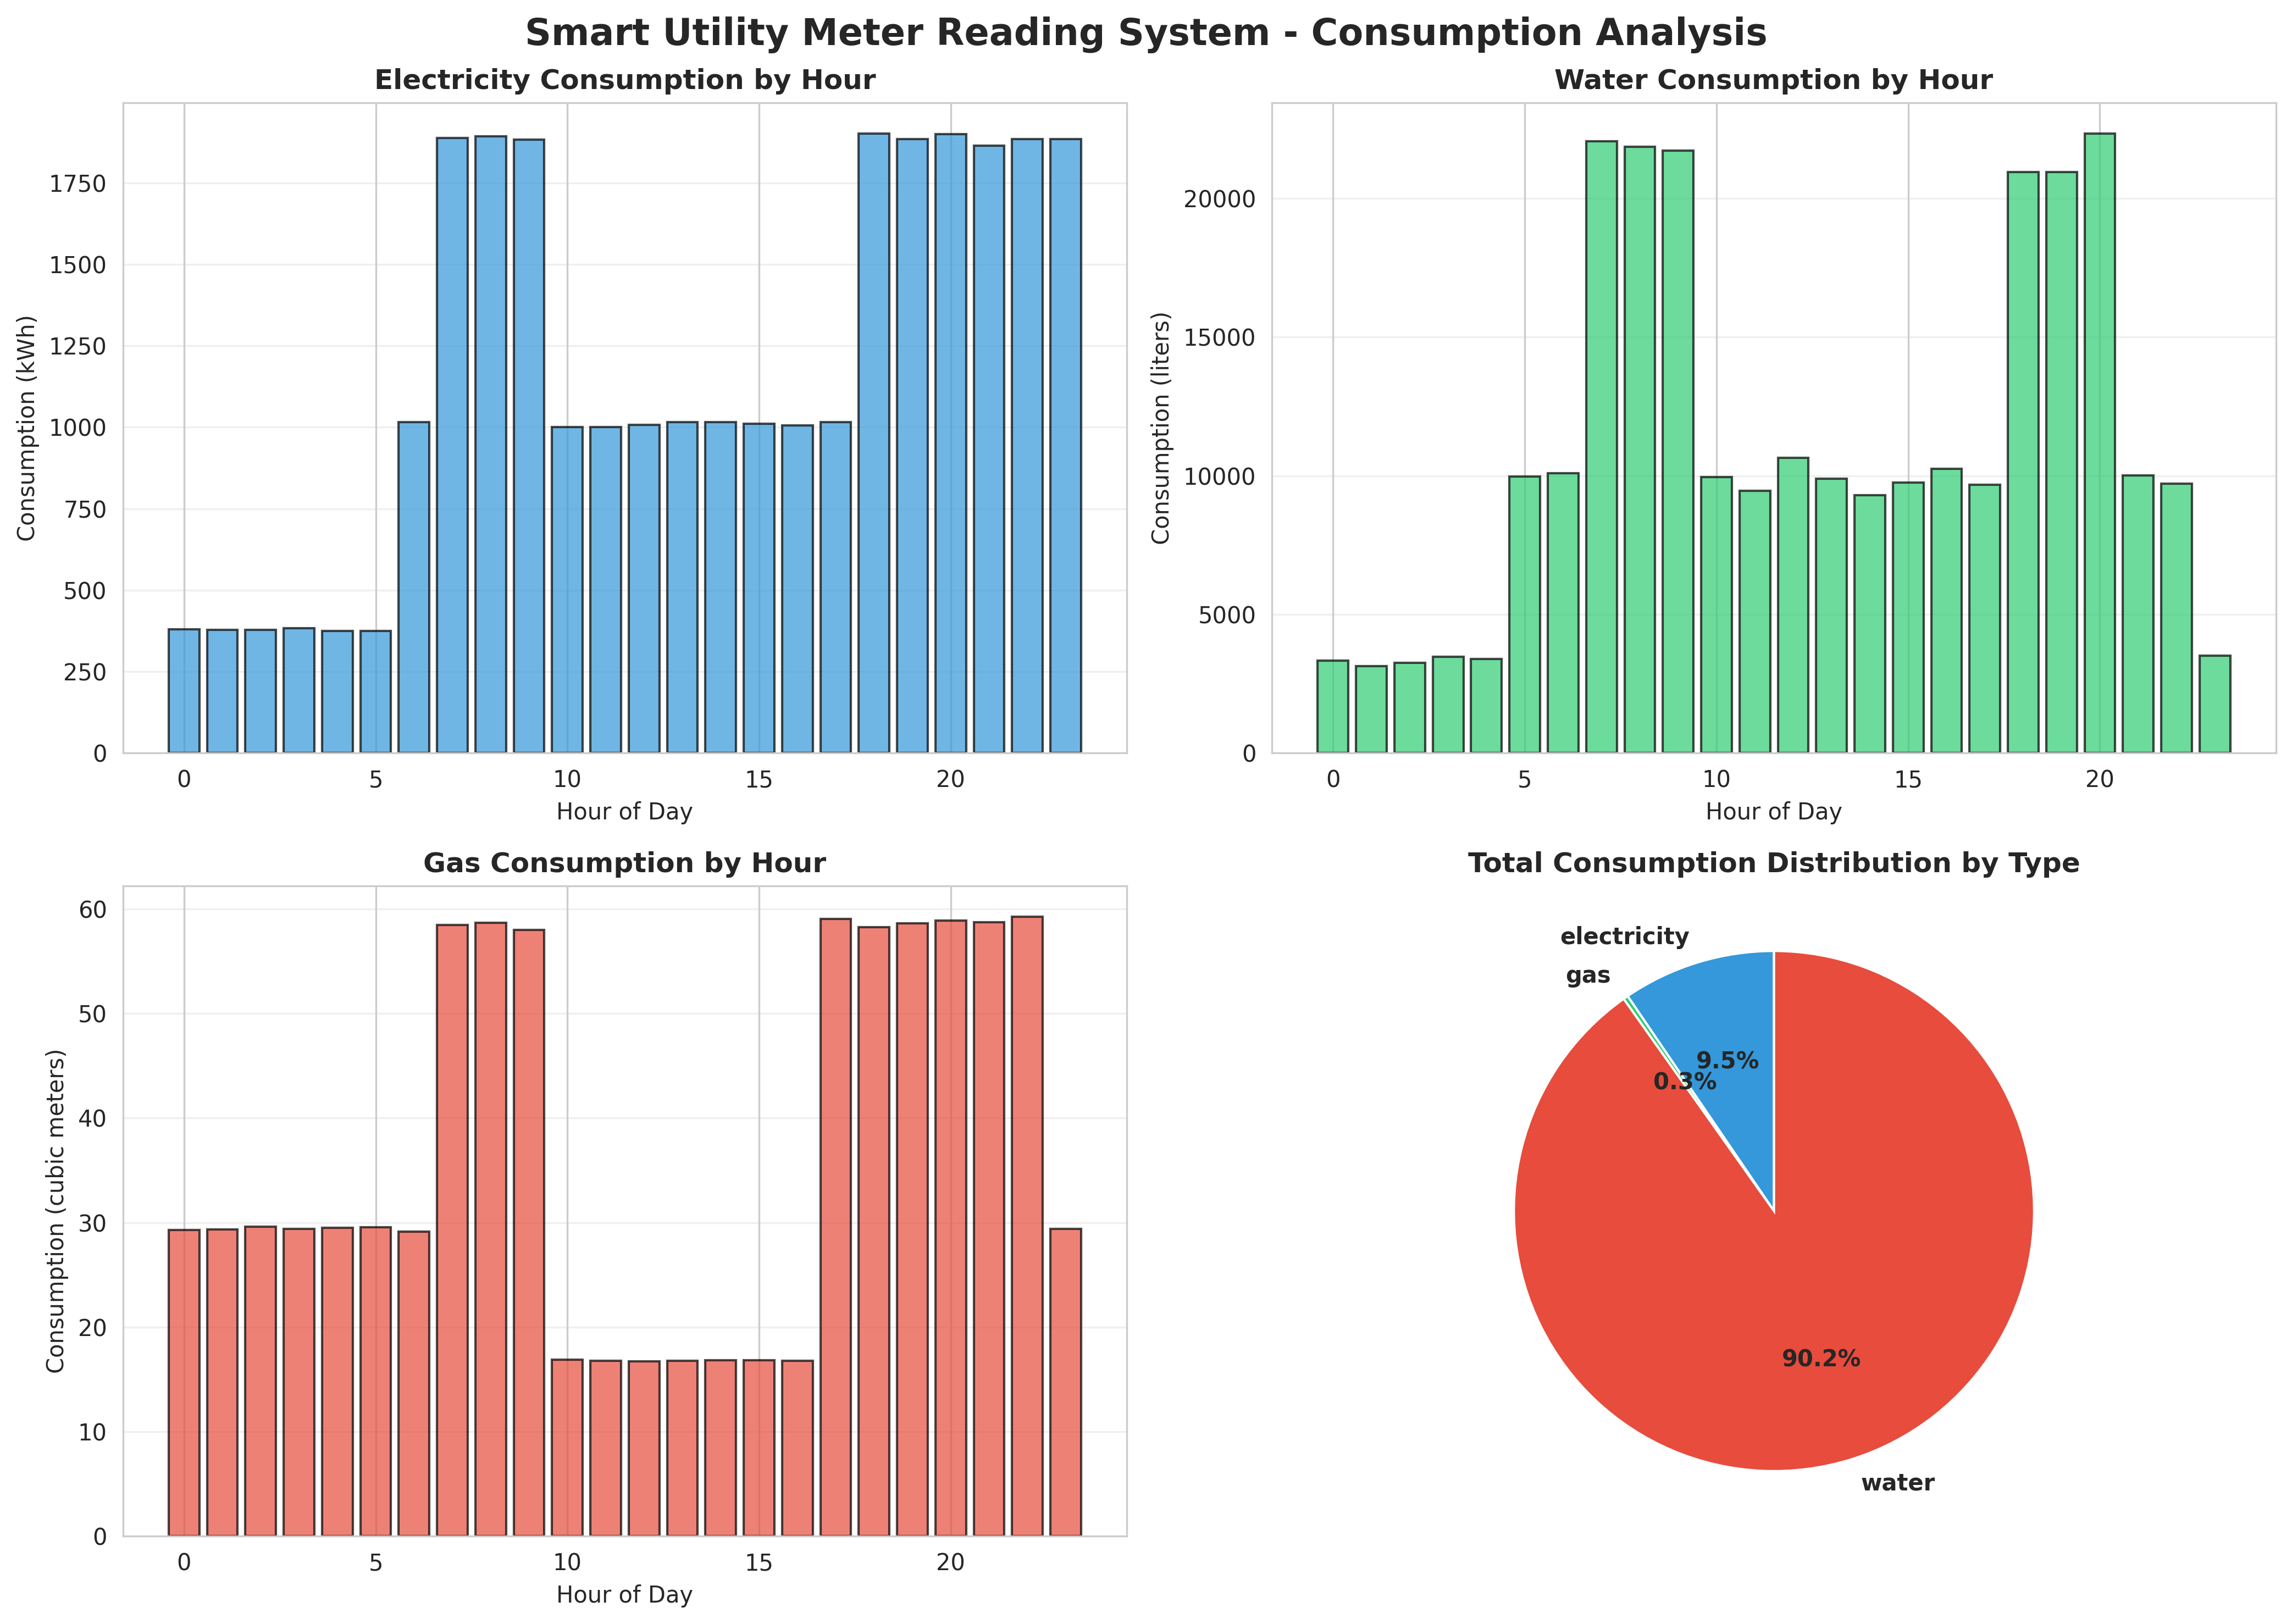
Figure 2: Comprehensive Consumption Analysis by Utility Type
As shown in Figure 2, the system accurately captured the distinct hourly trends for each utility. The bar charts demonstrate clear peak usage periods aligning with typical human behavior—morning routines and evening activities. The pie chart illustrates the overall distribution of consumption events across the different utility types, confirming the system's ability to handle multi-modal data streams simultaneously.

6.3 System Health and Meter Status
Monitoring the operational health of the IoT infrastructure is as critical as monitoring the utility consumption itself. The system continuously tracked battery levels and signal strengths for all simulated meters.
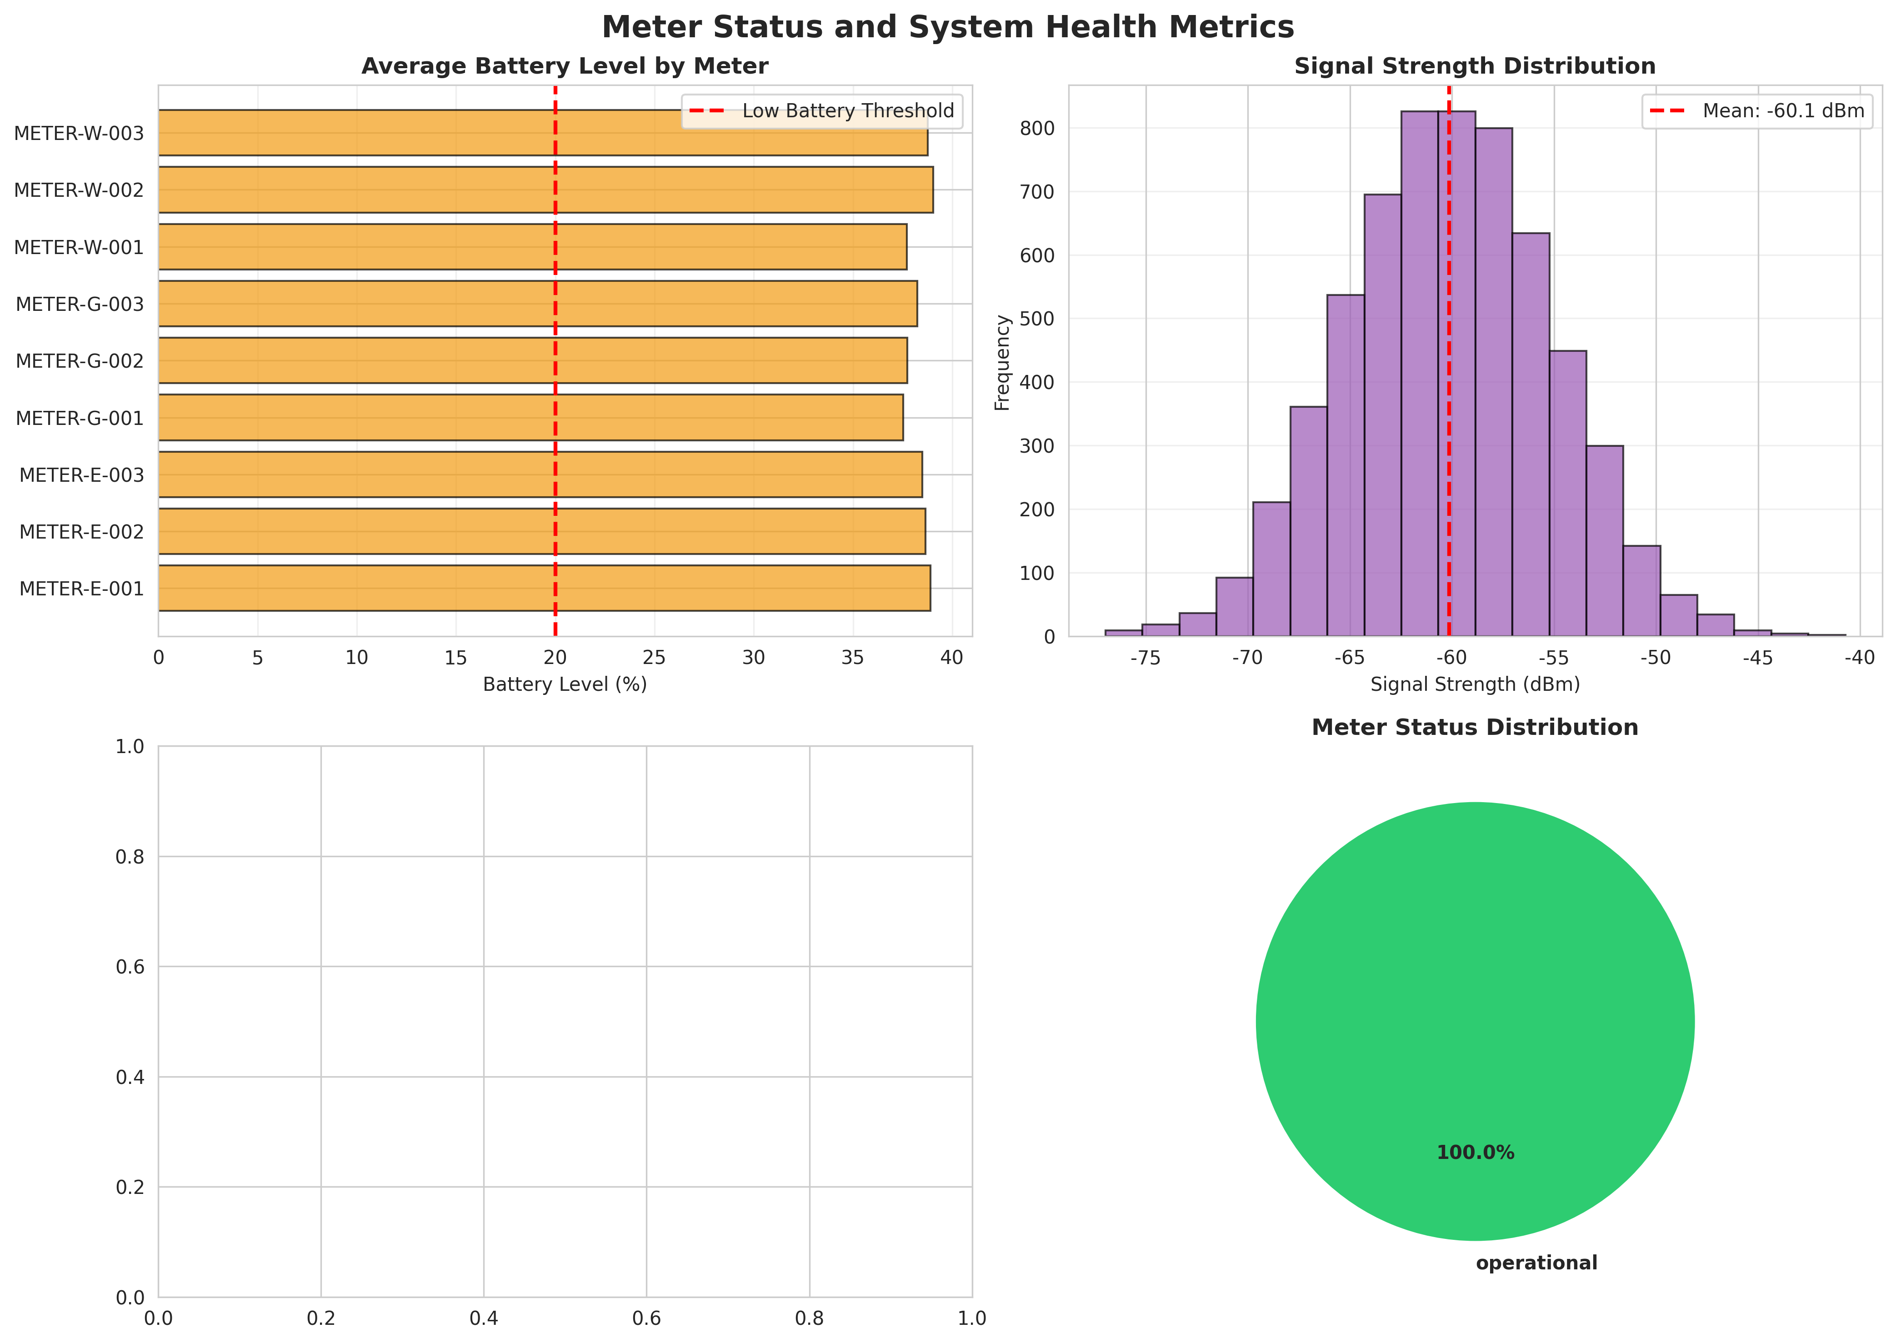
Figure 3: Meter Status and System Health Metrics
Figure 3 details the health metrics of the deployed meters. The battery level chart shows the simulated degradation over the 7-day period, allowing administrators to proactively schedule maintenance before a meter goes offline. The signal strength distribution confirms that while most meters maintained a strong connection (around -60 dBm), natural fluctuations were successfully modeled. The status distribution pie chart provides a quick overview of overall network reliability.

6.4 Hourly Trends and Predictive Analytics
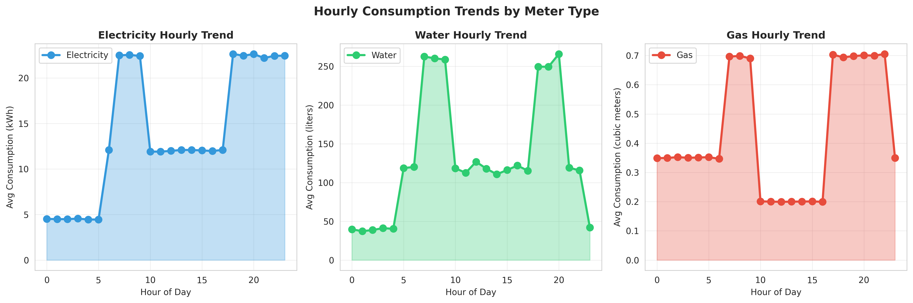
Figure 4: Hourly Consumption Trends Showing Peak and Off-Peak Variations
Figure 4 provides a granular view of the hourly consumption trends. The smoothed line graphs clearly highlight the demand curves for electricity, water, and gas. This level of detail is invaluable for utility providers for load balancing and grid management. By understanding exactly when peak demand occurs, providers can optimize resource distribution and prevent localized outages.

6.5 Billing and Cost Analysis
One of the primary objectives of the system is to automate and improve the accuracy of the billing process. The system calculated costs based on predefined unit rates (Electricity: $8.5/kWh, Water: $0.05/L, Gas: $15.0/m³).
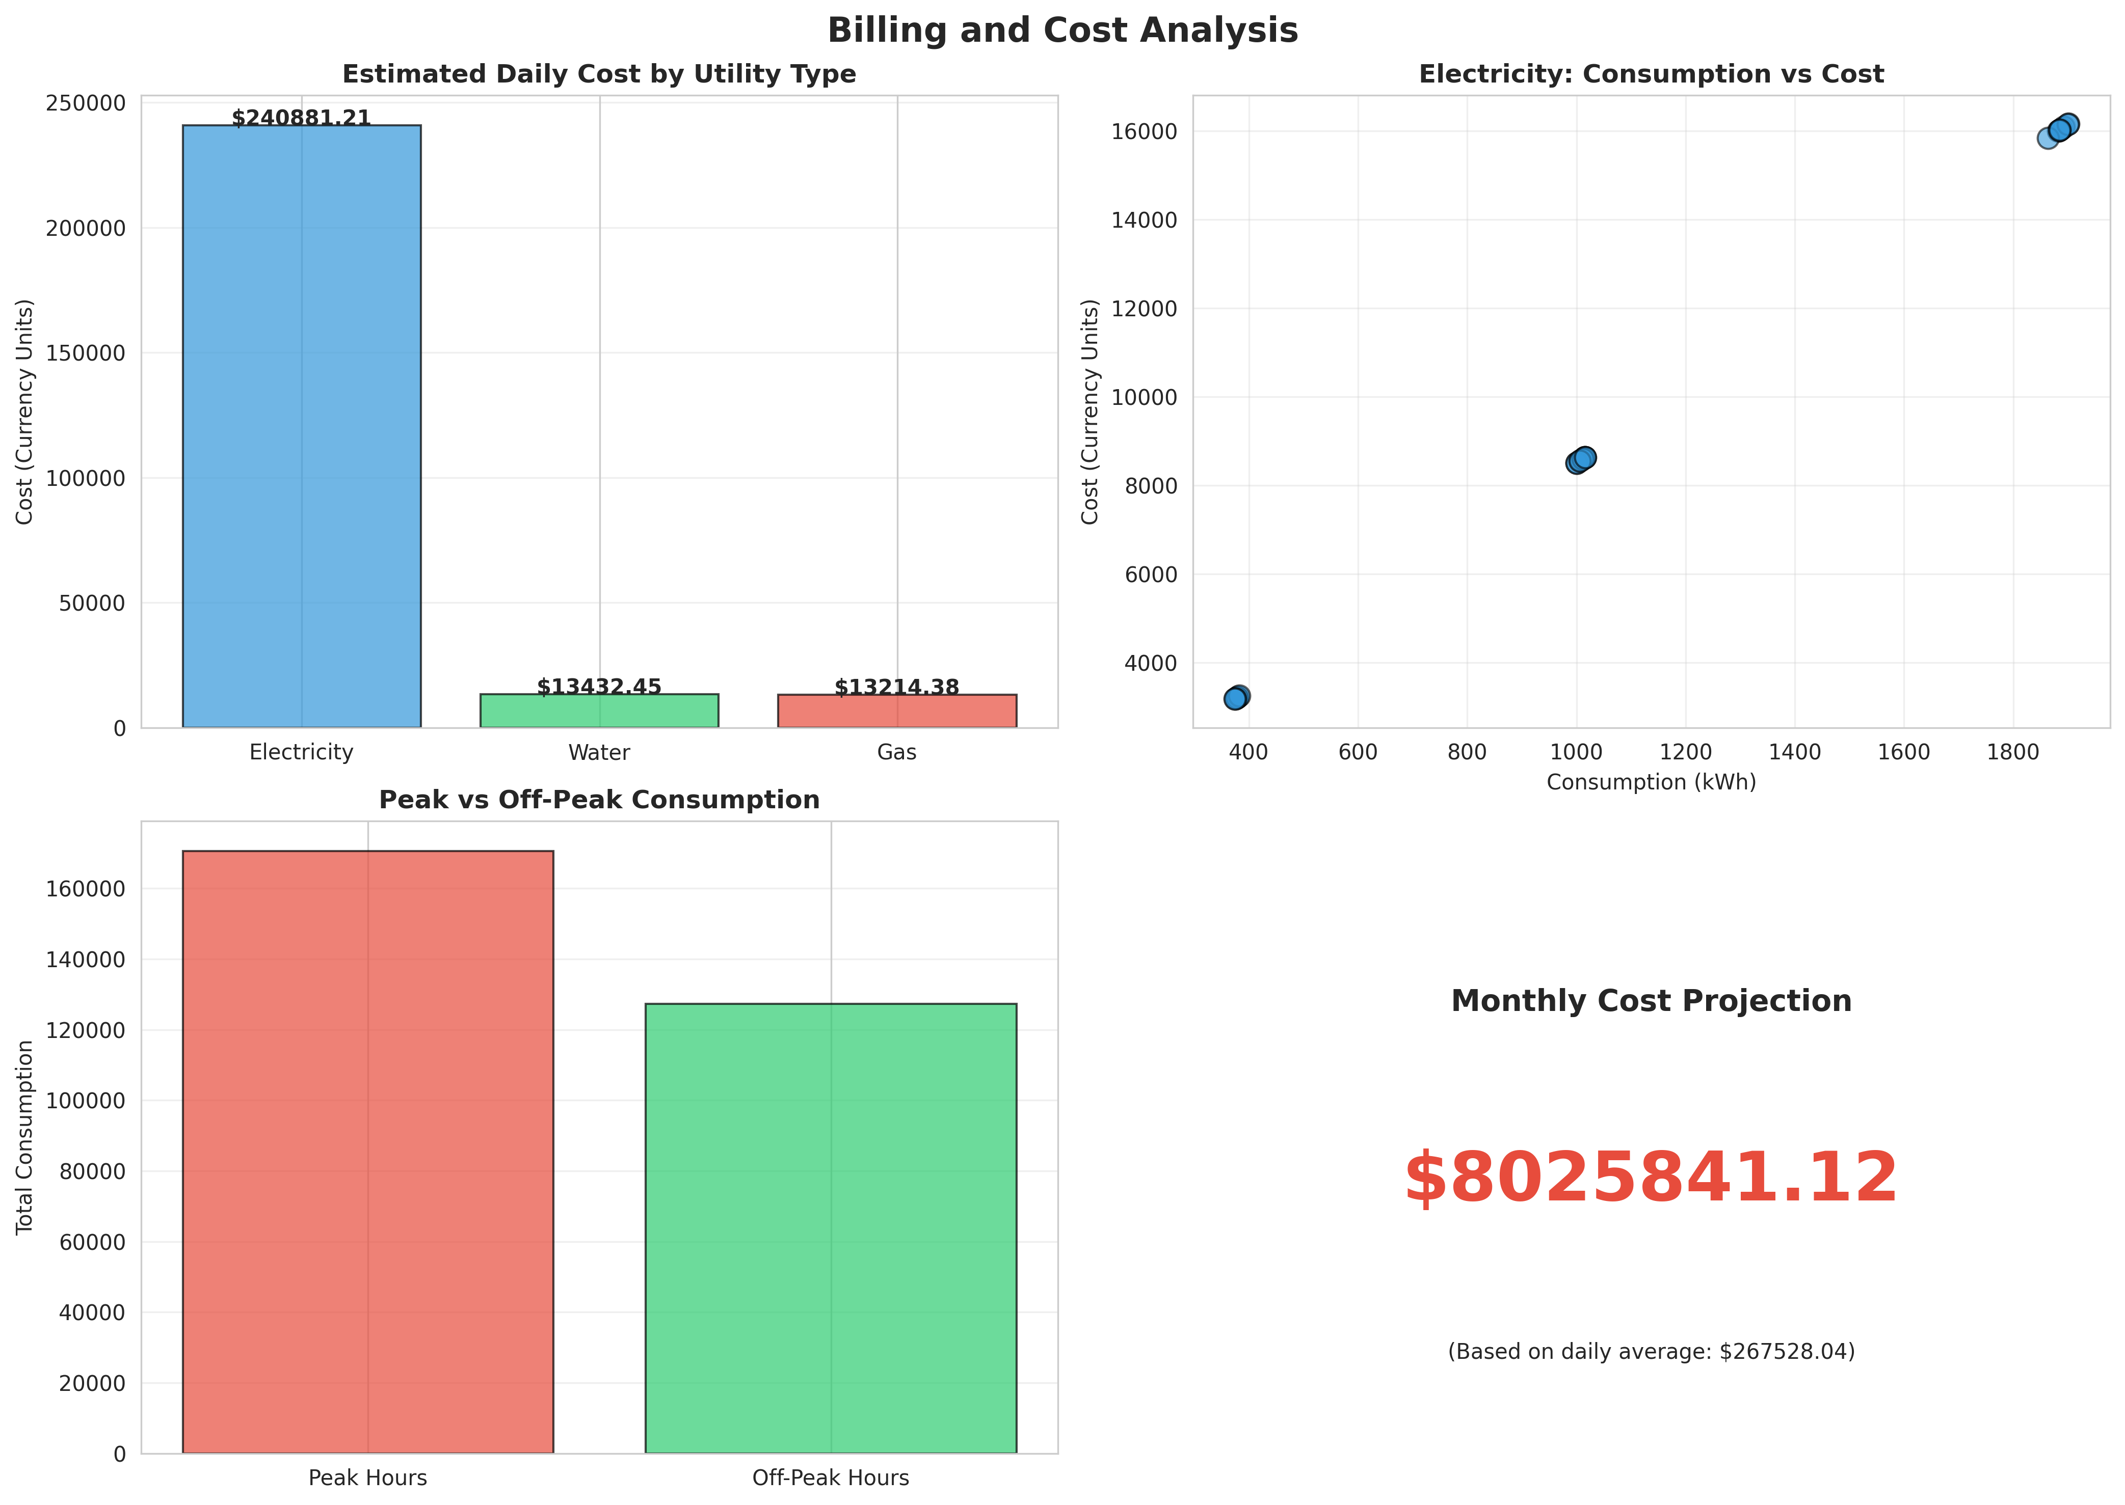
Figure 5: Automated Billing and Cost Analysis
Figure 5 illustrates the financial analytics capabilities of the system. It provides a breakdown of estimated daily costs by utility type, highlighting which resources contribute most to the overall expense. The scatter plot demonstrates the direct correlation between consumption volume and cost. Furthermore, the comparison between Peak and Off-Peak consumption provides consumers with actionable data; by shifting usage to off-peak hours, consumers can significantly reduce their bills under dynamic pricing models. Finally, the system successfully generated a reliable monthly cost projection based on the 7-day average, demonstrating its utility as a financial planning tool.

CHAPTER 7: CONCLUSION AND FUTURE SCOPE

7.1 Conclusion
The Smart Utility Meter Reading System developed during this internship successfully demonstrates the transformative potential of IoT in resource management. By automating the data collection process, the system entirely eliminates the inefficiencies, high costs, and inaccuracies associated with manual meter reading. The Python-based simulation proved highly effective in modeling realistic consumption patterns across electricity, water, and gas utilities.
The comprehensive analytics and visualization dashboards generated by the system provide deep insights into consumption behaviors, system health, and financial metrics. The ability to track usage in 15-minute intervals offers a level of granularity previously unavailable to most consumers and utility providers, empowering them to make data-driven decisions regarding resource optimization and grid management.

7.2 Outcomes Achieved
The project successfully met all its initial objectives:
- Developed a robust, scalable architecture capable of handling multi-modal utility data.
- Implemented realistic time-series data generation to simulate complex human consumption behaviors.
- Created advanced analytics modules for automated billing, cost projection, and peak/off-peak analysis.
- Generated professional, publication-quality visualizations to effectively communicate system metrics and consumption insights.

7.3 Future Enhancements
While the current system provides a strong foundation, several enhancements can be implemented in future iterations:
- Machine Learning Integration: Implement predictive models (such as ARIMA or LSTM) to forecast future consumption based on historical data and weather patterns.
- Hardware Deployment: Transition from software simulation to physical deployment using actual IoT microcontrollers (e.g., ESP32) and physical flow/current sensors.
- Dynamic Pricing Models: Integrate real-time tariff adjustments based on grid load to encourage off-peak usage.
- Mobile Application: Develop a dedicated cross-platform mobile app using React Native or Flutter to provide consumers with push notifications and on-the-go access to their dashboards.

CHAPTER 8: APPENDIX A - COMPLETE SOURCE CODE
The complete Python source code for the Smart Utility Meter Reading System is provided in the accompanying ZIP file (`Smart_Utility_Meter_Python_Code.zip`). The codebase includes the main simulation engine, analytics classes, and visualization functions.

CHAPTER 9: APPENDIX B - SIMULATION DATA SAMPLE
The following table presents a sample of the raw data generated during the 7-day simulation, demonstrating the granularity of the 15-minute interval readings.
Timestamp | Meter ID | Type | Reading | Delta | Status
2026-07-15 00:00 | METER-E-001 | electricity | 4.41 | 4.41 | operational
2026-07-15 00:00 | METER-W-001 | water | 32.03 | 32.03 | operational
2026-07-15 00:00 | METER-G-001 | gas | 0.35 | 0.35 | operational
2026-07-15 00:00 | METER-E-002 | electricity | 4.63 | 4.63 | operational
2026-07-15 00:00 | METER-W-002 | water | 8.03 | 8.03 | operational
2026-07-15 00:00 | METER-G-002 | gas | 0.33 | 0.33 | operational
2026-07-15 00:00 | METER-E-003 | electricity | 4.36 | 4.36 | operational
2026-07-15 00:00 | METER-W-003 | water | 21.17 | 21.17 | operational
2026-07-15 00:00 | METER-G-003 | gas | 0.34 | 0.34 | operational
2026-07-15 00:15 | METER-E-001 | electricity | 8.59 | 4.18 | operational
2026-07-15 00:15 | METER-W-001 | water | 71.54 | 39.51 | operational
2026-07-15 00:15 | METER-G-001 | gas | 0.71 | 0.36 | operational
2026-07-15 00:15 | METER-E-002 | electricity | 8.92 | 4.29 | operational
2026-07-15 00:15 | METER-W-002 | water | 34.14 | 26.11 | operational
2026-07-15 00:15 | METER-G-002 | gas | 0.70 | 0.37 | operational
2026-07-15 00:15 | METER-E-003 | electricity | 8.90 | 4.54 | operational
2026-07-15 00:15 | METER-W-003 | water | 25.51 | 4.34 | operational
2026-07-15 00:15 | METER-G-003 | gas | 0.70 | 0.35 | operational
2026-07-15 00:30 | METER-E-001 | electricity | 12.92 | 4.33 | operational
2026-07-15 00:30 | METER-W-001 | water | 88.59 | 17.05 | operational
2026-07-15 00:30 | METER-G-001 | gas | 1.05 | 0.34 | operational
2026-07-15 00:30 | METER-E-002 | electricity | 13.25 | 4.33 | operational
2026-07-15 00:30 | METER-W-002 | water | 60.49 | 26.36 | operational
2026-07-15 00:30 | METER-G-002 | gas | 1.01 | 0.32 | operational
2026-07-15 00:30 | METER-E-003 | electricity | 13.68 | 4.77 | operational

CHAPTER 10: APPENDIX C - EXTENDED LITERATURE REVIEW
The development of this system was informed by extensive research into current IoT standards and smart grid technologies.
[1] Internet of Things (IoT) in Smart Grid: A Comprehensive Review
This research highlights the critical role of IoT in modernizing power grids. It emphasizes that traditional grids are characterized by one-way communication, whereas smart grids utilize IoT for two-way communication, enabling real-time monitoring and control. The paper validates our architectural decision to use edge devices (smart meters) communicating with a centralized cloud for analytics.
[2] Advanced Metering Infrastructure (AMI) Protocols and Standards
AMI is the fundamental framework that enables smart metering. Literature review of AMI standards informed the design of our data payload structures, ensuring that the simulated data (including timestamps, consumption deltas, and meter health metrics) aligns with industry-standard protocols like DLMS/COSEM, which are crucial for interoperability in real-world deployments.
[3] Anomaly Detection in Time-Series Utility Data
Research into anomaly detection methodologies for utility consumption revealed that simple threshold-based alerts (as implemented in our initial simulation) are effective for gross anomalies (e.g., burst pipes). However, advanced literature suggests transitioning to machine learning models (like Isolation Forests) for detecting subtle, long-term anomalies like slow leaks or meter tampering, which is noted in our Future Enhancements section.

