Vijay Devops – Lab1

Configuring the amazon ec2 instance in aws.

Go to ec2 and launch instance

Select ubuntu server,64 bit and click on next

Click on next and next

Then configure key pairs

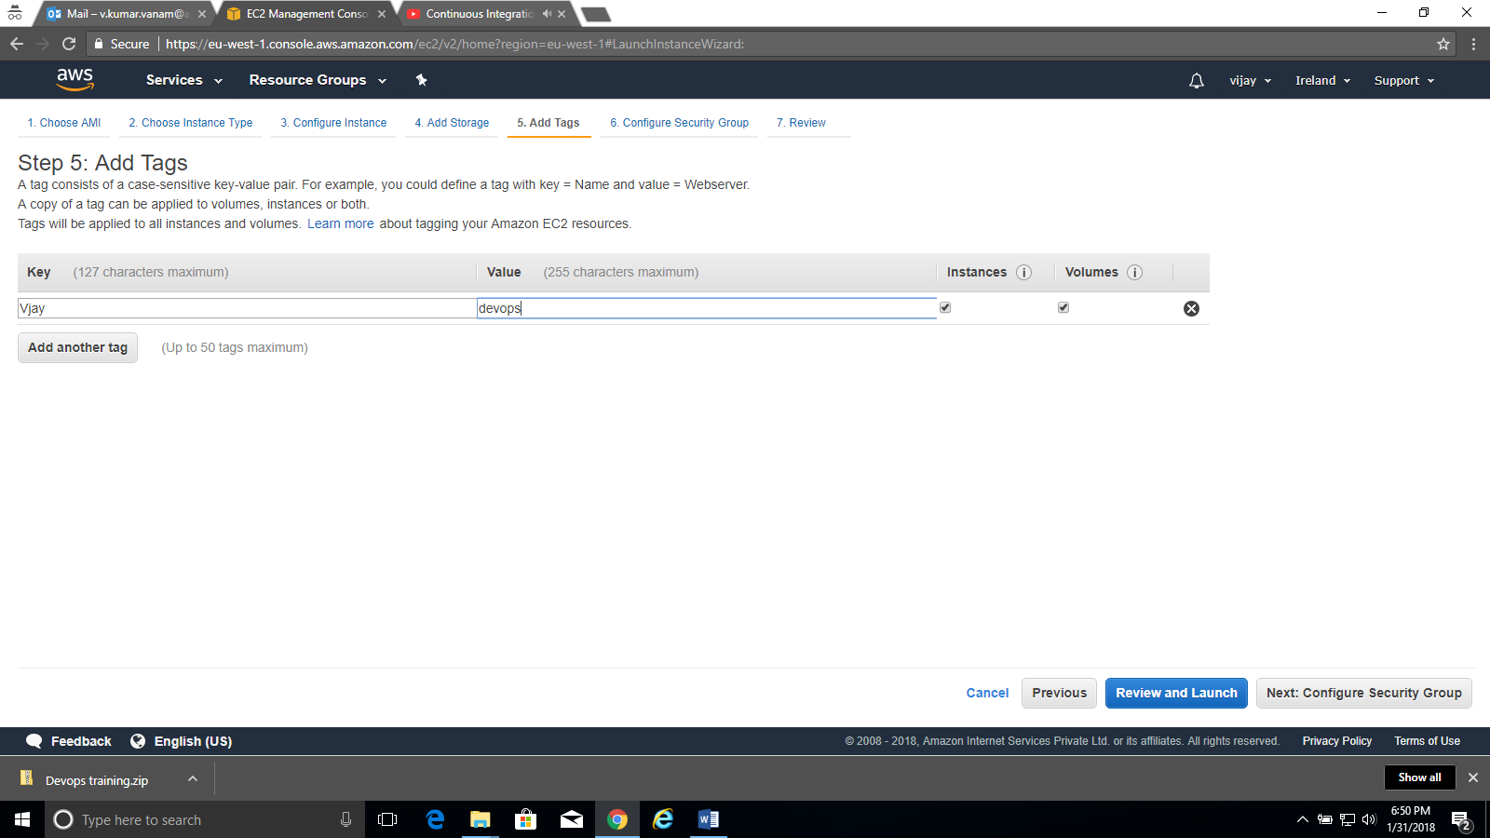

Next follow scrsnhot

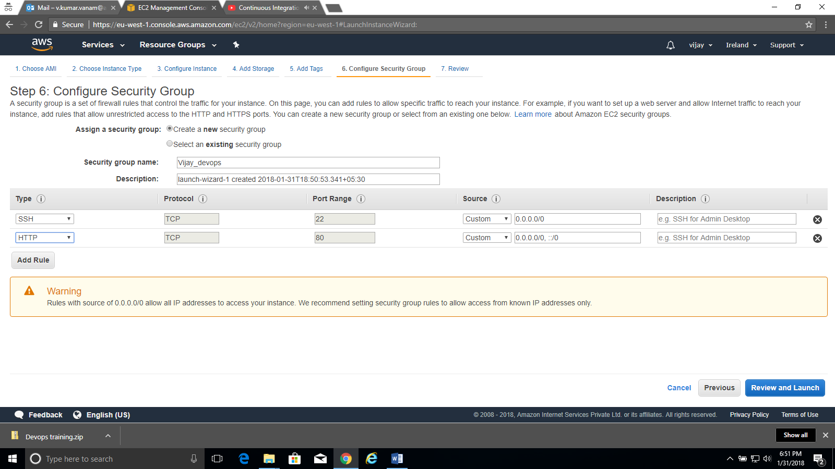

Passwords are not used in order t o login to ec2.

We use keypair t login into ec2. Download keypair.

Keep .pem file safely

Connecting amazon ec2 instance using putty in windows

Download putty and puttygen.exe files

Open puttygen.exe ( ist is exec fie)

Click on load and navigate to .pem file of ec2.

Click on all files and select .pem file to load into putty gen.

Click on save private key button and give the path to save .ppk file.

Copy public-ip of the ec2 instance, it looks like this in my case

**ec2-34-241-158-237.eu-west-1.compute.amazonaws.com**

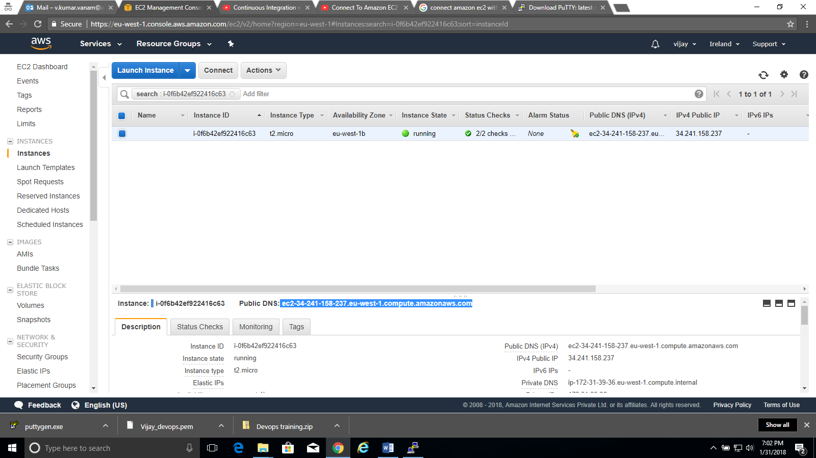

Go to putty and follow

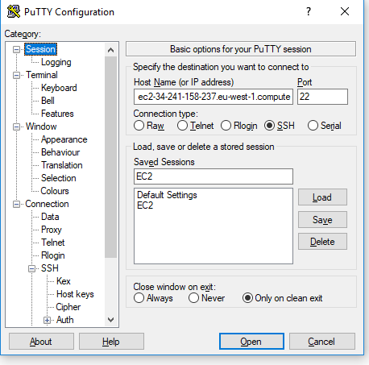

In data tab go to auto-login username : give as ubuntu.

Go to ssh auth

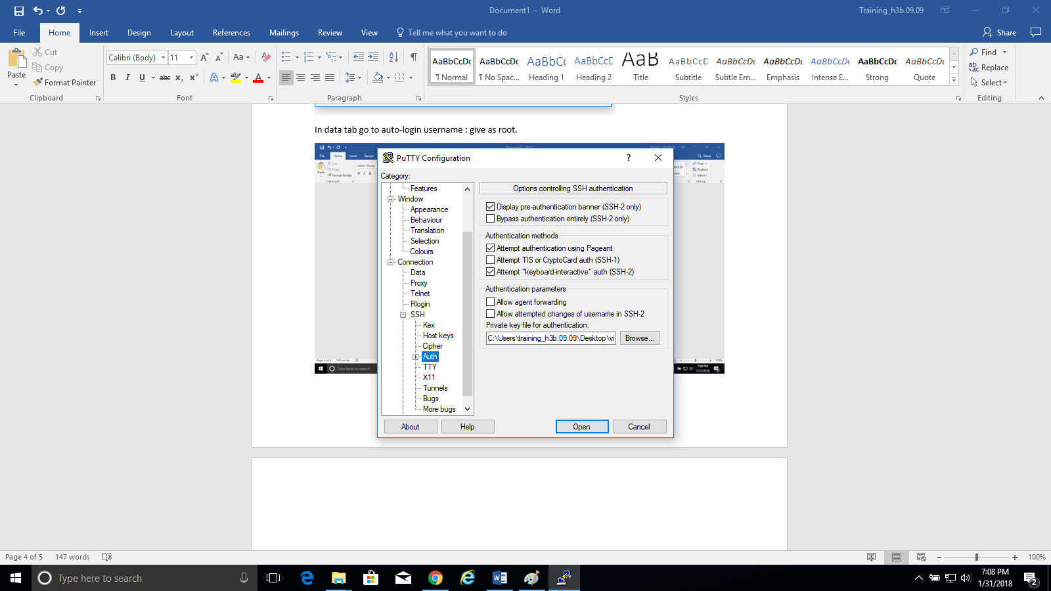

Click on open

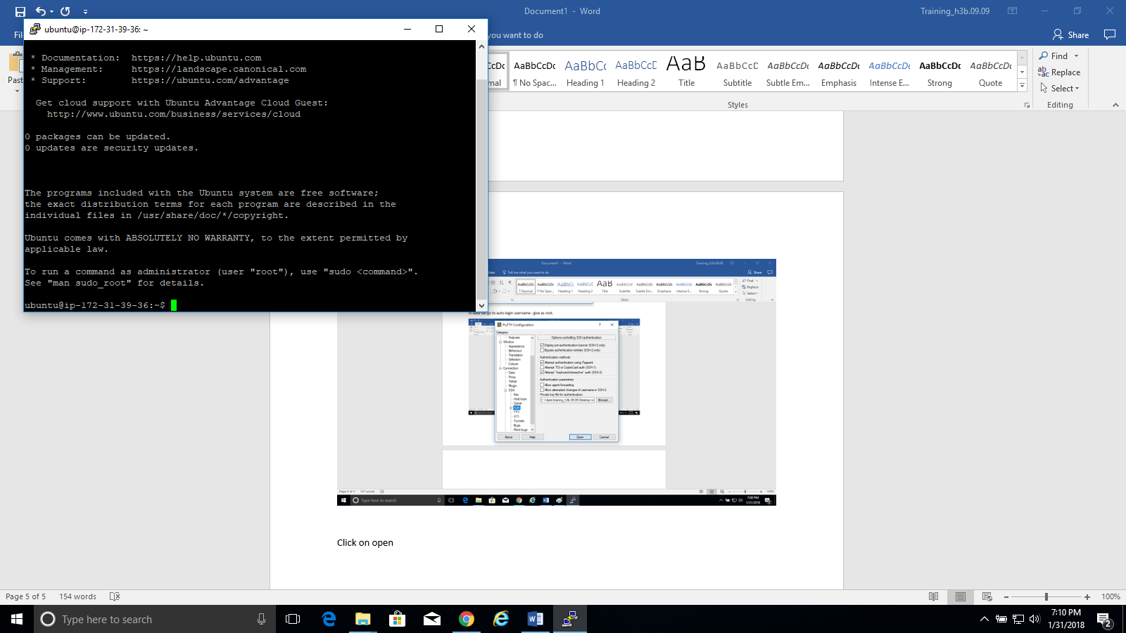

Click on save in the session tab in order to save the settings.

It it connected to the instance!!!!

Installing the req files and softwares

-------------------------

Follow the link for next steps

<https://gist.github.com/jsuwo/9038610>

**Fixing Locales in Ubuntu 13.04 on Amazon EC2**

sudo apt-get install language-pack-en

### Installing Jenkins

### Telling the following repo is trusted one.

wget -q -O - http://pkg.jenkins-ci.org/debian/jenkins-ci.org.key | sudo apt-key add -

echo "deb http://pkg.jenkins-ci.org/debian binary/" | sudo tee -a /etc/apt/sources.list.d/jenkins.list

Updatibg and nstalling Jenkins

----------------------------

sudo apt-get update

sudo apt-get install jenkins