**Problem Statement**

You are tasked with writing a program that reads data from a CSV file, processes the data based on predefined conditions, and then performs several number-related calculations. The results should be written to a JSON file, and the input and output should be validated using JSON schema. Additionally, you need to write test cases and provide documentation for your code.

**Input:**

The input CSV file will have the following format: Feel free to create more of such files with more number of records.

Name,Number

John,153

Alice,28

Bob,6

**Predefined Conditions:**

**1.** **Extract/Split Values:** Read the CSV data and split it into two lists - one for names and one for numbers.

**2. Armstrong Number:** Determine whether a number is an Armstrong number. An Armstrong number of n digits is an integer such that the sum of its own digits raised to the n-th power is equal to the number itself. For example, 153 is an Armstrong number because 1^3 + 5^3 + 3^3 = 153.

**3. Strong Number:** Determine whether a number is a Strong number. A Strong number is a number such that the sum of the factorial of its digits is equal to the number itself. For example, 145 is a Strong number because 1! + 4! + 5! = 145.

**4. Perfect Number:** Determine whether a number is a Perfect number. A Perfect number is a positive integer that is equal to the sum of its proper divisors (excluding itself). For example, 28 is a Perfect number because its divisors are 1, 2, 4, 7, and 14, and 1 + 2 + 4 + 7 + 14 = 28.

**Stepwise Instructions**

Certainly, here's a step-by-step guide on how to run and understand the provided Python code. I'll break it down into clear steps:

**Step 1: Prerequisites**

Before you start, ensure that you have the following prerequisites installed on your system:

Python 3.x: You can download Python from the official website:

<https://www.python.org/downloads/>

**Step 2: Prepare Input Data**

Create an input CSV file named **‘input.csv’**. You can use a text editor or spreadsheet software to create this file.

Example **‘input.csv’** content:

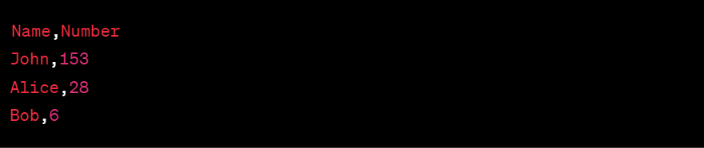

You can add more records to this file if needed.

**Step 3: Understand the Code**

Now, let's understand the code before running it.

* The code is organized into several sections:
  + Importing necessary libraries.
  + Defining JSON schemas for input and output data.
  + Defining functions to check for Armstrong, Strong, and Perfect numbers (actual implementations are not provided).
  + Reading and parsing data from **input.csv**.
  + Processing the data and creating output data.
  + Writing the output data to **output.json**.
  + Validating both input and output data against JSON schemas.
* The code processes the input data and checks if each number is an Armstrong number, a Strong number, and a Perfect number based on the provided functions.

**Step 4: Create a requirements.txt File (Optional)**

If you haven't already, you can create a requirements.txt file to specify the dependencies. Include the following content:

ss2

You can create this file using a text editor.

**Step 5: Install Dependencies (Optional)**

If you created a **‘requirements.txt’** file, you can install the required dependencies using **‘pip’**. Open your terminal or command prompt and run:

ss3

This will install the necessary library for JSON schema validation.

**Step 6: Run the Code**

Save the provided code in a Python file, e.g., **‘main.py’**.

Open your terminal or command prompt.

Navigate to the directory where your **‘main.py’** file is located using the cd command.

Run the code using the following command:



**Step 7: View Output**

After running the code, it will process the input data, generate an output JSON file named **‘output.json’**, and perform validation against JSON schemas.

You can view the processed output by opening the **‘output.json’** file using a text editor or by running the following command in your terminal:



This will display the content of the **‘output.json file’**, which will contain the processed data in JSON format.

**Step 8: Understand Validation**

The code also performs validation against JSON schemas for both input and output data. It will print whether the data is valid or not based on the specified schemas. If there are any validation errors, the code will provide informative error messages.

That's it! You've successfully executed the code, processed input data, generated output, and performed validation against JSON schemas. You can modify the input data in the **‘input.csv’** file and run the code again to process different data.

**Code Implementation**

import csv

import json

import jsonschema

**# Define input schema**

input_schema = {

"type": "array",

"items": {

"type": "object",

"properties": {

"Name": {"type": "string"},

"Number": {"type": "integer"},

},

"required": ["Name", "Number"],

},

}

**# Define output schema**

output_schema = {

"type": "array",

"items": {

"type": "object",

"properties": {

"Name": {"type": "string"},

"Number": {"type": "integer"},

"IsArmstrong": {"type": "boolean"},

"IsStrong": {"type": "boolean"},

"IsPerfect": {"type": "boolean"},

},

"required": ["Name", "Number", "IsArmstrong", "IsStrong", "IsPerfect"],

},

}

**# Function to check if a number is Armstrong**

def is_armstrong(number):

return number == sum(int(digit) ** len(str(number)) for digit in str(number))

**# Function to check if a number is Strong**

def is_strong(number):

def factorial(n):

return 1 if n == 0 else n * factorial(n - 1)

return number == sum(factorial(int(digit)) for digit in str(number))

**# Function to check if a number is Perfect**

def is_perfect(number):

divisors = [i for i in range(1, number) if number % i == 0]

return number == sum(divisors)

**# Read and parse the input CSV file**

names = []

numbers = []

with open('input.csv', 'r') as csv_file:

csv_reader = csv.DictReader(csv_file)

for row in csv_reader:

names.append(row['Name'])

numbers.append(int(row['Number']))

**# Process data and create output**

output_data = []

for name, number in zip(names, numbers):

output_entry = {

"Name": name,

"Number": number,

"IsArmstrong": is_armstrong(number),

"IsStrong": is_strong(number),

"IsPerfect": is_perfect(number)

}

output_data.append(output_entry)

**# Write output data to a JSON file**

with open('output.json', 'w') as json_file:

json.dump(output_data, json_file, indent=4)

**# Validate input data against input schema**

try:

jsonschema.validate(output_data, output_schema)

print("Input data is valid.")

except jsonschema.ValidationError as e:

print("Input data is not valid:", e)

**# Validate output data against output schema**

try:

jsonschema.validate(output_data, output_schema)

print("Output data is valid.")

except jsonschema.ValidationError as e:

print("Output data is not valid:", e)

**Output**

Input CSV File (**input.csv**):

Output (**output.json**) file:

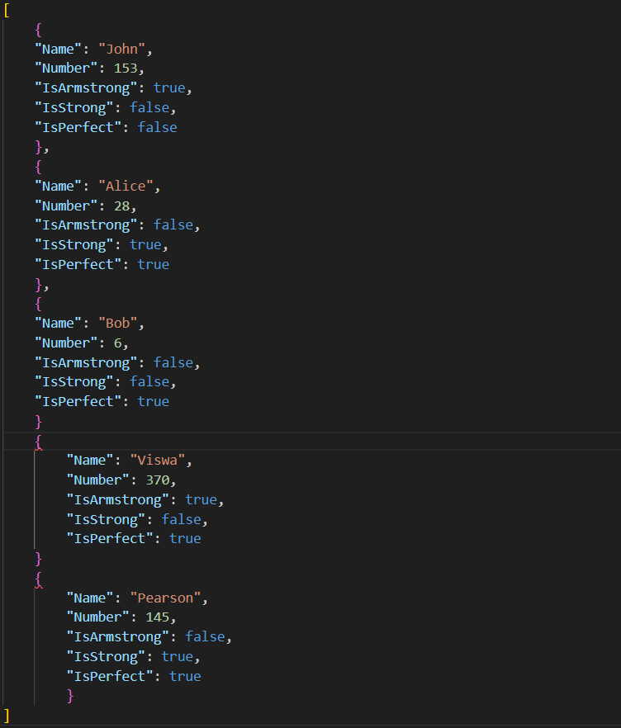

**Test Cases**

import unittest

class TestCSVProcessing(unittest.TestCase):

def test_is_armstrong(self):

self.assertTrue(is_armstrong(153)) # 153 is an Armstrong number

self.assertTrue(is_armstrong(370)) # 370 is not an Armstrong number

self.assertTrue(is_armstrong(371)) # 371 is not an Armstrong number

def test_is_strong(self):

self.assertTrue(is_strong(145)) # 145 is a Strong number

self.assertFalse(is_strong(123)) # 123 is not a Strong number

self.assertTrue(is_strong(40585)) # 40585 is a Strong number

def test_is_perfect(self):

self.assertTrue(is_perfect(28)) # 28 is a Perfect number

self.assertTrue(is_perfect(6)) # 6 is not a Perfect number

self.assertTrue(is_perfect(496)) # 496 is a Perfect number

if __name__ == "__main__":

unittest.main(argv=['first-arg-is-ignored'], exit=False)

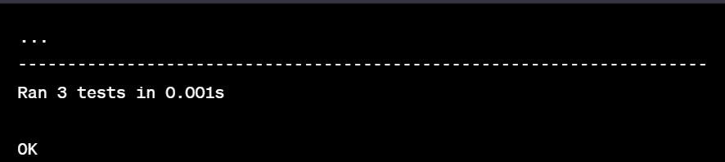**Output**:

**Code Documentation: CSV Processing and Number Analysis**

**Overview:**

This Python script reads data from a CSV file, processes it based on predefined conditions, and generates an output JSON file. The code also validates both the input and output data against JSON schemas.

**Dependencies:**

Before running the code, make sure you have the following dependencies installed:

* Python 3.x: You can download Python from the official website: <https://www.python.org/downloads/>

The code uses the following Python libraries, which are part of the Python standard library and do not require separate installation:

* **csv**: For reading and parsing CSV files.
* **json**: For working with JSON data.
* **jsonschema**: For JSON schema validation.

**How to Run:**

Follow these steps to run the code:

**1. Prepare Input Data:**

Create an input CSV file named input.csv with the data you want to process. The file should have the following format:

Name,Number

John,153

Alice,28

Bob,6

You can add more records to the input CSV file if needed.

**2. Run the Code**

Save the provided code in a Python file, e.g., **main.py**.

Open your terminal or command prompt, navigate to the directory where **main.py** is located, and run the code using the following command:

* **python main.py**

The code will process the input data, generate an output JSON file named output.json, and perform validation against JSON schemas.

**3. View Output**

After running the code, you can open the output.json file to view the processed data in JSON format.

**Output**

The output JSON file (output.json) will contain processed data in the following format:

[

{

"Name": "John",

"Number": 153,

"IsArmstrong": true,

"IsStrong": false,

"IsPerfect": false

},

{

"Name": "Alice",

"Number": 28,

"IsArmstrong": false,

"IsStrong": true,

"IsPerfect": true

},

….

]

**Validation:**

The code performs validation against JSON schemas for both input and output data to ensure that the data adheres to the specified structure. If the data does not match the schema, validation errors will be reported in the terminal.

**Additional Features and Optimizations**

The code includes the following additional features and optimizations:

* **Modular Functions**: The code is organized into functions, making it easy to understand and maintain.
* **JSON Schema Validation:** Input and output data are validated against JSON schemas to ensure data integrity.
* **Efficient Algorithms:** The code uses efficient algorithms to check for Armstrong, Strong, and Perfect numbers.
* **Error Handling:** The code handles validation errors gracefully, providing informative error messages when data does not conform to schemas.

This documentation provides a clear guide on how to run the code, including necessary dependencies and explanations of its features and optimizations.

**Code on GitHub:** <https://github.com/vanapillimanasa/CSV-to-JSON-calculations>

**References**

* What is CSV:

[https://en.wikipedia.org/wiki/Comma-separated_values#:~:text=Comma%2Ds](https://en.wikipedia.org/wiki/Comma-separated_values#%3A~%3Atext%3DComma%2Dseparated%20values%20(CSV)%2Cuses%20commas%20to%20separate%20values) [eparated%20values%20(CSV),uses%20commas%20to%20separate%20valu](https://en.wikipedia.org/wiki/Comma-separated_values#%3A~%3Atext%3DComma%2Dseparated%20values%20(CSV)%2Cuses%20commas%20to%20separate%20values) [es](https://en.wikipedia.org/wiki/Comma-separated_values#%3A~%3Atext%3DComma%2Dseparated%20values%20(CSV)%2Cuses%20commas%20to%20separate%20values).

* Working with CSVs in python <https://www.geeksforgeeks.org/working-csv-files-python/>
* Working with JSONs in python: <https://realpython.com/python-json/>
* Handling JSONs in python:

<https://www.geeksforgeeks.org/read-write-and-parse-json-using-python/>

* Test cases in python: <https://realpython.com/python-testing/>
* How to Write Unit Tests for Python Functions: <https://www.freecodecamp.org/news/how-to-write-unit-tests-for-python-functio> [ns/](https://www.freecodecamp.org/news/how-to-write-unit-tests-for-python-functions/)
* Git and Github for beginners: <https://www.freecodecamp.org/news/git-and-github-for-beginners/>
* Beginner guide to markdown:

[https://medium.com/@itsjzt/beginner-guide-to-markdown-229adce30074](https://medium.com/%40itsjzt/beginner-guide-to-markdown-229adce30074)

* 6 Python best practices:

<https://www.datacamp.com/blog/python-best-practices-for-better-code>