SSN COLLEGE OF ENGINEERING, KALAVAKKAM
DEPARTMENT OF COMPUTER SCIENCE & ENGINEERING
Compiler Lab – UCS 1602
Programming Assignment-2 - Implementation of Lexical Analyzer for the patterns using Lex
(identifier, comments, operators, constants)

Develop a Lexical analyzer to recognize the patterns namely, identifiers, constants, comments and operators using the following regular expressions. Construct symbol table for the identifiers with the following information.

Symbol Table
Identifier | Data Type | Initial Value
a | int | 0
b | char | ‘y’

Regular Expression for Identifier  letter → [a-zA-Z]  digit → [0-9]  id→letter(letter|digit)* | Regular Expression for Constant  digit → [0-9]  digits →digit digits  optFrac →.digits  optExp → E(+|-|ϵ) digits  numberconst →digits optFrac optExp  charconst → ‘(letter)’  stringconst → “(letter)*”  constant → numberconst | charconst |stringconst
Regular Expression for Comments  start1→ \*  end1 → */  multi → start (letter)* end  start2 → //  single → start (letter)* | Regular Expression for Operators  relop → < | <= | == | != | > | >=  arithop → + | - | * | / | %  logicalop → && | || | !  operator → relop | arithop | logicalop
Regular Expression for keywords
int → int
float → float
char → char
double → double
..
..
keywords → int|float|char|double|…..

Convert the regular expressions into cumulative transition diagram as shown in Figure 1. Each state represents a condition that could occur during the process of scanning the input looking for a lexeme that matches one of the several patterns. Convert each state into a piece of code.
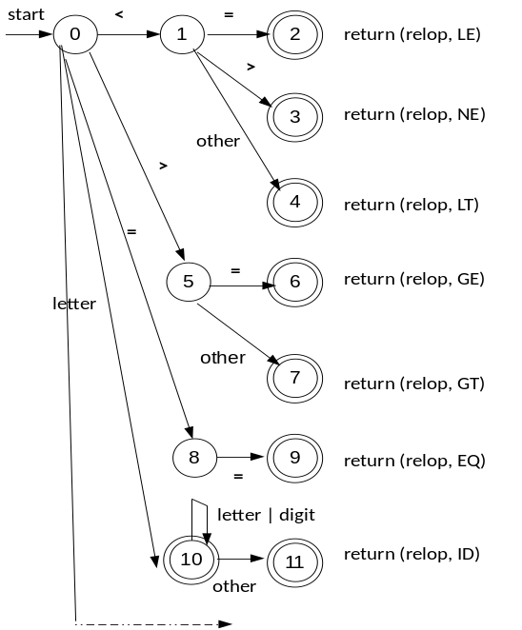

Figure 1. Cumulative Transition diagram

Develop a scanner that will recognize all the above specified tokens. Test your program for all specified tokens. Example input and output specification is given below.

EXAMPLE INPUT SOURCE PROGRAM
main()
{
int a=10,b=20;
if(a>b)
printf(“a is greater”);
else
printf(“b is greater”);
}

OUTPUT
FC
SP
KW ID ASSIGN NUMCONST SP ID ASSIGN NUMCONST SP
KW SP ID RELOP SP
FC
KW
FC
SP

