**Import and set data to SAS enterprise miner**

1. Create diagram

2. Sample > File import

3. Drag to diagram

4. 

Choose import file.

5. Run

6. Check result columns

7. Close results

8. File import(right-button) > edit variables. After that utility> save data and add node to our dataset.

**Create Model for Data**

9. Set Role and Level (check ur level in excel via this pic)

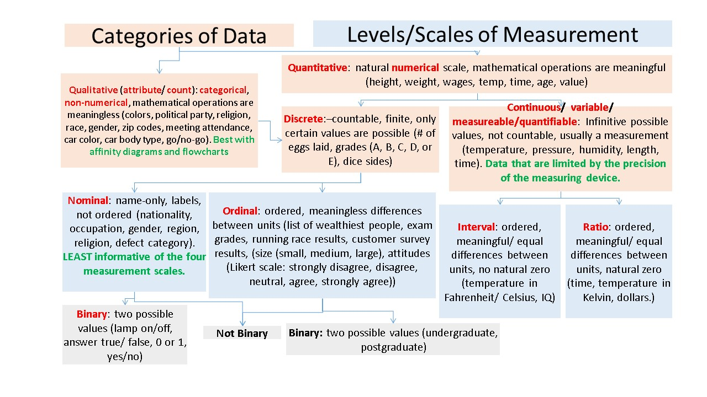

10. Modify > replacement. Work with missing values.

11. Sample > data partition. Separate data to train, validate and test.

12. Modify > impute. Set settings as u like

13. Model > regression. Set logistic regression, function logic.

14. Set selection model:

Backward – from all variables to 1. This choose best model with this way.

Forward – from 1 to all.

Stepwise – forward and backward together.

Choose selection model.

15. Run > result > view > model > iteration plot.

16. Check all of parameters. Choose best parameter which contain error on validation less than train (test set < validation set < train set). Use different target values in dataset for good graph.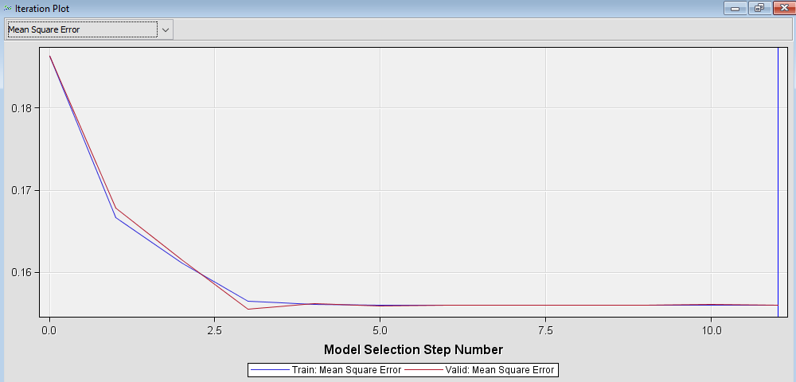

Pic 1. After 3rd variable dataset become worse

17. Choose selection criterion after that for creating a model.

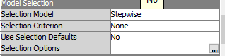

18. Check fit statistic, output window, research it.

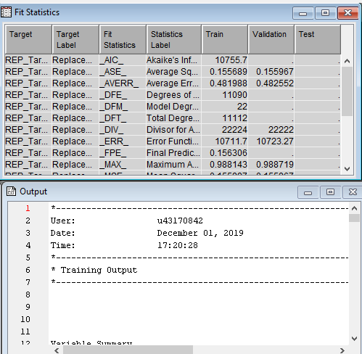

19. Also u can use 18 step before 10-18 steps. Maybe some steps u shouldn’t use coz maybe u haven’t missing values or something else

20. Assess > model comparison. Use to compare different types of algorithms.

21. IDK. NEED TODO: what is it?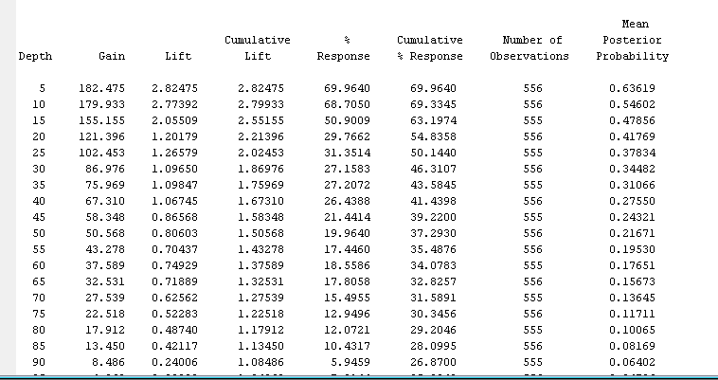

What is chi square and pr>chisqr

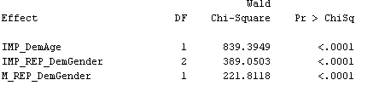

WHEN TO USE TRANSFORM VARIABLES?

How to choose target?

**ORGANICS**



In regression use square error and stepwise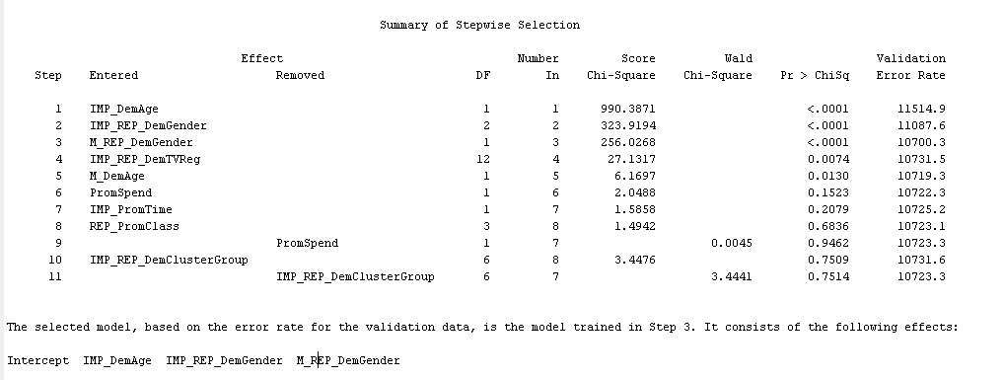

**WEB**

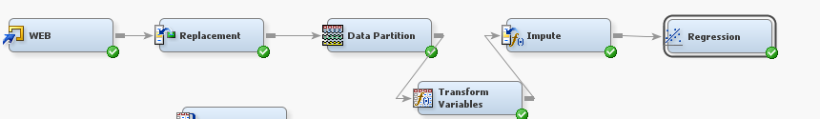

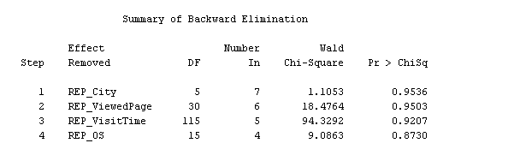

**Delete from all columns and add it to python.**

In regression use backwards and none in criterion.

TODO: set polinom in sas. Check how many variables should be in model. Compare logistic and polinom in sas and python.