The effect of response options on categorical perception and categorization beyond the binary ( provisional title)

Social categories may feel like both essential and natural part of the world, and are often treated as such by social psychologists, but scholars within a social constructivist framework have argued that they arise out of discourse, and are subject to continued construction and reconstruction (Focault, Butler). Because discourse is all-encompassing, efforts by scholars to measure and quantify these phenomena unavoidably reproduce these categories to some extent. This is especially true for sex/gender, which is already a highly contested social category. It is possible to present gender as being a binary consisting of just the categories of women and men, which is the dominant view in society, or to present gender as being more open, which is a counter-narrative being pushed by LGBTQ people and activists. In this study, we aimed to investigate how gender categorisation questions which more or less strongly imply that gender is binary impact binary perception of gender.

The pre-eminent importance of sex-gender is undeniable, but one example of is the tradition of reporting it in every journal article (Ref apa guidelines). Traditionally, the terms sex and gender have been used to distinguish between the characteristics of bodies and social category (ref). However, to avoid the implication that sex is something “real” and gender is a “mere” social construct, we use the term sex/gender to convey our position that the division of bodies into two specific types is also a social construct. Although there is a current convention to treat sex/gender as a simple binary consisting of women and men only this construction of sex is both ahistorical and excludes a large number of people with ambiguous bodies or who identify with gender categories outside this binary. We call this gender diversity.

Given the plentiful discourse posing gender diversity as a new and fringe phenomenon, it is tempting to view the status quo practice of measuring gender as a binary as neutral and more inclusive measurement as political. A number of arguments have been made against this position. One argument is that the binary view of gender is inaccurate. By showing the breadth of sex/gender, it is in fact easy to point how binary gender measurements fail to include a potentially large group of people and in so doing miss a large source of variation (see Westbrook & Saperstein, 2015; Lindqvist et al., 2019). Our position is that both viewpoints are political, and rather than litigating what is real and what is not real, what is interesting is how measurment itself cannot be neutral. Moreover, if measurments are not neutral, then how do they themselves shape the behaviour of the participants.

It seems like gender is a particular area where changing the outcome measure can drastically impact what comes out. Many researchers have found that when sex/gender is measured in a way that does does not suggest that gender is a binary category, the results often indeed suggest that it is not. For example, Bem (1974) constructed scales to measure femininity and masculinity as separate personality trajts. She found that many people had a mixture of feminine and masculine traits. Joel and colleagues (2014) introduced the concept of fluidity in the measurement of gender identity by allowing participants to indicate whether they sometimes experienced themselves as a different gender than **normal**. Their results also showed that many people did experience gender as less than a strict binary. Saperstein and Westbrook identified that researchers often conflate sex and gender, and later suggested several alternatives.

Furthermore, gender binaries can be created or enhanced through statistical practices. For example, Hyde and colleagues (2018) concluded that the statistical practice of examining mean differences between women and men exaggerates the difference and downplay gender similarities (Hyde et al., 2005). Hester and colleagues (2020), showed both that perceived differences between the faces of men and women were pronounced when only means were examined, and when gender was measured as consisting of a single dimension with femininity and masculinity at opposing ends. These studies show that when experiments are constructed to take diversity of gender into account, the results often reveal a diversity of gender. This primarily suggests that studies which only measure binary gender are unnecessarily and artificially restrictive.

This may be the case in social categorization research, This literature participants are forced to choose between the categories “woman” and “man” (or “male” and “female”) (see for example, Cloutier et al., 2005; Campanella et al., 2001; Webster et al., 2004; Zhao & Bentin, 2008). A slightly different task asks participants to rate the faces on gender as a quality, rather than a category, often with “feminine” and “masculine” as endpoints on a single scale.(e.g. D’Ascenzo et al., 2015; others). Overall, despite some variations, this is a literature where gender is frequently conflated with sex and assumed to be a binary.

When gender is measured as only the categories “woman” and “man” the implication may be that gender/sex consists of two discrete mutually exclusive categories (ref). When gender is measured on a continuum with femininity and masculinity as mutually exclusive polar opposites, it still reproduced femininity and masculinity as opposites, but suggests that degrees are possible. Additionally, there is a certain conceptual ambiguity around the terms femininity and masculinity, where they are conflated with the properties of women and men, even though there is evidence that these terms are applied differently to women and men (Hester et al., 2020).

However, creating alternative methods presents a challenge in and of itself. Using categories, presents a challenge because the very act of presenting participants with a set number of categories in itself suggests that those categories are discrete and mutually exclusive. Allowing participants to use more than one category is to overcome that….

Using a single gender dimensions of masc fem … is even more restricting as it cannot be expanded on allowing reponses of combination.

Using two diemnsions of femininity (One way forward is to draw inspiration from Bem’s (1993) work and measure gender as two separate dimensions, masculinity and femininity. This has the advantage of not suggesting that the two qualities are opposite and mutually exclusive. Howeer, gender is construd by fem and masculinity concepts. What are contained in these?

In the present study, I will elaborate on other options. For example

to supplement the traditional binary response categories with additional alternatives and the option to refrain from categorizing altogether. Indeed, when participants were given these options, many opted into them, suggesting that the standard categorization paradigm is unnecessarily restrictive (van Berlekom et al., in preparation). Such expanded categorization paradigm does not present gender as binary, but, it still implies that gender categories are discrete and determinable. A third possibility is to include one gender category (eg. “woman”) as contrasted with an option to refrain from categorizing altogether or as an alternative gender category (e.g. “not woman”). Great care needs to be taken into the formulation of the specific alternative categories, to consider which ideas of gender are being communicated.

One difficulty with examining how response options influence gender categorization is the risk of conflating the independent variable with the dependent variables. For example, A categorization task with alternatives woman/man/I don’t know cannot be compared to one with woman/man as options (why?). A solution can be in two main ways: the number of alternatives must be the same across the comparison and the faces and the main outcome variable can be defined as categorical perception.

**Overview of the present research**

I propose two studies.

Study 1 is descriptive and investigates categorical perception using a number of outcome measures. Participants are shown a face and asked to categorize it in terms of gender. A number of different types of response options will be given. The faces are morphs from 0% to 100% woman.

**General method**

*Overview*

*Stimuli*

Faces were produced using faces from the London Face Database (deBruine) and the Chicago Face Database (ref) morphed with on Webmorph (ref). For Black, Asian and White faces, the six most feminine faces of women and the six most masculine faces of men were selected, using the codebook provided by the researchers. The faces were matched, so that the most feminine face were morphed with the most masculine face and so on.

*Procedure*

**Experiment 1**

*Participants & design*

Participants (n = 120) were speakers recruited through advertising online and on the university campus (*M*age= 36.67, *SD*age = 12.54).All participants were informed that participation was voluntary. In term of gender X women and Y men participated The participants were randomly allocated to conditions.

*Design*

The main manipulated variable will be the scale used to measure for gender categorization/rating of faces. The following response options will be used (with a justification given for each).

- Woman/Man. These are the typical response options when measuring gender categorization

-“Woman – man” on the same sliding scale.

- Femininity and masculinity on separate scales.

- Woman/Man/Other/I don’t know

- Free text response

*Data analysis*

**Results**

The distribution of results of categorizations are presented in figure 1. Although there were slight differences in

How many made beyond-binary categorizations in the FT & MC conditions?

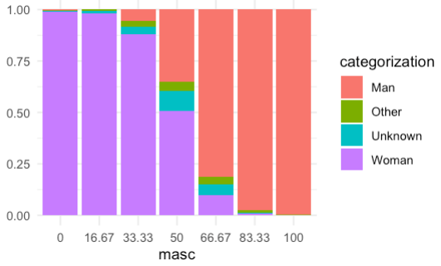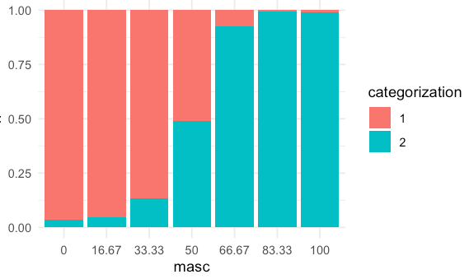

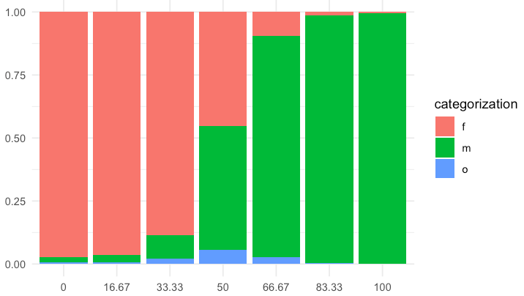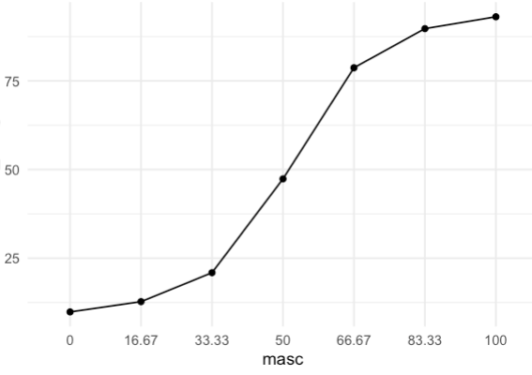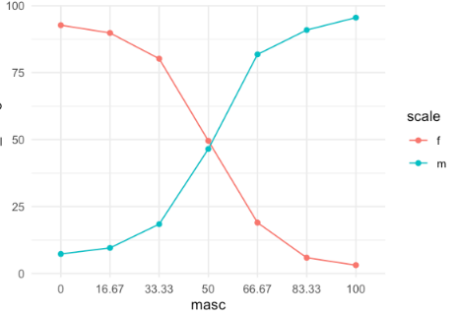

**Discussion**

A few takeaways from the results:

- There was evidence for categorial perception in all conditions.

- More participants made beyond-binary categorizations in the mc condition than the FT condition

- The pattern of results in the SD and MD were fairly similar and the curves for woman and men were mirrors of each other

- overall the binary bias is fairly strong

- There was a pretty clear pattern of categorical perception in all

- We still recommend using more inclusive scales, such as allowing for multiple categories

**Snips**

I suggest a modification of Campanella et al’s categorization study with the important independent variable being be measurment type. Either binary woman/man or multiple options, including “I don’t know” and non-binary, although there could be room for others as well. Campanella et al. Found perception to be categorical, which meant that faces were classified as women more often than the percentage of dimorphic “femininity” would suggest. This is illustrated using the red lines in figure 1. If binary measurment is causing participants to exaggerate perceived gender differences, we might expect the pattern of result to be similar to the blue line in figure 1. In other words, a 70% man morph would be categorized as “woman” 100% of the time.

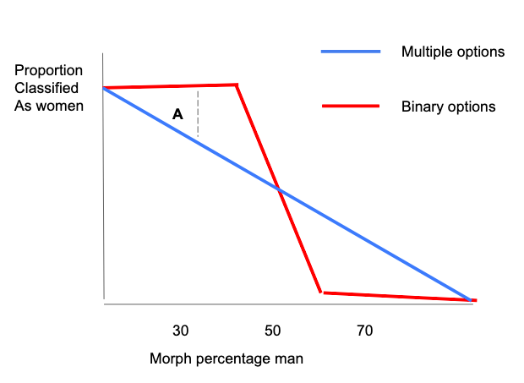

Figure 1. Hypothetical pattern of results from a categorization study comparing binary response options to multiple options. Dotted lines **A** epresent my suggestion for the main difference between the two conditions.

**Analyses & comparisons**

This presents a potentially difficult testing situation. There are a potential number of degrees of freedom. Which type of categorization should be compared? Which faces faces? I suggest a number of simplifications. First, I suggest limiting the analyses to one categorization, for example “women” categorizations.

Second, I see at least two ways to test the effect. One is illustrated by the dotted line **A** in Figure 1, simply comparing the number of 70/30 faces categorized as women when participants use binary or multiple response options. In this case, the relevant comparison would be of 70/30 faces only and other morph values may be included as within-subjects factors, but would only tested as negative controls because I would not expect there to an effect of response option at 50/50 faces or 100/0 faces. This would be quite simple. However, a possible concern is that the two conditions are so different that a direct comparison does not make sense.

Another option is illustrated in Figure 2 and would attempt to produce a measure which is more directly comparable. This option would require at least two morph types 70/30 and 50/50 as a within-subjects factor. The dotted lines B and C in figure 2 represent the average difference between 70/30 faces and 50/50 faces for participants responding using binary options (B) and multiple options (C). The relevant comparison would then be between the lines B and C. Comparing the difference scores would add a layer of complexity to the study. On the other hand, difference scores are arguably more comparable than the raw scores.

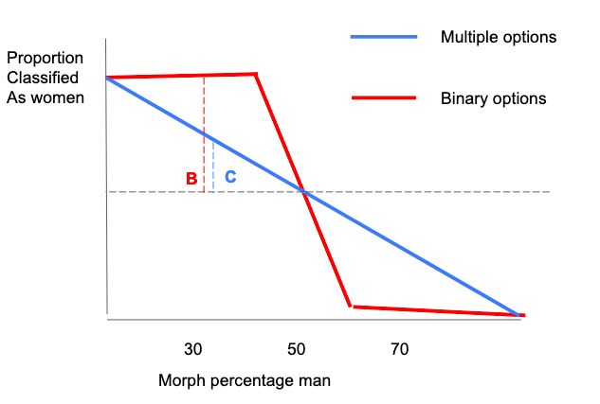

Figure 1. Hypothetical pattern of results from a categorization study comparing binary response options to multiple options. The Dotted lines **B** and **C r**epresent the hypothesized difference between 50/50 faces and 30/70 faces in each condition. The lines are meant to represent the same point on the X axis, but are kept slightly apart for illustrative purposes only.

**An alternative way to go**

I had another thought for a slightly different way to go as well. This idea is not clearly developed, but I’ll sketch it out very briefly. Basically, the thought is to investigate how measurement type (binary/multiple) affects which pronouns people use to describe a face. Here I’m imagining first you complete a categorization task similar to what we had in Study 1 and then people are either asked to describe the face or asked outright which pronoun they would use to describe that face. This gets at some conversations we’ve had earlier, pronouns are not labels, but they are indicative of categorization. In previous versions of the manuscript, we’ve talked about how misgendering is the real problem, not necessarily miscateorization, and what would be be best for most people would be if everyone avoided categorizing others, specifically verbally. Basically, someone can make an automatic categorization of someone else as “woman” but then have the second thought that gender is not visible from the face and use gender-neutral pronouns. I’m not sure if this is the best idea for the current study, but this sort of task could be a good continuation of study 1 in any case, with a measure that is closer to the relevant real-world behavior that we are interested in.

However, many of queer theories are compatible with psychology, and often the results show that the ways people categorize others are “queer” (Thorne & Hegarty, 2019).

Something about how experimenters bring their own assumptions about gender into studies. How

do psychologists talk about and treat gender categoreis? Well, very clearly as a binary, but also as a “natural” “essential” category. An important caveat to this research is that the binary nature of gender is almost invariably taken for granted in this research. Furthermore, gender is assumed by researchers to be an important organizing principle. For example,

Another challenge to this perspective is to point to the lived experiences of LGBTQ+ people. The existence of people who are Transgender and Gender Non-conforming (TGNC) suggests that the binary only studies are overly simplistic. Importantly, the queer experience is not defined by additional identities that function in a similar way to woman and man, but a multiplicity of flexible and fluid categories which may or may not be mutually exclusive to each other.

Much of the early work in this field evoked categories in a fairly simplistic way, by just writing out the category. This allowed that literature to examine ideas connected to social categories. Lately, we’ve started looking at faces too. The thing with faces is, they’re less digital, which more generally raises the question of what kind of categories are made. Furthermore, a face can be identified as belonging to a woman or a man, or it can be viewed as more or less feminine.

A big topic within this field is the degree to which gender categories are applied automatically. categorization. For gender specifically, there is some evidence from this body of work that categories are automatically activated. Researches in this tradition have identified gender as a particularly prominent characteristic and category, to the extent that people effortlessly judge gender from faces and automatically categorize others according to gender. Electroencephalographic (EEG) research has shown differential neural responses to feminine and masculine faces at 170 ms, leading to the common conclusion that people categorize gender within milliseconds of seeing a face (Freeman & Johnson, 2016; Kloth et al., 2010). Evidence for the automaticity of gender categorization comes from work showing that humans categorize gender even when not instructed to do so, (refs).

From this perspective, it also becomes quite clear that the literature of perception and categorization of gender makes a lot of assumptions based in the heterosexual matrix. Within this matrix is the idea that women and men are two distinct categories of people, with equally distinct appearances, and distinct facial features. In this system, faces are dimorphic and facial gender is defined as a single dimension with femininity on one end and masculinity at the other. According to this system, maleness, masculinity, and masculine facial features are all equally linked and femaleness, femininity, and feminine facial features are the opposite. The language used in studies supports this casual conflation of concepts.

I have a lot of underdeveloped ideas about measurment in general. I’m not even sure it will make it’s way into the final paper, but my thinking here is influenced by queer theory and feminist criticisms of science such as Haraway and Harding. One of the central ideas of queer theory is a rejection of the idea of categories. From a queer perspective, it becomes clear that the existence and importance of categories is routinely taken for granted by social psychology. Asking participants to categorize a face on the basis of two gender categories singled out by the researchers, from this perspective, constitutes not just a neutral measurement of a naturally occurring phenomenon, but a creation of a new situation where the researcher and subject work together to build a shared understanding of reality. The results from such studies are not necessarily invalid, but the queer perspective does show the literature has not considered the impact of measurement on the outcomes.

What does that mean for psychology? Well,this leads to the conclusion that how gender is measured can shape the results that we get. Therefore, we want to compare three types of measures of gender categorizations.

**Something something dimorphic perception of gender**

A related topic is the study of the dimorphic nature of faces and face perception. Gender as a facial characteristic is described as dimorphic, meaning as a single dimension defined as femininity on one end and masculinity on the other end. A related issue is whether are perceived dimoprhically. These are of course two different questions, but they go hand in hand Are faces dimorphic and are they perceived as dimorphic. Well, let’s see what the literature has to say.

The literature on face perception is a little bit complicated, but there are basically two approaches one can take when investigating the relationship between faces and perceived characteristics. The first is perhaps broadly defined as exploratory. Quantifying the shape of faces (using a field of research called morphometrics) and applying dimension reduction on that data. With this method, researchers have found one or two broad dimensions, which have alternatively been refereed to as approach and dominance (Todorov et al.,2008) and babyfacedness (Zebrowitz, 2007). The second approach is to investigate predefined dimensions, based on the average faces of existing groups of people, such as self-identified women and men. Researchers using this approach have reported that scores on this dimension are correlated with ratings of masculinity and femininity (Komori et al., 2011; Mitteroecker et al., 2015; Zaidi et al., 2019).

Here a paragraph outlining the results of Huart et al., 2015 and Wittlin et al., 2018. The point I want to make is similar to the paragraph in study 1 outline those papers, which is that people’s perceptions of gender can change depending on external stimuli. In other words, it is *queer* in the sense of not being stable.

Hester et al demonstrated very clearly that masculinity and femininity are not a singular dimension. Analysing data from ratings of faces of two databases, they showed convincingly that many of the assumptions of the binary viewpoint were not supported by empirical tests. These included the assumptions that both dimorphic facial features reflect and perceived femininity and masculinity reflect a single latent variable. This fits in with Hyde, 2019 about how research tends to focus on gender differences, obscuring similarities. Hester shows that people don’t necessarily view gender as dimorphic when asked in a way that let’s them express not that.

The conclusion I want to reach from the combination of the last two paragraphs it that perception of gender is not necessarily dimorphic, but it could become more dimorphic if the researchers communicate binary and dimorphic ideas of gender to the participants. Measuring perceived gender using a one-dimensional scale does suggest that femininity and masculinity are opposite. Therefore, measuring perceived gender as singe one-dimensional scale may make participants more prone to viewing gender as dimorphic.

Categorical thinking, as applied to humans, is a mode of thinking where individuals are primarily appraised according to the social group they belong to, rather than any individual qualities they may be possessed (Macrae & Bodenhausen, 2000). Although the idea has some support from neurological studies, in the main, categorical thinking has primarily been investigated as an outcome, and which ideas and categorizing evokes. For example, what characteristics are evoked by a masculine face or a masculine name. However, as we shall see, when looking at the categories evoked by faces, that is where we start having a problem.

x

This section needs one final paragraph to bring the point home. Bring it in to a more concrete level about response options and so on. Basically, something to connect to the method described below.

The literature has spent a lot of time thinking about what the consequences of a social categorization are and the what leads to social categorization, but somewhat less time thinking about the type of categories social categories. As Thorne and Hegarty point out, categories come in many shape and sizes. Categories themselves don’t have to be conflicting with queer, if they are allowed to be porous, flexible, and mutually exclusive. And here we see the limits of the standard categorization paradigm. The categorization paradigm is based on the normative gender view that gender categories are distinct, mutually exclusive and binary entities which are visible from faces. In these experiments, participants can’t possibly make queer categorization, they aren’t *allowed* to.

Implicitly, quite a lot. This is why we have fights for gender reform. And we have seen that gender-fair language opens up the mind. Conversely, is it the case that binary language closes the mind? Binary language is dominant in both psychology and in the world. So what happens if we move past that?

Sex and gender are complicated multifaceted concepts which cannot be summarized as simple binaries consisting of women and men (Hyde et al. 2018). In psychological experiments, however, that is precisely how sex/gender are frequently operationalized. Recently there has been a growing awareness that how researchers ask participants about their own gender identity, solely providing the responses woman and man is limiting and alienating to many (Linqvist et al., 20018; Westbrook & Saperstein, 2015). There has yet to be a similar examination of how participants are asked to categorize others. Often these are based in normative views on gender, and may consequently bias participants in favor of those views. Here, I propose two studies to examine whether binary views on gender communicated through response options shape participants outcome. Study 1 examines whether binary response options enhance categorical perception of gender. Study 2 examines whether the explicit inclusion of queer response options increases queer gender categorization.

the 1700s the French academy deliberately decreed male forms as defaults for most professions, deliberately to discourage women from joining them (Gygax, 2020), Hegarty’s example from England. More recently, attempts to reform language in the opposite direction have the opposite effect. The latest frontier in this battleground is binary gender. What happens if we let it not be binary? This study proposes to combine insights from post-structuralist and post-modern thinkers to test the impact of language presentation of binary gender. Specifically, we propose that

I need to narrow the scope down to a manageable experiment.

ost-modern thinkers and post-constructivists like Butler and Focault

Whelp! If there is no objective reality, what are we even doing research on? Great question. Thank you for asking, self. Well, as Hegarty explains, Empirical research does not have to be about finding objective reality. It can also show what realities are possible. This is anyway in accordance with arguments that the replication crisis is better concieved as a generalizibility crisis. What is research for then? Well maybe challenging established narratives and showing possibilities. Bringing it back to queer theory, empirical research can show how language and other things can constrain gender

The inclusion of queer categories additionally comes with the somewhat uncomfortable implication that queerness looks or should look a certain way. Despite this issues, an expanded social categorization paradigm is still more open than a simple binary categorization paradigm.

Another possibility for measuring queer categorization may be gender-neutral pronouns, such as the English singular “they”. “They” can be used to refer either to a person with a non-binary gender identity or to a person of unknown or irrelevant gender. This ambiguity means that to referring to someone using “they” leaves space for them to inhabit any possible gender identity, or multiple identities. In other words, it is queer. In contrast, using “she” or “he” is to implicitly mark someone out as belonging to the gender category associated with that pronoun. In other words, pronoun use is indicative of implicit categorization, and can therefore be useful as a measure of queer gender categorization. But it most be noted, is not necessarily a direct categorization in and of itself. Nevertheless, I think pronouns can still be useful for measuring the effect of how questions of gender affect queer social categorization.

**Categorical perception as a tool for measuring binary thinking**

anguage is a common battleground along which identities are contested. For example, in multiple places and times, authorities of language have instituted that the generic forms of pronouns or professions be masculine, specifically to exclude women (citation needed). More recently, LGBTQ+ advocates have promoted the widespread adoption of gender-neutral language, partly as way to legitimize and reclaim queer gender identities. In experimental psychology, this push has been felt in recommendations that researcher measures participants sex/gender in ways that allow them to express a wide range (Linqvist et al., 20018; Westbrook & Saperstein, 2015). There has yet to be a similar examination of how participants are asked to categorize others. Often these are based in normative views on gender, and may consequently bias participants in favor of those views.

The research differentiates between thinking about someone categorically, where they are primarily appraised according to the social group they belong to or individualistically, where they are appraised as individual (Fiske et al., 1998).

I need to hone in on faces quickly. I don’t know if I’ve done that fast enough…

Although the consequences and content of social categorization are well studied, relatively less time is spent considering how people represent categories. Thorne and Hegarty (2019) draw from both cognitive psychology and queer theory to outline several possible ways categories can be represented. These include *classical* categories, which are defined by the presence or absence of specific categoristics; *goal-oriented* or functional categories, which aredefined by use and purpose; and *exemplar-based* categories, which are defined by similarity to a prototype. These different systems define categories as more or less discrete, more or less permeable and more or less easily determinable. The point is not that gender categories are necessarily one way or another –though some research suggests that they are probably fuzzy, permeable and indeterminate (see Hyde et al., 2018) – the point is that different participants may have different conceptions on the nature of gender categories.

In contrast, the categorization paradigm, where participants have to choose from a selection of possible options, presents a view of gender categories as discrete, impermeable, and mutually exclusive. This does not suggest that social categorization research is inaccurate; inasmuch as the global north, where most of this scholarshiop originates from, is dominated by ideas of binary gender the results are probably an accurate reflection of those dominant views. However, it still leaves open the possibility that a categorization paradigm which affords participant an alternative construction of gender also influence how participants conceive of gender categories.

examined ratings and features of faces and found no evidence that there are two distinct types of gender in faces. Queer theory is a tool for generating research questions and hypothesis not based in the gender binary, and research based on queer theory is perhaps best thought of as illustrating potential realities, rather than reflecting any “true” reality.

It should be noted that an important distinction between queer theory and psychology is a fundamental epistemic one. Social psychology, borne from the positivist reasearch traditions, assumes an uderlying objective reality. Queer theory, which derives from the post-structural research tradition, rejects that. In practice, these views can be reconciled. Quote hegarty and thorne

From a normative viewpoint, nothing is communicated, these are just neutral measurements of naturally occurring categories. However, from a queer theory lens, what these studies do is communicate a very specific view of binary gender.

, They’ve done good work! In the last 20 years or so, post-structuralist, post-modern and queer thinkers like Focault and Butler have largely been ignored. This is changing in the last few years, but there is still a lot of insight to be mined from this field. An important one is that social categories, and especially gender categories, are continually created and co-created. This means that researchers need to be extra attentive to how they measure gender, for they know not what they do. Psychology We use queer theory as a lens to examine the literature on categorization, concluding that. The aim of this study is to examine whether binary gender communicated through response options increases the view of gender as binary.

Social categorization is process through which people use social information to ascribe social categories such as gender, race, occupation, is one of the more widely studied phenomena in social psychology (eg Bodenhausen et al., 2012, Fiske, others). Social categories are an important guiding principle in society: they can activate social stereotypes and influence social interactions (ref). Social categories are also socially constructed, they are not an inherent property of people, but a shared narrative which is continually being created and recreated (ref). This implies that efforts by researchers to measure these phenomena also, by necessity involves reinforcing or deconstructing these narratives through for example question phrasing or certain response options to questions. This is especially true for gender, which is already a highly contested and controlled social category. It is possible to present gender as being a binary consisting of just the categories of women and men, which is the dominant view in society, or to present gender as being more open, which is a counter-narrative being pushed by LGBTQ people and activists. In this study, we aimed to investigate how gender categorisation questions which more or less strongly imply that gender is binary impact binary perception of gender.