**Pronouns and categories**

**Background**

Something that has come up in discussions before is the possibility of adding an additional data collection, looking specifically at pronouns. The driving impetus for this study was to examine categorization changed depending on the types of response options participants used. Particularly if the pattern was less consistent with what we might call categorical perception. From what we can see, this did not necessarily pan out. Figure 1 shows an example of the comparison. Basically, what the figure suggests to me is that there was something like categorical perception and it occurred in

all of the conditions.

Figure 1.

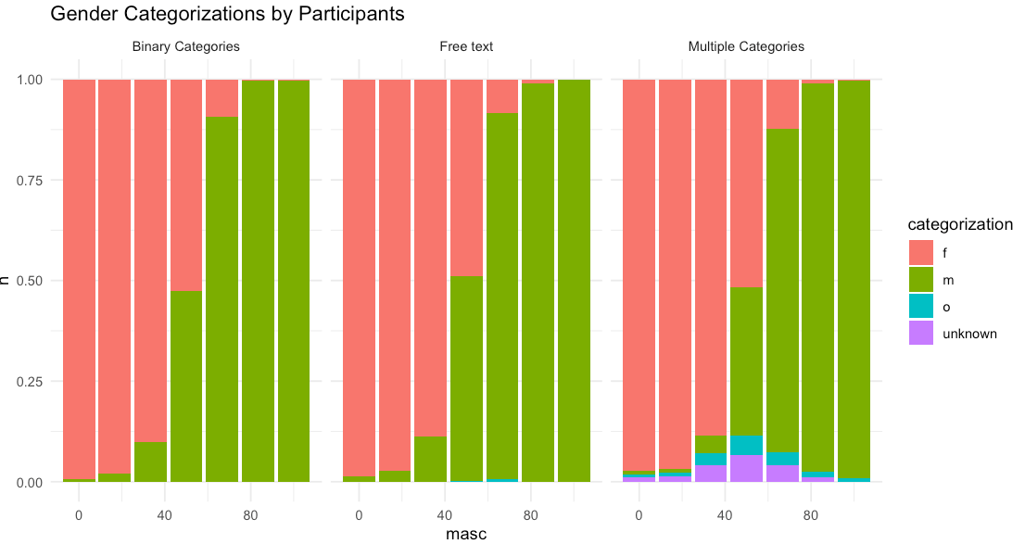Gender categorization of faces by participants in the experiment.

The clue is that there is a very clear s-shaped in pattern in all conditions and it seems to be the same. I won’t include the dimensional scales for space, but they show the same s-shaped pattern.

**Pronouns – upsides and downsides**

Okay, so why might we want to look at pronouns as an outcome? The upside of looking at pronouns are that they would be a more practically relevant outcome. Asking someone “which pronoun would you use to describe this person?” would get us a little closer to how they would treat a person in real life. What a lot of non-binary people are advocating for is this kind of habit, where most people refrain from using gendered pronouns without knowing them. Another upside of looking at pronouns would be that it would tie this study more neatly together with the other papers, as pronouns would be a more clearly occurring theme.

What are some downsides, or at least some challenges? There is a comparability problem. Is a condition where participants categorize using pronouns really the same as when participants are applying categories. This gets at the broader question of is a pronoun a category. And the difficulty is that it’s kind of not. It’s just a way to refer to someone. On the other hand, it is the case that using a pronoun is an indicator of having put someone into a category, and maybe more importantly, non-binary pronouns are specifically a way to not use place someone in a category. There’s also the issue if we’re talking about pronouns as an outcome, can we even talk about categorical perception? I mean, if people are using the pronoun she, is that based on them perceiving the person as a woman? It gets a little bit muddy there. So pronouns are related to categorization, are perhaps indicative of categorization, but can’t be said to be a direct measure of categorization. Is that a problem? Maybe! It might mean that that directly comparing a pronoun condition to the ones above is misleading.

Another potential issue is that using pronouns would take us a couple of steps away from the original research question. Again, the original research question is how do various types of response options affect categorical perception. The sort of implicit in this question is that the response options are ones used by researchers in experiments. I don’t think it ever happens to be the case that researchers in categorization studies are giving people the option to use certain pronouns. Fair enough, so we say that this study is about categorization on a broader, more naturalistic level. Okay, but even this, this type of design is a little awkward. It isn’t very naturalistic for someone to pick a set of pronouns from a list. So a potential pronoun condition would sort of awkwardly straddle a middle ground of not being very similar to anything done by practicing researchers but also not being a very naturalistic situation.

**Implications**

Okay, so given these strengths and challenges, where does that leave us? Does this suggest that we need to give up? Well, let’s think about. First of all something that I’ve noted is that we already have two types of outcomes: categorical and dimensional. These are already not quite comparable, so it might actually make sense to write them up as two separate experiments within the same paper. And if we already have an article with two experiments, why not add a third? So if we’re in the mindset of a third experiment, then that creates a little bit of space for the pronoun experiment, however, it looks, to be a little different.

Adding a pronoun condition might mean having to broaden the research question. Rather than “specific response options” affecting “categorical perception”, it could be something like “gender framing” affecting “binary treatment of gender” where binary treatment of gender is defined as categorical perception in experiment 1, 2 and 3 and maybe also just “beyond-binary responses” in experiment 3 (wow, return of a classic!)

So what could an additional experiment actually look like? One way is to compare a pronoun condition to the free-text condition (as in figure 2). When people spontaneously name gender categories, they think about of gender as something binary, but when people give pronouns, it might somehow be filtered through social interactions and they’d maybe be more open to going beyond the binary. That would be an interesting finding! Then the outcome of interest would be something more along the lines of “how often do you categorize beyond the binary”?

Figure 2.

Two possible conditions in a potential third experiment. This would focus on comparing pronouns to applying gender categories.

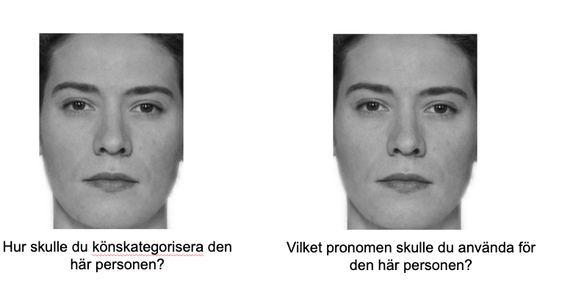

Another option would be to double down on pronouns, and compare two different conditions using pronouns. For example one condition where participants choose pronouns based on forced choice and another where participants select pronouns based on free text. This would get us a little bit closer to the original research question of how the way that options are presented affects the outcome. This kind of setup has the advantage of being more comparable.

Figure 3.

Two additional possible conditions in a potential third experiment. This would compare pronoun responses from forced choice and free text.

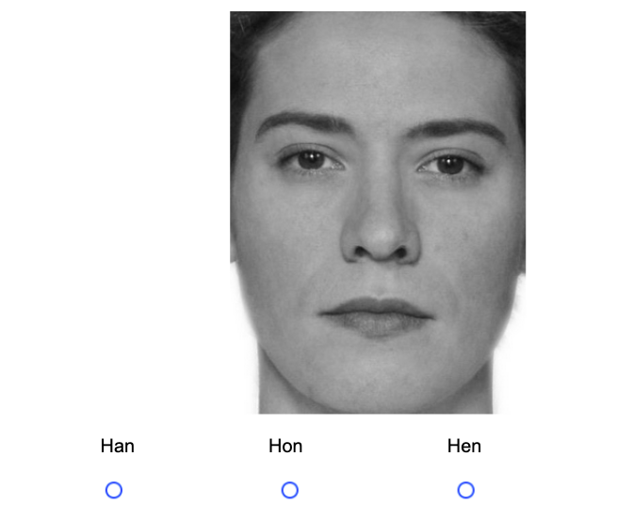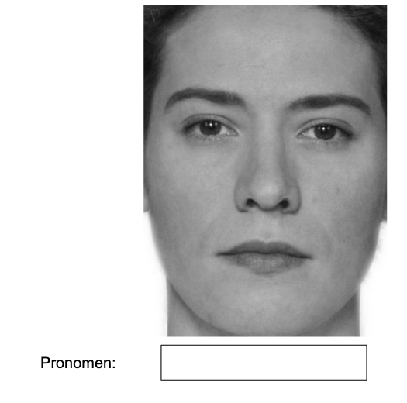

As I’m describing these two studies up side by side, it becomes clear that the question to answer is – are we interested in pronouns compared to explicit categories or do we want to use pronouns to examine the way that response options influence categorization.

I think perhaps before thinking *too* much about the specifics of this, it might be good to do some kind of pilot to see if there is a *there* there. I’m thinking just a quick pilot testing both kinds of pronoun conditions I mentioned above, i.e. free-text and forced choice. I think if the pattern of pronouns were completely similar to the categories that probably wouldn’t be very interesting