**CURRICULUM VITAE**

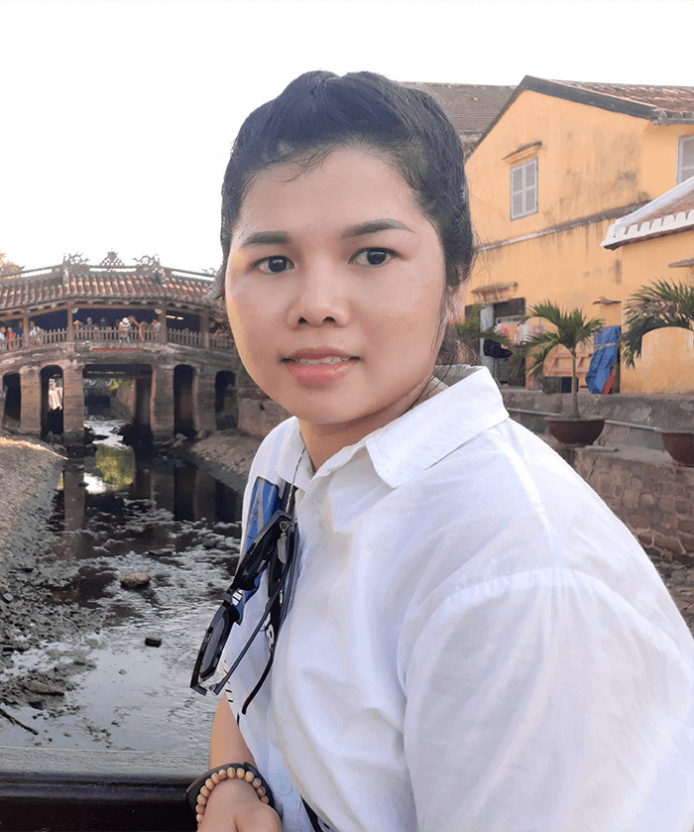Full name: Bui Thi Van

Gender: Female

Date of Birth: 10-10-1993

Marital Status: Single

Address: 25T1 Hoang Dao Thuy, P Trung Hoà, Q Cau Giay, Ha Noi.

Cell Phone: 0979 814 134

Email: van.bt.38@gmail.com

Website: <https://vanbui93.github.io/my_cv/>

# INTRODUCTION

I have over 8 years working as Front End Developer for many companies such as Vietnam, Japan, and Korea.

In the companies I have worked for, I have always been trusted and appreciated by my superiors for my dedication and hard work.

I'm also good at communication with everyone so if I have the opportunity to work at your company I believe that I’ll be an excellent employee too.

I hope to have a chance to present in more detail if the company chooses to interview me.

## EDUCATION

I graduated from **Ho Chi Minh City Industry And Trade College** (2011-2014)

My major is **Computer Science** (2011-2014): Good

## SKILLS

* **Programming languages:** 
  + 5 years:HTML5, CSS3, Javascript, jQuery, Bootstrap, Liquid, SASS /SCSS.
  + 1 year: ReactJS,Next JS, MUI, rsuitejs, Typescript, Redux,…
  + 3 month Wordpress (1 real project, 1 demo)
* **Database**: Firebase, PostgreSQL, MySQL, SQL
* Knowledge of ES2015 ( ES6), TypeScript
* **Design tool**: Photoshop, Zeplin, Figma, …
* Experience with GIT, Postman
* I have experience in e-commerce platforms with Liquid (Haravan, Shopify)
* Experience with website responsive, SEO Technical & mobile friendly
* Ability to learn new technology quickly
* **Languages**:
  + English - TOEIC 580
  + Japanese – N3 JLPT

## EXPERIENCE RECORD

**From 02-2022 To Present: Hivelab VINA**

* Position: Front end developer
* Descriptions:
  + Developing website UI for Korean clients.
  + Test and review products before sending to Korean side
* Technical using : HTML, CSS, JS, Jquery, ReactJS, NextJS, Wordpress
* Typical projects: Kakao Games, Hyundai Oilbank

**From 11-2020 To 11-2021: Cube System Viet Nam**

* Position: Front end developer
* Descriptions:
  + Developing website for Japanese clients.
  + Support QA team to test manual in Japanese in free time
* Technical using: HTML, CSS, JS, Angular 2, 1 little Vue Js
* Typical projects: Mizuho Bank

**From 06-2017 To 09-2020: Transcosmos Viet Nam**

* Position: Leader & Front end developer
* Descriptions:
  + Developing website UI for Japanese clients

(Converting from PSD, Zeplin, Figma,… to pixel perfect using HTML/CSS and Javascript for Japanese clients)

* + Receive projects from Japanese manager and assign them to members.
  + Weekly report meetings on team performance, ways to improve performance and finding new projects.
  + Build checklists to avoid product failures.
* Technical using: HTML, CSS, JS, Jquery
* Typical projects: Suntory, Hoya glasses

Also, while I was working for this company, I was appointed to go on a business trip to the Head Quarter of the company in Tokyo, Japan for a period of three months

**From 10-2014 To 05-2017: Haravan.com**

* Position: Technical Support & Leader
* Descriptions:
  + Use Haravan's liquid (like Shopify) to edit the interface and functionality.
  + Responsible for building, and organizing work for the team.
  + Responsible for technical aspects to meet customer requirements
  + Weekly report meetings on the team's activities, Directly recommended to the Director about policies and the payroll sheet for the team.
  + Build content for the "user guide" page of the e-commerce website system.
* Technical Using: Liquid

I also support many big Vietnamese clients such as Vinamilk, the Face shop, Juno, The Coffee House, Aeon Eshop, iBasic, Aothun.vn... Also I had experience working with partners such as giaohangnhanh, viettel post, giaohangtietkiem, kiotviet, Suno...

## CERTIFICATES, AWARDS

**2013 -** Ho Chi Minh City Industry and Trade College Prize

**2015 -** Haravan Company**:** The Employee Excellence Award

1. **-** Haravan Company**:** Dedication Award
2. **-** Transcosmos Company**:** Business improvement Award

**2019 -** Transcosmos Company**:** Revenue Development Award

## CAREER EXPECTATION

**What is my career objective?**

Try to learn as much as possible and do my best to accomplish my task

I want to improve my skills according to the company’s development Fluent my English to serve my work

## INTERESTED

Listening to music, reading newspapers, traveling, watching films, cooking, growing flower

Enjoy yoga, camping, picnic,…