**CURRICULUM VITAE**

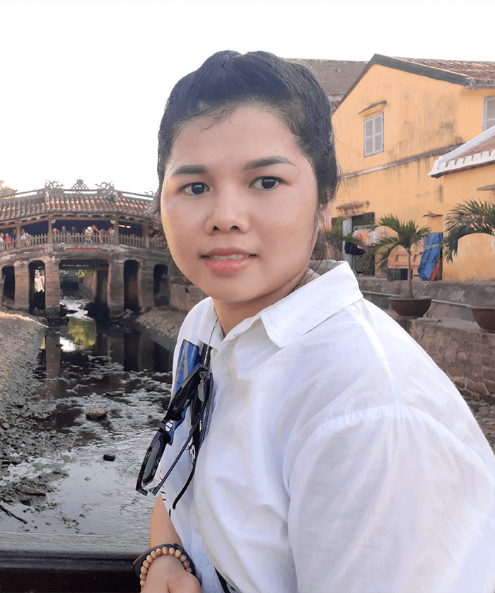Full name: Bui Thi Van

Gender: Female

Date of Birth: 10-10-1993

Marital Status: Single

Address: 25T1 Hoang Dao Thuy, Trung Hoa Ward, Cau Giay District, Ha Noi City.

Cell Phone: 0979 814 134

Email: van.bt.38@gmail.com

Website: <https://vanbui93.github.io/my_cv/>

# INTRODUCTION

I have 3 years of working as Technical Support in Vietnam's e-commerce website and 5 years working as Front End Developer for offshore companies like Japan and Korea.

In the companies I have worked for, I have always been trusted and appreciated by my superiors for my dedication and hard work.

I'm also good at communication with everyone so if I have the opportunity to work at your company I believe that I’ll be an excellent employee too.

I hope to have a chance to present in more detail if the company chooses to interview me.

## EDUCATION

I graduated from **Ho Chi Minh City Industry And Trade College** (2011-2014)

My major is **Computer Science** (2011-2014): Good

## SKILLS

**Programming languages:**

* HTML5, CSS3, Javascript, jQuery, Bootstrap, Liquid, SASS /SCSS.
* Strong knowledge in hand-coding HTML/CSS, converting from PSD, Figma, Zeplin,… to HTML/CSS, Javascript. - Basic Knowledge of ReactJS (Next JS)
* Database: Firebase, PostgreSQL, MySQL - Experience with GIT, Postman
* Can understand ES2015 ( ES6).
* Order skills: Photoshop, Zeplin, Figma, Dreamweaver, VS Code
* Ability to learn new technology quickly
* Experience with website responsive, SEO Technical & mobile friendly

**Client persuasion skills:**

* I have experience as a technical support team lead at Haravan company and support customers to use Haravan's e-commerce platform and consult on choosing the right solution for the business model of each customer.
* Work as a freelance web developer: Meet customers directly to exchange quotes.
* Own business: call and chat with customers about self-sold products

2 self-employed websites:

[www.phucngocan.com](http://www.phucngocan.com)

<https://vongdautambibac.blogspot.com>

**Problem-solving skills:**

* As the team leader, I always have to hold the hotline to solve urgent problems that arise such as system errors, reassure customers and contact the technical department to solve the problem.

**Languages:**

* English - TOEIC 580
* Japanese – N3 JLPT

## EXPERIENCE RECORD

**From 02-2022 To Present: Hivelab VINA**

* Position: Web developer
* Descriptions: Developing website layouts for Japanese clients.
* Typical projects: Kakao Games, Hyundai Oilbank

**From 11-2020 To 11-2021: Cube System Viet Nam**

* Position: Web developer
* Descriptions:
  + Developing website layouts for Japanese clients.
  + Support QA team to test manual in Japanese in free time
* Typical projects: Mizuho Bank

**From 06-2017 To 09-2020: Transcosmos Viet Nam**

* Position: Frontend Team Lead
* Descriptions:
  + Receive projects from Japanese manager and assign them to members.
  + Manage the team's work performance.
  + Manage the absence of team members and report back to the Japanese Manager.
  + Weekly report meetings on team performance, ways to improve performance and finding new projects.
  + Build checklists to avoid product failures.
  + Converting from PSD, Zeplin, Figma,… to pixel perfect using HTML/CSS and Javascript for Japanese clients.
* Typical projects: Suntory, Hoya glasses

Also, while I was working for this company, I was appointed to go on a business trip to the Head Quarter of the company in Tokyo, Japan for a period of three months

**From 09-2014 To 06-2017: Haravan.com**

* Position: Technical Support Team Lead
* Descriptions:
  + Responsible for building, and organizing work for the team.
  + Get feedback from clients and convey it to the producer
  + Training on the system and code (Liquid) for new members.
  + Weekly report meetings on the team's activities, Directly recommended to the Director about policies and the payroll sheet for the team.
  + Build content for the "user guide" page of the e-commerce website system.

I also support many big Vietnamese clients such as Vinamilk, the Face shop, Juno, The Coffee House, Aeon Eshop, iBasic, Aothun.vn... Also I had experience working with partners such as giaohangnhanh, viettel post, giaohangtietkiem, kiotviet, Suno...

## CERTIFICATES, AWARDS

**2013:** Ho Chi Minh City Industry and Trade College Prize

**2015 -** Haravan Company**:** The Employee Excellence Award

1. **-** Haravan Company**:** Dedication Award
2. **-** Transcosmos Company**:** Business improvement Award

**2018 -** Transcosmos Company**:** Revenue Development Award

## CAREER EXPECTATION

**What is my career objective?**

Try to learn as much as possible and do my best to accomplish my task

I want to improve my skills according to the company’s development Fluent my English to serve my work

## INTERESTED

Listening to music, reading newspapers, traveling, watching films, cooking, growing flower

Enjoy yoga, camping, picnic,…