**CURRICULUM VITAE**

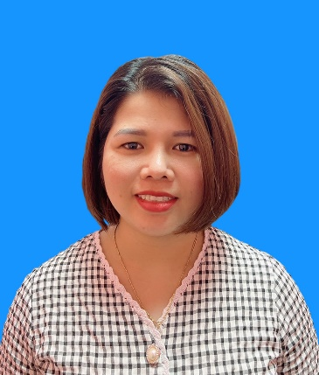

Full name: Bùi Thị Vân

Gender: Female

Date of Birth: 10-10-1993

Marital Status: Single

Address: Thạch Hội, Thạch Hà, Hà Tĩnh

Cell Phone: 0979814134

Email: van.bt.38@gmail.com

Website: <https://vanbui93.github.io/my_cv/>

# INTRODUCTION

With over 08 years of experience in environments such as Front-end, and e-commerce websites, for the companies I have worked with, I'm confident always trusted, and appreciated by my superiors for creating and working hard to devote myself to the company.

I'm also good at communicating with everyone so if I have the opportunity to work at your company I believe that I will be an excellent employee too.

I hope to have a chance to present in more detail if the company chooses to interview me.

## EDUCATION

I graduated from **Ho Chi Minh City Industry And Trade College** (2011-2014)

My major is **Computer Science** (2011-2014): Good

## SKILLS

* **Programming languages:** HTML5, CSS3, Javascript, jQuery, Bootstrap, Liquid, SASS /SCSS.
* Strong knowledge in hand-coding HTML/CSS, converting from PSD to HTML/CSS
* Basic Knowledge of ReactJS
* Database: Firebase, PostgreSQL, MySQL
* Experience with GIT
* Can understand ES2015 ( ES6).
* Order skills: Photoshop, Zeplin, Figma, Dreamweaver, VS Code
* Ability to learn new technology quickly
* Work under high pressure
* I have experience in e-commerce platforms with Liquid (Haravan, Shopify)
* Experience with website responsive, SEO Technical & mobile friendly
* Languages: Conversational Japanese – N3 JLPT, English communication

Nodejs, ES2015

Photoshop

Communication

Planning

Teamwork

Firebase,PostgreSQL,MySQL.

Bootstrap, Material UI

GIT

Javascript, jQuery

ReactJS

HTML5,CSS3,Scss/Sass

Skills chart

## EXPERIENCE RECORD

**From 02-2022 To 04-2023: Hivelab VINA**

* Position: Web developer
* Descriptions: Hand-coding HTML/CSS, converting from PSD to HTML/CSS.
* Typical projects: Kakao Games, Hyundai Oilbank

**From 11-2020 To 11-2021: Cube System Viet Nam**

* Position: Web developer
* Descriptions: Developing website layouts for Japanese clients.
* Typical projects: Mizuho Bank

**From 06-2017 To 09-2020: Transcosmos Viet Nam**

* Position: Web developer & Leader
* Descriptions: Hand-coding HTML/CSS, converting from PSD to HTML/CSS.

During this time I also made many websites for big Japanese clients such as Suntory, Hoya glasses…

Also, while I was working for this company, I was appointed to go on a business trip to the Head Quarter of the company in Tokyo, Japan for a period of three months

**From 09-2014 To 06-2017: Haravan.com**

* Position: Technical Support & Leader
* Descriptions:
  + Responsible for building, and organizing work for the team.
  + Get feedback from clients and convey it to the producer
  + Training on the system and code (Liquid) for new members.

I also support many big Vietnamese clients such as Vinamilk, the Face shop, and Juno during this time.vn, The Coffee House, Aeon Eshop, iBasic,

Aothun.vn...Also I had experience working with partners such as giaohangnhanh, viettel post, giaohangtietkiem, kiotviet,Suno...

## CERTIFICATES, AWARDS

**2013:** Ho Chi Minh City Industry and Trade College Prize

**2015 -** Haravan Company**:** The Employee Excellence Award

1. **-** Haravan Company**:** Dedication Award
2. **-** Transcosmos Company**:** Business improvement Award

**2018 -** Transcosmos Company**:** Revenue Development Award

## CAREER EXPECTATION

**What is my career objective?**

Try to learn as much as possible and do my best to accomplish my task

I want to improve my skills according to the company’s development Fluent my English to serve my work

## INTERESTED

Listening to music, reading newspapers, traveling, watching films, cooking, growing flower

Enjoy yoga, camping, picnic,…