Catalan Numbers:

C_n = \frac{1}{n+1}{2n\choose n} = \frac{(2n)!}{(n+1)!\,n!} = \prod\limits_{k=2}^{n}\frac{n+k}{k} \qquad\mbox{ for }n\ge 0.

[1](https://en.wikipedia.org/wiki/1_%28number%29), 1, [2](https://en.wikipedia.org/wiki/2_%28number%29), [5](https://en.wikipedia.org/wiki/5_%28number%29), [14](https://en.wikipedia.org/wiki/14_%28number%29), [42](https://en.wikipedia.org/wiki/42_%28number%29), [132](https://en.wikipedia.org/wiki/132_%28number%29), 429

Fibonnaci:

|  |  |  |  |  |  |  |  |  |
| --- | --- | --- | --- | --- | --- | --- | --- | --- |
| 0 | 1 | 1 | 2 | 3 | 5 | 8 | 13 | 21 |

F_n = \frac{\varphi^n-\psi^n}{\varphi-\psi} = \frac{\varphi^n-\psi^n}{\sqrt 5}

where

\varphi = \frac{1 + \sqrt{5}}{2} \approx 1.61803\,39887\cdots\,

\psi = \frac{1 - \sqrt{5}}{2} = 1 - \varphi = - {1 \over \varphi} \approx -0.61803\,39887\cdots

Pascal’s Triangle:

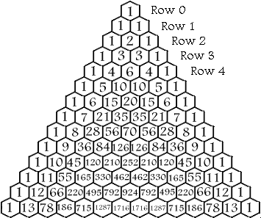

Law of Cosines: c^2=a^2+b^2-2abcosC.

Heron’s: A = \sqrt{s(s-a)(s-b)(s-c)},, where s=\frac{a+b+c}{2}.