Ultra low thermal conductivity and thermoelectric effects of quasi 1D topological insulator

The thermoelectric figure of merit ZT of recently synthesized quasi 1D topological insulator is explored from first principle. The thermal conductivity of this system is found rather low because of the large masses of the elements and large anharmonic scattering of phonons. Detailed analysis of lattice dynamic calculation is applied to explain the origin of the anharmonic effects. The Seebeck coefficients and electron lifetime are calculated from first principle accounting for electron-phonon coupling and then ZT value is given. We found is actually potential for the application of thermoelectric. The result of bulk and single strip are compared.

Keywords: Thermal conductivity,, , thermoelectric, phonons

I.INTRODUCTION

Thermoelectric (TE) materials can directly convert heat into electricity or vice versa and, consequently, have attracted wide attention for applications in energy harvesting, and solid state cooling that does not require refrigerants. The figure of merit for thermoelectric performance is , where S and σ are the Seebeck coefficient and electrical conductivity, and and are the lattice and electronic thermal conductivities, respectively. Controlling of the power factor and the reduction of thermal conductivity due to phonon scattering are available ways to overcome the limits of the current ZT value. However, it is very difficult to significantly improve the thermoelectric performance of conventional materials because the , S and are coupled unfavorably. For instance, a high electrical conductivity usually leads to a low Seebeck coefficient and a high electrical thermal conductivity, both of which are undesirable for thermoelectric applications.

Recently, topological insulators have attracted much attention from thermoelectric communities because of their potential high ZT based on the two reasons: (i) their narrow band gaps associated with band inversion is favorable for large Seebeck coefficients; Besides, the surface state of topological insulator may also help to increase electrical conductivity. (ii) topological insulators usually have complex structures and heavy elements which has large anharmonic scattering and thus reduce lattice thermal conductivity. For example, the traditional thermoelectric materials are based on the chemical compound of bismuth and tellurium (Bi2Te3), with the ZT between 0.8 to 1.0. They already gain some applications in fields such as portable refrigerators and electric component coolers. The high ZT of Bi2Te3 arises partly because of its intrinsically low both in theory and experiment. Ab-initio molecular dynamics (MD) simulations of the low in-plane and cross-plane of Bi2Te3 have yielded values of 1.4 and 0.8 at room temperature, respectively.

It is well known that one of the promising methods for the achievement of highly efficient thermoelectric properties is to construct low-dimensional nanostructures. For example, silicon nanowire has large ZT improvement than bulk systems because the quantum confinement reduce much of the thermal conductivity while has little influence with electronic properties.

is a recently synthesized good topological insulator with quasi-1D structure. It not only possesses the potential of TI to be good TE material, but also has the nature of nanowire which may largely reduce the lattice thermal conductivity of the system. In this work, we have employed first- principles lattice-dynamics calculations of bulk and single strip of . This paper will be arranged as follows: in section I the computational method detail will be introduced and then in section II the results of phonon properties and thermal conductivity will be discussed. Then in section III the electrical properties will be explored.

II. COMPUTATIONAL DETAILS

First-principles calculations are carried out by using the Vienna ab initio Simulation Package(VASP). The exchange and correlation interactions between electrons are described by the Perdew, Burke, and Ernzerhof functional(PBE). The projector augmented wave(PAW) pseudopotential is adopted to model the interaction between electrons and ions. The energy cutoff is chosen to be 520 eV for the expansion of the wave function by plane-wave basis sets. The structure of bulk is fully Relaxed with a k-point mesh of 4×4×4.

Thermal conductivity the system is calculated by using Boltzmann Transportation Equation with relaxation time approximation as implemented in ShengBTE, in which thermal conductivity tensor is given by

The calculations of , , and require second- and third-order force constants (FCs) as inputs. Both second- and third-order FCs are extracted from density functional theory computations by using the finite displacement method. The FCs are calculated with 4×2×2 supercell with a 3×3×3 Monkhorst-Pack k-point mesh. The phonon dispersion and states density are calculated with Phonopy with second order force constants. The interaction range of third-order FCs is truncated up to 4th neighbor.

The thermoelectric properties including Seebeck coefficients and electric thermal conductivity are calculated with Boltztrap with eigenvectors extracted from VASP with k-point mesh of 14x14x14.

The phonon-electron coupling lifetime is calculated with Quantum-Espresso and EPW developed by Steven Louie.

III.RESULTS AND DISCCUSION

1 结构

Bulk is consist of weakly bound 1D strips. As shown in Fig. 1, the optimized configuration of the Bulk possesses C2/m symmetry (space group no. 12) with an monoclinic lattice, which is lower than that of its bulk counterpart due to the lack of inversion symmetry. The single-layered SnSe has a highly puckered honeycomb structure, similar to that of the recently synthesized monolayer black phosphorus (phosphorene).40 We thereby denote the zigzag and armchair directions (Fig. 1a) in the nanosheet following previous studies on phosphorene. The obtained lattice constants are quite close, with the values of 4.307 Å and 4.362 Å respectively along the zigzag and armchair directions, which are in reasonable agreement with the previous literature.

2 动力学稳定性

To confirm the dynamical stability of the single-layered SnSe, phonon dispersion is calculated in the framework of the density functional perturbation theory.41 The results are plotted in Fig. 2a. The longitudinal acoustic (LA) branch and the transversal acoustic (TA) branch have linear dispersions as the wave vector approaches Γ point, whereas the out-of-plane ZA branch exhibits a parabolic dispersion due to the rapid decay of transversal forces.42 No appreciable imaginary modes are found in the first Brillouin zone, suggesting that the single-layered SnSe is dynamically stable.

3 热力学稳定性

To further study its thermal stability at finite-temperature, we performed ab initio molecular dynamics (MD) simulations seconds at typical temperatures. Therefore, the single-layered SnSe sheet is thermally stable in a wide temperature range from 300 K to 900 K. However, the layered structure starts decomposing when heated to 1000 K, and the total energy no longer remains invariant during simulations. Therefore, we conclude that the single-layered SnSe sheet at least can sustain temperature as high as 900 K. The simulated results at 700 K are given in Fig. 2b, and all the others are provided in Fig. S3 in the ESI.† We also looked at the bond length variance during the MD simulations. The details can be found in Table S1 in the ESI.† It is well known that the bulk SnSe undergoes a phase transition from a lower symmetry (space group Pnma #62) phase to a higher symmetry (space group Cmcm #63) phase at around 750–800 K. We assumed that the single- layered SnSe sheet may also experience a similar phase transition to other possible allotropes upon heating like bulk SnSe. However, the phase transition is beyond the scope of this study. Thus we only concentrated on the medium–high temperature range (300–700 K), and chose 700 K as a typical temperature to perform the thermoelectric calculations. Next

4 热导率的收敛性

5 热导率的声子分析

6 热导的各向异性

7 Seebeck系数

Fig. 2 shows the phonon dispersion along the high symmetrical path of the Brillouin zone and phonon states density of .

The thermal conductivity of random alloys is dopant ratio sensitive while that of regular alloys are not. Fig. 3(a) shows the calculated thermal conductivity of with different distribution versus doping ratio at 300K. For the usual random doping, only a 1% doping of nitrogen induces the reduction of thermal conductivity of 35% due to the presence of doping results in scatter of phonons and produce more localized modes. And it is reduced to almost 0 when the dopant ratio reaches 0.2, beyond which the structure is no more stable and we won’t consider it. Besides, for the regular distribution of nitrogen we have a much different curve. It not only has a much slower reduction at low dopant ratio, but increase when the ratio is beyond 1/13. If the ratio is small, these curves will overlap because of the less difference between regular and random alloys.

The distribution of dopants affects the thermal conductivity of alloys a lot. When the distribution of nitrogen is optimized using metropolis MC before the usual minimization of their positions, the curve moves upwards. The points along y axis in Fig. 3(a) represent the thermal conductivity of structures with the same dopant ratio but different distribution.

A more stable structure is more thermal conductive. Fig. 3(b) shows the thermal conductivity of with different ratio versus atom-averaged energy. It is clear that with the same dopant ratio, the thermal conductivity increases when the atom-averaged energy decreases. As the structure being more stable, the energy changes slower and slower, and a small change in energy leads to a relatively large thermal conductivity difference. Usually a more stable structure is more regular in its symmetry, and it’s of significant importance to explore how thermal conductivity depends on the structure symmetry.

For the specific graphene knot, the simulation is carried 5 times with different seeds.

The area embraced by the curve is the work we do to the graphene knot

Mode localization of phonons is believed to account for the dopant distribution dependence of thermal conductivity. To understand the underlying physical mechanism of thermal conductivity trends of alloys in Fig. 3(a), we have carried out a vibrational eigen-mode analysis on the regular ones. Mode localization can be quantitatively characterized by, the participation ratio7 for each eigen-mode

, (3)

where N is the total number of atoms and is the complex amplitude of atom s for eigen-mode. The participation ratio presents the fraction of atoms participating in a given mode and effectively indicates the localized modes with and delocalized modes with O (1). It can provide a more detailed information about the localization effect to each mode.

C12N

CN

The eigenvectors and frequencies are obtained using Phonopy8 with and mesh sampling. Fig. 4 shows the participation ratio of graphene,,. A reduction of p-ratio for both low frequency phonons and high frequency phonons comes out compared with graphene. Most of the eigen-modes in regular have p-ratio over 0.98, showing characteristic of delocalized mode, while some of the eigen-modes of the others showing a characteristic of localized mode. The average participation ratio are 1.00, 0.80, 0.86 and 0.95 respectively, which obeys the same trends as the thermal conductivity.

The average participation ratio is found to be the key quantity to connect the alloy structure and its thermal conductivity. Fig. 5 compares the average participation ratio for several structures. It can be seen that thermal conductivity depends on participation ratio almost linearly, regardless of dopant ratio and distribution. This means that structure changing influences thermal conductivity directly via the average phonon participation ratio.

The structure determines its average participation ratio mainly through the atom inequality. With ,we can reshape the participation ratio as

, (4)

which means that a mode with a larger vibrational amplitude variation is more localized. Although participation ratio can describe mode localization in a quantitative manner, it does not provide detailed information about the spatial distribution of a specific mode. To get a better understanding about the localization modes, we present the spatial vibration strength distribution of a typical mode of in Fig. 6. As we can see, with the presence of nitrogen dopant, carbon atoms are grouped into three invariant subspaces, under the operation of translation and inversion. So we can define the number of invariant subspaces under such a group as the inequality number of the structure. And the of graphene,, are 1,7,4,2 respectively. Fig. 7 shows the relationship between thermal conductivity and reciprocal of Ne for the four regular lattices. To be concluded, at least for the regular lattices, the presence of the dopants increases the inequality number of the structure. And they can interfere with the phonons, making them localized, which is responsible for the decrease of thermal conductivity.

For a relatively random system there should be another way to determine the inequality, because all the atoms are inequivalent in the most restrict sense. Here, we define a quantity only determined by the structure, called disorder degree, as

, (5)

where

, (6)

is the average radial distribution function of nitrogen atoms and is the radial distribution function9 with the nitrogen atom being the center atom.

, (7)

is the standard error of at r. In other words, we can define disorder degree as the average of the relative error of atom dependent radial distribution function. For a large enough r, because , so this quantity is converged. It could be proved that this quantity is insensible to the interval you use to calculate. As the consideration, reflects the environment of atom, and the larger relative error means the less equality. So it is a good quantity to describe inequality and disorder in the alloy. With this definition, the relation between the thermal conductivity and the structure could be easily clarified.

The thermal conductivity is found to depend on disorder degree linearly. Fig. 8 shows the relationship between the thermal conductivity and disorder degree for and relatively. Furthermore, when d reaches 0, thermal conductivity gets its largest value. The largest value of d due to the finite size of the cell gives out a minimal limit of thermal conductivity. Therefore, we can predict the thermal conductivity just use the radial distribution function.

Obviously it could be the dopant ratio r that causes the difference of the slope of the two lines. The thermal conductivity vs. is shown in Fig. 9, which means

(8)

is a good relation of thermal conductivity and structure for . This may be a universal scaling for binary alloys, which will be verified in future works. With this relation, it’s easy to estimate the thermal conductivity of an alloy with the knowledge of some points on this line, and we can also connect thermal conductivity and electric conductivity via disorder degree, which is helpful to find some more efficiency thermoelectric materials.

IV. CONCLUSIONS

To summarize, in this work, we propose to study the effects of doping distribution on thermal conductivity of alloys. Our numerical results demonstrate that a random distribution will deduce thermal conductivity rapidly as expected while a regular distribution leads to much slower deduction at room temperature. Moreover, thermal conductivity of will increase abnormally when x is beyond a value. The localization mode analysis demonstrates that the [inequivalent](http://www.baidu.com/s?f=13&nojc=1&wd=inequivalent) of the atoms within the same unit cell is responsible for the change of thermal conductivity in the alloy. To describe the [inequivalent](http://www.baidu.com/s?f=13&nojc=1&wd=inequivalent) for random alloys, we define a quantity named disorder degree and found thermal conductivity depends on it linearly, which is valuable for thermal conductivity manipulation and it maybe a universal scaling for a wide range of nanomaterials. These results would be helpful to the development of nonequilibium statistic mechanics and the theory of heat transportation in nanoscale systems.

ACKNOWLEGEMENTS

This paper was partially supported by the National Natural Science Foundation of China, the Special Funds for Major State Basic Research, the Foundation for the Author of National Excellent Doctoral Dissertation of China, the Program for Professor of Special Appointment at Shanghai Institutions of Higher Learning, and the Research Program of Shanghai Municipality and the Ministry of Education.

REFERENCES

(1) Kagimura, R.; Mazzoni, M. S. C.; Chacham, H. *Phys. Rev. B - Condens. Matter Mater. Phys.* **2012**, *85* (12), 1–4.

(2) Schelling, P. K.; Phillpot, S. R.; Keblinski, P. *Phys. Rev. B* **2002**, *65* (14), 144306.

(3) Ladd, A. J. C.; Moran, B.; Hoover, W. G. *Phys. Rev. B* **1974**, *34* (8), 26–44.

(4) Dickey, J. M.; Paskin, A. *Phys. Rev.* **1969**, *188* (1967), 1407–1418.

(5) Mu, F. **1999**, *59* (5), 4894–4898.

(6) Lammps. *Dev. - Lammps* **2011**, 1–9.

(7) Yang, L.; Yang, N.; Li, B. *Sci. Rep.* **2013**, *3*, 1143.

(8) Togo, a. **2013**.

(9) Kirkwood, J. G.; Boggs, E. M.; Kirkwood, G.; Boggs, E. M. **1992**, *394* (1942).

**FIG. 1.** (color online) The structure of .

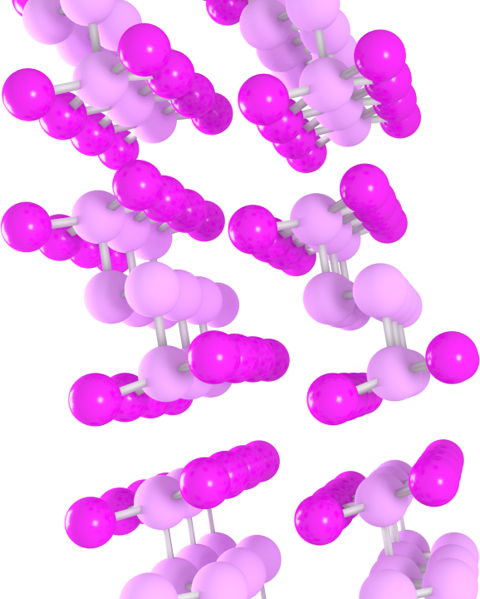

**FIG. 2.** (color online) Phonon dispersion and DOS of bulk .

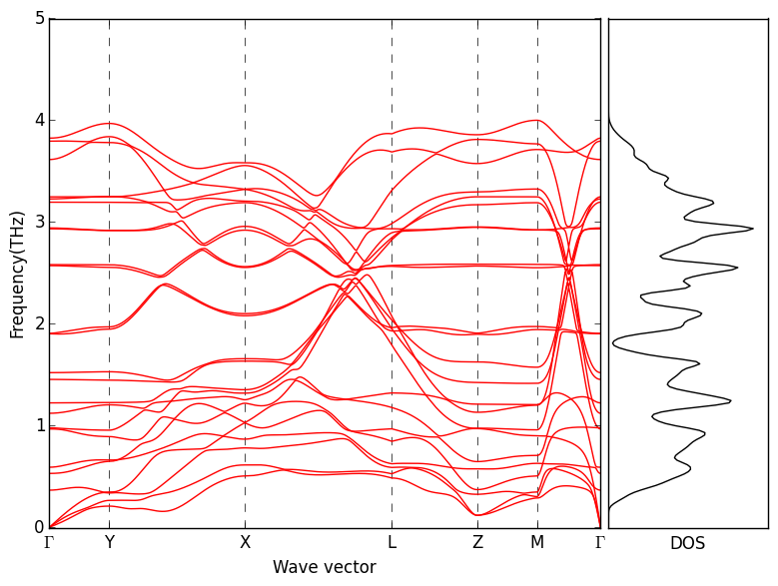

**FIG. 5.** (color online) MSD vs. time of various temperature. The melting point is above 800K and below 900K.

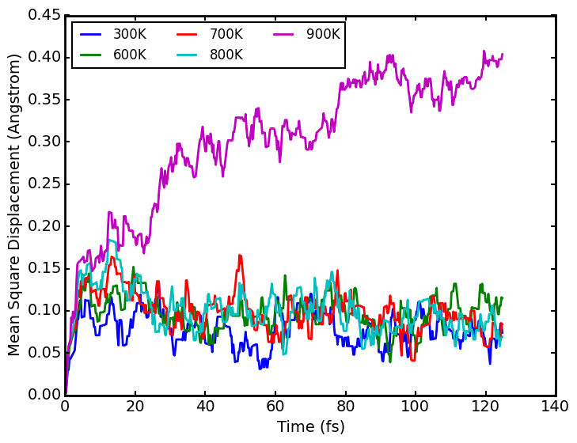

**FIG. 5.** (color online) Thermal conductivity convergence vs. q points of bulk .

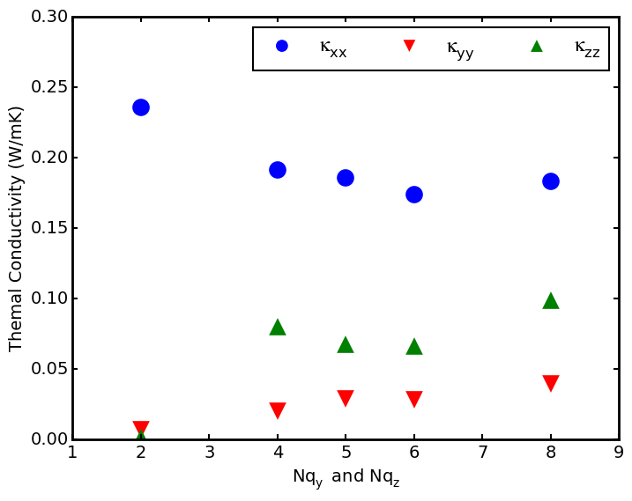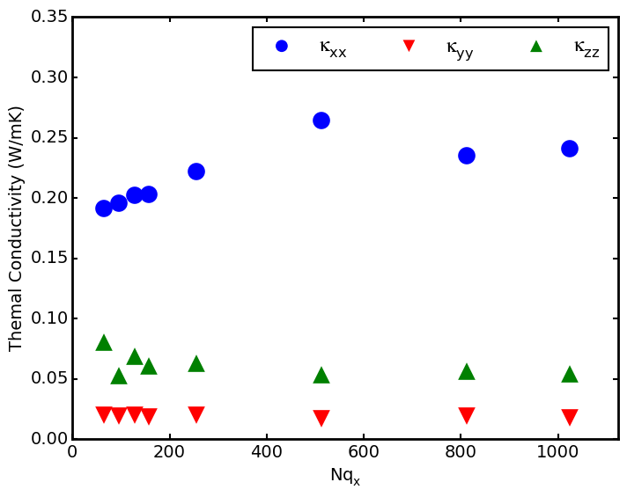

**FIG. 8.** (color online) Thermal conductivity vs. Temperature

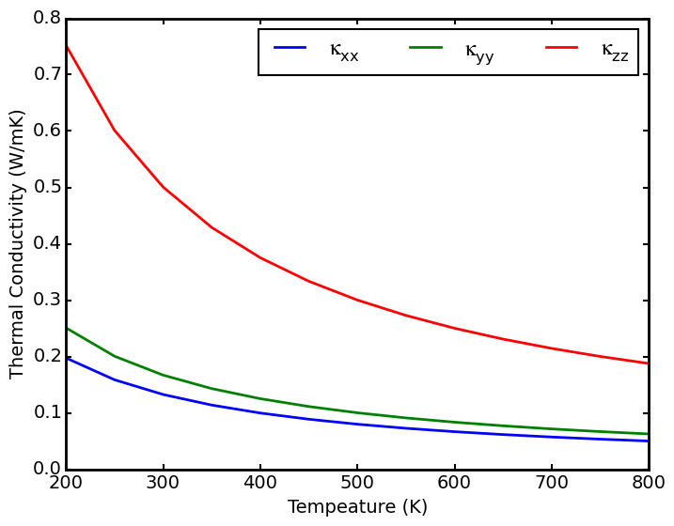

**FIG. 3.** (color online) Phonon group velocity of bulk .

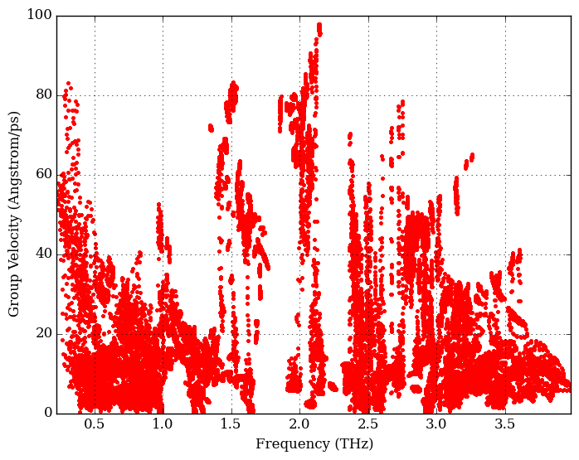

**FIG. 6.** (color online) Phonon lifetime caused by three phonon scattering vs. frequency of bulk .

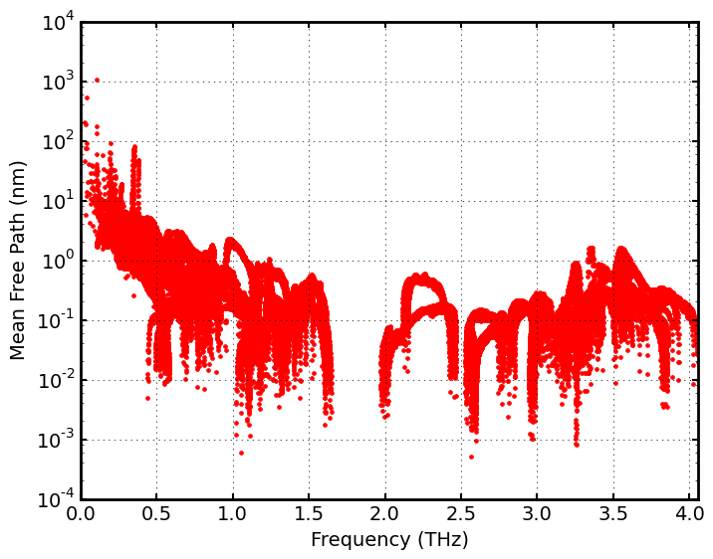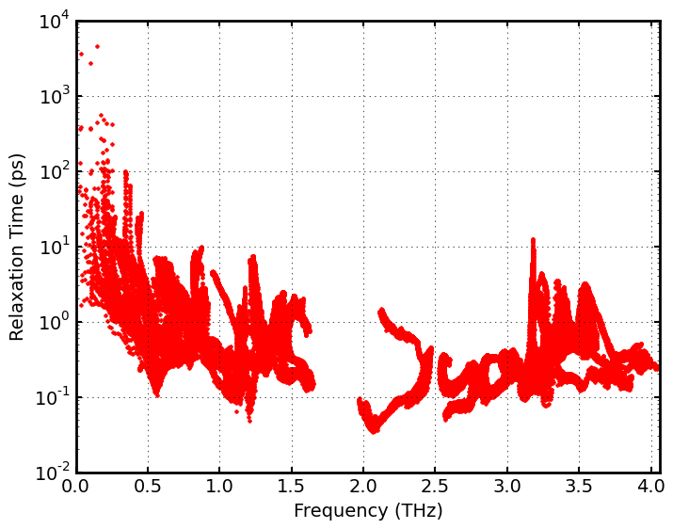

**FIG. 4.** (color online) Phonon participation ratio of bulk .

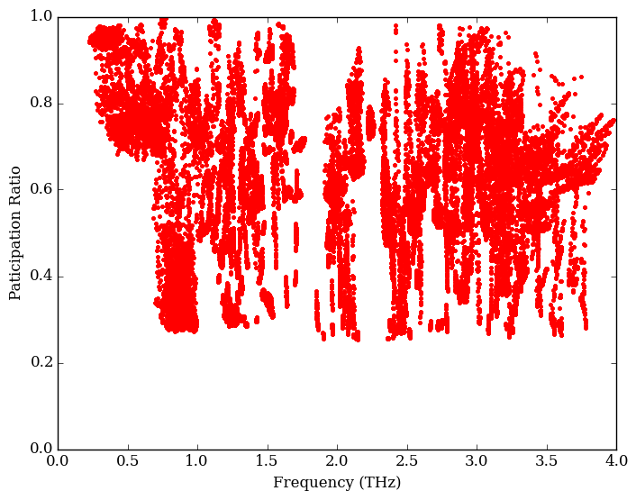

**FIG. 7.** (color online) Phonon scattering strength vs. frequency of bulk .

