Anisotropic in-plane thermal conductivity observed in multilayer silicene

By means of non-equilibrium molecular dynamics simulation, we systematically study the thermal transportation properties of different types of multilayer silicon. It is found that the thermal transport properties of multilayer silicon structures have significant surface effect and size effect in thickness direction. Surface reconstruction affects heat transport very well , the thermal conductivity of bilayer silicon with different reconstruction can reach up to 11.6 W/mK, and can be as low as 1.2 W/mK and the anisotropy can be as high as 57.3%.With the increase of the number of layers, the thermal conductivity of the zigzag direction changed little, but the thermal conductivity increased significantly in the armchair direction, and the anisotropy of thermal conductivity decreased which is due to the smaller affection in more layer structure. This work could be helpful in the field of heat management, thermoelectric applications involving silicon and other multilayer nano materials in the future.

Keywords: Thermal conductivity, multilayer silicon, surface reconstruction, anisotropy

I.INTRODUCTION

With the development of the existing silicon based circuit industry, the requirements of its integration and miniaturization make a lot of research work focusing on the application of the new two-dimensional materials. The theory and experiments in the last 10 years show that some new two-dimensional materials have many novel and excellent physical properties due to their structure and size. For example, the single atom layer MoS2 has a suitable band gap which makes its field effect transistor switching ratio as large as 1. Black phosphorus (BP) with thicknesses of several atomic layer have extremely high electron / hole mobility (1000 ${cm}^{2}/Vs$) and leakage current modulation rates ( ${10}^{4}$ times of graphene) and the field effect transistor of it has great potential in the application of nano electronic devices2. Due to the high thermal conductivity and electron mobility of graphene, it has great potential applications in the field of nano circuits3,4. However, materials prepared in the practical application is often multilayer structure to a few nanometers. Previous studies have focused on the weak Van der Waals interaction (vdW), and there is no surface reconstruction. There have been lots of studies on the electronic and thermal transport properties for this kind of typical layered structure and hetero structures, such as graphene5–7, MoS28, black phosphorus9–11 two-dimensional layered structure. The existing preparation technology such as mechanical stripping, molecular beam epitaxy has difficult to produce nano layered structure for the material with strong interaction between layers, and the research of this kind of super thin nano materials has been very scarce. Recently, it has been found that monolayer and multilayer silicon material can be grown on some metal substrates by molecular beam epitaxy12–16. The progress of these experiments ignited the upsurge the two dimensional nanomaterials with strong interaction between layers. In contrast to vdW, the two layer nano materials, which are represented by multi-layer silicon, exhibit special surface reconstructions which are different from the bulk surface12,13,16,17 and its physical and chemical properties are also very unique17,18, indicating that there is new physics in this kind of ultra-thin nano materials.

Silicon nano is currently the only one system, from its monolayer to multilayer, and then to the bulk structure, that have been prepared by experiment. And it has rich and typical structure in the dimension of zero dimension, one dimension and three dimensions, which have laid a very good foundation for the study of two-dimensional scale multilayer silicon. The study of multilayer silicon is also helpful to understand the physical evolution of matter from low dimension to high dimension. In addition, the preparation process of silicon nano materials is mature and the raw materials are rich, and It has a broad application prospect in the fields of micro nano electronics, energy, information and other important fields in the future.

At present, research of thermal transport properties based on the silicon nano structure mainly includes silicon nanowires19–22, silicene23–27, substrate supported silicene28,29, silicon thin film and bulk structure30–34. Due to the quantum size effect in the thickness direction and surface reconstruction effect, silicon multilayer structure is expected to have lower thermal conductivity than the bulk and is more suitable for thermoelectric applications. However, the study on the properties of multilayer silicon thermal transport is still very rare, To this end, based on the first principles calculation of Guo35, we explored the thermal transport properties of the 2 to 10 layer silicon structure.

II. COMPUTATIONAL DETAILS

In this paper, based on the large scale parallel and efficient LAMMPS molecular dynamics software package, we study the thermal conductivity of multilayer silicon structure by using the non-equilibrium temperature gradient method. Because of the abundant silicon structure model, the phase reconstruction has attracted much attention. In order to well simulate the structures of different phase by MD, the latest Mod potential is chosen36, which is able to reconstruct the silicon material elastic constants, the melting point and phase transition. Firstly, we use conjugate gradient method to optimize these structures. All structures are shown in **FIG.1**. For convenience, we define the names of these structures as "nlxs", where n is a pure number, representing the number of layers, l represents layer, x distinguishes different structures (concrete 1, 2, 3 etc. ) and s indicates the type along the length direction with value of a (armchair) or z (zigzag). **TABLE.1** lists the structure name, the minimum repeat cell periodicity, the binding energies, the first principle binding energies and the structural properties of the multilayer silicon. The Mod potential is constructed for different type of silicon structures by fitting its bond angle parameter to give correct melting point and elastic constants. It refers to the elastic properties predicted with first principle local density approximation (LDA) and the generalized gradient approximation (GGA). However, these first principle methods tend to overestimate the binding energy of materials and underestimate their equilibrium lattice constants. For this reason, the Mod potential is constructed referring the correction of the equilibrium bond length based on the experimental diamond structure and leads to smaller the binding energy than that predicted by the first principle method.

From **TABLE.1**, by comparing the binding energy of the first principles calculation of Guo is with that of MD, and from the point of view of stacking, the double layer of silicon is found more likely to form a monolayer of small and medium buckling slip stacking structure. The simulation is doing by velocity Verlet integral algorithm with the timestep to be 1fs. The length of the system in the x direction is 10~100nm, the transverse direction y is in periodic boundary condition with its simulated width to be 5 nm, and free boundary condition is applied in z direction. At the same time the outermost two ends of the x direction are fixed, close to witch a 3nm with Nose-Hoover bath is applied. The left and right ends of the temperature control at 310K and 290K. The simulation is carried out by NVT for 0.4ns, then control the temperature gradient for 10 ns, and finally we statistics the data of the last 10ns. By Fourier's law, the relationship between thermal conductivity and heat flux is

$κ=-\frac{J_{x}}{∇T∙S}$ (1)

where $κ$ stands for thermal conductivity, $J_{x}$, $∇T=(T_{L}-T_{R})/L_{x}$ is the average heat flux and temperature gradient along x direction respectively. $T_{L}$, $T_{R}$ and $L_{x}$ means the temperature of the two ends and the sample length between the heat baths. $S=W∙nd$ is the total cross area, where $W,n,d$ is the size in the y direction, the layer number and the thickness of each layer. According to the previous studies, we choose Si (111) layer spacing of 3.14 $Å$ as the thickness of each layer.

III.RESULTS AND DISCCUSION

We firstly investigate the effect of surface reconstruction on thermal conductivity. 5 kinds of silicon structures of armchair and zigzag were selected to study. The relationship between the thermal conductivity and the length of bilayer silicon in different directions is shown in **FIG.2**. the thermal conductivity of 2l1 structure increases with the length the most significantly, followed by the 2l3 structure and 2lr3 structure, while the least significant is the structure of 2l2 and 2lh. In addition, the structure with the thermal conductivity increasing significantly with the length is obviously anisotropy, different from single layer silicon and bulk silicon, who tend to be isotropic. In the aspect of structural, smooth 2l1 is most favorable for heat conduction, while 2l2 structure whose surface is made of a highly symmetrical and highly buckling pentacyclic ring "bird cage" is most unfavorable for thermal conductivity but suitable for thermoelectric materials. And the edges of the two directions are similar in shape, leading to small difference of heat transport.

When the length of the silicon is smaller than the mean free path of the phonon, the ballistic transport properties of the phonon are obvious. When the length is larger than the mean free path of the phonon, the phonon scattering transport characteristics are obvious. The empirical formula of the John A. Thomas37 can be used to characterize the thermal conductivity of the phonon transport from ballistic to scattering region, at the same time accurately obtaining thermal conductivity of the infinite long nano materials. Using this formula, we obtain the thermal conductivity of infinitely long multilayer silicon

$κ=κ_{∞}\left(1-e^{-\frac{L}{L_{c}}}\right)$ (2)

where $κ_{∞}$ is the fitted full scattering thermal conductance. $L_{c}$ is the transition length from the ballistic transportation to the scattering transportation. The value $χ=\frac{\left|κ_{z,∞}-κ_{z,∞}\right|}{\max\left(κ_{z,∞}-κ_{z,∞}\right)}×100\%$ is used to measure the thermal conductivity difference in different directions, where $κ_{z,∞}(κ_{z,∞})$ stands for the full scattering thermal conductivity (infinite thermal conductivity) in the zigzag (armchair) direction. And is $\max\left(κ_{z,∞}-κ_{z,∞}\right)$ the maximum value of thermal conductivity in the two directions.

The total scattering thermal conductivity and anisotropy of multilayer silicon is shown in **TABLE.2**. It can be seen from the table that the thermal conductivity of the bilayer silicon can reach up to 11.6 W/mK (2l1 structure). In addition, the 2lr3 with small top and bottom buckling possesses the most anisotropy, which can reach 57.3%. The smallest is 2l2 and 2lh (20%). The above results show that surface reconstruction has a significant effect on the thermal transport properties of multilayer silicon. The smooth surface is favorable for heat conduction, while the rough surface can greatly suppress the heat conduction. Meanwhile, the anisotropy of the surface structure leads to the significant anisotropy of the thermal conductivity.

The influence of thickness change on the thermal transport properties was then investigated. Here we study mainly on multilayer silicon structure with 3-10 layers, whose surface has typical Si (111) $2×1$ surface reconstruction. In order to compare, we also calculated the thermal conductivity of Si on its (111) surface and the thermal conductivity of the monolayer. The magnitude of the anisotropy is also shown in **TABLE.2**. From the **FIG.3**(a), in the case of the medium thickness of the 3~6 layers, the anisotropy of the multilayer silicon with zigzag type is higher than that of armchair. And with the increase of the number of layers, the anisotropy decreases gradually. The reason is that the zigzag direction of the multilayer silicon surface is composed of a smooth zigzag atomic chain (as shown in **FIG.1**). Compared with the bulk silicon structure, the heat conduction along the zigzag direction has no obvious effect on the heat flow. While along the armchair direction, the fluctuation of multilayer silicon surface is very large, the same is its obvious affection on heat flow. This difference is mainly caused by the surface reconstruction effect, and will decrease with the increase of the thickness of the silicon. In order to predict the relationship between the thermal conductivity and the thickness, we calculated the thermal conductivity of the 8-10 layers silicene with the $2×1$ surface reconstruction. In order to compare, the thermal conductivity of the bulk Si (111) surface with no surface reconstruction (9 layers) and the thermal conductivity of the monolayer were calculated. As shown in **TABLE.2**, with the increase of thickness, the anisotropy decreases gradually. When the thickness is up to 10 layers, the anisotropy of the thermal transport of multilayer silicon can be neglected (only about 1.5%), which is consistent with the results of bulk silicon and single silicon. On the other hand, as shown in **FIG.3**(b), at the same thickness, in the case of shorter length (10~50nm), the anisotropy is obvious. When the length is about 100nm, the anisotropy difference becomes very small, and the size effect of the thermal conductivity anisotropy is obvious. This is essentially due to the difference in the out-of-plane acoustic branch (LA), the transverse acoustic branch (TA), and the vertical plane acoustic phonon (ZA) of the multilayer silicon structures along different directions. However, with the increase of length, the ballistic transport is gradually saturated, and the difference of the heat transfer caused by the umklapp process is gradually reduced.

In order to understand the relationship between the thermal conductivity and the length of the different structures and different layers, we use molecular dynamics to measure the phonon spectra of several typical structures. The $10× 10 × 1$ multilayer structure is chosen. The selected high symmetry points are $\left(0.5, 0.5, 0.0\right)$, $\left(0.0, 0.0, 0.0\right)$, $J\left(0.5, 0.0, 0.0\right)$, $J^{'}\left(0.0, 0.5, 0.0\right)$, Take points along $→→J →J^{'}$ as shown in **FIG.4**.According to the supercell structure, the zigzag boundary corresponds to $→J$ direction in the dispersion, and the armchair boundary corresponds to direction. According to the relationship between the phonon spectrum and heat conduction, in the two-dimensional nano system, the acoustic phonon plays a major role in heat transport. There are a total of 3 acoustic branches, including the LA mode along the transmission direction, TA along the transverse and ZA mode along the perpendicular direction. **FIG.4**(a) and (b) corresponds to the calculated spectra of the bilayer structure 2l1 and 2l2. The group velocity of $→J$ acoustic branch in 2l1 is obviously larger than that of , making zigzag direction more heat conducive , which also verifies the difference between 2l1z and 2l1a thermal conductivity and anisotropy. Accordingly, the three phonons in the two direction is almost the same as that in the 2l2, so the 2l2z and 2l2a are the least anisotropic structures with surface reconstruction. Comparing the two graphs, it can be found that all the group velocities of three phonons of 2l2 decrease. At the same time, the low frequency optical branch has the trend of moving down and couple with acoustic ones, which makes it less heat conducive, so that the 2l2 heat transport changes little with the length. The figure (c) (d) (e) is the dispersion of 3l1, 4l1, 6l1 $2×1$ structure, all of whose three phonon group velocity are larger along zigzag than armchair. With the increase of layers, the optical branch participation gradually gathered in the high frequency area (>15THz), having almost no contribution to thermal conductivity while the vibration mode of the low frequency (<5THz) region is almost unchanged. On the other hand, with the increase of thickness, the acoustic velocity of armchair direction increases gradually, which prompts the decrease of anisotropic in multilayer silicon with the increase of layer number. Compared with phonon spectrum of the 6-layer structure(e), the difference between the 10 layers (f) is mainly the contribution of more atoms in the middle and high frequency (>5THz) region, which has little effect on the thermal conductivity.

IV. CONCLUSIONS

By means of non-equilibrium molecular dynamics simulation, we found that the thermal transport properties of multilayer silicon structures have significant surface effect and size effect in thickness direction. Under the influence of double layer surface reconstruction, the thermal conductivity of the bilayer silicon can reach up to 11.6 W/mK (2l1 structure), and can be as low as 1.2 W/mK (2l2 structure) and the anisotropy can be as high as 57.3%. The smooth surface is favorable for heat conduction, while the rough surface can greatly suppress the heat conduction. The ultra-low thermal conductivity indicates that the bilayer silicon has good thermoelectric properties. In the 3-6 layer multilayer silicon with the same $2×1$ surface reconstruction the zigzag direction is more heat conducive. With the increase of the number of layers, the thermal conductivity of the zigzag direction changed little, but the thermal conductivity increased significantly in the armchair direction, and the anisotropy of thermal conductivity decreased. The thermal conductivity anisotropy of the multilayer silicon with 10 layers is very small, which is consistent with the bulk Si and monolayer silicene. This work could be helpful in the field of heat management, thermoelectric applications involving silicon and other multilayer nano materials in the future.

ACKNOWLEGEMENTS

This paper was partially supported by the National Natural Science Foundation of China, the Special Funds for Major State Basic Research, the Foundation for the Author of National Excellent Doctoral Dissertation of China, the Program for Professor of Special Appointment at Shanghai Institutions of Higher Learning, and the Research Program of Shanghai Municipality and the Ministry of Education.

REFERENCES

1 L. Li, Y. Yu, G. J. Ye, Q. Ge, X. Ou, H. Wu, D. Feng, X. H. Chen and Y. Zhang, *Nat. Nanotechnol.*, 2014, **9**, 372–377.

2 RadisavljevicB, RadenovicA, BrivioJ, GiacomettiV, KisA, B. Radisavljevic, A. Radenovic, J. Brivio, V. Giacometti and A. Kis, *Nat Nano*, 2011, **6**, 147–150.

3 J. H. Chen, C. Jang, S. Xiao, M. Ishigami and M. S. Fuhrer, *Nat. Nanotechnol.*, 2008, **3**, 206–209.

4 A. A. Balandin, S. Ghosh, W. Bao, I. Calizo, D. Teweldebrhan, F. Miao and C. N. Lau, *Nano Lett.*, 2008, **8**, 902–907.

5 L. Lindsay, D. A. Broido and N. Mingo, *Phys. Rev. B - Condens. Matter Mater. Phys.*, 2011, **83**.

6 Y. Ni, Y. Chalopin and S. Volz, *J. Phys. Conf. Ser.*, 2012, **395**, 12106.

7 Z. Wang, R. Xie, C. T. Bui, D. Liu, X. Ni, B. Li and J. T. L. Thong, *Nano Lett.*, 2011, **11**, 113–118.

8 B. Liu, F. M. Meng, C. D. Reddy, J. A. Baimova, N. Srikanth, S. V Dmitriev and K. Zhou, *RSC Adv.*, 2015, **5**, 29193–29200.

9 Y.-Y. Zhang, Q.-X. Pei, J.-W. Jiang, N. Wei and Y.-W. ZHANG, *Nanoscale*, 2015, **8**, 483–491.

10 X. Peng and K. Chen, *Nat. Publ. Gr.*, 2015, 1–9.

11 A. Jain and A. J. H. McGaughey, *Sci. Rep.*, 2015, **5**, 8501.

12 A. Fleurence, R. Friedlein, T. Ozaki, H. Kawai, Y. Wang and Y. Yamada-Takamura, *Phys. Rev. Lett.*, 2012, **108**.

13 L. Meng, Y. Wang, L. Zhang, S. Du, R. Wu, L. Li, Y. Zhang, G. Li, H. Zhou, W. A. Hofer and H. J. Gao, *Nano Lett.*, 2013, **13**, 685–690.

14 P. Vogt, P. De Padova, C. Quaresima, J. Avila, E. Frantzeskakis, M. C. Asensio, A. Resta, B. Ealet and G. Le Lay, *Phys. Rev. Lett.*, 2012, **108**.

15 P. De Padova, P. Vogt, A. Resta, J. Avila, I. Razado-Colambo, C. Quaresima, C. Ottaviani, B. Olivieri, T. Bruhn, T. Hirahara, T. Shirai, S. Hasegawa, M. Carmen Asensio and G. Le Lay, *Appl. Phys. Lett.*, 2013, **102**.

16 B. Feng, Z. Ding, S. Meng, Y. Yao, X. He, P. Cheng, L. Chen and K. Wu, *Nano Lett.*, 2012, **12**, 3507–3511.

17 Z. X. Guo, S. Furuya, J. I. Iwata and A. Oshiyama, *Phys. Rev. B - Condens. Matter Mater. Phys.*, 2013, **87**.

18 Z. X. Guo and A. Oshiyama, *New J. Phys.*, 2015, **17**, 45028.

19 A. I. Hochbaum, R. Chen, R. D. Delgado, W. Liang, E. C. Garnett, M. Najarian, A. Majumdar and P. Yang, *Nature*, 2008, **451**, 163–167.

20 X. Yang, A. C. To and R. Tian, *Nanotechnology*, 2010, **21**, 155704.

21 L. Shi, D. Yao, G. Zhang and B. Li, *Appl. Phys. Lett.*, 2009, **95**.

22 A. I. Boukai, Y. Bunimovich, J. Tahir-Kheli, J.-K. Yu, W. A. Goddard and J. R. Heath, *Nature*, 2008, **451**, 168–71.

23 Q. X. Pei, Y. W. Zhang, Z. D. Sha and V. B. Shenoy, *J. Appl. Phys.*, 2013, **114**.

24 T. Y. Ng, J. Yeo and Z. Liu, *Int. J. Mech. Mater. Des.*, 2013, **9**, 105–114.

25 H. Xie, M. Hu and H. Bao, *Appl. Phys. Lett.*, 2014, **104**.

26 X. Zhang, H. Xie, M. Hu, H. Bao, S. Yue, G. Qin and G. Su, *Phys. Rev. B - Condens. Matter Mater. Phys.*, 2014, **89**.

27 B. Liu, C. D. Reddy, J. Jiang, H. Zhu, J. a Baimova, S. V Dmitriev and K. Zhou, *J. Phys. D. Appl. Phys.*, 2014, **47**, 165301.

28 Z. Wang, T. Feng and X. Ruan, *J. Appl. Phys.*, 2015, **117**, 1–10.

29 X. Zhang, H. Bao and M. Hu, *Nanoscale*, 2015, 6014–6022.

30 A. Bodapati, P. K. Schelling, S. R. Phillpot and P. Keblinski, *Phys. Rev. B - Condens. Matter Mater. Phys.*, 2006, **74**, 1–11.

31 G. H. Tang, C. Bi and B. Fu, *J. Appl. Phys.*, 2013, **114**, 184302–184308.

32 C. Jeong, S. Datta and M. Lundstrom, *J. Appl. Phys.*, 2012, **111**, 495–500.

33 W. Liu and M. Asheghi, *J. Heat Transfer*, 2006, **128**, 75–83.

34 Z. Wang and Z. Li, *Appl. Therm. Eng.*, 2006, **26**, 2063–2066.

35 Z. X. Guo, Y. Y. Zhang, H. Xiang, X. G. Gong and A. Oshiyama, *Phys. Rev. B*, 2015, **92**, 201413(R).

36 T. Kumagai, S. Izumi, S. Hara and S. Sakai, *Comput. Mater. Sci.*, 2007, **39**, 457–464.

37 J. A. Thomas, R. M. Iutzi and A. J. H. McGaughey, *Phys. Rev. B - Condens. Matter Mater. Phys.*, 2010, **81**.

**TABLE.1.** Symmetry of the structures, binding energy Ec(eV/Si) and structure features

|  |  |  |  |  |  |
| --- | --- | --- | --- | --- | --- |
| Name | Minimal  period | Symmetry | Ec in Guo | Ec in MD | Buckling Feature |
| 2l1 | 1×1 | Cmme | 5.000 | 4.145 | Smooth |
| 2l2 | √2×√2 | C12/m1 | 4.991 | 4.204 | Large buckling and symmetric |
| 2l3 | 2×2 | C12/m1 | 5.063 | 4.257 | Large buckling and tilt symmetric |
| 2lh | 2×2 | P1 | 5.073 | 4.216 | Large buckling |
| 2lr3 | √3×√3 | P1 | - | 4.225 | Small buckling and symmetric |
| 3l1 | 2×1 | P121/m1 | 5.138 | 4.337 | - |
| 3l2 | 2×1 | P1 | 5.135 | 4.298 | - |
| 4l1 | 2×1 | P1 | 5.225 | 4.368 | - |

**TABLE.2.** The thermal conductivity and anisotropic ratio of different multi-layer silicene.



**FIG.1.** (color online) Some typical structure of multilayer silicon. Within which (a) to (e) are top view and side view of bilayer structures. (f) to (g) are side view of trilayer structures and (h) is that of four-layers. The buckling atoms on the top surface are labeled as yellow while the red atoms represent the others on the top surface. All the atoms on the bottom surface are labeled as blue. The blacks represent those that are inside the structure. The top view of the cells is shown in the last.

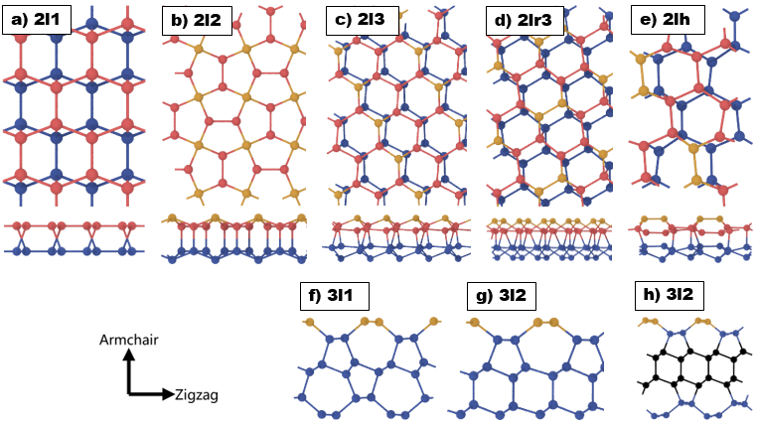

**FIG.2.** (color online) The thermal conductivity dependence on length for five types of bilayer silicon. The scatters are the results of MD simulations while the lines are fitted with Eq.1. The letter z/a in the legend mean the transport direction is zigzag/armchair.

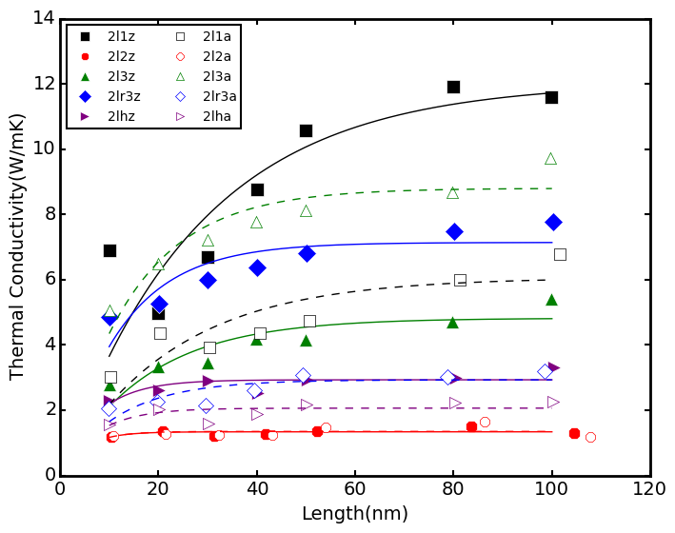

**FIG.2.5.** (color online) The participation ratio .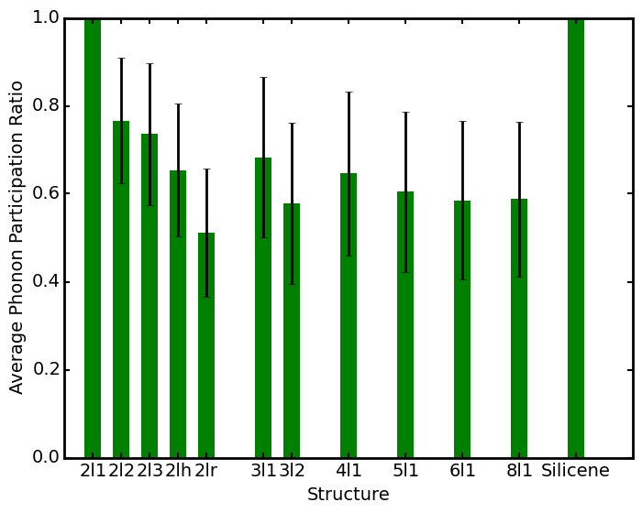

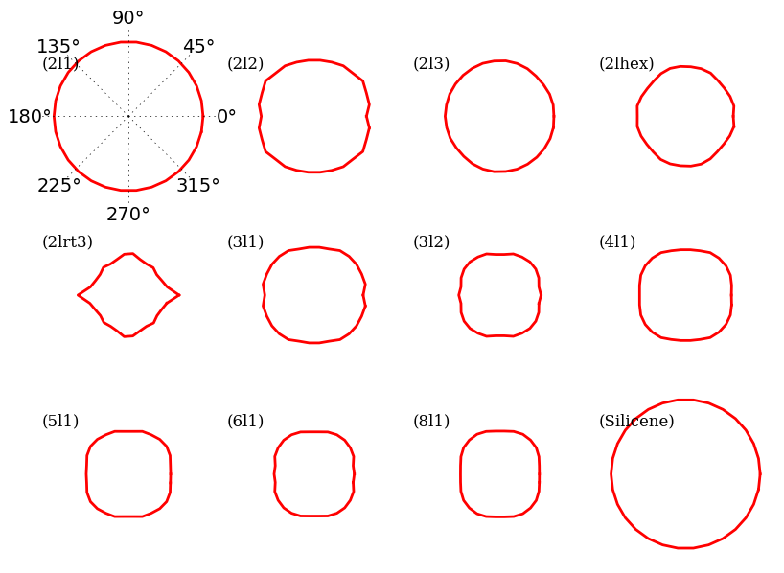

**FIG.2.7.** (color online) The transmission function 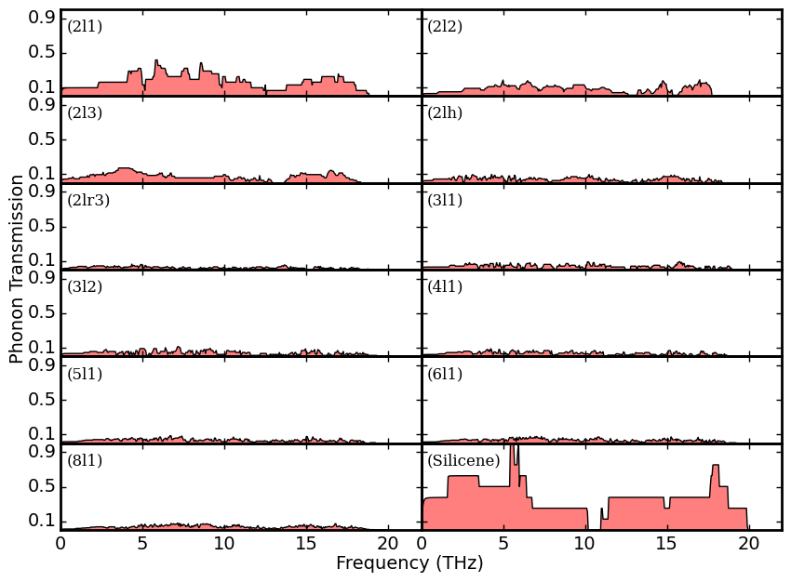

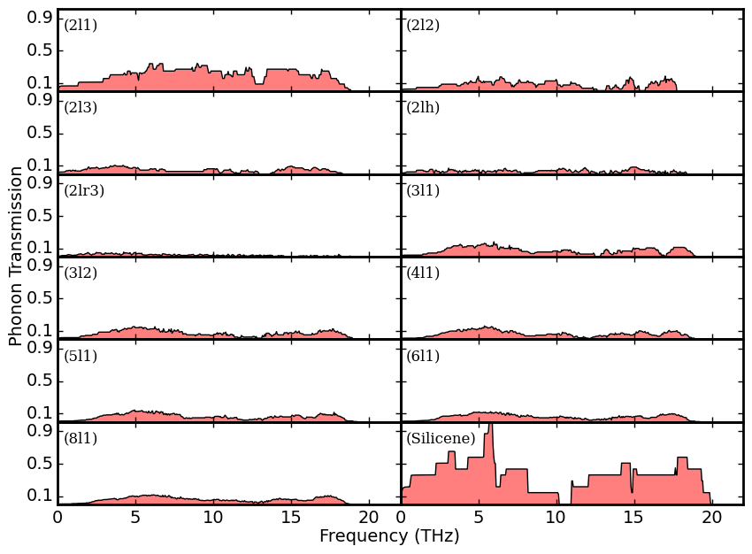

**FIG.2.8.** (color online) Group velocity

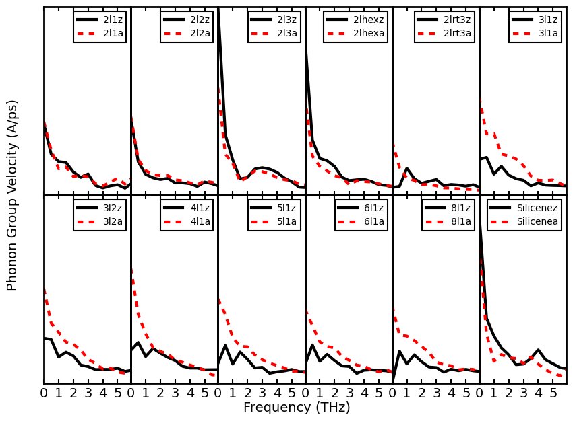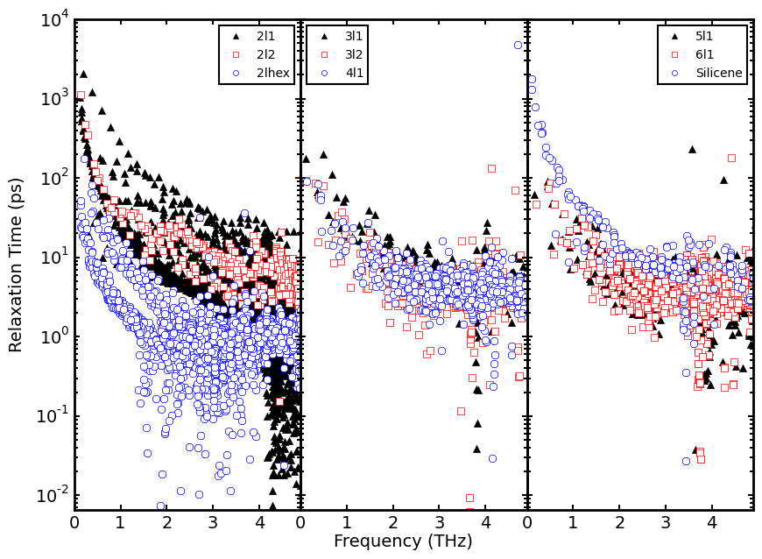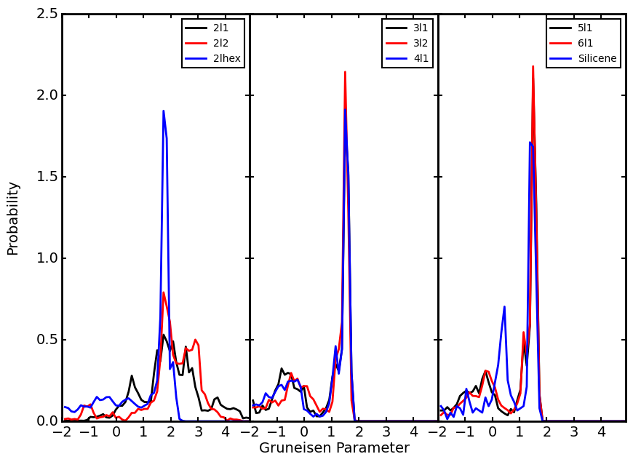

**FIG.3.** (color online) The dependence on length of thermal conductivity for silicon with variable layers.

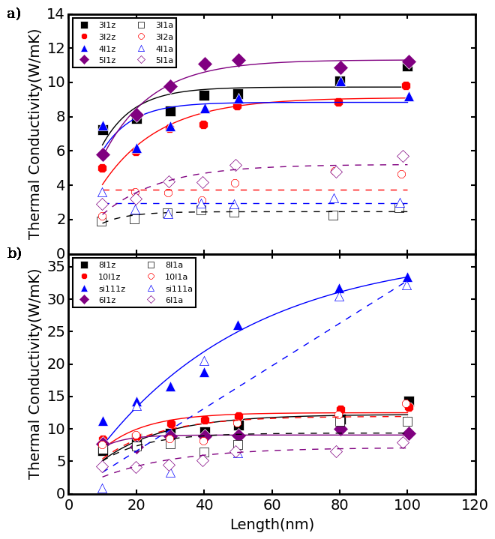

**FIG.4.** (color online) The phonon dispersion of multilayer silicon along high-symmetry points. (a)2l1 and (b) 2l2 are bilayer structure (c) 3l1 is trilayer structure, (d) 4l1 is four-layer structure and (e) 6l1 width six layers, (f)10l1 with ten layers.

